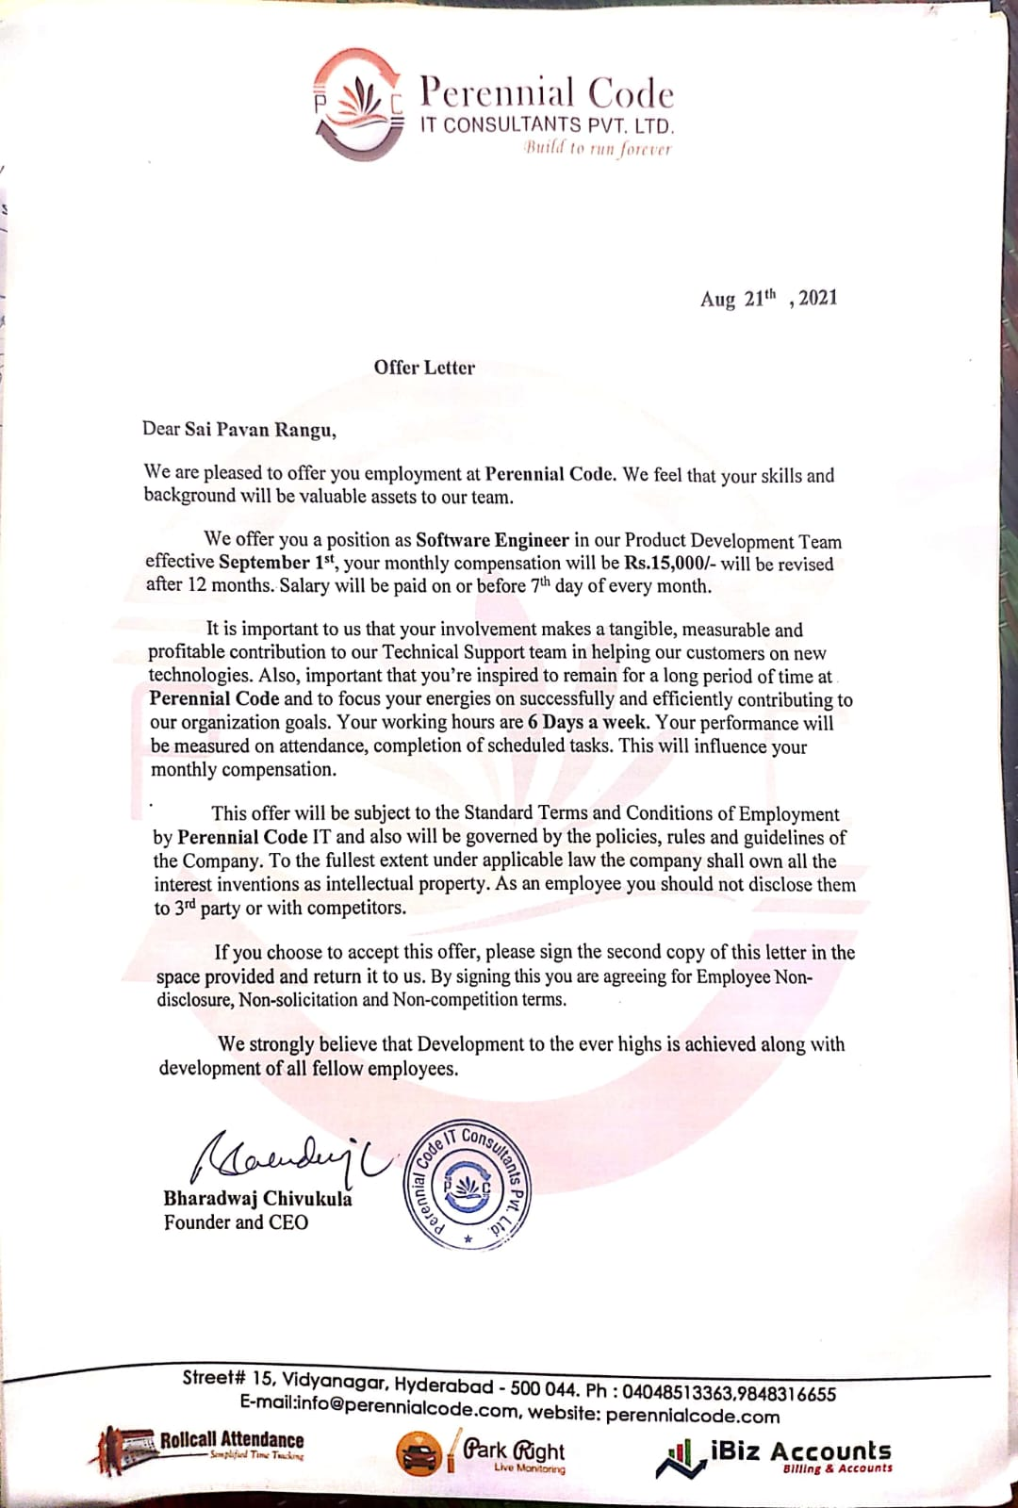
April
Bommineni Shivakumar
March 12th 2025

