

A Project Report On

**ATM**

**INTERFACE SYSTEM**

**By**

**Batch:** 2021 – 6526

**Center:Bangulour leap Digital Acadamy**

**PRESENTED BY:**

**Keerthi.Shivakumar.**

Under the Guidance of,

**Chittaranjan Ghosh,**

**Learner Trainer**

**EduBridge**

(School of coding)

# Introduction:

Automated Teller Machine enables the clients of a bank to have access to their account without going to the bank.  This is achieved only by development the application using online concepts.

When the product is implemented, the user who uses this product will be able to see all the information and services provided by the ATM, when he enters the necessary option and arguments.  The product also provides services like request for cheques, deposit cash and other advanced requirement of the user.  The data is stored in the database and is retrieved whenever necessary.  The implementation needs ATM machine hardware to operate or similar simulated conditions can also be used to successfully use the developed product.

.

To develop this ATM system the entire operation has been divided into the following step:

1. verification process
2. language, service and account selection
3. Banking services
4. Transactions
5. Special services.

I have developed this Application in **Java, JSP, Servlets, Hibernate and MySQL.** It’s a web-based projects so I have used **HTML, CSS, Java and My Sql.**

The program is designed in such a way that the user has to card and pin number.  Once verified, he is provided a menu and he/she had to enter the option provided in the menu.  For example, when the user wants to view the list of payment history than he/she had to enter the option for payment history provided in the main menu.  When the option is entered alone with the respective argument, then the payment history is displayed on the screen.

The user also must be given option to browse through the pages like previous page, next page, etc.  The user may experience a delay in retrieving or viewing the data, when there are many users logged on to the same bank branch system.

# ****Need for the ATM system:****

Millions of times per day around the globe people are instantly withdrawing money at automatic teller machines (ATMs).  Given the fast-pace of the world today, it is not surprising that the demand for access to quick cash is so immense.  The power of ATMs would not be possible without secure connections. The final act of ATM dispending cash is the result of an amazingly fast burst of the customer never sees, but a trust is being done in a confidential manner.

# SYSTEM SPECIFICATION:

# Hardware Requirements:

1. Processor                     – Pentium 4
2. RAM                           – 1 GB
3. Hard Disk                    – 40GB
4. Mouse                          – Standard Mouse
5. Keyboard                     – Logitech Keyboard
6. Processor Speed          – 2.4GHZ

# Software Requirements:

1. Operating System                     – Microsoft Windows .
2. Front-End                                – Java/J2EE technologies (Servlet, JSP), HTML
3. Back-End                                 – MySQL workbench 8.0 CE.

# Display Mode:

1. Color Quality                            – Highest[32 bit]
2. Screen Resolution                     – 1024 by 768 Pixels

# Data Dictionary:

* Create Database Connect;

­­­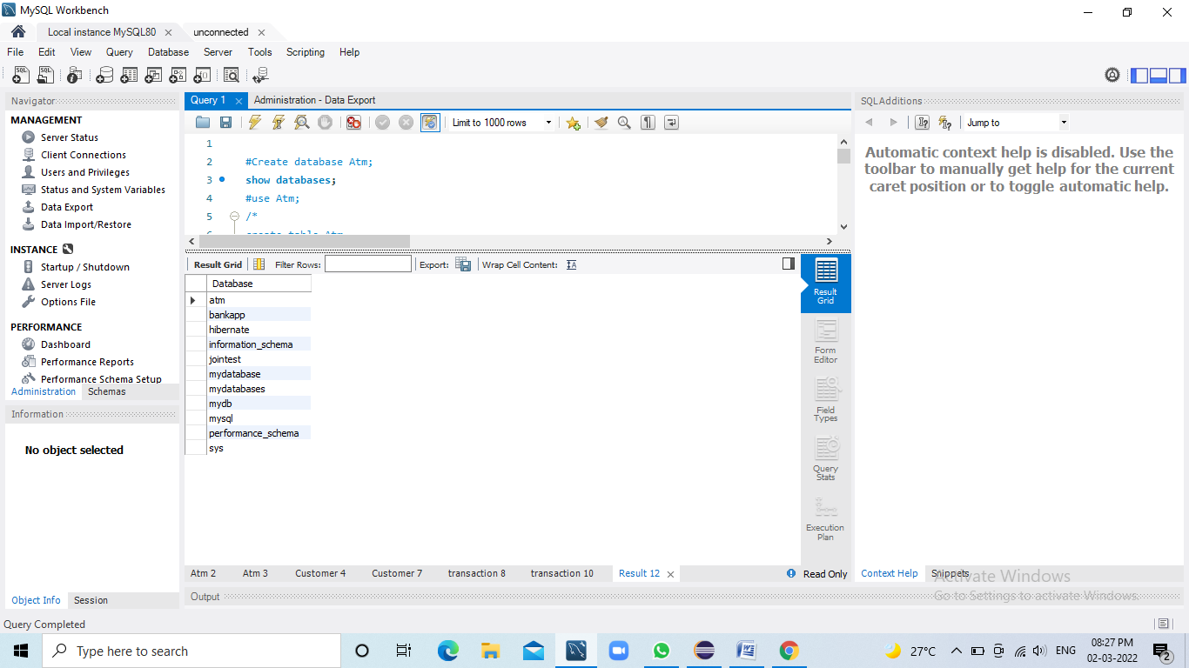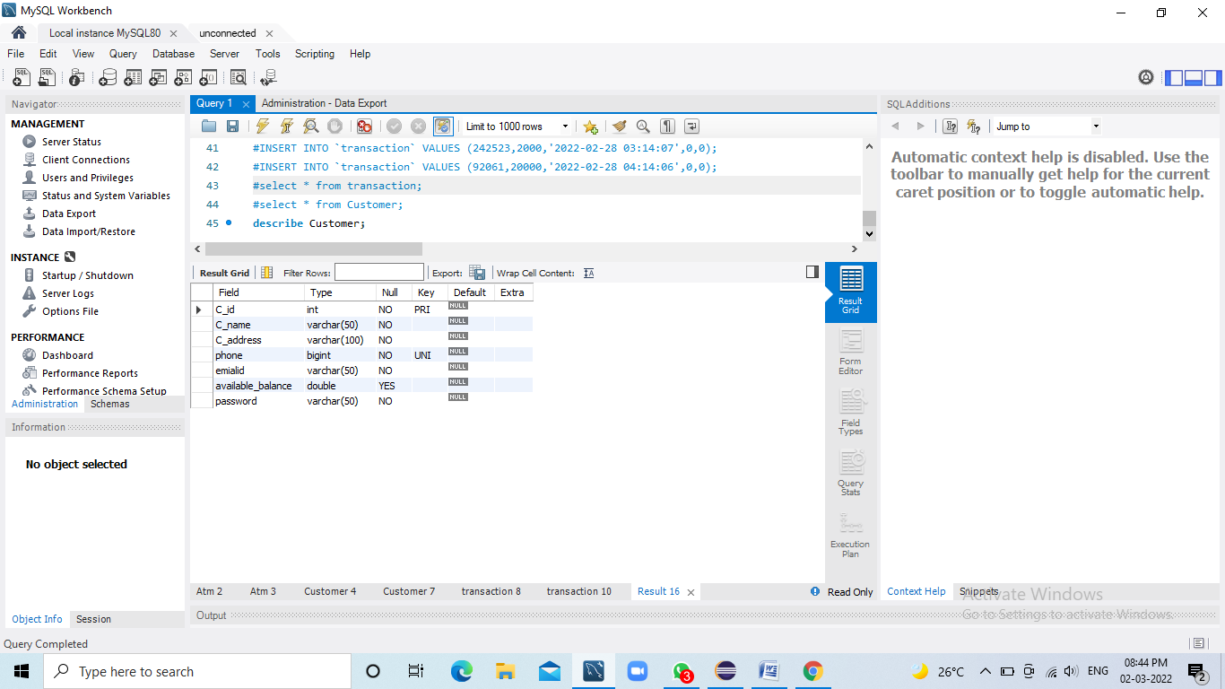

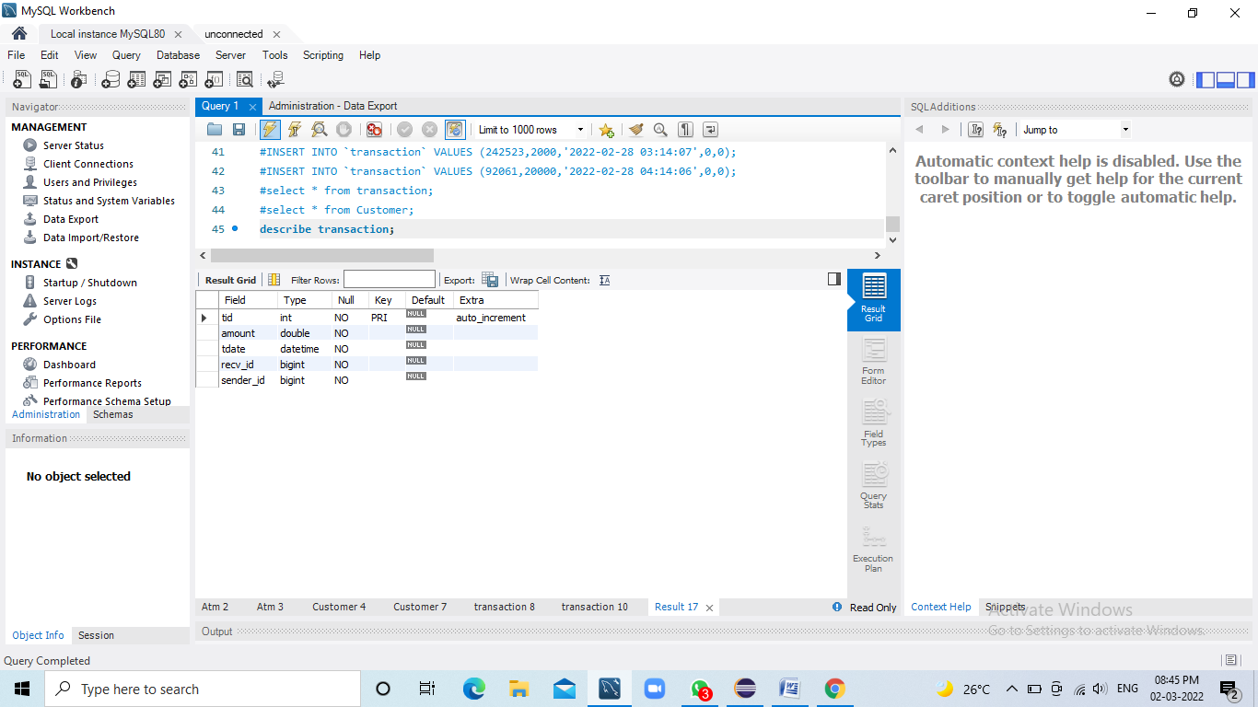

# FLOW CHAT OF ATM ER DIAGRAM:

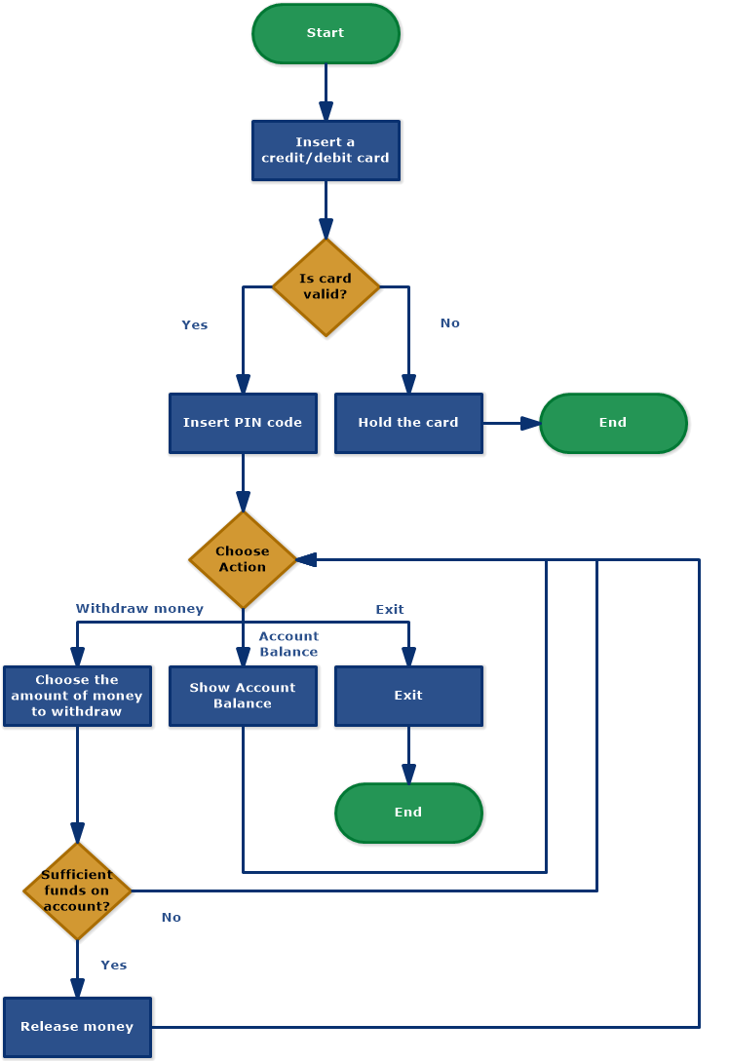

# Screenshots:-

## Home Page:

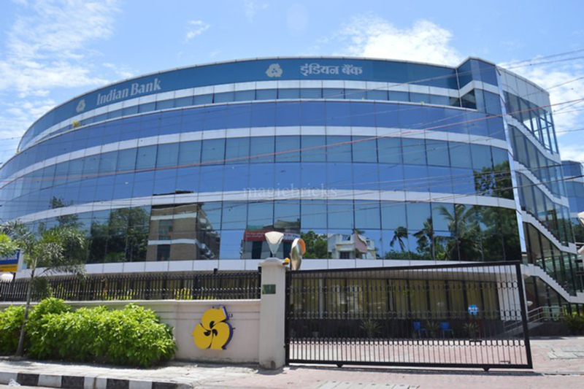

# LOGIN PAGE:

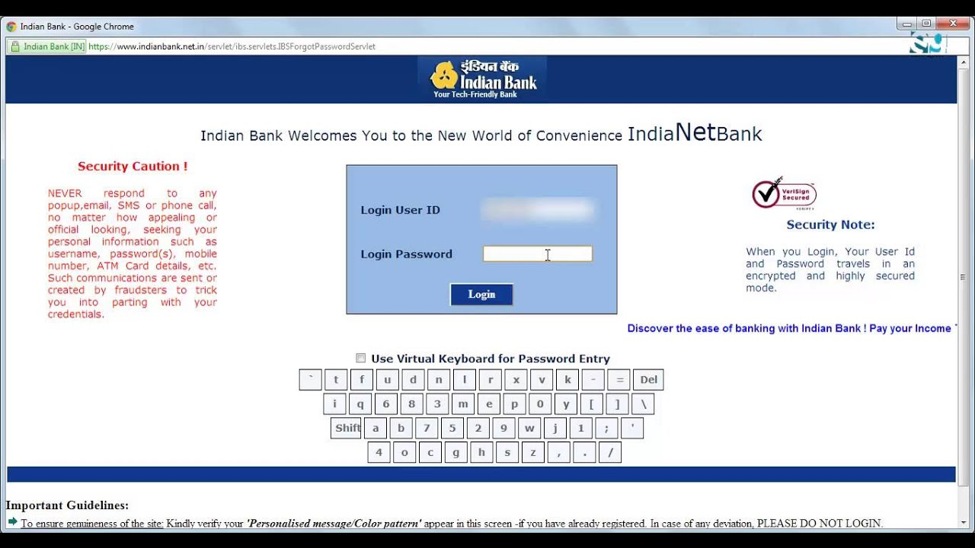

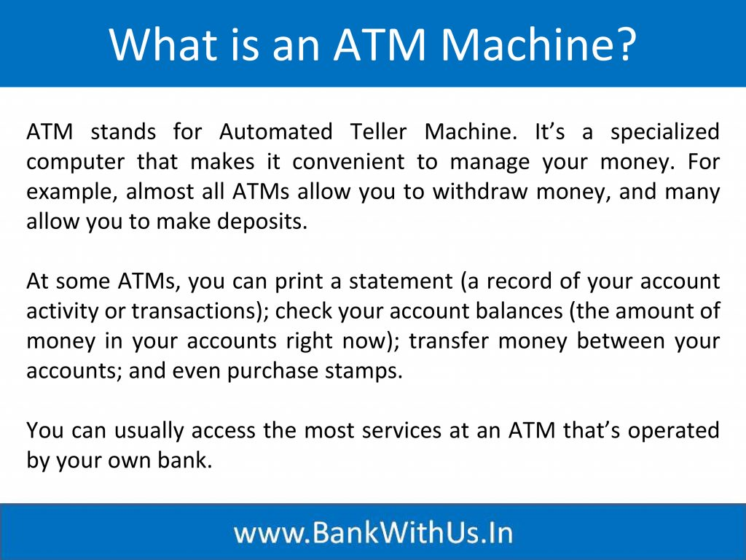

: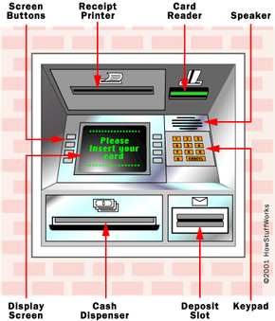

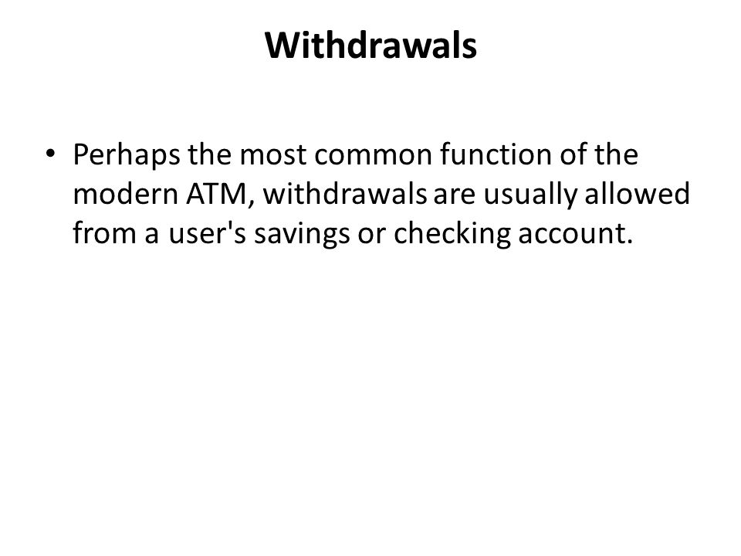

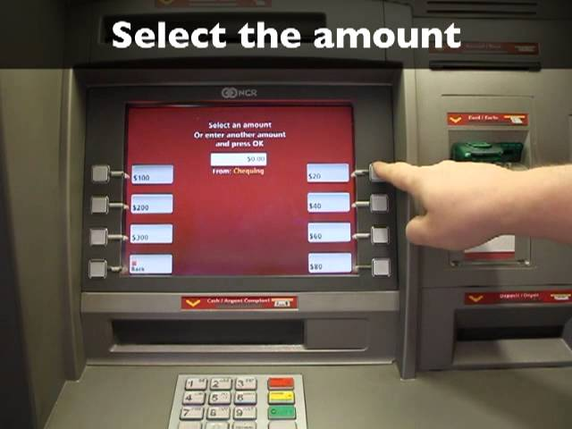

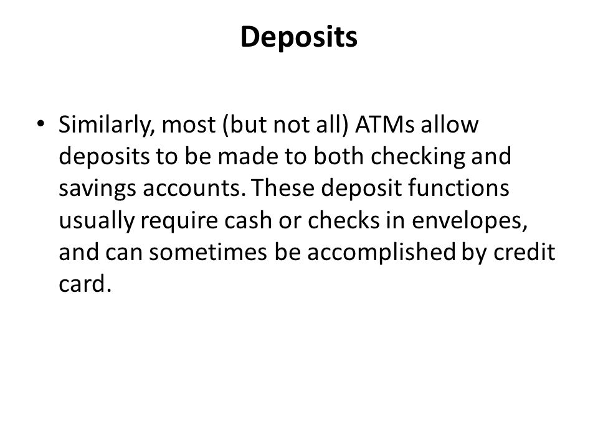

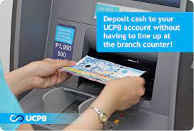

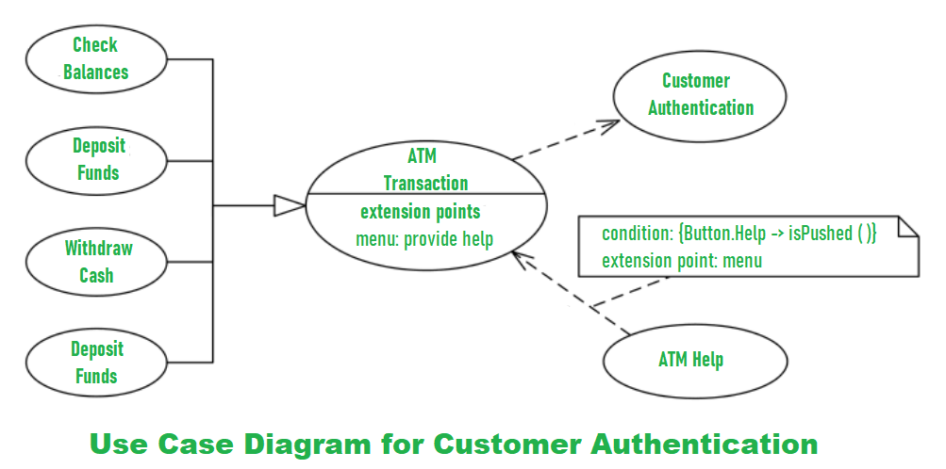

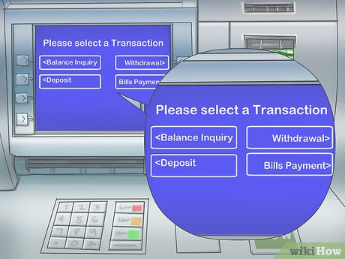

**Transaction Flow Chat:**

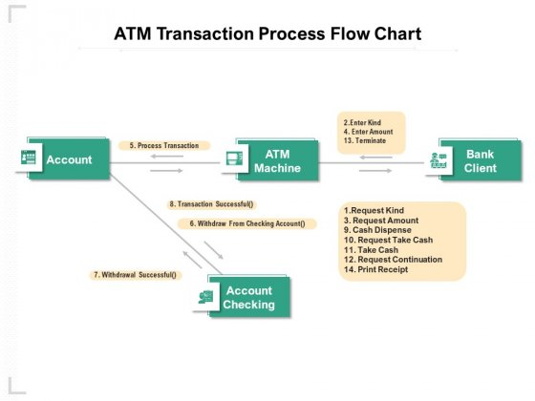

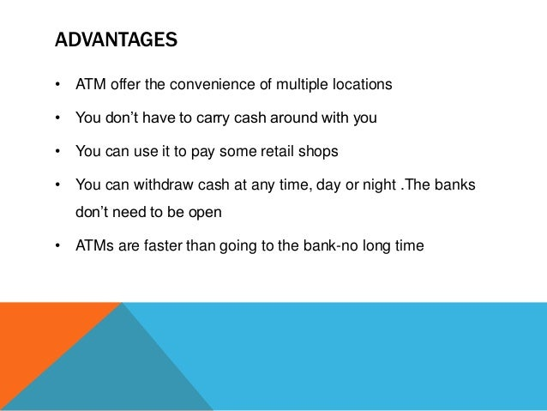

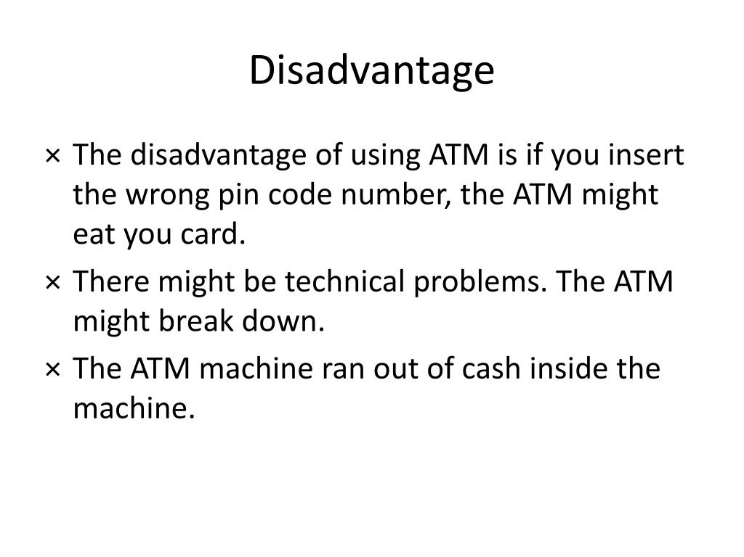

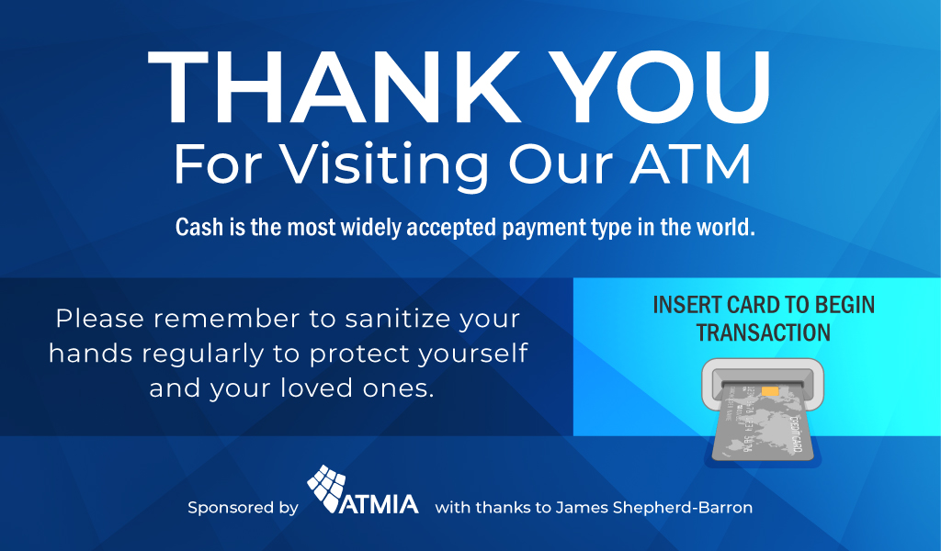

# Suggestions?......