Project - SURAKSHA
-- Safety at Your Fingertips --

Aim: To create a personal and community safety IOT based device that is portable,faster,and reliable and also solves many real-world problems and existing systems problems also

End Users:

1.All humans(boy/girl,small/older,women/men):
if wants a personal safety when they are alone or a family wants like to protect there children form any danger or alone situations. Or Rural Communities and Individuals in Remote Areas.

2.Disaster Response Teams (Government and NGOs):
Organizations like India’s National Disaster Response Force (NDRF), State Disaster Management Authorities, or NGOs (e.g., SEEDS India, Oxfam India) handling floods, earthquakes, or wildfires.

Why They’d Use Suraksha:
Search and Rescue: Deployed to locate stranded people over 50 km, with live video to assess situations
Rapid Deployment: The ESP32 trigger allows field agents to call the drone instantly from disaster zones.

3.Local Governments and Panchayats
- Who They Are: Village councils or small-town administrations managing public safety and infrastructure.
- Why They’d Use Suraksha:
  - Community Safety: Respond to emergencies (e.g., fires, missing persons)
  - Monitoring: Check illegal activities remotely.

Unique Feature's of SURAKSHA:
- Offline messages send using LoRa
- Community Alert Network
- Two-Way Communication
- Prioritizing Response Levels
- Self-defense mechanisms(stun gun mechanizam,High intensity LED)
- Crowd-sourced Safety Map
- AlertZone
- Emergency Mode Lock
- Send Recorded Voice File with alert message
- Safe-Authorization:Fingerprint access
- Smart Drone System:automation/aumated Drone
- SkyDefender:Drone
- Trace-Guard

Other normal Features:
- Send alert message with live location in SMS,
- Email,
- WhatsApp,
- Make Phone Call, and
- Post in other Social media platforms like X,telegram

Devices in SURAKSHA:
- Suraksha 1.0(personal/indiuviual device)
- Suraksha 2.0(To make Mesh-Network)
- Suraksha Smart-Drone System

- SURAKSHA 1.O:
- It is an personal device which can carried by an any person
Hardware componets:
- ESP32 NODE MCU ₹-700 to 1000
- Fingerprint sensor ₹- 1000 to 3000
- Led lights(white,blue,green,red) 4x ₹- 50 to 100
- Push buttons/other type button 4x ₹- 100 to 150
- GPS Module ₹-500 to 2000
- LoRa Module ₹- 800 to 1500
- Microphone ₹- 200 to 300
- Speaker ₹- 200 to 300
- Battery(3.7V, 2000mAh LiPo battery or a similar capacity Li-ion battery,) - ₹- 800 to 1500
- Charging module ₹- 200 to 300
- Boost converter ₹- 200 to 300
- Resistors, zerno diode ,male and female cables(extra) ₹- 500
- Total= min:₹-5,250 max: ₹-11,000
- Average= ₹-6000 to ₹-8000

- SURAKSHA 2.O:
- It is an central device, which can form a Mesh-Networks for quickness and offline usage.
- This suraksha 2.O placed in a reserved place which can not carrier by anyone.
- So, This device can developing by 3 ways, which can use any environment.
- Those are:
1st Way: with built in WiFi
Hardware components:
- ESP32-S3 Devkit(built in wifi) ₹-1000 to 2000
- LoRa module SX1276 (lora transceriver 915mhz) ₹-1500 to 3000
- NEO-M8N GPS module ₹-800 to 2000
- Power supply(5v,2A)-> AC adapter ₹-500
- 3s 2000mah lipo battery ₹-2000
- Lipo charging module ₹-300 to 500
- Power switch circuit ₹-500 to 1200
- Antenna(915 mhz) ₹- 500 to 1000
- Miscellaneous(wiers,connector,pcb,etc..) ₹-1000
- Total= MIN: ₹-8000 MAX: ₹-13,000
- AVG=₹-9000 to ₹- 10,000
2nd Way: With Ethernet support
Hardware components:
- ESP32-S3 Devkit(with out wifi) ₹- 1000 to 1500
- LoRa module SXI276 (lora transceriver 915mhz) ₹-1500 to 3000
- NEO-M8N GPS module ₹- 800 to 2000
- EN(28)60 Ethernet module ₹- 500 to 800
- Power supply(5v,2A)-> AC adapter ₹- 500
- 3s 2000mah lipo battery ₹-2000
- Lipo charging module ₹-300 to 500
- Power switch circuit ₹-500 to 1200
- Antenna(915 mhz) ₹-500 to 1000
- Miscellaneous(wiers,connector,pcb,etc..) ₹-1000
- Total= MIN: ₹-8500 MAX: ₹-13,500
- AVG=₹-9000 to ₹- 11,000
3rd Way: with cellular support(2G/3G/4G)
Hardware components:
- ESP32-S3 Devkit(with out wifi) ₹-1000 to 1500
- LoRa module SXI276 (lora transceriver 915mhz) ₹-1500 to 3000
- NEO-M8N GPS module ₹-800 to 2000
- SIM800L GSM module ₹-500 to 1000
- Power supply(5v,2A)-> AC adapter ₹-500
- 3s 2000mah lipo battery ₹-2000
- Lipo charging module ₹- 300 to 500
- Power switch circuit ₹-500 to 1200
- Antenna(915 mhz) ₹-500 to 1000
- Miscellaneous(wiers,connector,pcb,etc..) ₹-1000
- Total= MIN: ₹-8600 MAX: ₹-13,700
- AVG=₹-9000 to ₹- 11,000

- SURAKSHA Smart-Drone System:
1st Way: Drone with Battery Support
Hardware component
- Raspberry pi 4 (full kit) ₹-6000 to 10,000
- Pixhawk 2.4.8 flight controller ₹5000 to 8000
- S500 quadcopter Frame ₹ 2500 to 3000
- Brushless motors- 2122 1000kv (4x) ₹-1500 to 3000
- ESCs -30A BCHeli (4x) ₹-2000 to 4000
- Propellers-9*4.5-inch (4x) ₹-400 to 800
- GPS module ₹-1000 to 2000
- Lipo battery 6S 30,000MAH ₹16,000 to 25,000
- Power distribution board(PDB) ₹-500 to 1000
- Raspberry pi cemera module v2 ₹-2000
- Optional(Flysky Fs-i6 Transmitter & Recevier) ₹-2500 to 3000
- HC-SR04 ulterasonic sensor (4x) ₹-100 to 200
- Extra wires,monts ₹-1000
- Total= MIN: ₹-42,000 MAX: ₹-63,000
- AVG=₹- 45,000 or 50,000 to ₹- 60,000 or 70,000

2nd Way: Drone with Fuel support:
Hardware component
- Raspberry pi ₹- 6000 to 10,000
- Pixhawk 2.4.8 flight controller ₹- 5000 to 8000
- S500 quadcopter Frame ₹-2500 to 3000
- Brushless motors- 2122 1000kv (4x) ₹-1500 to 3000
- ESCs -30A BCHeli (4x) ₹-2000 to 4000
- Propellers-9*4.5-inch (4x)₹-400 to 800
- GPS module ₹-1000 to 2000
- Nitro Engine(5cc,1.5hp) ₹-5000 to 10,000
- Generator-50W ₹-4000 to 7000
- Lipo battery-6S 5000MAH ₹-3000 to 6000
- Fuel tank 150ml ₹-500 to 1000
- Power distribution board(PDB) ₹-500 to 1000
- Raspberry pi cemera module v2 ₹-2000
- Optional(Flysky Fs-i6 Transmitter & Recevier) -₹- 2500 to 3000
- HC-SR04 ulterasonic sensor (4x) ₹-100 to 200
- Extra wires,monts ₹-1000
- Total= MIN: ₹-38,000 MAX: ₹-62,000
- AVG=₹- 40,000 or 45,000 to ₹- 55,000 or 65,000

Comparing 2-ways:
- with battery:
Pros:
Simpler, reliable, no fuel—ideal for quick builds and testing.
Cons:
Costly, weight,
Limited time to fly and limited area cover(~20km)
It takes long time to re-charage
- With flue:
Pros:
Unlimited time to fly until flue over, large area cover(~60km for 150ml of flue)
It easy to re-fill the flue.
Cons:
Complex (tuning, fuel system), noisy, less reliable without maintenance.
It generates Noise/sound and vibrations.

- (optional 3rd Way: Solar-Based)

Example: Hyderabad
(include GHMC, Secunderabad, shamshabad, miyapur, dammaiguda, ramoji film city, and ect)
Total area cover: 650 sq.KM (~40km*25km)
- Mesh-Network (Suraksh 2.O):
Here each hub covers 15km*15km= Minimum ~200 sq.km
So to cover the whole Hyderabad we use 6-hubs for fast and quick responses and requests.

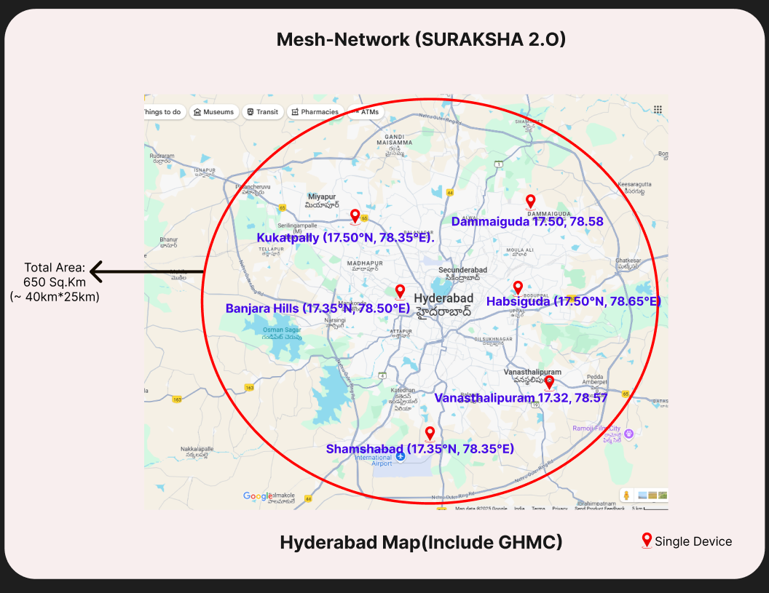
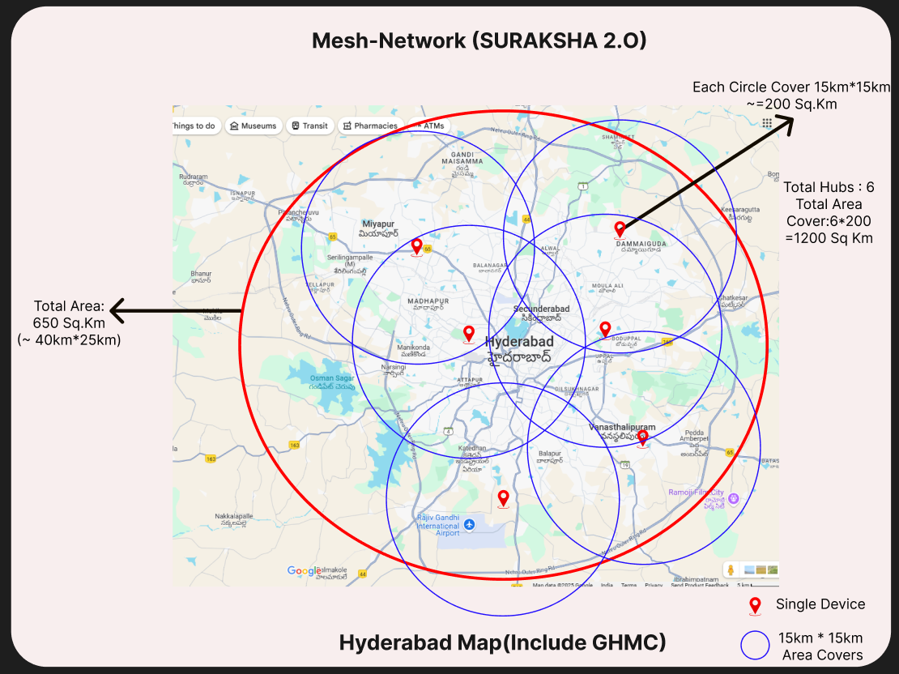

- Smart Drone System: (Battery-Based)
Here each hub covers 15km*15km= Minimum ~200 sq.km
So to cover the whole Hyderabad we use minimum 4 battery based drones for fast and quick responses and requests.

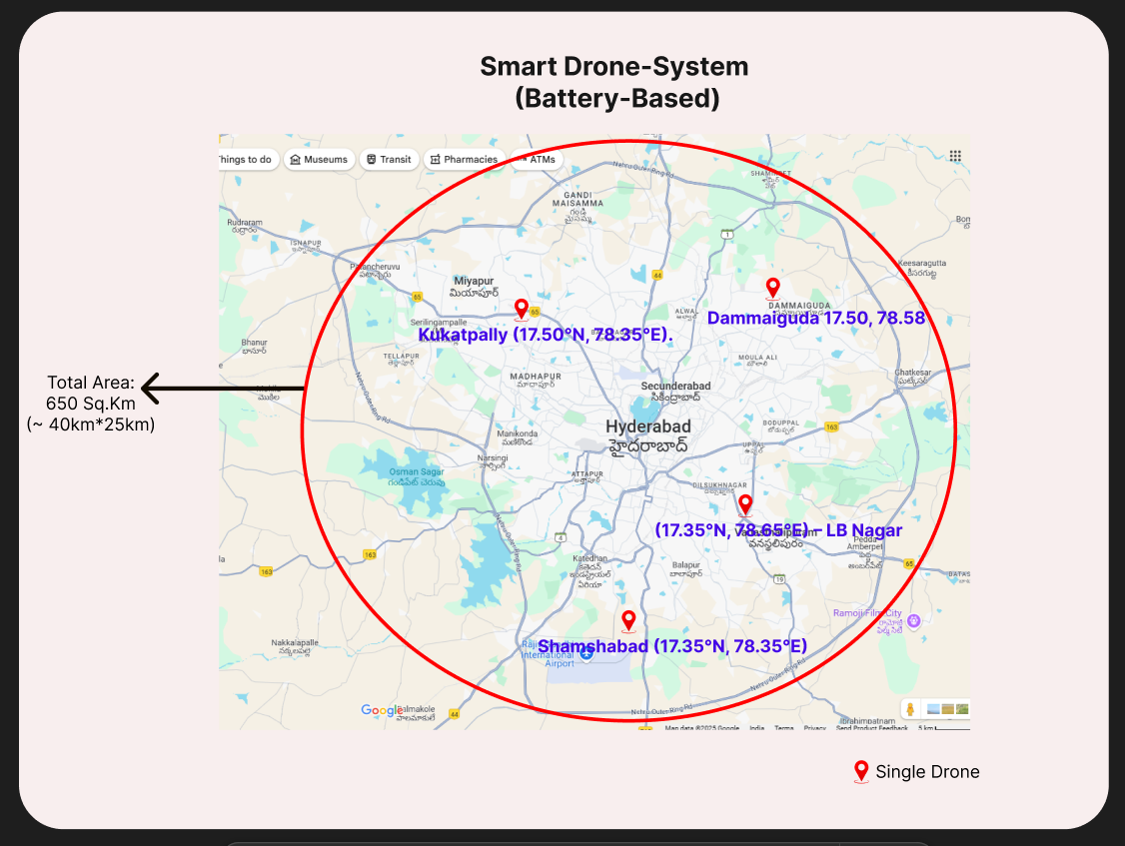

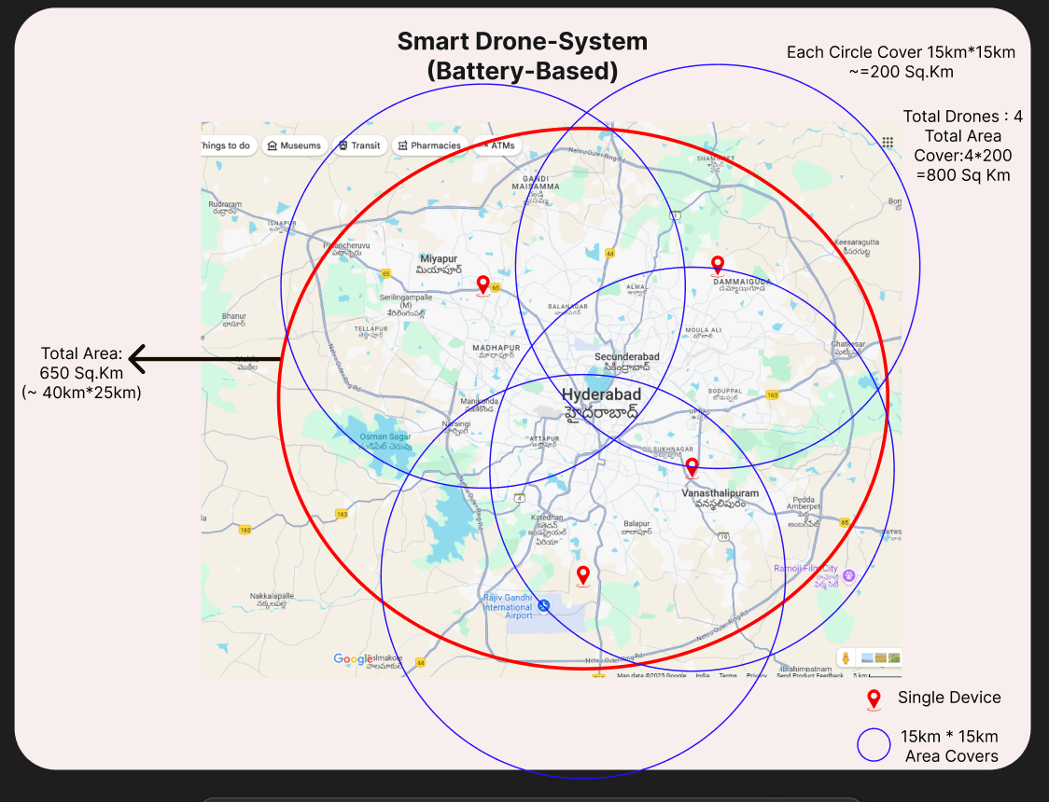
- Smart Drone System: (Fuel-Based)
Here each hub covers 20km*20km= Minimum ~400sq.km
So to cover the whole Hyderabad we use minimum 2-drones for fast and quick responses and requests.

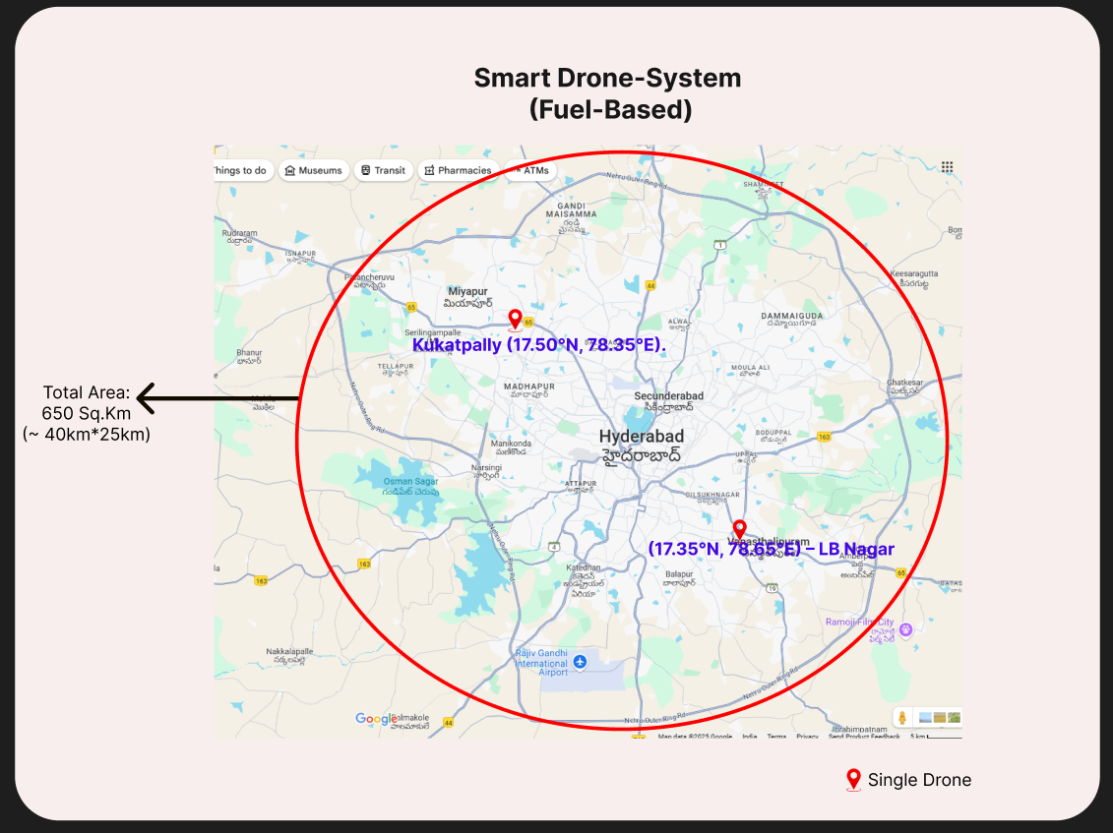
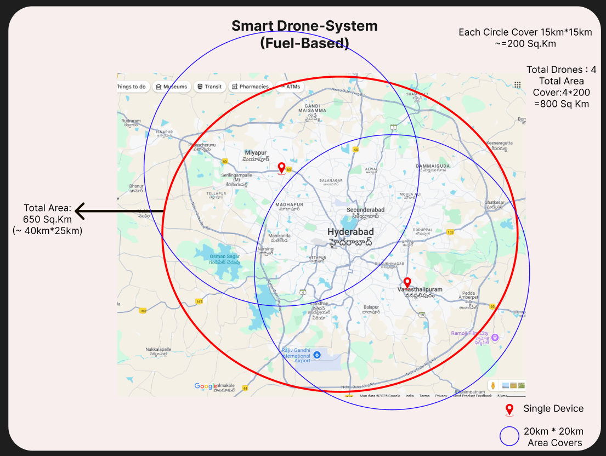

For Example:
- If a person in ‘Nehuru zoological park’ then that person use suraksha device for help
- Then next movement our system finds the nearest hub/drone and activate it, and process continues.
- Here this person comes under the range of Banjar Hills Hub-3, Shamshabad Hub-5 with Drone, and Vanathalipuram Hub-6, and Drone.
Distance:
Person to Banjar Hills Hub-3 = 8-10km,
Person to Shamshabad Hub-5 with Drone = 10-13km,
Person to Vanathalipuram Hub-6, Drone =15-17km
- If user with Internet: without using mesh-network, directly send alert signal to the nearest drone and your contacts.
- If user without Internet: using LoRa send signal to the nearest Hub and Drone and next that Hub sends send alert signal to your contacts.
- In this case if user with intenet then directly send alert signal and if that user wants drone then activate the nearest drone is ‘Shamshabad Drone’ with distance 10-13km.
- If user without internet then send alert signal to nearest Hub is Banjara Hills Hub-3 with distance is 8-10km
