Databricks
Databricks is a unified analytics platform that provides tools for building, managing, and deploying data pipelines, machine learning models, and big data processing applications. It is built on top of Apache Spark and offers an integrated workspace for data engineers, data scientists, and business analysts to collaborate.
History:
Databricks was founded by the original creators of Apache Spark in 2013, with the goal of developing a unified analytics platform to address the challenges faced by data engineers, data scientists, and business analysts in handling large-scale data processing and machine learning.
Databricks was founded by a team of researchers from the University of California, Berkeley’s AMPLab, including Matei Zaharia, Ali Ghodsi, Ion Stoica, and others.
2014: Apache Spark 1.0 and Databricks Cloud Released, marking a significant milestone in the development of the project.
2015: The company focused on building out its platform with additional features for data processing, machine learning, and data integration.
2016: Databricks launched the Community Edition, a free version of its platform, to make Apache Spark more accessible to individuals and small teams.
2017: Databricks introduced Delta Lake (initially called Databricks Delta), a storage layer that brings ACID transactions, scalable metadata handling, and unification of streaming and batch data processing to Apache Spark workloads.
2018: Funding with new features
2019: Continued growth of expansion
2020: Lakehouse Architecture Launched
2021 and 2022: Databricks continued to innovate and expand its product offerings, focusing on enhancing the Lakehouse platform and deepening integrations with cloud providers like AWS, Azure, and Google Cloud

Key Components of Databricks:
Databricks is composed of several key components that work together to provide a comprehensive platform for data engineering, data science, and business analytics.
- Workspace:
- An interactive environment where users can create, organize, and share notebooks and folders.
- Supports real-time collaboration and version control for code and documentation.
- Notebooks:
- Interactive documents that can contain code, visualizations, and narrative text.
- Supports multiple languages including Python, R, Scala, and SQL.
- Ideal for exploratory data analysis, prototyping, and sharing results.
- Clusters:
- Managed clusters of virtual machines running Apache Spark.
- Automatically scales up or down based on workload.
- Supports different cluster configurations for various workloads.
- Delta lake:
- A storage layer that brings ACID transactions, scalable metadata handling, and unification of streaming and batch data processing.
- Ensures data reliability and consistency.
- Jobs:
- Automated and scheduled workflows to run data processing and machine learning tasks.
- Can be triggered on a schedule or by specific events.
- MLflow:
- An open-source platform to manage the machine learning lifecycle.
- Supports experimentation, reproducibility, and deployment of machine learning models.

- Databricks SQL:
- Provides SQL analytics capabilities on top of the Lakehouse architecture.
- Allows users to run SQL queries, create dashboards, and generate reports.

Databricks Architecture
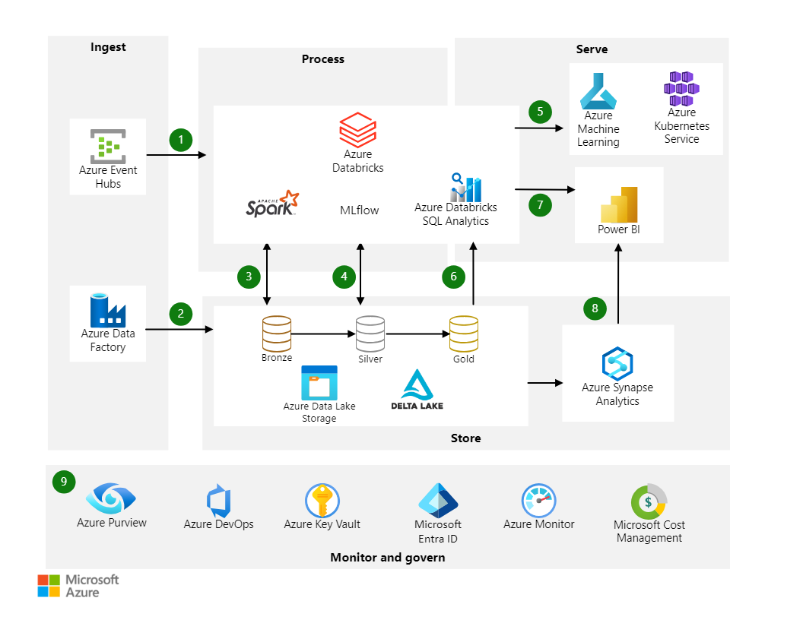

Databricks playing a central role in the data processing layer.
Let's break down the architecture step-by-step:
Ingest:
Azure Event Hubs: Used for real-time data ingestion. Event Hubs capture streaming data from various sources such as IoT devices, applications, and more.
Azure Data Factory: A data integration service that orchestrates and automates data movement and data transformation. It moves data from different sources into Azure Data Lake Storage.

Process:
Azure Databricks: A key component for processing data. Azure Databricks leverages Apache Spark to process large volumes of data. Data ingested from Event Hubs and Data Factory is processed here, possibly with initial transformations and cleaning, and then stored in different stages (Bronze, Silver, Gold) in Delta Lake on Azure Data Lake Storage.
MLflow: Integrated with Azure Databricks for managing the machine learning lifecycle, including experimentation, reproducibility, and deployment of ML models.
Azure Databricks SQL Analytics: Allows users to run SQL queries, build visualizations, and create dashboards directly within Databricks. This component also integrates with tools like Power BI for further analytics and reporting.
Store:
Azure Data Lake Storage (Delta Lake): Data is stored in a layered architecture:
- Bronze: Raw data.
- Silver: Cleaned and enriched data.
- Gold: Aggregated and refined data, ready for analytics and reporting.
Serve:
Azure Machine Learning: Deployed models from Databricks can be used in Azure Machine Learning for further model management, deployment, and monitoring.
Azure Synapse Analytics: A unified analytics service that brings together big data and data warehousing. Data from the Gold layer can be used for further analytics and querying using Synapse.
Power BI: A business analytics tool that connects to Azure Databricks and Azure Synapse Analytics to create interactive reports and dashboards for business users.
Monitor and Govern:
Azure Purview: Data governance service that allows you to manage and govern your data landscape.
Azure DevOps: Provides CI/CD pipelines for continuous integration and continuous delivery of code.
Azure Key Vault: Manages secrets, keys, and certificates.
Microsoft Entra ID: Identity management service for authentication and authorization.
Azure Monitor: Provides full-stack monitoring and alerting.
Microsoft Cost Management: Helps monitor and control Azure spending.

Languages Supported by Databricks
1. Python: Widely used for data analysis, machine learning, and ETL tasks. Libraries like Pandas, NumPy, and scikit-learn are commonly used. PySpark API allows users to interact with Spark using Python.
2. SQL: Used for querying structured data within Databricks. Ideal for analysts who are familiar with SQL and need to run complex queries. Supports ANSI SQL, allowing easy transition for users from other SQL environments.
3. SCALA: The native language for Apache Spark, offering the most extensive and efficient interface. Preferred by users who need to write high-performance Spark jobs.
4. R: Popular among data scientists and statisticians for statistical analysis and data visualization. Supported through SparkR and Sparklyr packages, allowing interaction with Spark using R.
5. Java: Supported for Spark applications and libraries.
Beneficial for users who need to integrate Spark with existing Java applications or libraries.

Supported Data types in Databricks:
Here are the primary types of data supported by Databricks:
1 Structured Data:
Data that is organized into rows and columns, typically found in relational databases and spreadsheets.
Examples: SQL databases, CSV files, Parquet files, and tables.
2 Semi-Structured Data:
Data that does not have a rigid structure like structured data but still follows a consistent format.
Examples: JSON files, XML files, and Avro files.
3. Unstructured Data:
Data that does not have a predefined structure, often text-heavy and rich in information.
Examples: Text files, log files, images, videos, and audio files
4. Streaming Data:
Data that is generated continuously by various sources and needs to be processed in real-time.
Examples: Data from IoT devices, social media feeds, and real-time analytics logs.
5. Time Series Data:
Data that is indexed or organized based on timestamps, often used in monitoring and forecasting.
Examples: Sensor data, stock prices, and system logs.
6. Geospatial Data:
Data that includes geographical information, often used in mapping and spatial analysis.
Examples: GPS coordinates, shapefiles, and GeoJSON files.

Creating Databricks Account:
Steps involved to create Databricks account:

Step 1. Visit the Databricks Community Edition Sign-Up Page:
Open your web browser and navigate to Databricks Community Edition.
Step 2. Start Your Free Trial:
Click on the "Get Started" or "Try Databricks" button to begin the sign-up process.
Step 3. Fill in the Sign-Up Form:
Enter your personal information, including your first name, last name, email address, company name (if applicable), and country. Create a strong password and confirm it.
Step 4. Verify Your Email:
Check your email inbox for a verification email from Databricks.
Click on the verification link in the email to verify your email address.
Step 5. Login to Account:
After verifying your email, go back to the Databricks Community Edition login page.
Enter your email and password to log in.

Cluster Creation in Databricks:
Create a New Cluster:
On the Clusters page, click on the "Create Cluster" button.
Configure Cluster Settings:
- Cluster Name: Give your cluster a meaningful name.
- Cluster Mode: Choose between Standard, High Concurrency, or Single Node. For most cases, "Standard" is appropriate.
- Databricks Runtime Version: Select the runtime version you want to use. The default is usually the latest stable version.
- Python Version: Choose the Python version if applicable.
- Node Type: Select the node type based on your compute requirements. The default is often sufficient for development and testing.
- Driver and Worker Nodes: Specify the number of worker nodes and the size of each node. You can use the default settings for a basic cluster.
Create Workspace:
A workspace in Databricks is an environment where you can organize and manage your Databricks assets such as notebooks, libraries, experiments, jobs, and data. It provides a user interface and a set of tools to help you collaborate, develop, and deploy data pipelines, machine learning models, and analytics workflows. Key Components of a Databricks Workspace
- Notebooks:
  - Interactive web-based interfaces where you can write code in languages like Scala, Python, SQL, and R.
  - Support for rich text, visualizations, and Markdown.
- Dashboards:
  - Tools to create interactive visualizations and share insights.
  - Can combine multiple visualizations into a single view.
- Libraries:
  - Packages or modules that add functionality to Databricks clusters.
  - Can include custom code or third-party libraries.
- Jobs:
  - Scheduled or on-demand tasks that run your notebooks or scripts.
  - Useful for automating workflows and ETL processes.
- Clusters:
  - Groups of virtual machines configured to run your notebooks and jobs.
  - Can be configured for different workloads, sizes, and purposes.

- Experiments:
  - Tools to track and manage machine learning experiments.
  - Integrates with MLflow to manage model training and deployment.
- Data:
  - Tools to manage and query your data, including Delta Lake tables.
  - Integrates with various data sources like Azure Blob Storage, AWS S3, and on-premises databases.
- Repos:
  - Integration with version control systems like Git to manage your code.
  - Allows for collaboration and versioning of notebooks and other code artifacts.

Databricks Pipeline:
Databricks pipeline architecture is designed to facilitate the process of building, deploying, and managing data pipelines. It leverages the capabilities of Apache Spark and the Databricks platform to handle large-scale data processing tasks efficiently.
Components:
• Data Sources: These are the origins of data, which can be various databases, cloud storage (e.g., Azure Blob Storage, AWS S3), streaming data sources (e.g., Kafka), or on-premises systems.
• Ingest: Data ingestion is the process of moving data from data sources into the pipeline. This can be done using tools like Azure Data Factory, Databricks' Auto Loader, or directly through APIs.
• Processing: This is where the core data transformation happens. Apache Spark jobs running on Databricks are used for batch processing, real-time processing, and complex analytics. Notebooks and jobs can be scheduled to automate these processes.
• Storage: Processed data is stored in a data lake (e.g., Azure Data Lake Storage, AWS S3) or a data warehouse (e.g., Azure Synapse, Snowflake) for further analysis and querying.
• Serving: This layer serves the processed data to end-users or downstream applications. It can include visualization tools like Power BI, dashboards, and custom applications.
• Monitoring and Management: Databricks provides tools for monitoring the health of pipelines, managing cluster performance, and logging.

DBFS:
DBFS (Databricks File System) is a distributed file system mounted into a Databricks workspace and is an abstraction over scalable object storage. DBFS allows you to work with files in a similar way to how you would work with them on a local filesystem. It provides a convenient way to access and store data files within Databricks.

Key Features of DBFS
- Mount Points: DBFS can be mounted to various cloud storage services like Azure Blob Storage, AWS S3, etc., allowing easy access to external data sources.
- Persistence: Files stored in DBFS are persistent and can be accessed across sessions and clusters.
- Scalability: As an abstraction over scalable object storage, DBFS can handle large volumes of data.
- Access Control: DBFS supports Databricks access control mechanisms, enabling secure data access.

Example Usage of DBFS
Let's walk through an example where we upload a CSV file to DBFS, read it into a DataFrame, and perform some basic operations.

Step 1: Uploading a File to DBFS
You can upload files to DBFS using the Databricks UI or through the Databricks CLI. Here, we'll demonstrate using the Databricks UI.

Step 2: Reading the File into a Data Frame
You can read the uploaded file into a Spark Data Frame using PySpark.
ex:
file_path = "/FileStore/tables/sales_data.csv"
Read the CSV file into a DataFrame
df = spark.read.csv(file_path, header=True, inferSchema=True)
# Show the first few rows of the DataFrame
df.show()
Databricks control plane and Data plane:

Control Plane
The control plane is responsible for managing the Databricks workspace, including user authentication, cluster management, job scheduling, and other administrative tasks. It operates outside of your cloud environment, typically in the cloud provider’s region.
Key Responsibilities of the Control Plane:
- User Authentication and Authorization: Manages user access and permissions.
- Cluster Management: Handles the creation, configuration, and monitoring of clusters.
- Job Scheduling: Manages the scheduling and execution of jobs.
- Notebook Management: Manages notebooks, their versions, and permissions.
- REST APIs: Provides REST APIs for interacting with Databricks services.

Data Plane
The data plane is responsible for processing and storing your data. It is deployed within your cloud account, ensuring that data processing happens in your environment and complies with your security and compliance requirements.
Key Responsibilities of the Data Plane:
- Data Processing: Executes workloads, including Spark jobs, data transformations, and machine learning models.
- Data Storage: Reads from and writes to various storage systems (e.g., AWS S3, Azure Blob Storage, ADLS).
- Networking: Manages network configurations to ensure secure communication between data processing nodes and data storage systems.

Delta Table and Its Features:
A Delta Table is a storage layer on top of data lakes, such as Apache Spark and Apache Hive, that provides ACID transactions (Atomicity, Consistency, Isolation, Durability) and scalable metadata handling. It enables reliable data pipelines, simplified data management, and efficient querying and performance optimizations.

Key Features of Delta Table:
- ACID Transactions: Ensures data integrity and reliability with atomicity, consistency, isolation, and durability.
- Scalable Metadata Handling: Efficiently manages metadata, allowing quick and easy access to large datasets.
- Time Travel: Allows querying of previous versions of the data, providing historical insights and data auditing capabilities.
- Schema Evolution: Automatically handles schema changes without requiring manual intervention.
- Data Reliability: Ensures data consistency and correctness with data validation and error handling mechanisms.
- Performance Optimization: Improves query performance through data compaction, caching, and indexing.

Understanding with Delta Table in Databricks Notebook
A Delta Table is a table stored in the Delta Lake format. It allows for efficient and reliable data management and query performance optimizations.
Create table:
%sql

create table employee
(
id int,
name string,
age int,
salary double
)
Insert values into employee table:
%sql

insert into employee values(1,'Hanish',3,2000);
insert into employee values(2,'Shiva',33,80000);
insert into employee values(3,'Ram',31,20000);
Display the records in a table:

id name age salary
1 Hanish 3 2000
2 Shiva 33 80000
3 Ram 31 20000

Employee Table Schema:
%sql
Describe detail employee

_sqldf:pyspark.sql.dataframe.DataFrame
format:string
id:string
name:string
description:string
location:string
createdAt:timestamp
lastModified:timestamp
partitionColumns:array
element:string
numFiles:long
sizeInBytes:long
properties:map
key:string
value:string
minReaderVersion:integer
minWriterVersion:integer
tableFeatures:array
element:string
statistics:map
key:string
value:long

Identify the table path using below command:
%fs ls 'dbfs:/user/hive/warehouse/employee'

Advanced Delta Lake Features:
Delta Lake is an open-source storage layer that brings reliability to data lakes. It provides ACID transactions, scalable metadata handling, and unifies streaming and batch data processing.
Features of Delta Lake are:
Data Lineage:
- Delta Lake provides a way to track the provenance of data. This is useful for debugging, audit logging, and reproducing experiments.
Compaction and Data Skipping:
- Compaction: Delta Lake optimizes storage by compacting small files into larger ones.
- Data Skipping: Delta Lake leverages file statistics to avoid scanning irrelevant files.
Z-Ordering:
- Z-Ordering is a multi-dimensional clustering approach to colocate related information in the same set of files. This can significantly improve query performance.
Optimized Reads and Writes:
- Delta Lake optimizes read and write operations by caching data and using indexing.
Concurrency Control:
- Delta Lake uses optimistic concurrency control to handle multiple users simultaneously writing to a data lake.
CICD Support:
- Delta Lake integrates well with CI/CD pipelines, allowing for automated testing and deployment.
Support for MERGE, UPDATE, DELETE, and OVERWRITE:
- These SQL-like commands enable users to perform sophisticated data transformations.

Support for Incremental Data Processing:
- Delta Lake supports incremental data processing, which is essential for ETL jobs and streaming data applications.

CREATE DATABASE AND TABLES
In Databricks, databases and tables are essential components for organizing and managing your data. Databricks, built on Apache Spark, integrates seamlessly with Delta Lake and various data storage systems. Here’s an overview of how databases and tables work in Databricks:

Databases in Databricks
A database in Databricks is a collection of tables, views, and functions. It serves as a namespace to organize these objects logically. You can create, list, and drop databases using SQL commands.
CREATE DATABASE my_database;
SHOW DATABASES;
USE my_databases;

Tables in Databricks
Tables in Databricks can be of different types, such as managed tables, external tables, and Delta tables. Here's a breakdown of each type:
- Managed Tables:
  - Databricks manages both the metadata and the data.
  - When you drop a managed table, Databricks deletes both the metadata and the data.
CREATE TABLE my_managed_table ( id INT, name STRING );
- Inserting Data:
INSERT INTO my_table VALUES (1, 'Alice'), (2, 'Bob');
- Query the Date

SELECT * from my_table

- Updating Data:
UPDATE my_table SET name = 'Charlie' WHERE id = 1;
- 5 Deleting Data:
DELETE FROM my_table WHERE id = 2;

DBFS Architecture:

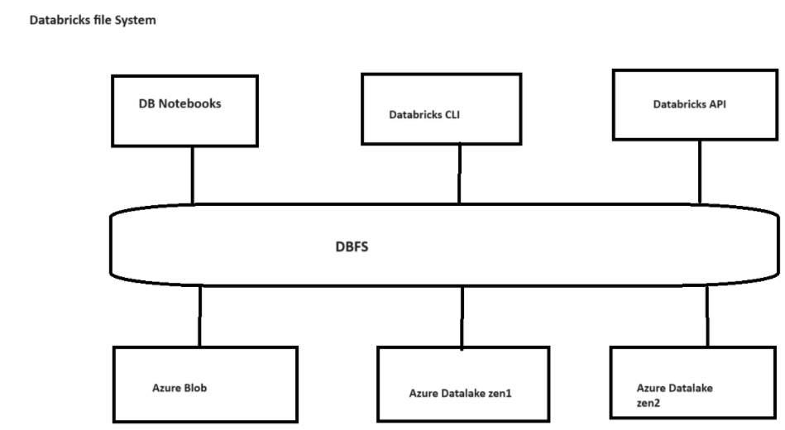

DBFS root is a storage location provisioned during workspace creation in the cloud account containing the Azure Databricks workspace.
Using DBFS Access the Data without requiring Credentials Store files to Object storage (eg: Azure blob)
Access Files using file semantics rather than storage URLS(eg:/mnt/storage)
DBFS root:
Backed up by azure blob storage in Databricks created resource group
Default storage location. But not recommended for user data
Access storage via web UI (Special folder Filestore)
Query results are stored here (eg: display commands)
Contains data and metadata for managed
%fs ls

Capabilities of a Databricks Lakehouse

A lake house built on Databricks replaces the current dependency on data lakes and data warehouses for modern data companies. Some key tasks you can perform include:
- Real-time data processing: Process streaming data in real-time for immediate analysis and action.
- Data integration: Unify your data in a single system to enable collaboration and establish a single source of truth for your organization.
- Schema evolution: Modify data schema over time to adapt to changing business needs without disrupting existing data pipelines.
- Data transformations: Using Apache Spark and Delta Lake brings speed, scalability, and reliability to your data.
- Data analysis and reporting: Run complex analytical queries with an engine optimized for data warehousing workloads.
- Machine learning and AI: Apply advanced analytics techniques to all of your data. Use ML to enrich your data and support other workloads.
- Data versioning and lineage: Maintain version history for datasets and track lineage to ensure data provenance and traceability.
- Data governance: Use a single, unified system to control access to your data and perform audits.
- Data sharing: Facilitate collaboration by allowing the sharing of curated data sets, reports, and insights across teams.
- Operational analytics: Monitor data quality metrics, model quality metrics, and drift by applying machine learning to lake house monitoring data.

Relational Entities in Databricks:
- Tables:
  - Managed Tables: Databricks manages both the metadata and the data. When you drop a managed table, Databricks also deletes the data files.
  - External Tables: You manage the data, and Databricks manages the metadata. When you drop an external table, Databricks does not delete the data files.
  - Delta Tables: A type of managed or external table that provides ACID transactions, scalable metadata handling, and data versioning using Delta Lake.
- Schemas:
  - Schemas (or databases) are logical collections of tables. They help organize tables and manage permissions within Databricks.
- Views:
  - Views are virtual tables defined by a SQL query. They allow you to present data in a particular format or structure without changing the underlying data.
- SQL Operations:
  - Databricks supports a wide range of SQL operations, including joins, aggregations, and subqueries, allowing you to perform complex queries on your relational entities.
DBFS Commands:
DBFS (Databricks File System) commands are used to interact with Databricks' file storage. Here are some commonly used DBFS commands:
To list files in a directory:
dbfs ls <directory-path>

Copy Files
To copy files from local to DBFS:
dbfs cp <local-path> <dbfs-path>

Move Files
dbfs mv <local-path> <dbfs-path>
Remove Files
Dbfs rm<local-path><dbfs-path>

Supported Files in Databricks
Databricks supports various file formats for data storage and processing. Here are some of the common file formats supported by Databricks, along with examples of how to read and write these files:

1. Parquet

Reading Parquet
python
Copy code
# Read Parquet file into DataFrame
df = spark.read.parquet("/path/to/parquet/file")

# Show the DataFrame
df.show()

Writing Parquet
python
Copy code
# Write DataFrame to Parquet file
df.write.parquet("/path/to/output/parquet/file")

2. JSON

Reading JSON
python
Copy code
# Read JSON file into DataFrame
df = spark.read.json("/path/to/json/file")

# Show the DataFrame
df.show()

Writing JSON
python
Copy code
# Write DataFrame to JSON file
df.write.json("/path/to/output/json/file")

3. CSV

Reading CSV
python
Copy code
# Read CSV file into DataFrame
df = spark.read.csv("/path/to/csv/file", header=True, inferSchema=True)

# Show the DataFrame
df.show()

Writing CSV
python
Copy code
# Write DataFrame to CSV file
df.write.csv("/path/to/output/csv/file", header=True)

4. Delta
Delta Lake is an open-source storage layer that brings ACID transactions to Apache Spark and big data workloads.

Reading Delta
python
Copy code
# Read Delta table
df = spark.read.format("delta").load("/path/to/delta/table")

# Show the DataFrame
df.show()

Writing Delta
python
Copy code
# Write DataFrame to Delta table
df.write.format("delta").save("/path/to/output/delta/table")

5. ORC

Reading ORC
python
Copy code
# Read ORC file into DataFrame
df = spark.read.orc("/path/to/orc/file")

# Show the DataFrame
df.show()

Writing ORC
python
Copy code
# Write DataFrame to ORC file
df.write.orc("/path/to/output/orc/file")

6. Avro

Reading Avro
python
Copy code
# Read Avro file into DataFrame
df = spark.read.format("avro").load("/path/to/avro/file")

# Show the DataFrame
df.show()

Writing Avro
python
Copy code
# Write DataFrame to Avro file
df.write.format("avro").save("/path/to/output/avro/file")

Example Workflow
Here is an example workflow that demonstrates reading from a CSV file, transforming the data, and writing it to a Parquet file:
python
Copy code
# Read CSV file into DataFrame
csv_df = spark.read.csv("/path/to/input/csv/file", header=True, inferSchema=True)

# Perform some transformations (e.g., filtering rows)
filtered_df = csv_df.filter(csv_df['age'] > 30)

# Write the transformed DataFrame to a Parquet file
filtered_df.write.parquet("/path/to/output/parquet/file")

Databricks Workflows:
A Databricks workflow is a set of tasks that can be executed in a sequence or parallel to achieve a data processing goal. Workflows in Databricks are typically orchestrated using Jobs, which allow you to schedule and run notebooks, JAR files, Python scripts, or other tasks. Here’s an overview of how to create a simple Databricks workflow with an example.

Steps to Create the Workflow:

Step 1: Create Notebooks for Each Task
- Notebook 1: Data Extraction (Extract and Load)
  - This notebook will read data from ADLS and write it to a Delta table.
from pyspark.sql import SparkSession spark = SparkSession.builder.appName("DataExtraction").getOrCreate() # Read data from ADLS df = spark.read.format("csv").option("header", "true").load("abfss://<container>@<storage_account>.dfs.core.windows.net/input/data.csv") # Write data to Delta table df.write.format("delta").mode("overwrite").saveAsTable("raw_data")
- Data Transformation:

from pyspark.sql import functions as F # Read data from raw Delta table
df = spark.table("raw_data") # Apply some transformation logic (e.g., filtering, adding new columns) transformed_df = df.withColumn("processed_date", F.current_date()) # Write transformed data to a new Delta table transformed_df.write.format("delta").mode("overwrite").saveAsTable("processed_data")

- Send Notification:

This notebook will send a notification (e.g., via email) after the workflow completes successfully.

Databricks Cluster:

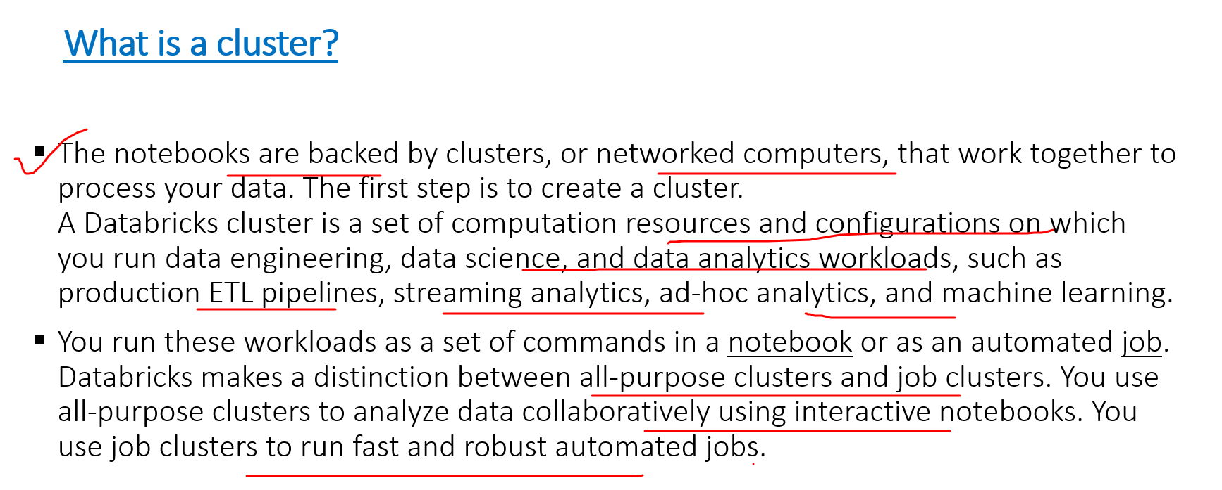

Cluster Mode:
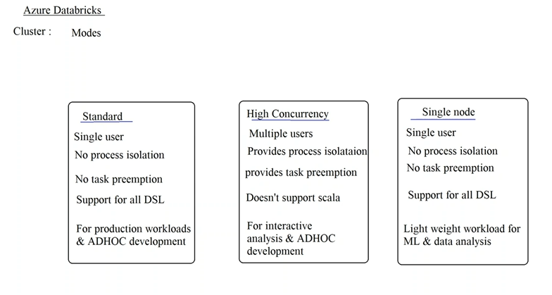

Databricks Cluster Runtime:

The Databricks cluster runtime is a pre-configured environment in Databricks that includes a specific set of libraries, dependencies, and configurations necessary to run data processing and analytics workloads. These runtimes are essentially the software environments on which your Spark applications and other code execute within a Databricks cluster.

Key Aspects of Databricks Cluster Runtime:
- Apache Spark Version: Each runtime is associated with a specific version of Apache Spark. Databricks regularly updates its runtimes to include newer versions of Spark along with improvements, bug fixes, and security patches.
- Pre-installed Libraries: The runtime includes a set of pre-installed libraries for common data science, machine learning, and big data processing tasks. These might include libraries for data manipulation (like pandas), machine learning (like TensorFlow or scikit-learn), and more.
- Optimizations: Databricks runtimes include optimizations that improve the performance of Spark workloads. These optimizations might involve improved data caching, enhanced shuffle operations, or other performance-tuning features that are specific to Databricks.
- Support for Multiple Languages: The runtime supports multiple programming languages, such as Python, Scala, SQL, and R, enabling users to write Spark jobs and other code in the language of their choice.
- Compatibility: The runtimes ensure compatibility between different components, like the version of Spark, Python, and other libraries. This helps in reducing dependency conflicts and ensures that your code runs smoothly.
- Extended Runtimes: Databricks offers specialized runtimes for certain workloads, such as:
  - ML Runtime: Includes additional libraries for machine learning, such as TensorFlow, XGBoost, and MLflow.
  - Photon Runtime: Optimized for SQL workloads, leveraging Photon, Databricks' query engine for faster query performance.

Working with Databricks SQL:
Databricks SQL is a powerful component of the Databricks Lakehouse platform designed to enable SQL users to run queries on structured and semi-structured data. It combines the scalability and flexibility of a data lake with the simplicity and familiarity of SQL, making it easy for data analysts, engineers, and scientists to work with large datasets in a performant environment.

Key Features of Databricks SQL:
- Interactive Querying: Run interactive SQL queries on large datasets.
- Dashboards: Create and share dashboards to visualize query results.
- Delta Lake Integration: Leverage the power of Delta Lake for ACID transactions and performance optimizations.
- Data Exploration: Explore your data using SQL without needing to manage infrastructure.
- Scheduling and Alerts: Schedule queries and set up alerts based on query results.

Getting Started with Databricks SQL
To start working with Databricks SQL, follow these steps:
- Step 1: Navigate to the Databricks SQL workspace.
- Step 2: Click on the "SQL Queries" tab.
- Step 3: Click on "New Query" to create a new SQL query.
- Step 4: Select the appropriate cluster or SQL warehouse where your query will be executed.
%sql
Create table emp
(
ID int,
Name string,
Gender string,
Salary int
)

After Creating Table insert values into emp Table

Insert into emp values(1,’Shiva’,’Male’,12000);
Insert into emp values(2,’Naga’,’Male’,8000);
Insert into emp values(3,’Sushma,’Female’,38000);
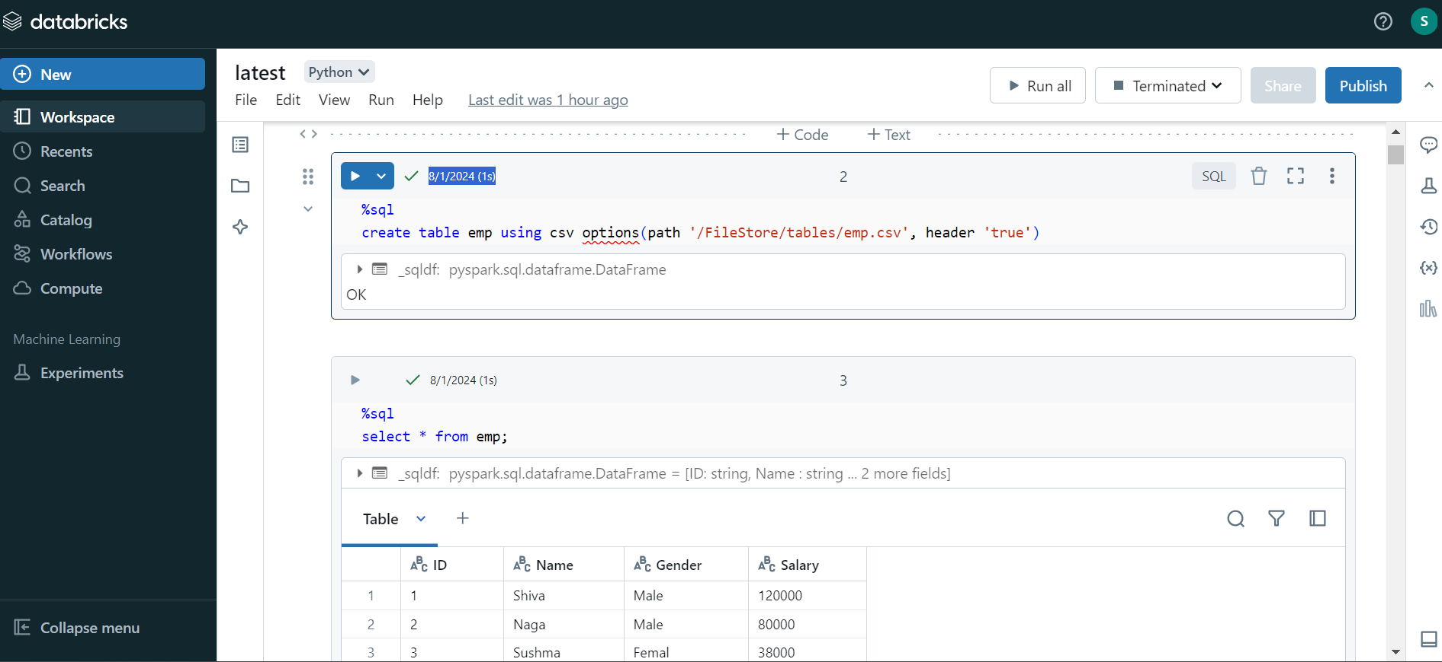

Display the results using sql query:

%sql
Select * from emp:

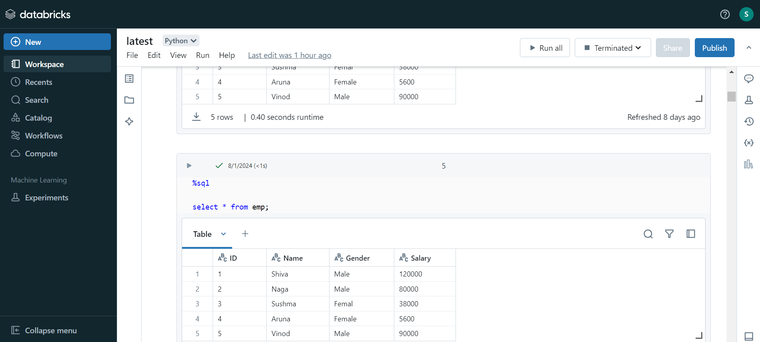

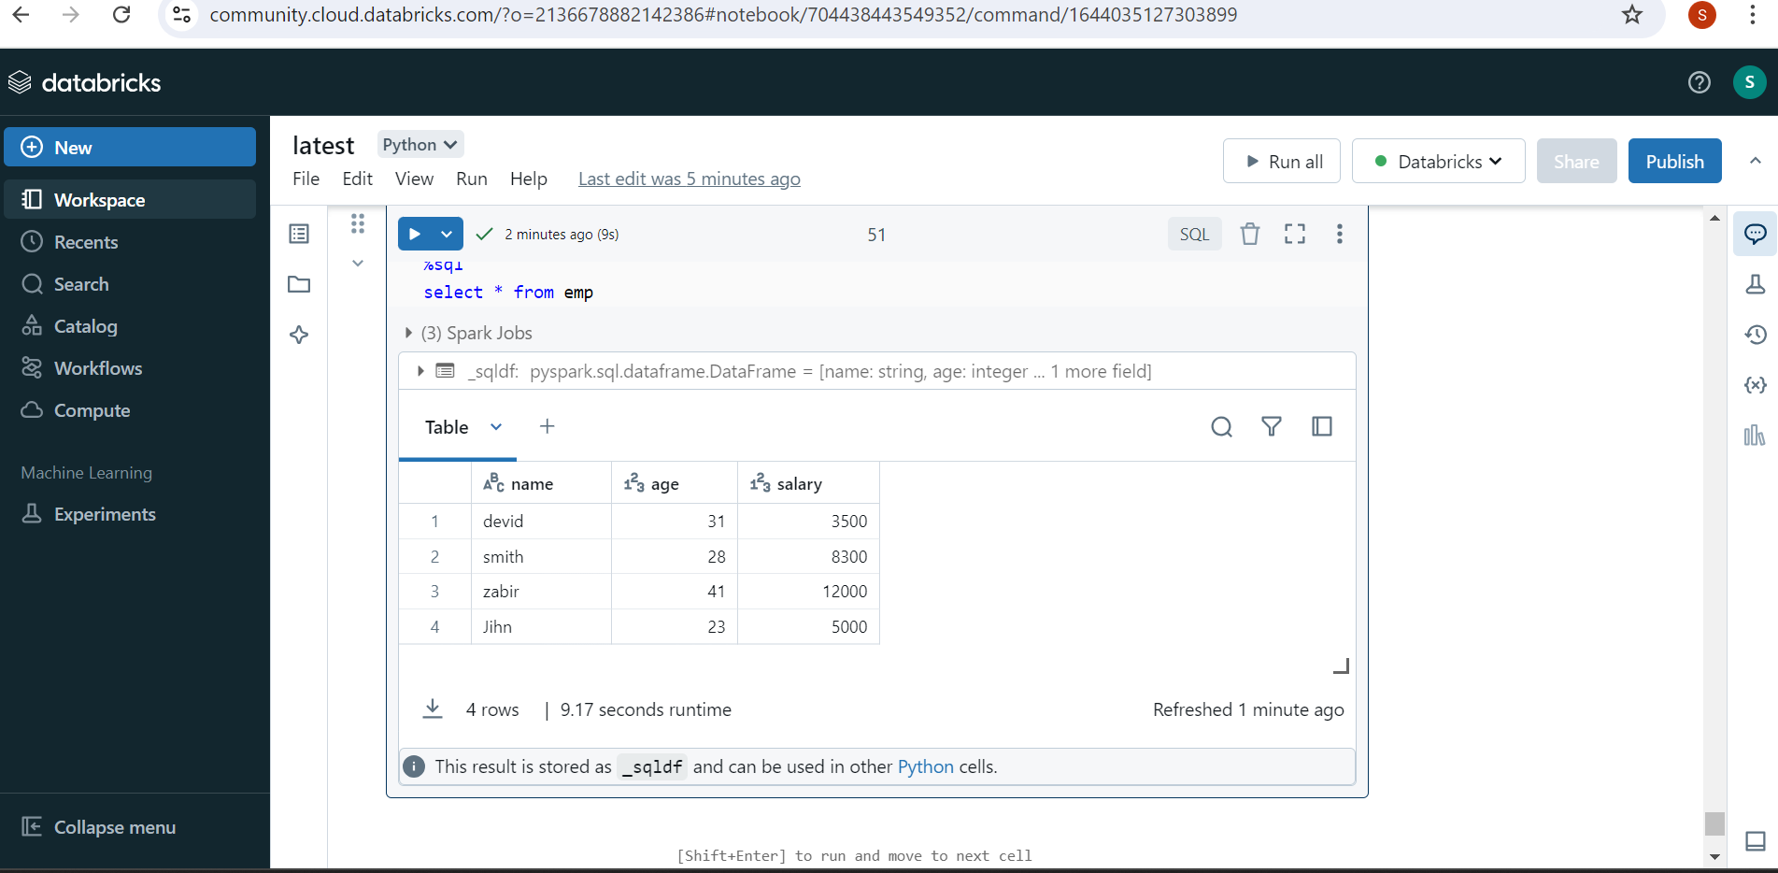

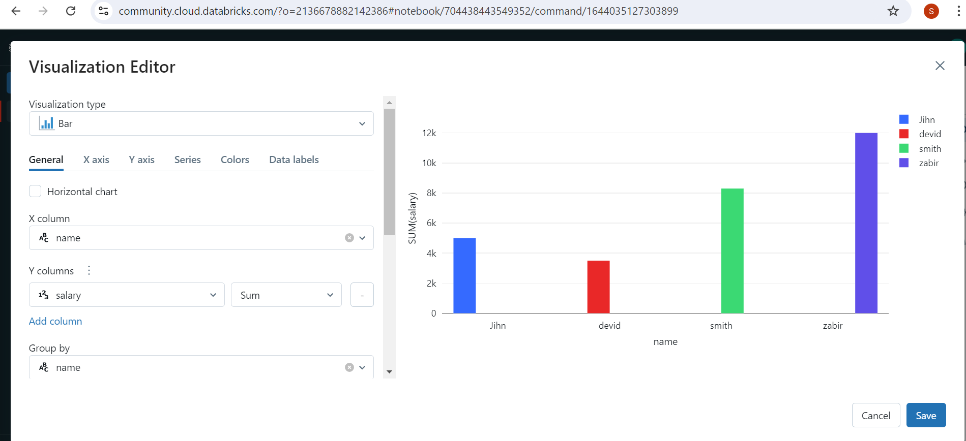

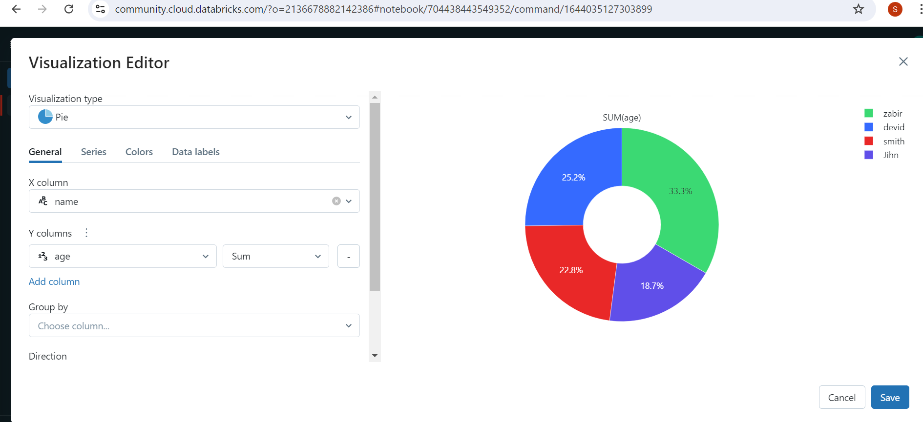

Databricks Lakehouse:
The combination of a Data Lake and a Data Warehouse is often referred to as a Lakehouse architecture. The Lakehouse architecture aims to bring the best of both worlds by combining the scalability and flexibility of a Data Lake with the reliability, performance, and governance features of a Data Warehouse. This allows organizations to handle a wide variety of data types and workloads, from raw data ingestion to complex analytics, within a unified platform.

Benefits of the Lakehouse Architecture:
- Simplified Data Architecture: No need for separate ETL pipelines to move data between lakes and warehouses.
- Unified Governance: Consistent data governance across the entire data landscape.
- Cost Efficiency: Reduced costs by minimizing data movement and storage redundancy.
- Flexibility: Supports a wide range of data types and workloads, from raw ingestion to advanced analytics.
- Scalability: Seamlessly scales with the volume and variety of data.

Azure Databricks Pipeline Architecture:
Azure Databricks is the Azure implementation of Apache Spark. Apache Spark is an Open source big data processing platform. Azure Databricks was developed in consultation with the developer of Apache Spark, M. Zaharia, who later became the founder of a company named Databricks.
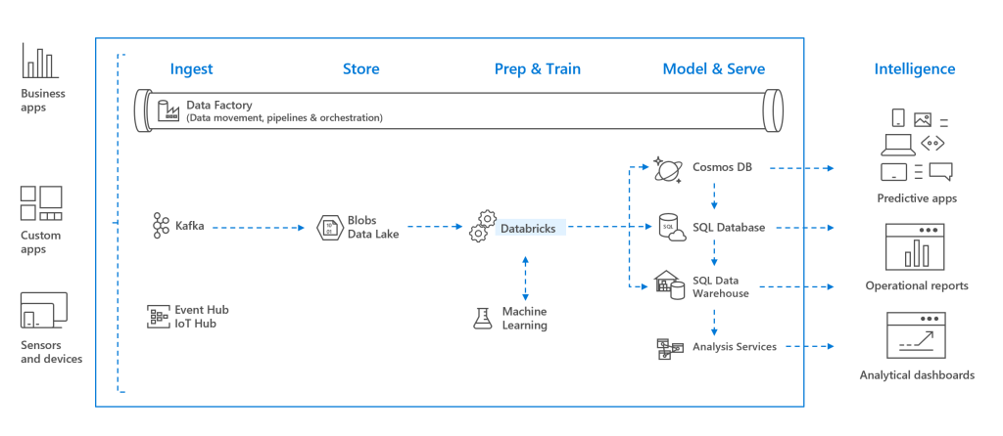

Databricks sits in the data preparation or processing stage in the data lifecycle. This starts with the data being ingested in Azure using Data Factory and stored in a permanent storage (such as ADLS Gen2 or Blob Storage). Alternatively, data could be streamed using Kafka, Event Hub or IoT Hub.
In the next stage data is processed using Machine Learning in Databricks (which uses Apache Spark under the hood) and the extracted insights are then loaded into one of the Analysis Services in Azure (Cosmos DB, Synapse Analytics or SQL Database).
These insights are now ready to be visualized and presented to the end users with the help of Analytical reporting tools such as Power BI.
SparkSQL and Dataframes: Spark SQL is the module that enables users to query structured data. Dataframe is a Spark data structure which is equivalent of a table in SQL. Data is organized into named columns in a dataframe.
Streaming: This module adds real time data processing capabilities. Data can be streamed using HDFS, Flume or Kafka.

MLlib: Machine Learning library consists of a variety of machine learning tools such as ML Algorithms, pipelines and utilities.
GraphX: Graphx module provides graph computation features for various analytics use cases.
Spark Core API: support for R, SQL, Python, Scala, and Java.

Magic Commands in Databricks:
The %fs ls command in Databricks is a magic command used to list the contents of a directory in the Databricks File System (DBFS). DBFS is an abstraction layer over cloud storage that allows you to access and manage files stored in cloud storage (like AWS S3, Azure Blob Storage, etc.) as if they were part of a local filesystem.

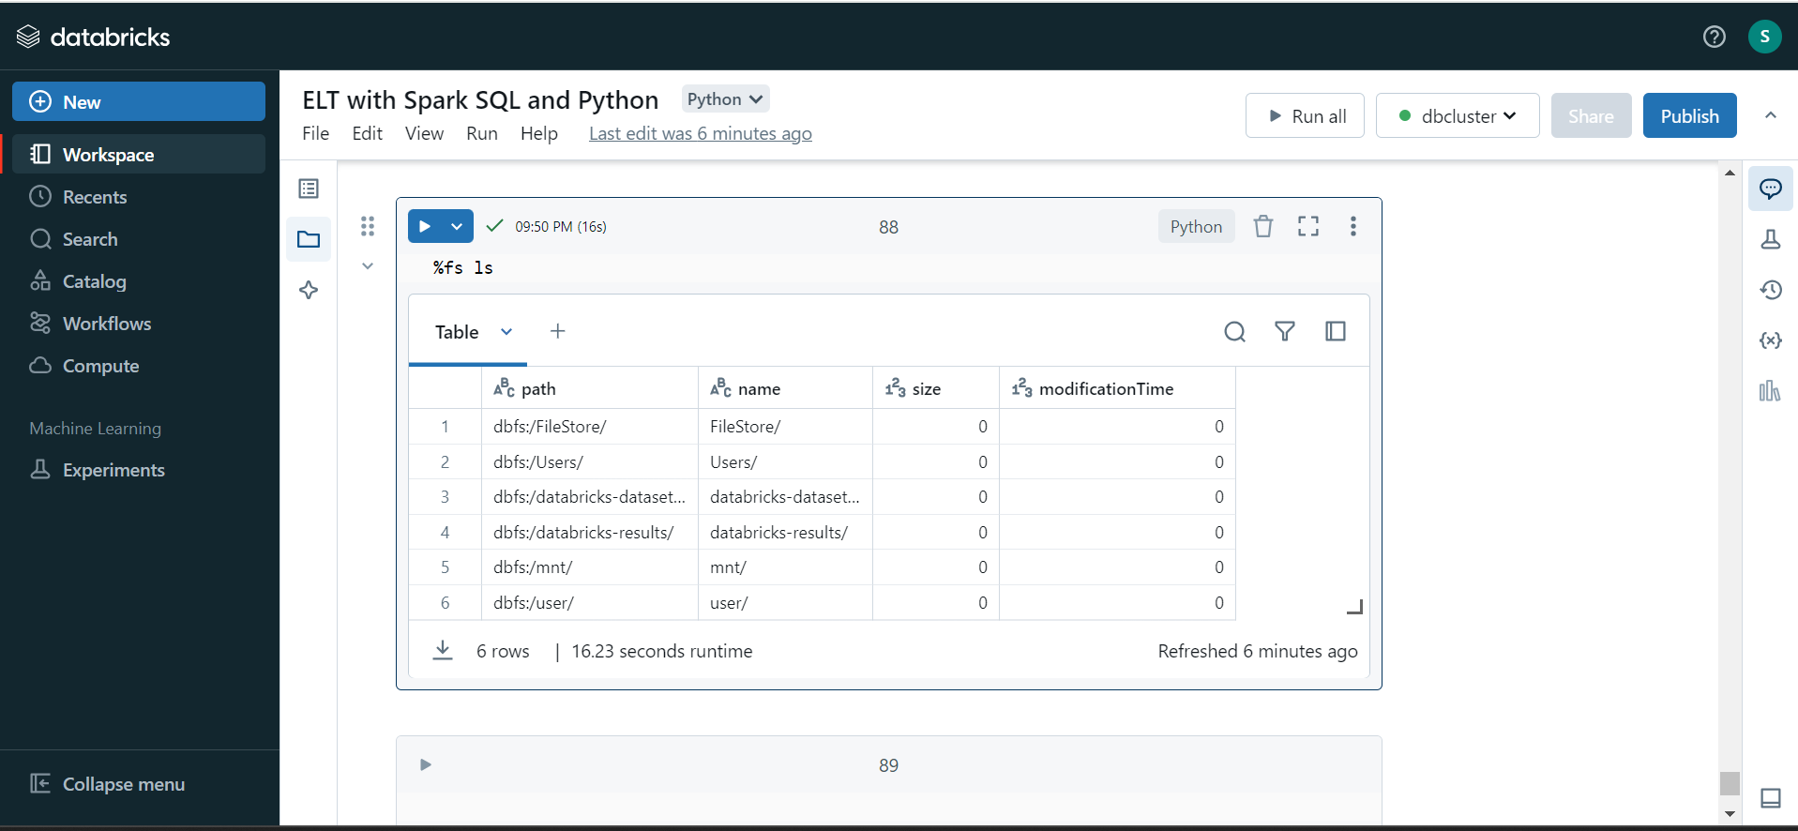

Here are some common magic commands in Databricks:

%python: Runs the cell content as Python code.
Print(“Hello”)
%sql: Runs the cell content as SQL code.
Select* from table_name

%scala: Runs the cell content as Scala code.
Val x = 10
Println(x)
%r: Runs the cell content as R code.
%r print("Hello, R!")
%md: Renders the cell content as Markdown.

Delta Lake Is/Is not:
Is: Open-source technology, storage framework and Enabling building lakehouse.
Is not: Proprietary technology storage format/medium Data warehouse/Database service

Mount in Databricks:

Mount refers to the process of linking an external storage system, such as Azure Data Lake Storage (ADLS), Amazon S3, or Azure Blob Storage, to Databricks. This allows users to access and interact with the data stored in these external systems as if it were part of the Databricks file system (DBFS).

Upload CSV/Excel File from Local to Databricks:
To upload a CSV or Excel file into Databricks and use it for analysis, you can follow these steps:

Step 1: Upload the File to Databricks

Option 1: Upload via Databricks UI
- Open Databricks:
  - Navigate to your Databricks workspace and select Catalog on Home page.
- Go to the Data Tab:
  - Click on the Data tab on the left sidebar.
- Add Data:
  - Click on + Add Data (usually located at the top right of the Data tab).
- Upload File:
  - Choose Upload File.
  - Click Browse and select the CSV or Excel file from your local machine.
  - Select a target location (such as DBFS or a specific mount point).
  - Click Next and then Create Table in Notebook to create a new table.
- Load Data into a Table:
  - Databricks will automatically generate code in a new notebook to load the data into a Spark DataFrame and display it.

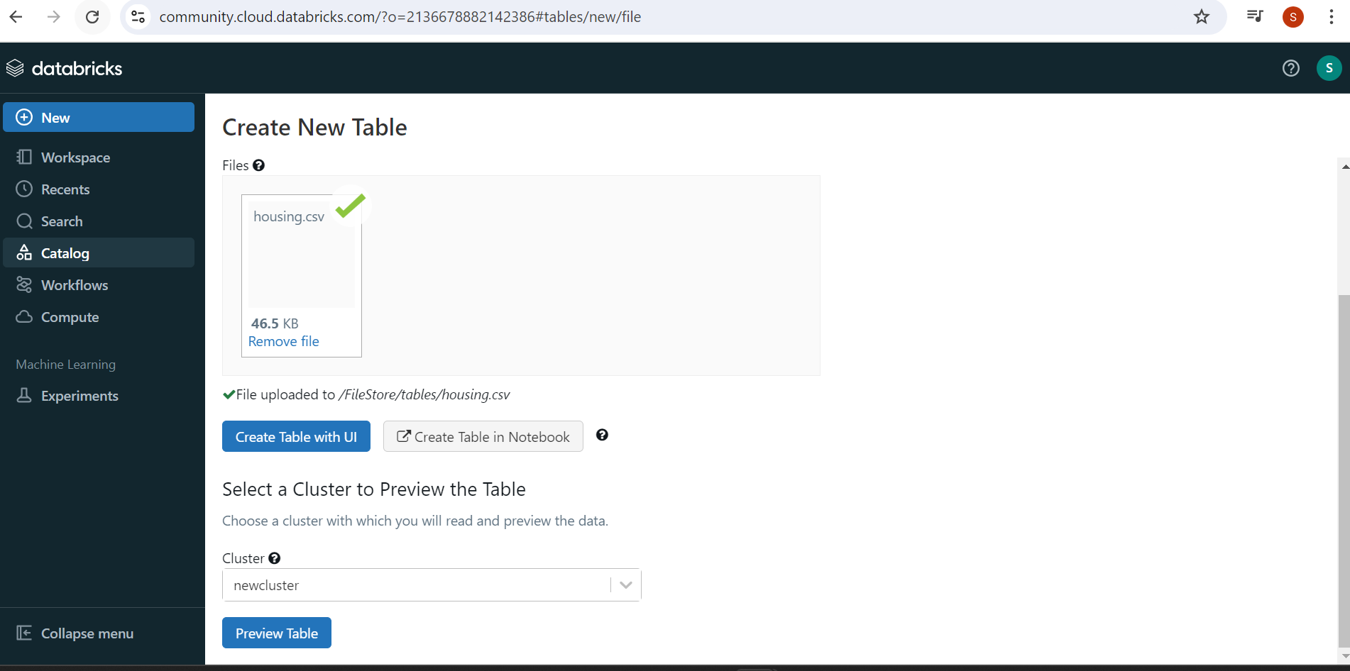

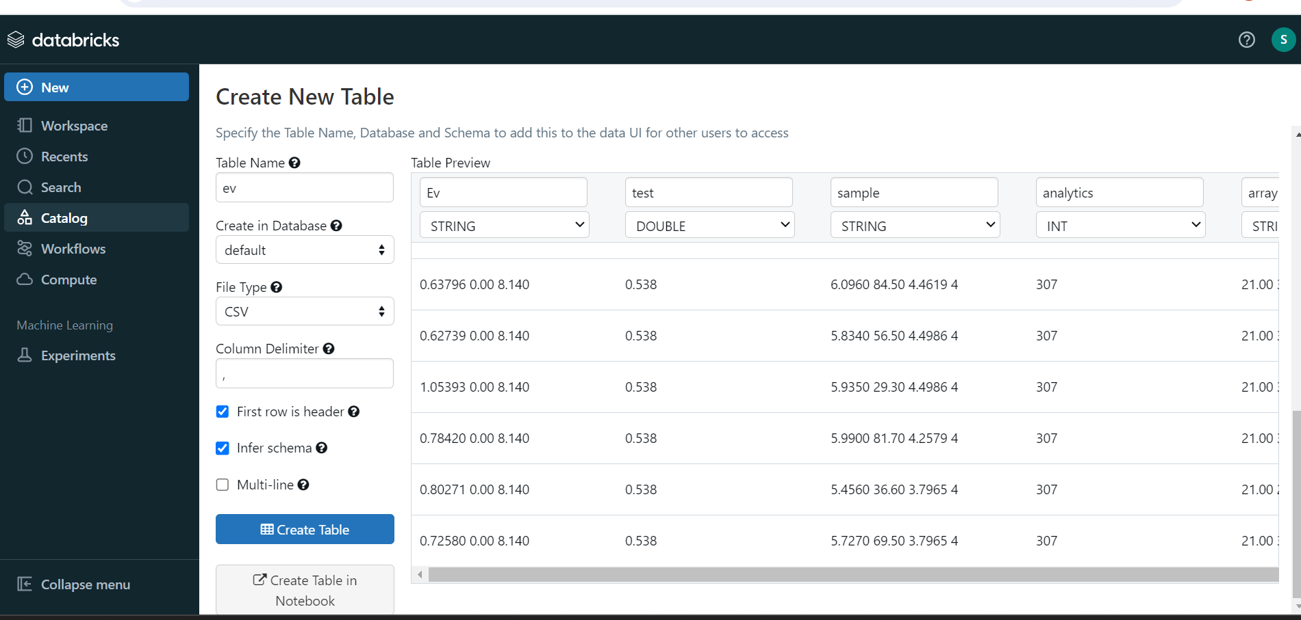

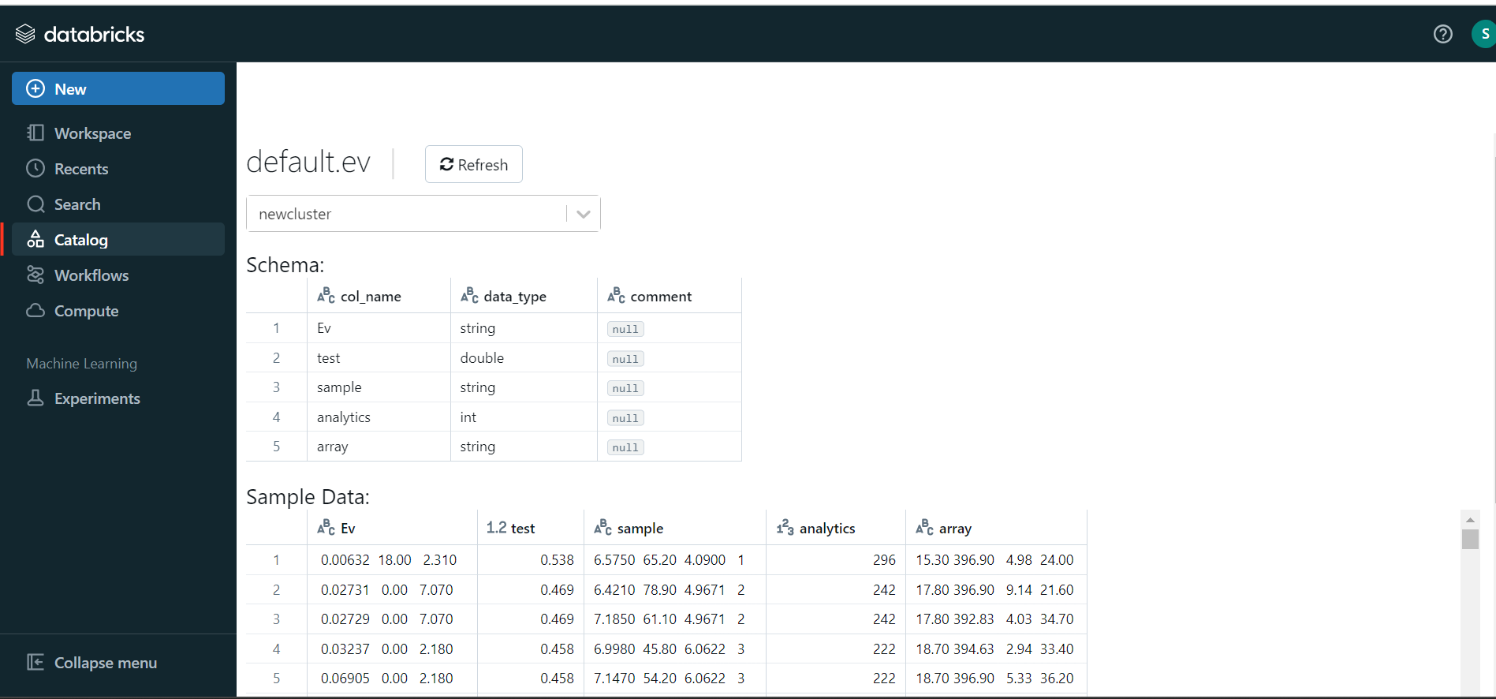

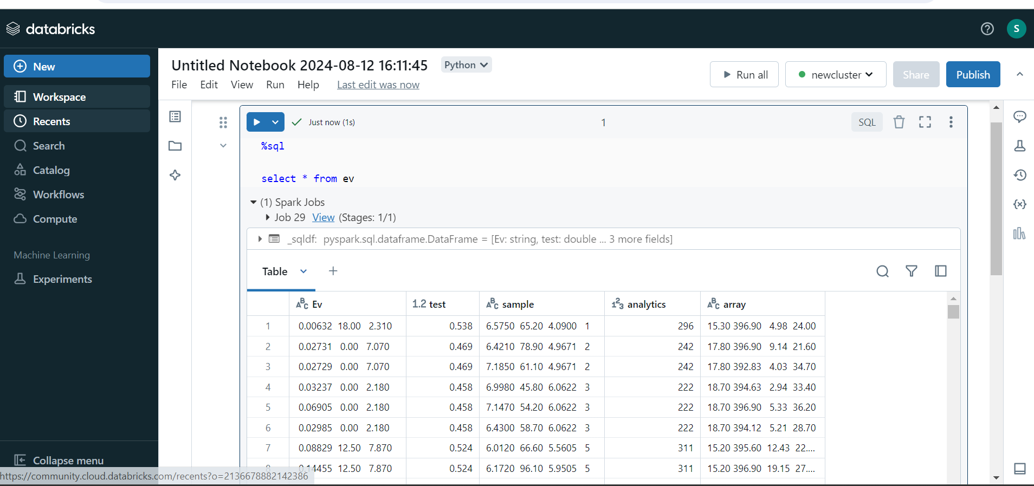

What is Parquet in Databricks?
Apache Parquet is a columnar file format with optimizations that speed up queries. It’s a more efficient file format than CSV or JSON. For more information, see Parquet Files.
Options:
See the following Apache Spark reference articles for supported read and write options.
- Read
  - Python
  - Scala
- Write
  - Python
  - Scala

To read Parquet files in Databricks using Python, you can use either PySpark or the pandas library. Below is an example using PySpark, which is the most common method in Databricks for handling big data.

Steps:
- Import Required Libraries: Ensure you have imported the required libraries such as pyspark.sql and you have a Spark session created, which is usually preconfigured in Databricks.

- Read the Parquet File: Use the spark.read.parquet() method to load a Parquet file.

Example with Code:

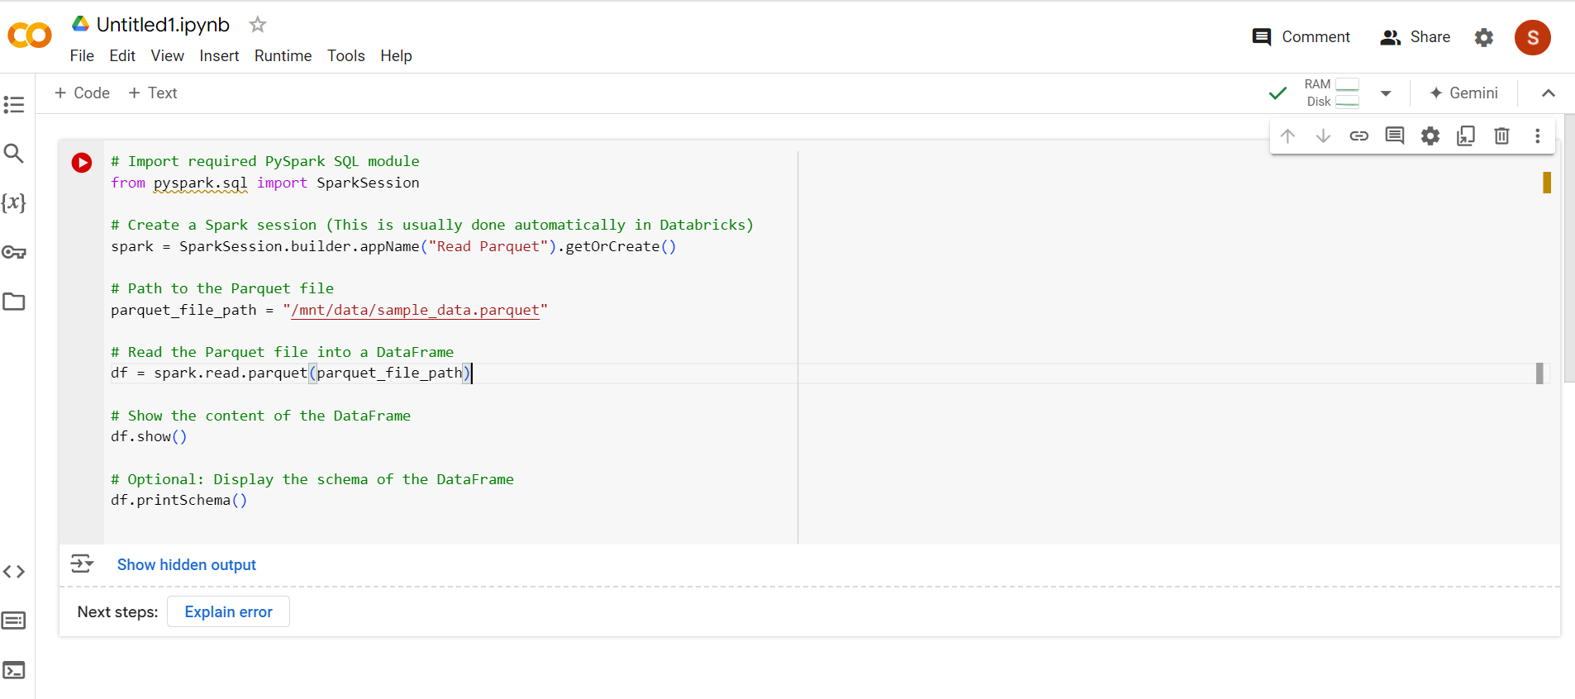

Explanation:
- spark.read.parquet(parquet_file_path): Reads the Parquet file from the specified path and loads it into a Spark DataFrame.
- df.show(): Displays the first 20 rows of the DataFrame in tabular format.
- df.printSchema(): Prints the schema of the DataFrame, showing the structure of the data.
Output
+----+-------+-------+
| id | name | salary|
+----+-------+-------+
| 1 | John | 50000 |
| 2 | Alice | 60000 |
| 3 | Bob | 55000 |
+----+-------+-------+
Databricks File System (DBFS): Ensure that your Parquet file is either available in DBFS (Databricks File System) or accessible through cloud storage (e.g., Azure Blob Storage, AWS S3). The file path should be adjusted accordingly.

Data format options

Databricks has built-in keyword bindings for all of the data formats natively supported by Apache Spark. Databricks uses Delta Lake as the default protocol for reading and writing data and tables, whereas Apache Spark uses Parquet.
These articles provide an overview of many of the options and configurations available when you query data on Databricks.
The following data formats have built-in keyword configurations in Apache Spark DataFrames and SQL:

- Delta Lake
- Delta Sharing
- Parquet
- ORC
- JSON
- CSV
- Avro
- Text
- Binary
- XML

Unity Catalog:
Unity Catalog is a unified governance solution for data in Databricks. It provides centralized access control, auditing, lineage, and data discovery capabilities across all data assets, such as files, tables, and machine learning models in Databricks.

Key Features of Unity Catalog:
- Centralized Governance: Offers a unified interface for managing permissions and access control across all data sources.
- Data Lineage: Tracks the flow of data, showing how data moves through various processes.
- Fine-Grained Access Control: Grants permissions at the catalog, schema, table, and column levels.
- Auditing: Allows tracking of who accessed or modified data.
- Define once, secure everywhere: Unity Catalog offers a single place to administer data access policies that apply across all workspaces.
- Standards-compliant security model: Unity Catalog’s security model is based on standard ANSI SQL and allows administrators to grant permissions in their existing data lake using familiar syntax, at the level of catalogs, schemas (also called databases), tables, and views.
- Built-in auditing and lineage: Unity Catalog automatically captures user-level audit logs that record access to your data. Unity Catalog also captures lineage data that tracks how data assets are created and used across all languages.
- Data discovery: Unity Catalog lets you tag and document data assets, and provides a search interface to help data consumers find data.
- System tables (Public Preview): Unity Catalog lets you easily access and query your account’s operational data, including audit logs, billable usage, and lineage.

The Unity Catalog object model
Unity Catalog, all metadata is registered in a metastore. The hierarchy of database objects in any Unity Catalog metastore is divided into three levels, represented as a three-level namespace (catalog.schema.table-etc) when you reference tables, views, volumes, models, and functions.

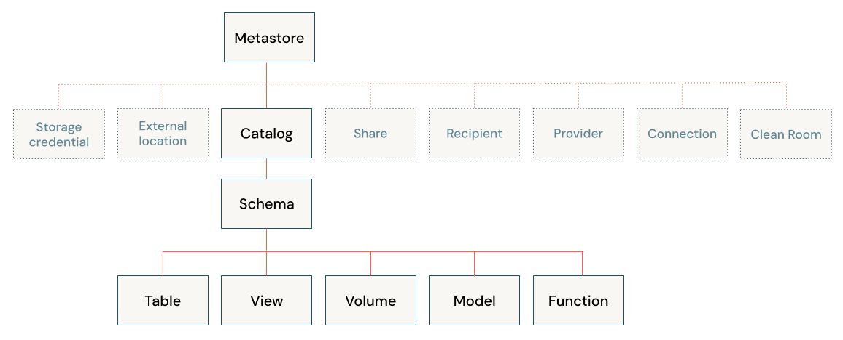

Metastores
The metastore is the top-level container for metadata in Unity Catalog. It registers metadata about data and AI assets and the permissions that govern access to them. For a workspace to use Unity Catalog, it must have a Unity Catalog metastore attached.
You should have one metastore for each region in which you have workspaces. Typically, a metastore is created automatically when you create a Azure Databricks workspace in a region for the first time. For some older accounts, an account admin must create the metastore and assign the workspaces in that region to the metastore.

Object hierarchy in the metastore:
Level one:
- Catalogs are used to organize your data assets and are typically used as the top level in your data isolation scheme. Catalogs often mirror organizational units or software development lifecycle scopes.
- Non-data securable objects, such as storage credentials and external locations, are used to managed your data governance model in Unity Catalog. These also live directly under the metastore.
Level two:
- Schemas (also known as databases) contain tables, views, volumes, AI models, and functions. Schemas organize data and AI assets into logical categories that are more granular than catalogs.
Level three:
- Volumes are logical volumes of unstructured, non-tabular data in cloud object storage. Volumes can be either managed, with Unity Catalog managing the full lifecycle and layout of the data in storage, or external, with Unity Catalog managing access to the data from within Azure Databricks, but not managing access to the data in cloud storage from other clients.

Tables :

Tables are collections of data organized by rows and columns. Tables can be either managed, with Unity Catalog managing the full lifecycle of the table,

Structured Streaming in Databricks:
Structured Streaming in Databricks is a scalable and fault-tolerant stream processing engine built on the Spark SQL engine. It allows you to process streaming data as if it were a continuous table, meaning you can use SQL queries or Data Frame operations to process live data streams just as you would with batch data.
Key Concepts of Structured Streaming:
Input Sources: Data can be ingested from multiple sources like Kafka, Azure Event Hubs, files, etc.

Output Sinks: The processed data can be written to sinks such as Delta Lake, Kafka, or other databases.
Triggers: Specifies when the streaming query will execute (e.g., continuous, once, or micro-batch intervals).
Structured Streaming in Databricks:
Creating a streaming pipeline in Databricks involves a few steps using Apache Spark Structured Streaming, combined with Databricks' cloud-based platform. Below is a guide to creating a real-time data pipeline in Databricks:

Steps to Create a Streaming Pipeline in Databricks:

1. Set Up Your Databricks Environment
- Create a Databricks account and workspace (in Azure, AWS, or GCP).
- Launch a Databricks cluster with the necessary libraries (e.g., org.apache.spark:spark-sql-kafka-0-10_2.12 for Kafka).

2. Create Data Source
- Your streaming data source could be from Kafka, Azure Event Hub, IoT devices, or cloud storage (like AWS S3 or Azure Blob).
- Databricks can easily integrate with Kafka, Event Hubs, or other external services.

3. Data Ingestion using Spark Structured Streaming
- You will use Spark’s readStream() function to ingest streaming data from your chosen source.

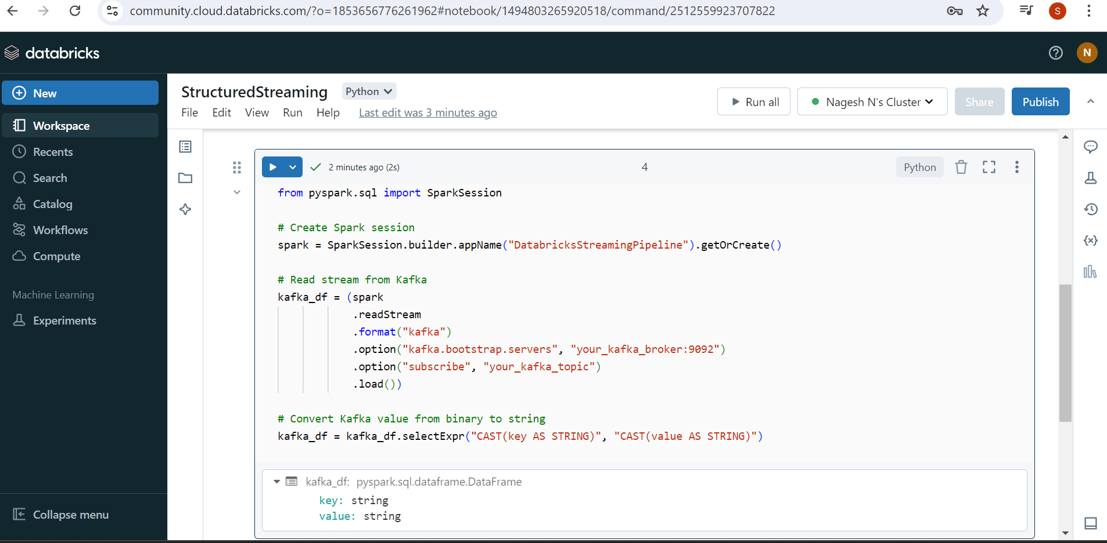

4. Data Processing Using Spark SQL / DataFrame API
- You can apply various transformations to the streaming data using Spark's DataFrame API or SQL queries.
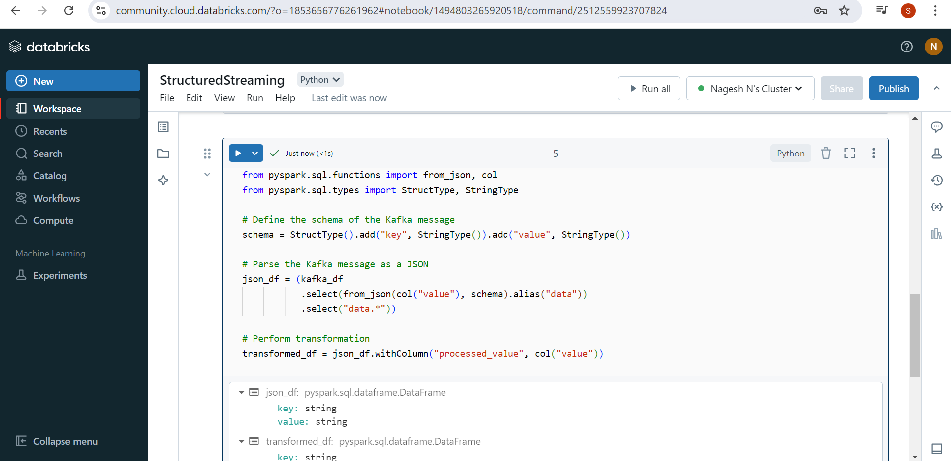

5. Writing to a Sink (Data Storage)
- After processing the data, you need to write the results to a sink such as cloud storage (S3, Azure Data Lake), a database (Snowflake, MySQL), or a streaming platform (like Kafka).
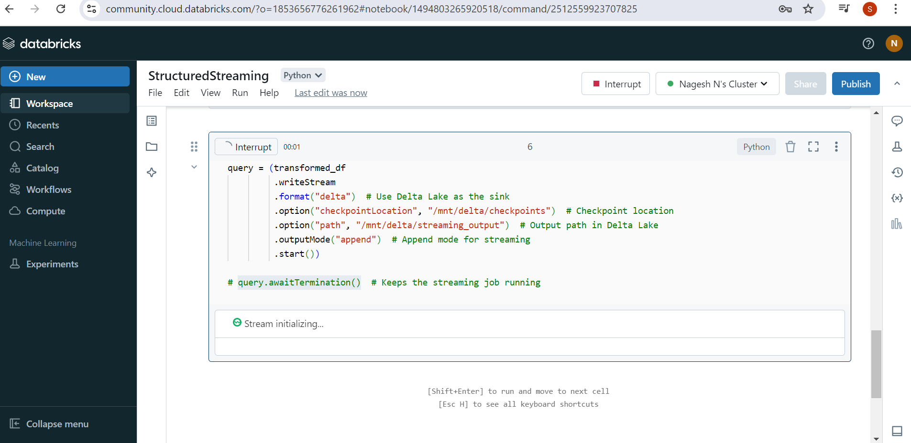

6. Monitor and Manage the Streaming Job
- Databricks provides notebooks to develop and test your streaming jobs interactively.
- Use Databricks Job to schedule the streaming pipeline for production workloads.
- Monitor the pipeline using the Structured Streaming UI or the Delta Lake UI in Databricks.

7. Stream Aggregation and Advanced Processing
- Spark Structured Streaming supports windowed aggregations, stateful transformations, and complex event processing.

Example Pipeline Overview:
- Source: Kafka, Event Hubs, or file sources like CSV, JSON from S3 or Azure Blob Storage.
- Processing: Apply transformations, filtering, aggregations using Spark DataFrame APIs.
- Sink: Store the processed stream in Delta Lake, a database, or a messaging system like Kafka.

Benefits of Using Databricks for Streaming:
- Scalability: Auto-scaling clusters for distributed processing.
- Delta Lake: Enables ACID transactions, data versioning, and time travel for streaming data.
- Integration: Easily integrates with cloud-native storage and streaming services (S3, Azure Data Lake, Event Hubs, etc.).
- Unified Platform: Combine batch and stream processing under the same platform.

Integrate ADLS storage with Databricks:
To integrate Azure Data Lake Storage (ADLS) with Databricks, you typically set up a connection between Databricks and ADLS using either OAuth 2.0 with service principals, Access Keys, or SAS tokens. Below are the steps to integrate Azure Data Lake Storage Gen2 (ADLS Gen2) with Databricks using OAuth 2.0 via a Service Principal (the most secure method).
Step by Step Guide to Integrate with ADLS with Databricks in Azure
Step 1: Create Storage Account for Gen2 lake in Azure portal
Step 2: create container
Step 3: Navigate to Databricks Account and Setup and Configure cluster
Step 4: Configure Spark in Databricks
Ex: spark.conf.set(
)
Step 5: list the files
dbutils.fs.ls("abfss://shiva@storage19aug2024.dfs.core.windows.net/")

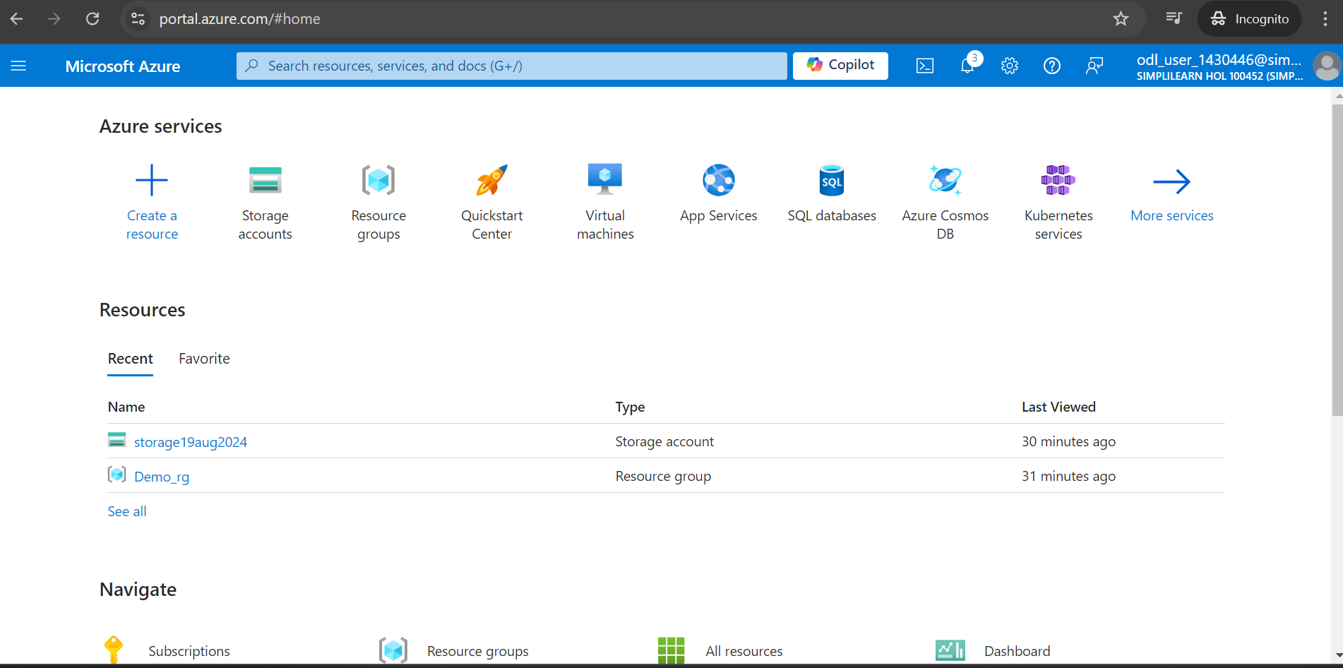

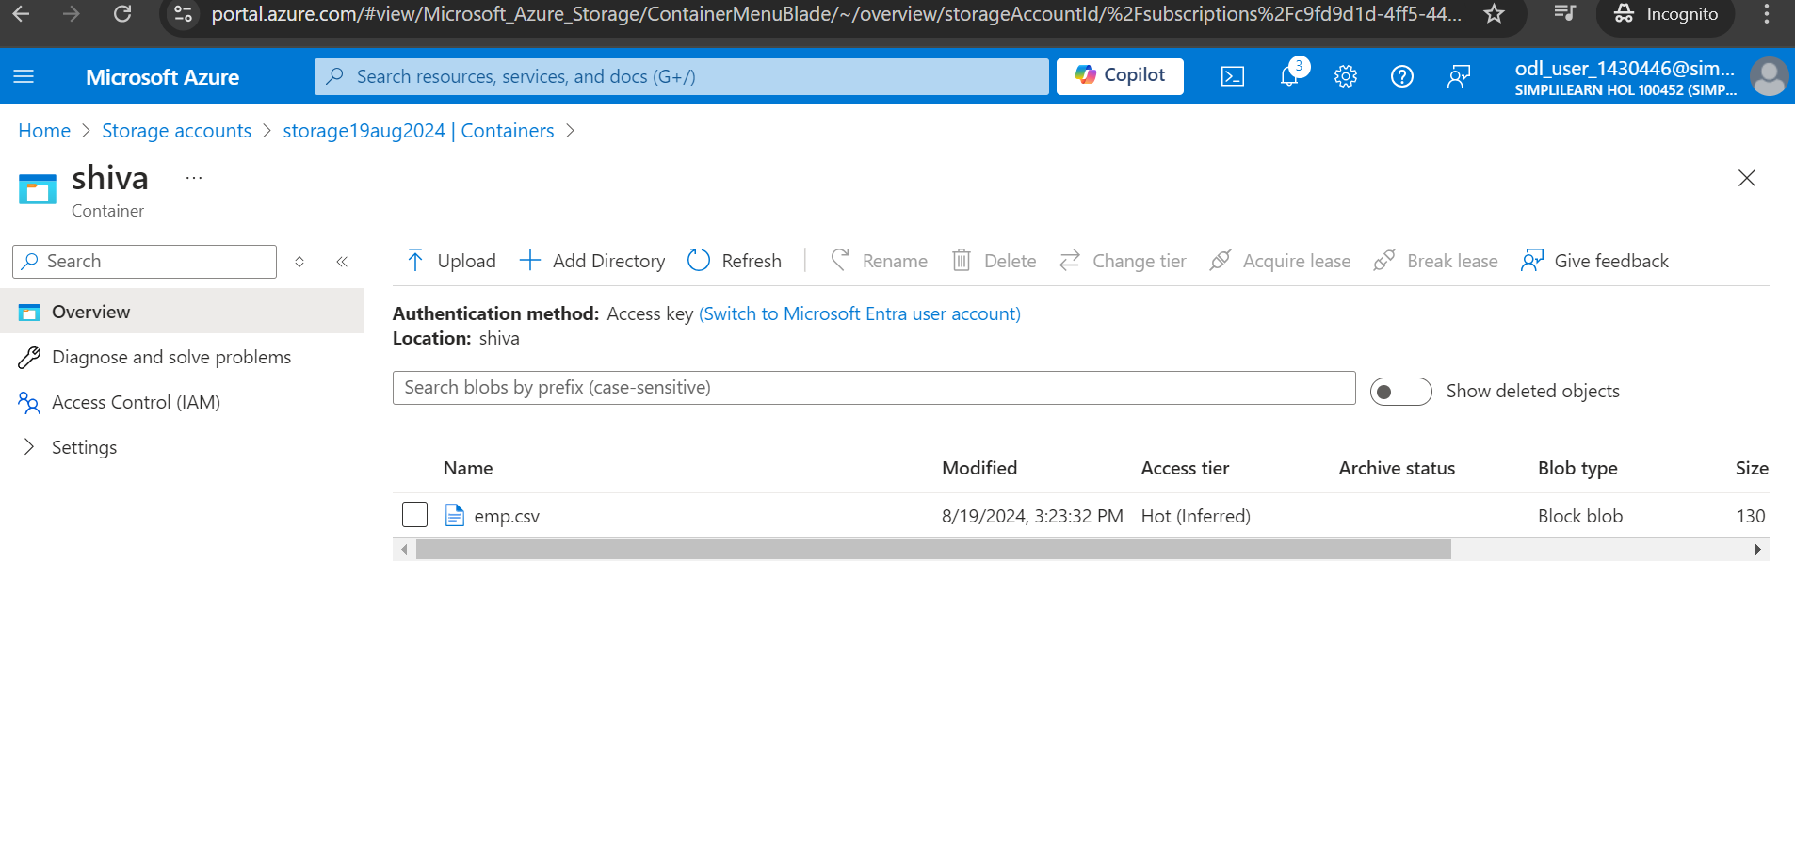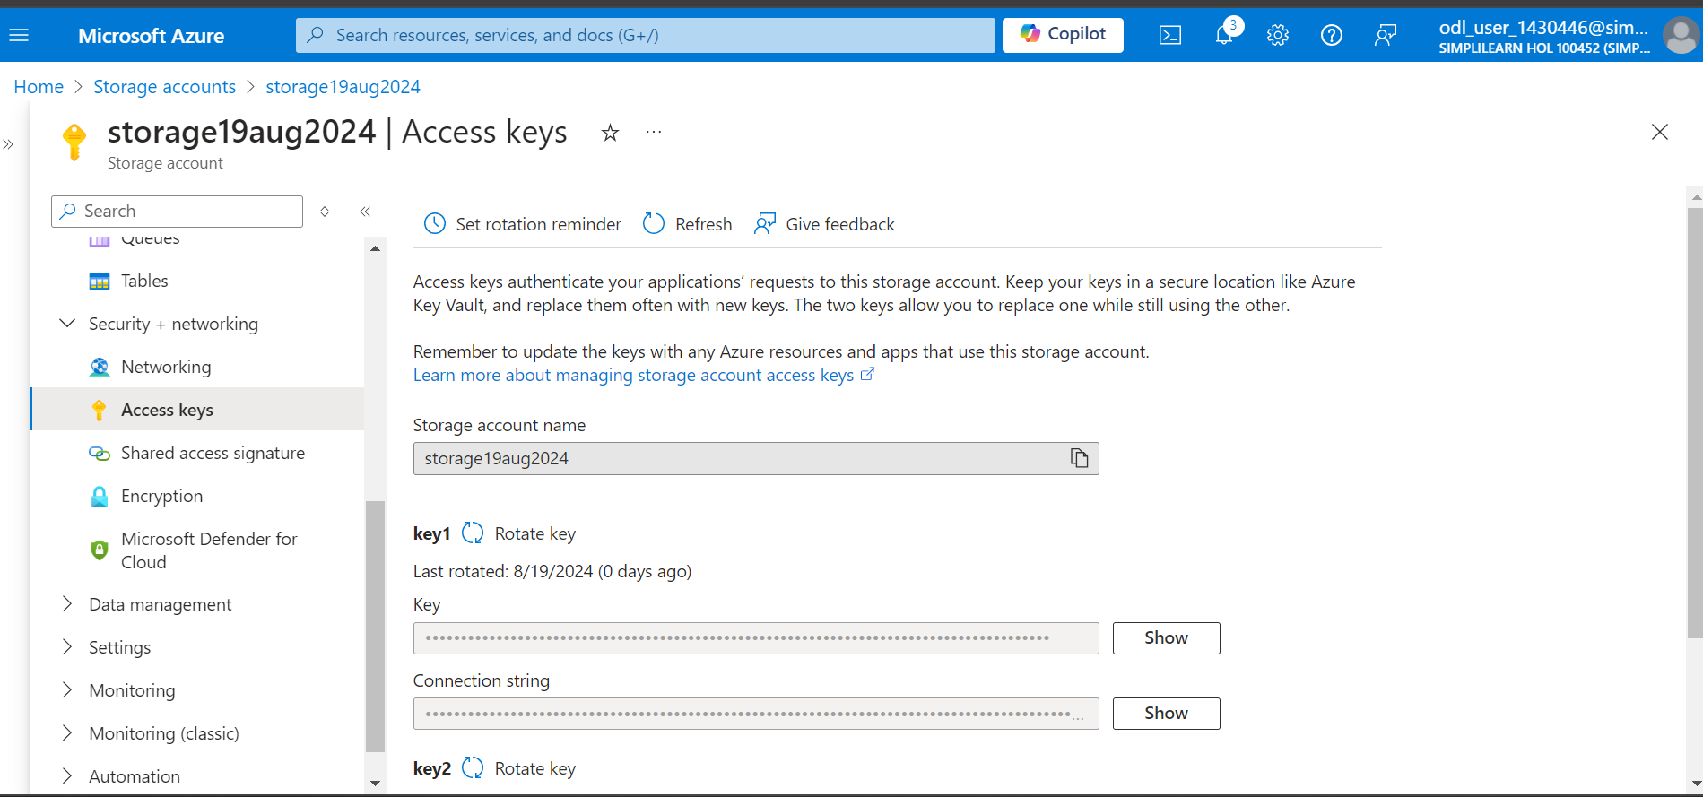

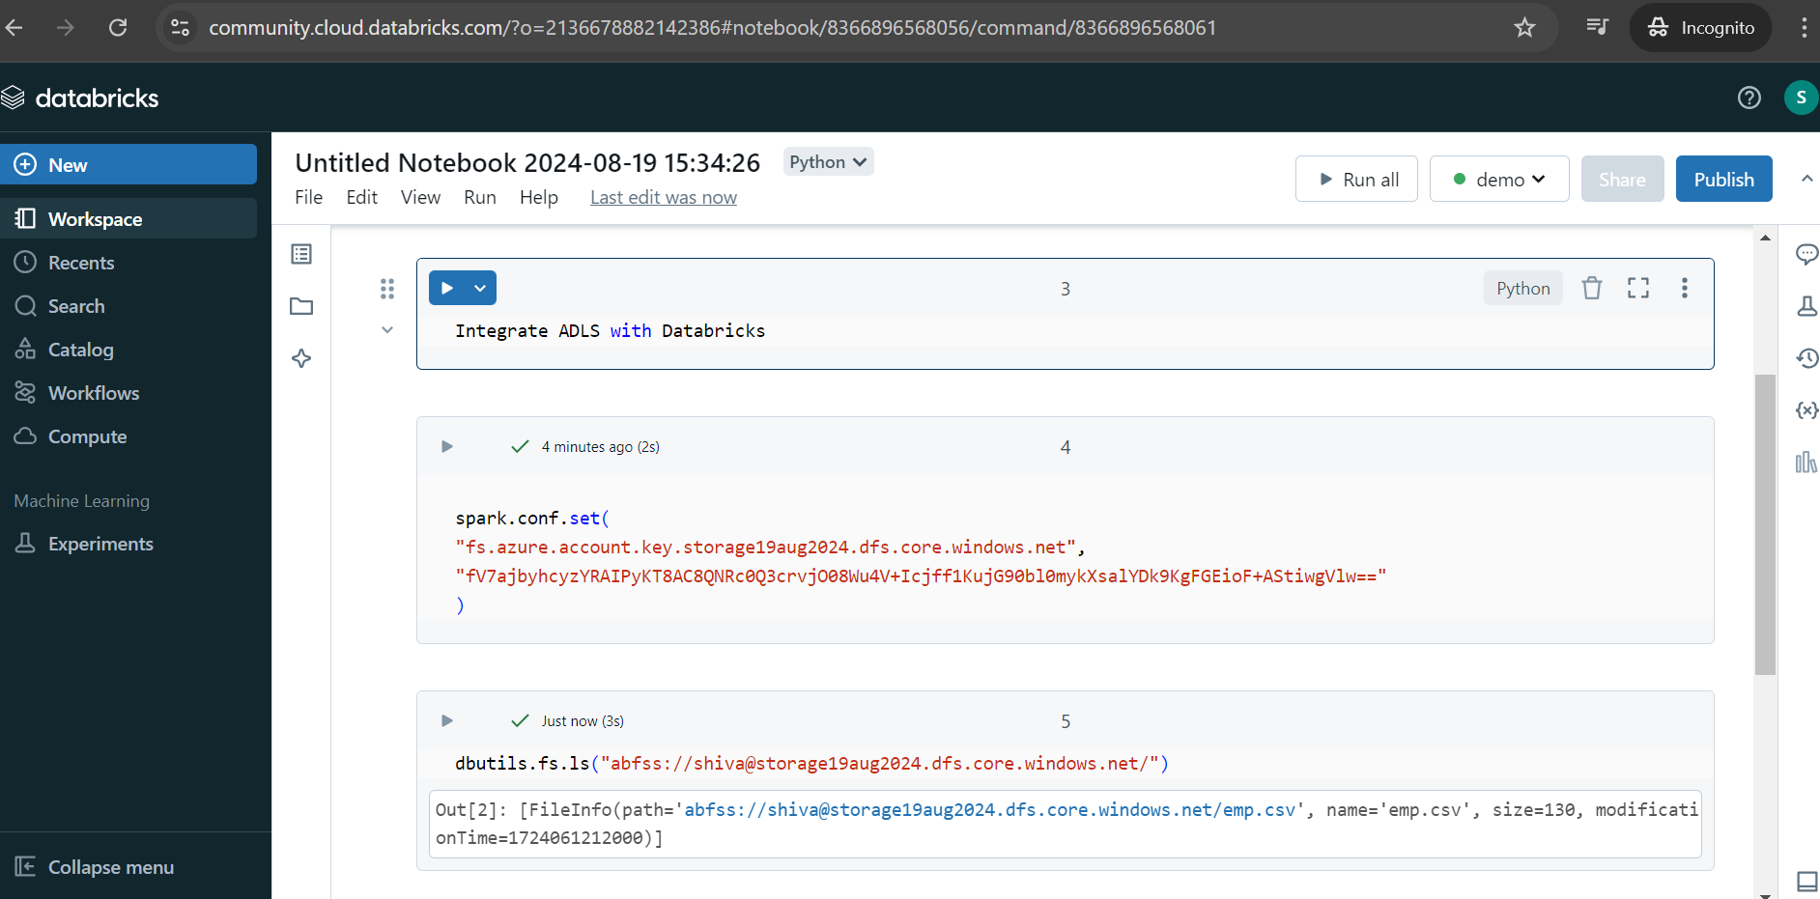

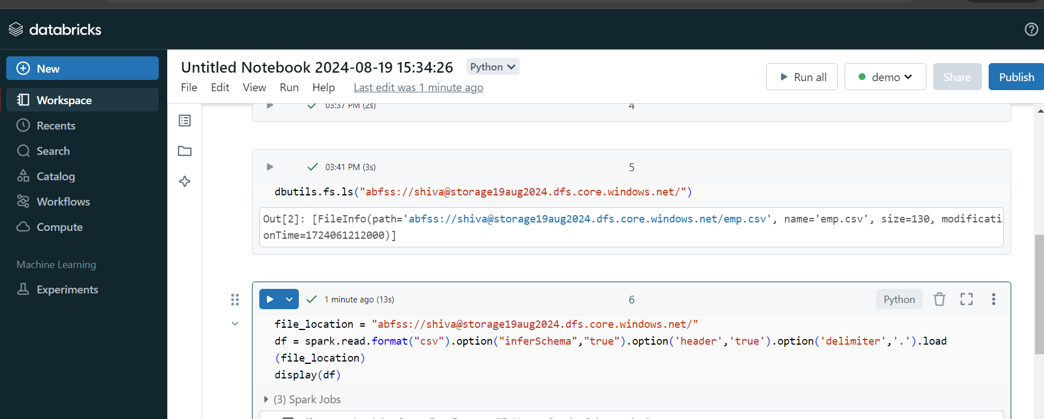

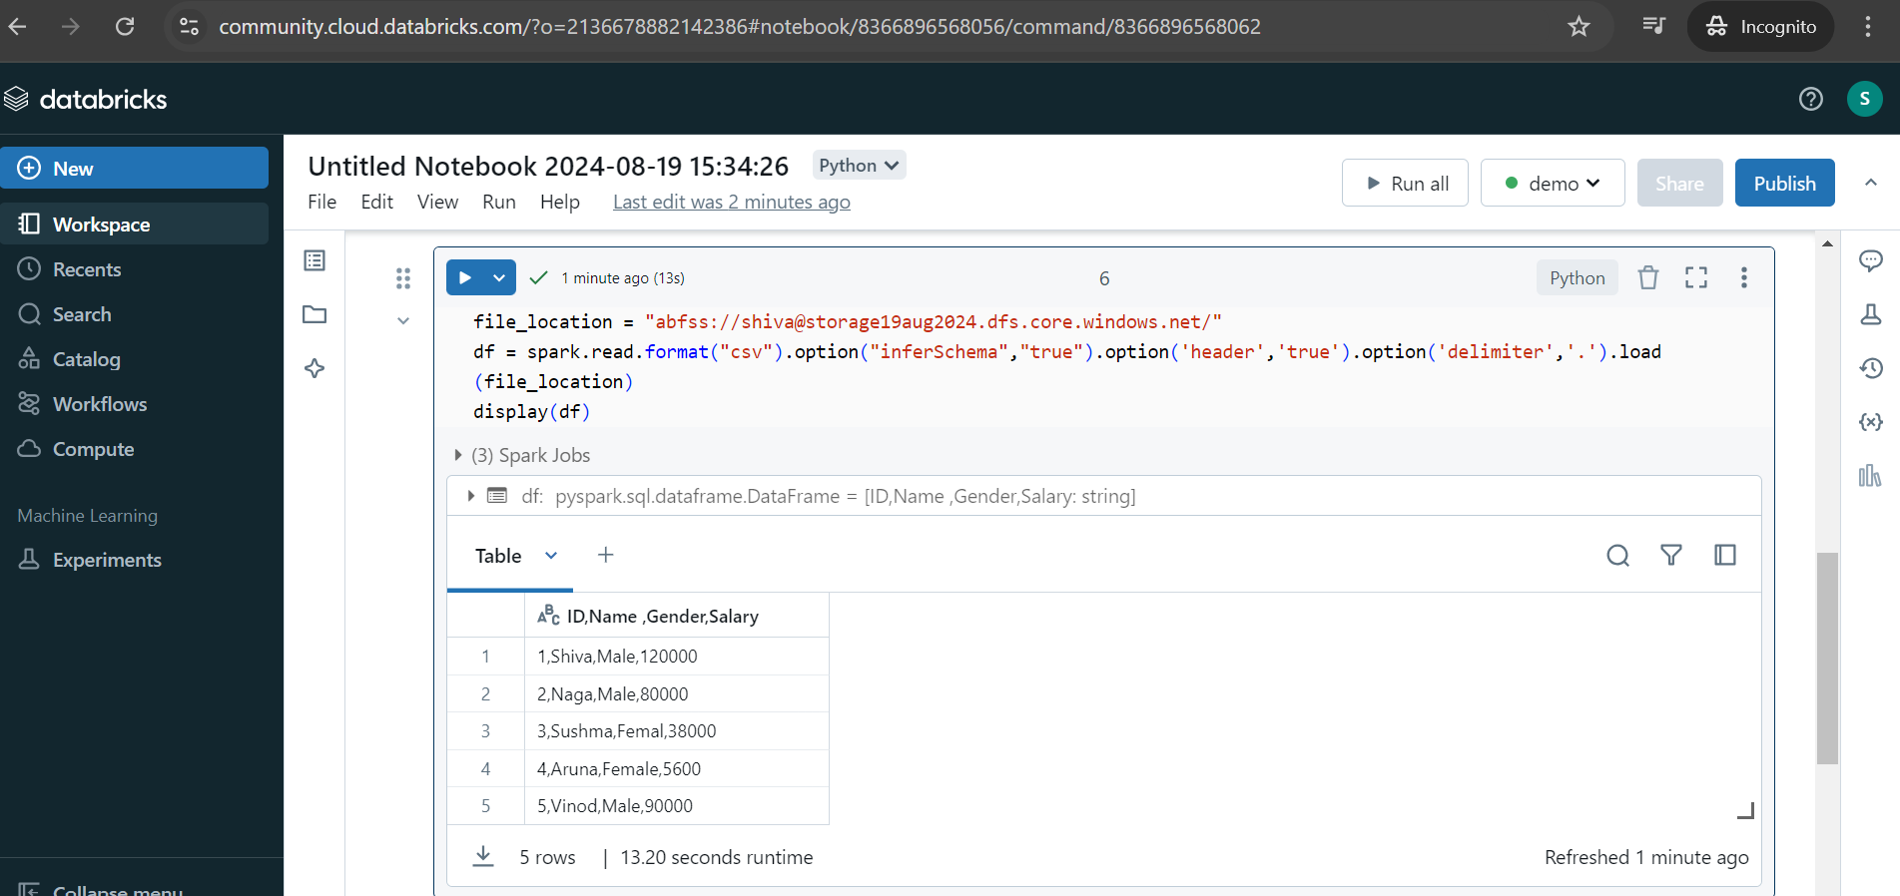

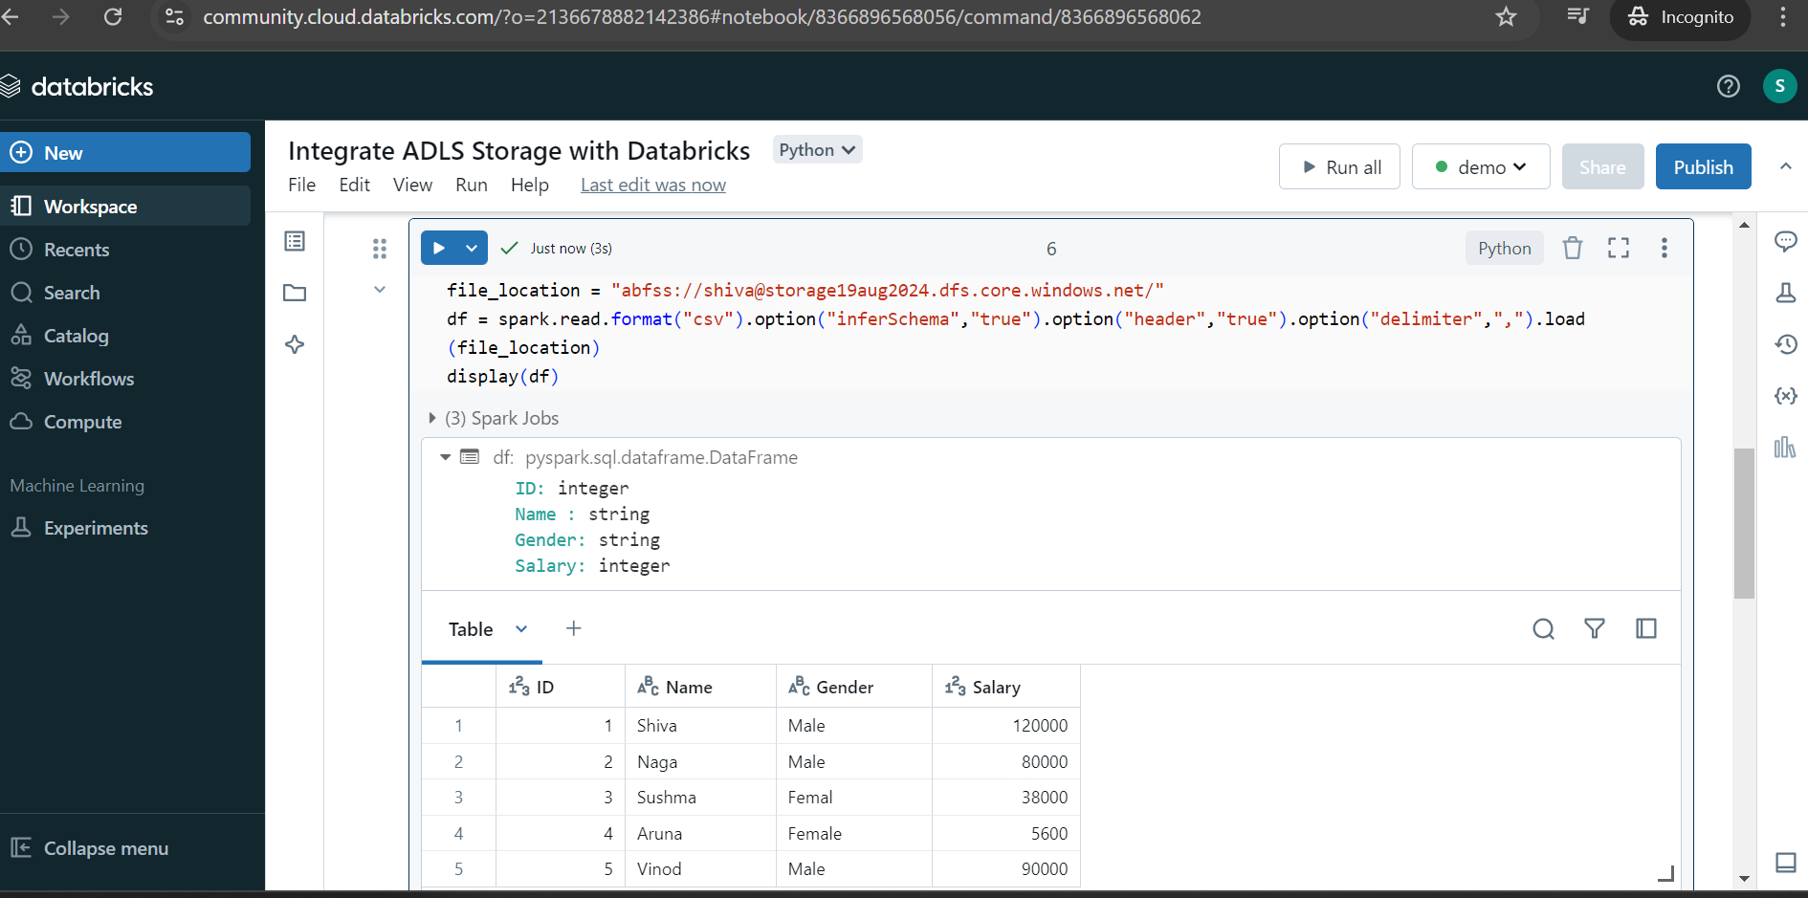

Incremental Data Ingestion:
Incremental data ingestion is the process of transferring only the new or updated data from the source to the destination system, rather than ingesting the entire dataset each time. This approach is useful when dealing with large datasets, as it reduces the load on the network, storage, and processing resources by focusing only on changes (new rows or updates) since the last ingestion.

Example of Incremental Data Ingestion:

Scenario:
Suppose you have a table Orders in a relational database that records customer orders. The orders data is frequently updated as new orders are placed or existing orders are modified (e.g., change of status, quantities, etc.). You want to transfer this data to a data warehouse daily.

Approach 1: Full Data Ingestion (Non-Incremental)
Every day, you extract the entire Orders table and load it into the destination system (data warehouse). If the Orders table has millions of rows, this process becomes inefficient because most of the data might be unchanged.

Approach 2: Incremental Data Ingestion
Instead of ingesting all data every day, you only transfer the data that has been added or changed since the last ingestion.
- Assume the Orders table has a LastModified column. This column captures the timestamp of the last modification (insert, update) of each order record.
- Identify Incremental Data: On each run, you query only the rows where the LastModified timestamp is greater than the timestamp of the last ingestion (let's call it LastRunTime).
sql
Copy code
SELECT * FROM Orders
WHERE LastModified > '2024-08-15 00:00:00';
This query extracts only the rows that have been updated or added after 2024-08-15 00:00:00, ensuring that only incremental data is processed.
- Load Incremental Data into the Destination: These new or updated rows are ingested into the data warehouse, either by appending or updating the records based on keys like OrderID.

Benefits:
- Efficiency: Reduces the amount of data transferred and processed.
- Cost-Effective: Saves on storage and compute resources.
- Faster Loads: Since only a small subset of data is handled, ingestion is faster compared to full data loads.
This method is typically used in ETL pipelines, where tools like Apache NiFi, Talend, or Azure Data Factory allow for incremental data processing using watermarking, change data capture (CDC), or custom logic based on timestamps.

Autoloader:
Autoloader in Databricks is a feature that simplifies the process of ingesting data from cloud storage systems like AWS S3, Azure Data Lake, or Google Cloud Storage into a Databricks-managed Delta Lake table. It automatically handles incremental data ingestion, allowing you to load new or updated files without manually tracking the data state. Autoloader supports both batch and streaming use cases.

Key Features of Autoloader:
- Scalability: Automatically scales to handle millions of files.
- Schema Evolution: Automatically detects schema changes in the incoming data.
- Incremental Data Ingestion: Efficiently processes new or updated data as it arrives, without reprocessing the entire dataset.
- File Notification Mode: Uses cloud file change notifications to efficiently identify new data, which can drastically reduce the time spent scanning directories.

Configure Auto Loader to ingest data to Delta Lake
Databricks recommends using Auto Loader for incremental data ingestion. Auto Loader automatically detects and processes new files as they arrive in cloud object storage.
Databricks recommends storing data with Delta Lake. Delta Lake is an open source storage layer that provides ACID transactions and enables the data lakehouse. Delta Lake is the default format for tables created in Databricks.
To configure Auto Loader to ingest data to a Delta Lake table, copy and paste the following code into the empty cell in your notebook:

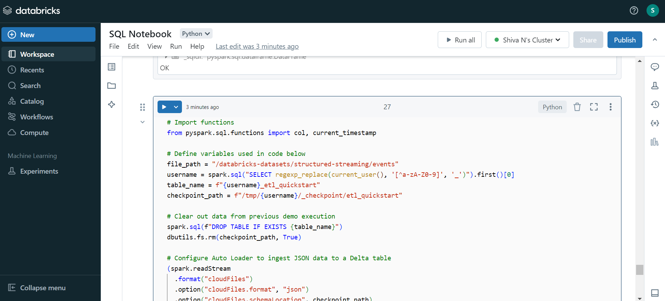

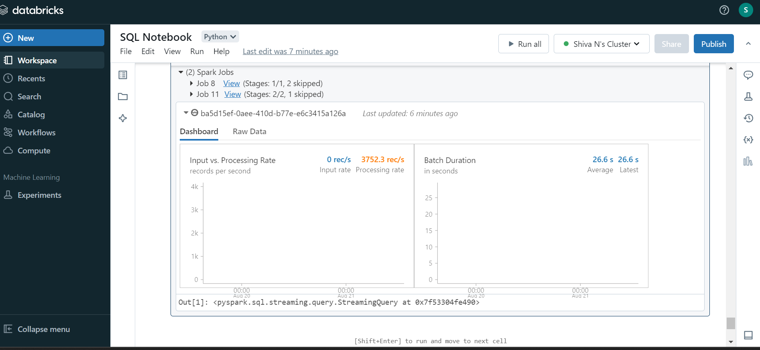

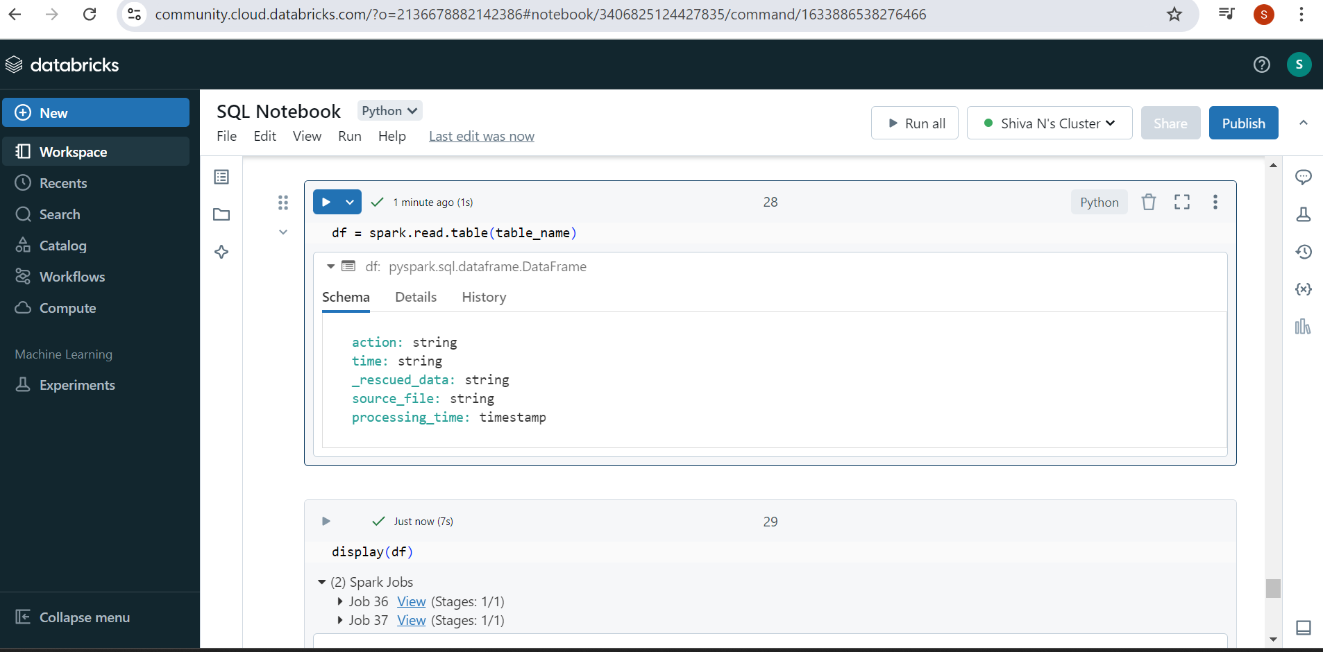

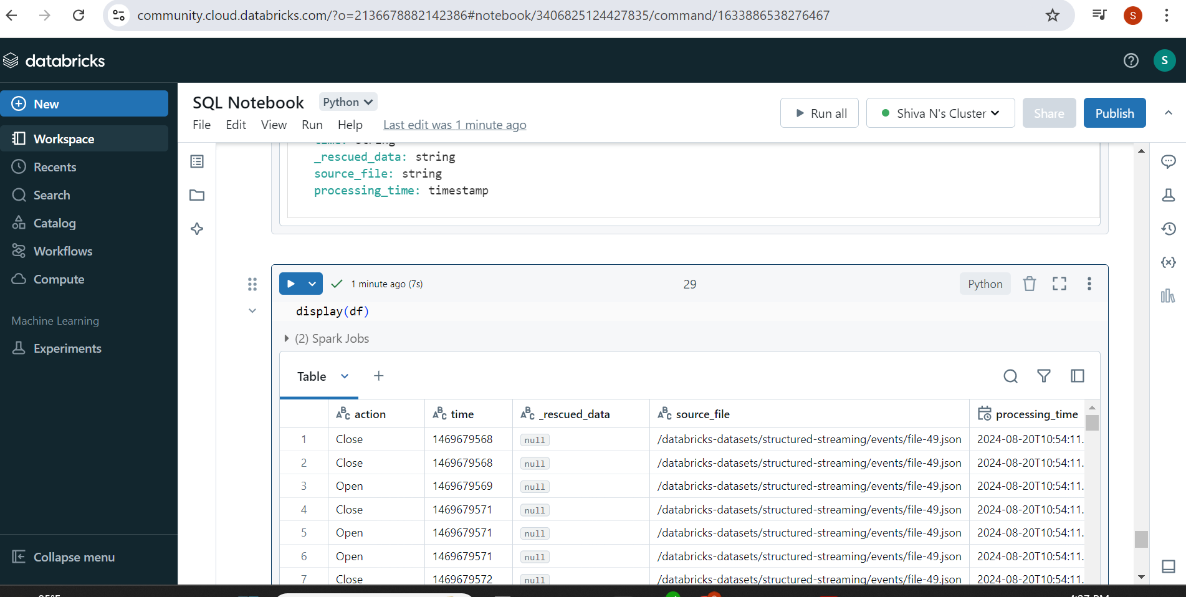

Medallion Architecture in Databricks
A medallion architecture is a data design pattern used to logically organize data in a lakehouse, with the goal of incrementally and progressively improving the structure and quality of data as it flows through each layer of the architecture (from Bronze ⇒ Silver ⇒ Gold layer tables). Medallion architectures are sometimes also referred to as "multi-hop" architectures.
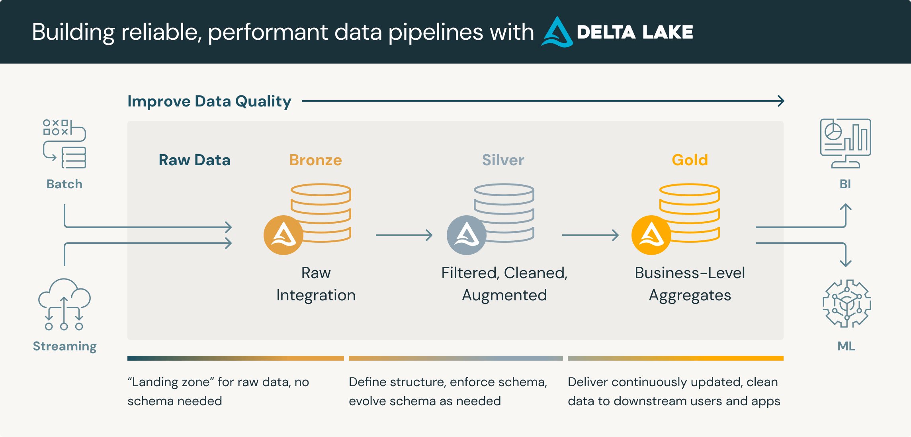

Layers in Medallion Architecture
- Bronze Layer (Raw Data):
  - Purpose: Stores raw, unprocessed data in its original format.
  - Data Type: This layer includes all ingested data from various sources (e.g., JSON, CSV, or Avro files), often containing duplicates, missing values, and other inconsistencies.
  - Characteristics:
    - Minimal transformation
    - Used as the "single source of truth" for auditing
    - Enables replayability (re-processing of raw data if needed)
  - Example:
    - Ingesting data from IoT devices, logs, or transactions into the Bronze layer as-is.
    - Schema might not be strictly enforced, as the focus is on retaining raw data.
2. Silver Layer (Cleaned Data):
- Purpose: Stores data that has been cleaned, transformed, and validated, often ready for analytics or reporting.
- Data Type: This layer typically includes data that has undergone some level of transformation, such as removing duplicates, handling missing values, and filtering out irrelevant information.
- Characteristics:
  - Enforced schema
  - Quality and consistency checks
  - Handles joins with other datasets
- Example:
  - Removing duplicates from transactional data and filtering out corrupt records, resulting in clean data that is ready for further processing or analysis.
3. Gold Layer (Aggregated/Curated Data):
- Purpose: Stores aggregated, summarized, and curated data that is optimized for business intelligence (BI) and advanced analytics.
- Data Type: This layer consists of data that is often aggregated or processed for specific business use cases, like reporting, machine learning models, or dashboards.
- Characteristics:
  - High-quality data
  - Ready for consumption by analysts, data scientists, and business users
  - Derived metrics and KPIs
- Example:
  - Aggregating customer transaction data to generate a summary of total sales by region and period for reporting purposes.

Benefits of the Medallion Architecture in Databricks:
- Scalability: It helps in scaling data ingestion and processing, especially in large environments with multiple data sources and formats.
- Data Quality: By incrementally cleaning and transforming data at each stage, Medallion Architecture ensures higher data quality.
- Flexibility: It supports both batch and real-time data processing workflows.
- Layered Data Management: Each layer serves a distinct purpose, allowing for the separation of concerns (raw vs. curated data), which helps manage complexity.
- Ease of Use: The structured approach allows data teams to work on specific layers depending on their role, whether data engineers (Bronze/Silver) or data scientists and analysts (Gold).

