Assignment 2

1. What is semantic in HTML5?

Ans: Semantic HTML elements clearly describe it’s meaning in a human and

machine readable way. Elements such as <header>,<footer> and

<article> are all considered semantic because they accurately describe

the purpose of element and the type of content that is inside it.

1. What happens when we click on the URL in our browser?

Ans: URL-Uniform Resource Locator, it is an address of the place where we

want to go to interact with or find information.

* Example: http://www.youtube.com.In this http is a protocol and

remaining is the domain name.

* Domain name is the address of the website. It gives a unique identity to your website in such a huge web world.

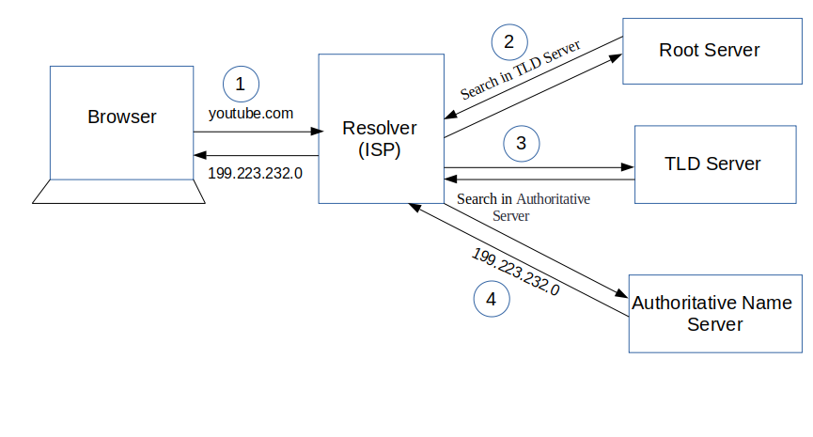Fig1:Processing of URL

3. Why HTML5 instead of HTML?

Ans: HTML5 makes creating accessible sites easier for reason like semantics.

With this screen readers can better examine the HTML document and

create a better experience for those who use them.

4.Why HTML is important or necessary?

Ans: HTML was made to allow people to design websites on the internet.

* If we did not have HTML we would not have the internet. All of the tasks in the world that revolve around the internet would not exist.
* If we lived in a world without internet communication would be dramatically affected.
* All of the information we access on a daily basis would have to be found in other places which would be much harder.
* All programming languages are useful. HTML is essential because of its web-based application.
* HTML also helps introduce beginners to the programming world. This helps people from taking too large of a first step then quitting.
* HTML has many applications and uses which makes it a very important programming language in our world.

1. What are the different methods of Grid creation?

Ans: The following are the different methods

* **Base method:** The basic way to create a grid is to declare grid-template- column.This property determines the number of items in a row.

# List Method: Using the “**base method**” and the **repeat () function,** we can easily achieve a list sequence of items.

# Positioning Method: In every grid we create, we also create grid lines automatically. Using these grid lines, we can position the grid items in any square we want.

# Dynamic List Method: This is similar to the “**List Method**”, except that in the “**Dynamic List Method**”, the number of items in each row is dynamic, and may change according to the width of the view-port.

# 6. Different versions of HTML.

# Ans: HTML (1989-1994):

# This supported inline images and text controls. This was very limited in terms of styling and presentation of content. In this

# For ex: We could not use:

# Tables or forms

# Specify fonts, change page background or use forms.

# Because of these limitations, every web page created with HTML looked the

# same with similar background and the type.

# HTML 2.0 (1995):

# This specification supported more browsers. It also supported

# For ex:

# Forms with limited set of form elements and such as text boxes and option buttons.

# Change of page background.

# Use of tables.

# HTML 3.20 (1997): [First named-code: WILBUR)

# This version included support for creating tables and expanded options for form elements. This also allowed to include complex mathematical equations.

# Because W3C delayed agreeing on the next version of HTML, HTML3.2 was created instead of HTML3.0.

# Although HTML3.20 specification included support for CSS, browser

# manufactures did not support it very well in their browsers.

# HTML 4.01 (1999):

# This version added support for style sheet and scripting ability for multimedia elements.

# In HTML 4.0 with use of style sheet, it is now possible to change the appearance/look of website by changing just the style sheet itself.

# HTML 5 (2014):

# The HTML5 specification that we see today has been published as a working draft and it is not yet final.

# Its core aim has been to improve the language with support for the

# Latest multimedia while keeping it understood by computers and devices.

# 7.What is box model?

# Ans: In css we broadly have two types of boxes

# Block Boxes

# Inline Boxes

# Block Boxes:

# This will behave like to fill the space available in its container. In most cases this means that the box will become as wide as its container, filling up 100% of space available.

# The box will break onto a newline.

# The width and height properties are respected.

# Padding, margin, and border will cause other elements to be pushed away from the box.

# Inline Boxes:

# The box will not break onto a newline.

# The width and height properties will not apply.

# Padding, margin and borders will apply but will not cause other inline boxes to move away from the boxes.

# 