DATA ANALYTICS WITH POWER BI PROJECT REPORT
(Project Semester September – December 2025)

CENSUS OF INDIA – POPULATION & DEMOGRAPHIC ANALYSIS DASHBOARD
Submitted by:
SHIVALI V
Registration No.: 12316054
Programme: Bachelor of Technology Section: K23LE
Course Code: INT374

Under the Guidance of Dr.BaljinderKaur UID: (27952)

Discipline of CSE/IT
Lovely School of Computer Science & Engineering Lovely Professional University, Phagwara


CERTIFICATE

This is to certify that Shivali V, bearing Registration no. 12316054 has completed INT374 project titled, “PROPERTY PRICING ANALYTICS – (NEW YORK) DASHBOARD”
under my guidance and supervision. To the best of my knowledge, the present work is the result of his original development, effort and study.

Signature and Name of the Supervisor: Dr.Baljinder Kaur Designation of the Supervisor:

School of Computer Science & Engineering Lovely Professional University Phagwara, Punjab.

Date: 09-12-2025

DECLARATION

I, Shivali C, a student of Bachelor of Technology in Computer Science and Engineering at Lovely Professional University, Punjab, hereby declare that the work presented in this project report titled “CENSUS OF INDIA – POPULATION & DEMOGRAPHIC ANALYSIS DASHBOARD” is a result of my own independent research, efforts, and analysis.
All the data utilized in this project has been collected from publicly available and authentic sources, and the insights generated have been developed solely by me using appropriate analytical and visualization techniques.
This declaration is made with full honesty and sincerity, reflecting the originality and genuine nature of this work.

Date: 09-12-2025

Signature: Shivali V Registration No.: 12316054

ACKNOWLEDGEMENT

I express my sincere gratitude to my course instructor, Dr.Baljinder Kaur for their invaluable guidance and support throughout the " DATA ANALYTICS WITH POWER BI" course. Their expertise in data organization and visualization techniques was instrumental in helping me successfully complete this project on creating the “PROPERTY PRICING ANALYTICS – (NEW YORK) DASHBOARD” using Power BI.

Dashboard link: https://drive.google.com/file/d/1ZPwBv8NjlkEch7ivCNDD5sQKMgz5TaZD/view?usp=drive
_link

LinkedIn link: https://www.linkedin.com/posts/saurav-kumar-ba10a3298_powerbi-dataanalytics- dashboarddesign-activity-7405580944713322496- AFNE?utm_source=social_share_send&utm_medium=member_desktop_web&rcm=ACoAAEfq hOkB1W8fzK443EpKrJOmdp_yZsST5Hg

Table of Contents

- Introduction
- Source of dataset
- EDA process
- Analysis on dataset (for each analysis)
  - Objective 1: Analyse Total Sales Value by Borough
  - Objective 2: Identify Monthly Price Trends in the NYC Property Market
  - Objective 3: Evaluate Overall Market Pricing Performance
  - Objective 4: Analyse Market Share by Property Usage
  - Objective 5: Evaluate Value Shift Based on Building Age
  - Objective 6: Identify High-Value Market Hotspots Across NYC
  - Objective 7: Assess Overall Market Performance Through Key Sales Indicators
- Conclusion
- Future scope
- References

Introduction

Population data plays a critical role in understanding the social, economic, and developmental structure of a country. In a diverse and populous nation like India, demographic indicators such as population distribution, literacy levels, workforce participation, and gender balance vary significantly across states and regions. Analyzing these variations is essential for effective policy planning, resource allocation, and socio-economic development.

With the availability of large-scale census data, data analytics and visualization techniques can be applied to convert raw demographic data into meaningful insights. Business intelligence tools like Power BI enable interactive analysis and visual storytelling, making complex datasets easier to interpret for decision-makers.

This project focuses on analyzing Census of India data using Power BI to gain insights into national and state-wise population trends. The dashboard aims to highlight key demographic indicators such as total population, male and female population distribution, literacy rates, child population, workforce participation, and gender gaps.

The primary objective of this project is to provide a comprehensive and interactive demographic analysis that supports data-driven understanding of India’s population structure and regional disparities.

Source of Dataset

The dataset used in this project is sourced from the Census of India, an official government dataset released for public analysis and research. The dataset contains state-wise demographic information including total population, male and female population, literacy data, workforce details, and child population statistics.

Being a government-authenticated dataset, it is reliable, accurate, and suitable for large-scale demographic and socio-economic analysis. The dataset provides a real-world foundation for understanding population patterns and regional differences across India.

Dataset link

Exploratory Data Analysis

A detailed Exploratory Data Analysis (EDA) process was carried out to understand the dataset structure, improve data quality, and prepare it for effective visualization and analysis.

  - Data Understanding
    - Inspected dataset structure to understand number of rows, columns, and attribute types
    - Studied important variables like:
      - Sale Price
      - Borough & Neighbourhood
      - Building Class Category
      - Land & Gross Square Feet
      - Sale Date
      - Building Age
      - Residential/Commercial usage

  - Data Cleaning
    - Removed invalid records
      - Entries with Sale Price = 0 or extremely low prices indicating non-arm’s-length transactions
      - Duplicates and non-sales entries.
    - Handled missing values
      - Checked nulls in area fields
      - Filtered blank neighbourhood or borough fields
    - Corrected inconsistent formats
      - Converted sale date to proper datetime format
      - Ensured area and price fields are numeric and usable

  - Feature Engineering
New columns were created to support deeper analysis:

Feature | Purpose
Price per SqFt | Fair comparison of differently sized properties
Building Age Group | Categorization into New, Mid-Age, Old, Very Old
Price Bands | Affordability and luxury segmentation
Year & Month from Sale Date | For monthly trend analysis

Property Usage Category | Residential / Commercial / Mixed-Use share study

OBJECTIVES:
The objective of this project is to analyze Census of India data using Power BI in order to gain a detailed understanding of India’s population and demographic characteristics. The project aims to study how population is distributed across different states and regions and to identify patterns related to gender composition, literacy levels, and workforce participation.

Objective 1: Analyze State-wise Population Distribution
This objective focuses on understanding how the total population of India is distributed across different states and union territories. Population distribution analysis helps identify regions with high population concentration as well as states with relatively smaller population sizes. By comparing state-wise population figures, this analysis highlights demographic imbalances across the country.
The visualization enables easy identification of densely populated states, which are often associated with higher demand for infrastructure, healthcare, education, and employment opportunities. At the same time, it also brings attention to sparsely populated regions that may require different development strategies.

Insight:

Population distribution in India is highly uneven, with states like Uttar Pradesh, Maharashtra, and Bihar contributing significantly to the national population. This highlights the need for region-specific planning in infrastructure, healthcare, and public services.

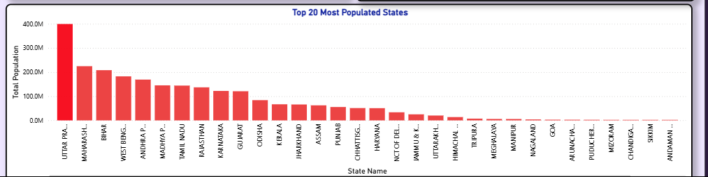

Objective 2: Identify Monthly Price Trends in the NYC Property Market

This objective aims to analyse the gender-wise population distribution by comparing male and female population across Indian states. Gender-based population analysis helps understand demographic balance and social structure at the regional level.

The visualization allows for clear comparison of male and female population counts across states, making it easier to observe patterns and variations. Such analysis is important for identifying regions where gender imbalance may exist due to social, economic, or cultural factors.

Key Observations:
    - Most states show a higher male population compared to female population
    - Gender difference varies across states rather than being uniform

Insights:
Although the national gender distribution is relatively balanced, state-level variations indicate demographic and social differences that require continuous monitoring and gender-focused initiatives.

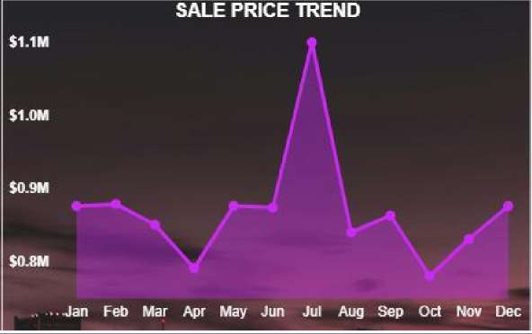

Objective 3: Evaluate Overall Market Pricing Performance
A key business KPI was included to assess the current pricing level in the NYC property market.
The Market Pricing Performance visualization represents the average market price positioning on a price gauge.

Key Findings:
    - The KPI displays a value around $554K
    - The gauge indicates this value lies in the mid-to-high range of the real estate market scale

    - It signals that NYC maintains a strong and competitive pricing environment

Insight:
New York remains a high-value property market, with pricing significantly above national housing averages.
The KPI instantly communicates the market's pricing health, enabling:

- Quick benchmarking of current pricing level
- A performance indicator for investors evaluating entry cost
- A realistic expectation for buyers about affordability

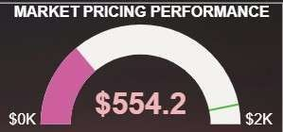

Objective 4: Analyse Market Share by Property Usage
Properties in New York City serve different purposes such as Residential, Commercial, or Mixed-Use.
Understanding how much each category contributes to the total properties sold gives clarity on market demand and development patterns.
The Market Share by Property Usage chart clearly shows:

Key Findings:
    - Residential properties dominate the market

➝ They hold the largest share in total units sold
➝ Driven by high housing needs in NYC’s growing population

    - Mixed-Use properties contribute a notable share
➝ Common in urban spaces with commercial floors + residential units above

    - Commercial-only properties have the smallest share
➝ Fewer in number but much higher in price value per unit

Insight:
The NYC property market is primarily residential-driven, confirming that:
- Housing demand remains the core driver of real estate transactions
- Mixed-use developments support urban lifestyle and business convenience
- Commercial units are niche but high-value assets for investors
This helps identify where developers and investors can focus to maximize returns.

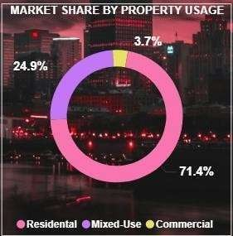

Objective 5: Evaluate Value Shift Based on Building Age
Property value is closely related to the age of the building. This visualization highlights how median sale price changes across different building age categories in NYC:
- New
- Very Old
- Mid Age
- Old

Key Observations:
- New buildings have the highest market value
➝ Modern construction, advanced amenities, better structural safety
➝ Preferred by luxury buyers & investors

- Very Old buildings appear priced lower than new buildings but still hold high value
➝ Especially those located in premium and historically preserved neighbourhoods
➝ Reflects age + location premium effect

- Mid Age and Old buildings show reduced pricing
➝ Older infrastructure & higher renovation needs
➝ Less market demand compared to newer constructions

Insight:
The market clearly rewards newer constructions, but heritage-rich very old buildings still retain strong pricing due to location advantage and architectural uniqueness.
This insight supports:

- Investors targeting redevelopment projects
- Buyers planning long-term appreciation
- Developers focusing on modernization to increase returns

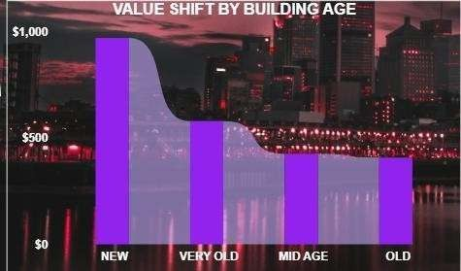

Objective 6: Identify High-Value Market Hotspots Across NYC
Location is one of the biggest determinants of property value.
To visually detect areas with strong sales density and high pricing, a Market Value Hotspot Map was included in the dashboard.
This map displays sales concentration using geospatial plotting of properties sold across:
- Manhattan
- Brooklyn
- Queens
- Bronx
- Staten Island

Key Insights:
- Central and Lower Manhattan show the highest concentration of high-value properties

➝ Premium commercial zones, financial hubs, upscale apartments

- Brooklyn’s northern and western neighbourhoods also form strong hotspots
➝ Increasing residential development and rising lifestyle demand

- Queens shows moderate to dense clusters near transport-connected areas
➝ Affordable and family-oriented housing zones

- Bronx and Staten Island have lower density, implying:
➝ More affordable housing
➝ Less high-value real estate activity

Strategic Conclusion:
Hotspot areas highlight prime investment zones, while outer regions reflect budget-friendly opportunities.
This allows:

- Developers to target expanding neighbourhoods
- Investors to diversify between luxury and affordable regions
- Buyers to evaluate pricing vs. location trade-offs

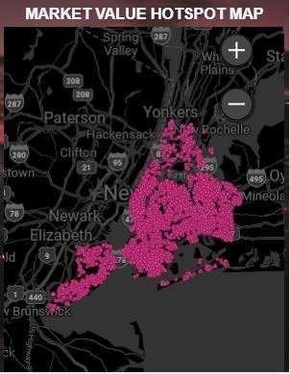

Objective 7: Assess Overall Market Performance Through Key Sales Indicators
To provide a quick business overview of NYC’s real estate strength, multiple high-level KPIs were included in the dashboard:
KPI Visual | Metric | Key Observation
Total Properties Sold | 8.43K+ | Indicates strong market activity and transaction  volume
Total Sales Volume | $18.6B+ | Reflects high-value market contributing massively to  NYC economy
Median Sale Price | $850K+ | Confirms NYC is a premium-priced housing market
Total SqFt Sold | 163M SqFt | Highlights massive scale of space traded in property  market

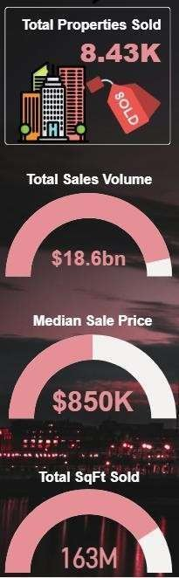

Conclusion
This project successfully demonstrates the application of data analytics and business intelligence techniques to analyze large-scale demographic data from the Census of India. By using Power BI as the primary analytical tool, raw census data was transformed into an interactive and visually intuitive dashboard that enables meaningful exploration of population trends across India.

Through systematic data cleaning and preprocessing using Power Query, the dataset was standardized, validated, and prepared for analysis. The use of DAX measures ensured accurate aggregation and dynamic calculation of key indicators such as total population, gender-wise population, literacy percentages, workforce participation, and gender gaps. This approach enhanced both the reliability and interactivity of the dashboard.

The analysis reveals significant regional disparities in population distribution, literacy levels, and employment structure across Indian states. States with large population shares contribute substantially to the national demographic profile, while variations in literacy and gender gaps highlight differences in access to education. The child population and workforce analysis further provide insights into future demographic pressures and economic dependency patterns.

Overall, the dashboard serves as an effective decision-support and analytical tool that presents complex census data in a clear and structured manner. It enhances data-driven understanding of India’s demographic landscape and demonstrates the practical use of Power BI for real-world data analysis. This project not only strengthened technical skills in data preparation, DAX, and visualization but also improved analytical thinking and data storytelling capabilities.

Future Scope
Although the current dashboard effectively highlights key pricing insights of New York City’s real estate market, there are several opportunities to enhance and expand the analysis further. Future improvements may include:
- Neighbourhood-Level Deep Dive
  - Add detailed comparisons within boroughs
  - Identify micro-markets with highest growth potential
- Advanced Predictive Analytics
  - Apply forecasting models for future pricing trends, demand estimation, and rental yield predictions
  - Use machine learning to identify investment-worthy properties
- Affordability and Buyer Profile Analysis

  - Include income-to-price ratio and mortgage affordability KPIs
  - Segment buyers based on budget categories
- Additional Real-Estate Market Factors
  - Include external influences such as:
    - Infrastructure development
    - Proximity to transport and schools
    - Economic policy impacts
- Automated Data Refresh
  - Connect live or scheduled data refresh to keep the dashboard updated with latest transactions
  - Enable continuous monitoring for real estate organizations
- Integration with Rental Market Data
  - Compare rental yields vs purchase values for investment decision support
- Mobile-Friendly and Interactive Deployment
  - Publish Power BI report online for real-time access across devices
  - Add drill-through features for individual property analysis

References
- NYC Department of Finance – Rolling Sales Data
Public dataset used for property sale records across New York City boroughs.
- Microsoft Power BI Documentation
Used for data modelling, visualization techniques, and dashboard development guidance.
- U.S. Real Estate Market Publications & Reports
Referred for understanding industry trends, market behaviours, and pricing factors.

