Week 10 Coding Practice Submission

Section 1
// Test - Change your File Path, preferably keep it in directories not having space in the name
LOAD CSV WITH HEADERS FROM
'file:///HospitalGeneralInformation.csv' AS line
WITH line
LIMIT 1
RETURN line
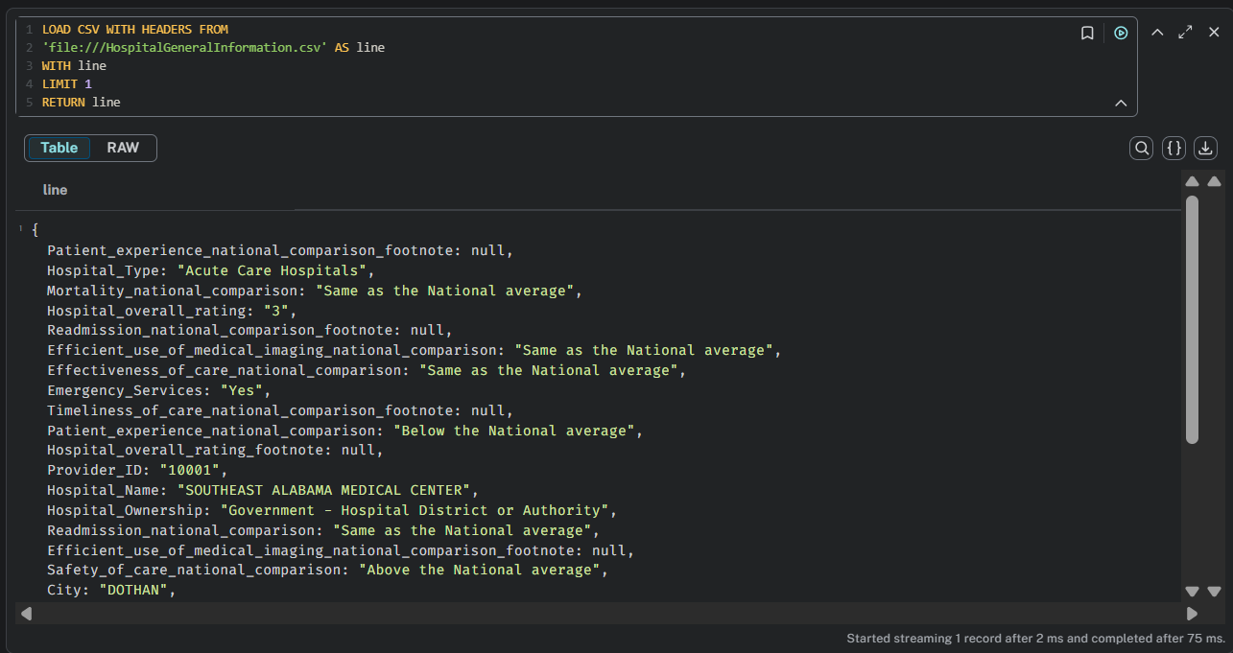

//Indexes

CREATE INDEX index_name For (n: County) ON (n.name);
CREATE INDEX index_name1 For (n:City) ON (n.name);
CREATE INDEX index_name2 For (n: ZipCode) ON (n.name);
CREATE INDEX index_name For (n:Address) ON (n.name);
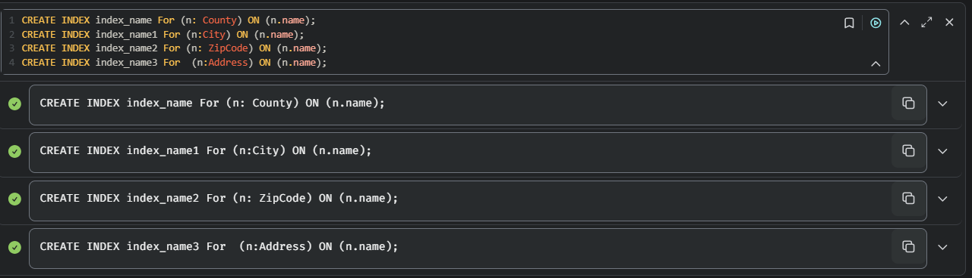
//Check indexes
SHOW INDEXES
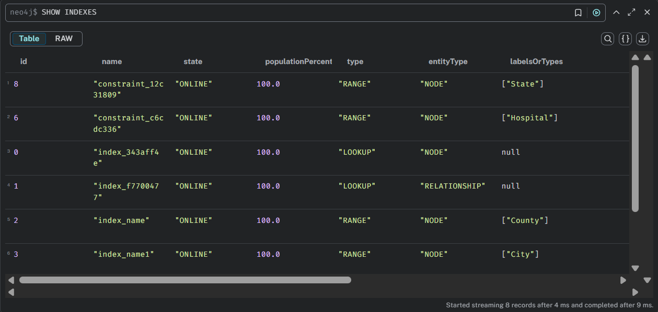
//Constraints
CREATE CONSTRAINT FOR (h:Hospital) REQUIRE h.id IS UNIQUE;
CREATE CONSTRAINT FOR (s:State) REQUIRE s.name IS UNIQUE;
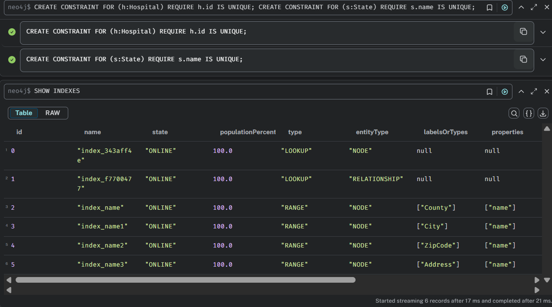

// Check constraints
SHOW CONSTRAINTS
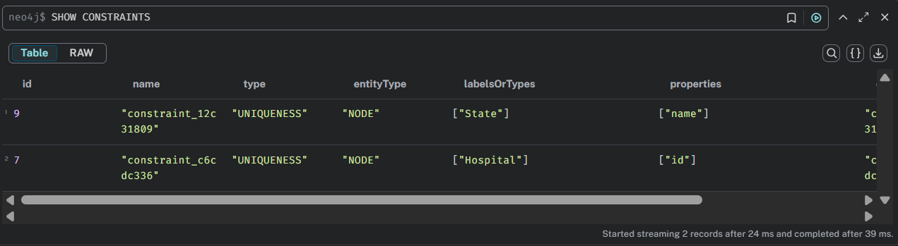
// Main Load
LOAD CSV WITH HEADERS FROM
'file:///HospitalGeneralInformation.csv' AS row
WITH row
WHERE row.State = 'NY'
// state name is unique
MERGE (state:State{name:row.State})
// merge by pattern with their parents
MERGE (state)<-[:IS_IN]-(county:County{name:row.County_Name})
MERGE (county)<-[:IS_IN]-(city:City{name:row.City})
MERGE (city)<-[:IS_IN]-(zip:ZipCode{name:row.ZIPCode})
MERGE (zip)<-[:IS_IN]-(address:Address{name:row.Address})
// for entities, it is best to have an id system
MERGE (h:Hospital{id:row.Provider_ID})
MERGE (h)-[:IS_IN]->(address)
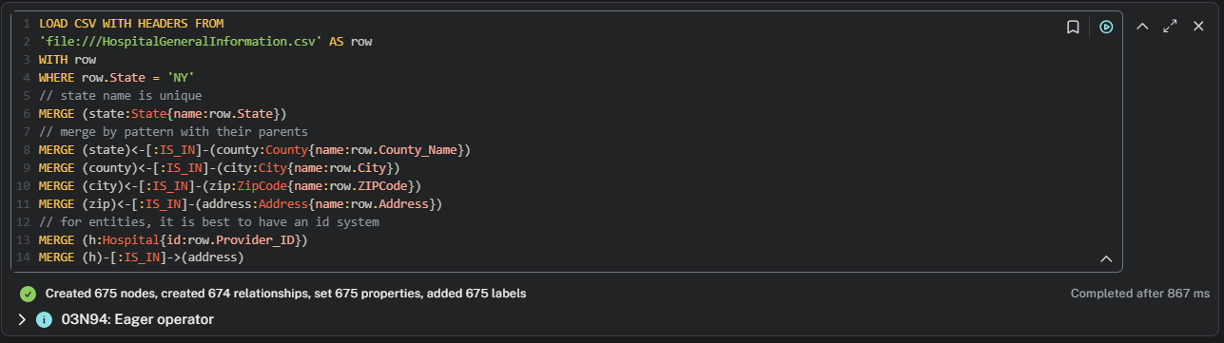

//Additional Information

LOAD CSV WITH HEADERS FROM
'file:///HospitalGeneralInformation.csv' AS row
WITH row
WHERE row.State = 'NY'
MATCH (h:Hospital{id:row.Provider_ID})
SET h.phone=row.Phone_Number,
h.emergency_services = row.Emergency_Services,
h.name= row.Hospital_Name,
h.mortality = row.Mortality_national_comparison,
h.safety = row.Safety_of_care_national_comparison,
h.timeliness = row.Timeliness_of_care_national_comparison,
h.experience = row.Patient_experience_national_comparison,
h.effectiveness = row.Effectiveness_of_care_national_comparison
MERGE (type:HospitalType{name:row.Hospital_Type})
MERGE (h)-[:HAS_TYPE]->(type)
MERGE (ownership:Ownership{name: row.Hospital_Ownership})
MERGE (h)-[:HAS_OWNERSHIP]->(ownership)
MERGE (rating:Rating{name:row.Hospital_overall_rating})
MERGE (h)-[:HAS_RATING]->(rating)
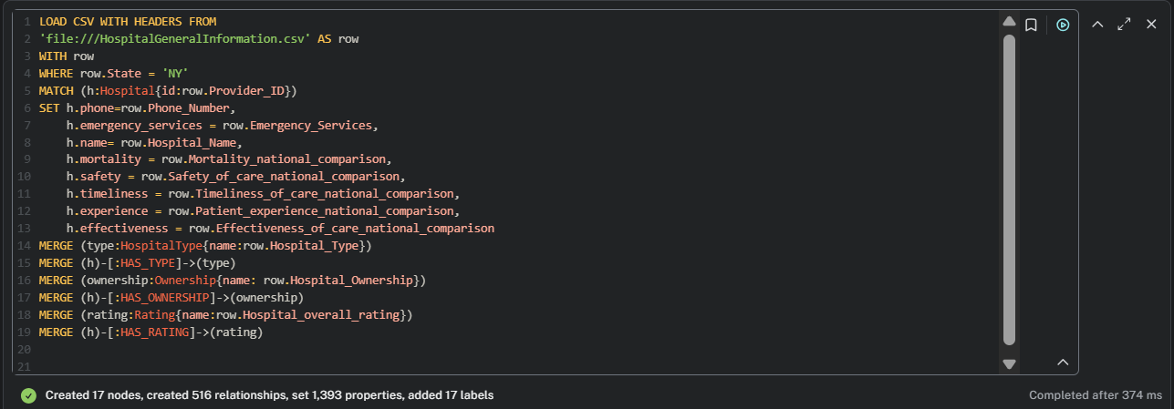

// Geospatial Load

LOAD CSV WITH HEADERS FROM 'file:/// gpsinfo.csv' AS row
WITH row
MATCH (hospital:Hospital {id:row.id})
SET hospital.latitude = toFloat(row.latitude),
hospital.longitude = toFloat(row.longitude)
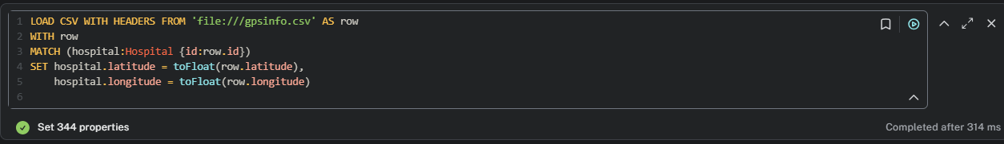

// schema

call db.schema.visualization()
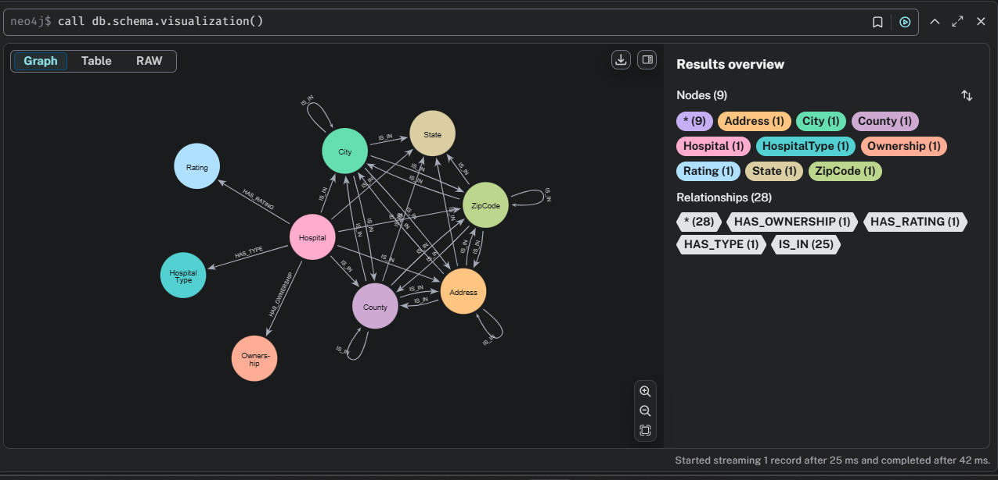

// Check nodes
MATCH (n) RETURN n LIMIT 14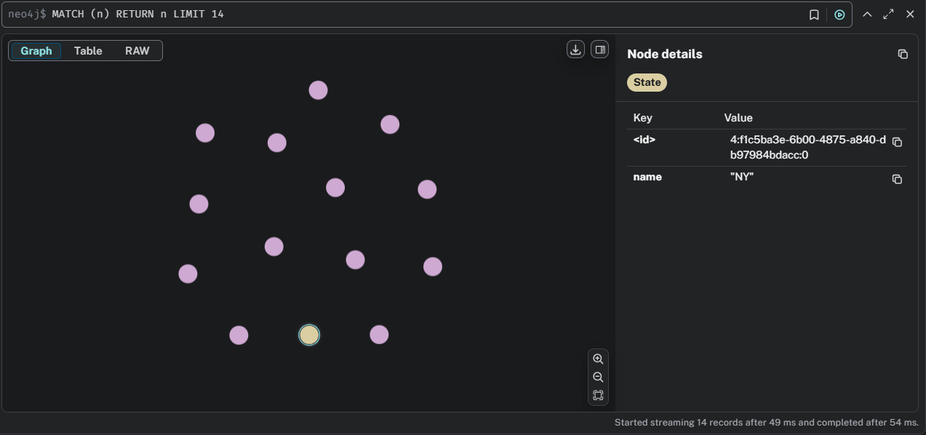

// Check nodes for City label
MATCH (n:City) RETURN n LIMIT 10
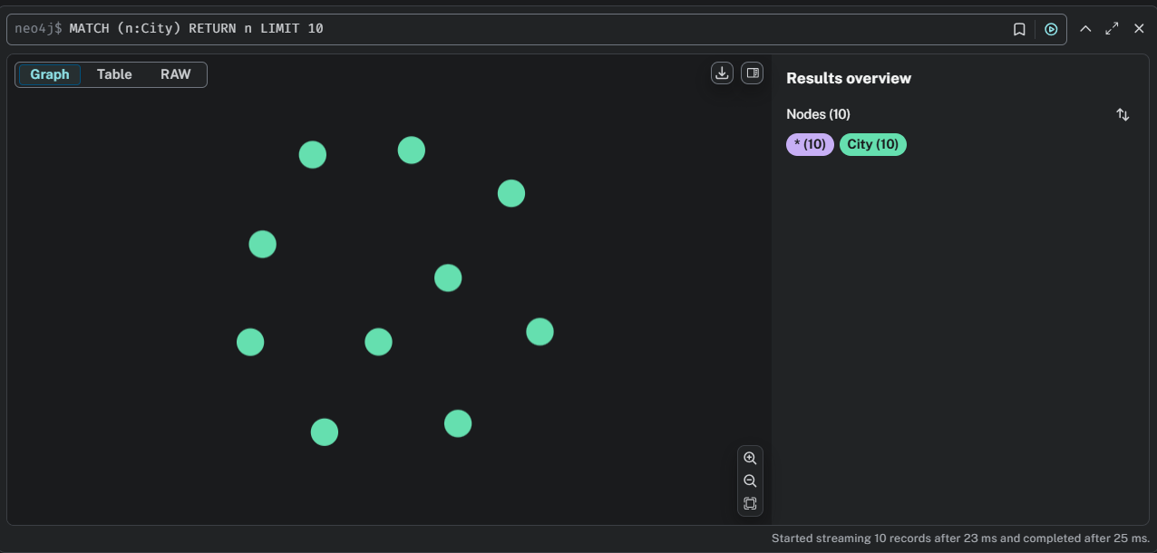

// Query 1 number of hospitals per city

MATCH (h:Hospital)-[:IS_IN*3..3]->(city)
RETURN city.name AS city, count(h) AS NumberOfHospitals
ORDER BY NumberOfHospitals DESC LIMIT 15
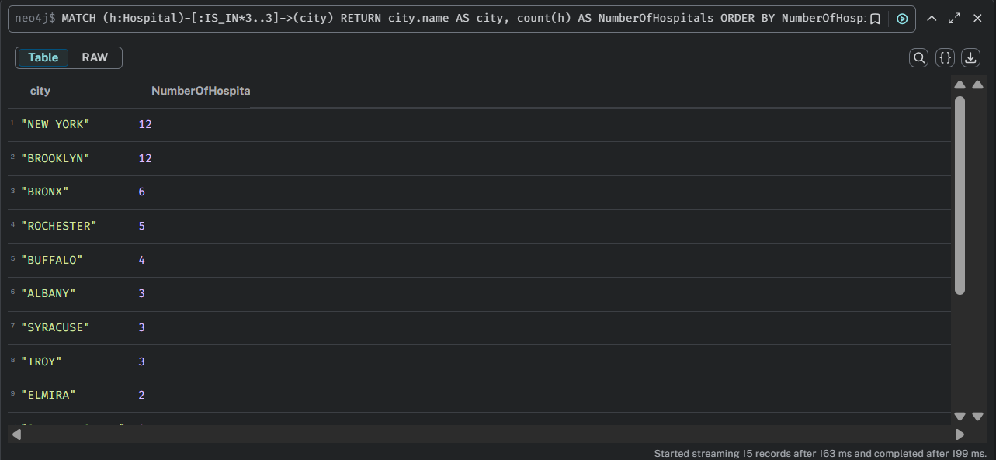

// Query 2 number of hospitals per zip

MATCH (h:Hospital)-[:IS_IN*2..2]->(city)
RETURN city.name AS zip, count(h) AS NumberOfHospitals
ORDER BY NumberOfHospitals DESC LIMIT 15
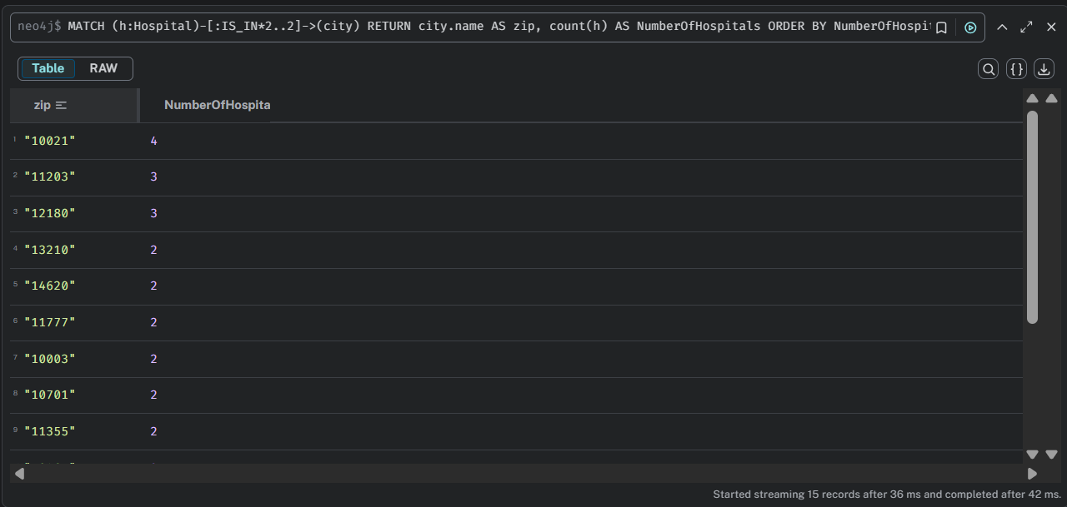

// Query 3 number of hospitals per street

MATCH (h:Hospital)-[:IS_IN*2..2]->(city)
RETURN city.name AS street, count(h) AS NumberOfHospitals
ORDER BY NumberOfHospitals DESC LIMIT 15
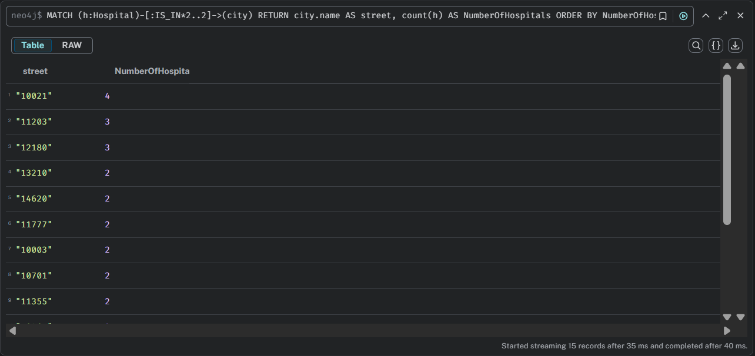

// Query 4 hospitals in city with below mortality average

MATCH (h:Hospital)-[:IS_IN*3..3]->(City)
WHERE h.mortality = 'Below the National average'
RETURN City.name AS city, count(h) AS NumberOfHospitals
ORDER BY NumberOfHospitals DESC LIMIT 15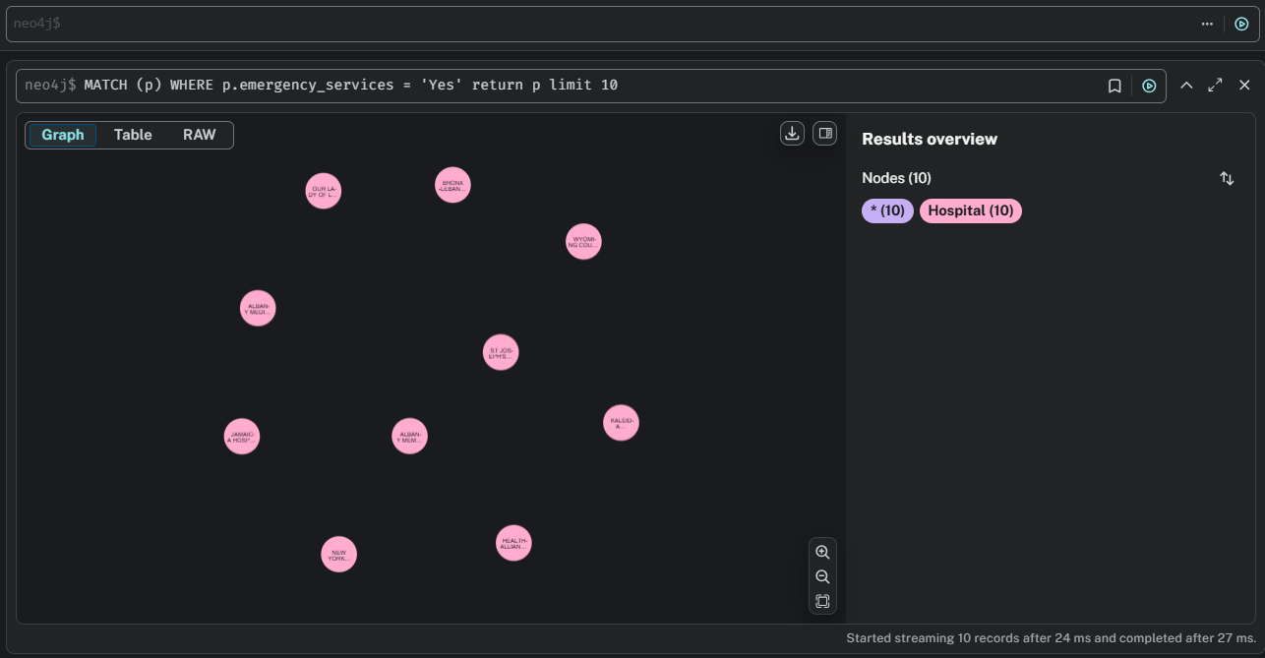

// Query 5

MATCH (p) WHERE p.emergency_services = 'Yes'
return p
limit 10
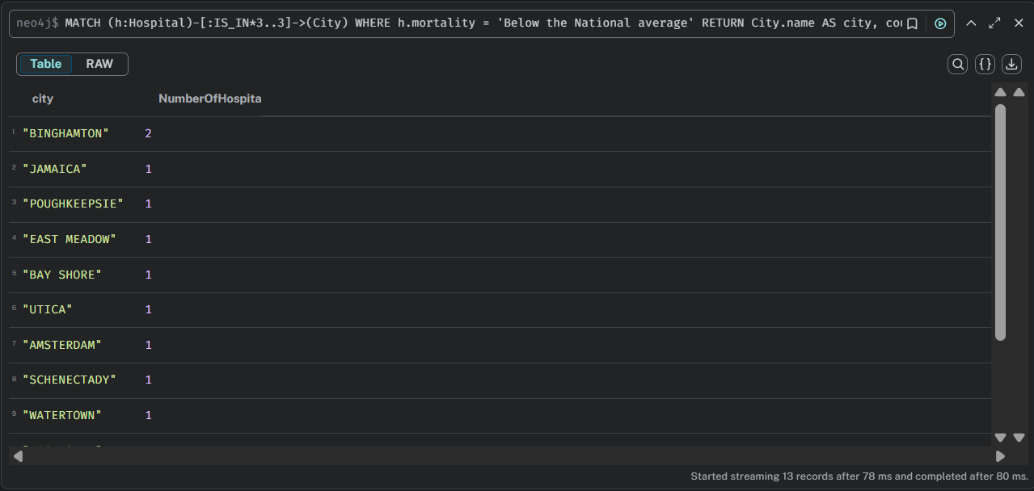

Section 2
// Look at the first 5 lines (add your full path).
LOAD CSV WITH HEADERS FROM "file:///flights_10k.csv" AS row
RETURN row
LIMIT 5
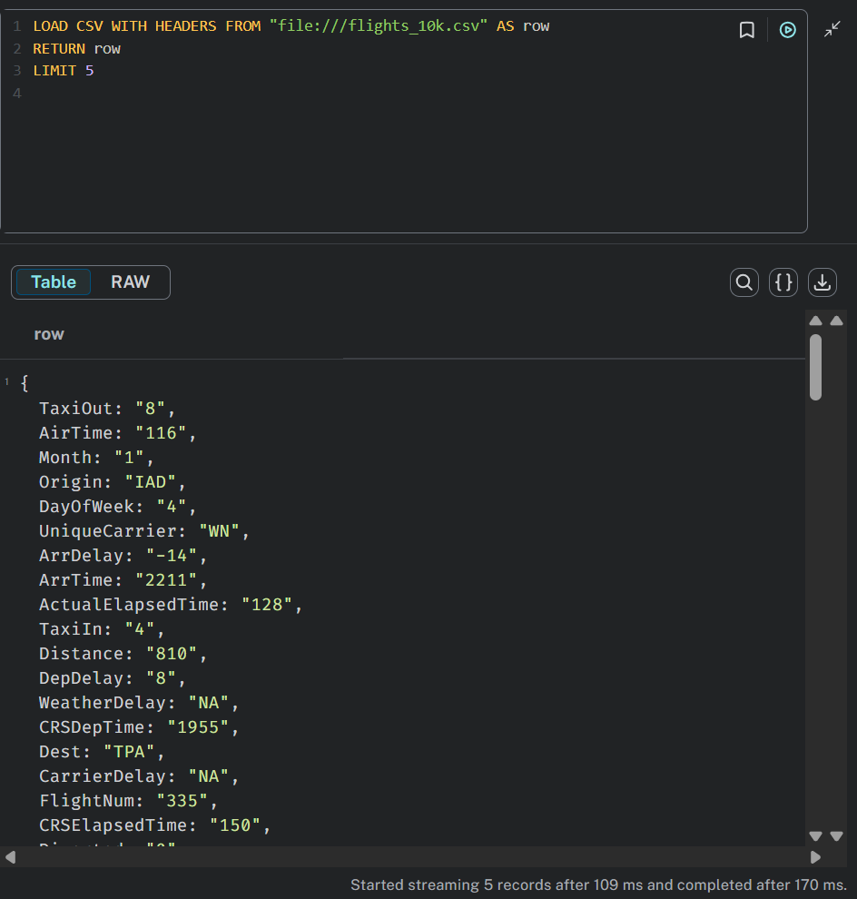
// Create nodes and constraints for
- node with the label Airport
- node with the label Flight
CREATE CONSTRAINT FOR (a:Airport)
REQUIRE a.code IS UNIQUE;
CREATE CONSTRAINT FOR (f:Flight)
REQUIRE f.id IS UNIQUE;
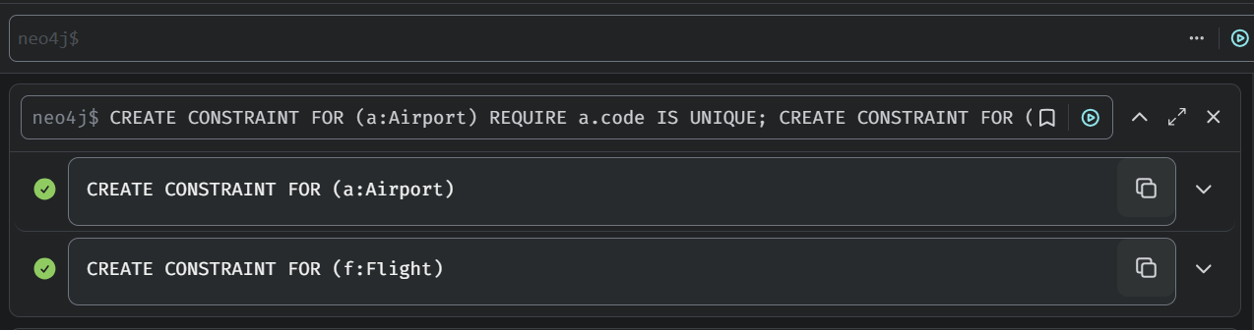

// Import nodes and relationships
- create nodes with the Airport label for the origin (Origin column) and destination (Dest column) airports if they don’t already exist
- creates nodes with the Flight label for flights if they don’t already exist. Here we combine several columns to create the FlightIdentifier field. We invent our own flightIdentifier as there isn’t one in the dataset
- creates an ORIGIN relationship between the origin airport and the flight
- creates a DESTINATION relationship between the destination airport and the flight
LOAD CSV WITH HEADERS FROM "file:////flights_10k.csv" AS row
MERGE (origin:Airport {code: row.Origin})
MERGE (destination:Airport {code: row.Dest})
WITH row.UniqueCarrier + row.FlightNum + "_" + row.Year + "-" + row.Month + "-" + row.DayofMonth + "_" + row.Origin + "_" + row.Dest AS flightIdentifier, row, origin, destination
MERGE (flight:Flight { id: flightIdentifier })
ON CREATE SET flight.date = row.Year + "-" + row.Month + "-" + row.DayofMonth,
flight.airline = row.UniqueCarrier, flight.number = row.FlightNum, flight.departure = row.CRSDepTime,
flight.arrival = row.CRSArrTime, flight.distance = row.Distance, flight.cancelled = row.Cancelled
MERGE (flight)-[:ORIGIN]->(origin)
MERGE (flight)-[:DESTINATION]->(destination)
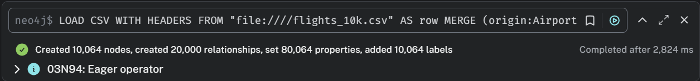

// Check your import
- How many flights do you have in the database?
MATCH (:Flight)
RETURN count(*)
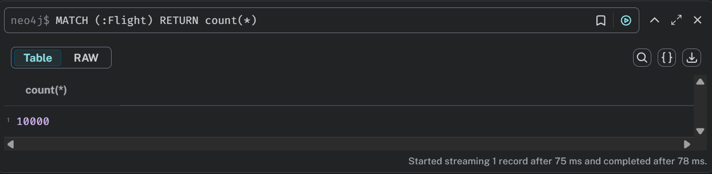

- Check schema
call db.schema.visualization()
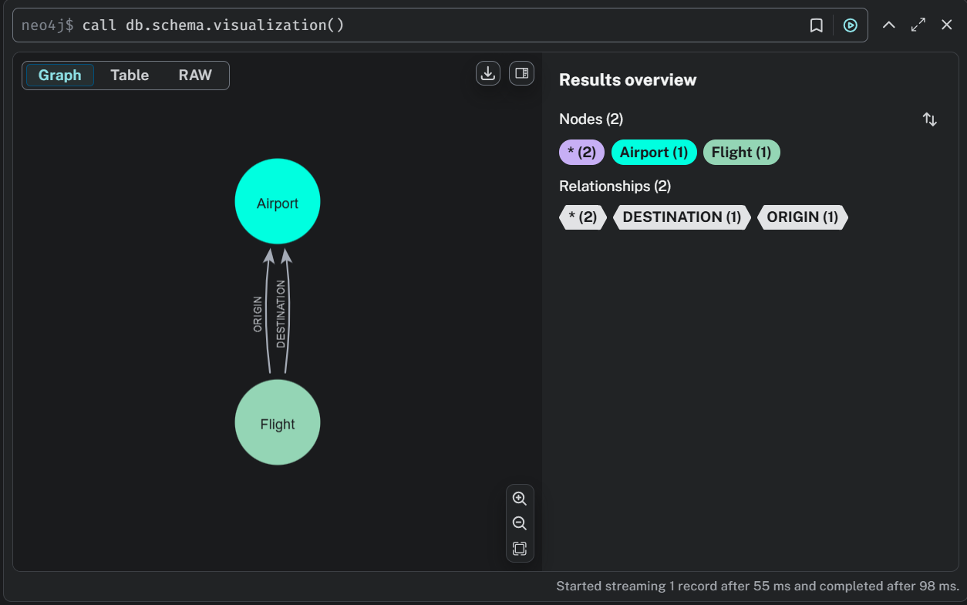

// Coercing values: Integers
- All values are imported as String
- Use Cypher to coerce them to Integer toInteger()
MATCH (flight:Flight)
SET flight.distance = toInteger(flight.distance)

- Test the integer
MATCH (flight:Flight)
WHERE flight.distance > 500
RETURN flight

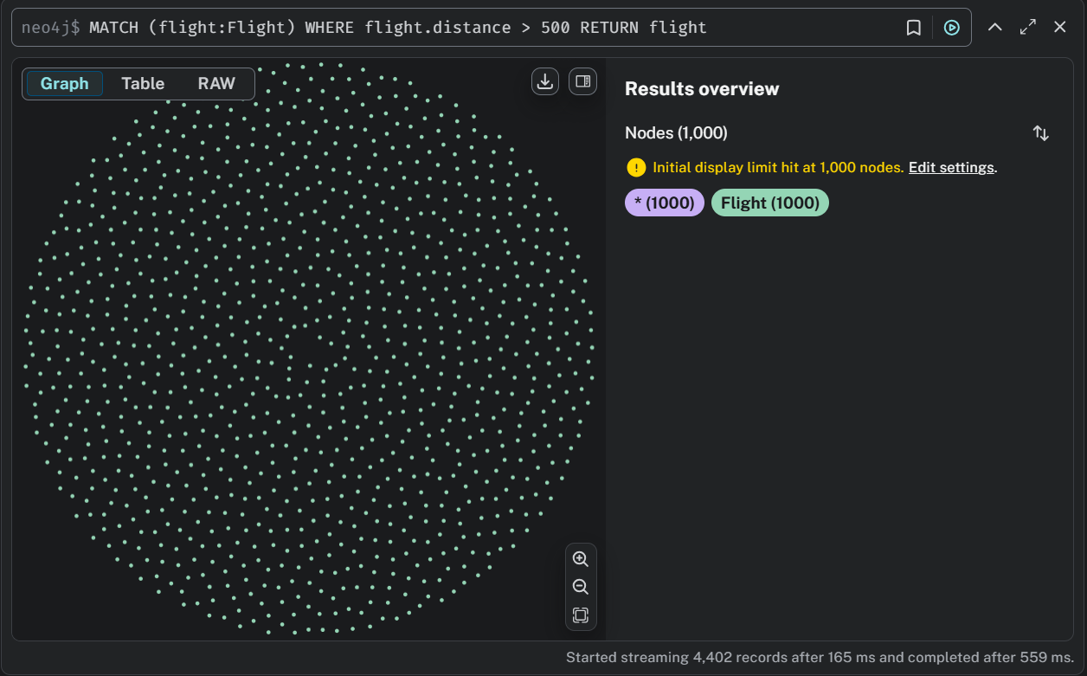
- set integer also for departure, arrival
MATCH (flight:Flight)
SET flight.departure = toInteger(flight.departure),
flight.arrival = toInteger(flight.arrival);
MATCH (flight:Flight)
WHERE flight.departure > 1000 AND flight.arrival > 1000
RETURN flight.departure, flight.arrival
LIMIT 10;
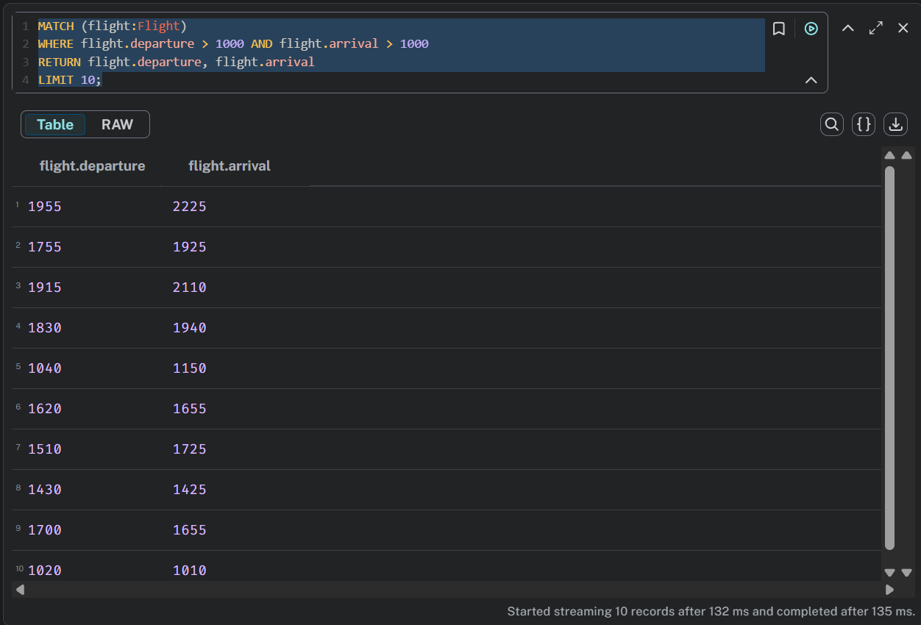

// Coercing values: Boolean
- Boolean (Cancelled) is stored as 0 and 1. Use Cypher to change it to TRUE and FALSE
MATCH (flight:Flight)
SET flight.cancelled = CASE WHEN flight.cancelled = "1" THEN true ELSE false END

- Test the boolean
MATCH (flight:Flight)
WHERE flight.cancelled
RETURN flight
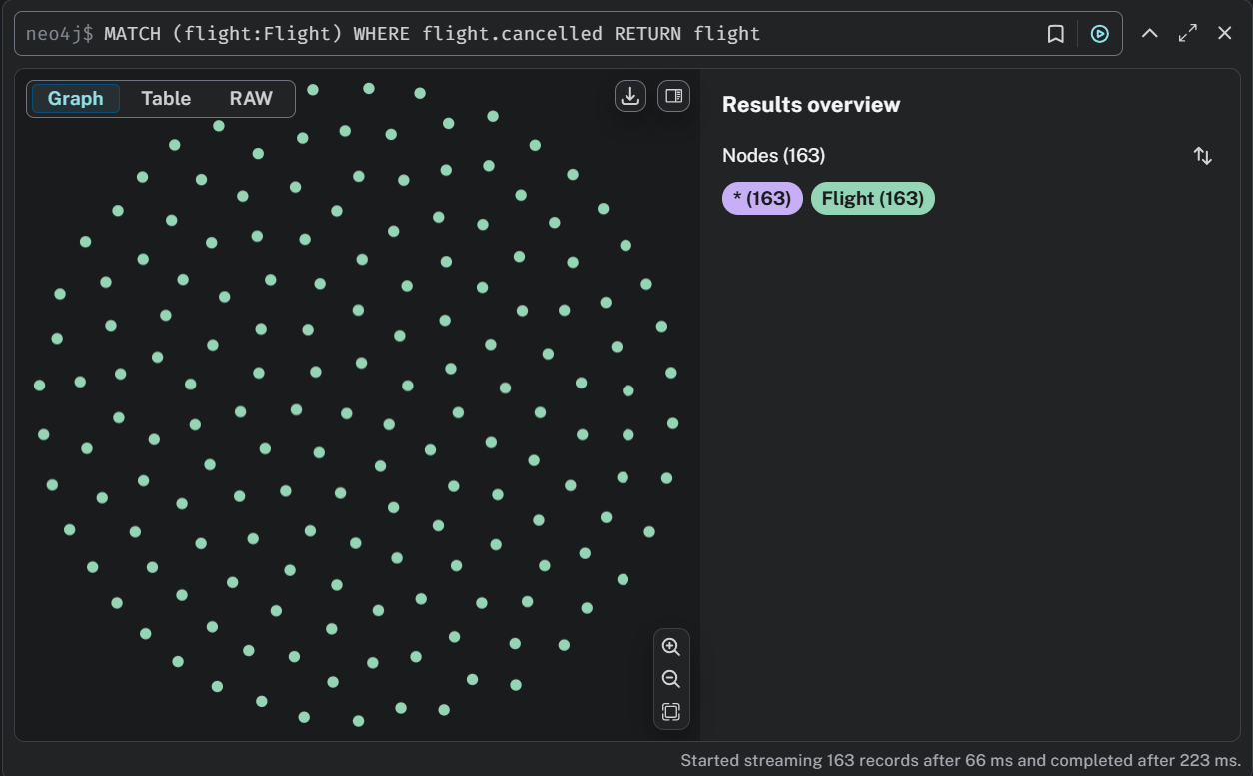

// Profiling queries
- Before submitting the query, check the Cypher execution plan. Note the statement PROFILE.
PROFILE
MATCH path = (origin:Airport {code: "LAS"})<-[:ORIGIN]-(flight:Flight)-[:DESTINATION]->(destination:Airport {code: "MDW"})
WHERE flight.date = "2008-1-3"
RETURN path
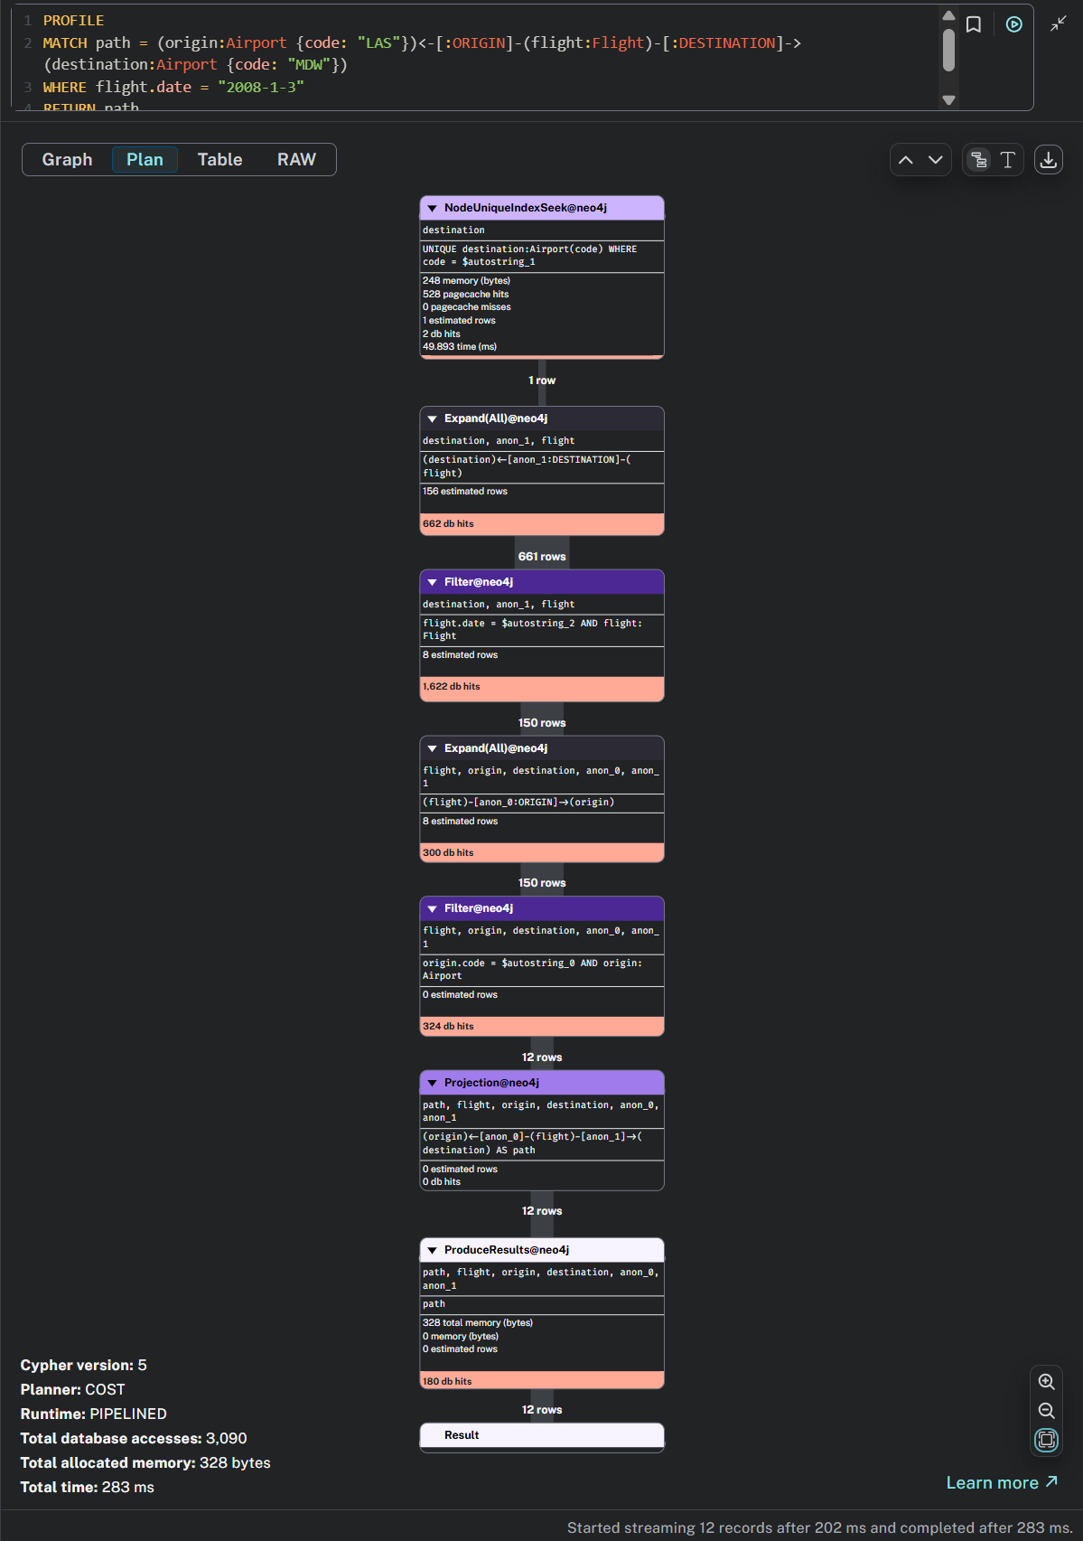

// Add a new relationship
- Add CONNECTED_TO
:auto LOAD CSV WITH HEADERS FROM "file:///you_path/flights_10k.csv" AS row
MERGE (origin)-[connection:CONNECTED_TO {
airline: row.UniqueCarrier,
flightNumber: row.FlightNum,
date: toInteger(row.Year) + "-" + toInteger(row.Month) + "-" + toInteger(row.DayofMonth)}]->(destination)
ON CREATE SET connection.departure = toInteger(row.CRSDepTime), connection.arrival = toInteger(row.CRSArrTime)
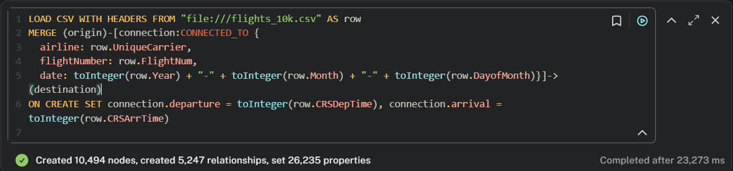

- Count Connections
MATCH ()-[:CONNECTED_TO]->()
RETURN COUNT(*)
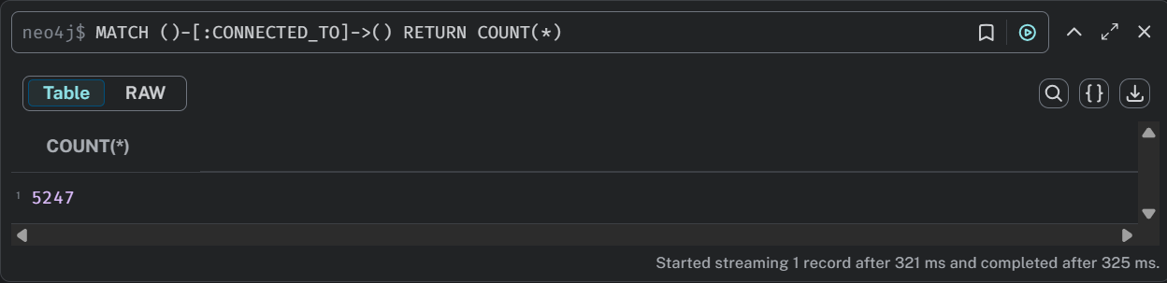

// Search
- Finding flights between Los Angeles and Chicago Midway International on the date "2008-1-3"
MATCH path = (origin:Airport {code: "LAS"})<-[:ORIGIN]-(flight:Flight)-[:DESTINATION]->(destination:Airport {code: "MDW"})
WHERE flight.date = "2008-1-3"
RETURN path

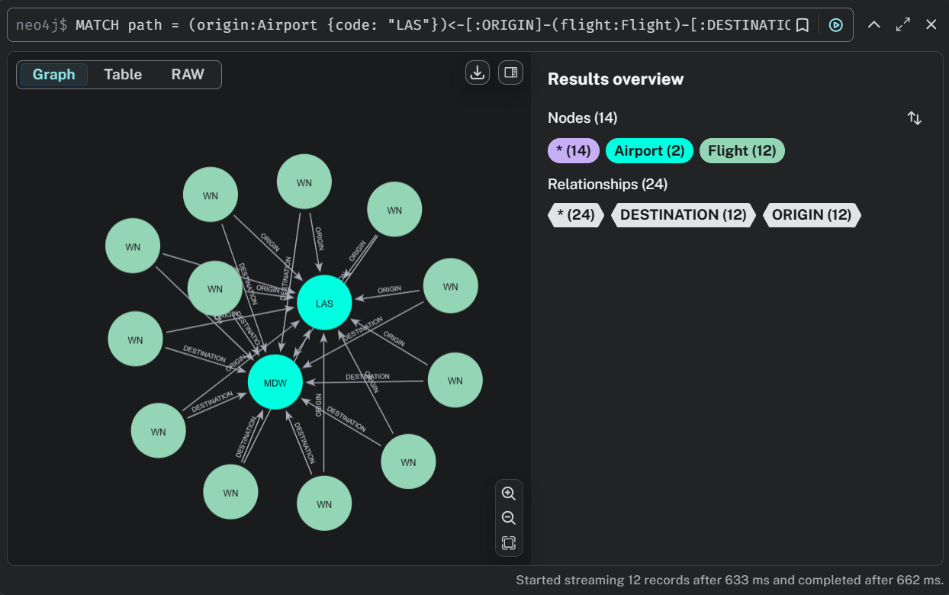

Similar queries on bigger dataset
// Load and Create Airports and Flights for 100k Dataset
LOAD CSV WITH HEADERS FROM "file:///flights_100k.csv" AS row
MERGE (o:Airport {code: row.Origin})
MERGE (d:Airport {code: row.Dest})
MERGE (f:Flight {
id: row.UniqueCarrier + row.FlightNum + "_" + row.Year + "-" + row.Month + "-" + row.DayofMonth + "_" + row.Origin + "_" + row.Dest
})
ON CREATE SET
f.date = row.Year + "-" + row.Month + "-" + row.DayofMonth,
f.airline = row.UniqueCarrier,
f.number = row.FlightNum,
f.departure = toInteger(row.CRSDepTime),
f.arrival = toInteger(row.CRSArrTime),
f.distance = toInteger(row.Distance),
f.cancelled = row.Cancelled = "1"
MERGE (f)-[:ORIGIN]->(o)
MERGE (f)-[:DESTINATION]->(d);
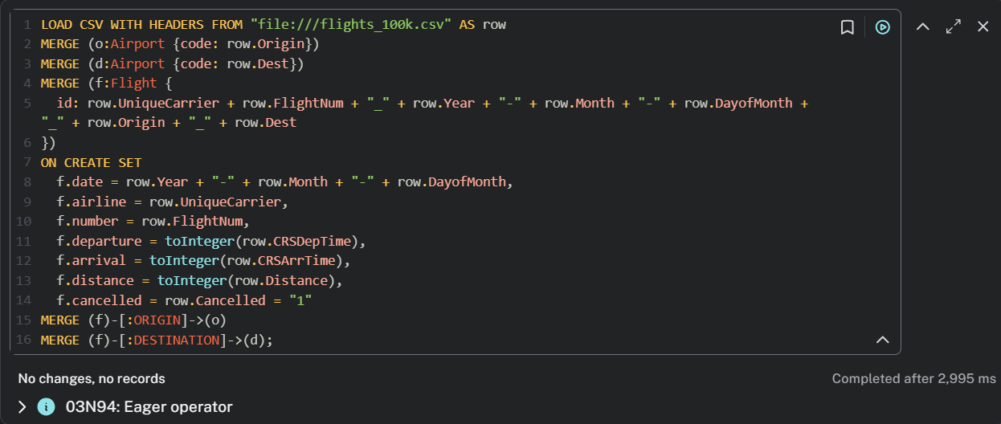
// Check the Number of Flights and Airports
MATCH (f:Flight)
RETURN count(f) AS totalFlights;

MATCH (a:Airport)
RETURN count(a) AS totalAirports;

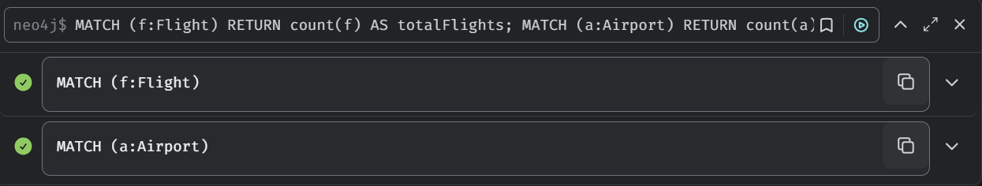

// Find the Longest Flights (by Distance)
MATCH (f:Flight)
WHERE f.distance IS NOT NULL
RETURN f.airline AS Airline, f.number AS FlightNumber, f.distance AS Distance
ORDER BY f.distance DESC
LIMIT 10;

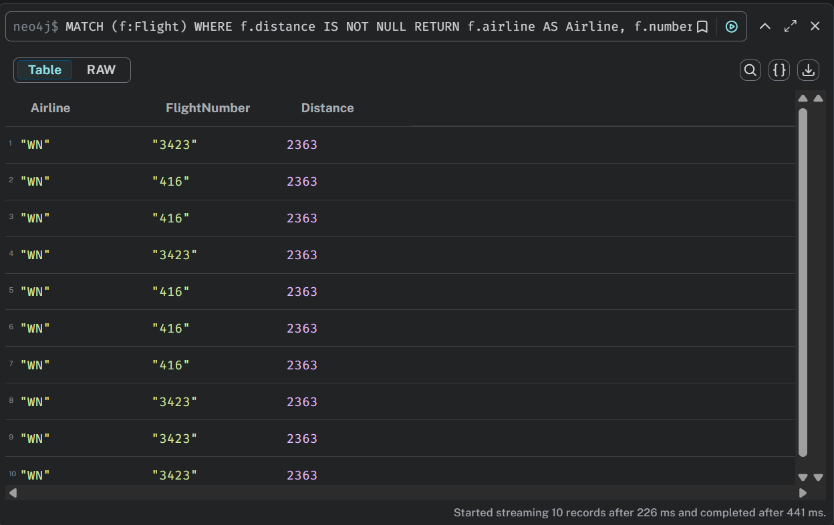

// Find Most Active Airline (Flights Count)
MATCH (f:Flight)
RETURN f.airline AS Airline, count(f) AS TotalFlights
ORDER BY TotalFlights DESC
LIMIT 5;

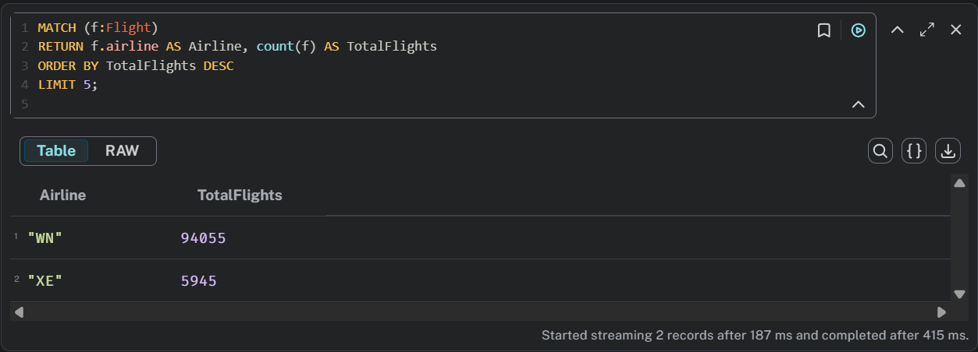

// Visualize Schema

CALL db.schema.visualization();
