Week 11 Coding Practice Submission

Cypher Queries: Network Management Sandbox

- call db.schema.visualization()
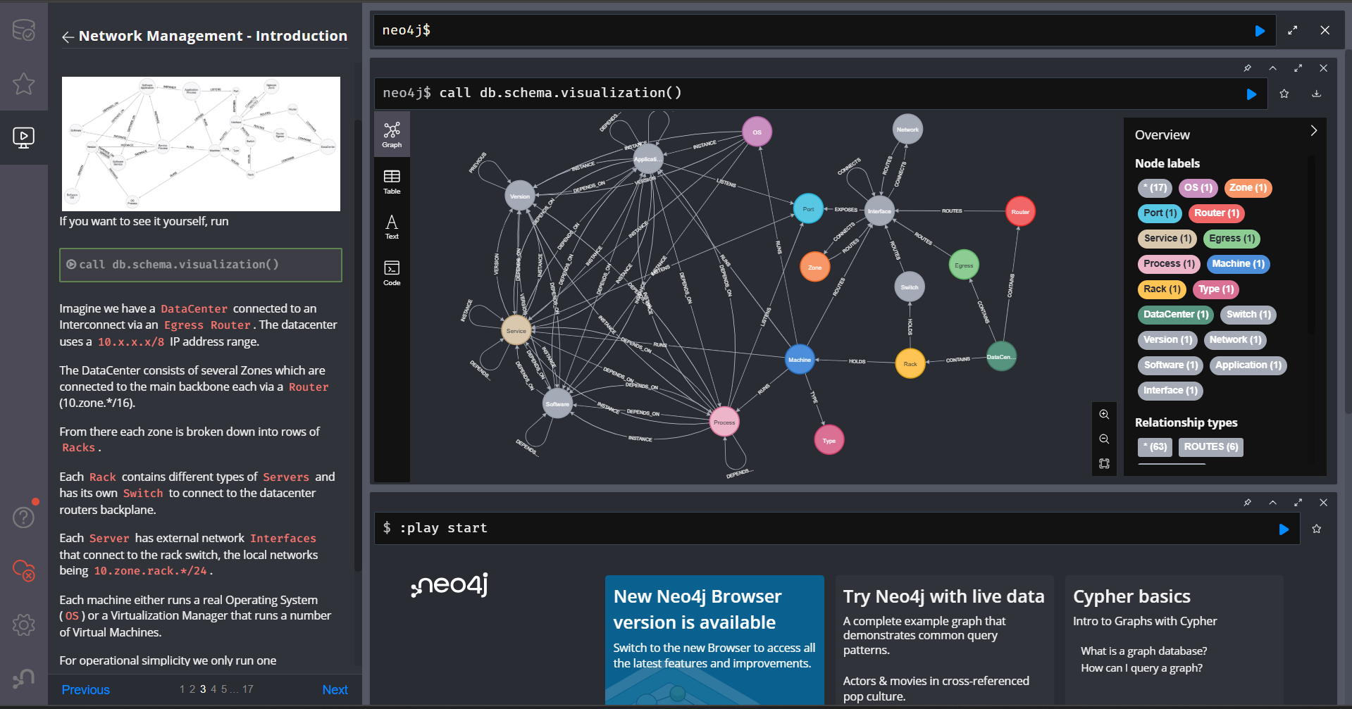

- MATCH network = (dc:DataCenter {name:"DC1",location:"Iceland, Rekjavik"})
-[:CONTAINS]->(:Router)
-[:ROUTES]->(:Interface)
RETURN network;
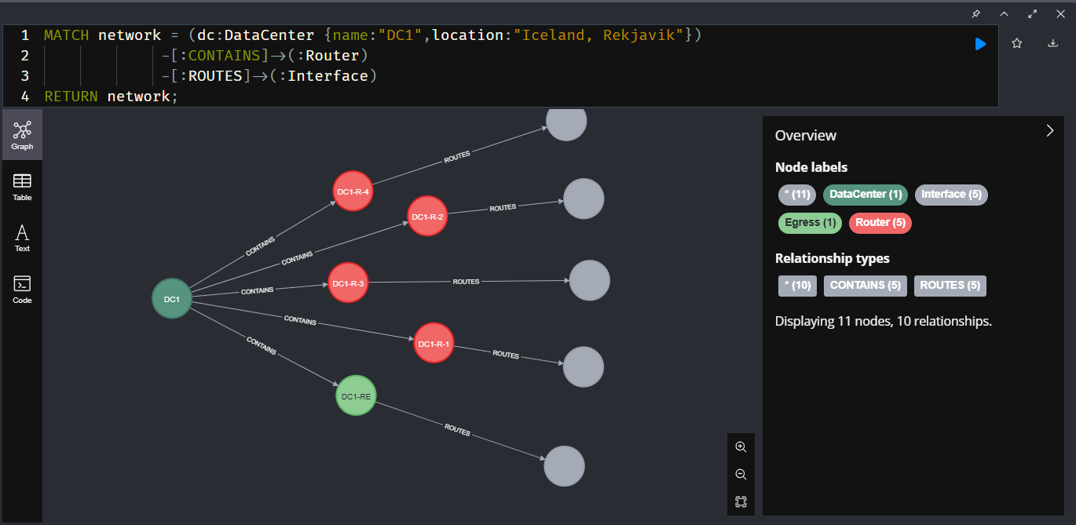

- MATCH (dc:DataCenter {name:"DC1"})-[:CONTAINS]->(re:Router:Egress)-[:ROUTES]->(rei:Interface)
MATCH (nr:Network:Zone)<-[:CONNECTS]-(rei)
// router in DC, connect it via an interface to the zone network
MATCH (dc)-[:CONTAINS]->(r:Router)-[:ROUTES]->(ri:Interface)-[:CONNECTS]->(nr)
RETURN *;

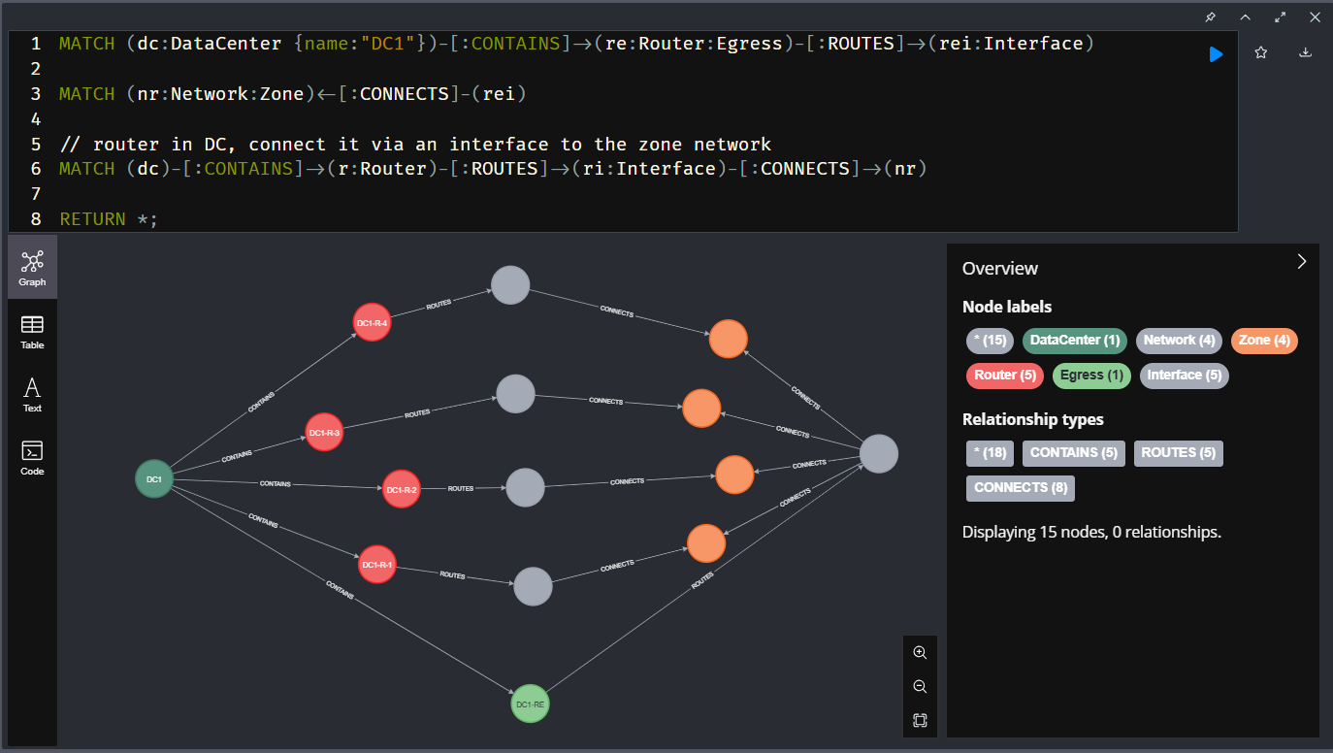

- MATCH path = (dc:DataCenter)-[*3]-(:Network)
RETURN path;
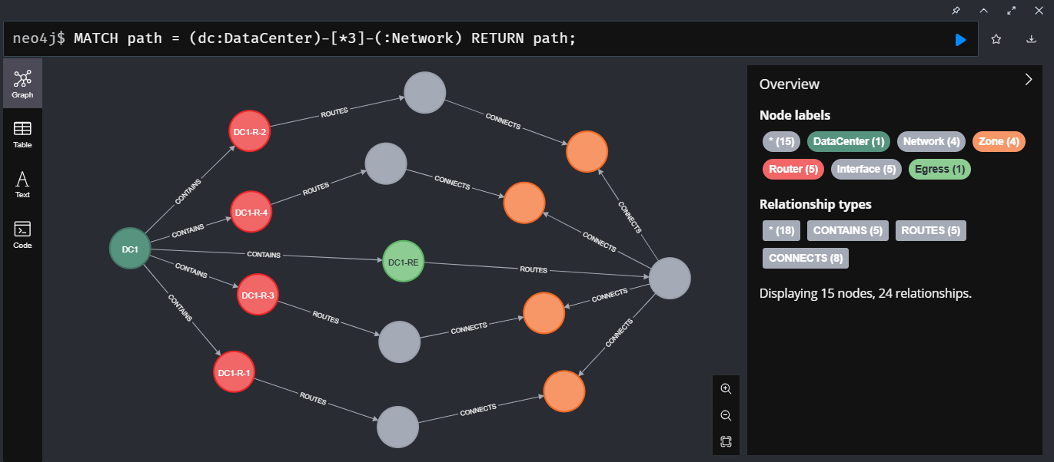

- MATCH (r:Router)-[:ROUTES]->(ri:Interface)-[:CONNECTS]->(nr:Network)
WHERE r.zone IS NOT NULL
RETURN nr.ip as network_ip, ri.ip as router_if_ip, r.name as router, r.zone as zone;

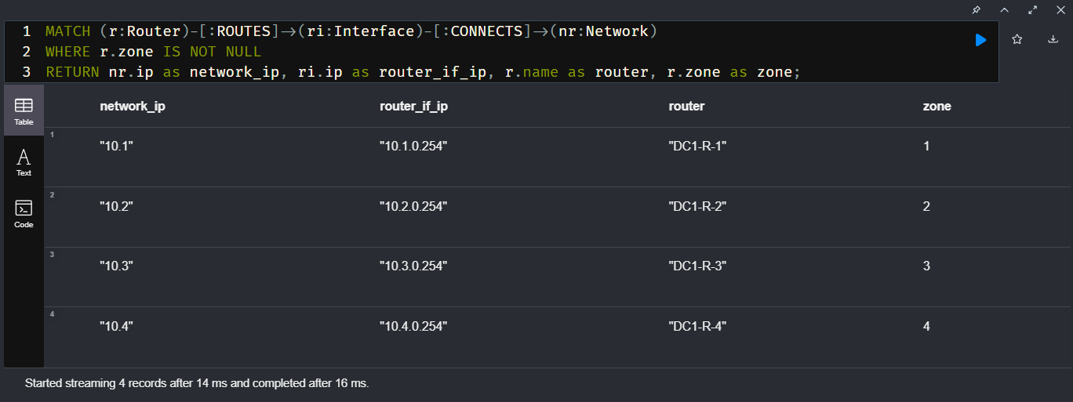

- MATCH (dc:DataCenter {name:"DC1"})-[:CONTAINS]->(rack:Rack)-[:HOLDS]->(s:Switch)-[:ROUTES]->(si:Interface)<-[:ROUTES]-(nr:Network:Zone)
RETURN *;
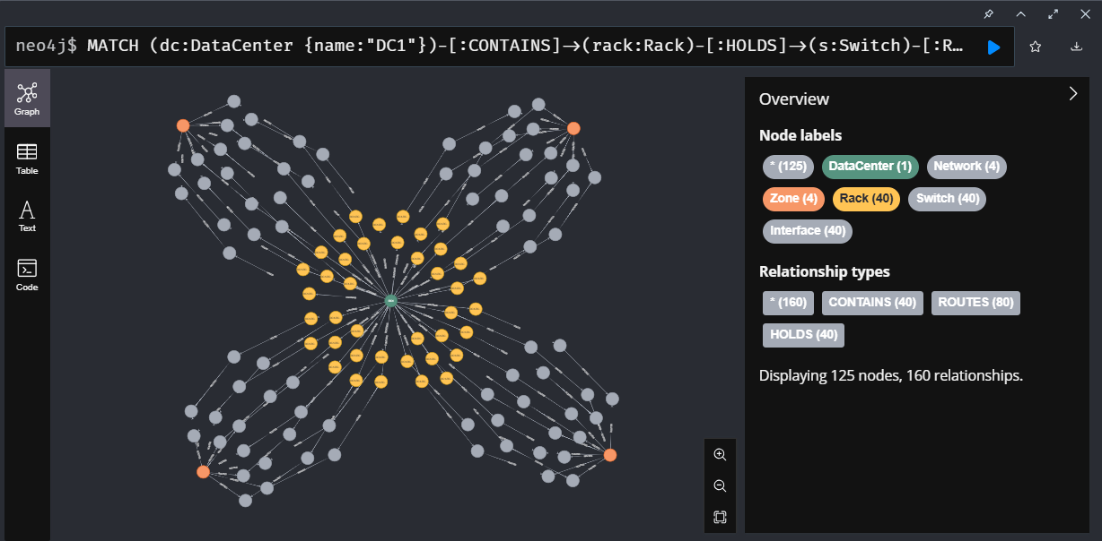

- MATCH network = (dc:DataCenter)-[*6]-(:Rack)
RETURN network;
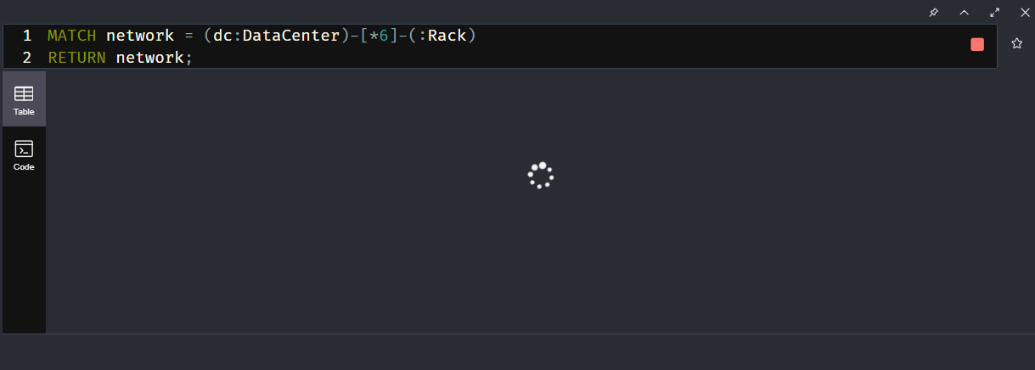

- MATCH path = allShortestPaths( (rack:Rack)-[:HOLDS|ROUTES|CONNECTS*]-(router:Router:Egress) )
RETURN length(path) as hops, count(*) as count;
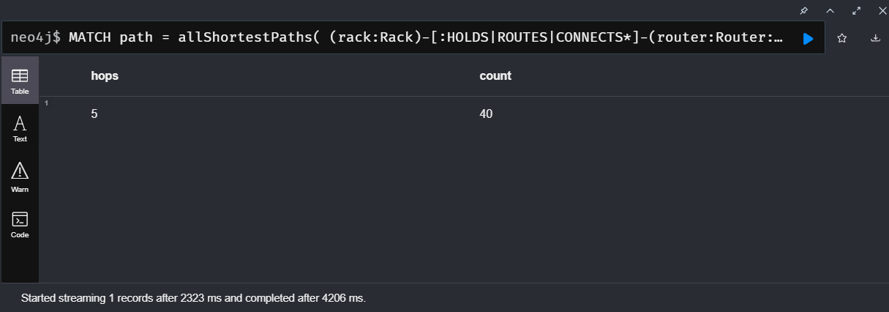

- MATCH (:Interface {ip:"10.1.1.254"})<-[rel:ROUTES]-(:Network)
DELETE rel
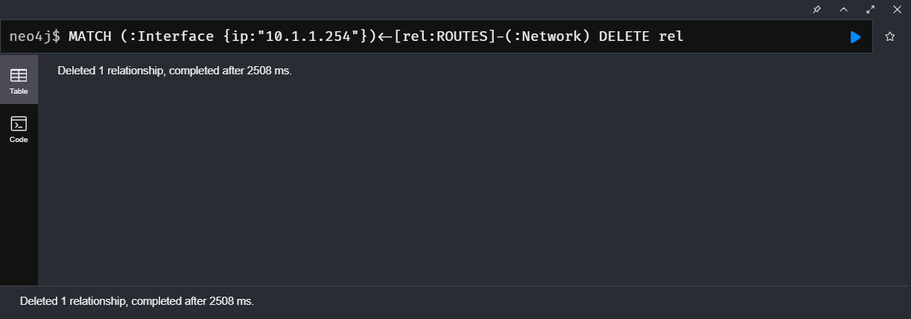

- MATCH path = allShortestPaths( (rack:Rack)-[:HOLDS|ROUTES|CONNECTS*]-(router:Router:Egress) )
RETURN length(path) as hops, count(*) as count;
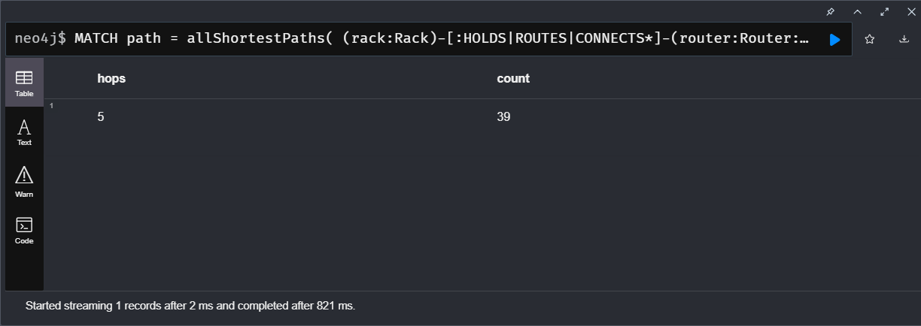

- MATCH connection = allShortestPaths( (rack:Rack {name:"DC1-RCK-1-1"})-[:HOLDS|ROUTES|CONNECTS*]-(router:Router:Egress) )
RETURN connection;
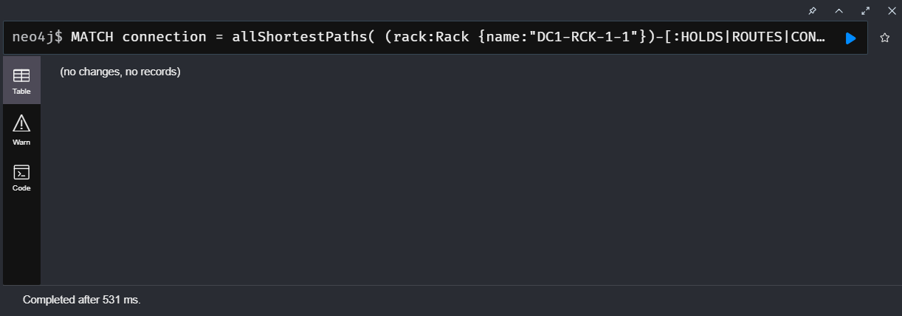

- MATCH (nr:Network:Zone)
MATCH (s:Switch)-[:ROUTES]->(si:Interface)
MERGE (si)<-[:ROUTES]-(nr);
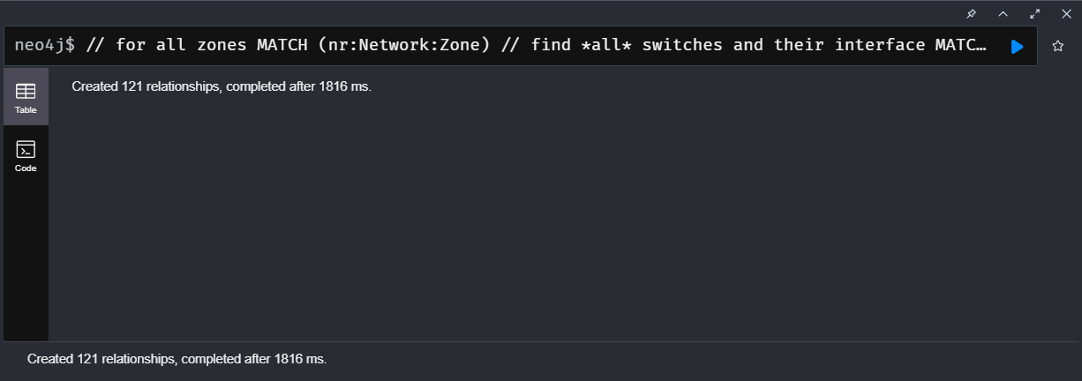

- MATCH path = allShortestPaths((rack:Rack)-[:HOLDS|ROUTES|CONNECTS*]-(router:Router:Egress))
RETURN length(path) as hops, count(*) as count;
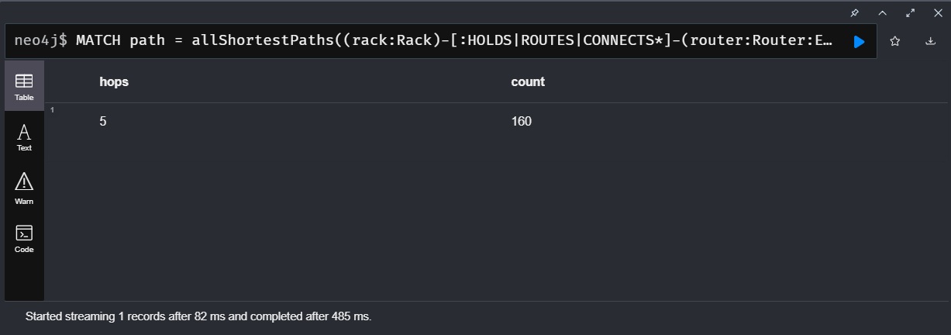

- MATCH (:Interface {ip:"10.1.1.254"})<-[rel:ROUTES]-(:Network)
WITH rel LIMIT 1
DELETE rel
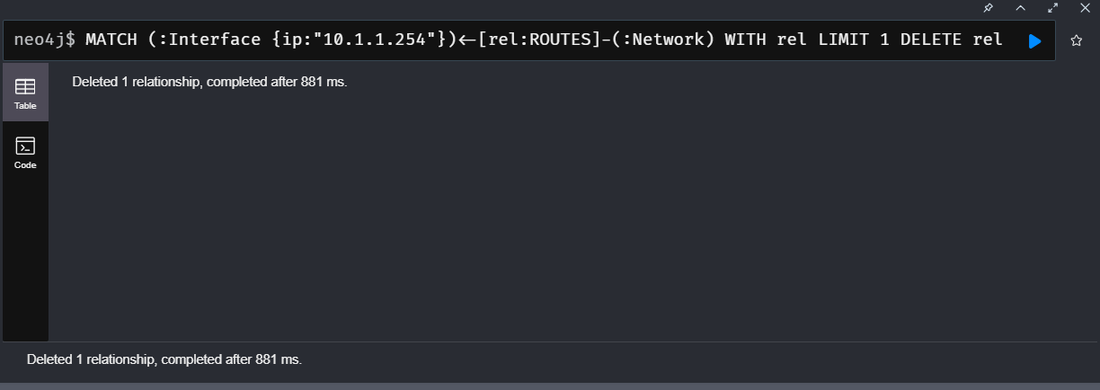

- MATCH path = allShortestPaths((rack:Rack {zone:1,rack:1})-[:HOLDS|ROUTES|CONNECTS*]-(router:Router:Egress))
RETURN path;
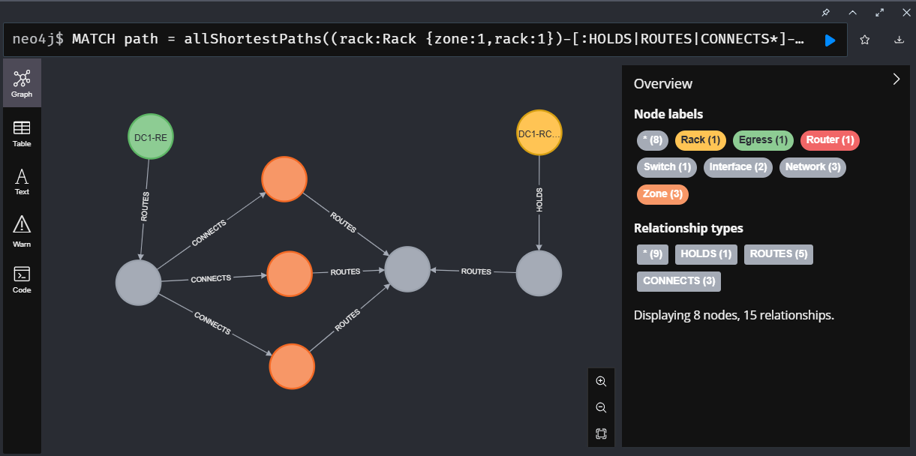

- MATCH (t:Type)
RETURN t.name, t.id, t.cpu, t.ram, t.disk;
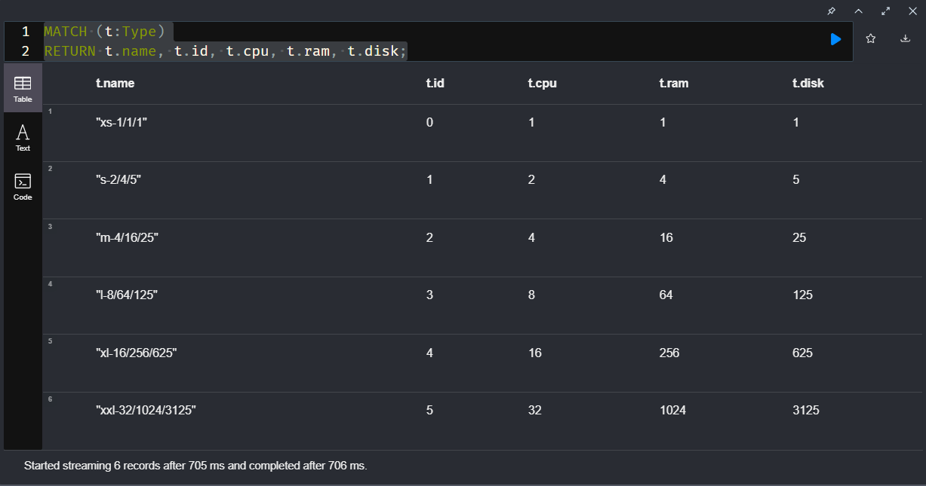

- MATCH (r:Rack {name:"DC1-RCK-2-1"})-[:HOLDS]->(m:Machine),
(m)-[:ROUTES]->(i:Interface)-[:CONNECTS]->(si)<-[:ROUTES]-(s:Switch),
(m)-[:TYPE]->(type:Type)
RETURN *

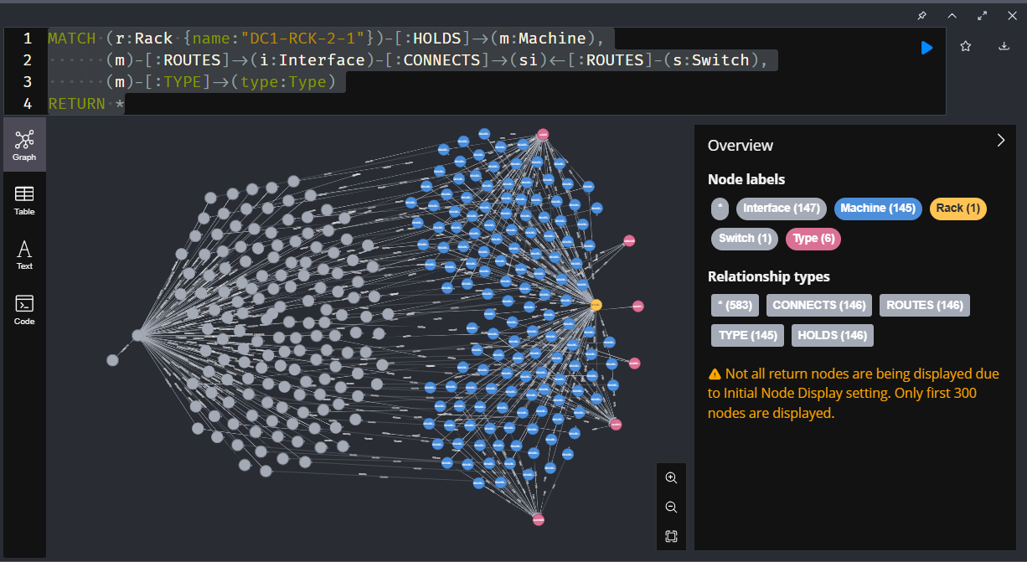

- MATCH (r:Rack {name:"DC1-RCK-2-1"})-[:HOLDS]->(m:Machine),
(m)-[:ROUTES]->(i:Interface)-[:CONNECTS]->(si)<-[:ROUTES]-(s:Switch),
(m)-[:TYPE]->(type:Type)
RETURN r.name as rack, si.ip as switchIp, properties(type) as type, count(m) as machines, min(i.ip) as minIp, max(i.ip) as maxIp
ORDER BY machines DESC;

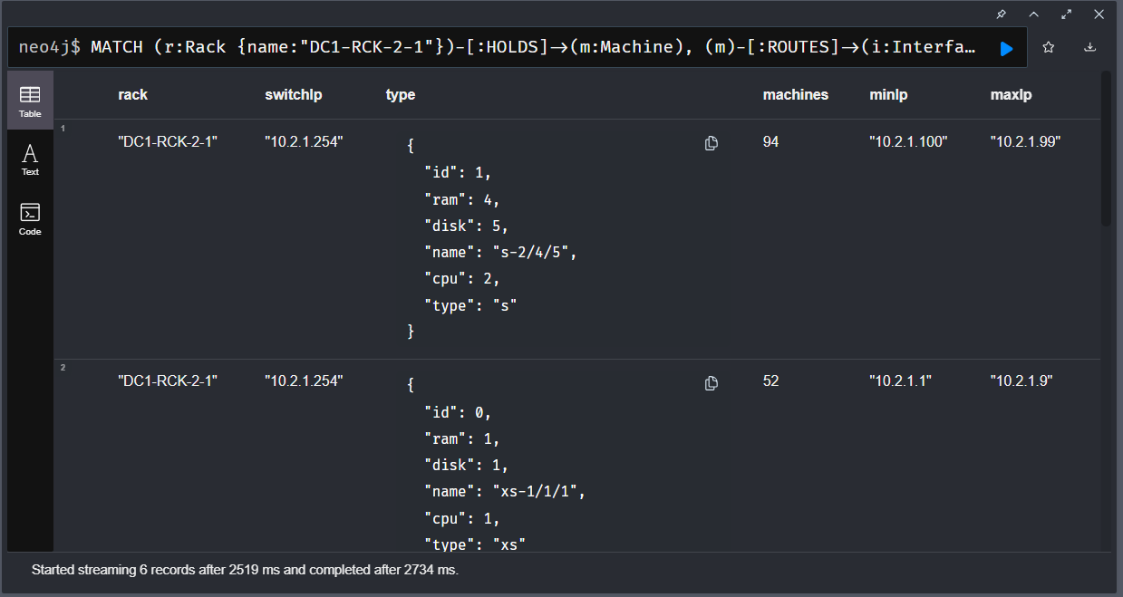

- MATCH (r:Rack)-[:HOLDS]->(m:Machine)-[:TYPE]->(type:Type)
RETURN properties(type) as type, count(*) as c
ORDER BY c DESC;
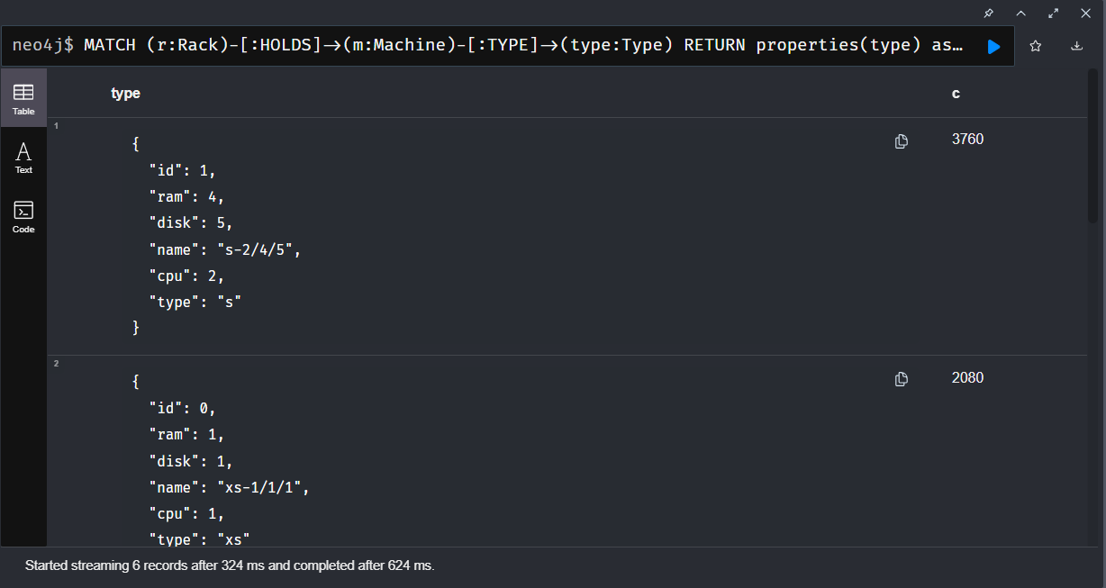

- MATCH (m:Machine)-[:TYPE]->(type:Type)
RETURN count(*) as count, sum(type.cpu) as cpus, sum(type.ram) as ram, sum(type.disk) as disk;
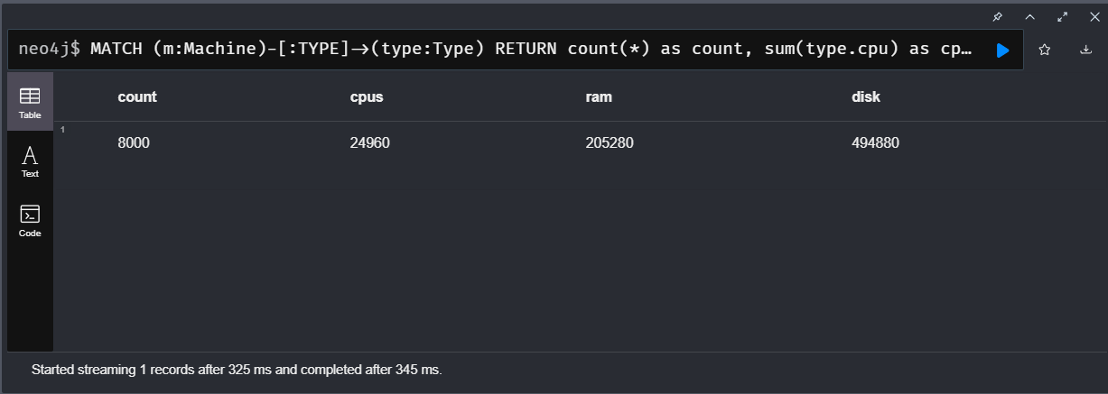

- MATCH (o:OS:Software)-[:VERSION]->(v)
OPTIONAL MATCH (v)<-[:PREVIOUS]-(vnext)
RETURN o.name as os, v.name as version, vnext.name as next_version
ORDER BY os, version;
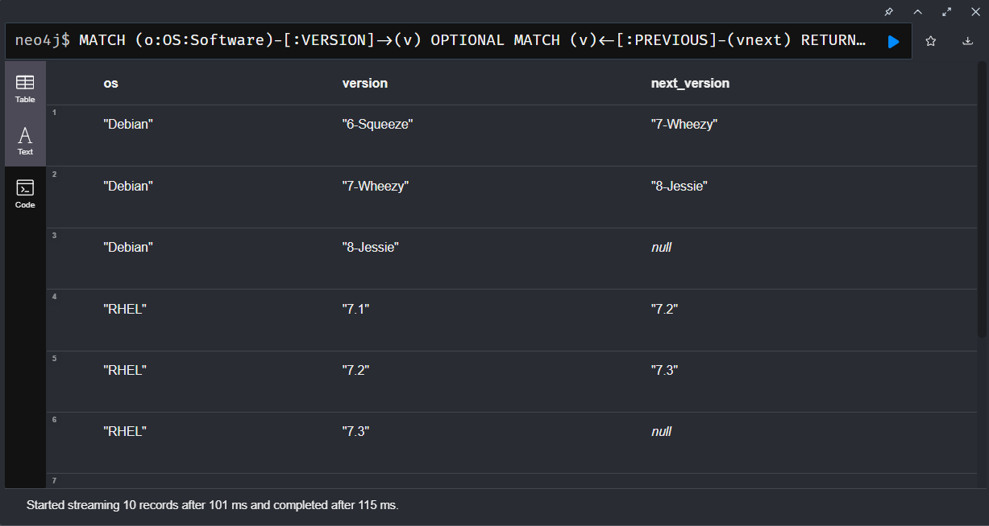

- MATCH (s:Software) WHERE not s:OS
OPTIONAL MATCH (s)-[:VERSION]->(v)
OPTIONAL MATCH (s)-[:DEPENDS_ON]->(dv)<-[:VERSION]-(d)
RETURN s.name, collect(v.name) as versions, [x IN collect([d.name,dv.name]) WHERE x[0] IS NOT NULL] as dependencies, s.ports;

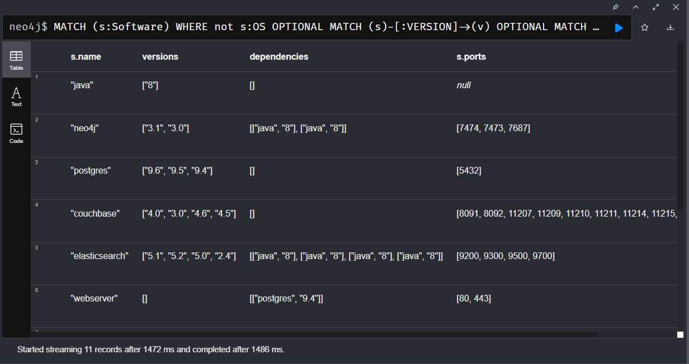

- MATCH (m:Machine) WHERE (m)-[:RUNS]->() AND rand() < 0.05 WITH m LIMIT 1

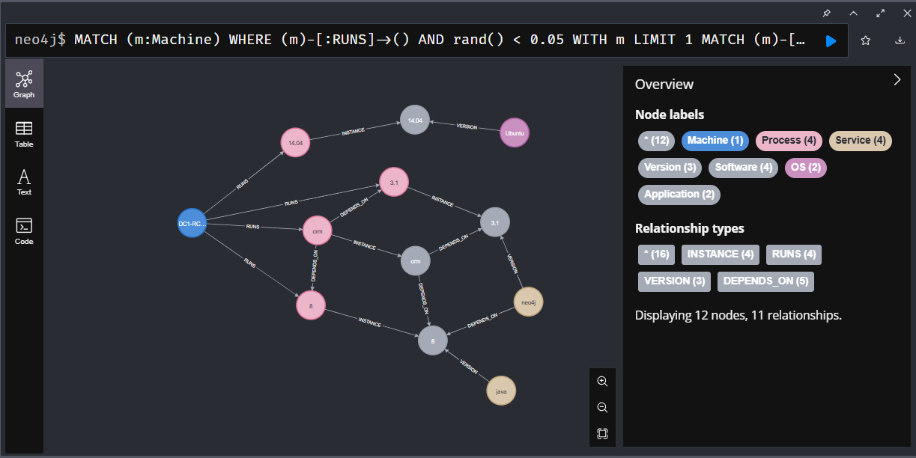

- MATCH (s)-[:DEPENDS_ON]->(nv:Version)<-[:VERSION]-(n:Software:Service {name:"neo4j"})
MATCH (s)<-[:INSTANCE]-(sp)<-[:RUNS]-(sm:Machine)
MATCH (sp)-[DEPENDS_ON]->(np)-[:INSTANCE]->(nv)
MATCH (np)<-[:RUNS]-(nm:Machine)
RETURN sm as software_machine, sp as software_process, s as software, nv as neo_version,np as neo4j_process, np as neo_machine
LIMIT 10
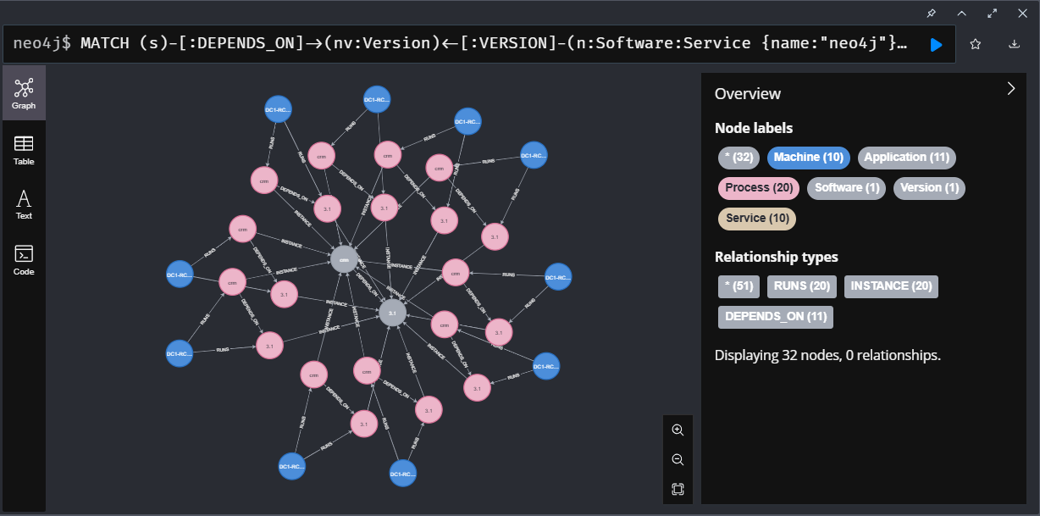

- MATCH (os:OS:Software)-[:VERSION]->(newVersion) WHERE os.name = 'Debian' and newVersion.name = '8-Jessie'
MATCH (m:Machine)-[:RUNS]->(op:OS:Process)-[:INSTANCE]->(currentVersion)
WHERE (currentVersion)<-[:PREVIOUS*]-(newVersion)
CREATE (m)-[:UPDATE_TO {ts:timestamp()}]->(newVersion)
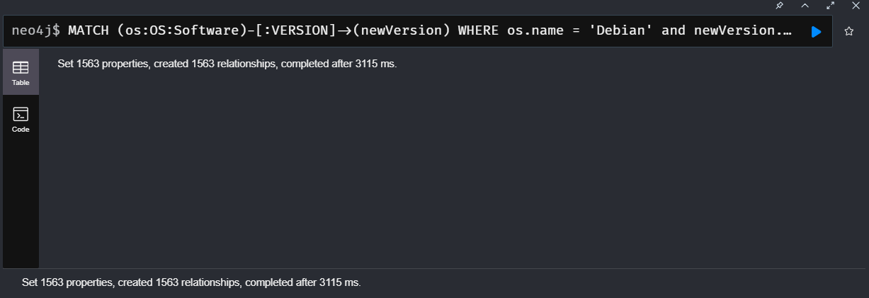

- MATCH (r:Rack)-[:HOLDS]->(m:Machine)-[:UPDATE_TO]->(vNew:Version)<-[:VERSION]-(os:OS:Software)
MATCH (m)-[:RUNS]->(:OS:Process)-[:INSTANCE]->(vCurr)
WHERE vCurr <> vNew
RETURN r.name, m.name, os.name, vCurr.name as currentVersion, vNew.name as newVersion
LIMIT 100;
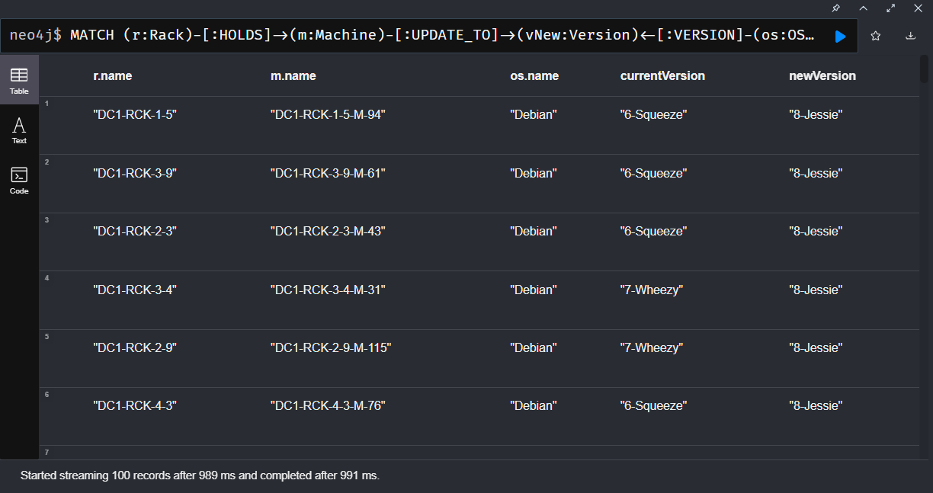

- MATCH (m:Machine)-[:UPDATE_TO]->(vNew:Version)<-[:VERSION]-(os:OS:Software)
MATCH (m)-[:RUNS]->(op:OS:Process)-[:INSTANCE]->(vCurr)
WHERE vCurr <> vNew
CREATE (m)-[:RUNS]->(opNew:OS:Process)-[:INSTANCE]->(vNew)
DETACH DELETE op;
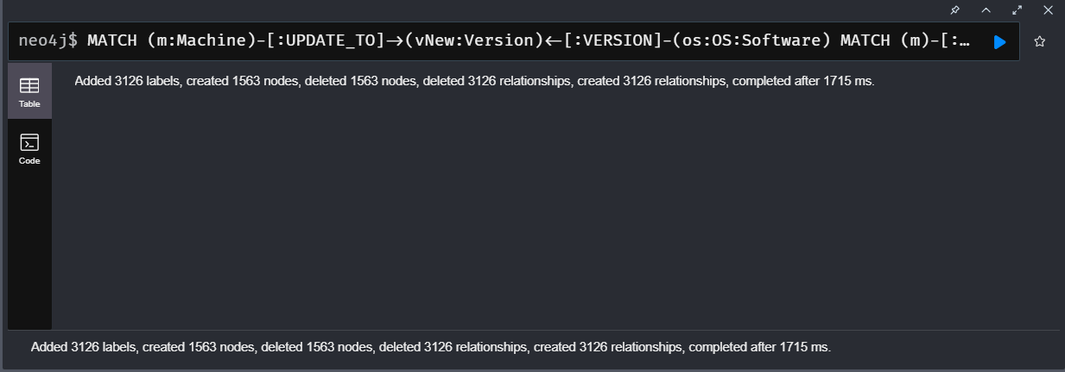

- MATCH (m:Machine)-[update:UPDATE_TO]->(v:Version)<-[:VERSION]-(os:OS:Software)
WHERE (m)-[:RUNS]->(:OS:Process)-[:INSTANCE]->(v)
DELETE update;
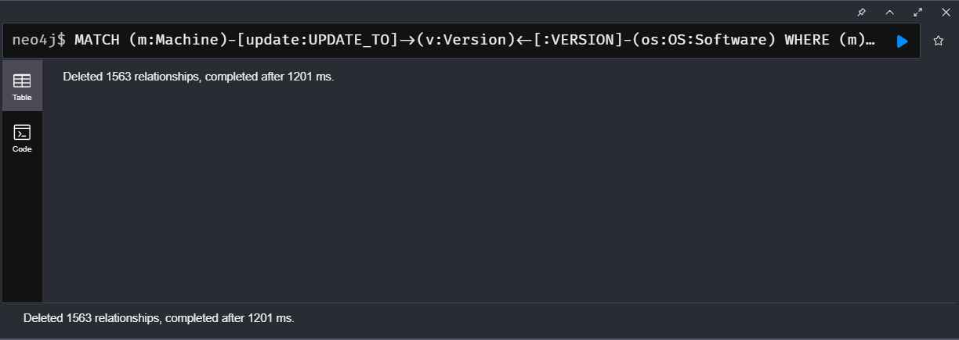

- MATCH (m:Machine) WITH collect(m) as machines
WITH machines, size(machines) as len
UNWIND range(1,10) as idx
WITH machines[toInteger(rand()*len)] as source, machines[toInteger(rand()*len)] as target
MATCH (source)-[:ROUTES]->(si:Interface)-[:EXPOSES]->(sp:Port)<-[:LISTENS]-(sourceAppProcess)-[:INSTANCE]->(sourceApp)
WITH target, source,si,head(collect(sp)) as sp, sourceAppProcess,sourceApp
// todo limit to first port
MATCH (target)-[:ROUTES]->(ti:Interface)-[:EXPOSES]->(tp:Port)<-[:LISTENS]-(targetAppProcess)-[:INSTANCE]->(targetApp)
WITH source,si,sp, sourceAppProcess,sourceApp,target,ti,head(collect(tp)) as tp, targetAppProcess, targetApp
// todo limit to first port
RETURN {id: randomUUID(), type:"OpenConnection",source:{ip:si.ip, port:sp.port},target:{ip:ti.ip,port:tp.port},
connection: {source:sourceApp.name, target:targetApp.name, user: "user"+toString(toInteger(rand()*1000))+"@"+source.name,
time:timestamp(), packets: 1, mtu: 1500 }} as event

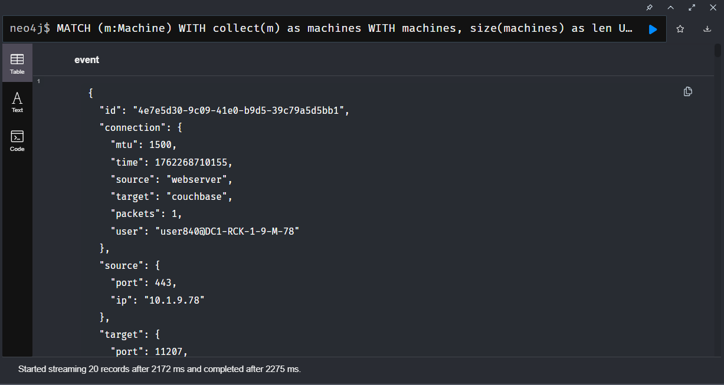

- :param events:
[
{"source":{"ip":"10.1.7.100","port":11210},"id":"3e41d6f0-fdce-48f4-9bff-818359d8f0af","target":{"ip":"10.3.3.112","port":8080},
"connection":{"source":"couchbase","target":"webapp","user":"user436@DC1-RCK-1-7-M-100","time":1490540382971},"type":"OpenConnection",
"packets": 1, "mtu": 1500, "time": 1490904418539 },
{"source":{"ip":"10.1.4.91","port":7474},"id":"fed44be6-55f5-4e42-aab1-bebc5c818268","target":{"ip":"10.4.6.7","port":8080},
"connection":{"source":"neo4j","target":"webapp","user":"user911@DC1-RCK-1-4-M-91","time":1490540382971},"type":"OpenConnection",
"packets": 1, "mtu": 1500, "time": 1490904464824 }
]
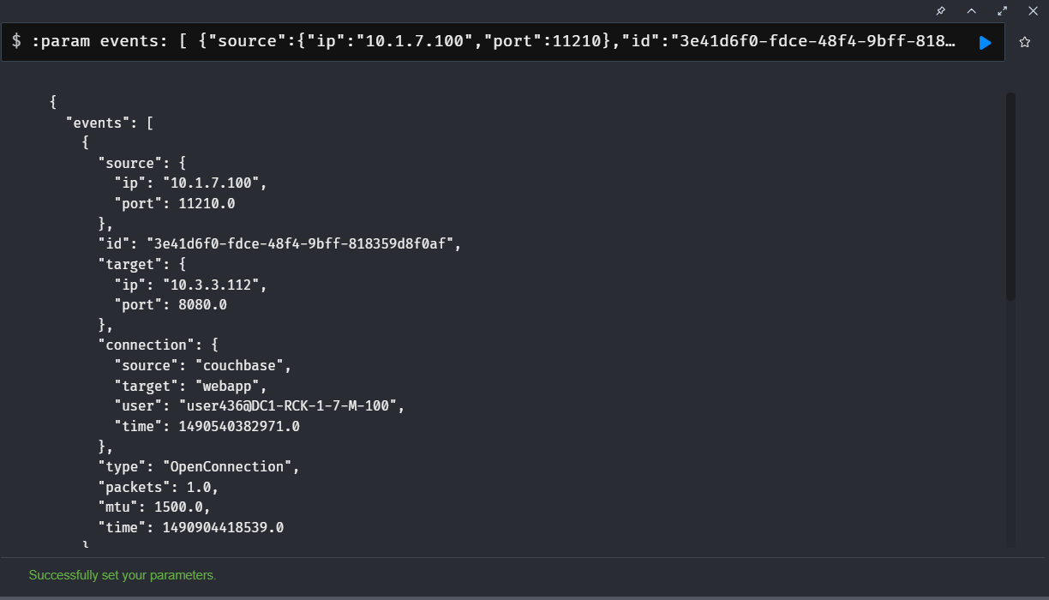

- UNWIND $events AS event
WITH event WHERE event.type = 'OpenConnection'
MERGE (si:Interface {ip:event.source.ip})
MERGE (si)-[:OPENS]->(sp:Port {port: event.source.port})
MERGE (ti:Interface {ip:event.target.ip})
MERGE (ti)-[:LISTENS]->(tp:Port {port:event.target.port})
CREATE (sp)<-[:FROM]-(c:Connection {id:event.id})–[:TO]->(tp)
SET c += event.connection // type, timestamp, user-info, ...
MERGE (si)-[cstats:CONNECTIONS]->(ti)
SET si.count = coalesce(si.count,0) + 1
SET si.packets = coalesce(si.packets,0) + event.packets
SET si.volume = coalesce(si.volume,0) + event.packets * event.mtu
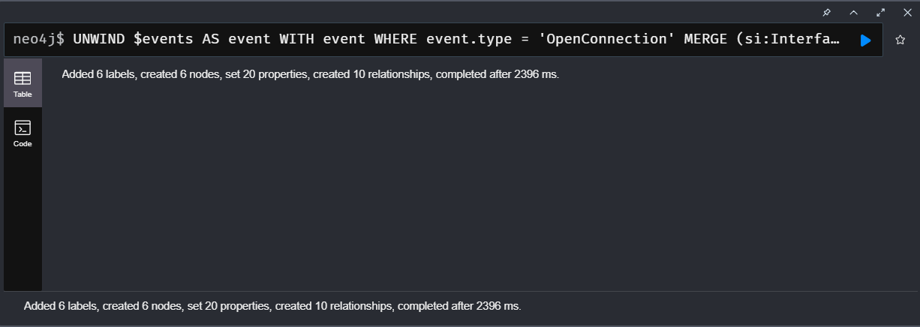

- MATCH (si:Interface)-[:OPENS]->(sp:Port)<-[:FROM]-(c:Connection)–[:TO]->(tp:Port)<-[:LISTENS]-(ti:Interface)
WHERE c.type = 'OpenConnection'
RETURN si.ip as source, ti.ip as target, apoc.date.format(c.time,'ms','yyyy-MM-dd HH') as hour, count(distinct c) as count
ORDER BY hour ASC, count DESC
LIMIT 100;
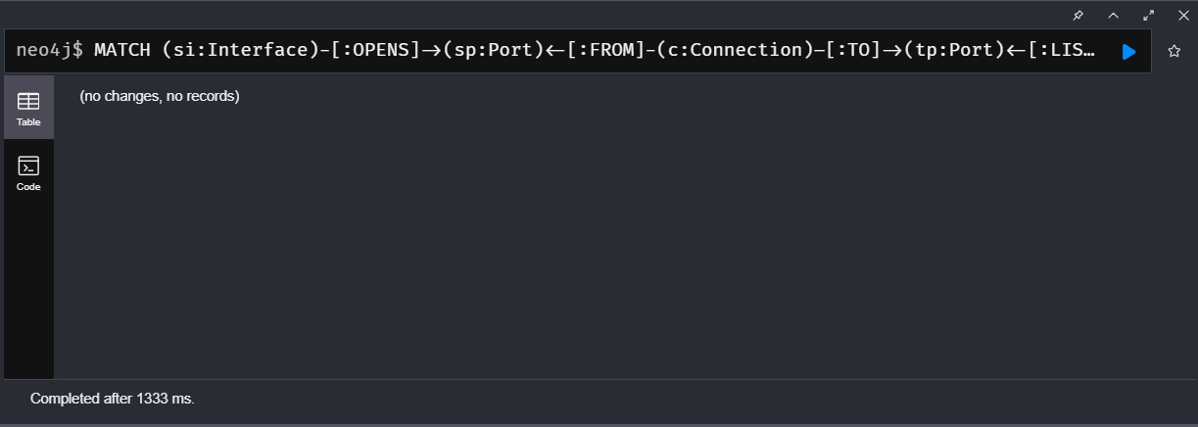

- MATCH (v)<-[:INSTANCE]-(sp:Process)<-[:RUNS]-(sm:Machine)
MATCH (s:Software)-[:VERSION]->(v:Version)
WITH s.name as software, v.name as version, timestamp() - sp.startTime as runtime
RETURN software, version, count(*) as instances, { min: min(runtime), max: max(runtime), avg:avg(runtime) } as runtime
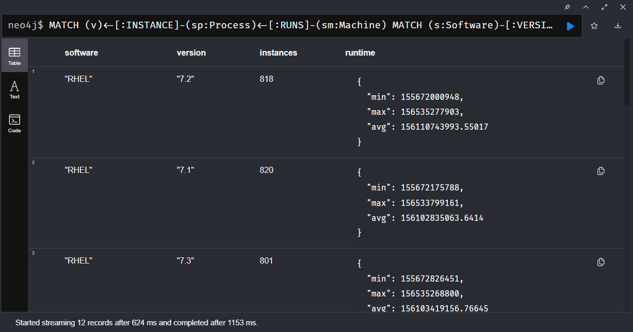

- MATCH path = (source:Interface)-[con:CONNECTIONS]->(target:Interface)
RETURN source.ip, target.ip, sum(con.packets) as packets, sum(con.volume) as volume
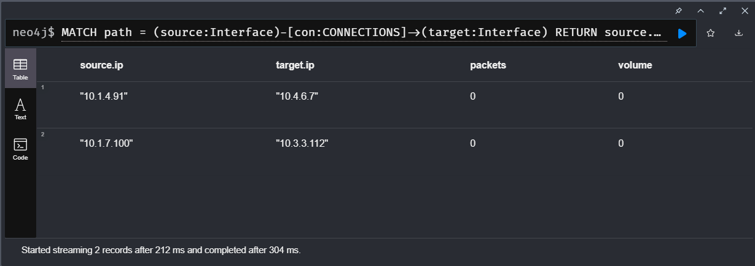

Findings and Discussion

Through this practice, I learned how Neo4j makes it easier to represent and explore complex network structures using relationships instead of tables. I worked with new Cypher queries like allShortestPaths(), MERGE, and multi-level MATCH patterns, which helped me understand how to connect and analyze data dynamically. One of my queries didn’t load because the dataset likely lacked matching nodes or the query was too large to process, showing the importance of refining query depth and result limits for better performance.

