Week 11 Homework 3

Part 1:
Graph Model
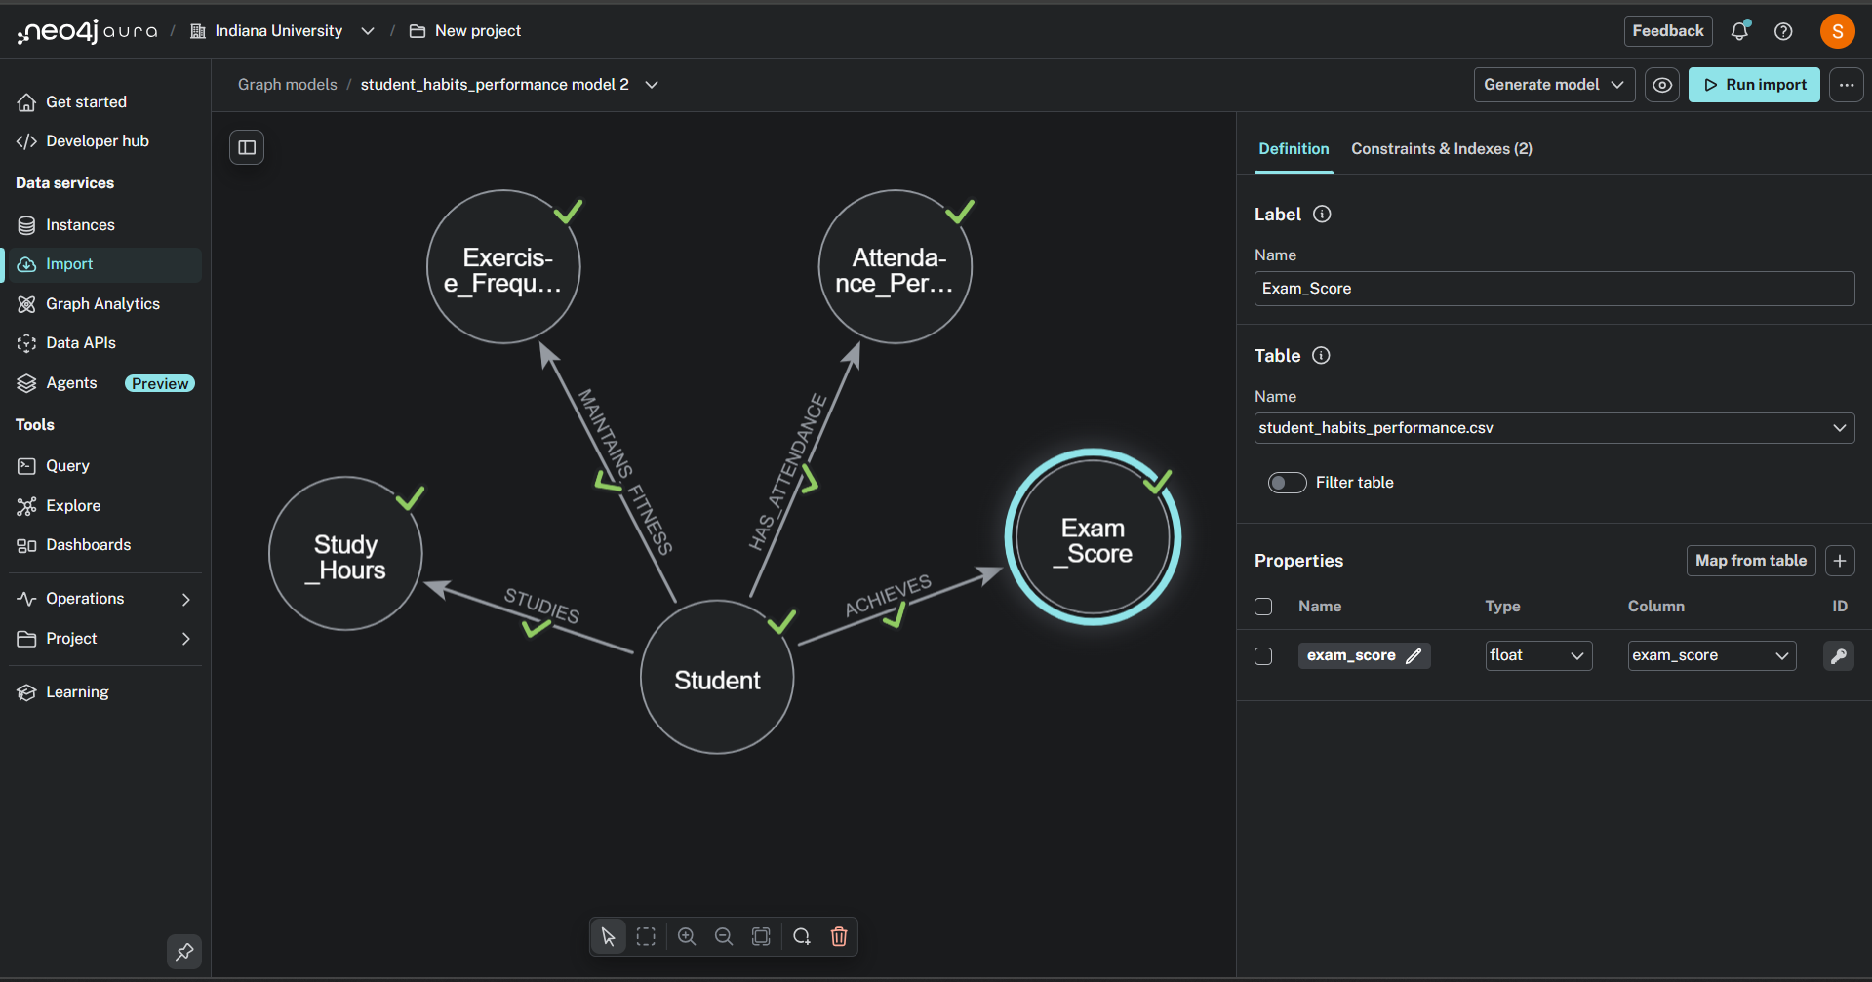
Preview all
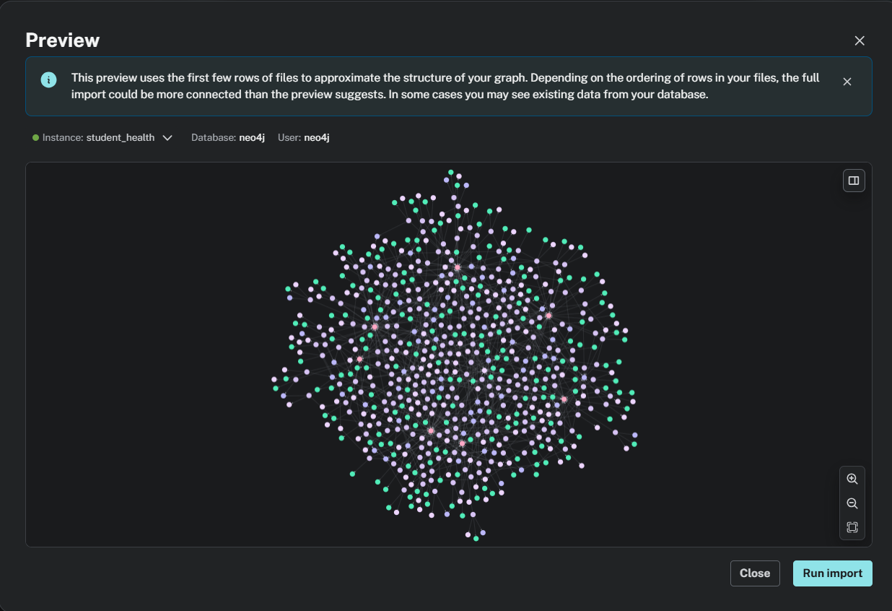

Import Results
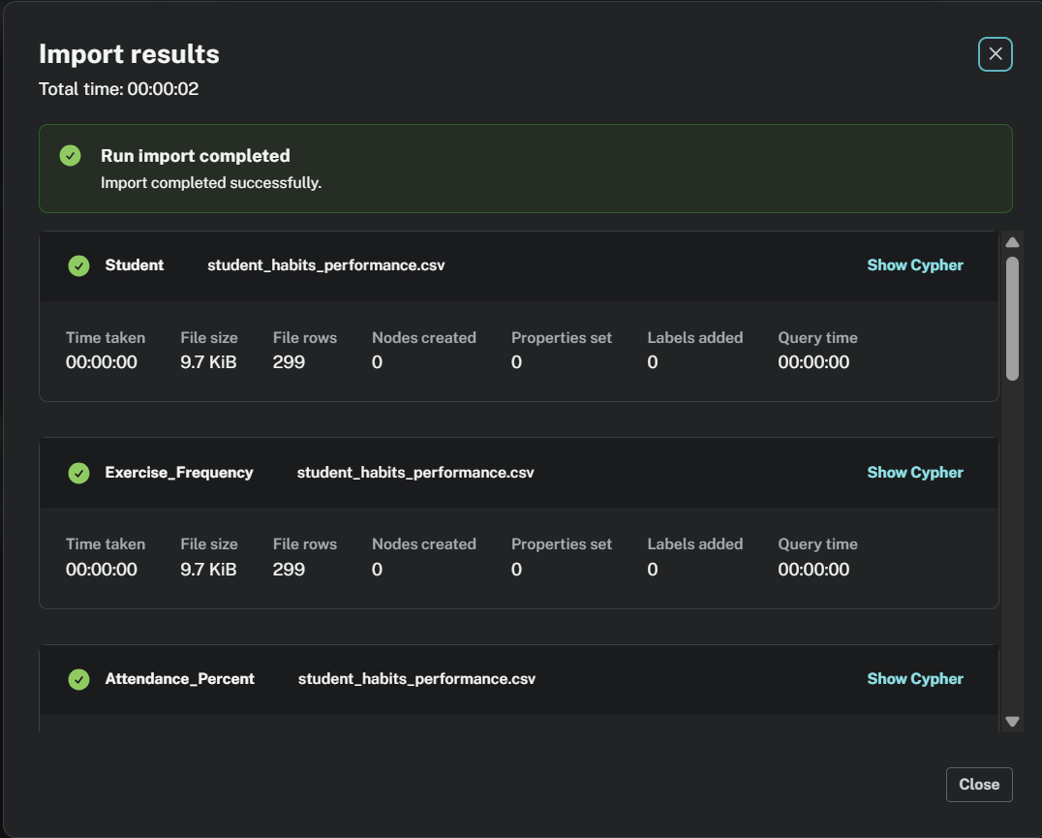

Part 2:
Cypher Queries for Data Import
Student
Key statement
CYPHER 5 CREATE CONSTRAINT `student_id_Student_uniq` IF NOT EXISTS
FOR (n: `Student`)
REQUIRE (n.`student_id`) IS UNIQUE;
Load statement
CYPHER 5 UNWIND $nodeRecords AS nodeRecord
WITH *
WHERE NOT nodeRecord.`student_id` IN $idsToSkip AND NOT nodeRecord.`student_id` IS NULL
MERGE (n: `Student` { `student_id`: nodeRecord.`student_id` });

Exercise_Frequency
Key statement
CYPHER 5 CREATE CONSTRAINT `exercise_frequency_Exercise_Frequency_uniq` IF NOT EXISTS
FOR (n: `Exercise_Frequency`)
REQUIRE (n.`exercise_frequency`) IS UNIQUE;
Load statement
CYPHER 5 UNWIND $nodeRecords AS nodeRecord
WITH *
WHERE NOT nodeRecord.`exercise_frequency` IN $idsToSkip AND NOT toInteger(trim(nodeRecord.`exercise_frequency`)) IS NULL
MERGE (n: `Exercise_Frequency` { `exercise_frequency`: toInteger(trim(nodeRecord.`exercise_frequency`)) });

Attendance_Percent
Key statement
CYPHER 5 CREATE CONSTRAINT `attendance_percentage_Attendance_Percent_uniq` IF NOT EXISTS
FOR (n: `Attendance_Percent`)
REQUIRE (n.`attendance_percentage`) IS UNIQUE;
Load statement
CYPHER 5 UNWIND $nodeRecords AS nodeRecord
WITH *
WHERE NOT nodeRecord.`attendance_percentage` IN $idsToSkip AND NOT toFloat(trim(nodeRecord.`attendance_percentage`)) IS NULL
MERGE (n: `Attendance_Percent` { `attendance_percentage`: toFloat(trim(nodeRecord.`attendance_percentage`)) });

Study_Hours
Key statement
CYPHER 5 CREATE CONSTRAINT `study_hours_per_day_Study_Hours_uniq` IF NOT EXISTS
FOR (n: `Study_Hours`)
REQUIRE (n.`study_hours_per_day`) IS UNIQUE;
Load statement
CYPHER 5 UNWIND $nodeRecords AS nodeRecord
WITH *
WHERE NOT nodeRecord.`study_hours_per_day` IN $idsToSkip AND NOT toFloat(trim(nodeRecord.`study_hours_per_day`)) IS NULL
MERGE (n: `Study_Hours` { `study_hours_per_day`: toFloat(trim(nodeRecord.`study_hours_per_day`)) });

Exam_Score
Key statement
CYPHER 5 CREATE CONSTRAINT `exam_score_Exam_Score_uniq` IF NOT EXISTS
FOR (n: `Exam_Score`)
REQUIRE (n.`exam_score`) IS UNIQUE;
Load statement
CYPHER 5 UNWIND $nodeRecords AS nodeRecord
WITH *
WHERE NOT nodeRecord.`exam_score` IN $idsToSkip AND NOT toFloat(trim(nodeRecord.`exam_score`)) IS NULL
MERGE (n: `Exam_Score` { `exam_score`: toFloat(trim(nodeRecord.`exam_score`)) });

MAINTAINS_FITNESS
Load statement
CYPHER 5 UNWIND $relRecords AS relRecord
MATCH (source: `Student` { `student_id`: relRecord.`student_id` })
MATCH (target: `Exercise_Frequency` { `exercise_frequency`: toInteger(trim(relRecord.`exercise_frequency`)) })
MERGE (source)-[r: `MAINTAINS_FITNESS`]->(target);

HAS_ATTENDANCE
Load statement
CYPHER 5 UNWIND $relRecords AS relRecord
MATCH (source: `Student` { `student_id`: relRecord.`student_id` })
MATCH (target: `Attendance_Percent` { `attendance_percentage`: toFloat(trim(relRecord.`attendance_percentage`)) })
MERGE (source)-[r: `HAS_ATTENDANCE`]->(target);

STUDIES
Load statement
CYPHER 5 UNWIND $relRecords AS relRecord
MATCH (source: `Student` { `student_id`: relRecord.`student_id` })
MATCH (target: `Study_Hours` { `study_hours_per_day`: toFloat(trim(relRecord.`study_hours_per_day`)) })
MERGE (source)-[r: `STUDIES`]->(target);

ACHIEVES
Load statement
CYPHER 5 UNWIND $relRecords AS relRecord
MATCH (source: `Student` { `student_id`: relRecord.`student_id` })
MATCH (target: `Exam_Score` { `exam_score`: toFloat(trim(relRecord.`exam_score`)) })
MERGE (source)-[r: `ACHIEVES`]->(target);

Data Description
The dataset captures various aspects of student habits and their impact on academic performance. It includes details such as study hours, attendance percentage, exercise frequency, and exam scores for each student. By representing this information in a graph model, connections between student behaviours and outcomes can be visualized more clearly. This structure helps identify how different habits may influence overall performance and well-being.

Part 3:
Graph Exploration

MATCH (s:Student)
RETURN keys(s) AS props, s
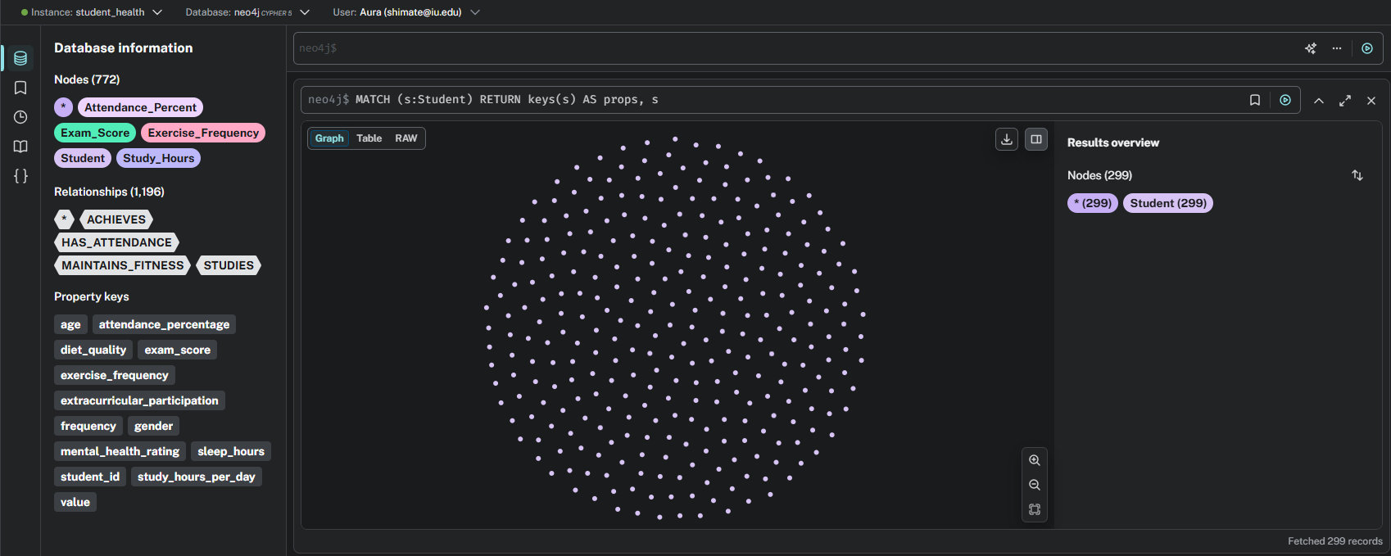

MATCH (n:Exercise_Frequency) RETURN keys(n) AS props, n;
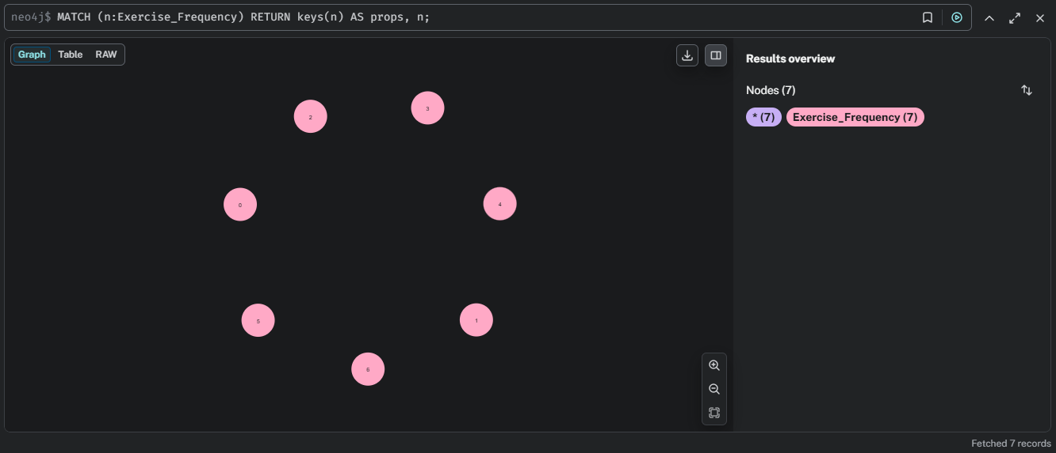

- MATCH (s:Student)-[:STUDIES]->(sh:Study_Hours)
RETURN s.student_id AS Student, sh.study_hours_per_day AS StudyHours;
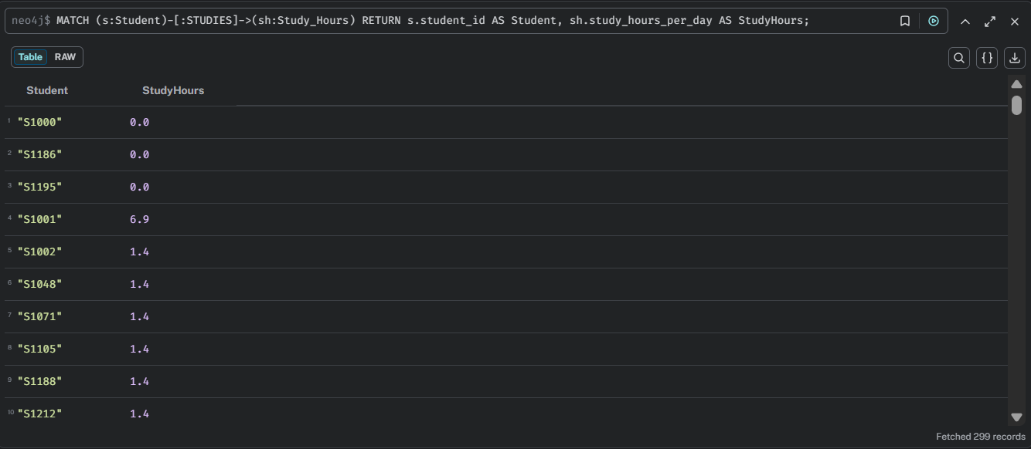

- MATCH (s:Student)-[:MAINTAINS_FITNESS]->(ex:Exercise_Frequency)
RETURN s.student_id AS Student, ex.exercise_frequency AS ExerciseFrequency;
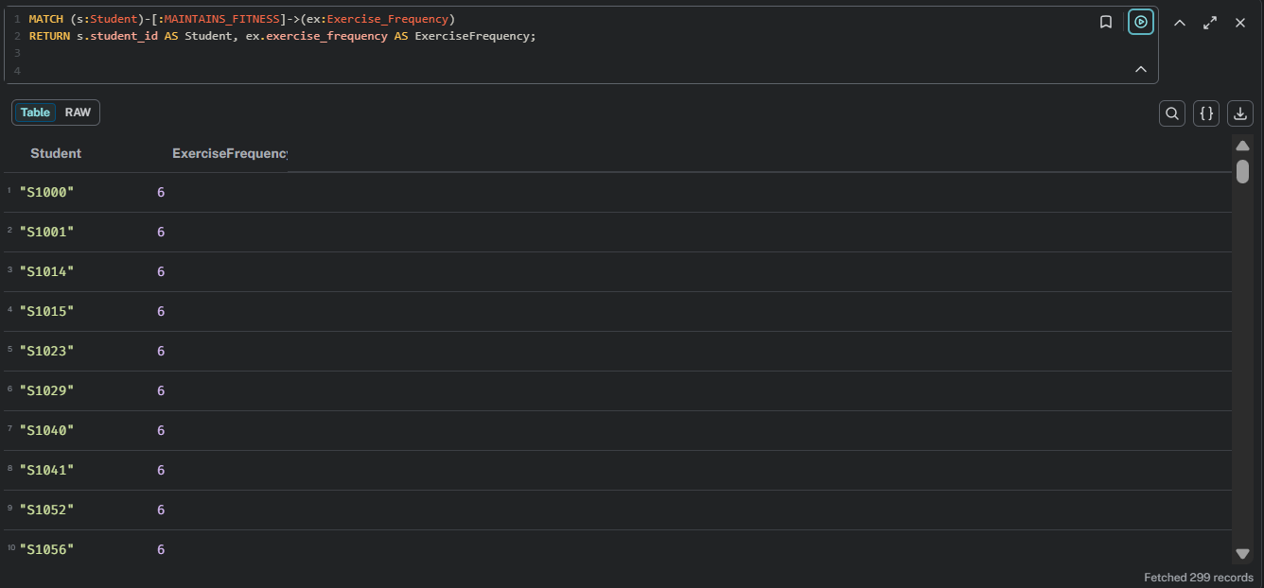

- MATCH (s:Student)-[:HAS_ATTENDANCE]->(a:Attendance_Percent)
RETURN s.student_id AS Student, a.attendance_percentage AS Attendance;
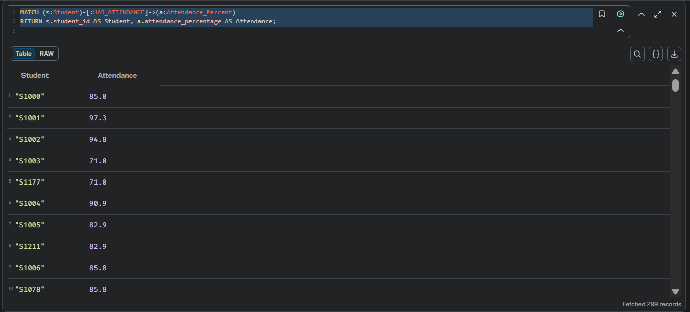

- MATCH (s:Student)-[:ACHIEVES]->(e:Exam_Score)
RETURN s.student_id AS Student, e.exam_score AS ExamScore;
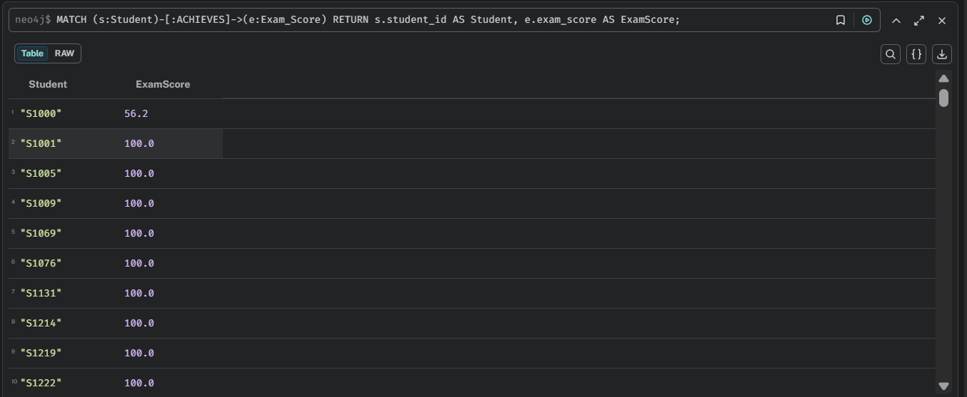

- MATCH (s:Student)-[:STUDIES]->(sh:Study_Hours),
(s)-[:ACHIEVES]->(e:Exam_Score)
RETURN s.student_id AS Student, sh.study_hours_per_day AS StudyHours, e.exam_score AS ExamScore
ORDER BY e.exam_score DESC
LIMIT 20;

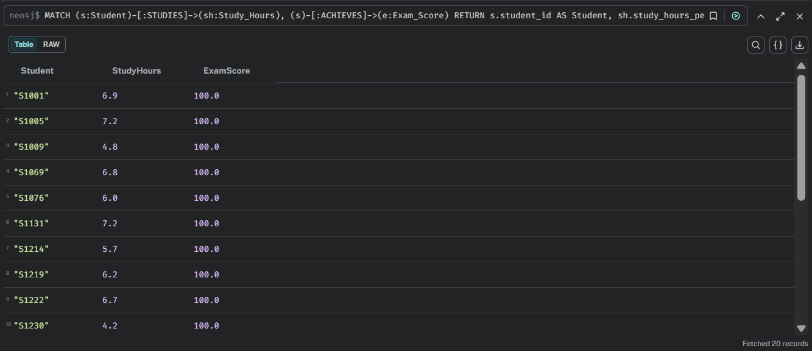

- MATCH (s:Student)-[:MAINTAINS_FITNESS]->(ex:Exercise_Frequency),
(s)-[:ACHIEVES]->(e:Exam_Score)
RETURN ex.exercise_frequency AS ExerciseFrequency, avg(e.exam_score) AS AvgExamScore
ORDER BY AvgExamScore DESC;

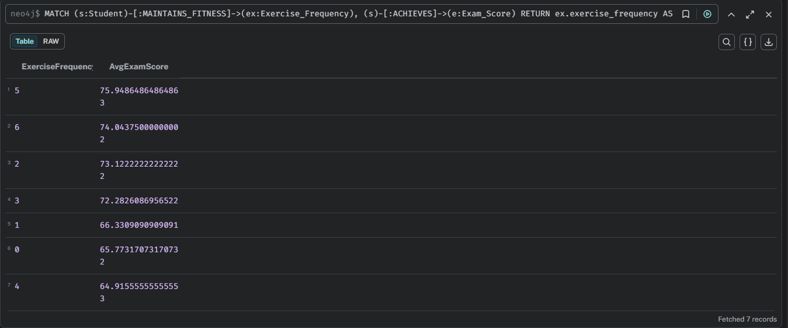

- MATCH (s:Student)-[:HAS_ATTENDANCE]->(a:Attendance_Percentage),
(s)-[:ACHIEVES]->(e:Exam_Score)
RETURN a.attendance_percentage AS Attendance, avg(e.exam_score) AS AvgExamScore
ORDER BY Attendance DESC;
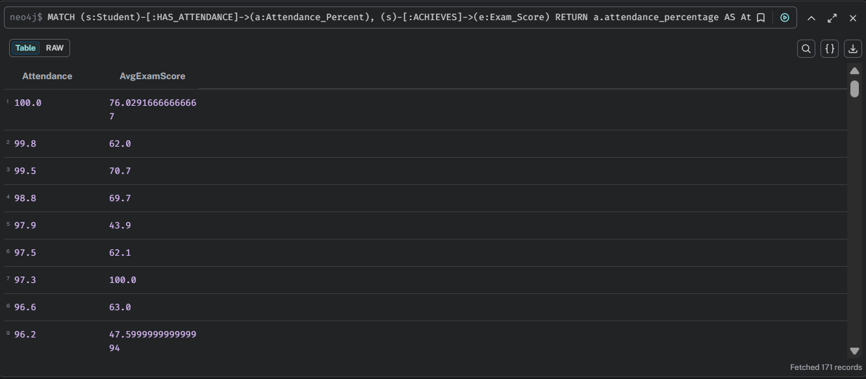

Full Relationship Overview
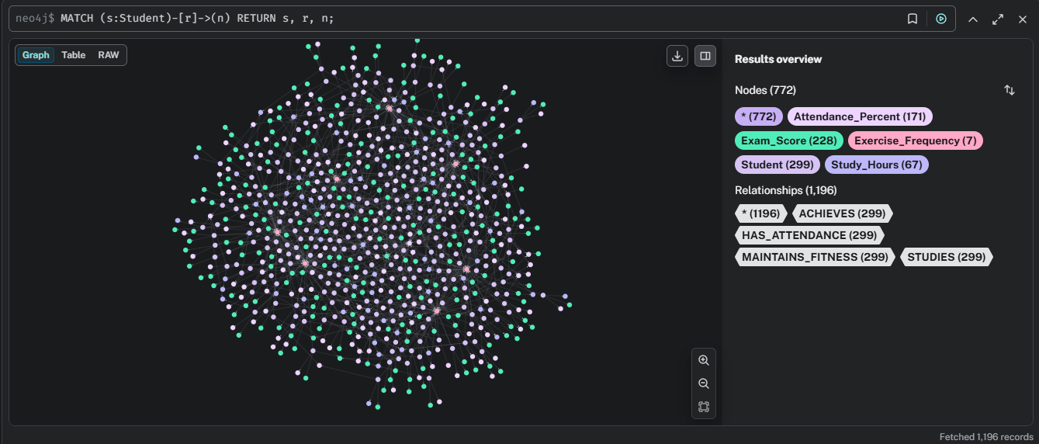

Explore Graphs
Force-Based Layout
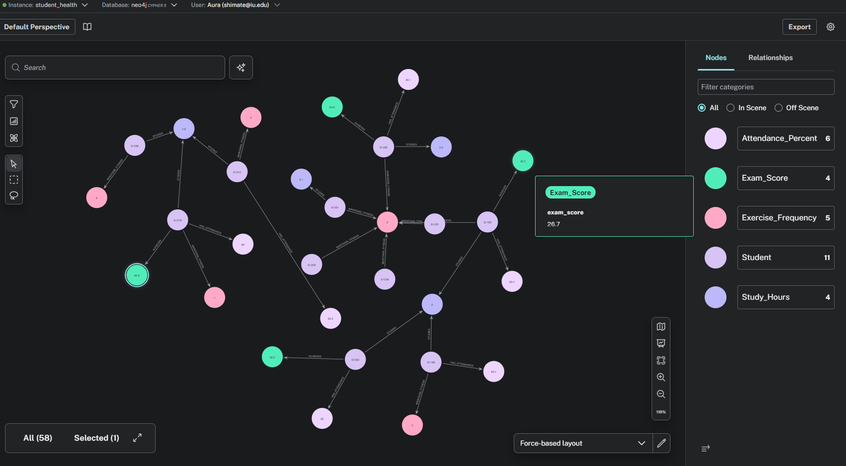

Hierarchical Layout
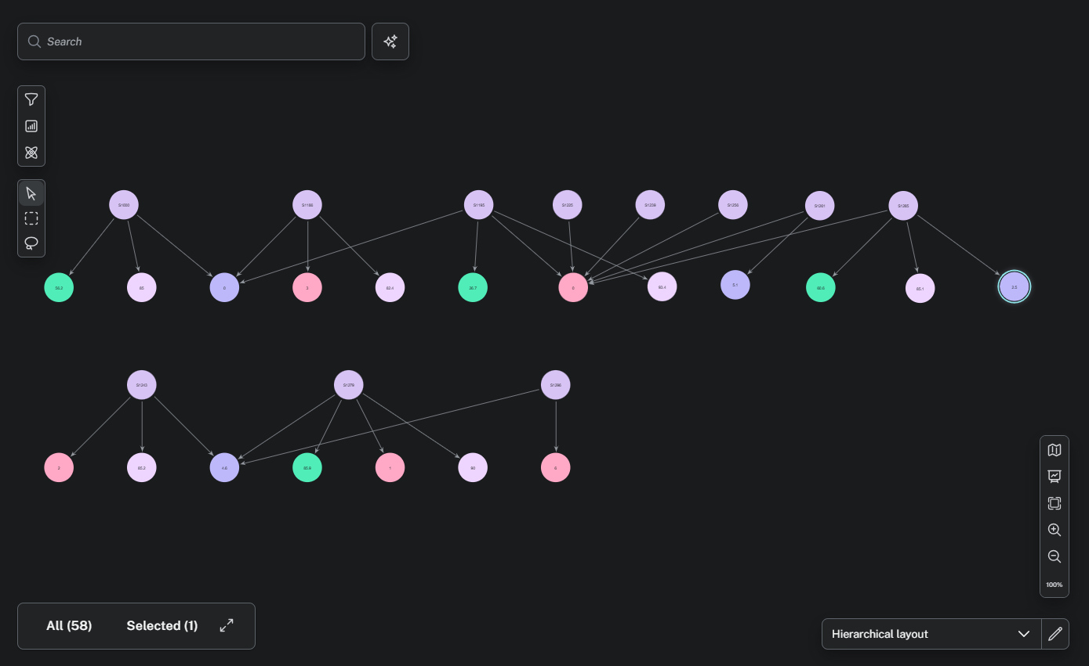

Student contains 001
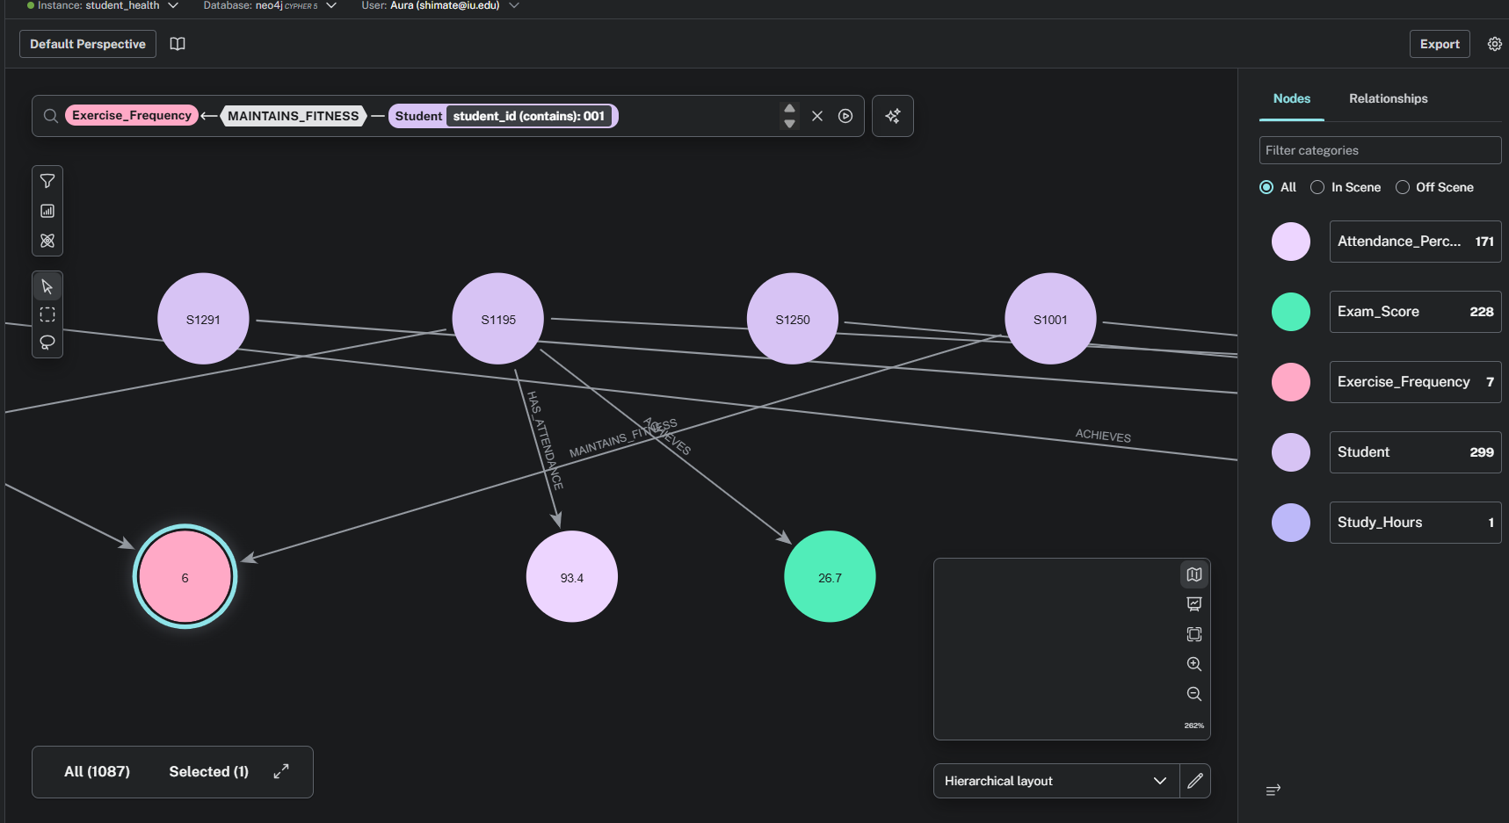

Dashboard Card
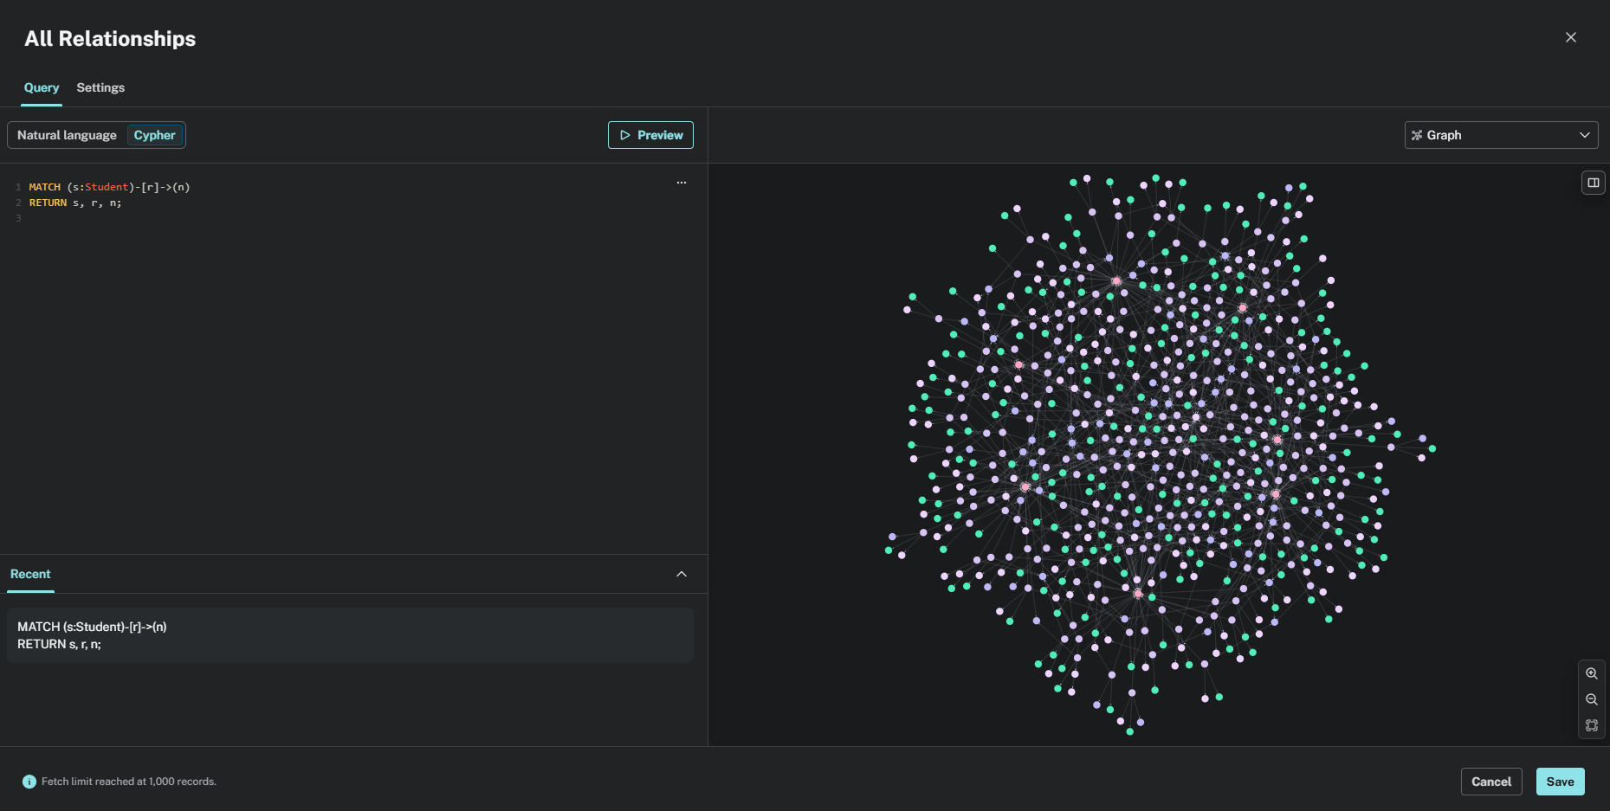

Reflections

Q. What was the most interesting thing you discovered while using graph database (open-ended question - can be about the technology or data)?
While exploring my data in the Explore tab, I really enjoyed using the force-based layout because it showed how different nodes like students, study hours, and exam scores were naturally connected. Changing to the hierarchical layout helped me see these relationships in a clear and organized structure. I also used the filter option to focus on specific students, such as those with IDs containing “001”, which made it easier to observe their related data. This experience helped me understand how graph databases can visually display connections and make complex relationships easier to interpret compared to normal tables.

