Week 12 Coding Practice Submission

Preliminary Steps
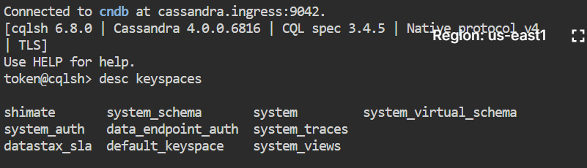

Cassandra Console Steps
- Select your keyspace (for example adt_demo) and go to CQL console. Let's verify if your keyspace was created properly (it should be listed in the console output)
DESC KEYSPACES;
2. Now let’s use the keyspace
USE shimate;
3. Create a table
CREATE TABLE shimate.users (
country_code TEXT,
city TEXT,
gender TEXT,
birth_year INT,
first_name TEXT,
last_name TEXT,
email TEXT,
phone_number TEXT,
address TEXT,
job_title TEXT,
PRIMARY KEY ((country_code, city, gender), birth_year, last_name, first_name)
);

DESC TABLES;

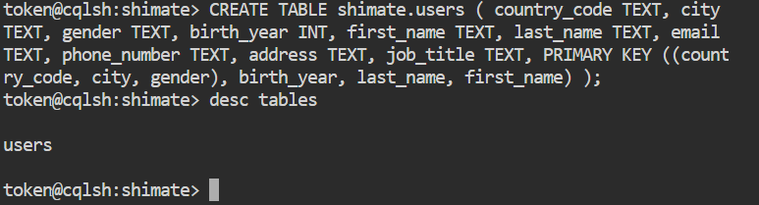

4. Insert data
INSERT INTO shimate.users (country_code, city, gender, birth_year, first_name, last_name, email, phone_number, address, job_title) VALUES
('US', 'New York', 'Male', 1980, 'John', 'Doe', 'john@example.com', '123-456-7890', '123 Main St', 'Manager');
INSERT INTO shimate.users (country_code, city, gender, birth_year, first_name, last_name, email, phone_number, address, job_title) VALUES
('US', 'San Francisco', 'Female', 1990, 'Jane', 'Doe', 'jane@example.com', '456-789-0123', '456 Elm St', 'Engineer');
INSERT INTO shimate.users (country_code, city, gender, birth_year, first_name, last_name, email, phone_number, address, job_title) VALUES
('UK', 'London', 'Male', 1985, 'James', 'Smith', 'james@example.com', '789-012-3456', '789 Oak St', 'Manager');
INSERT INTO shimate.users (country_code, city, gender, birth_year, first_name, last_name, email, phone_number, address, job_title) VALUES
('UK', 'Manchester', 'Female', 1995, 'Sophie', 'Williams', 'sophie@example.com', '012-345-6789', '12 High St', 'Engineer');
INSERT INTO shimate.users (country_code, city, gender, birth_year, first_name, last_name, email, phone_number, address, job_title) VALUES
('FR', 'Paris', 'Male', 1992, 'Thomas', 'Martin', 'thomas@example.com', '345-678-9012', '345 Maple St', 'Analyst');
INSERT INTO shimate.users (country_code, city, gender, birth_year, first_name, last_name, email, phone_number, address, job_title) VALUES
('FR', 'Lyon', 'Female', 1982, 'Marie', 'Dupont', 'marie@example.com', '678-901-2345', '678 Oak St', 'Manager');
INSERT INTO shimate.users (country_code, city, gender, birth_year, first_name, last_name, email, phone_number, address, job_title) VALUES
('JP', 'Tokyo', 'Male', 1987, 'Taro', 'Suzuki', 'taro@example.com', '901-234-5678', '901 Elm St', 'Engineer');
INSERT INTO shimate.users (country_code, city, gender, birth_year, first_name, last_name, email, phone_number, address, job_title) VALUES
('JP', 'Osaka', 'Female', 1997, 'Yui', 'Nakamura', 'yui@example.com', '234-567-8901', '234 High St', 'Analyst');
INSERT INTO shimate.users (country_code, city, gender, birth_year, first_name, last_name, email, phone_number, address, job_title) VALUES
('AU', 'Sydney', 'Male', 1975, 'David', 'Wilson', 'david@example.com', '567-890-1234', '567 Maple St', 'Manager');
INSERT INTO shimate.users (country_code, city, gender, birth_year, first_name, last_name, email, phone_number, address, job_title) VALUES
('AU', 'Melbourne', 'Female', 1988, 'Emily', 'Taylor', 'emily@example.com', '890-123-4567', '890 Oak St', 'Engineer');
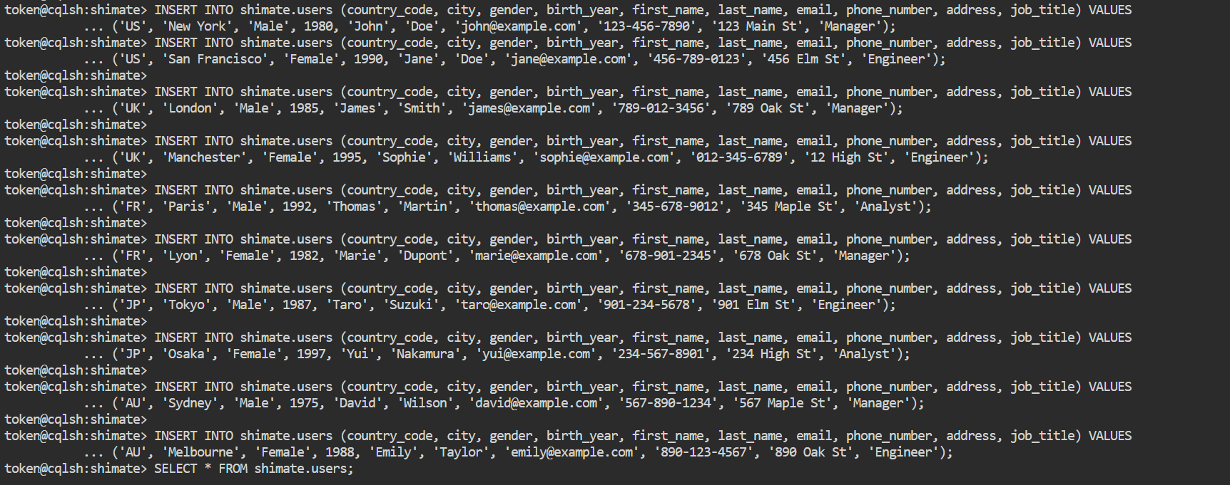

5. Retrieve data
SELECT * FROM shimate.users;
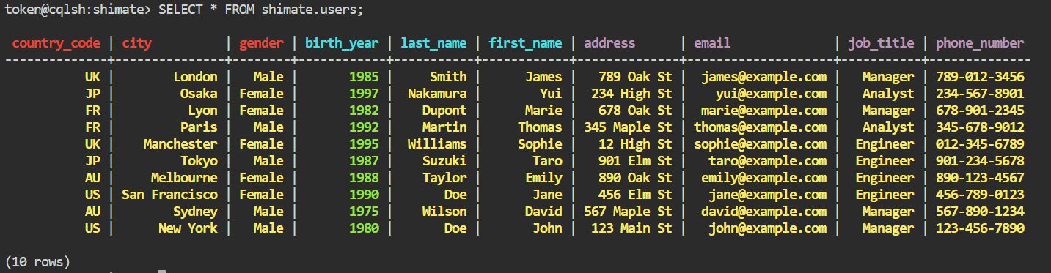

6. Update data
UPDATE shimate.users SET job_title = 'Senior Manager' WHERE country_code = 'US' AND city = 'New York' AND gender = 'Male' AND birth_year = 1980 AND first_name = 'John' AND last_name = 'Doe';
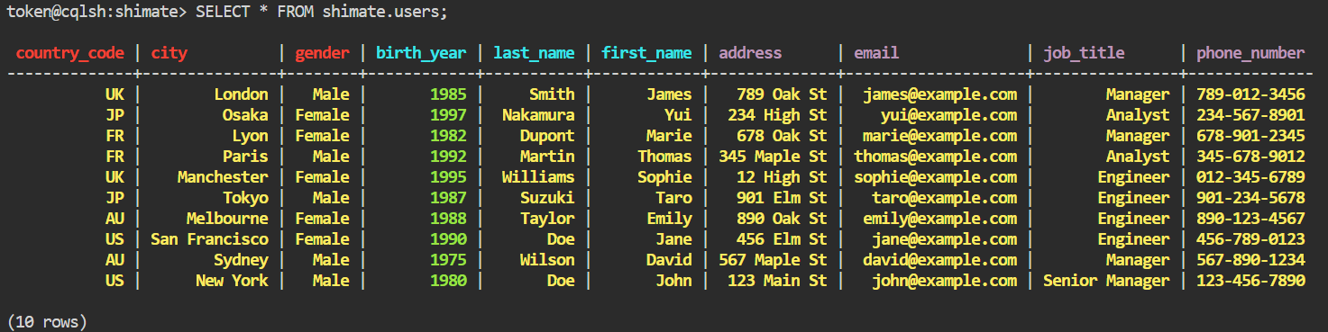

7. Delete data
DELETE FROM shimate.users WHERE country_code = 'US' AND city = 'New York' AND gender = 'Male' AND birth_year = 1980 AND first_name = 'John' AND last_name = 'Doe';
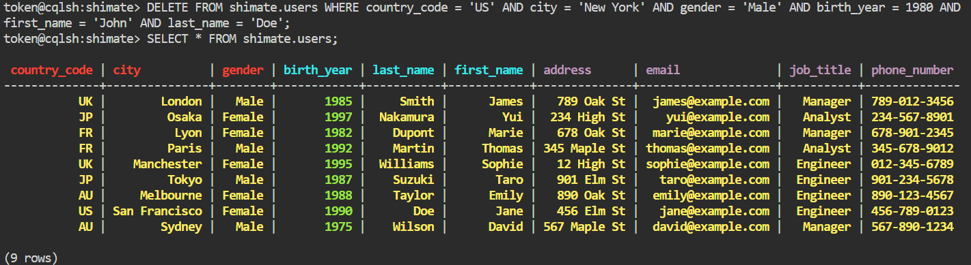

8. Truncate table
TRUNCATE shimate.users;
