ADT Lab 3 (10pts)
Q1 Executed all 4 Queries from Practical SQL Book/GitHub Link
Q2 Created count_hospitals_in_city View
Q3 Created materialized view mat_count_hospitals_in_city

Highlight the questions you are done with to green colour before you submit
Instructions-
- Install Postgres for Windows- https://www.guru99.com/download-install-postgresql.html
Install Postgres for Mac- https://adamtheautomator.com/install-postgresql-on-mac/

Create a new Database and give the name as your IU username
(Right click on the Databases on the browser pane, click on create, click on database)
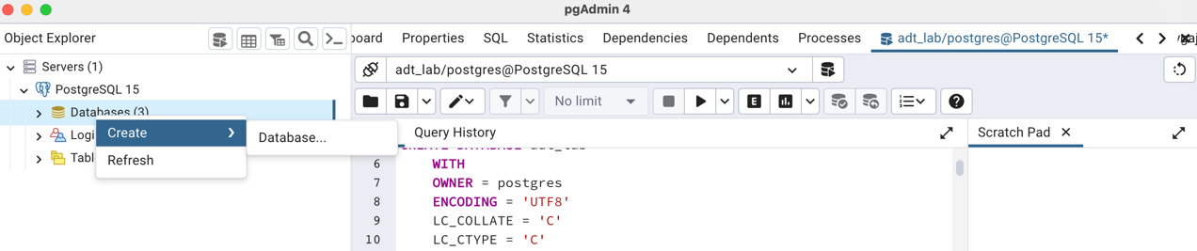

- See Chapter 3 from Practical SQL book
Book available from IU Library (with IU Login) - Link
GitHub Link for Chapter 3 SQL queries from book: Link

Reference for MySQL Datatypes:
Link: https://www.w3schools.com/sql/sql_datatypes.asp
Read Chapter 3 from start until Listing 3-4: The timestamps and interval types in action
- Execute queries from the book/ GitHub link provided above up until Listing 3-4: Timestamp and interval types in action. Similar to the last lab post the screenshot below.
Sample screenshot:
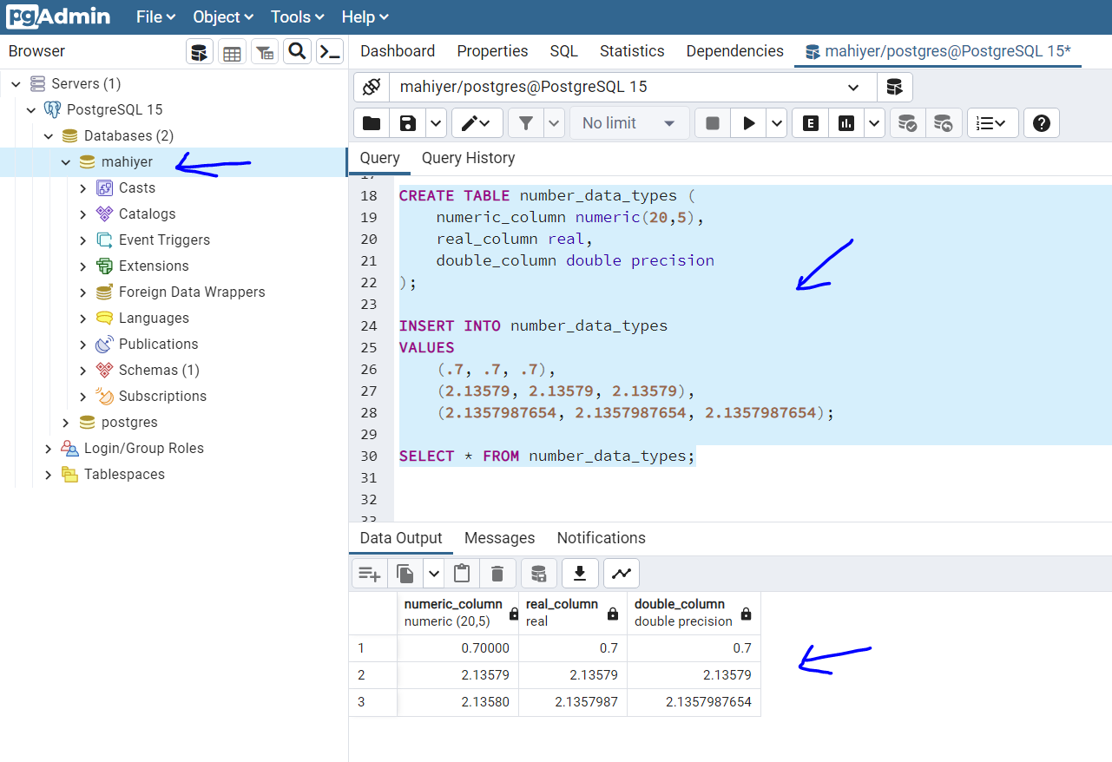

Listing 3-1: Character data types in action
If you ae getting permission denied error while writing the file kindly refer- https://www.neilwithdata.com/copy-permission-denied
# Screenshot
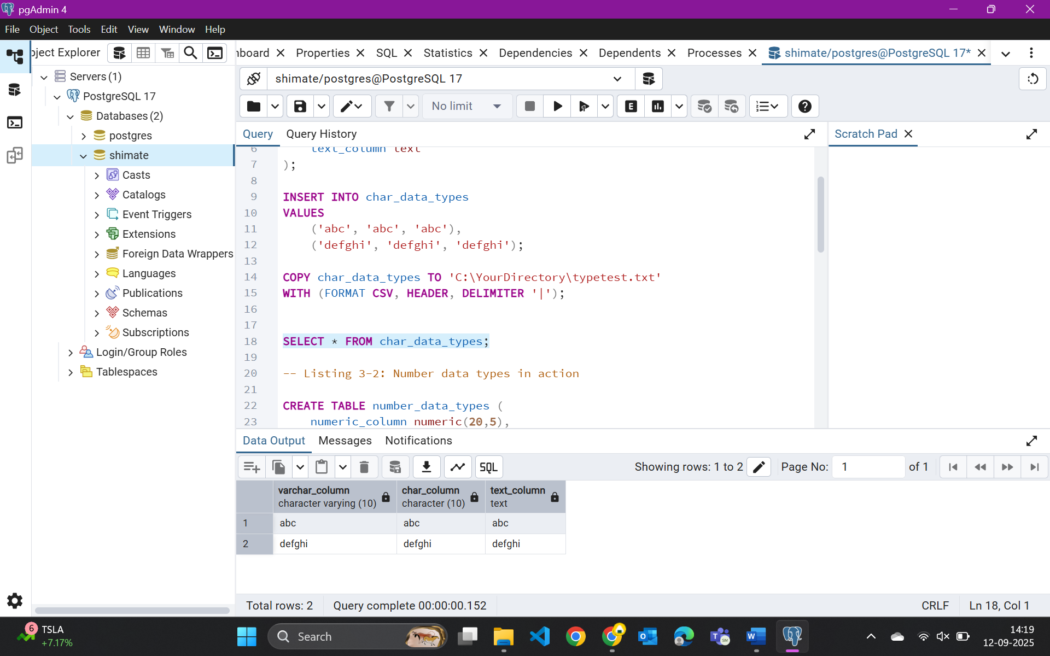

Listing 3-2: Number data types in action
# Screenshot
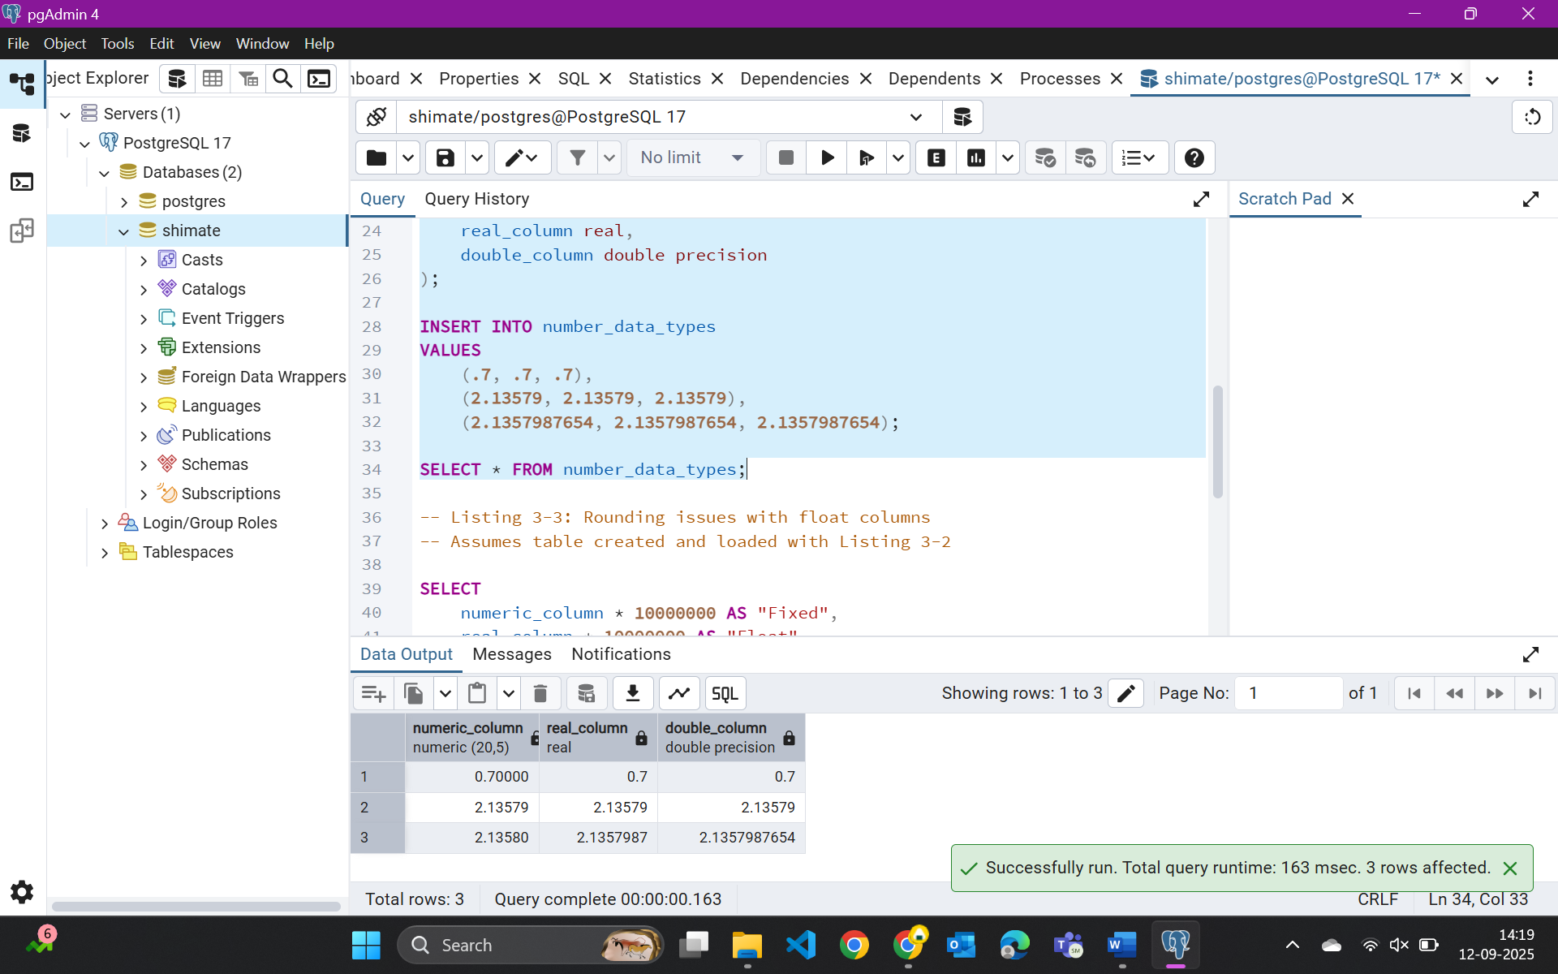

Listing 3-3: Rounding issues with float columns
# Screenshot
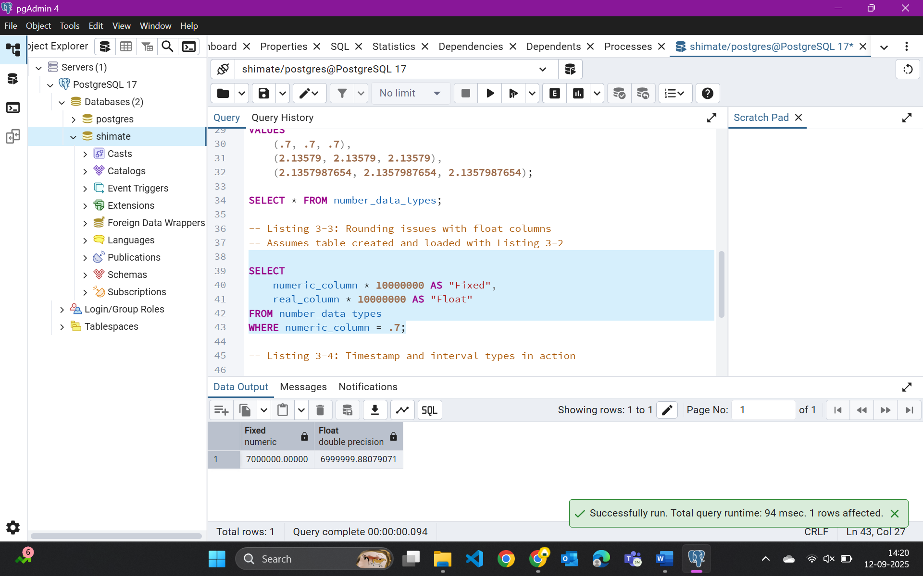

Listing 3-4: Timestamp and interval types in action
# Screenshot
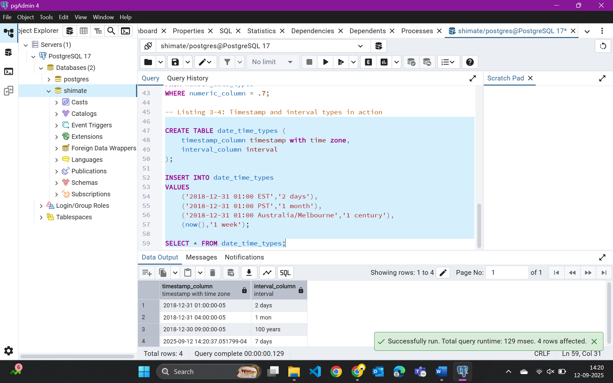

- Read about what is a materialized view in PostgreSQL and Difference between Postgres view and materialized view from - https://blog.devart.com/postgresql-materialized-views.html#difference
Run the script doctors_db.sql from the Lab 3 files to create a doctors and a hospitals table
Create a view to count the number of hospitals in each city from the hospitals table by using the query-
CREATE VIEW count_hospitals_in_city AS
SELECT city,count(*) as hospital_count
FROM hospitals
group by city;
Under the Schema dropdown, check under views dropdown on the browser pane if your view is created and paste the screenshot below.

# Screenshot
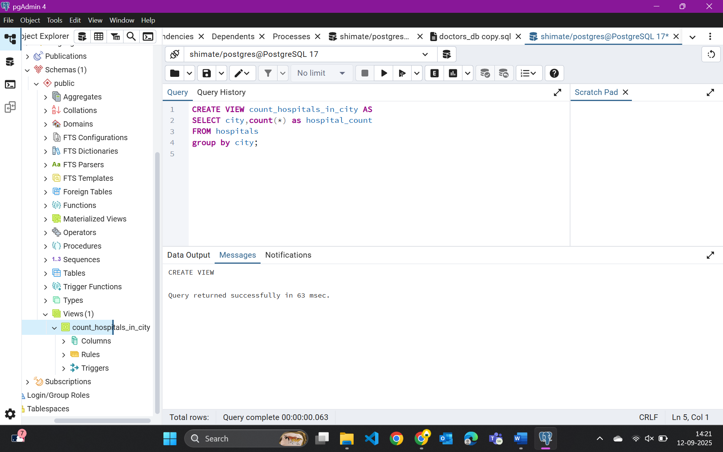
Example
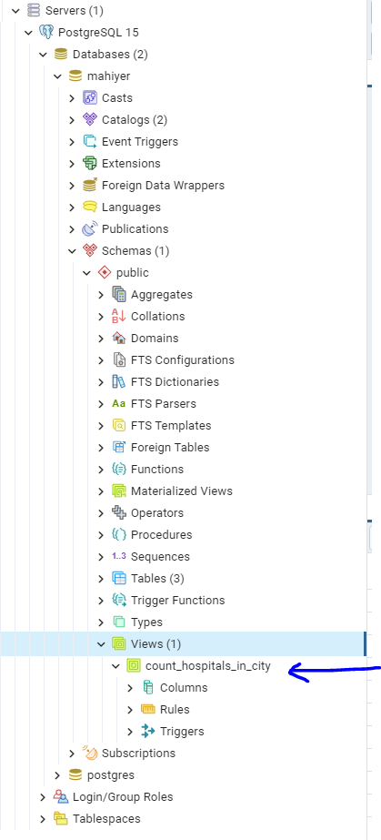

- Create a martialized view by using the query-
CREATE MATERIALIZED VIEW mat_count_hospitals_in_city AS
SELECT city,count(*) as hospital_count
FROM hospitals
group by city;

Under the schema dropdown, check for your newly created materialized view and post a screenshot of it-
Example-
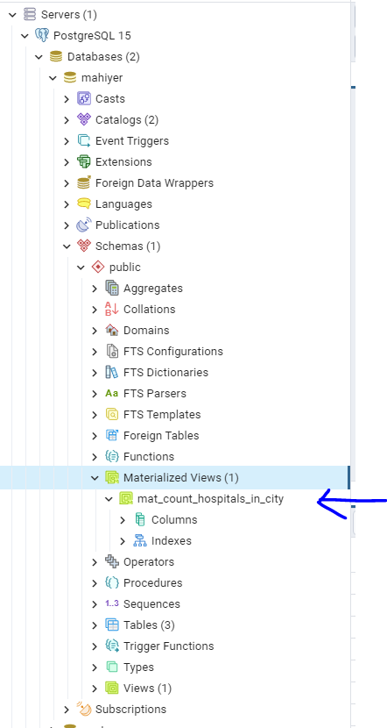

# ScreenShot
