Week 3 Homework 1

Part 1: Creating Tables Queries
CREATE DATABASE IF NOT EXISTS week3hw1;
USE week3hw1;

CREATE TABLE IF NOT EXISTS hospitals (
hospital_id INT AUTO_INCREMENT PRIMARY KEY,
hospital_name VARCHAR(120) NOT NULL,
state CHAR(2) NOT NULL,
city VARCHAR(80) NOT NULL,
doctor VARCHAR(120) NOT NULL
);

CREATE TABLE IF NOT EXISTS doctors (
doctor_id INT AUTO_INCREMENT PRIMARY KEY,
name VARCHAR(120) NOT NULL,
gender VARCHAR(10),
insurance VARCHAR(3) NOT NULL,
new_patients VARCHAR(3) NOT NULL,
speciality_one VARCHAR(80),
speciality_two VARCHAR(80),
speciality_three VARCHAR(80),
license VARCHAR(3) NOT NULL,
phone CHAR(10) NOT NULL,

CONSTRAINT chk_insurance
CHECK (insurance IN ('Yes','No')),
CONSTRAINT chk_new_patients
CHECK (new_patients IN ('Yes','No')),
CONSTRAINT chk_license
CHECK (license IN ('MFT','PhD','MD'))
);
SELECT COUNT(*) AS doctor_rows FROM doctors;
SELECT COUNT(*) AS hospital_rows FROM hospitals;

We can see that database week3hw1 is created (along with tables for normalization)
Part 2: Normalization Queries
- Converting Tables for normalization
CREATE TABLE IF NOT EXISTS hospitals_norm (
hospital_id INT AUTO_INCREMENT PRIMARY KEY,
hospital_name VARCHAR(120) NOT NULL,
city VARCHAR(80) NOT NULL,
state CHAR(2) NOT NULL,
CONSTRAINT uq_hosp UNIQUE (hospital_name, city, state)
);

CREATE TABLE IF NOT EXISTS doctors_norm (
doctor_id INT PRIMARY KEY,
name VARCHAR(120) NOT NULL,
gender VARCHAR(10),
insurance VARCHAR(3) NOT NULL,
new_patients VARCHAR(3) NOT NULL,
speciality_one VARCHAR(80),
speciality_two VARCHAR(80),
speciality_three VARCHAR(80),
license VARCHAR(3) NOT NULL,
phone CHAR(10) NOT NULL
);

- Creating tables for normalization
CREATE TABLE IF NOT EXISTS doctor_hospital (
doctor_id INT NOT NULL,
hospital_id INT NOT NULL,
PRIMARY KEY (doctor_id, hospital_id),
CONSTRAINT fk_dh_doc FOREIGN KEY (doctor_id) REFERENCES doctors_norm(doctor_id),
CONSTRAINT fk_dh_hos FOREIGN KEY (hospital_id) REFERENCES hospitals_norm(hospital_id)
);

CREATE TABLE IF NOT EXISTS specialties (
specialty_id INT AUTO_INCREMENT PRIMARY KEY,
specialty_name VARCHAR(120) NOT NULL,
CONSTRAINT uq_spec UNIQUE (specialty_name)
);

CREATE TABLE IF NOT EXISTS doctor_specialty (
doctor_id INT NOT NULL,
specialty_id INT NOT NULL,
PRIMARY KEY (doctor_id, specialty_id),
CONSTRAINT fk_ds_doc FOREIGN KEY (doctor_id) REFERENCES doctors_norm(doctor_id),
CONSTRAINT fk_ds_spec FOREIGN KEY (specialty_id) REFERENCES specialties(specialty_id)
);

- Migrate & clean data into normalized tables
INSERT IGNORE INTO hospitals_norm (hospital_name, city, state)
SELECT DISTINCT
TRIM(hospital_name),
TRIM(city),
UPPER(TRIM(state))
FROM hospitals;

INSERT INTO doctors_norm (doctor_id, name, gender, insurance, new_patients,
speciality_one, speciality_two, speciality_three,
license, phone)
SELECT
d.doctor_id,
TRIM(d.name),
NULLIF(TRIM(d.gender),''),
TRIM(d.insurance),
TRIM(d.new_patients),
NULLIF(TRIM(d.speciality_one), ''),
NULLIF(TRIM(d.speciality_two), ''),
NULLIF(TRIM(d.speciality_three), ''),
TRIM(d.license),

CASE
WHEN LENGTH(REGEXP_REPLACE(d.phone, '[^0-9]', '')) = 10
THEN REGEXP_REPLACE(d.phone, '[^0-9]', '')
ELSE d.phone
END
FROM doctors d;

INSERT IGNORE INTO doctor_hospital (doctor_id, hospital_id)
SELECT dn.doctor_id, hn.hospital_id
FROM hospitals h
JOIN doctors_norm dn
ON TRIM(h.doctor) = dn.name
JOIN hospitals_norm hn
ON hn.hospital_name = TRIM(h.hospital_name)
AND hn.city = TRIM(h.city)
AND hn.state = UPPER(TRIM(h.state));

INSERT IGNORE INTO specialties (specialty_name)
SELECT DISTINCT s.spec FROM (
SELECT speciality_one AS spec FROM doctors_norm WHERE speciality_one IS NOT NULL
UNION
SELECT speciality_two AS spec FROM doctors_norm WHERE speciality_two IS NOT NULL
UNION
SELECT speciality_three AS spec FROM doctors_norm WHERE speciality_three IS NOT NULL
) s;

INSERT IGNORE INTO doctor_specialty (doctor_id, specialty_id)
SELECT dn.doctor_id, sp.specialty_id
FROM doctors_norm dn
JOIN specialties sp ON sp.specialty_name = dn.speciality_one
WHERE dn.speciality_one IS NOT NULL;

INSERT IGNORE INTO doctor_specialty (doctor_id, specialty_id)
SELECT dn.doctor_id, sp.specialty_id
FROM doctors_norm dn
JOIN specialties sp ON sp.specialty_name = dn.speciality_two
WHERE dn.speciality_two IS NOT NULL;

INSERT IGNORE INTO doctor_specialty (doctor_id, specialty_id)
SELECT dn.doctor_id, sp.specialty_id
FROM doctors_norm dn
JOIN specialties sp ON sp.specialty_name = dn.speciality_three
WHERE dn.speciality_three IS NOT NULL;

- Checking Data
SELECT COUNT(*) AS doctors_original FROM doctors;
SELECT COUNT(*) AS hospitals_original FROM hospitals;

- Creating Views to perform queries
CREATE OR REPLACE VIEW v_doctor_specialties AS
SELECT d.doctor_id, d.name, s.specialty_name
FROM doctor_specialty ds
JOIN doctors_norm d ON d.doctor_id = ds.doctor_id
JOIN specialties s ON s.specialty_id = ds.specialty_id;

CREATE OR REPLACE VIEW v_doctor_hospitals AS
SELECT d.doctor_id, d.name, h.hospital_name, h.city, h.state
FROM doctor_hospital dh
JOIN doctors_norm d ON d.doctor_id = dh.doctor_id
JOIN hospitals_norm h ON h.hospital_id = dh.hospital_id;

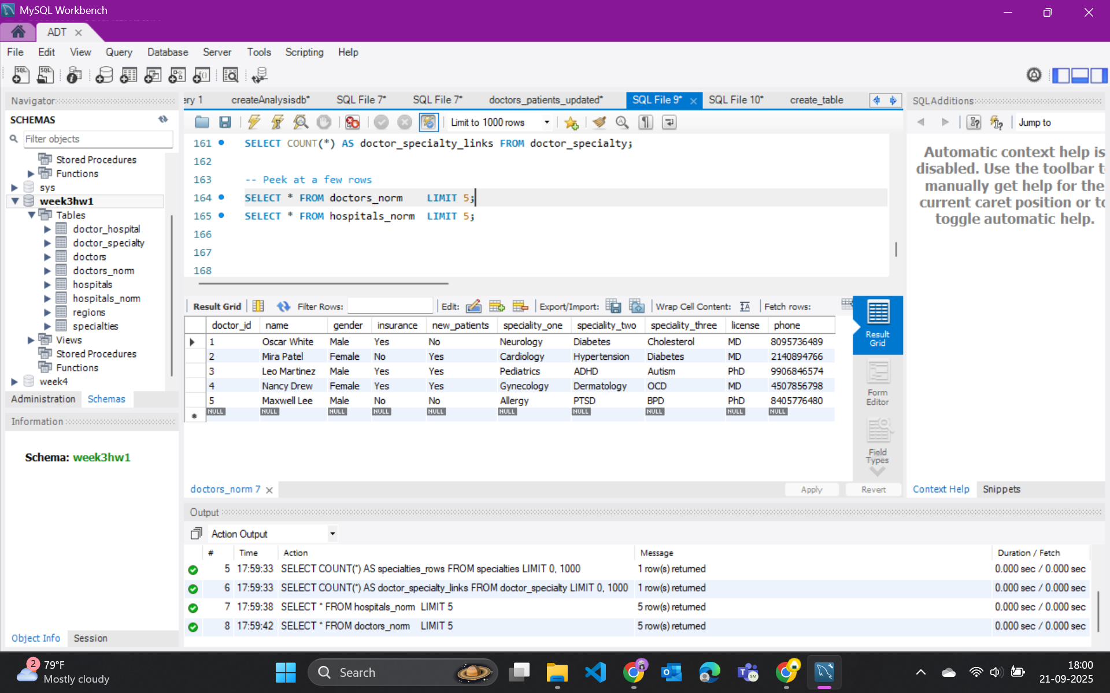
We can see that normalization is done and the doctors_norm table is displayed.
- Explanation
In the second part of the assignment, the database was normalized to eliminate redundancy and bring it closer to first and third normal form. The initial design stored a doctor’s name directly in the hospitals table and listed three specialties in separate columns within the doctors table. This setup led to unnecessary duplication and made it difficult to manage changes. To resolve this, the schema was restructured into separate, cleaner tables: doctors_norm, hospitals_norm, a linking table doctor_hospital to show which doctors work in which hospitals, and a specialties table with a many-to-many link through doctor_specialty. This allowed each specialty to be stored only once while still linking to multiple doctors.
Additionally, views such as v_doctor_specialties and v_doctor_hospitals were created. These views were not required for further tasks, but they were designed to simplify queries and make it easier to explore the normalized data without repeatedly writing complex joins. Even if they were not actively used later, the views served as a convenient abstraction layer for clearer and more efficient querying.
- Normalization Schema
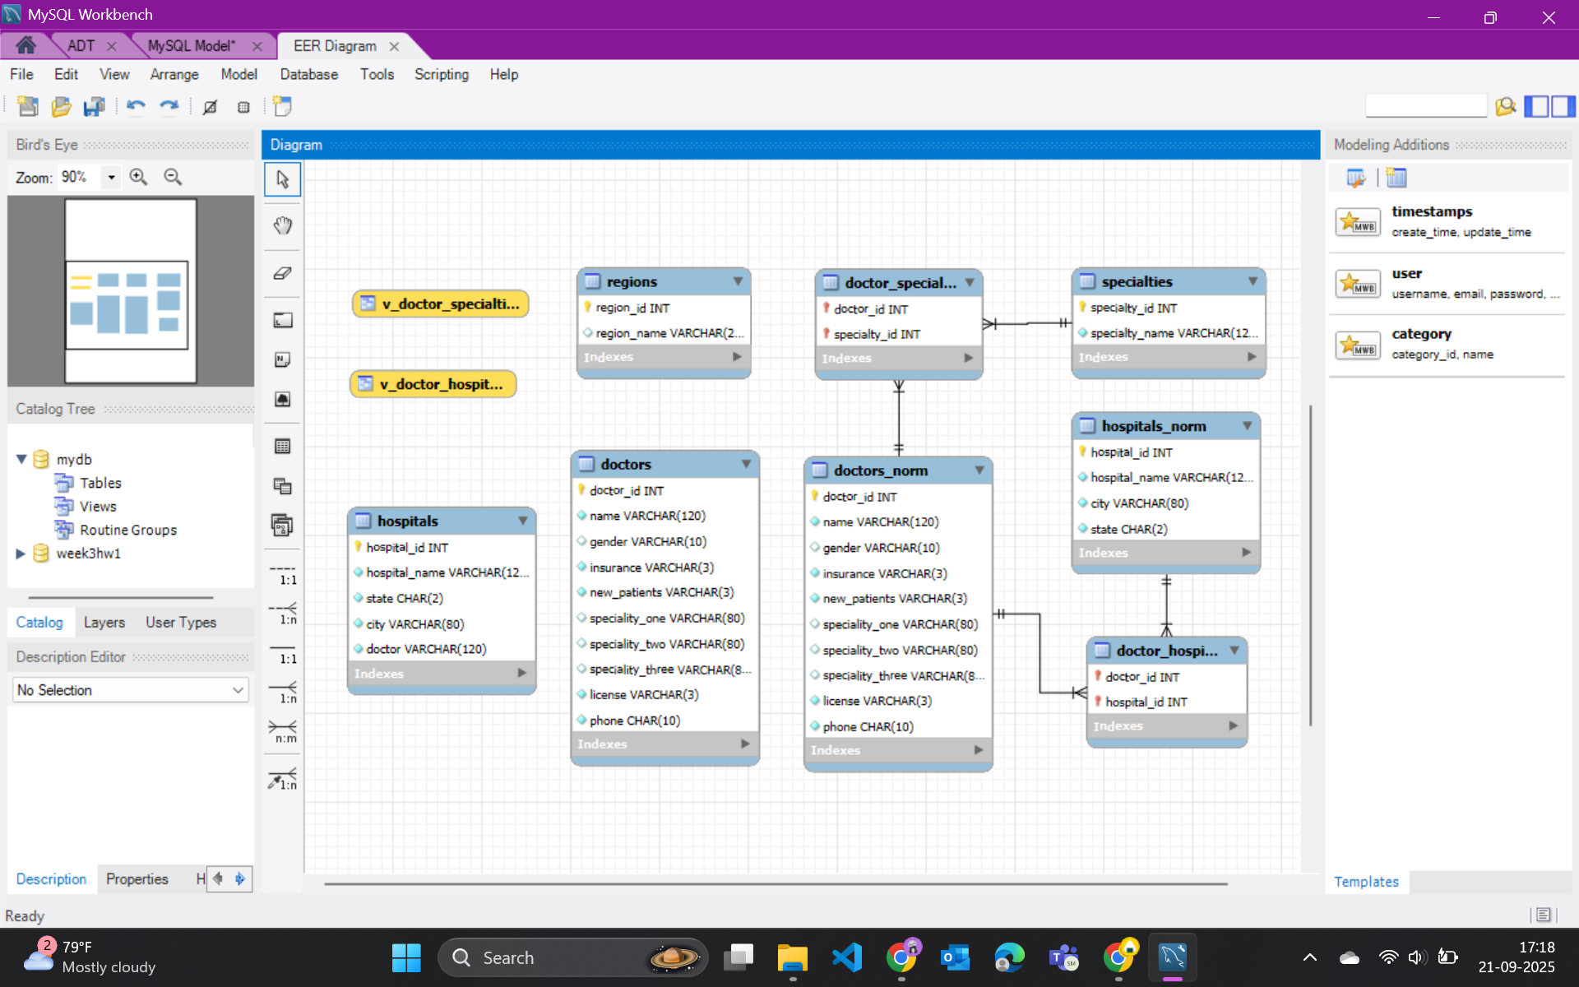
Part 3: Exploration
!pip -q install mysql-connector-python pandas matplotlib seaborn
import warnings
warnings.filterwarnings("ignore")
import mysql.connector as mc, pandas as pd, matplotlib.pyplot as plt, seaborn as sns, numpy as np
conn = mc.connect(host="127.0.0.1", user="root", password="Liv@shita2023", database="week3hw1")
# Hospitals with the most distinct doctors (Top 10)
q1 = """
SELECT h.hospital_name, h.city, h.state, COUNT(DISTINCT dh.doctor_id) AS doctor_count
FROM doctor_hospital dh
JOIN hospitals_norm h ON h.hospital_id = dh.hospital_id
GROUP BY h.hospital_id, h.hospital_name, h.city, h.state
ORDER BY doctor_count DESC, h.hospital_name
LIMIT 10;
"""
df = pd.read_sql(q1, conn)
print(df.head())
hospital_name city state doctor_count
0 Open Clinic San Jose CA 3
1 Blue Cross Clinic Los Angeles CA 2
2 Blue Cross Clinic San Francisco CA 2
3 Clear Minds Community Sacramento CA 2
4 Holistic Health Services Santa Barbara CA 2
This query counts how many unique doctors are associated with each hospital. The output shows, for example, that Open Clinic in San Jose, CA has 3 doctors, while several others like Blue Cross Clinic (San Francisco, Los Angeles) each have 2. This highlights which hospitals have the largest medical staff presence in the dataset.
# Doctors accepting new patients, by specialty and state
q2 = """
SELECT h.state, s.specialty_name, COUNT(DISTINCT d.doctor_id) AS doctors_accepting
FROM doctors_norm d
JOIN doctor_specialty ds ON ds.doctor_id = d.doctor_id
JOIN specialties s ON s.specialty_id = ds.specialty_id
JOIN doctor_hospital dh ON dh.doctor_id = d.doctor_id
JOIN hospitals_norm h ON h.hospital_id = dh.hospital_id
WHERE d.new_patients = 'Yes'
GROUP BY h.state, s.specialty_name
ORDER BY h.state, doctors_accepting DESC;
"""
df = pd.read_sql(q2, conn)
print(df.head())
state specialty_name doctors_accepting
0 CA Hypertension 11
1 CA Dermatology 8
2 CA immunology 7
3 CA OCD 6
4 CA ADHD 5
This query filters doctors who are currently accepting new patients and groups them by state and specialty. The results indicate that in California, specialties such as Hypertension (11 doctors) and Dermatology (8 doctors) have the highest availability. This provides insight into both geographic and specialty-specific access to care.
# List doctors whose specialties mention 'Cholesterol'
q3 = """
SELECT DISTINCT d.doctor_id, d.name
FROM doctors_norm d
JOIN doctor_specialty ds ON ds.doctor_id = d.doctor_id
JOIN specialties s ON s.specialty_id = ds.specialty_id
WHERE s.specialty_name LIKE '%Cholesterol%'
ORDER BY d.name;
"""
df = pd.read_sql(q3, conn)
print(df.head())
doctor_id name
0 6 Flora Martinez
1 1 Oscar White
Here, the query identifies doctors linked to any specialty containing the keyword “Cholesterol.” The result lists Flora Martinez and Oscar White as the two providers. This is useful for quickly locating specialists focused on cholesterol-related conditions.
# Count by license and insurance acceptance
q4 = """
SELECT d.license, d.insurance, COUNT(*) AS n
FROM doctors_norm d
GROUP BY d.license, d.insurance
ORDER BY d.license, d.insurance;
"""
df = pd.read_sql(q4, conn)
print(df.head())
license insurance n
0 MD No 6
1 MD Yes 8
2 MFT No 1
3 MFT Yes 3
4 PhD No 1
This groups doctors by their license type (e.g., MD, MFT, PhD) and whether they accept insurance. For instance, the output shows 6 MDs who do not accept insurance and 3 MDs who do, with smaller counts for MFTs and PhDs. This breakdown reveals patterns in how licensing may correlate with insurance participation.
# All Doctor names
q5 = """
SELECT name
FROM doctors_norm;
"""
df = pd.read_sql(q5, conn)
print(df.head())
name
0 Oscar White
1 Mira Patel
2 Leo Martinez
3 Nancy Drew
4 Maxwell Lee
The result includes names like Oscar White, Mira Patel, and Nancy Drew. This shows which practitioners provide broader expertise and may serve patients across multiple areas of care.
# Number of doctors for each Speciality
v1 = """
SELECT s.specialty_name, COUNT(*) AS doctor_count
FROM doctor_specialty ds
JOIN specialties s ON s.specialty_id = ds.specialty_id
GROUP BY s.specialty_name
ORDER BY doctor_count DESC
LIMIT 15;
"""
df1 = pd.read_sql(v1, conn)
plt.figure()
sns.barplot(data=df1, x="doctor_count", y="specialty_name")
plt.title("Specialties by No.of Doctors")
plt.xlabel("Doctors"); plt.ylabel("Specialty")
plt.tight_layout(); plt.show()
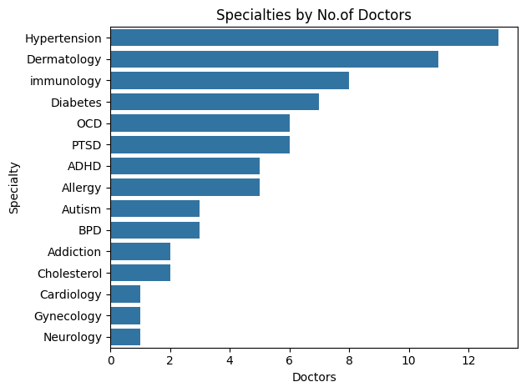
This horizontal bar chart presents the top 15 specialties ranked by the number of doctors associated with them. Hypertension and Dermatology stand out as the most common specialties, followed by Immunology and Diabetes. This visualization provides a clear overview of which areas of medicine have the highest representation among doctors in the dataset.
# Number of Doctors in each Hospital
v2 = """
SELECT h.hospital_name, h.city, h.state, COUNT(DISTINCT dh.doctor_id) AS doctor_count
FROM doctor_hospital dh
JOIN hospitals_norm h ON h.hospital_id = dh.hospital_id
GROUP BY h.hospital_id, h.hospital_name, h.city, h.state
ORDER BY doctor_count DESC, h.hospital_name
LIMIT 10;
"""
x = np.arange(len(df2))
y = df2["doctor_count"].values
plt.figure()
plt.vlines(x, 0, y)
plt.plot(x, y, "o")
plt.xticks(x, df2["hospital_name"], rotation=45, ha="right")
plt.ylabel("Doctors")
plt.title("Hospitals vs No.of Doctors")
plt.ylim(0, y.max() * 1.1)
plt.tight_layout()
plt.show()
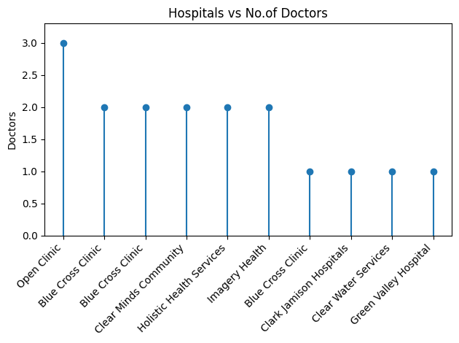
This vertical lollipop chart shows the number of distinct doctors affiliated with the top 10 hospitals. Open Clinic leads with 3 doctors, while several others like Blue Cross Clinic and Holistic Health Services have 2. The chart highlights which hospitals in the dataset have comparatively larger medical staff.

