Week 4 Coding Practice Submission

Step 1: Metadata, Strings, Numbers, Math
The queries for this step are done in Jupyter Notebook and MySQL Workbench. The part1 ipynb file is converted to pdf and the part 2 sql file with factorial function are attached with this file.

Step 2: Creating a New Database
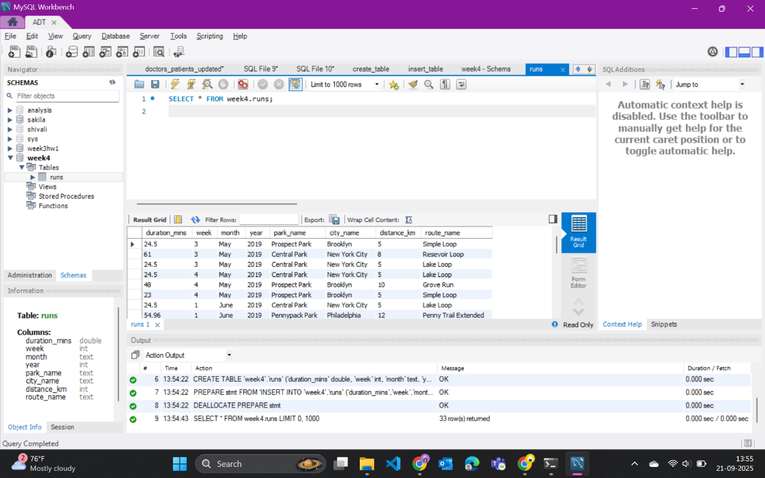

Step 3: Practice DB Nominalization
Before Normalization
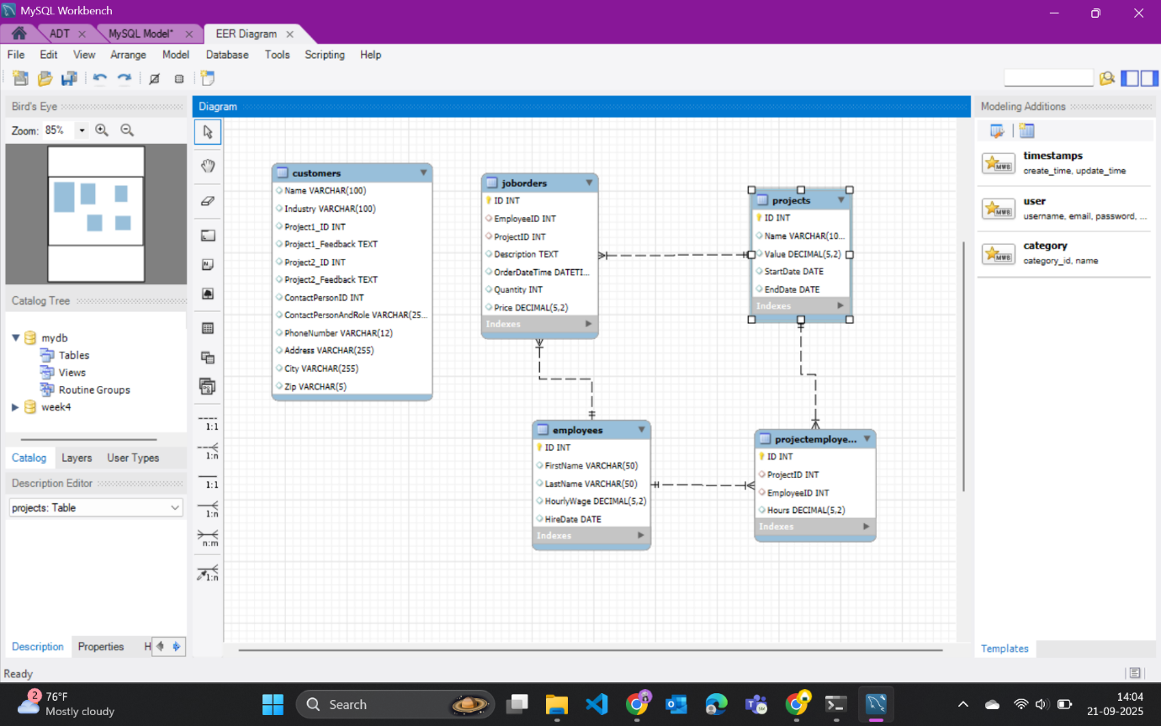
After Normalization
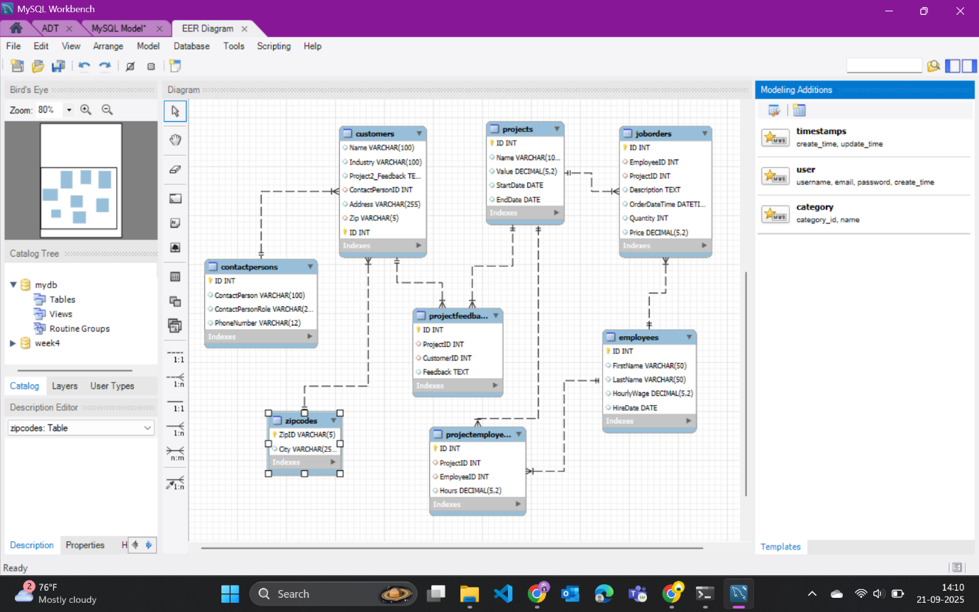

Reflection
Q. What did you find challenging in this practice and how you solved it
A. At first, I got stuck when the query on information_schema.tables returned TABLE_NAME in all caps. I fixed it by adding an alias, so it showed up as table_name instead. Later, I ran into errors creating the factorial function in Workbench—it kept saying the connection was lost. I solved that by rewriting the function to use a REPEAT loop instead of WHILE, and it worked fine.

