ADT Lab 8 (10pts)
Q1
Q2

Highlight the questions you are done with to green colour before you submit
Setup Instructions:
- Open Compass and create a new database named ‘sales’ and a collection named ‘sales_data’. Be sure to use the same new cluster you created in the previous lab using Atlas.
- Import the sales.csv file to the sales_data collection. Before importing change the data type for Order Quantity and Unit Price.
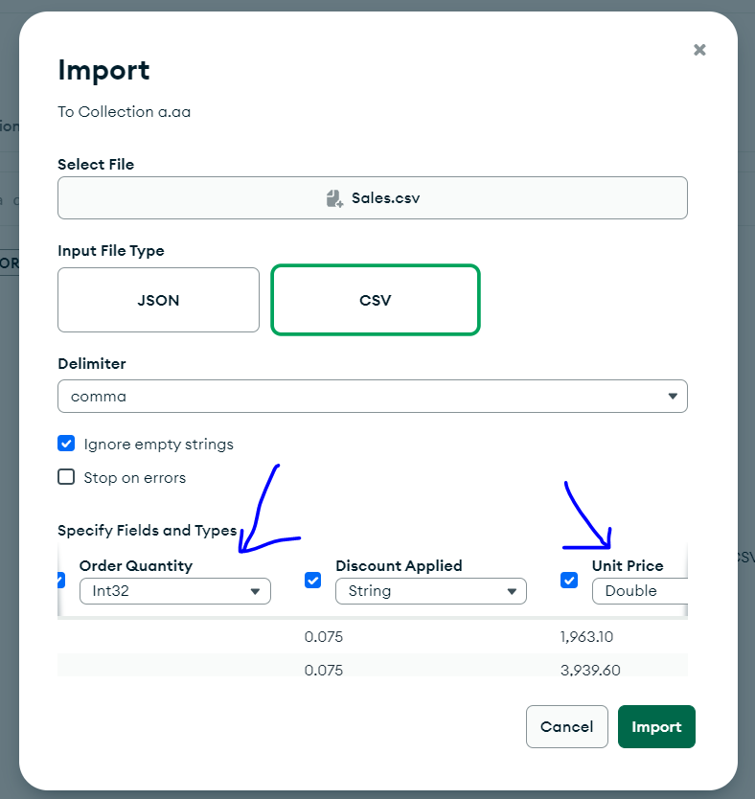
- Once data is imported you will see that the Order quantity field looks good but the Unit Price field is not. Most of them are Nan values
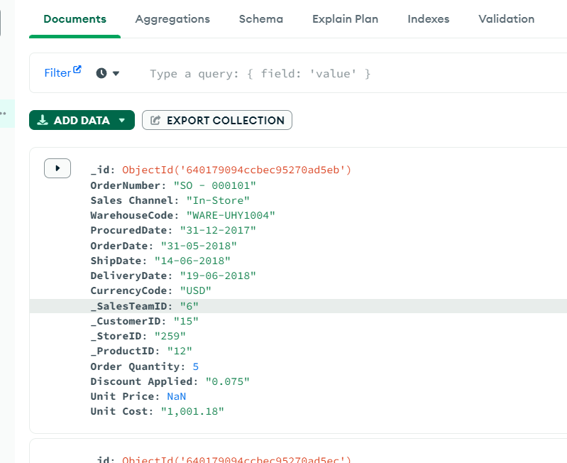

- This is happening because there are commas in the Unit Price Field Values. If you open the sales.csv file in excel you will see the following-
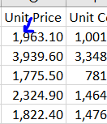

- You will frequently encounter such scenarios in real-world situations where data needs to be pre-processed before importing.
- In this case, we need to manipulate the data before importing it into MongoDB.
- Open a jupyter notebook, read the CSV file using pandas, and look at the data types of each column-
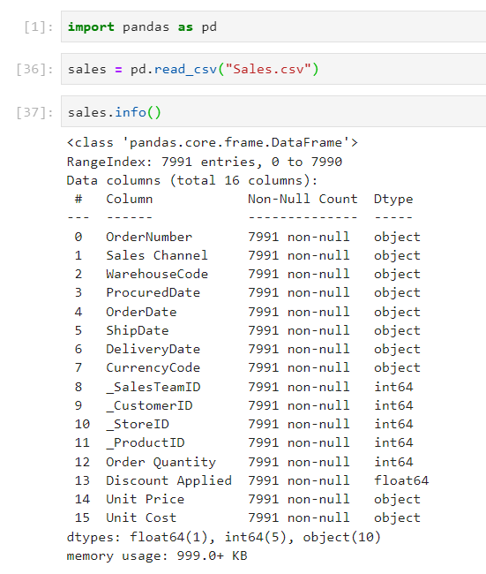
The Unit Price column is of type object.
Try to convert it to float like this-
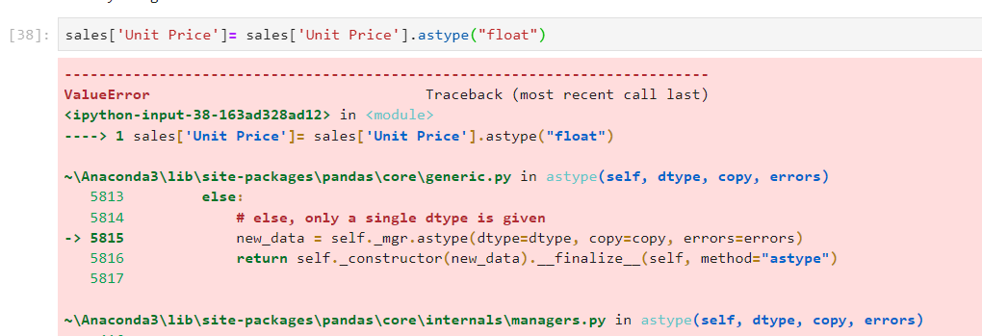
You will encounter an error like this-
This is because of the comma that’s present in the string.
Figure out what can be done to solve this error. You need to convert the given string value to a float but won’t happen because of the “comma” (,) that’s present in between the numbers. For E.g - 1,963.10.
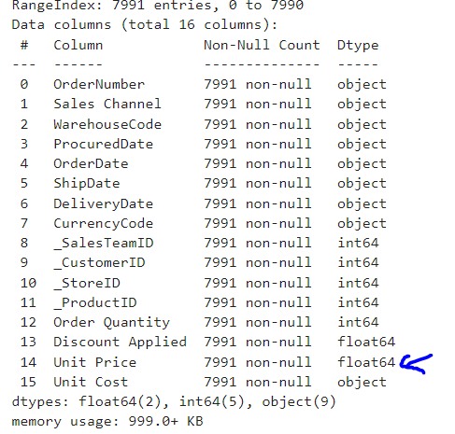

- Once this is done save the data frame as csv.
- Then import the transformed csv file into MongoDB compass into the collection sales_data that we created earlier
- Now you should be able to see the Unit Price field properly-
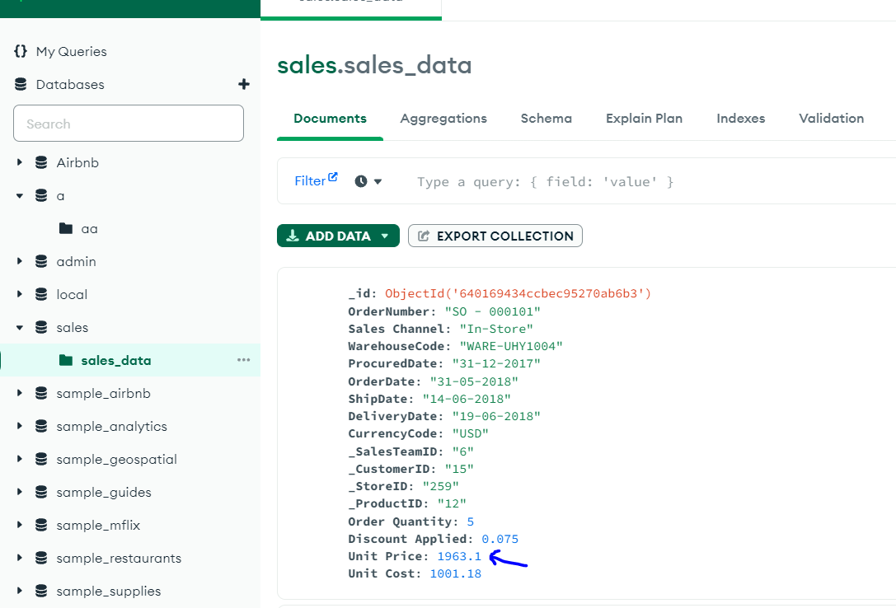
- Now login into MongoDB atlas and open the database
- You should be able to see the collection sales_data that you created before-
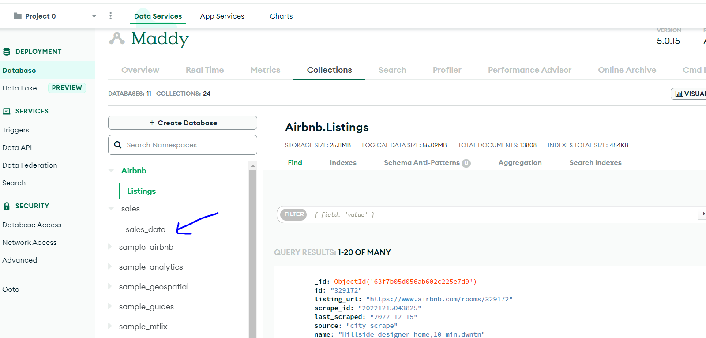
- Open Charts and then create a new dashboard
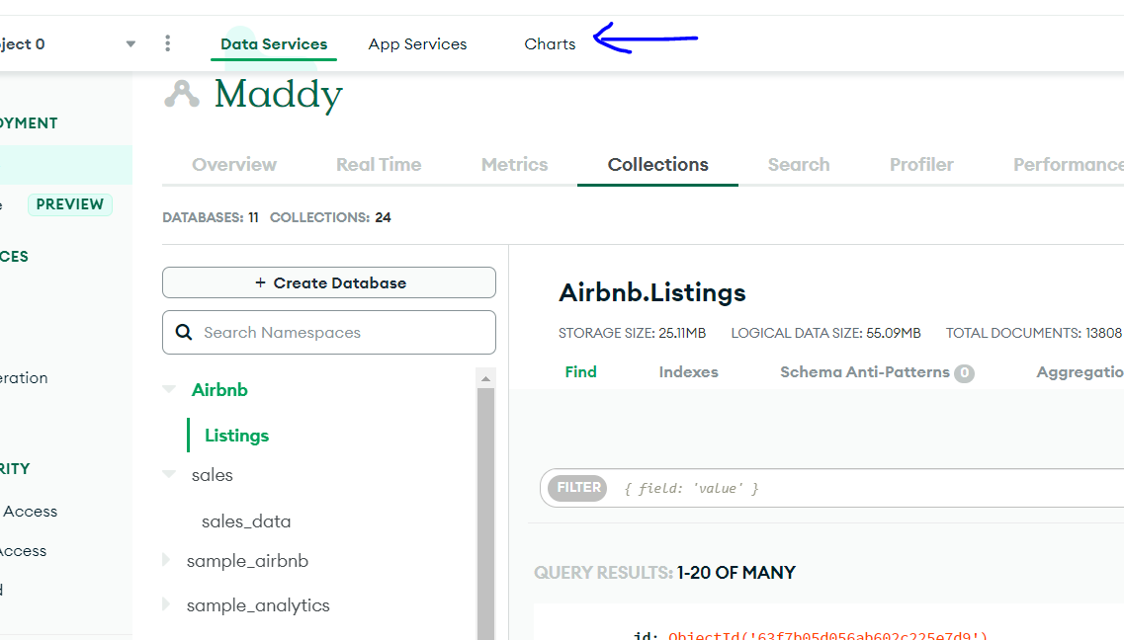
- Now click Add chart and select the sales_data collection
We need to create two charts in this lab

- Heatmap of _ProductID and total revenue
- Stacked Bar chart of _ProductID grouped by Sales Channel

But first, you need to calculate revenue by multiplying Unit Price and Order Quantity.
To do that click the + symbol-
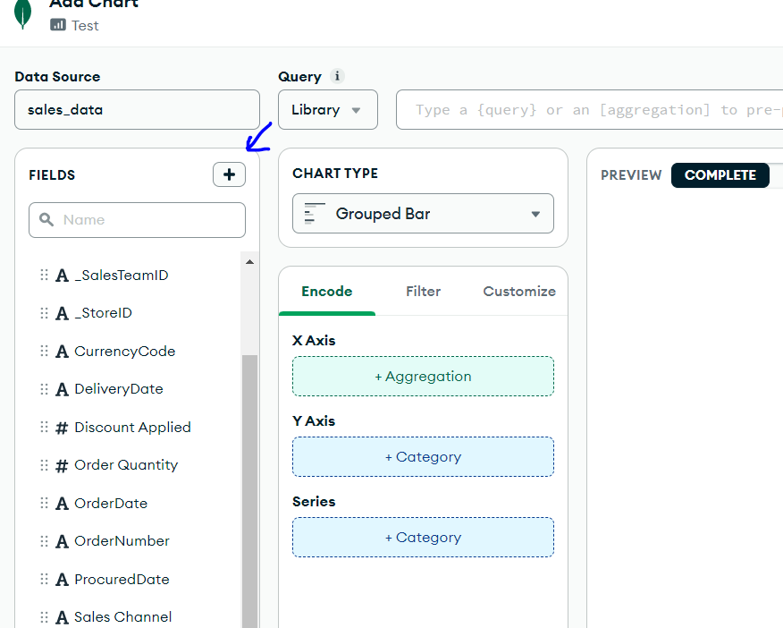

Type the query to multiply Unit Price and Order Quantity in the Value Expression field

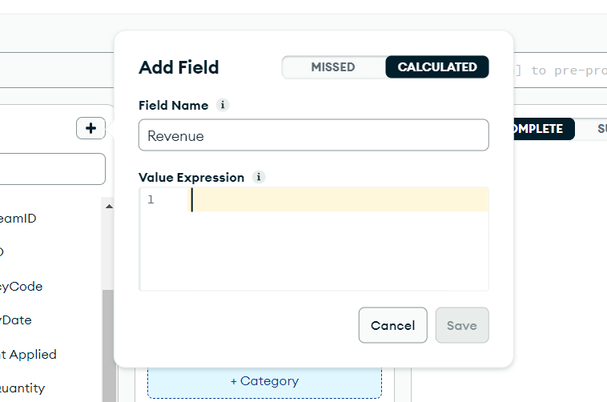

Hint- https://www.mongodb.com/docs/charts/calculated-fields/

Once you create a calculated field you can see a new column appear in the left pane-
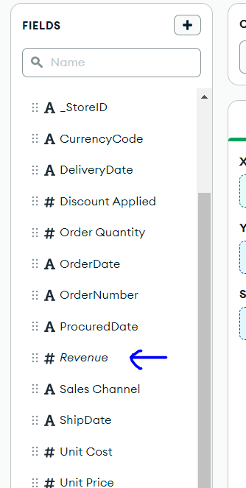

- Now create 14. A and 14. B charts using the Revenue calculated column.
Expected output-

14. A

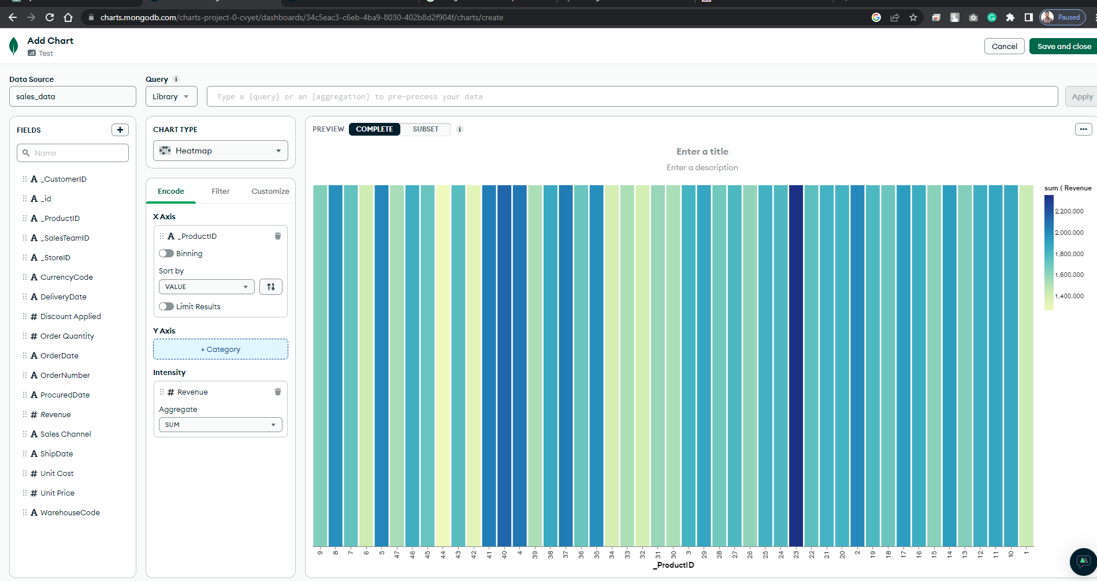

14. B

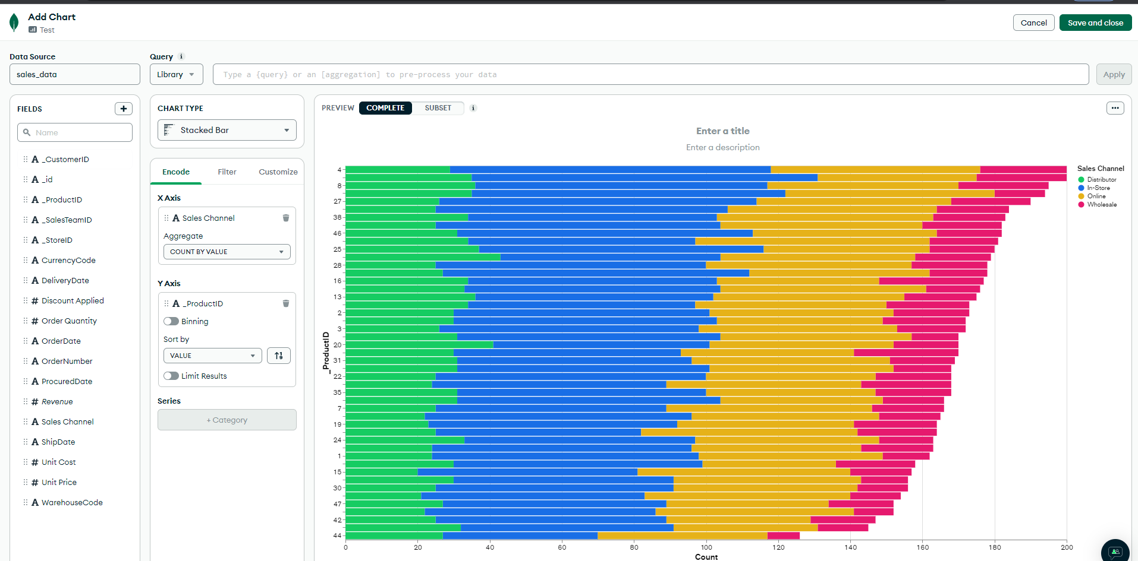

Q1
#Your Screenshot
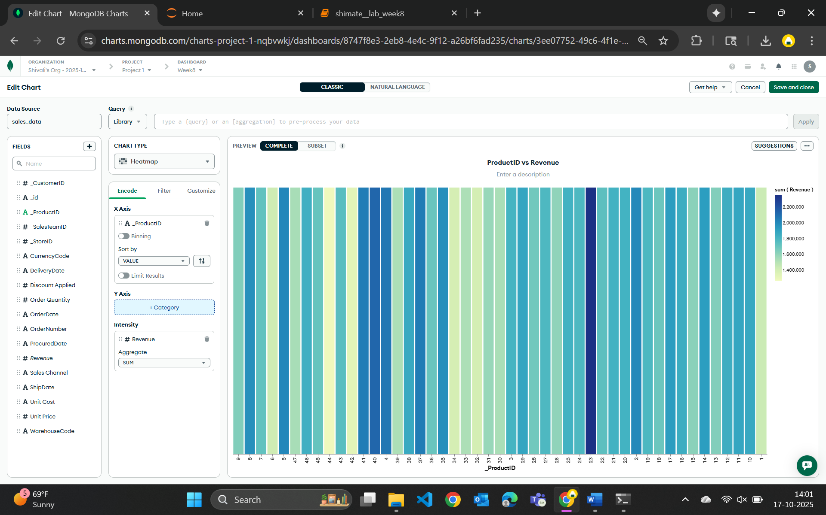
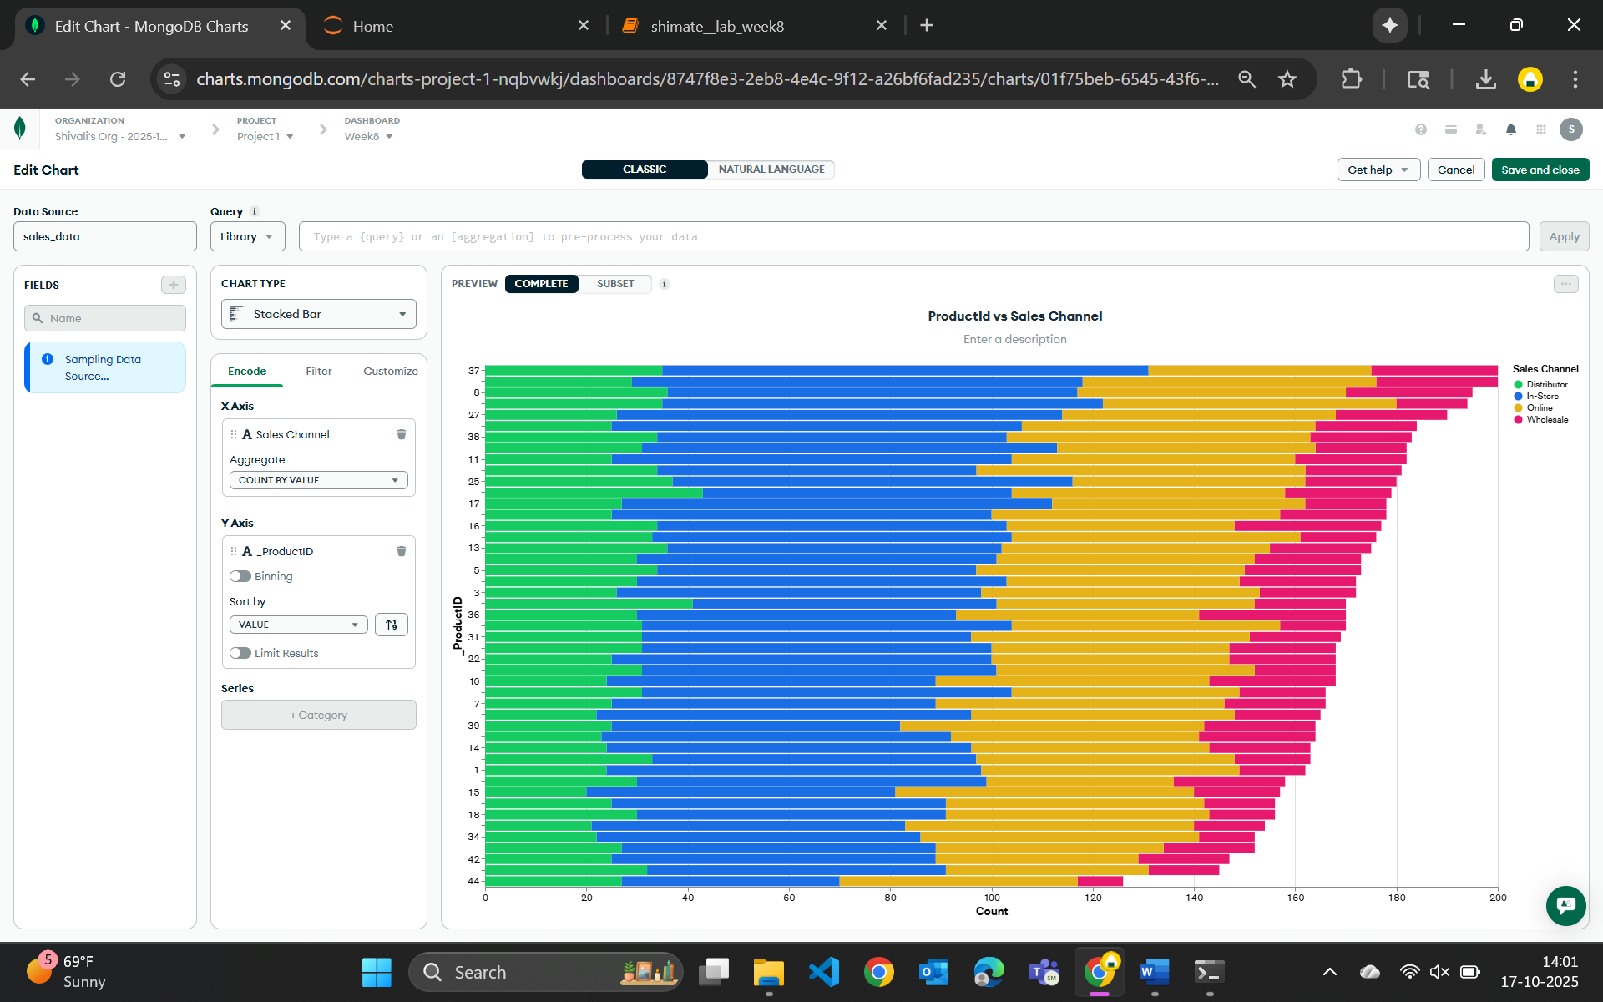
Q2
Explain your inference of these two charts -
ProductID vs Revenue (Heatmap):
This heatmap highlights the total revenue generated by each product. The darker bars indicate products that bring in higher revenue, showing that a few products, like those around IDs 22 and 39 perform significantly better than others. It gives a quick visual cue of which products are driving the most sales value.
ProductID vs Sales Channel (Stacked Bar Chart):
This chart shows how different products are sold across various sales channels. It’s clear that In-store and Online sales make up the majority for most products, while Distributor and Wholesale channels contribute less overall. The even spread suggests that many products are available across multiple channels, though their popularity differs slightly.

