Week 8 Coding Practice Submission

Part 1
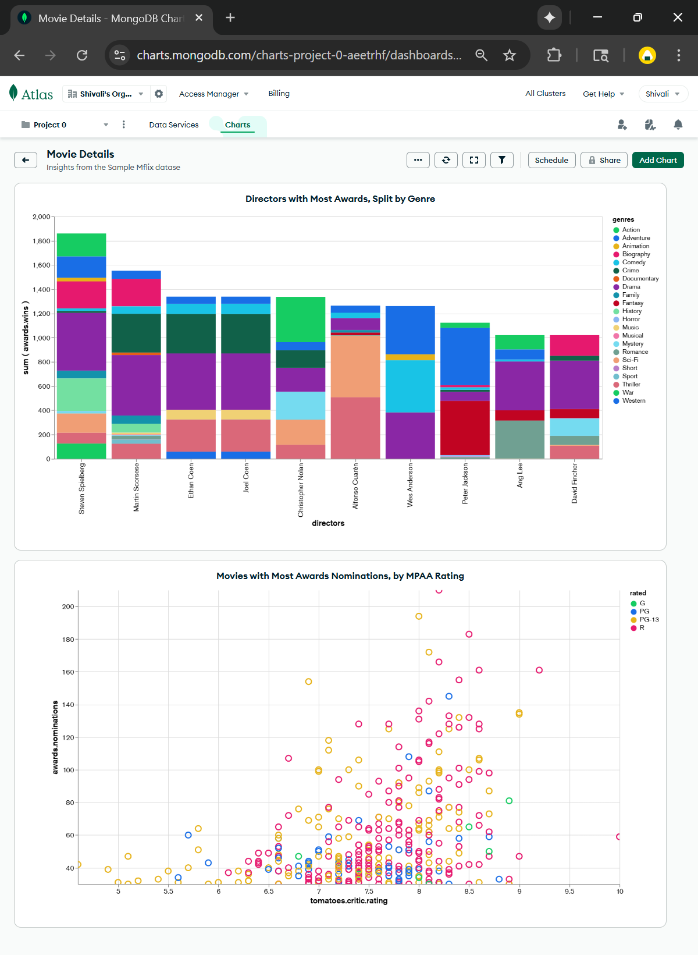
Part 2
Q Description of any troubleshooting issues, what was hard, and what did you learn (Part 2)
While setting up MongoDB, there were a few challenges connecting and uploading data. The first issue was a network timeout, which was fixed by adding the correct IP address in Atlas and allowing the right port. Then, authentication errors showed up because of wrong credentials and unencoded special characters in the URI, so the password was reset and properly formatted. In part 2, a “documents must be a non-empty list” error occurred because the script was running in a Linux environment that couldn’t access the Windows drive. After updating the file path, the connection worked smoothly. Through these steps, the learner gained a better understanding of MongoDB connections and how to troubleshoot issues across different environments.

Step 1. MongoDB Overview and Your First MongoDB Python Connection
https://colab.research.google.com/drive/176Zz3WHgntfKKIbdQYPuZuTGNnOCLa_4
Step 2. MongoClient in-depth, Import Source Data, Connect to Notebook
https://colab.research.google.com/drive/1IERxHL0dpJ4eELuT0H2PradiN3ohx7gW

