Week 9 Coding Practice Submission

Steps
- Retrieve all Person nodes
MATCH (p:Person)
RETURN p

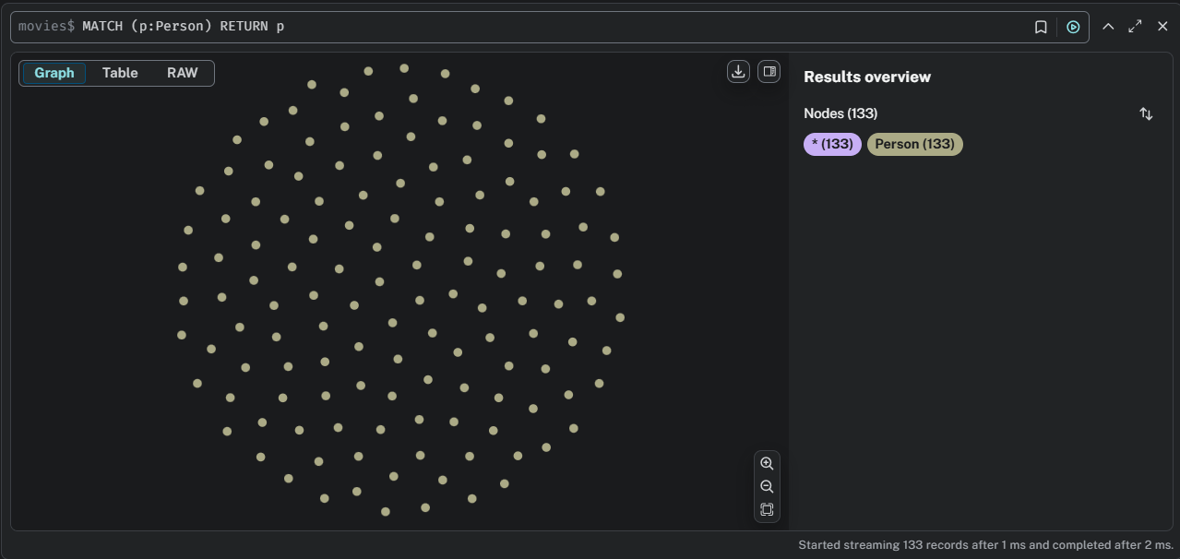

- Retrieve Person nodes that have a born property value of 1970
MATCH (p:Person {born: 1970})
RETURN p

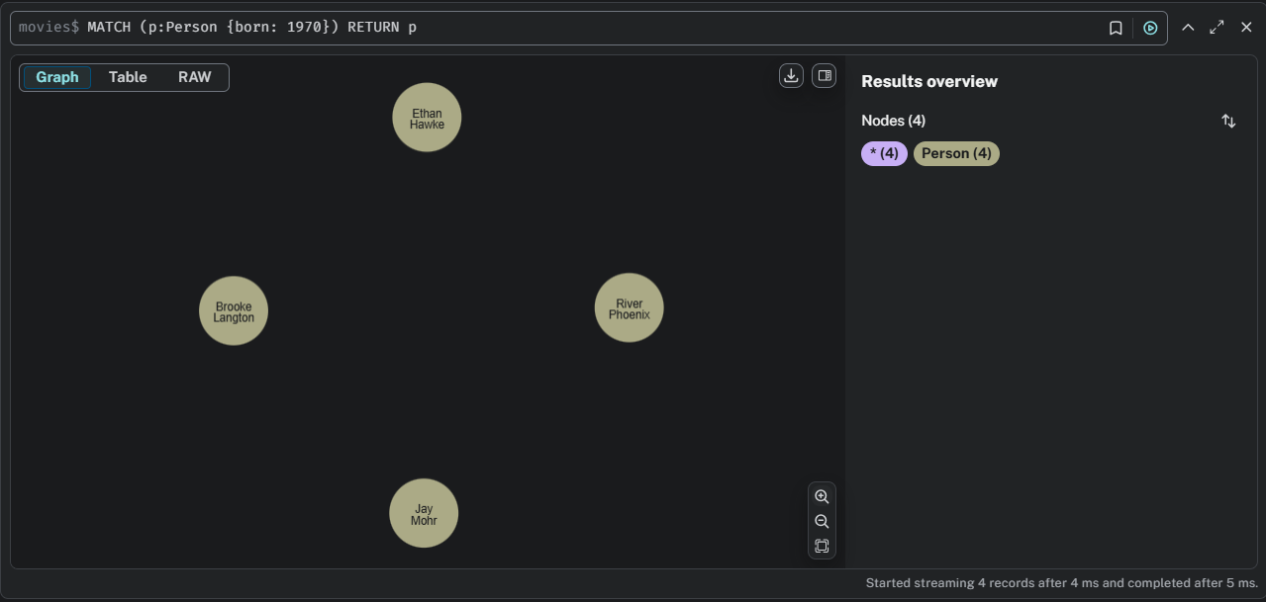

- Retrieve a movie released in 2003 with the tagline "Free your mind"
MATCH (m:Movie {released: 2003, tagline: 'Free your mind'})
RETURN m

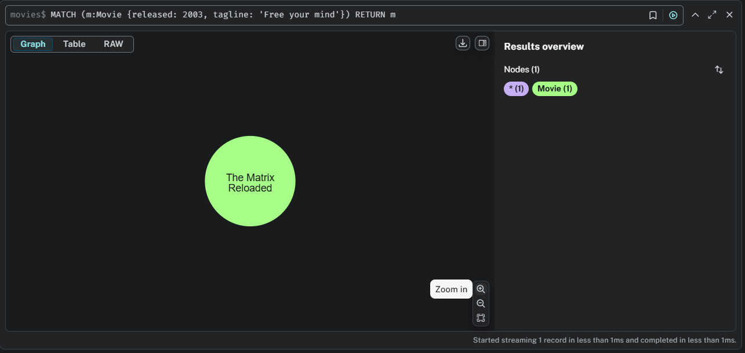

- Return property values as a table for a person born in 1965 with two columns name and year
MATCH (p:Person {born: 1965})
RETURN p.name, p.born

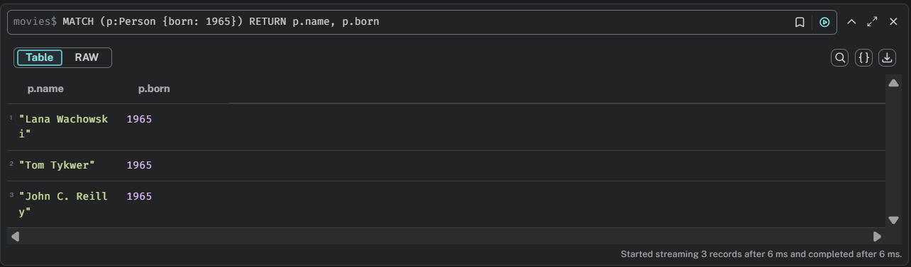

- Add aliases column headings NAME and YEAR for the query #4
MATCH (p:Person {born: 1965})
RETURN p.name AS NAME, p.born AS YEAR

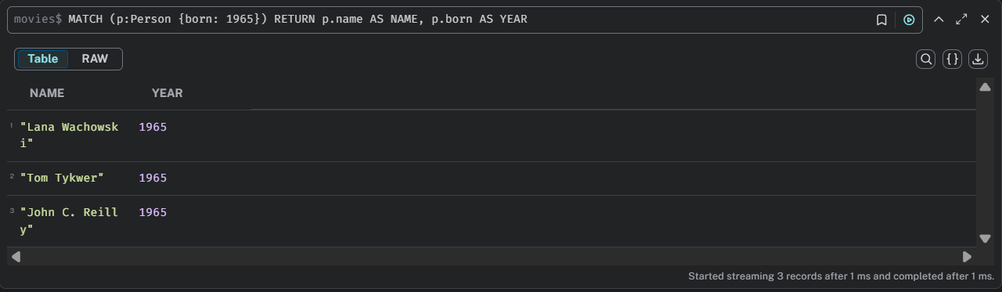

- Add aliases column headings NAME OF PERSON and YEAR BORN for the query #4
MATCH (p:Person {born: 1965})
RETURN p.name AS `NAME OF PERSON`, p.born AS `YEAR BORN`

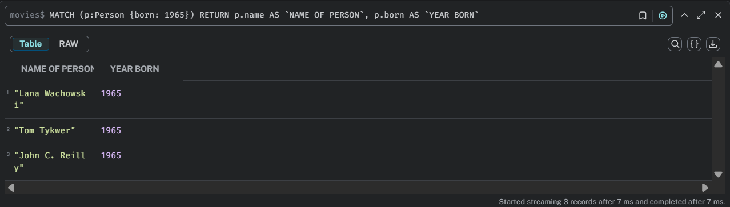

- Examine the relationship schema in the Movie database + make a screenshot
CALL db.schema.visualization()

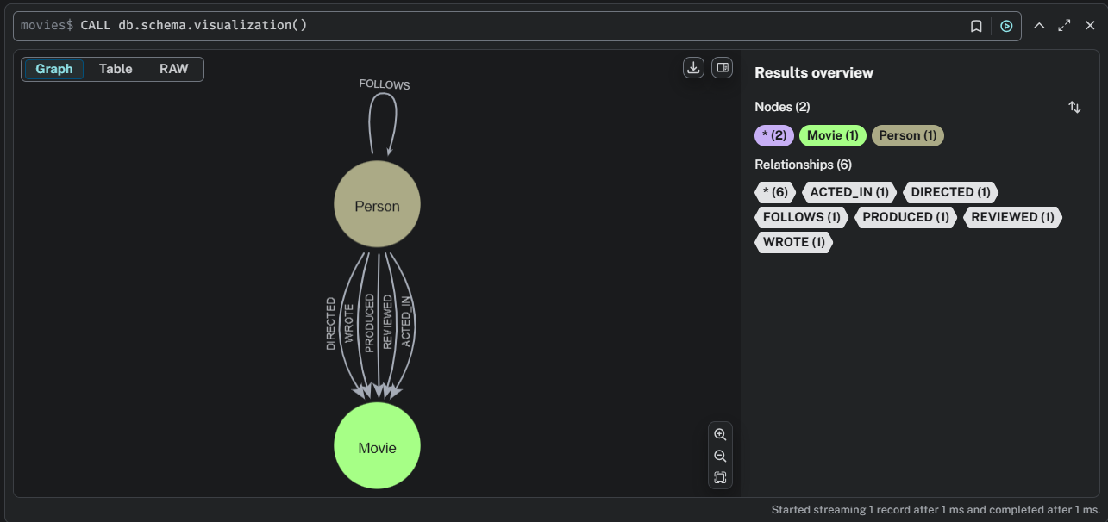

The schema visualization showed the overall structure of the Movie database, displaying how Person and Movie nodes are interconnected through relationships such as ACTED_IN, DIRECTED, PRODUCED, FOLLOWS, and REVIEWED, providing a clear overview of the data model.

- Find a person who acted in the movie "The Matrix" and return person, relation, and movie
MATCH (p:Person)-[rel:ACTED_IN]->(m:Movie {title: 'The Matrix'})
RETURN p, rel, m

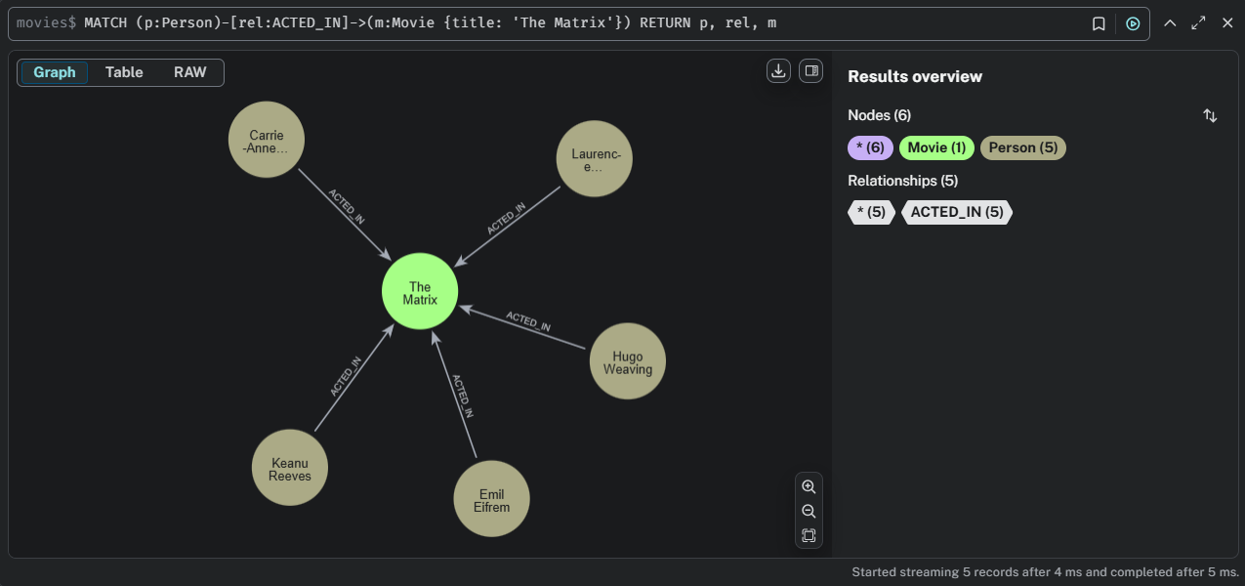

The query identified all people who acted in The Matrix, returning the person, relationship, and movie nodes. It displayed actors like Keanu Reeves, Carrie-Anne Moss, and Hugo Weaving connected through the ACTED_IN relationship.

- Retrieve all movies that are connected to Tom Hanks. Note two alternative ways of writing the same query.
MATCH (m:Movie)<--(p:Person {name: 'Tom Hanks'})
RETURN m.title
//or
MATCH (p:Person {name: 'Tom Hanks'})--> (m:Movie)
RETURN m.title

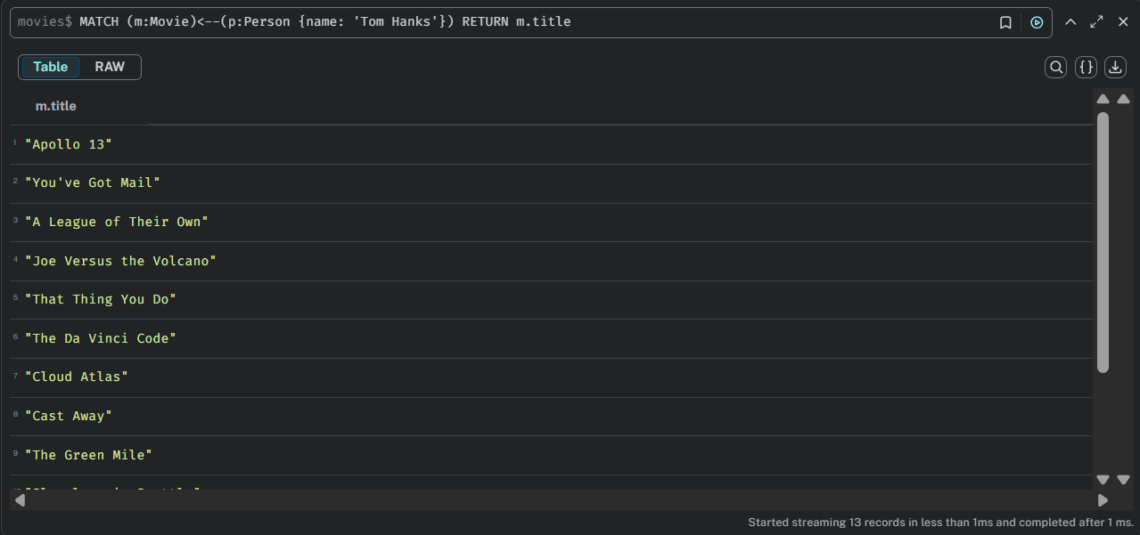

This query retrieved all movies linked to the actor Tom Hanks, showing alternative ways of writing the Cypher query. It returned a list of films such as Apollo 13, Cast Away, and The Da Vinci Code, demonstrating flexible syntax for relationship traversal.

- Return all relationships for the title "The Matrix"
MATCH (p:Person)-[rel]->(m:Movie {title:'The Matrix'})
RETURN p.name, type(rel)

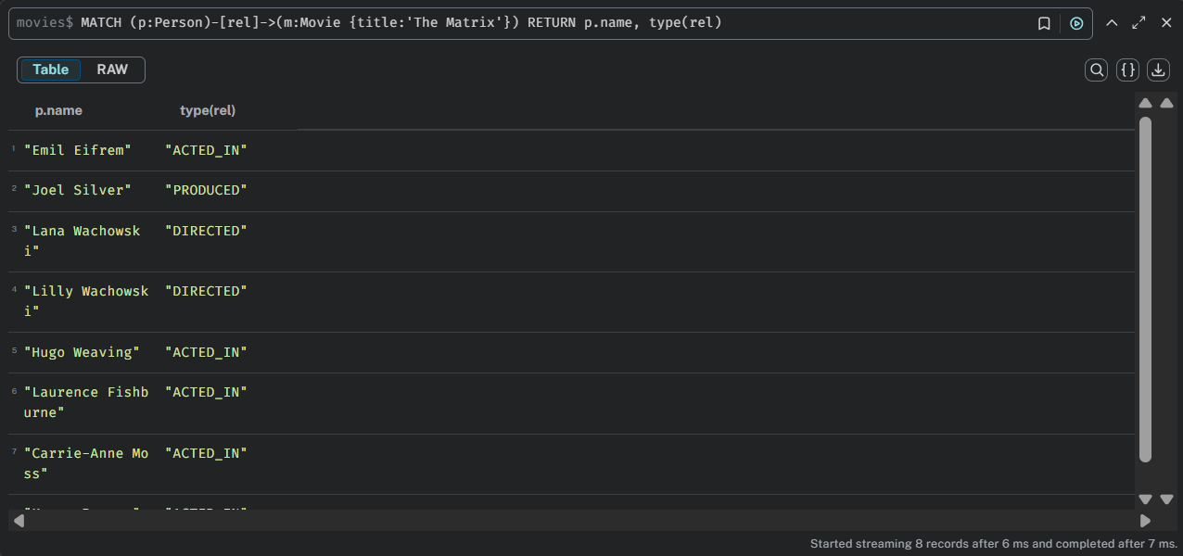

The final query listed all relationships associated with The Matrix, showing how each person (e.g., actor, director, producer) is connected to the movie and specifying the type of relationship such as ACTED_IN, DIRECTED, or PRODUCED.

- Use an anonymous relationship for the title "The Matrix"
MATCH (p:Person)--(m:Movie {title: 'The Matrix'})
RETURN p, m

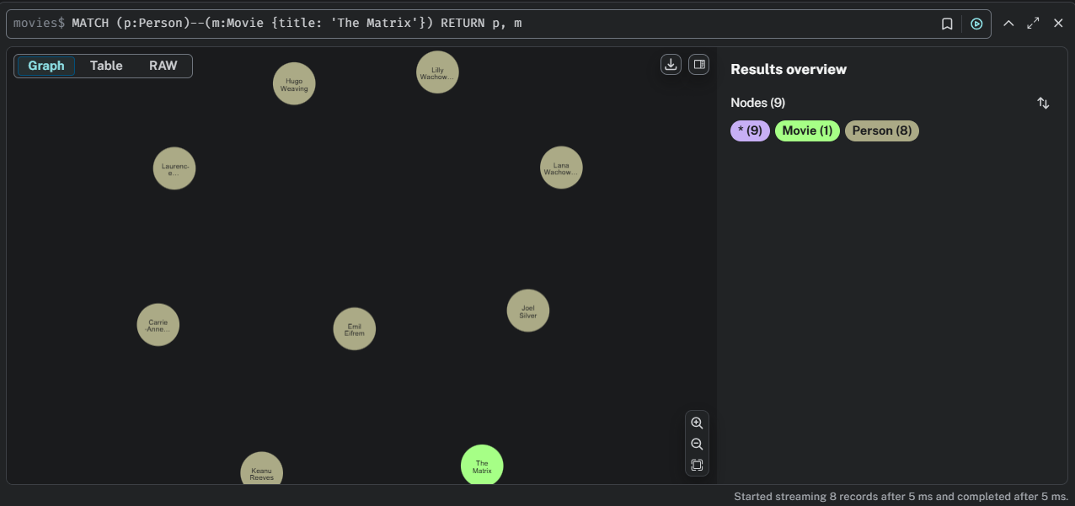

- Find who reviewed "Cloud Atlas" and return the name and rating
MATCH (p:Person)-[r:REVIEWED]->(m:Movie {title: 'Cloud Atlas'})
RETURN p.name, r.rating

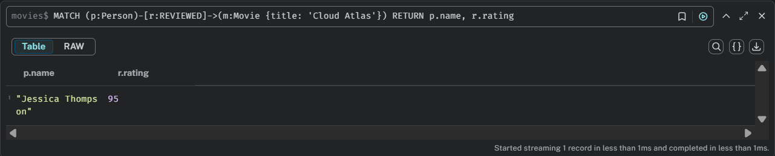

- Find all nodes (Person) who follow Angela Scope. Note: you can leave an empty variable (:Person) if you do not need to return it
MATCH (p:Person)-[:FOLLOWS]->(:Person {name:'Angela Scope'})
RETURN p

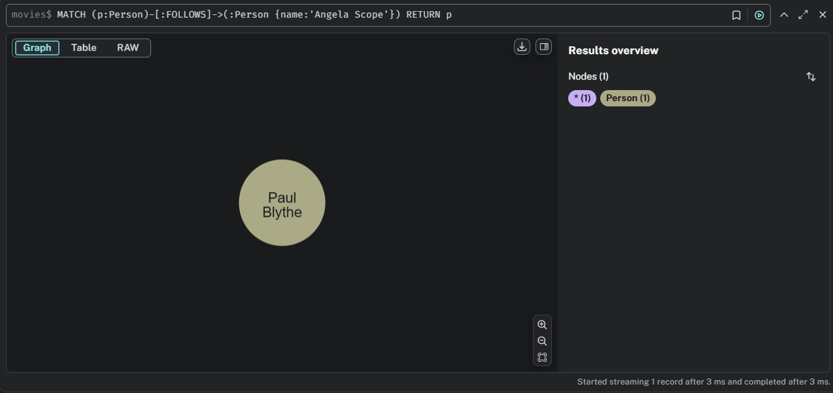

- Find a person whom Angela Scope follows. Note the change of direction.
MATCH (p:Person)<-[:FOLLOWS]-(:Person {name:'Angela Scope'})
RETURN p

