Week 9 Homework 2

Part 1: Queries Translation
Question 1
db.students.find({age: {$gte: 18, $lte: 22}});
Summary:
This query retrieves all students whose age is between 18 and 22, inclusive.
SQL Query:
SELECT * FROM students WHERE age >= 18 AND age <= 22;

Question 2
db.restaurants.find(
{
"cuisine": {$eq: "Italian"},
"grades.score": {$gte: 80},
"address.coord": {$gte: -75.754168}
}
);
Summary:
This query finds all Italian restaurants with a grade score of at least 80 and coordinates greater than -75.754168.
SQL Query:
SELECT * FROM restaurants
WHERE cuisine = 'Italian'
AND grades_score >= 80
AND address_coord >= -75.754168;

Question 3
db.restaurants.find(
{
"borough": "Manhattan",
$or: [
{"cuisine": "Mexican"},
{"cuisine": "Japanese"}
]
}
);
Summary:
This query retrieves restaurants in Manhattan that serve either Mexican or Japanese cuisine.
SQL Query:
SELECT * FROM restaurants
WHERE borough = 'Manhattan'
AND (cuisine = 'Mexican' OR cuisine = 'Japanese');
Question 4
db.restaurants.find(
{
"borough": {$in: ["Manhattan", "Queens", "Bronx", "Brooklyn"]}
},
{
"restaurant_id": 1,
"name": 1,
"borough": 1,
"cuisine": 1,
}
);
Summary:
This query selects restaurants located in any of the four main boroughs and returns only their ID, name, borough, and cuisine.
SQL Query:
SELECT restaurant_id, name, borough, cuisine
FROM restaurants
WHERE borough IN ('Manhattan', 'Queens', 'Bronx', 'Brooklyn');

Question 5
db.products.find(
{
"category": "Electronics",
"ratings": {$elemMatch: {"score": {$gte: 4.5}}},
"price": {$lt: 500}
}
);
Summary:
This query finds electronic products priced under $500 that have at least one rating with a score of 4.5 or higher.
SQL Query:
The $elemMatch operator tells MongoDB to look inside that array and find documents where at least one element matches all the given conditions, in this case to find products that have at least one rating with a score of 4.5 or more. But in SQL, you can’t store arrays like that directly, hence it is difficult to translate the query to SQL.
Part 2: Creating Charts
Collection Name: student.student_performance
Source: Kaggle https://www.kaggle.com/datasets/jayaantanaath/student-habits-vs-academic-performance

- Bar Chart
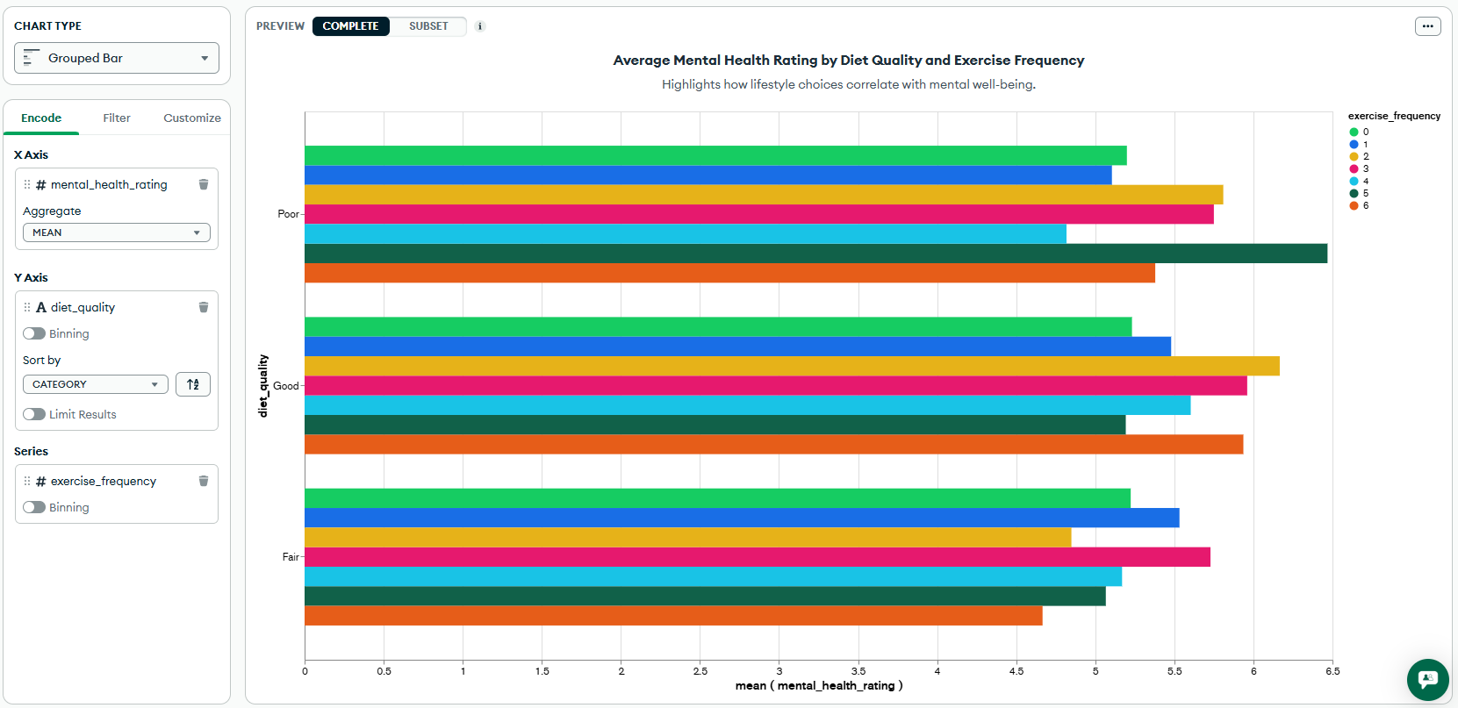

- Scatter Plot
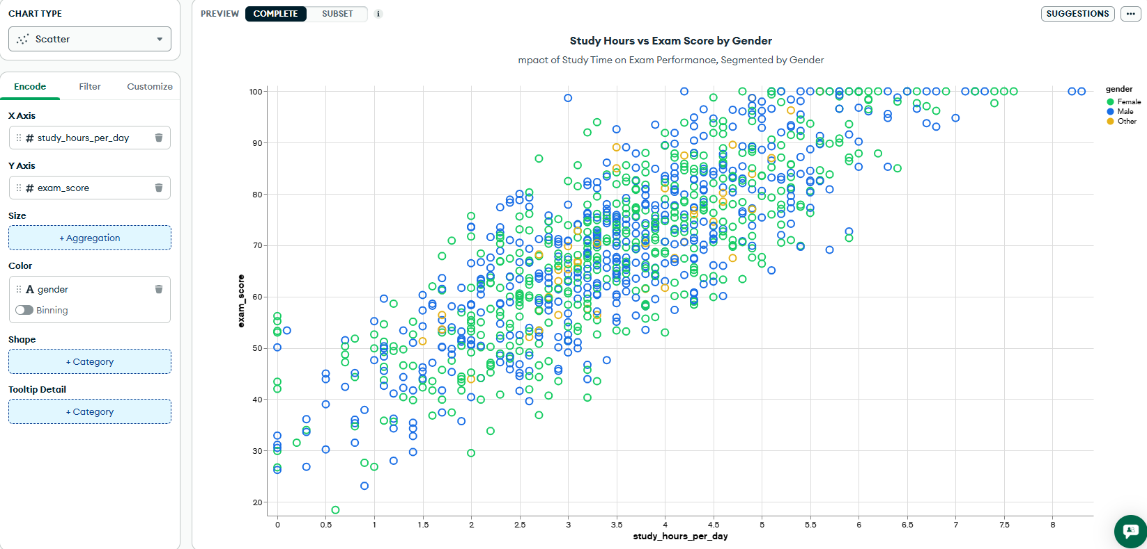
- Line Chart (A chart of choice)
Created Field: total_screen_time = social_media_hours + netflix_hours
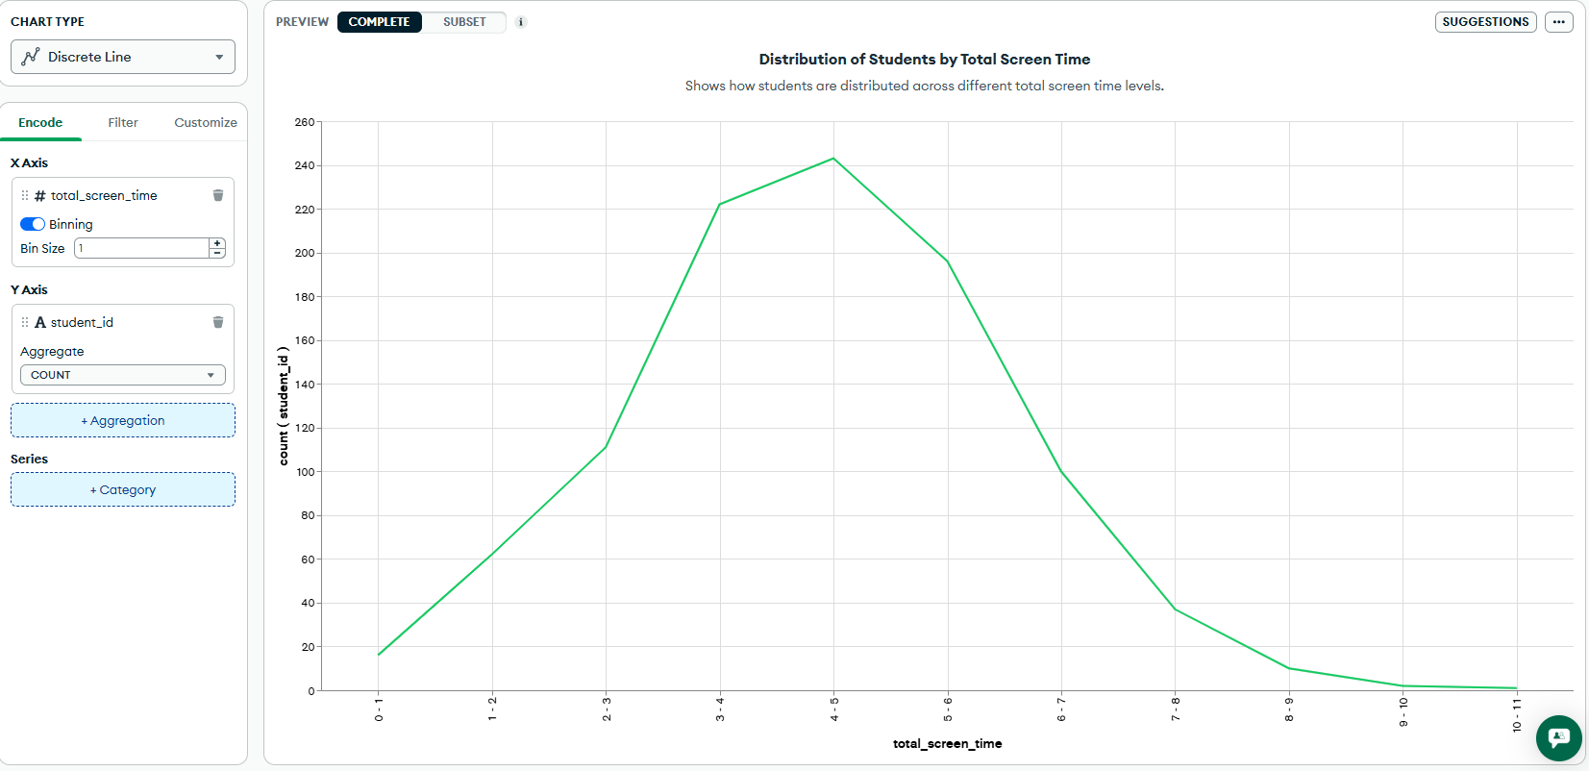
- MongoDB query to filter chart (applied on Bar chart)
Query: {exercise_frequency : {$gt : 2 }}
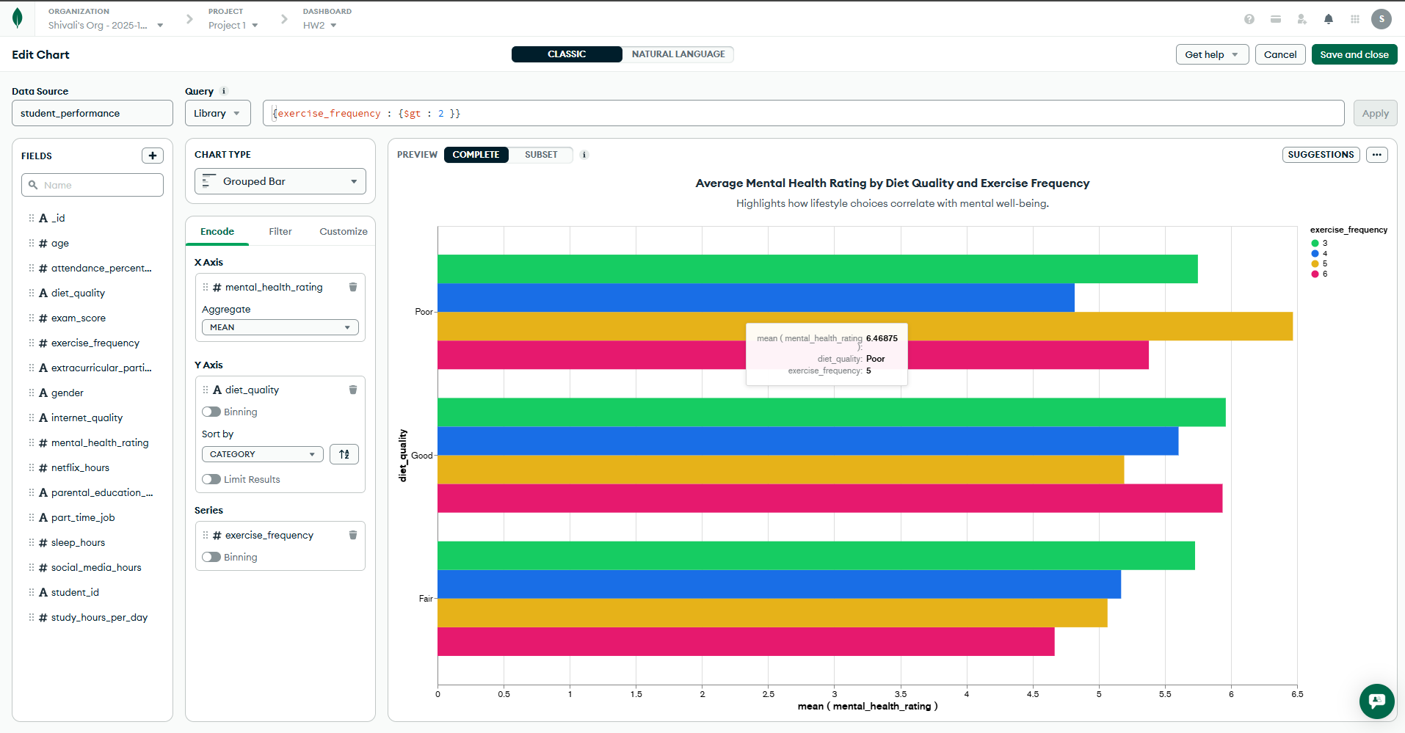

Part 3: Reflection
- Do you see yourself using NoSQL in the future (at your job, for example)?
Yes, I can definitely see myself using NoSQL in the future, especially MongoDB. It’s very flexible and works well with large or unstructured data, which is common in many modern applications. I like that it allows quick data modeling changes without needing to redesign the whole database. It’s also scalable, making it useful for real-world projects where data keeps growing.

- What was the most challenging part learning MongoDB?
The most challenging part of learning MongoDB was understanding the aggregation framework and how it differs from SQL. At first, the query structure with operators like $match, $group, and $project felt confusing. It took some time to get used to working with nested documents instead of tables. But after practicing and seeing how powerful it is for data analysis, it became much easier and more interesting to use.

