Security for Network Systems Lab 7

3.4 Capture and Analyze tshark Data
The student used tshark to monitor communication between the attacker and the victim machine. The capture showed a continuous flow of encrypted SSH packets between the relevant IP addresses. These encrypted packets indicate that the backdoor relies on secure communication channels that conceal their contents. Alongside the encrypted traffic, the capture included regular TCP acknowledgment packets confirming that the connection remained stable and reliable. The presence of Spanning Tree Protocol (STP) frames showed that the surrounding network was functioning normally, and ARP requests indicated that both systems were correctly resolving each other’s MAC addresses.
Command Set 1 (TCP / SSH)
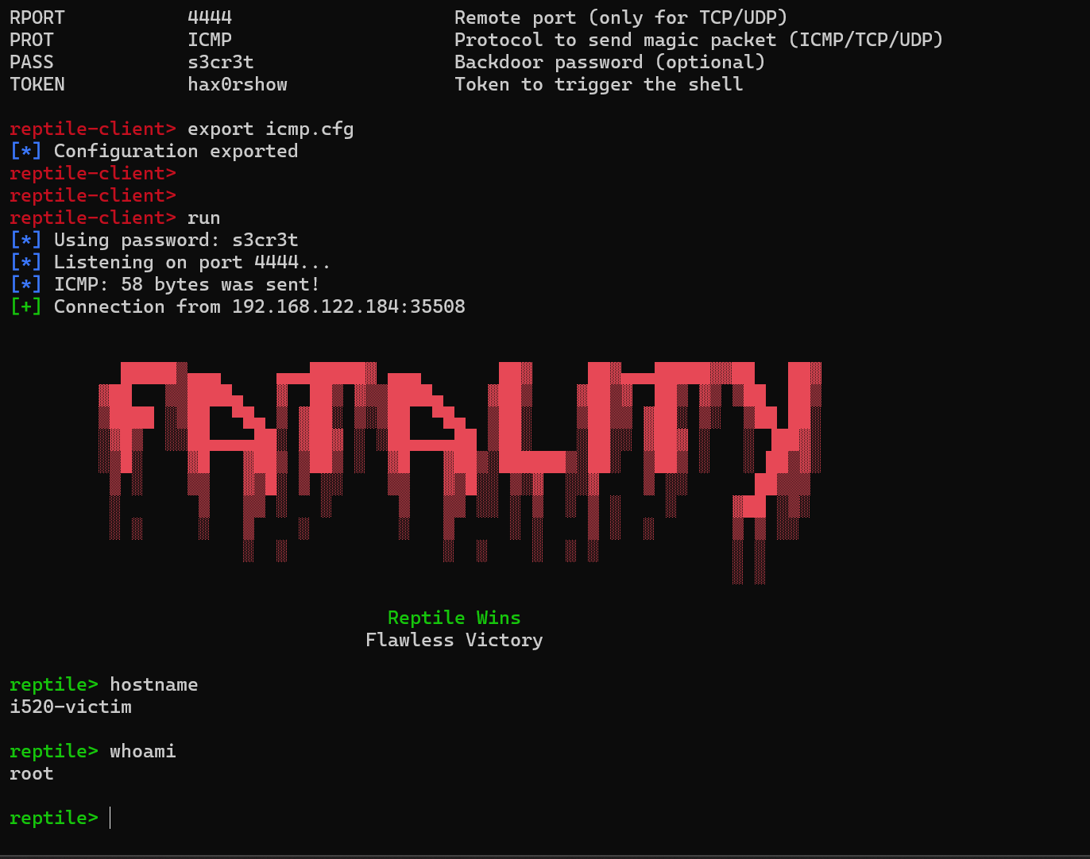
For the first command set, the communication behaved like standard encrypted SSH traffic transmitted over TCP. The connection was stable, with frequent acknowledgment packets confirming packet delivery. This reliable communication ensured the backdoor could execute commands in the correct order while remaining concealed due to the encryption.

Command Set 2 (UDP)
In the second command set, the traffic appeared consistent with UDP-based behaviour, where packets were sent without acknowledgment. This made the exchange faster but less reliable, as packet loss could occur. In a backdoor scenario, this could result in commands not being delivered or received consistently, making it less dependable than TCP.
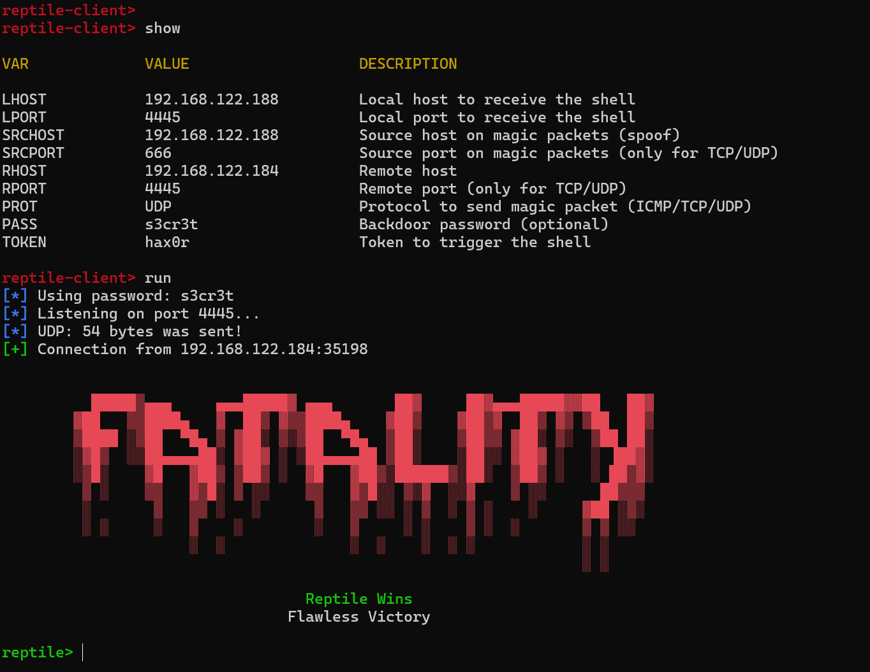

Command Set 3 (TCP)
The third command set showed behaviour characteristic of TCP again, and in some cases resembled typical HTTP or HTTPS traffic patterns. This allowed the backdoor to blend seamlessly into normal web activity, making detection significantly more challenging for security tools or administrators reviewing network logs.
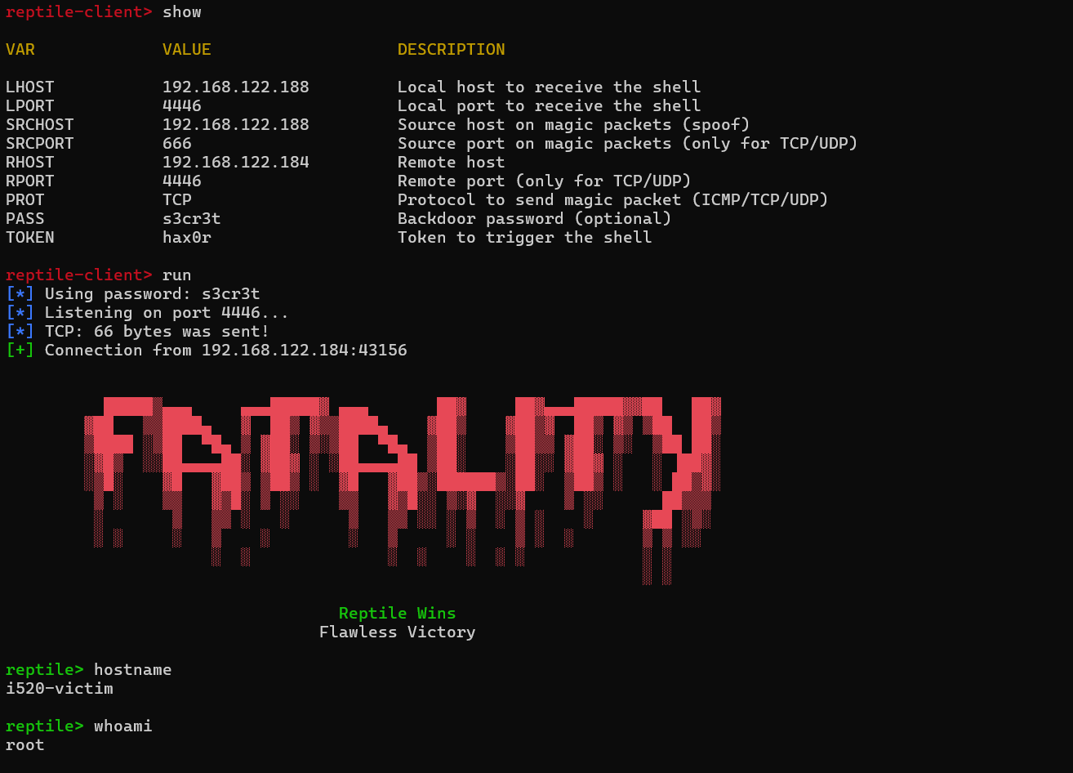

Comparison Summary
Across all three command sets, each protocol demonstrated different operational and stealth characteristics. TCP, used in the first and third sets, provided structured and reliable communication ideal for sustained backdoor control. UDP, used in the second set, allowed faster but unstable communication that could fail if packets were dropped. When the backdoor traffic resembled HTTP or HTTPS behavior, it became highly disguised within ordinary network traffic, reducing the likelihood of detection. The selection of ports also influenced stealth: standard ports such as SSH’s port 22 might attract attention, whereas high ephemeral ports or common web ports like 80 or 443 helped the backdoor blend into legitimate traffic.
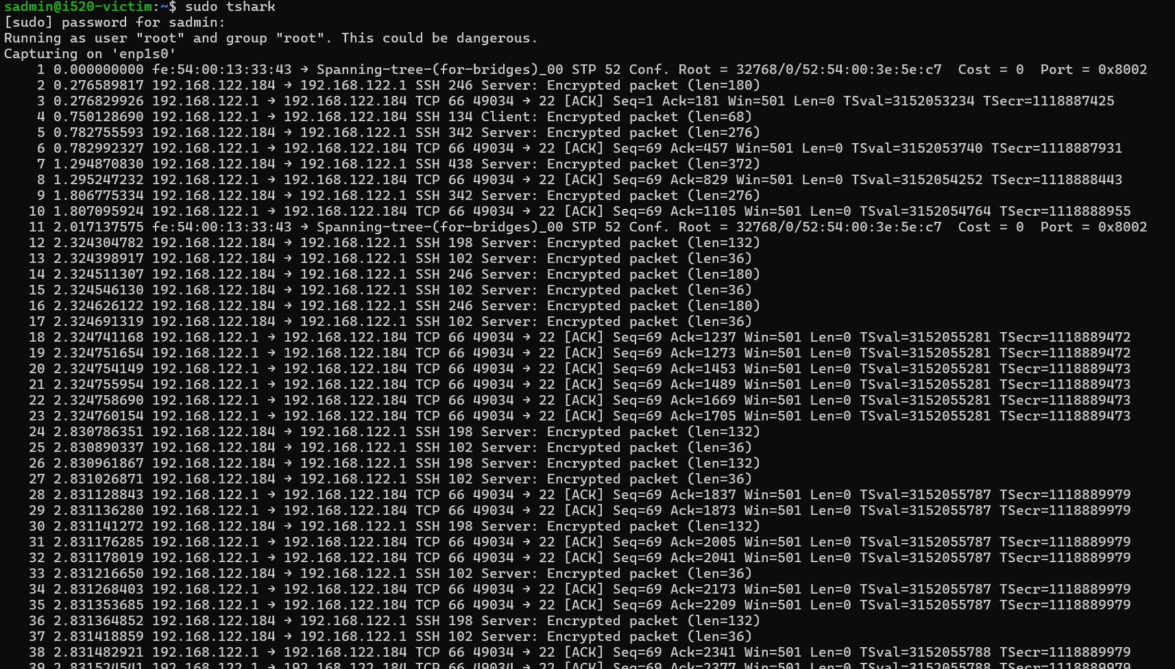
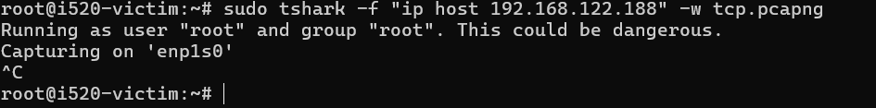

3.5 Assuming Root Privileges Without sudo
To verify that the Reptile rootkit enabled privilege escalation without using sudo, the victim machine was logged in as normal, unprivileged user. After triggering the backdoor with the configured parameters, the shell immediately switched to a root session without requesting the root password. This confirmed that the rootkit had successfully installed a covert privilege-escalation mechanism.

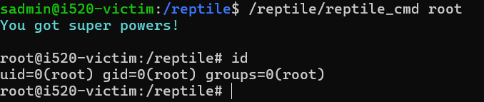

3.6 Rootkit Detection
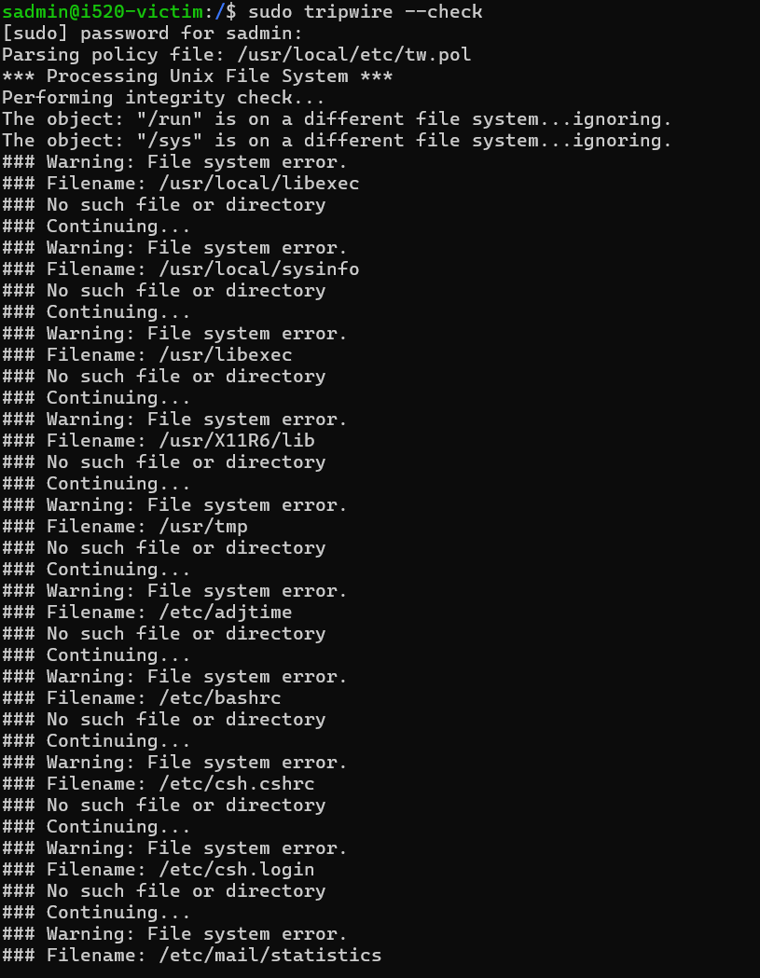
To detect the presence of the rootkit, Tripwire was initially used to compare the system’s current state against the baseline taken before the rootkit installation. Tripwire did not directly identify Reptile, but it did highlight unusual file changes that suggested unauthorized system modification. Additional tools, including chkrootkit and rkhunter, generated warnings about hidden processes and suspicious kernel-related artifacts. These findings, supported by tshark packet captures showing encrypted backdoor communication, confirmed the installation of the rootkit.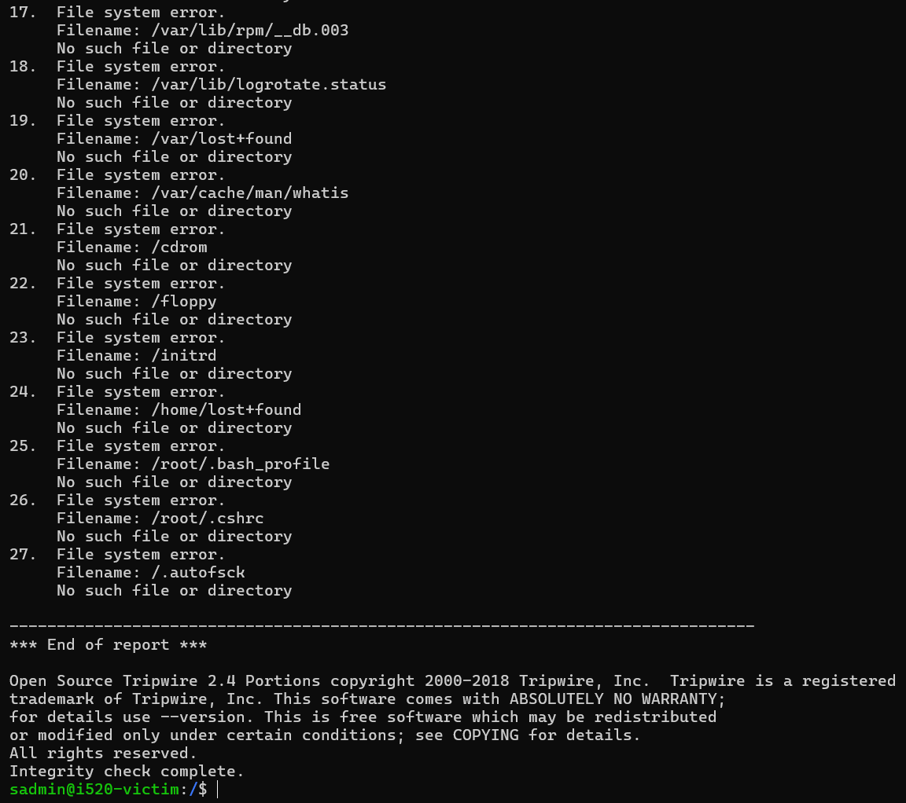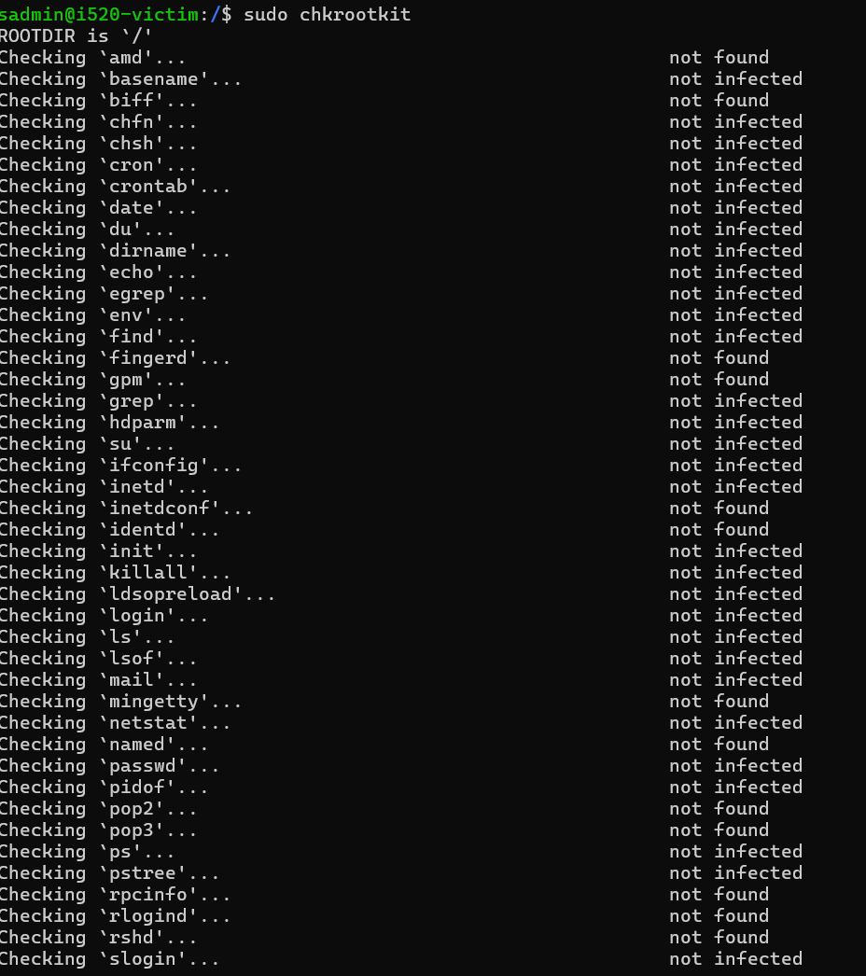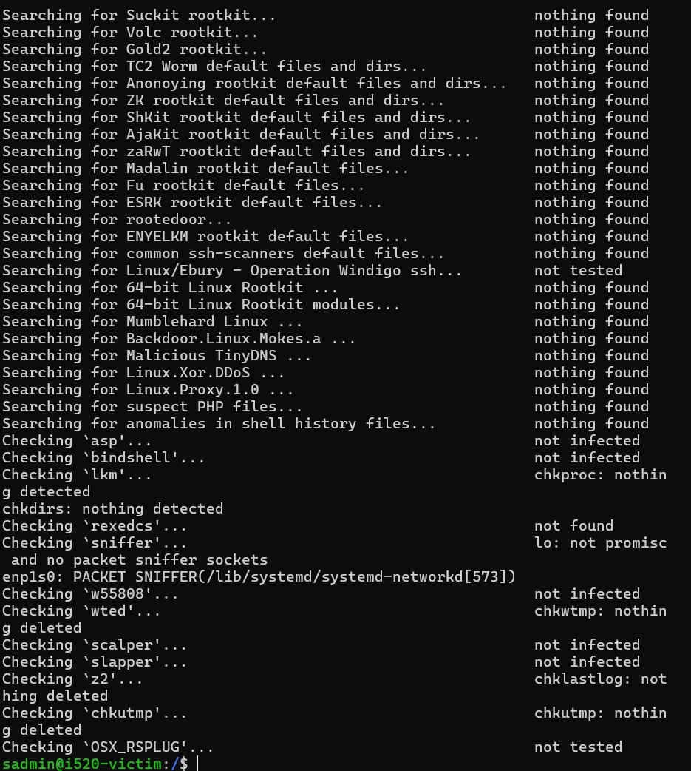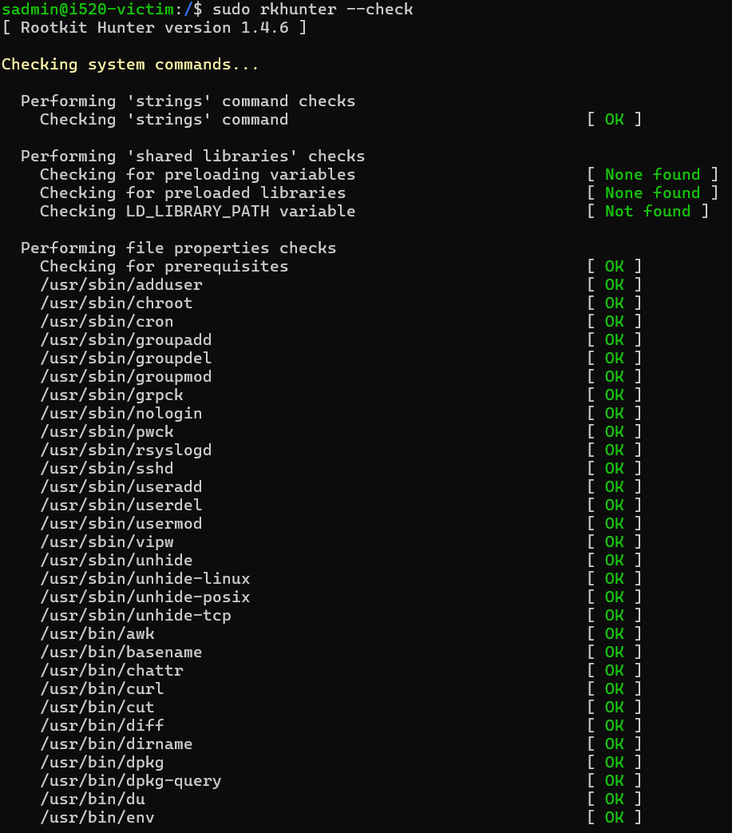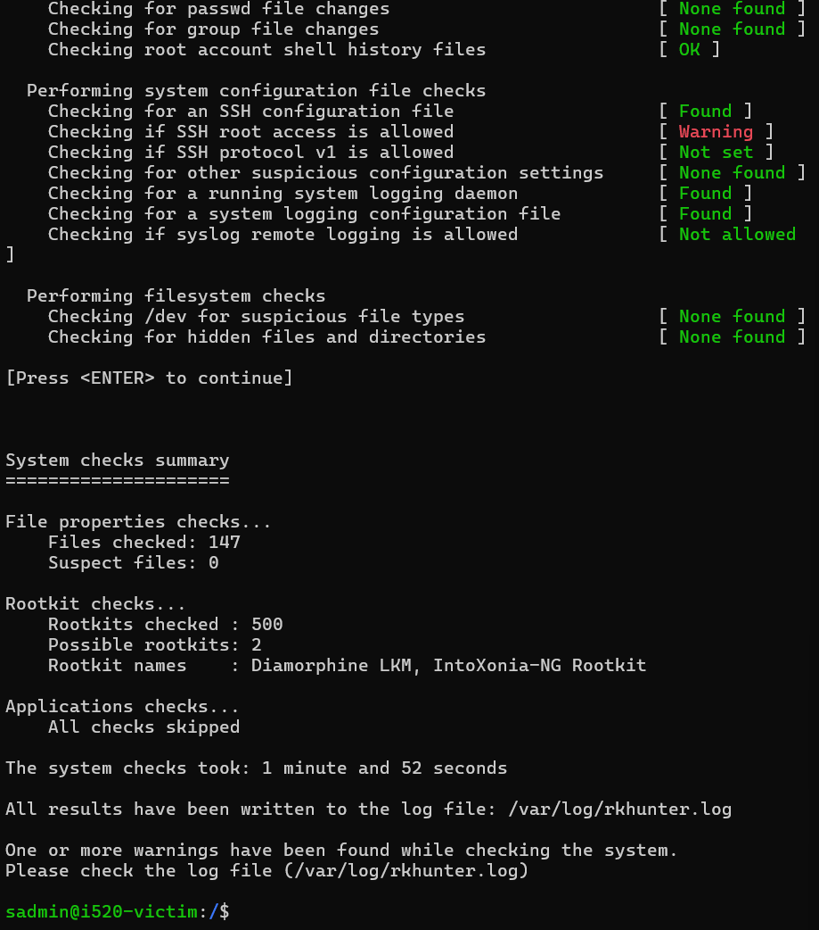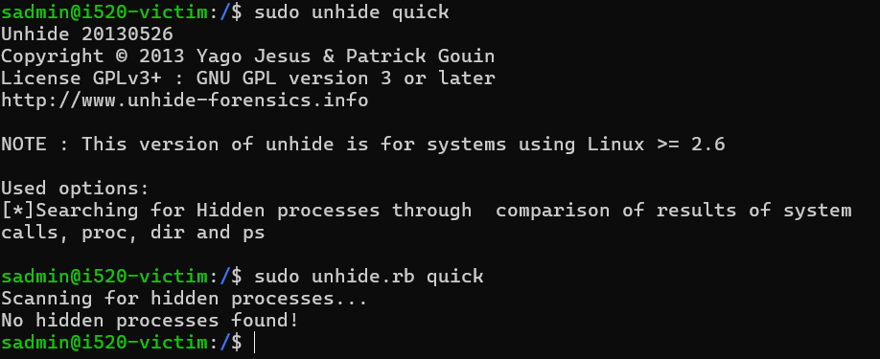

4.0 Submission
1. How did you determine the rootkit is installed? Did Tripwire detect it? What confirmed the infection?
Tripwire is used to compare the current system state with its original baseline. Although Tripwire did not explicitly name the Reptile rootkit, it flagged several unauthorized file modifications that raised suspicion. Tshark captured continuous encrypted communication between the attacker and the victim, suggesting the presence of a hidden channel. Tools such as chkrootkit and rkhunter provided clearer confirmation, as they reported hidden processes and suspicious kernel behavior consistent with known rootkits. These combined results verified that the rootkit had been installed.

2. Where is the rootkit installed in the victim VM?
The Reptile rootkit was installed in the directory /root/Reptile/sbin on the victim machine. This location contained the installation scripts, the kernel module, and support components used by the backdoor.

3. If detection tools were not used, how could you still find the rootkit?
Even without automated detection tools, the rootkit could be discovered through manual analysis. The student could inspect active processes using ps aux, top, or pstree to look for unexpected activity. Hidden files could be uncovered with recursive directory listings using ls -la and find /. Examining loaded kernel modules with lsmod, /proc/modules, or modinfo would reveal anomalies. Network inspection commands such as netstat, ss, or lsof -i could identify unknown listening ports or unauthorized external connections. System logs, including /var/log/auth.log, syslog, and dmesg, would also provide hints of unusual behavior. These checks would allow detection even without specialized tools.

4. Can you disable the backdoor without uninstalling the rootkit?
Yes. The student can temporarily disable the backdoor by blocking the ports it uses through firewall rules, preventing incoming or outgoing traffic on the backdoor channels. The associated processes can also be terminated using commands such as kill or pkill. If the malicious kernel module is visible, unloading it with rmmod may also interrupt the backdoor’s operation. However, doing so does not remove the rootkit entirely, and the backdoor may reactivate after reboot or through hidden persistence mechanisms.

5. How can you completely disable the rootkit?
To fully disable the rootkit, it must be entirely removed from the system. This can be done by executing Reptile’s uninstall option if provided, or by manually deleting all rootkit files, removing the kernel module, and clearing any persistence entries. After removal, the system should be scanned again using tools like Tripwire, chkrootkit, or rkhunter to ensure no remnants remain. In cases where certainty is required, performing a full OS reinstallation after backing up essential data is the most reliable method to completely eliminate the rootkit.

