**Updated Query Written In Last Part: First is previous query After which new query is written (See Below at page no 2)**

**Changes asked to do were : change grouping from zip to month.**

**SELECT NAME, ZIP, CALQUARTER, SUM(EXTCOST) AS TOT_COST, COUNT(*) AS COUNT**

**FROM INVENTORY_FACT , CUST_VENDOR_DIM , DATE_DIM**

**WHERE TRANSTYPEKEY = 5**

**AND**

**DATE_DIM.CALYEAR BETWEEN 2011 AND 2012**

**AND**

**INVENTORY_FACT.CUSTVENDORKEY = CUST_VENDOR_DIM.CUSTVENDORKEY**

**GROUP BY GROUPING SETS((CUST_VENDOR_DIM.NAME, CUST_VENDOR_DIM.ZIP, DATE_DIM.CALQUARTER), (CUST_VENDOR_DIM.NAME, CUST_VENDOR_DIM.ZIP),**

**(CUST_VENDOR_DIM.NAME, DATE_DIM.CALQUARTER), (CUST_VENDOR_DIM.ZIP, DATE_DIM.CALQUARTER), CUST_VENDOR_DIM.NAME, CUST_VENDOR_DIM.ZIP, DATE_DIM.CALQUARTER, ());**

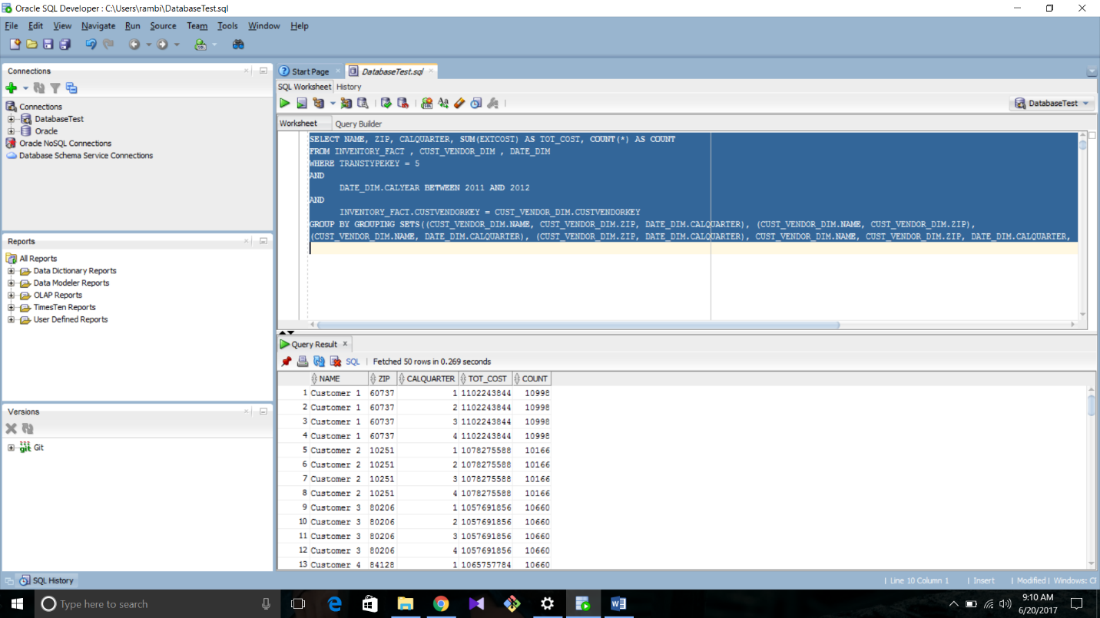

**UPDATED: QUERY :**

**SELECT NAME, DATE_DIM.CALMONTH, CALQUARTER, SUM(EXTCOST) AS TOT_COST, COUNT(*) AS COUNT**

**FROM INVENTORY_FACT , CUST_VENDOR_DIM , DATE_DIM**

**WHERE TRANSTYPEKEY = 5**

**AND**

**DATE_DIM.CALYEAR BETWEEN 2011 AND 2012**

**AND**

**INVENTORY_FACT.CUSTVENDORKEY = CUST_VENDOR_DIM.CUSTVENDORKEY**

**GROUP BY GROUPING SETS((CUST_VENDOR_DIM.NAME, DATE_DIM.CALMONTH, DATE_DIM.CALQUARTER), (CUST_VENDOR_DIM.NAME, DATE_DIM.CALMONTH),**

**(CUST_VENDOR_DIM.NAME, DATE_DIM.CALQUARTER), (DATE_DIM.CALMONTH, DATE_DIM.CALQUARTER), CUST_VENDOR_DIM.NAME, DATE_DIM.CALMONTH, DATE_DIM.CALQUARTER, ());**

