Gujarat Technological University
Chandkheda, Ahmedabad



Ahmedabad Institute of Technology
Gota-Ognaj Road, Ahmedabad (Affiliated with GTU)

A Summer Internship Report on

“Aerolytics: Tracking Every Flight Insight, From Takeoff to Touchdown ”

At the company
At BrainyBeam Info-Tech Pvt Ltd
Under the subject
Summer Internship (3170001)

Information Technology Department
Submitted By

Name : Enrollment No:
Krish Naileshbhai Patel 220020116034

2025-26

Ahmedabad Institute of Technology
(Affiliated with GTU)

DEPARTMENT OF INFORMATION TECHNOLOGY

COMPLETION CERTIFICATE

This is to certify that the Summer Internship at At BrainyBeam Info-Tech Pvt Ltd has been satisfactorily completed by Krish Naileshbhai Patel (220020116034) under my guidance in the partial fulfillment of the course Summer Internship (3170001) work during the academic year 2025-2026.

Mrs. VANITA G DANDHWANI Mr. Vipul Patel Sagar Jasani
Internal Guide HOD (IT) External Guide

GTU Internship Completion Certificate
(Download from PMMS Portal, Take a Color Print ,
Get it Signed by your Internal Guide and attach here)

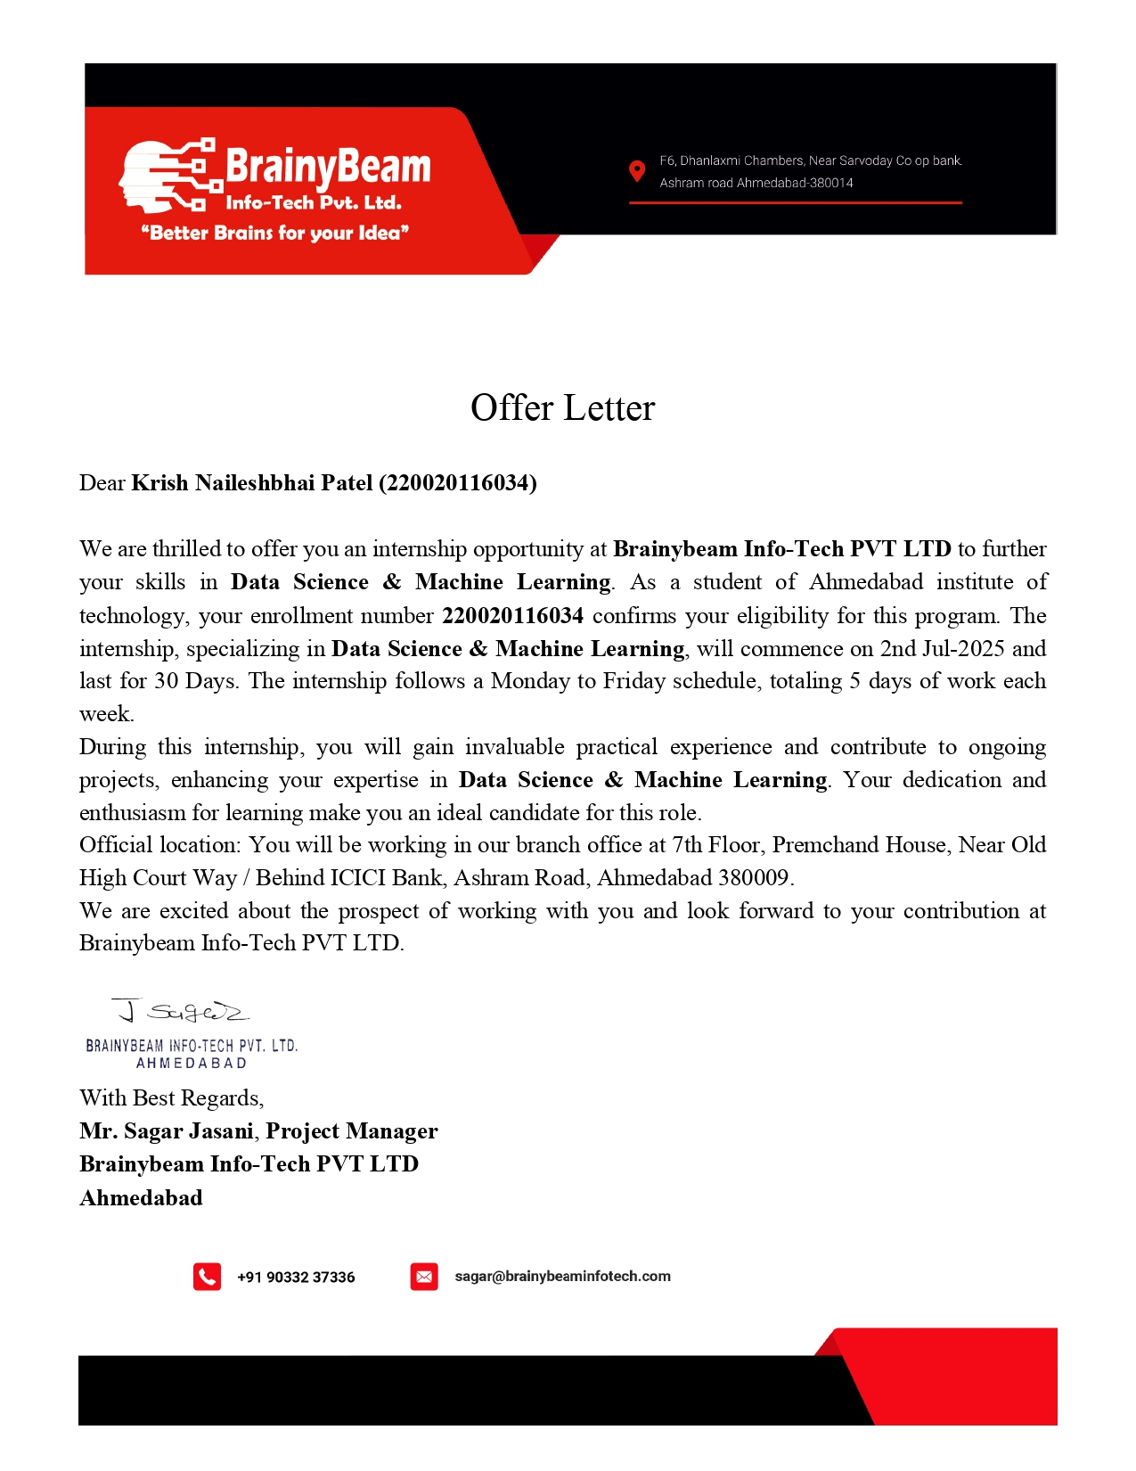
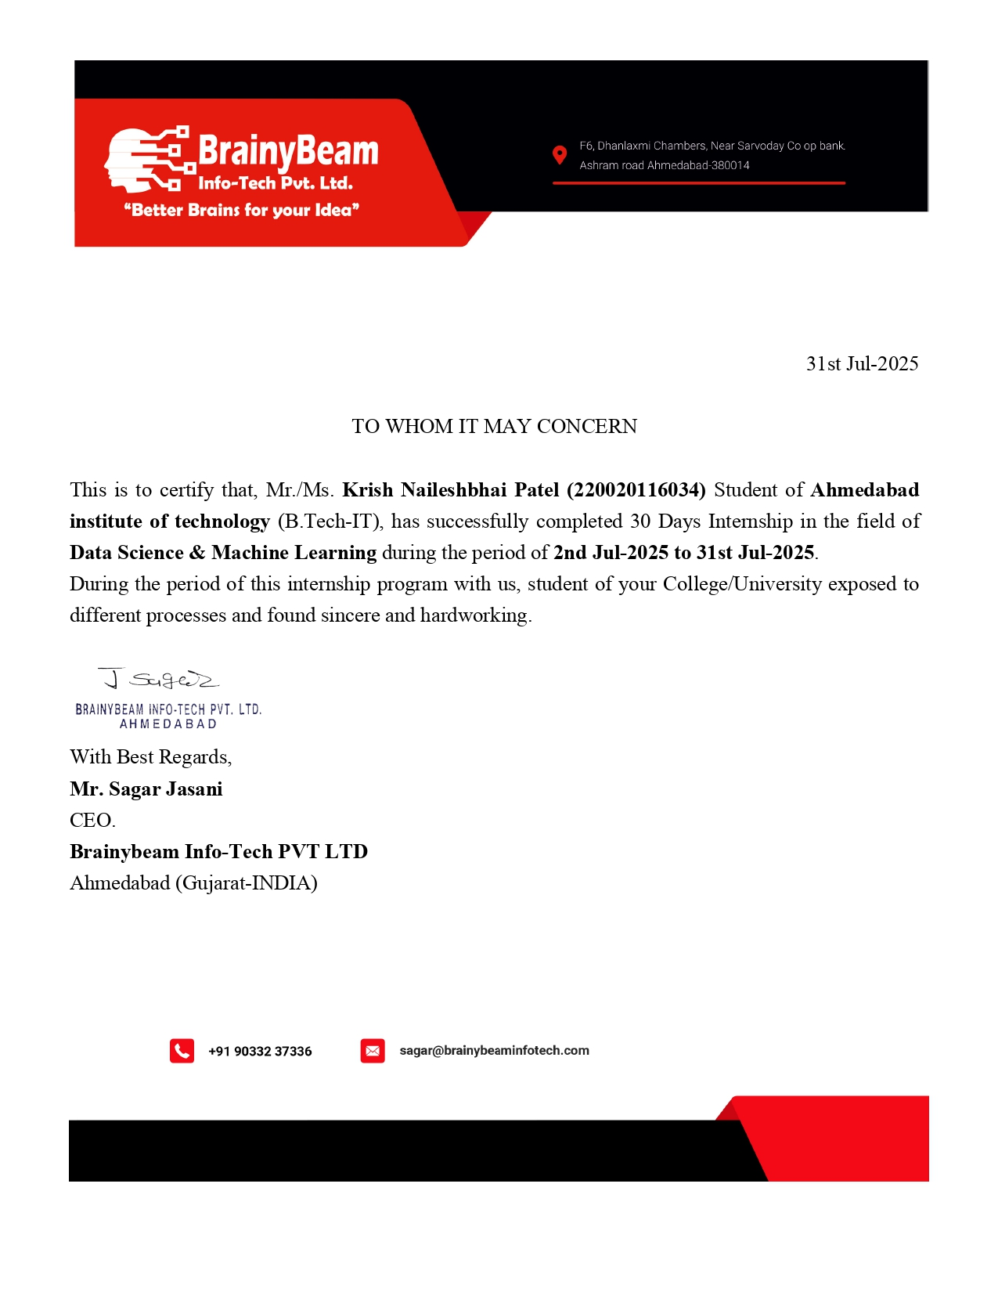
Index

Acknowledgement i
Abstract... ii
Chapter 1: Introduction
  - About the company. 11
  - Aim and Objectives of the Internship. 11
Chapter 2: Roles and Responsibilities during internship 12

  - My Roles and Responsibilities 13
  - Tasks/Problems Given (Day-wise) 14
  - Daily Tasks and Activities Performed… 14-22
Chapter 3: Skills Learned 23
  - About the Tools & Technologies learned 23
  - How do I learnt the skill/s 24
Chapter 4: Overall Experience 25
4.1 Technical/Non-Technical Experience 25
4.2 Personal Experience 26
Conclusion References/Bibliography

Acknowledgement

I wish to express my deep sense of gratitude to my External Guide, Mr. Sagar Jasani, CEO at BrainyBeam Info-Tech Pvt Ltd, for his invaluable guidance, continuous support, and encouragement throughout the internship. His mentorship provided me with both technical knowledge and professional discipline that have been vital for completing my work successfully.
I am also grateful to my Internal Guide, Mrs. Vanita G Dandhwani, from Ahmedabad Institute of Technology, for her constant encouragement, timely feedback, and constructive suggestions during this journey.
I extend my thanks to the staff and colleagues at BrainyBeam Info-Tech Pvt Ltd for creating a collaborative environment where I could learn and experiment freely. Finally, I am indebted to my parents, friends, and well-wishers for their unwavering moral support and motivation during this internship period.

Thank You
Krish Naileshbhai Patel

Abstract

Aerolytics is a data-driven analytics project aimed at uncovering patterns in India’s domestic aviation sector using a simulated dataset of over 100,000 flights. The project focuses on key performance indicators such as flight delays, cancellations, seat load factor (SLF), customer satisfaction, and route profitability. Developed using Power BI, Excel, Python, and DAX, the project transforms raw flight data into interactive dashboards that support strategic decision-making.

.

Chapter 1: Introduction

1.1 About the company

BrainyBeam Info-Tech Pvt Ltd is a Gujarat-based software development company that sees innovation as a core differentiator. The company specializes in delivering customized, cost-effective IT solutions with a focus on web and mobile applications. Its mission is to reduce time-to-market for businesses while maintaining high standards of functionality, reliability, and usability.
With well-documented processes and strong domain expertise, BrainyBeam partners with both startups and established brands to deliver scalable, revenue-driven solutions. Services offered range from application development and maintenance to analytics and data-driven consulting.
1.2 Aim and Objectives of the Internship
The primary aims of my internship were:
- To gain hands-on experience in data science and machine learning workflows.
- To learn and implement data visualization techniques for industry applications.
- To enhance skills in Python, Excel, Power BI, and DAX.
- To understand the process of transforming raw datasets into insightful dashboard.
- To contribute to a realistic industry-oriented project from conception to final delivery.

Chapter 2 Roles and Responsibilities during internship

2.1 My Roles and Responsibilities

During my internship as a Data Science and Machine Learning Intern, I was responsible for:
- Learning and applying Python libraries for data cleaning, manipulation, and visualization.
- Using Excel for structured data cleaning and feature creation.
- Designing interactive Power BI dashboards with KPIs, charts, and slicers.
- Implementing DAX formulas to derive advanced metrics like SLF%, Cancelled%, and On-Time%.
- Collaborating with the team to document insights and present results to mentors.
2.2 Tasks Given (Day-wise)
Sr. No | Tasks/Problem statements
TASK 1 : | Orientation — company introduction, internship objectives, and workflow overview.
TASK 2 : | Learning NumPy, Pandas, Matplotlib, Seaborn basics for data analysis.
TASK 3 : | Data preprocessing and cleaning with Pandas; handling missing values.
TASK 4 : | Introduction to Jupyter Notebook and VS Code as development environments.
TASK 5 : | Power BI basics — data import, relationships, basic visuals, and DAX introduction.
TASK 6,7 | Understanding Linear Regression and Logistic Regression models.
TASK 8,9: | Studying Decision Tree and Random Forest classification models.
TASK 10: | Project selection — finalizing Aerolytics dashboard as the main deliverable.
TASK 11: | Data preparation for Aerolytics — creating features, cleaning records, adding weather/temperature categories.
TASK 12-13 | Dashboard development — KPI cards, delay distribution, profitability analysis, SLF gauges, route filters.
TASK 14 | Testing dashboard interactions, finalizing insights, and preparing presentation slides.
TASK 15 : | Final review meeting, project handover, and internship conclusion.

Daily Tasks and Activities Performed

TASK –1 Date: 02-07-2025

- Activity: Orientation session at BrainyBeam Info-Tech Pvt Ltd, introduction to company services, work culture, and internship objectives.
- Definition: Internship – A short-term work experience that provides practical exposure to industry practices and skills relevant to your career path.
- Software installation: Python, Jupyter Notebook, VS Code, Excel, Power BI Desktop.
- Briefing on GitHub for version control.
TASK –2 Date: 04-07-2025
- Activity: Introduction to Python syntax, variables, data types, and operators.
- Definition: Python – A high-level, general-purpose programming language widely used in data science for its simplicity and large library ecosystem.
- Practiced basic scripts for string manipulation and arithmetic operations.
- Learning NumPy – creation of arrays, indexing, slicing, mathematical operations.
- Definition: NumPy – A Python library for numerical computing that enables efficient storage and manipulation of large datasets.
- Applied vectorized operations to improve computational efficiency.
- Learning Pandas – Series, DataFrames, and reading/writing CSV/Excel files.
- Definition: Pandas – A Python library providing data structures and functions for efficient manipulation of structured data.
- Hands-on with .head(), .describe(), and .info() for dataset exploration.
TASK –3 Date: 07-07-2025

- Activity: Advanced Pandas – merging, joining, grouping datasets, creating calculated columns.
- Applied .apply() with lambda functions for feature creation.
- Visualization using Matplotlib – bar charts, line charts, scatter plots.
- Definition: Matplotlib – A Python plotting library for creating static, animated, and interactive visualizations.
- Introduction to Seaborn for statistical data visualization.
TASK –4 Date: 09-07-2025
- Activity: Interactive visualizations using Plotly – line and bar charts with hover effects.
- Compared static (Matplotlib) vs. interactive (Plotly) visualizations.
- Configuring Jupyter Notebook and VS Code for data science workflows.
- Practiced markdown documentation inside Jupyter.
TASK –5 Date: 11-07-2025
- Activity: Introduction to machine learning concepts – supervised vs. unsupervised learning.
- Definition: Supervised learning – A type of ML where the model learns from labeled data to make predictions.
- Installed and tested Scikit-learn library.
- Implemented Linear Regression using Scikit-learn.
- Definition: Linear Regression – A statistical method to model the relationship between a dependent variable and one or more independent variables.
- Plotted regression line and evaluated using R² score.
- Implemented Logistic Regression for binary classification.
- Evaluated model using confusion matrix, precision, recall, and F1-score.
Description : In this project, we build Support Vector Machine (SVM) and k-Nearest Neighbors (k-NN) models from scratch, avoiding high-level libraries like Scikit-learn for the core algorithmic implementations. The objective is to apply these algorithms to a real-world dataset for multi-class classification, including:
- Manually coding the kernel trick (Linear, Polynomial, RBF) for SVM.
- Creating distance metrics (Euclidean, Manhattan) from scratch for k-NN.
- Using the Elbow Method to determine the optimal number of neighbors k for k-NN.
This hands-on implementation boosts understanding of low-level mechanics behind popular machine learning algorithms.
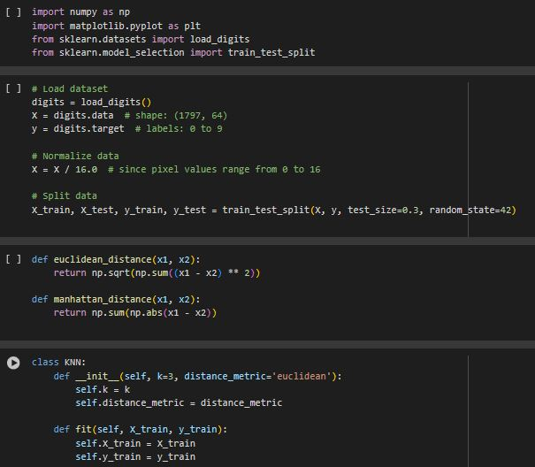
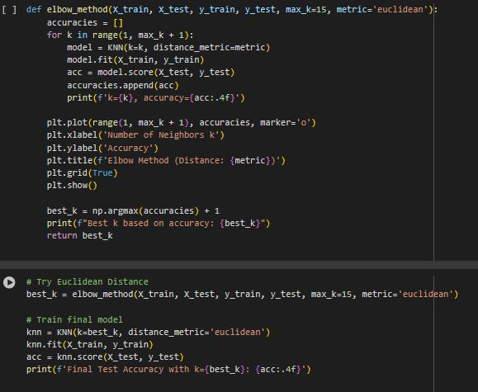
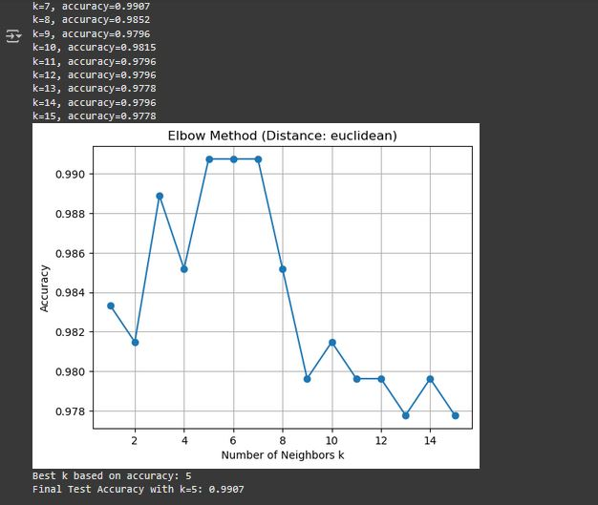
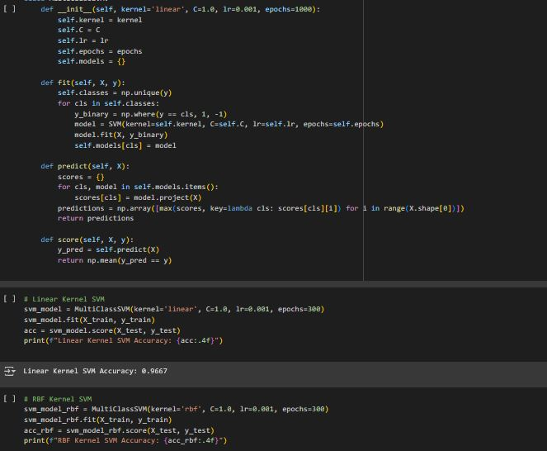

Conclusion :

In this project, we successfully implemented:
- A custom k-NN model using Euclidean and Manhattan distances.
- k selection via the Elbow Method for optimal performance.
- A custom SVM model using gradient descent and kernel trick for nonlinear decision boundaries.
- Comparison of linear, polynomial, and RBF kernels for multi-class classification.
By building these models from scratch, we developed a deeper understanding of the inner workings of powerful algorithms often treated as black boxes.
TASK –6,7 Date: 14-07-2025
- Activity: Built a Decision Tree model, explored depth control, and visualized splits.
- Definition: Decision Tree – A model that makes predictions by learning simple decision rules inferred from data features.
- Implemented Random Forest and compared accuracy with Decision Trees.
- Analyzed feature importance.
TASK –8,9 Date: 16-07-2025
- Activity: Introduction to Power BI – connecting data sources, creating basic visuals.
- Definition: Power BI – A Microsoft business analytics tool for creating interactive visualizations and dashboards.
- Learning DAX (Data Analysis Expressions) – writing calculated columns and measures.
- Created KPIs such as Total Revenue, SLF%, and On-Time %.
TASK –10 Date: 18-07-2025

(Aerolytics project begins)
Aerolytics: Tracking Every Flight Insight, From Takeoff to Touchdown.
Overview:
The aviation sector plays a critical role in connecting cities, economies, and people. However, flight operations are often affected by variables like delay patterns, weather conditions, customer sentiment, and seat load efficiency. Aerolytics is a data analytics project that aims to uncover these patterns using a simulated dataset of over 100,000 Indian domestic flights. The project leverages Power BI to convert raw data into interactive dashboards and meaningful business insights.

TASK –11 Date: 19-07-2025
- Activity: Cleaned dataset in Excel and Python, handled missing values.
- Created temperature range and delay type categories.
- Definition: SLF (Seat Load Factor) – A measure of capacity utilization: (Seats Sold / Seats Available) × 100.

- Calculated Profit (Revenue - Fuel Cost) and derived KPIs (Cancelled %, On-Time %).
- Exported cleaned dataset to Power BI for visualization.
- Created KPI cards for Total Flights, Total Revenue, On-Time %, and Average Customer Rating.
- Referenced Aerolytics insight: On-time flights = 52.9%, showing scope for operational improvement.
- Developed Delay Distribution visuals (donut and bar charts).
- Added insight: Minor delays account for 54.82% of flights; severe and major delays affect 24%.
- Created visuals for Top Routes by Revenue and Profitability by Flight Type.
- Found that long-haul flights are most profitable
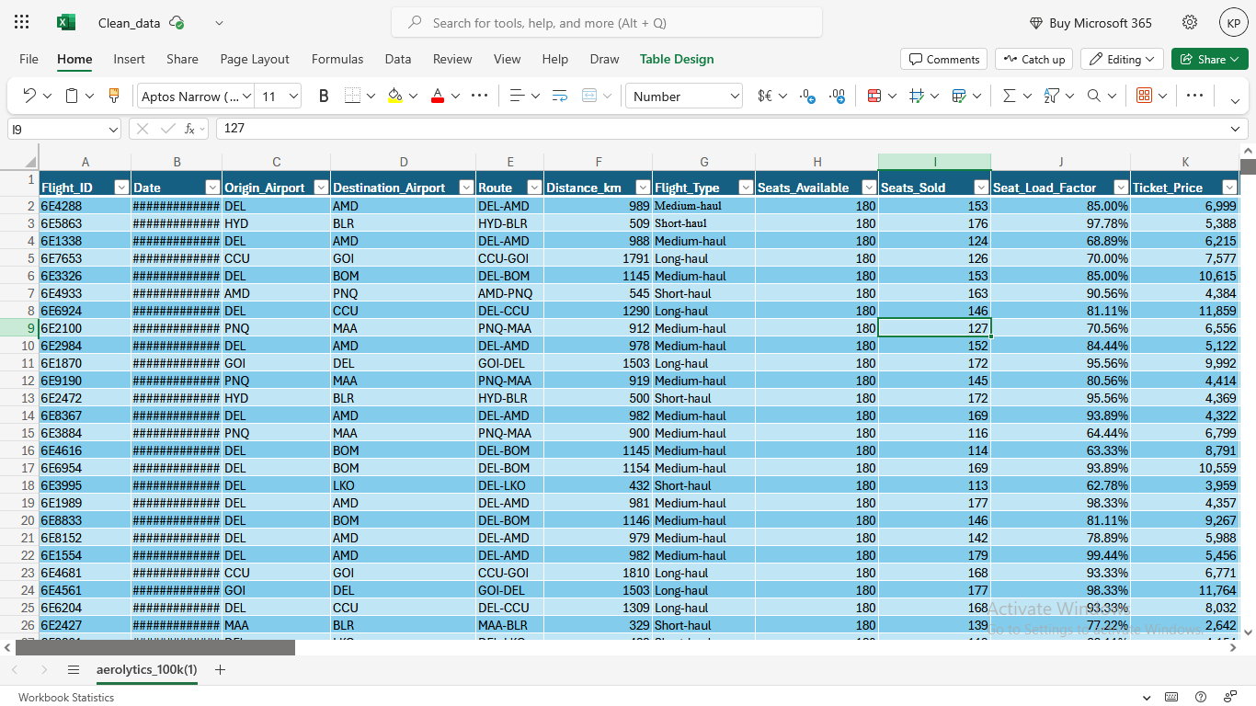
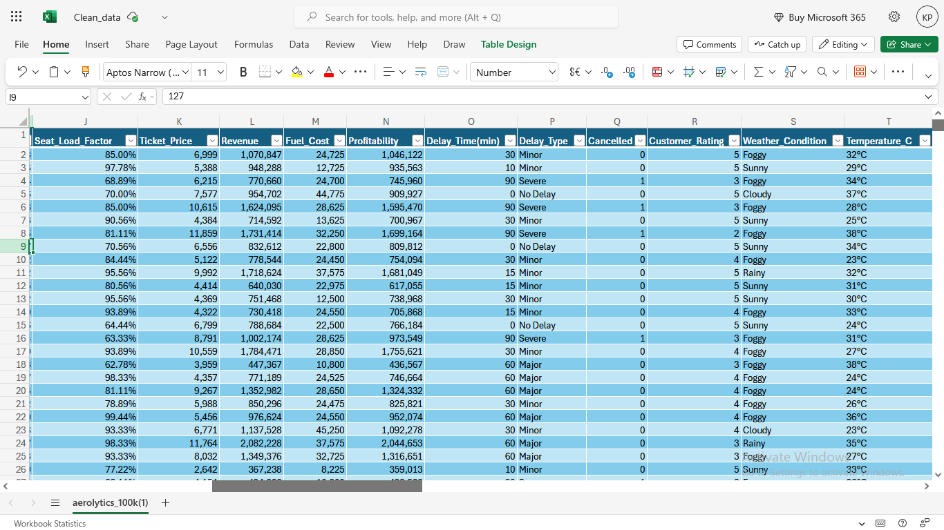 Excel Cleaned_data view

TASK –12-14 Date: 24-07-2025
- Activity: Designed SLF gauge chart and scatter plot (SLF vs. Cancellation Rate).
- Added route slicers for detailed analysis.
- Added Revenue Over Time chart and seasonal trend analysis.
- Insight: Revenue is cyclical with clear seasonal peaks.

- Activity: Created visuals for Customer Rating vs. Delay Type and Cancellations by Temperature.
- Found: Extreme temperatures increase cancellation rates.
- Improved dashboard aesthetics – consistent colors, layout alignment.
- Compiled project documentation and insights for final report.

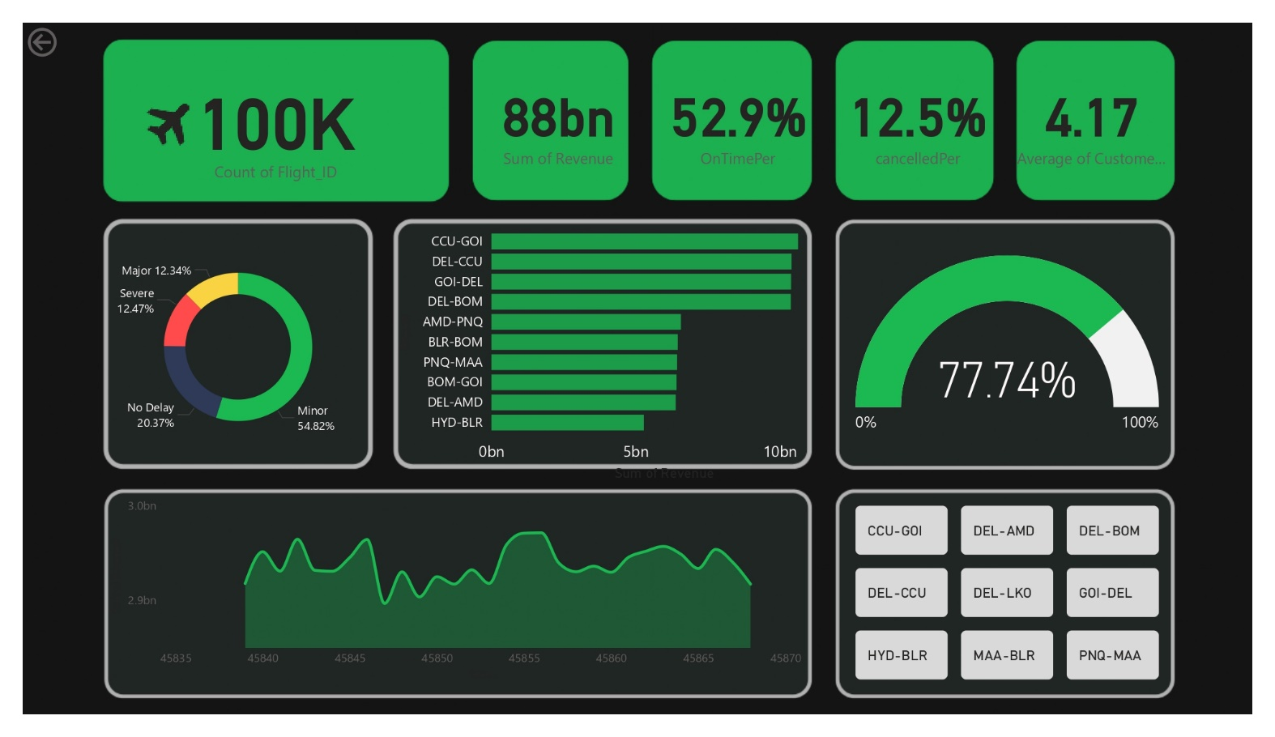 page-1 of dashboard (powerBI view)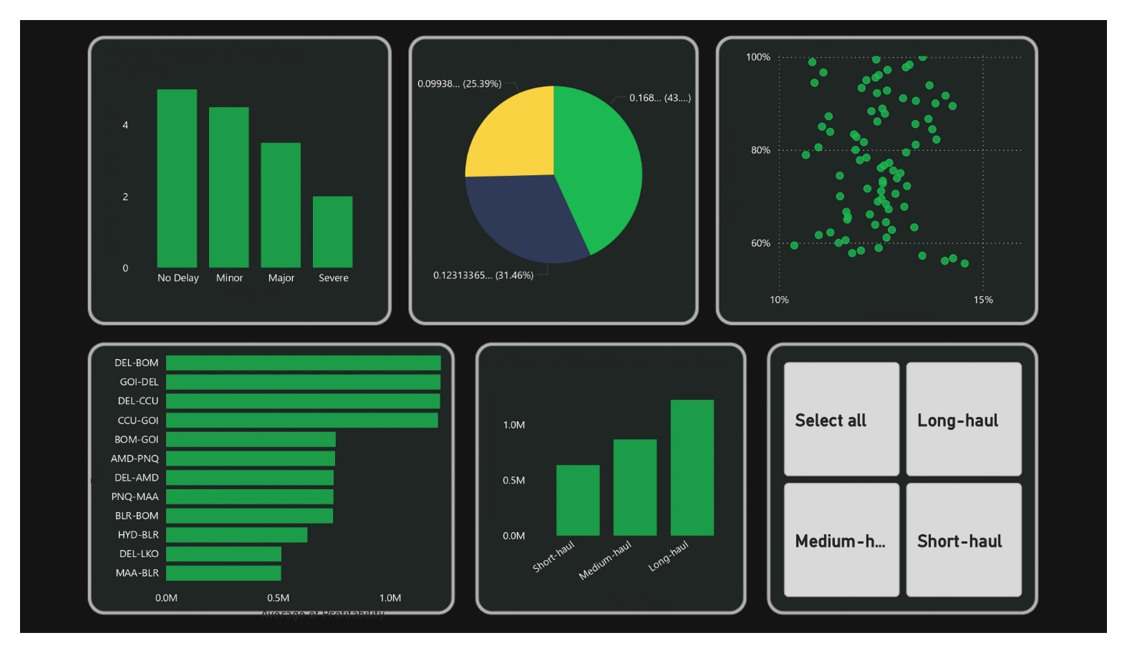 page-2 of dashboard (powerBI view)
TASK –15 Date: 29-07-2025 to 31-07-2025
- Activity: Incorporated mentor feedback, refined DAX measures.
- Finalized dashboard, exported .pbix file, prepared PPT slides.
- Presented Aerolytics project to mentors, discussed learnings, and closed internship.

Chapter 3: Skills Learned
3.1 Tools/Technologies Learned
- Python – Used as the primary programming language for data analysis, preprocessing, and automation.
- NumPy – Utilized for numerical computations, handling arrays, and performing vectorized mathematical operations efficiently.
- Pandas – Applied for data cleaning and manipulation, including handling missing values, merging datasets, and creating calculated columns.
- Seaborn – Used for creating visually appealing statistical plots to identify patterns and relationships in the data.
- Matplotlib – Implemented for basic and advanced data visualizations, such as line charts, bar charts, and scatter plots.
- Plotly – Leveraged to create interactive charts for dynamic and exploratory data analysis.
- Excel – Used for structured data cleaning and preprocessing, including filtering, sorting, feature creation, and validating datasets before importing into Power BI.
- Power BI – Served as the primary dashboard creation tool, enabling the development of interactive and business-ready reports. It was used to visualize KPIs such as revenue, SLF, cancellation rates, and customer satisfaction scores.
- DAX (Data Analysis Expressions) – Used within Power BI to create calculated measures and KPIs, such as Seat Load Factor, Cancelled %, and On-Time %, enabling deeper insights beyond raw data.
- Machine Learning – Applied basic ML models to understand predictive analysis and pattern recognition in datasets:
- Linear Regression – Used for modeling and predicting continuous variables (e.g., revenue trends).
- Logistic Regression – Implemented for binary classification tasks (e.g., cancellation prediction).
- Decision Tree – Used for rule-based classification and insight into feature importance.
- Random Forest – Applied for improving prediction accuracy and reducing overfitting through ensemble learning.
3.2 How do I learnt the skills

During my on-site internship at BrainyBeam Info-Tech Pvt Ltd, I had the opportunity to learn in a professional environment under the direct guidance of my mentor and team members. The learning process included:
- Mentor-led tutorials and demonstrations – My external guide provided step-by-step explanations of Python libraries, Excel techniques, Power BI features, and DAX formulas. Working in the office allowed me to ask questions immediately and get real-time feedback.
- Hands-on practice with company datasets – I practiced cleaning, transforming, and visualizing data using both sample datasets and the Aerolytics project dataset. This hands-on approach helped me strengthen my technical skills in a practical setting.
- Following official documentation and industry references – Whenever I encountered complex functions or new features, I referred to official documentation for Python, Power BI, and DAX, as well as industry best practices shared by my mentor.
- Collaborative learning with colleagues – Being in the office allowed me to observe and interact with other team members, learn different problem-solving approaches, and improve my teamwork skills.
- Applying skills directly in the Aerolytics project – Each new skill I learned was immediately applied to a real deliverable in the project, such as creating KPIs, designing dashboard visuals, or implementing calculated measures. This ensured my learning was reinforced through real-world application.

Chapter 4: Overall Experience

4.1 Technical/Non-Technical Experience

From a technical perspective, this internship improved my proficiency in Python programming, data preprocessing, dashboard development, and data visualization. I learned how to structure datasets for analytics and create meaningful KPIs.
From a non-technical perspective, I enhanced my problem-solving skills, teamwork, and presentation abilities. Regular project reviews improved my communication and reporting skills.

4.2 Personal Experience
- Gained first-hand exposure to a professional work environment at BrainyBeam Info-Tech Pvt Ltd.
- Improved technical skills in Python, Excel, Power BI, and DAX through practical, real-world applications.
- Learned the importance of data accuracy and cleaning for ensuring reliable analysis results.
- Developed better teamwork and communication by working closely with mentors and colleagues.
- Gained confidence in presenting insights to an audience using structured reports and dashboards.
- Experienced the complete data analytics workflow – from raw data to actionable insights.

Conclusion
The internship at BrainyBeam Info-Tech Pvt Ltd was a highly rewarding and transformative experience that allowed me to bridge the gap between academic knowledge and industry practices. Working on the Aerolytics project gave me the opportunity to apply Python, Excel, Power BI, and DAX in a real-world context, enabling me to understand the complete data analytics workflow from data cleaning to dashboard creation. I gained practical skills in developing KPIs, analyzing trends, and presenting insights that can support strategic decision-making. Beyond technical abilities, I also improved my teamwork, problem-solving, and communication skills by collaborating closely with my mentor and colleagues in a professional office environment. This experience has strengthened my foundation in data science and analytics, preparing me for future challenges in the field

References/Bibliography
- Microsoft Power BI Documentation. (n.d.). Power BI Documentation. Retrieved from: https://learn.microsoft.com/en-us/power-bi/
- Pandas Development Team. (n.d.). Pandas Documentation. Retrieved from: https://pandas.pydata.org/docs/
- NumPy Developers. (n.d.). NumPy Documentation. Retrieved from: https://numpy.org/doc/
- Microsoft. (n.d.). DAX in Power BI. Retrieved from: https://learn.microsoft.com/en-us/dax/
- Matplotlib Development Team. (n.d.). Matplotlib Documentation. Retrieved from: https://matplotlib.org/stable/
- Plotly Technologies, Inc. (n.d.). Plotly Python Open Source Graphing Library. Retrieved from: https://plotly.com/python/
- Aerolytics Project Repository. Retrieved from: https://github.com/Aerolytics-4129/Aerolytics-Airline-Data-Visualization

