Script 1:
from rdkit import Chem
from rdkit.Chem import AllChem
from rdkit.Chem import rdMolTransforms
from rdkit.Chem.Draw import MolToImage
import py3Dmol

# Create a molecule from SMILES
smiles = 'CC(=O)NC1=CC=C(C=C1)O'
mol = Chem.MolFromSmiles(smiles)
mol = Chem.AddHs(mol)

# Generate 3D coordinates
AllChem.EmbedMolecule(mol, randomSeed=42)
AllChem.UFFOptimizeMolecule(mol)

# Convert to 3Dmol.js format
mol_block = Chem.MolToMolBlock(mol)

# Visualize with py3Dmol
viewer = py3Dmol.view(width=800, height=600)
viewer.addModel(mol_block, 'mol')
viewer.setStyle({'stick': {}})
viewer.setBackgroundColor('white')
viewer.zoomTo()
viewer.show()
Script 2:
from rdkit import Chem
from rdkit.Chem import Descriptors

# Define a molecule using SMILES
smiles = 'CC(=O)NC1=CC=C(C=C1)O' # Paracetamol
mol = Chem.MolFromSmiles(smiles)

# Calculate molecular weight
mol_weight = Descriptors.MolWt(mol)
print(f"Molecular Weight: {mol_weight}")

# Calculate LogP
logp = Descriptors.MolLogP(mol)
print(f"LogP: {logp}")

# Calculate Topological Polar Surface Area (TPSA)
tpsa = Descriptors.TPSA(mol)
print(f"Topological Polar Surface Area (TPSA): {tpsa}")

# Calculate number of hydrogen bond donors
hbd = Descriptors.NumHDonors(mol)
print(f"Number of Hydrogen Bond Donors: {hbd}")

# Calculate number of hydrogen bond acceptors
hba = Descriptors.NumHAcceptors(mol)
print(f"Number of Hydrogen Bond Acceptors: {hba}")

# Calculate number of rotatable bonds
rotatable_bonds = Descriptors.NumRotatableBonds(mol)
print(f"Number of Rotatable Bonds: {rotatable_bonds}")

Script 1 UI/UX:
User Input Dropdown/Combo-box
Generic Name:
- Paracetamol

User Input Dropdown/Combo-box
Available Variant:
Display
CC(=O)NC1=CC=C(C=C1)O

Display Molecular Structure:
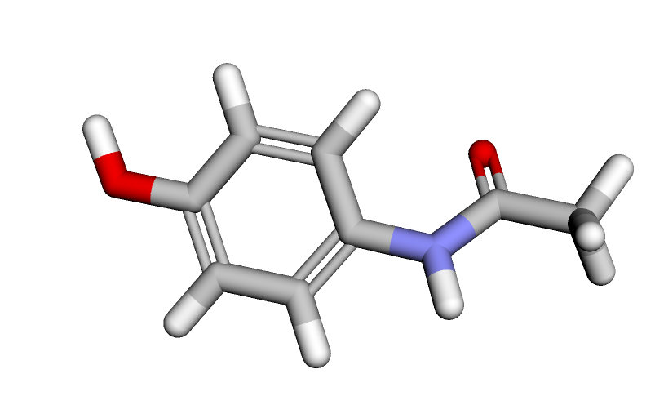
Script 2 UI/UX:
Molecular Weight: 151.165
LogP: 1.3505999999999998
Topological Polar Surface Area (TPSA): 49.33
Number of Hydrogen Bond Donors: 2
Number of Hydrogen Bond Acceptors: 2
Number of Rotatable Bonds: 1

Script 3:
from rdkit import Chem
from rdkit.Chem import AllChem, Descriptors
from rdkit.Chem.rdchem import RWMol

# Original paracetamol molecule
smiles = 'CC(=O)NC1=CC=C(C=C1)O'
mol = Chem.MolFromSmiles(smiles)

# Function to generate variants by modifying substituents
def generate_variants(mol, num_variants=10):
variants = []
for _ in range(num_variants):
rw_mol = RWMol(mol)
# Randomly change a hydrogen to a methyl group as an example modification
idx = rw_mol.GetNumAtoms() - 1 # Last atom index
rw_mol.ReplaceAtom(idx, Chem.Atom('C'))
variant = rw_mol.GetMol()
Chem.SanitizeMol(variant)
variants.append(variant)
return variants

variants = generate_variants(mol)
variant_smiles = [Chem.MolToSmiles(variant) for variant in variants]
print("Generated Variants SMILES:", variant_smiles)

# Calculate molecular descriptors for each variant
descriptors = []
for variant in variants:
desc = [Descriptors.MolWt(variant), Descriptors.NumRotatableBonds(variant)]
descriptors.append(desc)

print("Descriptors for Variants:", descriptors)

Script 4:
import deepchem as dc
from deepchem.feat import ConvMolFeaturizer
from rdkit import Chem
from rdkit.Chem import Draw
import matplotlib.pyplot as plt

# SMILES string for Paracetamol
variant_smiles = "CC(=O)Nc1ccc(C)cc1"

# Convert SMILES to molecule
mol = Chem.MolFromSmiles(variant_smiles)

# Draw the molecule
img = Draw.MolToImage(mol, size=(300, 300))
plt.imshow(img)
plt.axis('off')
plt.show()

# Featurize the molecule using DeepChem
featurizer = ConvMolFeaturizer()
X_pred = featurizer.featurize([variant_smiles])

# Check if featurization was successful
if X_pred is None or len(X_pred) == 0 or X_pred[0] is None:
print("Featurization failed for the variant molecule.")
else:
print("Featurization successful.")
print(X_pred)

Script 5:

from rdkit import Chem
from rdkit.Chem import Descriptors, Draw

# SMILES string for Paracetamol
smiles = "CC(=O)Nc1ccc(C)cc1"
molecule = Chem.MolFromSmiles(smiles)

# Calculate some structural properties
mol_weight = Descriptors.MolWt(molecule)
logp = Descriptors.MolLogP(molecule)
num_h_donors = Descriptors.NumHDonors(molecule)
num_h_acceptors = Descriptors.NumHAcceptors(molecule)

print(f"Molecular Weight: {mol_weight}")
print(f"LogP: {logp}")
print(f"Number of Hydrogen Donors: {num_h_donors}")
print(f"Number of Hydrogen Acceptors: {num_h_acceptors}")

# Draw the molecule
Draw.MolToImage(molecule)

Script 6:
import pandas as pd
from rdkit import Chem
from rdkit.Chem import Descriptors
from sklearn.ensemble import RandomForestRegressor
from sklearn.model_selection import train_test_split
from sklearn.metrics import mean_squared_error
import numpy as np

# dummy dataset for Paracetamol
data = {
"Compound": ["Paracetamol_Variant_1", "Paracetamol_Variant_2", "Paracetamol_Variant_3", "Paracetamol_Variant_4"],
"IC50 (µM)": [1.0, 0.75, 1.25, 0.5],
"EC50 (µM)": [2.0, 1.5, 2.5, 1.0],
"Ki (nM)": [15, 10, 20, 5],
"Cell Viability (%)": [85, 90, 80, 95],
"Comments": ["Moderate potency", "High potency", "Low potency", "Very high potency"]
}

paracetamol_activity_df = pd.DataFrame(data)

# add SMILES for each variant
paracetamol_activity_df['smiles'] = ["CC(=O)Nc1ccc(C)cc1"] * len(paracetamol_activity_df) # Simplified example

# Saving the DataFrame to a CSV file
paracetamol_activity_df.to_csv('paracetamol_activity_data.csv', index=False)

# Load the synthetic dataset
data = pd.read_csv('paracetamol_activity_data.csv')

# Function to featurize molecules using RDKit
def featurize(smiles):
molecule = Chem.MolFromSmiles(smiles)
if molecule is None:
return None
features = np.array([
Descriptors.MolWt(molecule),
Descriptors.MolLogP(molecule),
Descriptors.NumHDonors(molecule),
Descriptors.NumHAcceptors(molecule)
])
return features

# Featurize
data['features'] = data['smiles'].apply(featurize)
data = data.dropna(subset=['features'])

# Prepare the feature matrix
X = np.stack(data['features'].values)

# Extract target values
y_ic50 = data['IC50 (µM)'].values
y_ec50 = data['EC50 (µM)'].values
y_ki = data['Ki (nM)'].values
y_cv = data['Cell Viability (%)'].values

# Split the data into training and test sets for each target
X_train_ic50, X_test_ic50, y_train_ic50, y_test_ic50 = train_test_split(X, y_ic50, test_size=0.2, random_state=42)
X_train_ec50, X_test_ec50, y_train_ec50, y_test_ec50 = train_test_split(X, y_ec50, test_size=0.2, random_state=42)
X_train_ki, X_test_ki, y_train_ki, y_test_ki = train_test_split(X, y_ki, test_size=0.2, random_state=42)
X_train_cv, X_test_cv, y_train_cv, y_test_cv = train_test_split(X, y_cv, test_size=0.2, random_state=42)

# Train the Random Forest models
model_ic50 = RandomForestRegressor(n_estimators=100, random_state=42)
model_ec50 = RandomForestRegressor(n_estimators=100, random_state=42)
model_ki = RandomForestRegressor(n_estimators=100, random_state=42)
model_cv = RandomForestRegressor(n_estimators=100, random_state=42)

model_ic50.fit(X_train_ic50, y_train_ic50)
model_ec50.fit(X_train_ec50, y_train_ec50)
model_ki.fit(X_train_ki, y_train_ki)
model_cv.fit(X_train_cv, y_train_cv)

# Evaluate the models
y_pred_ic50 = model_ic50.predict(X_test_ic50)
y_pred_ec50 = model_ec50.predict(X_test_ec50)
y_pred_ki = model_ki.predict(X_test_ki)
y_pred_cv = model_cv.predict(X_test_cv)

mse_ic50 = mean_squared_error(y_test_ic50, y_pred_ic50)
mse_ec50 = mean_squared_error(y_test_ec50, y_pred_ec50)
mse_ki = mean_squared_error(y_test_ki, y_pred_ki)
mse_cv = mean_squared_error(y_test_cv, y_pred_cv)

print(f"Mean Squared Error for IC50: {mse_ic50}")
print(f"Mean Squared Error for EC50: {mse_ec50}")
print(f"Mean Squared Error for Ki: {mse_ki}")
print(f"Mean Squared Error for Cell Viability: {mse_cv}")

# SMILES string for Paracetamol variant
target_smiles = "CC(=O)Nc1ccc(C)cc1"

# Featurize the target molecule
target_features = featurize(target_smiles)

# Predict the activities for the target molecule
if target_features is not None:
target_features = target_features.reshape(1, -1) # Reshape to match the model's input

predicted_ic50 = model_ic50.predict(target_features)
predicted_ec50 = model_ec50.predict(target_features)
predicted_ki = model_ki.predict(target_features)
predicted_cv = model_cv.predict(target_features)

print(f"Predicted IC50 (µM) for Paracetamol: {predicted_ic50[0]}")
print(f"Predicted EC50 (µM) for Paracetamol: {predicted_ec50[0]}")
print(f"Predicted Ki (nM) for Paracetamol: {predicted_ki[0]}")
print(f"Predicted Cell Viability (%) for Paracetamol: {predicted_cv[0]}")
else:
print("Failed to featurize the target molecule.")

Script 3-4-5-6 UI/UX:
1
Generate Variants

Y
Generated Paracetamol (New Variant) – Molecule “CC(=O)Nc1ccc(C)cc1” [[149.19299, 1]
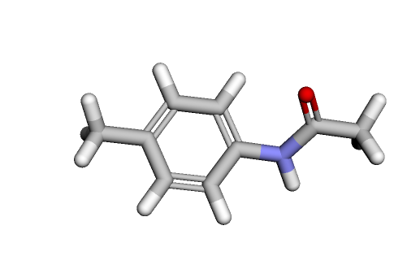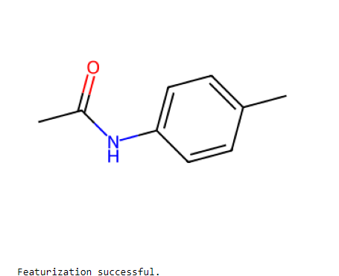
Molecular Weight: 149.19299999999998
LogP: 1.95342
Number of Hydrogen Donors: 1
Number of Hydrogen Acceptors: 1
Mean Squared Error for IC50: 0.019367361111111172
Mean Squared Error for EC50: 0.07746944444444469
Mean Squared Error for Ki: 7.746944444444444
Mean Squared Error for Cell Viability: 7.746944444444355
Predicted IC50 (µM) for Paracetamol: 0.8891666666666669
Predicted EC50 (µM) for Paracetamol: 1.7783333333333338
Predicted Ki (nM) for Paracetamol: 12.783333333333333
Predicted Cell Viability (%) for Paracetamol: 87.21666666666668

Script 7:
import re
import random

import numpy as np
from collections import deque
import matplotlib.pyplot as plt
from sklearn.metrics.pairwise import cosine_similarity

from sklearn.model_selection import train_test_split
from sklearn.preprocessing import LabelEncoder

from rdkit import Chem
from rdkit.Chem import Descriptors
from rdkit.Chem.Draw import MolToImage

from tensorflow.keras.layers import Dense
from tensorflow.keras.optimizers import Adam
from tensorflow.keras.models import Sequential

class DRLAgent:
"""
Deep Reinforcement Learning Agent

Args:
state_size (int): Size of the state space
action_size (int): Size of the action space
"""

def __init__(self, state_size, action_size, selected_X_train):
self.state_size = state_size
self.action_size = action_size
self.memory = deque(maxlen=2000)
# discount rate
self.gamma = 0.95
# exploration rate
self.epsilon = 1.0
self.epsilon_min = 0.01
self.epsilon_decay = 0.995
self.learning_rate = 0.001
self.selected_X_train = selected_X_train
self.model = self._build_model(selected_X_train)
# target model for stability
self.target_model = self._build_model(selected_X_train)
self.update_target_model()

def _build_model(self, selected_X_train):
"""
Build the Deep Q-Network model

Returns:
model (Sequential): Deep Q-Network model
"""
model = Sequential()
model.add(Dense(32, input_shape=(selected_X_train.shape[1],), activation='relu'))
model.add(Dense(16, activation='relu'))
model.add(Dense(self.action_size, activation='linear'))
model.compile(loss='mse', optimizer=Adam(learning_rate=self.learning_rate))
return model

def update_target_model(self):
"""Update the target model weights with the current model weights"""
self.target_model.set_weights(self.model.get_weights())

def remember(self, state, action, reward, next_state, done):
"""
Store the experience in the replay memory

Args:
state (ndarray): Current state
action (int): Action taken
reward (float): Reward received
next_state (ndarray): Next state
done (bool): Whether the episode is done
"""
self.memory.append((state, action, reward, next_state, done))

def act(self, state):
"""
Choose an action given the current state

Args:
state (ndarray): Current state

Returns:
action (int): Chosen action
"""
if np.random.rand() <= self.epsilon:
return np.random.randint(self.action_size)
if state is None:
state = np.zeros((1, self.state_size))
else:
state = state.reshape(1, self.state_size)
act_values = self.model.predict(state)
return np.argmax(act_values[0])

def replay(self, batch_size):
"""
Train the model by replaying experiences from the replay memory

Args:
batch_size (int): Size of the minibatch
"""
# Sample a minibatch of experiences from the replay memory
minibatch = random.sample(self.memory, batch_size)
for state, action, reward, next_state, done in minibatch:
if state is not None:
if not done:
# Calculate the target value using the target model
target = (reward + self.gamma * np.amax(self.target_model.predict(next_state)[0]))
else:
target = reward
# Make the agent approximately map the current state to future discounted reward
target_f = self.model.predict(state)
target_f[0][action] = target
# Train the model using the current state and target value
self.model.fit(state, target_f, epochs=1, verbose=0)
# Decay the exploration rate
if self.epsilon > self.epsilon_min:
self.epsilon *= self.epsilon_decay

def load(self, name):
"""Load the model weights from a file"""
self.model.load_weights(name)

def save(self, name):
"""Save the model weights to a file"""
self.model.save_weights(name)

def preprocess_smiles(smiles):
"""
Preprocess the SMILES string by removing salts and stereochemistry information

Args:
smiles (str): SMILES string

Returns:
preprocessed_smiles (str): Preprocessed SMILES string
"""
# Remove salts
preprocessed_smiles = re.sub(r'\[.*?\]', '', smiles)
# Remove stereochemistry information
preprocessed_smiles = re.sub(r'[@]\S*', '', preprocessed_smiles)
return preprocessed_smiles

def calculate_molecular_properties(smiles):
"""
Calculate molecular properties of a compound given its SMILES string

Args:
smiles (str): SMILES string

Returns:
properties (dict): Dictionary of molecular properties
"""
molecule = Chem.MolFromSmiles(smiles)
properties = {}

if molecule is not None:
properties['Molecular Weight'] = Descriptors.MolWt(molecule)
properties['LogP'] = Descriptors.MolLogP(molecule)
properties['H-Bond Donor Count'] = Descriptors.NumHDonors(molecule)
properties['H-Bond Acceptor Count'] = Descriptors.NumHAcceptors(molecule)

return properties

if __name__ == '__main__':
smiles = 'CC(=O)NC1=CC=C(C=C1)O'
preprocessed_smiles = preprocess_smiles(smiles)
properties = calculate_molecular_properties(preprocessed_smiles)
print(properties) # {'Molecular Weight': 180.15899999999996, 'LogP': 1.3101, 'H-Bond Donor Count': 1, 'H-Bond Acceptor Count': 3}

# Convert the properties dictionary to a NumPy array
selected_X_train = np.array(list(properties.values())).reshape(1, -1)

agent = DRLAgent(state_size=selected_X_train.shape[1], action_size=3, selected_X_train=selected_X_train)

# Get the model's output for the selected input
output = agent.model.predict(selected_X_train)
print("Model Output:", output)

# Obtain the SMILES representation of the molecule after processing with the model
reconstructed_smiles = Chem.MolToSmiles(Chem.MolFromSmiles(preprocessed_smiles))
print("Reconstructed SMILES:", reconstructed_smiles)

mol = Chem.MolFromSmiles(reconstructed_smiles)
if mol is None:
print(f"Error generating molecule from SMILES: {reconstructed_smiles}")
else:
display(MolToImage(mol))

Script-7 UI/UX
Re-Construct/Regenerate Variant
Reconstruct Variant

User Input
Mol Wt.: Range Slider – 148 to 180
LogP: Range Slide – 1 to 2
Number of Hydrogen Donors: 1 to 2
Number of Hydrogen Acceptors: 1 to 2

Model Output: [[-17.815142 -22.224714 -9.834815]]
Reconstructed SMILES: CC(=O)Nc1ccc(O)cc1

{'Molecular Weight': 151.165, 'LogP': 1.3505999999999998, 'H-Bond Donor Count': 2, 'H-Bond Acceptor Count': 2}

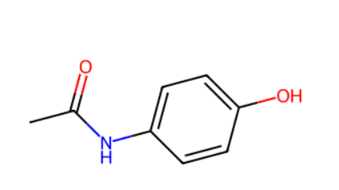

Clinical Trials: Dummy Data Script 8:
import pandas as pd
import numpy as np

# Parameters
num_patients = 100 # Number of patients

# Data generation
np.random.seed(42)
data = {
'Patient_ID': range(1, num_patients + 1),
'Age': np.random.randint(18, 66, num_patients),
'Gender': np.random.choice(['Male', 'Female'], num_patients),
'Weight_kg': np.random.randint(50, 101, num_patients),
'Dose_mg': np.random.choice([500, 1000], num_patients),
'Pain_Level_Before': np.random.randint(0, 11, num_patients),
'Pain_Level_After': [max(0, x - np.random.randint(0, 6)) for x in np.random.randint(0, 11, num_patients)],
'Side_Effects': np.random.choice(['None', 'Nausea', 'Dizziness'], num_patients),
'Outcome': np.random.choice(['Improved', 'No Change', 'Worse'], num_patients),
'Paracetamol_Variant': np.random.choice(['Paracetamol_Variant 1', 'Paracetamol_Variant 2', 'Paracetamol_Variant 3', 'Paracetamol_Variant 4'], num_patients)
}

# Creating DataFrame
df = pd.DataFrame(data)

# Adjusting Outcome based on Pain Levels
df['Outcome'] = np.where(df['Pain_Level_Before'] > df['Pain_Level_After'], 'Improved', df['Outcome'])
df['Outcome'] = np.where(df['Pain_Level_Before'] == df['Pain_Level_After'], 'No Change', df['Outcome'])
df['Outcome'] = np.where(df['Pain_Level_Before'] < df['Pain_Level_After'], 'Worse', df['Outcome'])

# Displaying the DataFrame in tabular format
print(df.head(10).to_string(index=False))

Script 9 :
import pandas as pd
import numpy as np
import plotly.express as px

# Parameters
num_patients = 100 # Number of patients

# Data generation
np.random.seed(42)
data = {
'Patient_ID': range(1, num_patients + 1),
'Age': np.random.randint(18, 66, num_patients),
'Gender': np.random.choice(['Male', 'Female'], num_patients),
'Weight_kg': np.random.randint(50, 101, num_patients),
'Dose_mg': np.random.choice([500, 1000], num_patients),
'Pain_Level_Before': np.random.randint(0, 11, num_patients),
'Pain_Level_After': [max(0, x - np.random.randint(0, 6)) for x in np.random.randint(0, 11, num_patients)],
'Side_Effects': np.random.choice(['None', 'Nausea', 'Dizziness'], num_patients),
'Outcome': np.random.choice(['Improved', 'No Change', 'Worse'], num_patients),
'Paracetamol_Variant': np.random.choice(['Paracetamol_Variant 1', 'Paracetamol_Variant 2', 'Paracetamol_Variant 3', 'Paracetamol_Variant 4'], num_patients)
}

# Creating DataFrame
df = pd.DataFrame(data)

# Adjusting Outcome based on Pain Levels
df['Outcome'] = np.where(df['Pain_Level_Before'] > df['Pain_Level_After'], 'Improved', df['Outcome'])
df['Outcome'] = np.where(df['Pain_Level_Before'] == df['Pain_Level_After'], 'No Change', df['Outcome'])
df['Outcome'] = np.where(df['Pain_Level_Before'] < df['Pain_Level_After'], 'Worse', df['Outcome'])

# Creating an interactive bar chart
fig = px.bar(
df,
x='Paracetamol_Variant',
color='Outcome',
barmode='group',
facet_col='Gender',
category_orders={'Outcome': ['Improved', 'No Change', 'Worse']},
title="Gender-wise Outcomes for Different Paracetamol Variants",
labels={'Paracetamol_Variant': 'Paracetamol Variant', 'count': 'Number of Patients'}
)

fig.show()

# Adding Age Category
bins = [18, 30, 40, 50, 65, 100] # Adjusted to include ages up to 100
labels = ['18-29', '30-39', '40-49', '50-65', '65+']
df['Age_Category'] = pd.cut(df['Age'], bins=bins, labels=labels, right=False)

# Optional: Remove rows with NaN in 'Age_Category' if any
df = df.dropna(subset=['Age_Category'])

# Creating an interactive bar chart
fig = px.bar(
df,
x='Paracetamol_Variant',
color='Outcome',
barmode='group',
facet_col='Age_Category',
category_orders={'Outcome': ['Improved', 'No Change', 'Worse']},
title="Age-wise Outcomes for Different Paracetamol Variants",
labels={'Paracetamol_Variant': 'Paracetamol Variant', 'count': 'Number of Patients'}
)

fig.show()

UI/UX for Script 9:
Show Clinical Trials Data Gender wise:
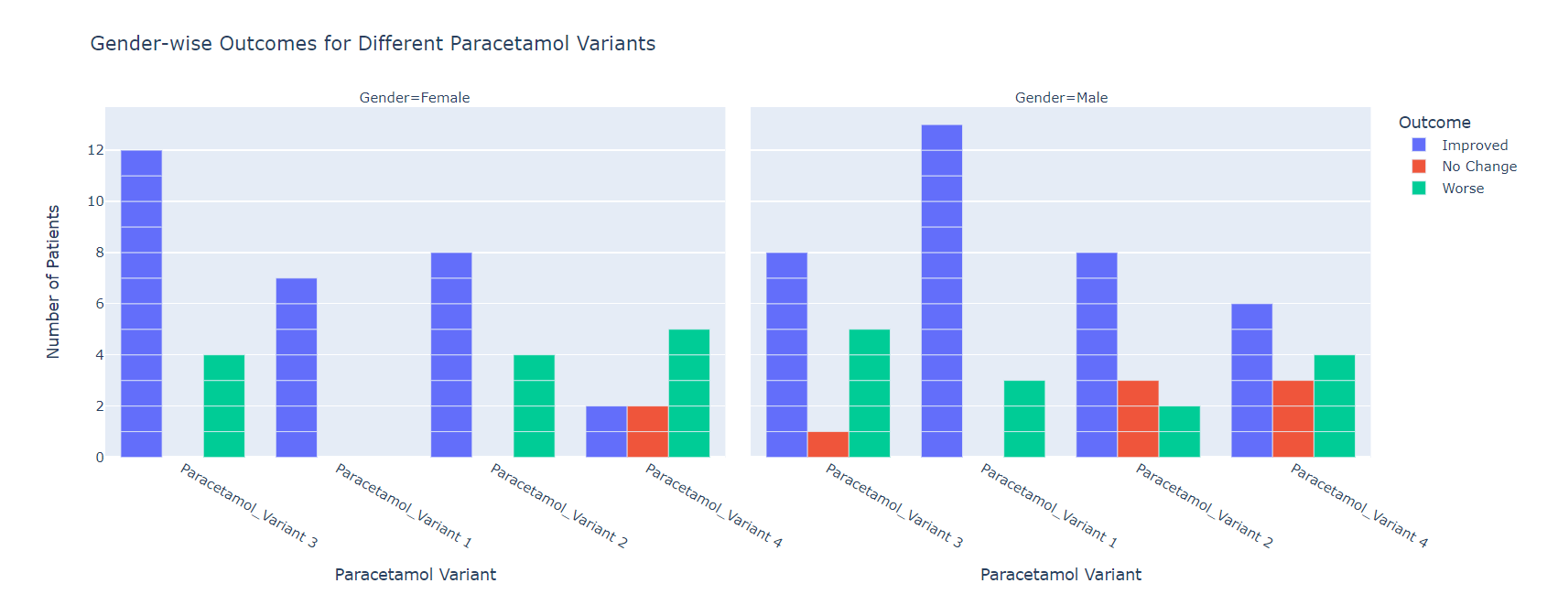
Show Clinical Trials Data age wise:

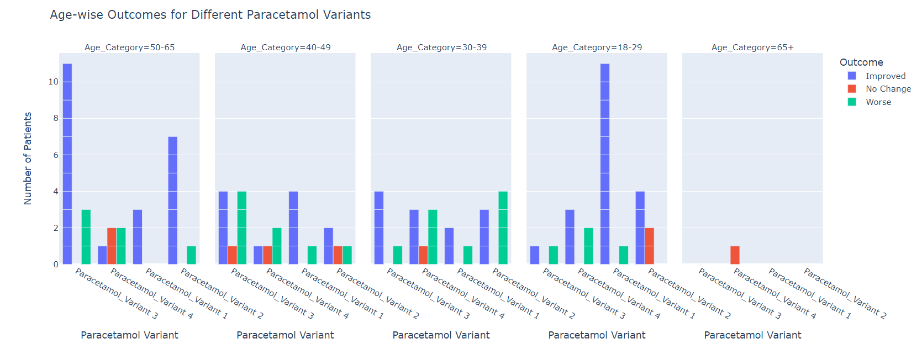

Script 10:

from rdkit import Chem
from rdkit.Chem import AllChem, DataStructs

# Given SMILES string for prediction
test_smiles = 'CC(=O)Nc1ccc(C)cc1'

# Paracetamol variants with their SMILES
variants = {
'Paracetamol_Variant 1': 'CC(=O)NC1=CC=C(C=C1)O',
'Paracetamol_Variant 2': 'CC(=O)NC1=CCC=C(C=C1)O',
'Paracetamol_Variant 3': 'CC(=O)NC1=CCC(C=C1)O',
'Paracetamol_Variant 4': 'CC(=O)NC1=CCC(CC=C1)O'
}

# Convert SMILES to RDKit molecules
test_mol = Chem.MolFromSmiles(test_smiles)
variant_mols = {key: Chem.MolFromSmiles(smiles) for key, smiles in variants.items()}

# Compute fingerprints
test_fp = AllChem.GetMorganFingerprintAsBitVect(test_mol, 2)
variant_fps = {key: AllChem.GetMorganFingerprintAsBitVect(mol, 2) for key, mol in variant_mols.items()}

# Calculate Tanimoto similarities
similarities = {key: DataStructs.TanimotoSimilarity(test_fp, fp) for key, fp in variant_fps.items()}

# Find the most similar variant
most_similar_variant = max(similarities, key=similarities.get)

# Clinical trial outcomes based on the most similar variant
outcomes = {
'Paracetamol_Variant 1': 'Improved',
'Paracetamol_Variant 2': 'No Change',
'Paracetamol_Variant 3': 'Improved',
'Paracetamol_Variant 4': 'No Change'
}

predicted_outcome = outcomes[most_similar_variant]

print(f"Most similar paracetamol variant: {most_similar_variant}")
print(f"Predicted clinical trial outcome: {predicted_outcome}")

UI/UX for Script 10

User Input
Predict Outcome
CC(=O)Nc1ccc(C)cc1

Most similar paracetamol variant: Paracetamol_Variant 1
Predicted clinical trial outcome: Improved

