Minor-2 Project: Metasploitable & Mutillidae II – Explanation with Screenshots

Step 1: Metasploitable IP Configuration
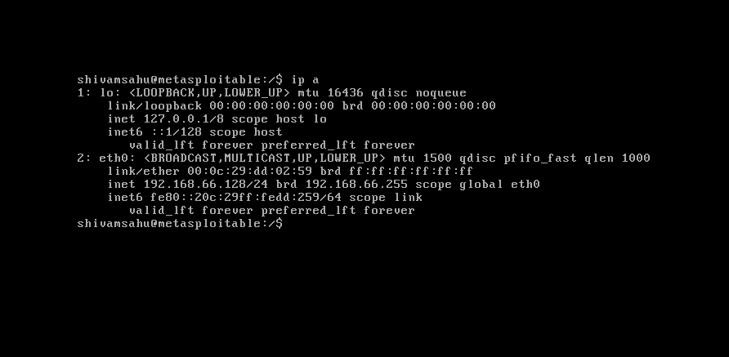
This screenshot shows the successful network configuration of Metasploitable 2. An IPv4 address (192.168.66.128) is assigned to the eth0 interface using NAT mode. This confirms that the virtual machine can communicate with the host system. Obtaining a valid IP address is mandatory to access web applications like Mutillidae from the browser.

Step 2: User Creation (Initial)
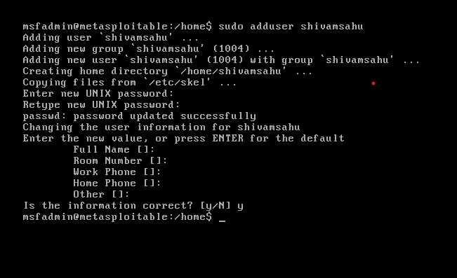
This image shows the creation of a new user using the adduser command. The system creates a new user, group, and home directory. User details such as password and basic information are set. This fulfills the project requirement of creating a user inside Metasploitable.

Step 3: Mutillidae Database Error
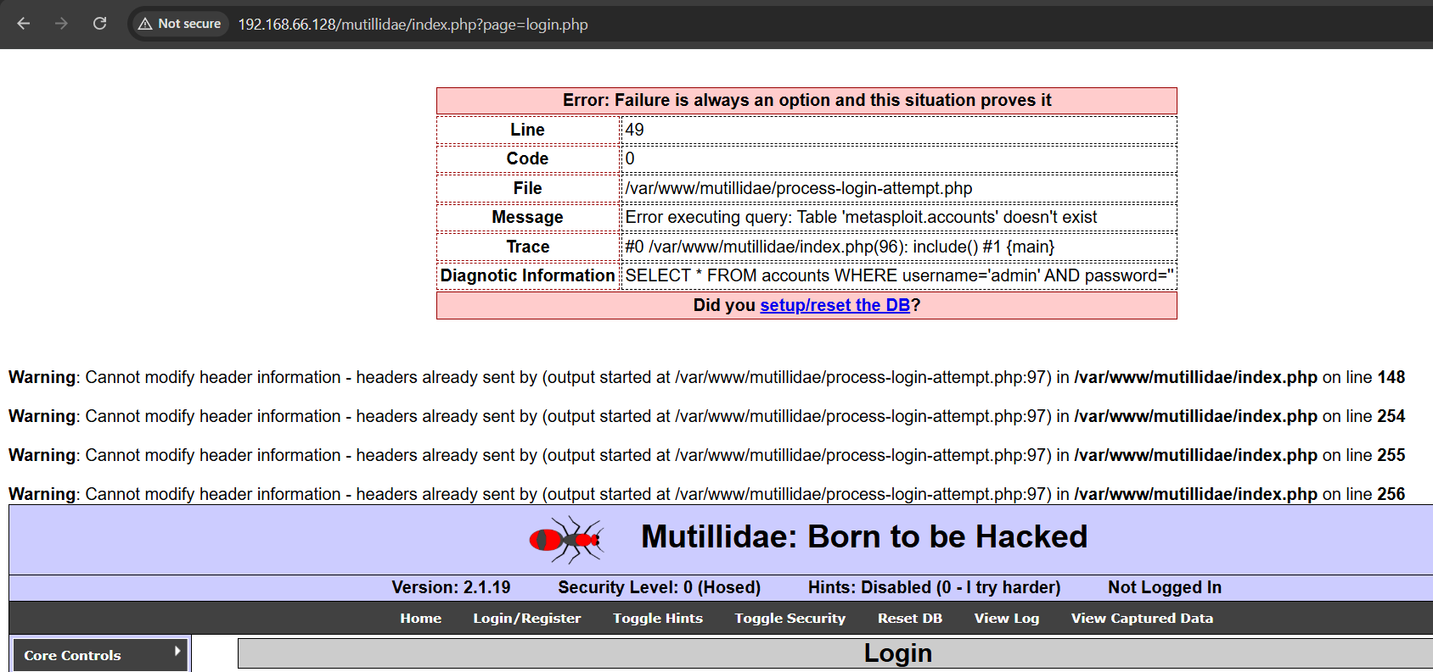
This image shows the Mutillidae II database error. The error indicates that the required database tables do not exist. This happens because the database is not initialized by default. Identifying this error is part of the project requirement.
Here, we are shown a directory /var/www/mutillidae/ .
The directory /var/www/mutillidae/ contains all server-side files of the Mutillidae II web application. This includes PHP scripts, configuration files, and database interaction logic. Since Apache serves content from /var/www/, accessing this directory confirms that Mutillidae is correctly hosted on the web server. Any database misconfiguration directly affects files inside this directory. Analyzing this path helps in understanding how web applications are structured on Linux servers.

Step 4: Mutillidae Database Configuration
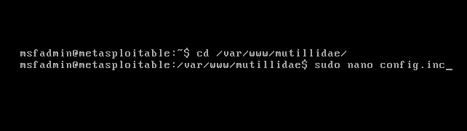
This screenshot shows editing of the Mutillidae configuration file. Database connection parameters such as host, user, and database name are verified. Correct configuration is necessary for proper database communication. This step helps resolve database-related issues.

Step 5: Database Reset and OWASP Setup
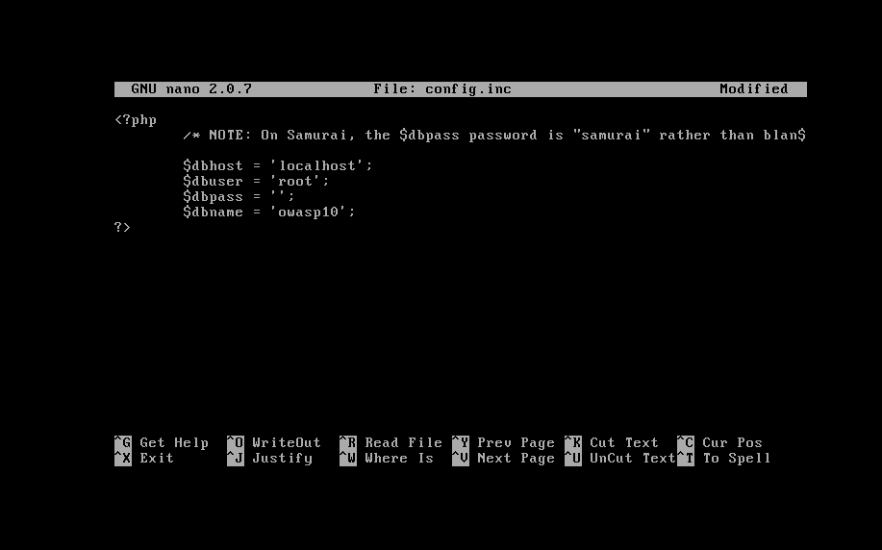
This image shows the database setup/reset option in Mutillidae. Resetting the database creates required tables automatically. OWASP Top 10 vulnerabilities become accessible after this step. This confirms successful database initialization.

Step 6: Mutillidae Working Successfully
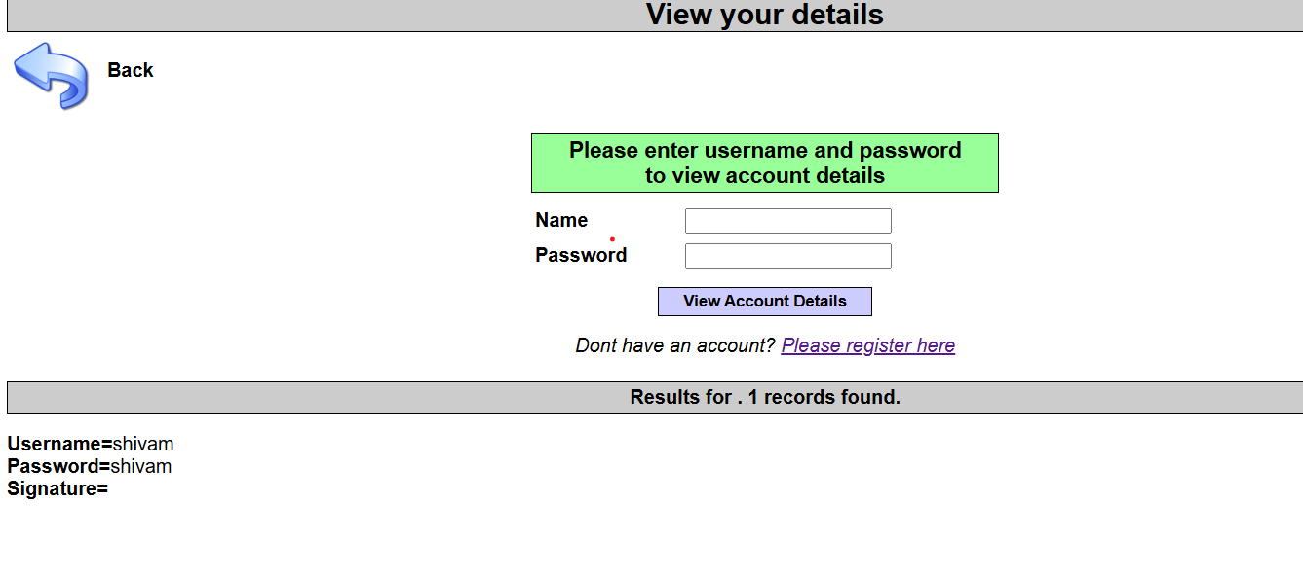
This screenshot confirms that Mutillidae II is working correctly. The application loads without database errors. User data can be viewed successfully, proving full functionality. This completes the Mutillidae II fix requirement.

