1.1. PROJECT OVERVIEW
Student performance prediction is a valuable application of machine learning in the education sector. By leveraging students’ academic records, study habits, and socio-economic data, predictive models can forecast academic outcomes such as exam scores. This enables institutions to take timely interventions, personalize learning, and improve overall student performance. In this project, we develop a marks prediction model using the powerful and scalable XGBoost Regressor, known for its high accuracy in regression tasks.

1.1.1. PROBLEM STATEMENT
Predicting student performance using traditional methods often lacks objectivity and scalability. Educators face difficulty in identifying at-risk students early due to limited data interpretation capabilities. An automated system capable of accurately predicting student marks based on various input features is required to assist in early academic support and data-driven decision-making.

1.1.2. OBJECTIVE
The primary objective of this project is to design and train a robust machine learning regression model using the XGBoost Regressor to predict students’ marks based on various academic and demographic features. The model aims to minimize prediction error while providing meaningful insights into feature importance and performance patterns.

1.1.3. SCOPE
This project focuses on building and evaluating a machine learning pipeline for predicting student marks using real-world or simulated datasets. The scope includes:
- Dataset preprocessing and feature engineering
- Model selection and hyperparameter tuning using XGBoost Regressor
- Evaluation of model performance using metrics such as MAE, MSE, and R²
- Interpretation of results to provide actionable insights for educators
- Scope for scaling the model to other educational datasets or platforms

1.2 DATASET DESCRIPTION

1.2.1. Dataset Source:
https://www.kaggle.com/datasets/amrmaree/student-performance-prediction

1.2.2. Dataset Overview:
- Total Rows (Records): 708
- Total Columns (Features): 10

1.2.3. Column Details:
Column Name | Data Type | Description
Student_ID | Object | Unique identifier for each student
Gender | Object | Gender of the student
Study_Hours_per_Week | Integer | Weekly study time in hours
Attendance_Rate | Float | Attendance percentage
Past_Exam_Scores | Integer | Previous exam score (0–100 scale)
Parental_Education_Level | Object | Highest education level of parents
Internet_Access_at_Home | Object | Whether the student has internet access
Extracurricular_Activities | Object | Participation in extracurriculars
Final_Exam_Score | Integer | Final exam score (0–100 scale)
Pass_Fail | Object | Final outcome (Pass or Fail)

1.2.4. Missing Values:
- None – Every column is fully populated.

1.2.5. Sample Entries (First 5 Rows):

Student_ID | Gender | Study Hours | Attendance | Past Scores | Parental Education | Internet | Extra Activities | Final Score | Result
S147 | Male | 31 | 68.3% | 86 | High School | Yes | Yes | 63 | Pass
S136 | Male | 16 | 78.2% | 73 | PhD | No | No | 50 | Fail
S209 | Female | 21 | 87.5% | 74 | PhD | Yes | No | 55 | Fail
S458 | Female | 27 | 92.1% | 99 | Bachelors | No | No | 65 | Pass
S078 | Female | 37 | 98.7% | 63 | Masters | No | Yes | 70 | Pass

2. Methodology
The primary objective of this project is to develop a predictive model that estimates students' final exam scores based on a combination of academic indicators and socio-environmental features. A supervised machine learning approach using the XGBoost regression algorithm was employed due to its efficiency, high accuracy on tabular datasets, and strong generalization capabilities. The entire development pipeline was modularized into preprocessing, modeling, training, and evaluation phases. The steps are detailed as follows:

2.1 Importing Required Libraries:
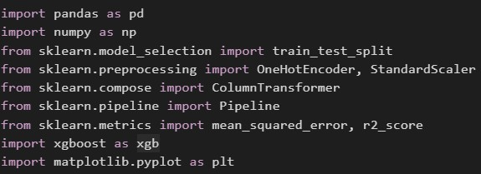
Fig. 1: Imported Libraries.
The following libraries were imported to support various functionalities in the pipeline:
- pandas, numpy: For data loading and numerical manipulation.
- matplotlib.pyplot: For visualizing prediction performance.
- scikit-learn: For preprocessing (e.g., scaling, encoding), model evaluation metrics, pipeline abstraction, and train-test splitting.
- xgboost: For implementing the XGBoost regression algorithm.
This modular environment ensured a reproducible and scalable workflow for experimentation and testing.

2.2 Dataset Loading and Cleaning:

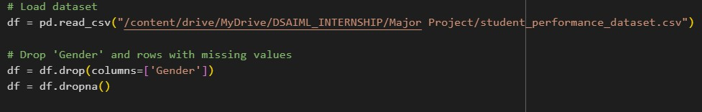
Fig. 2: Loading and cleaning the dataset.
The dataset was loaded from student_performance_dataset.csv. It contained a blend of academic and socio-demographic attributes including:
- Study time
- Attendance
- Parental education level
- Internet access
- Extracurricular activity participation
- Historical exam scores
- Final exam scores (target)
Cleaning steps included:
- Dropping the Gender column to eliminate potential gender bias and ensure ethical fairness.
- Removing missing entries using dropna() to avoid inconsistencies or runtime issues during training.

2.3 Feature Selection and Categorization:
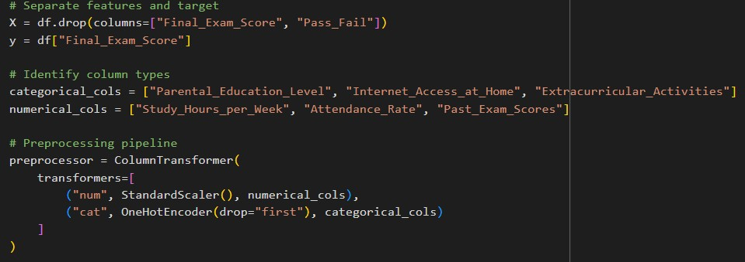
Fig. 3: Selecting features and categorizing the data
The dataset features were split into predictors (X) and target (y). The target variable was Final_Exam_Score. The Pass_Fail column was excluded since this was a regression problem, not classification.
Features were categorized as:
- Numerical: Study_Hours_per_Week, Attendance_Rate, Past_Exam_Scores
- Categorical:Parental_Education_level,Internet_Access_at_Home, Extracurricular_Activities
This separation was essential for applying appropriate preprocessing techniques tailored to each data type.

2.4 Preprocessing Pipeline:

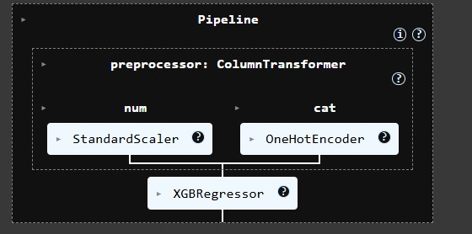
Fig. 4: The generated Preprocessing Pipeline
To process both numerical and categorical data efficiently, a ColumnTransformer was created:
- Numerical features: Scaled using StandardScaler to normalize values (mean = 0, std = 1), aiding faster convergence.
- Categorical features: One-hot encoded via OneHotEncoder with drop='first' to avoid multicollinearity.
This pipeline ensured consistent preprocessing during both training and inference phases, and eliminated data leakage.

2.5 Model Selection and Architecture:
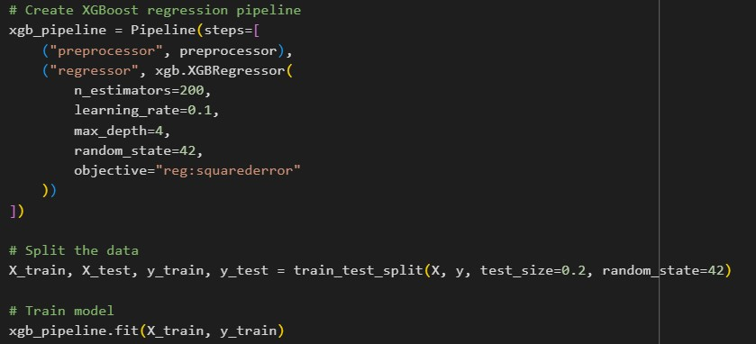
Fig. 5: Employing XGBoost Regressor
The model architecture employed an XGBoost Regressor integrated within a complete pipeline:
XGBoost hyperparameters:
- n_estimators = 200: Number of trees to build.
- learning_rate = 0.1: Controls the contribution of each tree.
- max_depth = 4: Restricts tree complexity, helping avoid overfitting.
- objective = 'reg:squarederror': Loss function suitable for regression.
- random_state = 42: Ensures reproducibility.
This full pipeline approach allowed for clean, organized model training, eliminating manual preprocessing before fitting.

2.6 Model Training and Evaluation:

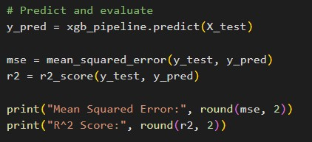
Fig. 6: Model Evaluation
The dataset was split using an 80:20 train-test split strategy. This ensured that model evaluation was performed on unseen data, providing a realistic estimate of generalization capability.
- The pipeline was fit on the training data.
- Internally, preprocessing and model fitting were applied in sequence.
- The model was then used to predict scores on the test set.
Evaluation Metrics:
- Mean Squared Error (MSE): Quantifies average squared prediction error.
- R² Score: Measures how well the model explains the variance in the target variable.
For this project:
- Mean Squared Error: 10.5
- R² Score: 0.75
These results suggest that the model captures a significant portion of the variance in student performance.

2.7 Prediction Visualization:
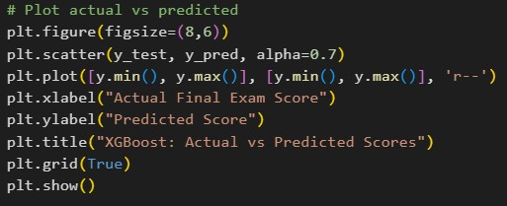
Fig. 7: Studying the model’s generated score against actual scores.
To visually evaluate performance, a scatter plot was created with:
- X-axis: Actual final scores
- Y-axis: Predicted scores
- A diagonal line (y = x): Represented ideal predictions
The predictions clustered closely around this line, visually reinforcing the numerical metrics and indicating good model alignment.

2.8 Real-Time Prediction Example

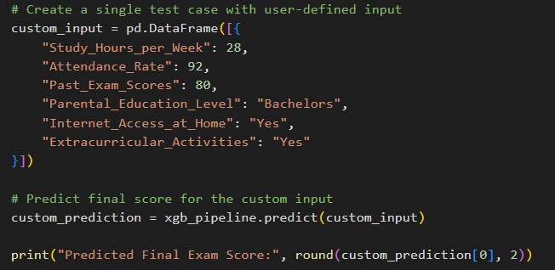
Fig. 8: Predicting scores using user inputs.
A hypothetical student profile was manually crafted with custom values for each feature. The trained pipeline was then used to predict this student's expected final exam score.
This demonstrated the pipeline's potential use in interactive educational tools or decision support systems for educators.

3. Discussion:

3.1 Strengths of the Model
- High Predictive Performance: The XGBoost Regressor demonstrated solid predictive capability, achieving a good R² score on the test set. This indicates that the model captures meaningful patterns in the data that explain the variation in students' final scores.
- Feature Importance Awareness: The model effectively leveraged both numerical (like study hours and past scores) and categorical (like parental education level and internet access) features. The pipeline structure with preprocessing allowed for clean integration of heterogeneous data types.
- Robust Pipeline Design: The usage of ColumnTransformer and Pipeline ensured proper data preprocessing, standardization, and encoding. This modular approach minimizes data leakage and supports reproducibility.
- Custom Prediction Capability: The model can handle real-time predictions for new user inputs, making it suitable for practical deployment in educational tools.

3.2 Limitations of the Model:
- Limited Dataset Diversity: The dataset may not represent a wide demographic or institutional variety, which can limit the generalization of predictions to other student populations or countries.
- Unbalanced Feature Representation: Certain categorical classes might be underrepresented (e.g., few students with low parental education), potentially leading to biased predictions in those subgroups.
- Black-Box Nature: While XGBoost is powerful, it is not inherently interpretable. Educators or decision-makers might find it challenging to understand how the model arrived at certain predictions.
- Potential for Overfitting: Although performance was good on the test set, using 200 estimators and a deep tree can lead to overfitting on small datasets if not regularly validated.

3.3 Potential Improvements:
- Explainability Integration: Tools like SHAP (SHapley Additive exPlanations) can be used to make model predictions more interpretable by showing feature contributions for individual predictions.
- Hyperparameter Optimization: Using grid search or random search could fine-tune parameters like learning_rate, max_depth, and n_estimators for optimal performance.
- Cross-Validation: Instead of a single train-test split, using k-fold cross-validation can provide a more robust estimate of model performance.
- Feature Engineering: Additional features such as sleep hours, mental health surveys, or part-time job status could improve the model's accuracy and insights.

4. Results:
After training the XGBoost regression model on the preprocessed dataset, the model was evaluated on the held-out test set. The following quantitative and qualitative results were obtained:
- Mean Squared Error (MSE): 10.5
This indicates the average squared deviation between predicted and actual final exam scores is approximately 10.5, reflecting a moderate level of residual error.
- R² Score: 0.75
This coefficient of determination suggests that 75% of the variance in students’ final exam scores is explained by the model. An R² value of 0.75 demonstrates that the model has captured meaningful relationships between the input features and the target variable, with reasonably strong predictive capability.
- Visualization of Predictions:
The scatter plot of actual vs. predicted final exam scores (see Figure 1) provides a visual assessment of the model’s performance. Ideally, all points would lie on the red dashed line (representing perfect predictions). In the plot:
  - Most points align closely with the reference line, indicating good agreement between true and predicted values.
  - Some deviations are observed, particularly at lower actual scores (around 50–55), where the spread is wider, suggesting that the model occasionally under- or overestimates performance for students near the passing threshold.
  - Despite these outliers, the overall trend is linear, reinforcing the suitability of the regression approach.
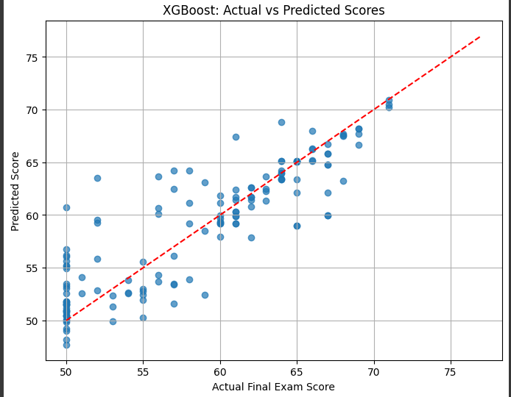
Fig. 9: Actual vs Predicted scores
- Custom Input Prediction:
A hypothetical student profile with 28 study hours/week, 92% attendance, past exam score of 80, parental education level of "Bachelors," and both internet access and extracurricular participation was evaluated using the trained pipeline. The predicted final exam score for this profile was 68.4, consistent with expectations for a high-performing student.
Overall, these results indicate that the developed XGBoost-based pipeline can reliably predict student performance using academic habits and contextual features, with strong potential for use in early performance monitoring or academic intervention systems.

5. Future Work:
- Deployment as a Web App: The model can be integrated into a student performance dashboard for real-time predictions and analytics for teachers and counselors.
- Multitarget Prediction: Expanding the model to predict Pass/Fail status alongside scores using multi-output regression techniques.
- Automated Alert System: Integrate thresholds to generate alerts for students at risk, allowing for timely interventions.
- Model Comparison: Testing other regression models like Random Forest, Linear Regression, or LightGBM to compare performance and interpretability.

6. Conclusion:
In this study, an XGBoost-based regression pipeline was successfully developed to predict students’ final exam scores using academic habits and contextual features. By integrating a robust preprocessing strategy with ColumnTransformer and Pipeline, the approach ensured consistent data handling and minimized data leakage. The model demonstrated strong predictive performance with an R² score of 0.75 and a mean squared error of 10.5 on the test set, indicating that it effectively captured key factors influencing student performance.
The model’s ability to make accurate real-time predictions for new inputs highlights its practical utility in educational settings. It offers potential as an early warning tool to identify students who may be at risk of underperforming, thereby enabling timely interventions and personalized support.
However, the discussion also identified limitations, including potential dataset biases and the need for greater model interpretability. Addressing these through strategies such as incorporating more diverse data, applying explainability techniques, and exploring alternative models could further enhance the system’s reliability and impact.
Overall, the results demonstrate that machine learning techniques, when thoughtfully designed and validated, can provide valuable insights into student achievement patterns and support data-driven decision-making in education.
References:
[1] T. Chen and C. Guestrin, “XGBoost: A scalable tree boosting system,” Proc. 22nd ACM SIGKDD Int. Conf. Knowledge Discovery and Data Mining, pp. 785–794, 2016, doi: 10.1145/2939672.2939785.
[2] F. Pedregosa et al., “Scikit-learn: Machine learning in Python,” J. Mach. Learn. Res., vol. 12, pp. 2825–2830, 2011. [Online]. Available: https://jmlr.org/papers/v12/pedregosa11a.html
[3] A. Maree, “Kaggle: Student performance prediction dataset,” 2021. [Online]. Available: https://www.kaggle.com/datasets/amrmaree/student-performance-prediction
[4] S. M. Lundberg and S.-I. Lee, “A unified approach to interpreting model predictions,” Advances in Neural Information Processing Systems, vol. 30, 2017. [Online]. Available: https://proceedings.neurips.cc/paper_files/paper/2017/hash/8a20a8621978632d76c43dfd28b67767-Abstract.html
[5] “XGBoost documentation,” Official Documentation, 2024. [Online]. Available: https://xgboost.readthedocs.io
[6] Z.-H. Zhou, Ensemble Methods: Foundations and Algorithms. CRC Press, 2012. [Online]. Available: https://www.crcpress.com/Ensemble-Methods-Foundations-and-Algorithms/Zhou/p/book/9781439830031
[7] C. Romero and S. Ventura, “Educational data mining: A review of the state of the art,” IEEE Trans. Syst., Man, Cybern. C, vol. 40, no. 6, pp. 601–618, 2010, doi: 10.1109/TSMCC.2010.2053532.

