**Internship Report on**



**ONLINE VEGETABLE WEBSITE**



**Submitted in partial fulfilment of the requirement for the award of the degree of**

**BACHELOR OF TECHNOLOGY**

**IN**

**COMPUTER SCIENCE & ENGINEERING**

***Under the Mentorship of***

**Yuvraj Joshi**

**(Assistant Professor)**

**Submitted by:**

**Aditya Negi 2016588**

**Ayushman Bhatt 2017640**

**Shivam 2017024**

**Anushk Pathak 2016655**



**Department of Computer Science and Engineering**

**Graphic Era (Deemed to be University)**

**Dehradun, Uttarakhand**

**July-2023**



**CANDIDATE’S DECLARATION**

**I/We hereby certify that the work which is being presented in the Report entitled “Sigma Mandi” in partial fulfillment of the requirements for the award of the Degree of Bachelor of Technology in Computer Science and Engineering in the Department of Computer Science and Engineering of the Graphic Era (Deemed to be University), Dehradun shall be carried out by the undersigned under the supervision of Mr. Yuvraj Joshi, Assistant Professor , Department of Computer Science and Engineering, Graphic Era (Deemed to be University), Dehradun.**

**Aditya Negi 2016588**

**Ayushman Bhatt 2017640**

**Shivam 2017024**

**Anushk Pathak 2016655**

**The above mentioned students shall be working under the supervision of the undersigned on the “Online Vegetable Website”**

**Table of Contents**

|  |  |  |
| --- | --- | --- |
| **Chapter No.**  **Html,CSS** | **Description** | **Page No.** |
| Chapter 1 | Introduction | **4** |
| Chapter 2 | User Interface | **5** |
| Chapter 3 | Technologies Used | **7** |
| Chapter 4 | Result and Discussion | **10** |
| Chapter 5  **Java Script**  Chapter 1  Chapter 2  Chapter 3  Chapter 4  Chapter 5  **React js**  Chapter 1  Chapter 2  Chapter 3  **Backend**  Chapter 1  Chapter 2  Chapter 3  Chapter 4  Chapter 5  **ML**  Chapter 1  Chapter 2  Chapter 3  Chapter 4 | Conclusion & Future Work  Problem Statement  Dynamic Website  Technologies Used  Result and Discussion  Conclusion & Future Work  Problem Statement  Technologies Used  Transformation  Problem Statement  Technologies Used  Steps  Result and Discussion  Conclusion & Future Work  Problem Statement  Technologies Used  Result and Discussion  Conclusion & Future Work | **13**  **14**  **14**  **16**  **17**  **20**  **21**  **21**  **23**  **26**  **26**  **28**  **29**  **31**  **33**  **33**  **37**  **38** |
|  |  |  |
|  |  |  |
|  |  |  |
|  |  |  |
|  |  |  |
|  |  |  |
|  |  |  |
|  |  |  |
|  |  |  |

**WEEK 1**

**Chapter 1**

**Introduction**

**PROBLEM STATEMENT:-** To create and design the User Interface of Online Vegetable Market Website using HTML and CSS.

In the rapidly evolving digital age, technology has wrought significant changes in many facets of our lives, including our approach to grocery shopping. Traditional brick-and-mortar stores are no longer the sole source of fresh food, thanks to the advent of online vegetable websites. These platforms have fundamentally reshaped our engagement with local farmers and granted us effortless access to an extensive assortment of top-quality vegetables, all from the comfort of our own homes.

This Project endeavors to conduct a comprehensive examination of online vegetable websites, shedding light on their paramount importance, myriad advantages, and far-reaching effects on both the agricultural sector and consumers. Our aim is to gain a profound understanding of how these platforms play a pivotal role in promoting sustainable farming practices, ensuring food security, and meeting the ever-evolving demands of contemporary consumers, achieved by dissecting their essential characteristics, merits, and challenges.

**Chapter 2**

**User Interface (Design Layout)**

**Design Overview:** The website follows a contemporary design approach, combining attractive visuals, intuitive navigation, and engaging content. It consists of several sections, including a header with a logo and navigation menu, a home section with a welcoming message and a call-to-action button, an about section providing information about the company, and a products section showcasing the latest vegetable offerings. The design incorporates the use of images, icons, and appealing color schemes to enhance visual appeal and user engagement.

.

**Navigation and User Interface:** The navigation menu, located in the header, allows users to easily access different sections of the website. The use of clear and descriptive anchor links helps users navigate to specific sections such as Home, About, Market, Contact Us, Dashboard. The inclusion of icons for search and cart functionalities in the header enhances user convenience and provides a familiar interface.

**Home Section:** The home section aims to captivate visitors with a visually appealing layout. The heading combines an eye-catching font style and a tagline, emphasizing the freshness and organic nature of the vegetables. A brief description creates an emotional connection with the user, and a call-to-action button encourages further exploration of the website.

**About Section:** The about section provides an overview of the company and its values. The inclusion of an image adds visual interest and supports the content. The tagline and accompanying paragraph highlight the company's mission and establish credibility. The "Learn More" button encourages users to delve deeper into the company's story.

**Market:** The products section showcases the latest vegetable offerings. A clear heading introduces the section, and a descriptive paragraph provides additional information. Each vegetable product is presented in a visually appealing card layout, featuring an image, a tagline, and a "Learn More" button. The addition of a cart icon allows users to easily add products to their shopping cart.

**Visual Elements and Branding:** The website employs consistent branding elements, such as the logo and color scheme, to create a cohesive visual identity. Images are used strategically throughout the website to enhance the appeal of the vegetables and evoke a sense of freshness and quality.

**Responsiveness and Compatibility:** The website appears to be responsive, adapting well to different screen sizes and devices. The use of the meta viewport tag ensures proper scaling on various devices. Additionally, external CSS and font libraries, such as Font Awesome, are properly linked, ensuring compatibility and accessibility across different browsers.

**Chapter 3**

**Technologies Used**

**HTML**

HTML (Hypertext Markup Language) is the standard markup language used for creating the structure and content of web pages. It is the fundamental language of the World Wide Web and provides a set of tags or elements that define the structure and semantics of a web document.

Here is the list of HTML tags used in the provided HTML code:

**1. `<html>`:** The root element that wraps the entire HTML document.

**2. `<head>`:** Contains meta information and external resources for the webpage.

**3. `<meta>`:** Defines metadata such as character set and viewport settings.

**4. `<title>`:** Specifies the title of the webpage displayed in the browser's title bar.

**5. `<link>`:** Used to link external stylesheets and font libraries to the HTML document.

**6. `<body>`:** Represents the main content area of the webpage.

**7. `<nav>`:** Defines a section containing navigation elements.

**8. `<div>`:** A generic container used to group and style content.

**9. `<ul>`:** Represents an unordered list of items.

**10. `<li>`:** Represents a list item within an unordered or ordered list.

**11. `<a>`:** Creates a hyperlink to another webpage or a specific location within the same webpage.

**12. `<img>`:** Inserts an image into the webpage.

**13. `<section>`:** Defines a standalone section or area of content.

**14. `<h1>`, `<h2>`:** Headings of different levels, used to structure the content hierarchy.

**15. `<p>`:** Represents a paragraph of text.

**16. `<i>`:** Displays italicized text or icons.

**17. `<br>`:** Inserts a line break.

**18. `id="..."`:** Assigns a unique identifier to an HTML element.

**19. `class="..."`:** Assigns one or more classes to an HTML element for styling and targeting with CSS.

These tags are essential building blocks for structuring and formatting the content within an HTML document.

**CSS:-**

The given CSS code defines the styling attributes for various elements of a website. Here is a breakdown of the attributes used in the CSS file:

- The universal selector (*) sets the margin and padding to 0 for all elements and includes the CSS box-sizing property to ensure proper box model behavior.

- The HTML element is styled to have smooth scrolling behavior using scroll-behavior: smooth.

- The navigation bar (nav) is positioned at the top of the page and has a white background with a box shadow. It contains a logo and a list of navigation links.

- The logo image within the navigation bar is styled with a width of 60px and a cursor pointer.

- The navigation links (li a) are styled with a color, and their color changes to a different shade on hover.

- The search icon within the navigation bar is styled with a font size and changes color on hover.

The CSS code also includes styling rules for different sections of the website, such as the home section, about section, products section, banner section, services section, blog section, and footer section. Each section has its own set of styling attributes defining the layout, positioning, background, fonts, colors, and other visual properties.

The CSS code also includes animations and transitions for certain elements. For example, the home section has an animation called moveside that moves elements horizontally and increases their opacity.

Overall, the CSS code aims to create a visually appealing and responsive website layout with consistent styling across different sections and elements.

**Chapter 4**

**Result and Discussion**

The outcome of the website is as follows: -

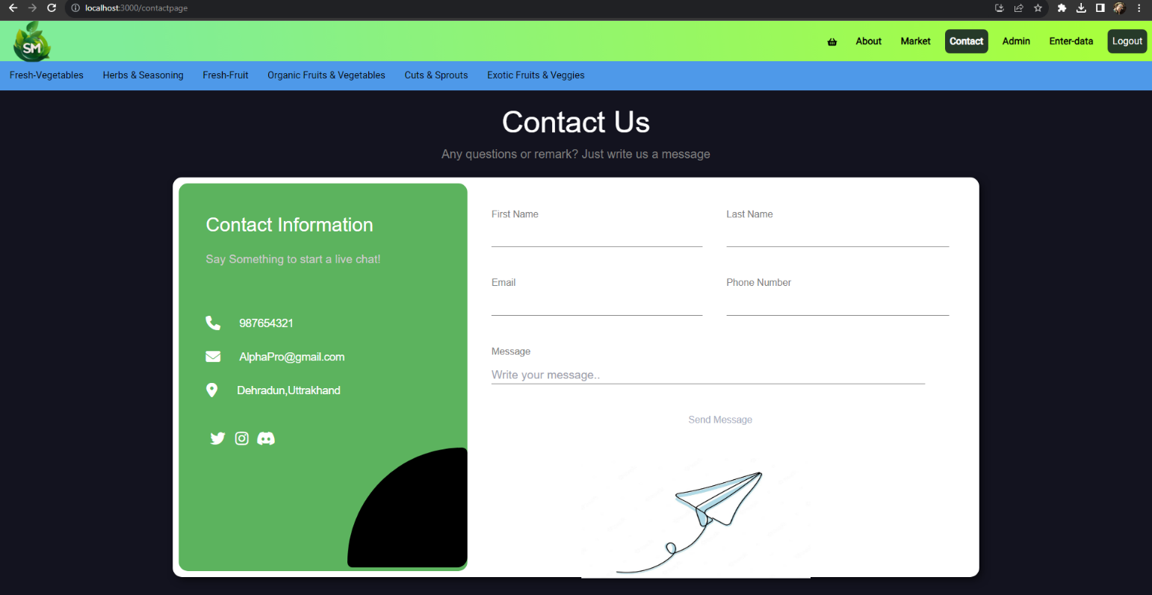

**Chapter 5**

**Conclusion and Future Work**

Online vegetable websites have emerged as a convenient and efficient way to connect consumers with local farmers and provide access to fresh, high-quality produce. They offer a wide range of advantages, including convenience, transparency, and supporting sustainable agriculture. While challenges exist, the potential for growth and innovation in this sector is substantial. By embracing technology and addressing consumer demands, online vegetable websites can continue to shape the future of food retail, fostering a healthier and more sustainable relationship between consumers and the agricultural ecosystem.

**Future Work: -**

**1. Enhance Responsiveness:** Ensure that the website is fully responsive across various devices and screen sizes. Test and optimize the layout and functionality for mobile devices, tablets, and larger screens.

**2. Improve Visual Design:** Consider enhancing the overall visual design of the website by refining the color scheme, typography, and imagery. Create a more visually appealing and cohesive look and feel, add dark theme.

**3. Add Dynamic Content:** Implement dynamic content features such as a blog management system or a content management system (CMS) to easily add, update, and manage blog posts, products, and other website content.

**WEEK 2**

**Chapter 1**

**Introduction**

**PROBLEM STATEMENT: -** Dynamic Website Enhancement with JavaScript.

**Chapter 2**

**DYNAMIC WEBSITE**

**JavaScript Integration:**

JavaScript is a versatile scripting language that runs in the browser, allowing us to manipulate the webpage's content and behavior. Here are some ways we can use JavaScript to enhance the website:

**Interactive Cart:** Implement an interactive shopping cart that updates in real-time as users add or remove products. JavaScript will enable us to manage the cart's state and display the total price dynamically.

**User Authentication:** Add user registration and login functionality to create personalized accounts. JavaScript can help manage user sessions, handle authentication, and display personalized content.

**Image Sliders:** Create dynamic image sliders or carousels to showcase featured products or promotions. Users can navigate through images with ease.

**Search Functionality:** Implement a search bar with real-time suggestions as users’ type. JavaScript can send search queries to the server and display results dynamically.

**Real-time Updates:** Display real-time updates, such as stock availability or price changes, without the need for manual page refresh.

**Smooth Page Transitions:** Create smooth transitions between different sections of the website to enhance the user experience. JavaScript can control scrolling behavior and animations.

**Chapter 3**

**Technologies Used**

**JAVA SCRIPT: -**

To implement JavaScript functionality on the Online Vegetable Market website, the following steps were taken:

**Cart Functionality:** JavaScript was used to create an interactive shopping cart. When users click the "Add to Cart" button on a product card, JavaScript adds the selected item to the cart. The cart dynamically updates to show the added items and calculate the total price. Users can also remove items from the cart, which updates the cart in real-time.

**User Authentication:** JavaScript was employed to handle user registration and login. Users can create accounts, log in, and stay authenticated across different pages. Their personalized information and order history are accessible through their accounts.

**Image Sliders:** Dynamic image sliders were created using JavaScript. Users can navigate through product images using the slider, enhancing the visual presentation of products.

.

**Chapter 4**

**Result and Discussion**

**Chapter 5**

**Conclusion and Future Work**

The integration of JavaScript has significantly improved the Online Vegetable Market website, making it more dynamic and user-centric. Users can now interact with the website in real-time, creating a more engaging and convenient experience.

**Future Work:**

**Mobile App:** Consider developing a mobile app using JavaScript frameworks like React Native or Flutter to reach a broader audience and provide a native mobile experience.

**Push Notifications:** Implement push notifications to alert users about special promotions, new arrivals, or order updates, increasing user engagement.

**Localization:** Expand the website's reach by adding multi-language support with JavaScript libraries like i18next for seamless translation.

**Progressive Web App (PWA):** Convert the website into a PWA to enable offline access and offer a more app-like experience, improving user retention.

**WEEK 3**

**Chapter 1**

**Introduction**

**PROBLEM STATEMENT: -**The SRS outlines the requirements for an online vegetable website developed using React.js.

**Chapter 2**

**Technologies Used**

**React Framework: Building Dynamic User Interfaces**

React is an open-source JavaScript library for building user interfaces (UIs), specifically designed to create interactive and dynamic front-end applications. Developed and maintained by Facebook, react has gained widespread adoption due to its component-based architecture and efficient rendering capabilities.

Key Concepts and Features:

**Component-Based Architecture:** React revolves around the concept of components, which are self-contained, reusable building blocks for UI elements. Components encapsulate both the UI and the logic associated with it, making development modular and maintainable.

**Virtual DOM (Document Object Model):** React employs a virtual DOM, an in-memory representation of the actual DOM. When data changes occur, react compares the virtual DOM with the previous version, identifies differences, and then updates only the necessary parts of the actual DOM. This approach minimizes unnecessary DOM manipulation and enhances performance.

**Declarative Syntax:** React uses a declarative approach, where developers specify the desired outcome of UI components, and React takes care of the underlying updates and rendering. This leads to more predictable code and easier debugging.

**Reconciliation:** React's reconciliation algorithm efficiently updates the DOM by minimizing changes and avoiding unnecessary re-renders. This contributes to faster rendering and improved performance.

**Component Lifecycle Methods:** React components have lifecycle methods that allow developers to perform actions at specific stages of a component's existence, such as when it is created, updated, or removed. This enables tasks like data fetching, updating state, and cleanup operations.

**State Management:** React allows components to manage their internal state, making it easier to handle dynamic data and interactive behavior. The useState hook introduced in newer versions of React simplifies state management within functional components.

**Context API:** The Context API enables data to be passed down the component tree without manually passing props at each level. This is particularly useful for managing global data and themes across an application.

**React Router:** React Router is a popular library for handling navigation and routing in React applications. It allows for creating single-page applications with multiple views while maintaining a seamless user experience.

**Server-Side Rendering (SSR) and Static Site Generation (SSG):** React can be used to render UI on the server side or generate static HTML pages, enhancing SEO, initial load times, and accessibility.

**Component Reusability:** React components are highly reusable, which leads to efficient development and codebase maintenance. Developers can build a library of components to be used across different projects.

**Transforming a Static HTML/CSS Website into a React-Powered Application**

In the dynamic realm of web development, the evolution of technologies has led to new and more efficient ways to build interactive and responsive websites. Converting a website from traditional HTML/CSS to React, a powerful JavaScript library, marks a significant step towards enhancing user experiences, streamlining development, and embracing modern web practices.

**Understanding the Transition:**

1. **Component-Based Paradigm:** The fundamental shift when migrating to React lies in its component-based architecture. Instead of monolithic HTML files, the website is broken down into reusable components. These components encapsulate UI elements and their behaviors, fostering modularity, reusability, and easier maintenance.
2. **Declarative Approach:** React employs a declarative approach to building interfaces. Developers describe the desired UI outcome, and React takes care of efficiently updating the DOM. This approach simplifies the process of handling dynamic content, user interactions, and state changes.
3. **Virtual DOM Optimization:** React's virtual DOM mechanism minimizes direct manipulation of the actual DOM, resulting in faster rendering and better performance. It intelligently updates only the necessary parts of the DOM, reducing overhead and enhancing the user experience.
4. **Data Flow:** React enforces a unidirectional data flow. This clear flow of data ensures predictability and makes it easier to track changes, debug issues, and maintain codebases as the application grows.

**Migration Process:**

1. **Component Identification:** The HTML structure is analyzed to identify logical components. Elements that repeat or have shared functionality can be turned into React components.
2. **Component Creation:** Each identified component is transformed into a React component. HTML markup becomes JSX, which allows embedding JavaScript logic within the markup.
3. **State Management:** Elements that require dynamic updates are integrated with React's state management. This enables seamless handling of changes and real-time interactions.
4. **CSS Adaptation:** Existing CSS styles can be retained, but React's approach often involves component-specific styling methodologies like CSS Modules or Styled Components. This encapsulates styles and reduces the risk of class name collisions.
5. **Event Handling:** Event handling is achieved using React's event system. Inline JavaScript event attributes in HTML are replaced with event listeners attached to React components.
6. **Data Binding:** Any data binding in HTML is replaced with JSX expressions, which render dynamic content within React components.
7. **Refactoring:** Refactor the codebase to align with React's best practices, including component naming conventions, prop handling, and state management.

**WEEK 4**

**Chapter 1**

**Introduction**

**Problem Statement: -**To create Front End and Backend of Online Vegetable Market Website using Node js ,Express js and MongoDB.

**Chapter 2**

**Technologies Used**

**Backend (Node js,MongoDB)**

**1.User Authentication and Authorization**:Implement user registration and login functionality to allow users to create accounts and log in. Use sessions or JSON Web Tokens (JWT) for authentication and ensure that only authenticated users can access certain features of the website, such as placing orders or managing their profiles.

**2.Product Listings**:Create APIs to display a list of available vegetables with their prices, descriptions, and images. Users should be able to browse through the list and filter vegetables based on categories or search terms.

**3.Shopping Cart**:Implement a shopping cart functionality that allows users to add vegetables to their cart, adjust quantities, and view the total cost of their selections. The cart should persist between user sessions.

**4.Order Management**:Enable users to place orders for the vegetables in their cart. After placing an order, users should receive confirmation emails, and the order details should be stored in the database for future reference.

**5.User Reviews and Ratings**:Allow users to leave reviews and ratings for the vegetables they have purchased. Display the average rating and individual reviews on the product pages.

**NODE JS:**

Node.js is a popular open-source runtime environment that allows you to execute JavaScript code outside of a web browser. It is built on the V8 JavaScript engine, which is also used by the Google Chrome browser, and it enables developers to run JavaScript on the server-side, making it ideal for building scalable and high-performance applications.

**1.User Login Function**

It defines a user login function in a Node.js application using Express.js and MongoDB. The purpose of this function is to authenticate users based on their provided credentials (username and password) and respond accordingly.

**2. User Registration Function**

It defines a user registration function in a Node.js application using Express.js and MongoDB. The purpose of this function is to register new users by saving their provided information (username, email, password) to the database.

**3.Connecting to MongoDB**

It is a Node.js module responsible for connecting to a MongoDB database using the Mongoose library. It establishes a connection to the MongoDB database specified in the process.env.MONGO_URL environment variable.

**4.User Login Form Validation and Submission**

The provided code is a JavaScript script that handles the validation and submission of a user login form on the client-side. It performs input validation for the username and password fields and sends the form data to the server using a fetch API for user authentication.

Get DOM Elements and Form Submission Event Listener

Form Submission Event Handler

Form Data Preparation and Submission

Handling Server Response

**5. User Signup Form Validation and Submission**

The provided JavaScript code is a client-side script responsible for handling the validation and submission of a user signup form. It performs input validation for the username, email, password, and password confirmation fields and sends the form data to the server using a fetch API for user registration.

Steps:

1. The script provides client-side validation for a user signup form.

2. It checks if the username, email, password, and password confirmation fields meet specific criteria before proceeding with registration.

3. The fetch API is used to send a JSON payload containing the signup credentials to the "/signup" endpoint on the server for registration.

4. Depending on the server's response, the script displays success or error messages on the form using the displayFormMessage function.

5. The form submission is asynchronous, ensuring a smoother user experience for the user.

6. Despite client-side validation, it's crucial to implement server-side validation and security measures to ensure data integrity and protect user data during registration. Server-side validation helps prevent potential security vulnerabilities and ensures consistent validation checks.

**Chapter 4**

**Result and Discussion**

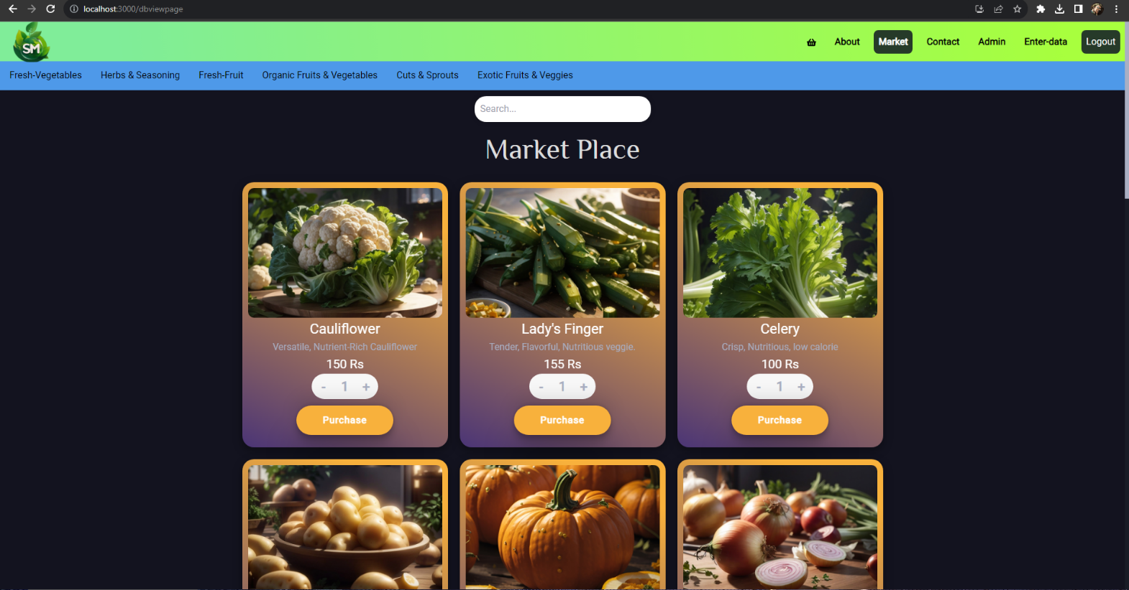

**Chapter 5**

**Backend Future Work:**

**1. User Profiles:**

Create user profiles where users can view and update their personal information, track order history, and manage delivery addresses.

**2. Admin Dashboard:**

Implement an admin dashboard that allows authorized administrators to manage the list of vegetables, add new products, update prices, and view order details. Proper authentication and authorization should be applied to restrict access to the admin features.

**3. Wishlist:**

Give users the option to add vegetables to their wishlist, allowing them to save products for future reference or purchases.

**4. Search Functionality:**

Implement a robust search feature that allows users to quickly find specific vegetables based on name, category, or other attributes.

**5. Order Tracking:**

Provide users with the ability to track the status of their orders. You can use real-time updates or periodic notifications to keep users informed about their order progress.

**WEEK 5**

**Chapter 1**

**Introduction**

Welcome to this comprehensive machine learning report focused on the analysis and prediction of vegetable prices. In this report, we embark on a data-driven journey to understand the dynamics of vegetable pricing, employ machine learning techniques to make accurate price predictions, and contribute valuable insights to the agricultural sector.

**Problem Statement**

To detect the future prices of vegetables based on the database .

**Data and Methodology**

Our approach to addressing the problem consists of the following steps:

**Data Collection**: We sourced a comprehensive dataset containing historical records of vegetable prices from various markets and regions. The dataset includes information on factors such as type of vegetable, market location, date, supply, demand, weather conditions, and more.

**Data Preprocessing**: To ensure data quality, we conducted data preprocessing, including handling missing values, removing outliers, and encoding categorical variables. We also performed feature engineering to extract relevant features that could impact vegetable prices.

**Exploratory Data Analysis (EDA)**: Through visualizations and statistical analysis, we explored the dataset to uncover patterns, trends, and correlations. EDA allowed us to gain valuable insights into the relationships between variables and the dynamics of vegetable prices.

**IMPORTED LIBRARIES: -**

**Flask:** A web framework for building web applications in Python.

**render template:** A function from Flask used for rendering HTML templates.

**request:** A module from Flask used to access HTTP request data.

**NumPy (np):** A library for numerical computations in Python.

**pandas (read_csv, pd):** A library for data manipulation and analysis.

**train_test_split:** A function from scikit-learn used to split data into training and testing sets.

**StandardScaler:** A class from scikit-learn used for feature scaling.

algorithms from scikit-learn.

**warnings:** A module for handling warnings.

**Sequential:** A class from Keras (TensorFlow) used to build sequential neural network models.

**Input, Dense, Dropout:** Different types of layers from Keras (TensorFlow) for building neural networks.

**LSTM:** Long Short-Term Memory layer from Keras (TensorFlow) for building recurrent neural networks.

**layers:** A module from Keras (TensorFlow) for defining different types of layers in neural networks.

**MinMaxScaler:** A class from scikit-learn used for feature scaling between a specified range.

**mean_squared_error:** A function from scikit-learn used for calculating mean squared error.

**tensorflow (tf):** A library for deep learning and neural networks.

**MACHINE LEARNING (JUPYTER NOTEBOOK, PyCHARM):-**

**Jupyter Notebook**

Jupyter Notebook is an interactive environment that allows data scientists and machine learning practitioners to create and share documents containing live code, equations, visualizations, and explanatory text. It supports various programming languages, including Python, which makes it a popular choice for machine learning workflows.

**PyCharm**

PyCharm is a powerful integrated development environment (IDE) specifically designed for Python programming. It provides advanced coding assistance, a rich set of tools for debugging and testing, and seamless integration with version control systems. PyCharm's user-friendly interface and robust features make it suitable for developing complex machine learning projects.

Methodology

Our approach to exploring machine learning using Jupyter Notebook and PyCharm involves the following steps:

**Installation and Setup:** We begin by installing both Jupyter Notebook and PyCharm and configuring the necessary dependencies, such as machine learning libraries (e.g., scikit-learn, TensorFlow) and data manipulation tools (e.g., pandas).

**Data Preparation:** We source a dataset suitable for a chosen machine learning task, ensuring that it is properly cleaned, preprocessed, and formatted. This step mightinclude handling missing values, encoding categorical variables, and splitting data into training and testing sets.

**Model Development in Jupyter Notebook:** We create a machine learning model within Jupyter Notebook. We demonstrate the process of importing libraries, loading and preprocessing data, selecting a suitable algorithm (e.g., linear regression, random forest), training the model, and evaluating its performance using appropriate metrics.

**Model Development in PyCharm:** We replicate the same machine learning task in PyCharm. We showcase the benefits of using an IDE like PyCharm for code organization, debugging, and project management. The process includes creating a project, writing code, integrating version control, and running the model.

**Comparative Analysis:** We compare the experiences of developing machine learning models in both Jupyter Notebook and PyCharm. We discuss the advantages and limitations of each environment, focusing on factors such as code readability, ease of debugging, collaboration, and integration with external tools.

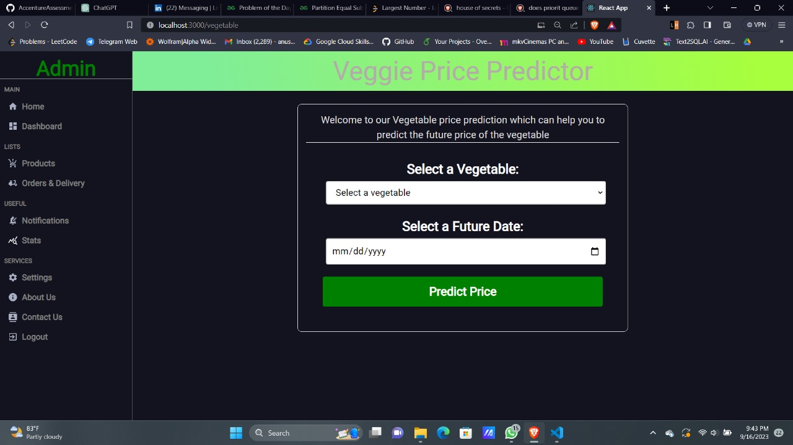**RESULT AND ANALYSIS:-**

**CONCLUSION: -**

As we conclude this report, we celebrate the symbiotic relationship between Jupyter Notebook, PyCharm, and Streamlit in solving real-world challenges. Through effective data analysis, model development, and interactive visualization, we've harnessed the power of these tools to predict vegetable prices, empowering stakeholders in the agricultural industry.

**Integration of Tools:** The seamless integration of Jupyter Notebook, PyCharm, and Streamlit facilitated a fluid workflow. Jupyter Notebook supported initial data exploration and preprocessing, PyCharm enabled advanced model development, and Streamlit provided a user-friendly interface for presenting results.

**Predictive Power:** Our machine learning models demonstrated promising predictive capabilities, offering accurate insights into future vegetable prices. These models have the potential to guide farmers, distributors, and policymakers in making informed decisions.

**Visualization and Interaction:** Streamlit elevated our findings by creating an interactive web application. Users can now visually explore trends, observe predicted price changes, and comprehend the impact of various factors on vegetable prices.

**FUTURE WORK: -**

**Ensemble Techniques**: Exploring ensemble techniques, such as combining the predictions of multiple models, could potentially enhance the accuracy and robustness of our predictions.

**Real-Time Data:** Integrating real-time data feeds into our models and application could provide users with up-to-the-minute insights, enhancing the usefulness of our solution.

**User Feedback:** Collecting user feedback on the Streamlit application will help us refine its usability and cater to specific user needs.