**Python | Using 2D arrays/lists the right way**

[Python](https://www.geeksforgeeks.org/python-programming-language/) provides powerful data structures called lists, which can store and manipulate collections of elements. Also provides many ways to create 2-dimensional lists/arrays. However one must know the differences between these ways because they can create complications in code that can be very difficult to trace out. In this article, we will explore the right way to use 2D arrays/lists in Python.

**Using 2D arrays/lists the right way**

Using 2D arrays/lists the right way involves understanding the structure, accessing elements, and efficiently manipulating data in a two-dimensional grid. When working with structured data or grids, 2D arrays or lists can be useful. A 2D array is essentially a list of lists, which represents a table-like structure with rows and columns.

**Creating a 1-D list**

In Python, Initializing a collection of elements in a linear sequence requires creating a 1D array, which is a fundamental process. Although Python does not have a built-in data structure called a ‘1D array’, we can use a list that can achieve the same functionality. Python lists are dynamic and versatile, making them an excellent choice for representing 1D arrays. Let’s start by looking at common ways of creating a 1d array of size N initialized with 0s.

**Creating 1D List using Naive Methods**

Manually initializing and populating a list without using any advanced features or constructs in Python is known as creating a 1D list using “Naive Methods”.

* Python3

|  |
| --- |
| N = 5  ar = [0]*N  print(ar) |

**Output**

[0, 0, 0, 0, 0]

**Creating 1D List using List Comprehension**

Here we are multiplying the number of rows by the empty list and hence the entire list is created with every element zero.

* Python3

|  |
| --- |
| N = 5  arr = [0 for i in range(N)]  print(arr) |

**Output**

[0, 0, 0, 0, 0]

**Creating a 2-D list**

Using 2D arrays/lists the right way involves understanding the structure, accessing elements, and efficiently manipulating data in a two-dimensional grid. By mastering the use of 2D arrays, you can significantly improve your ability to handle complex data and efficiently perform various operations.

**Creating 2D List using Naive Method**

Here we are multiplying the number of columns and hence we are getting the 1-D list of size equal to the number of columns and then multiplying it with the number of rows which results in the creation of a 2-D list.

* Python3

|  |
| --- |
| rows, cols = (5, 5)  arr = [[0]*cols]*rows  print(arr) |

**Output**

[[0, 0, 0, 0, 0], [0, 0, 0, 0, 0], [0, 0, 0, 0, 0], [0, 0, 0, 0, 0], [0, 0, 0, 0, 0]]

**Note:** Using this method can sometimes cause unexpected behaviors. In this method, each row will be referencing the same column. This means, even if we update only one element of the array, it will update the same column in our array.

* Python

|  |
| --- |
| rows, cols = (5, 5)  arr = [[0]*cols]*rows  print(arr, "before")    arr[0][0] = 1 # update only one element  print(arr, "after") |

**Output**

([[0, 0, 0, 0, 0], [0, 0, 0, 0, 0], [0, 0, 0, 0, 0], [0, 0, 0, 0, 0], [0, 0, 0, 0, 0]], 'before')  
([[1, 0, 0, 0, 0], [1, 0, 0, 0, 0], [1, 0, 0, 0, 0], [1, 0, 0, 0, 0], [1, 0, 0, 0, 0]], 'after')

**Creating 1D List using List Comprehension**

Here we are basically using the concept of list comprehension and applying a loop for a list inside a list and hence creating a 2-D list.

* Python3

|  |
| --- |
| rows, cols = (5, 5)  arr = [[0 for i in range(cols)] for j in range(rows)]  print(arr) |

**Output**

[[0, 0, 0, 0, 0], [0, 0, 0, 0, 0], [0, 0, 0, 0, 0], [0, 0, 0, 0, 0], [0, 0, 0, 0, 0]]

**Creating 1D List using Empty List**

Here we are appending zeros as elements for a number of columns times and then appending this 1-D list into the empty row list and hence creating the 2-D list.

* Python3

|  |
| --- |
| arr=[]  rows, cols=5,5  for i in range(rows):      col = []      for j in range(cols):          col.append(0)      arr.append(col)  print(arr) |

**Output**

[[0, 0, 0, 0, 0], [0, 0, 0, 0, 0], [0, 0, 0, 0, 0], [0, 0, 0, 0, 0], [0, 0, 0, 0, 0]]

**Initializing 2D Array**

The provided code demonstrates two different approaches to initializing a 2D array in [Python](https://www.geeksforgeeks.org/python-programming-language/). First, the array arr is initialized using a 2D list comprehension, where each row is created as [0, 0, 0, 0, 0]. The entire array is created as a list of references to the same inner list, resulting in aliasing. Any change made to an element in one row will be reflected in all rows. The code then shows another approach using a nested list comprehension to create the 2D array arr. This method avoids aliasing by creating a new list for each row, resulting in a proper 2D array.

* Python3

|  |
| --- |
| # Python 3 program to demonstrate working  # of method 1 and method 2.  rows, cols = (5, 5)  # method 2 1st approach  arr = [[0]*cols]*rows  # lets change the first element of the  # first row to 1 and print the array  arr[0][0] = 1    for row in arr:      print(row)    # method 2 2nd approach  arr = [[0 for i in range(cols)] for j in range(rows)]    # again in this new array lets change  # the first element of the first row  # to 1 and print the array  arr[0][0] = 1  for row in arr:      print(row) |

**Output**

[1, 0, 0, 0, 0]  
[1, 0, 0, 0, 0]  
[1, 0, 0, 0, 0]  
[1, 0, 0, 0, 0]  
[1, 0, 0, 0, 0]  
[1, 0, 0, 0, 0]  
[0, 0, 0, 0, 0]  
[0, 0, 0, 0, 0]  
[0, 0, 0, 0, 0]  
[0, 0, 0, 0, 0]

**Explanation:**

We expect only the first element of the first row to change to 1 but the first element of every row gets changed to 1 in method 2a. This peculiar functioning is because Python uses shallow lists which we will try to understand.  
In method 1a, Python doesn’t create 5 integer objects but creates only one integer object, and all the indices of the array arr point to the same int object as shown.

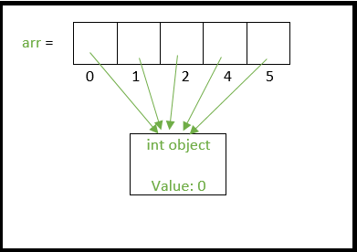

If we assign the 0th index to another integer say 1, then a new integer object is created with the value of 1 and then the 0th index now points to this new int object as shown below

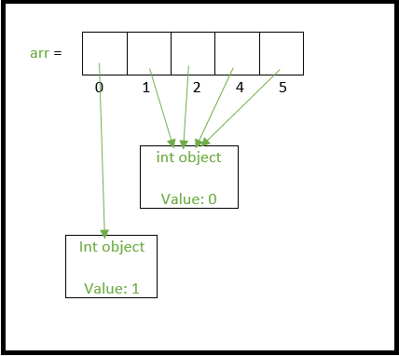

Similarly, when we create a 2d array as “arr = [[0]*cols]*rows” we are essentially extending the above analogy.

1. Only one integer object is created.
2. A single 1d list is created and all its indices point to the same int object in point 1.
3. Now, arr[0], arr[1], arr[2] …. arr[n-1] all point to the same list object above in point 2.

**The above setup can be visualized in the image below.**

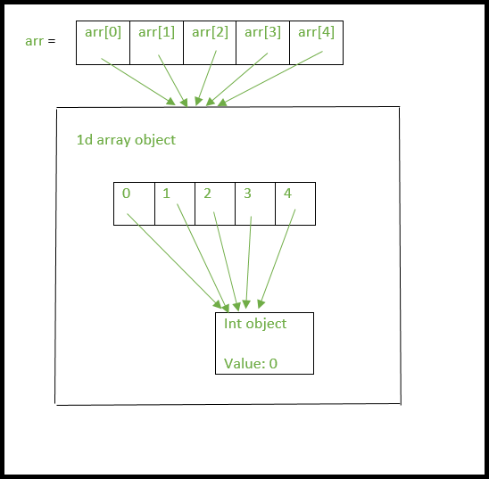

Now lets change the first element in first row of “arr” as arr[0][0] = 1

* arr[0] points to the single list object we created we above.(Remember arr[1], arr[2] …arr[n-1] all point to the same list object too).
* The assignment of arr[0][0] will create a new int object with the value 1 and arr[0][0] will now point to this new int object.(and so will arr[1][0], arr[2][0] … arr[n-1][0])

**This can be clearly seen in the below image.**

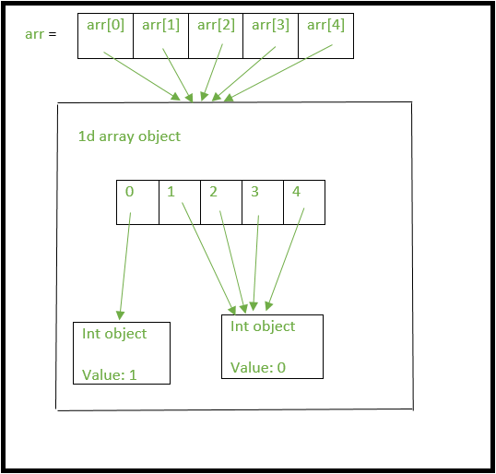

So when 2d arrays are created like this, changing values at a certain row will affect all the rows since there is essentially only one integer object and only one list object being referenced by the all the rows of the array.

As you would expect, tracing out errors caused by such usage of shallow lists is difficult. Hence the better way to declare a 2d array is

* Python3

|  |
| --- |
| rows, cols = (5, 5)  print([[0 for i in range(cols)] for j in range(rows)]) |

**Output**

[[0, 0, 0, 0, 0], [0, 0, 0, 0, 0], [0, 0, 0, 0, 0], [0, 0, 0, 0, 0], [0, 0, 0, 0, 0]]

This method creates 5 separate list objects, unlike method 2a. One way to check this is by using the ‘is’ operator which checks if the two operands refer to the same object.

* Python3

|  |
| --- |
| rows, cols = (5, 5)    # method 2 2nd approach  arr = [[0 for i in range(cols)] for j in range(rows)]    # check if arr[0] and arr[1] refer to  # the same object  print(arr[0] is arr[1]) # prints False    # method 2 1st approach  arr = [[0]*cols]*rows    # check if arr[0] and arr[1] refer to the same object prints True because there is only one  #list object being created.  print(arr[0] is arr[1]) |

**Output**

False  
True

Reference:

https://www.geeksforgeeks.org/python-using-2d-arrays-lists-the-right-way/