NAME: M.Sai Chaitanya ID NO: 2520090023

PRACTICAL WEEK 8

Task 1: Develop a program using malloc(), calloc(), realloc(), and free(). Monitor memory allocation behavior and identify memory leaks using Valgrind.
- Create a file
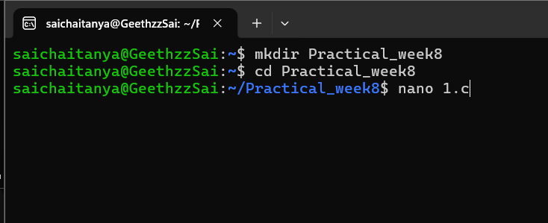
Then press enter to open command

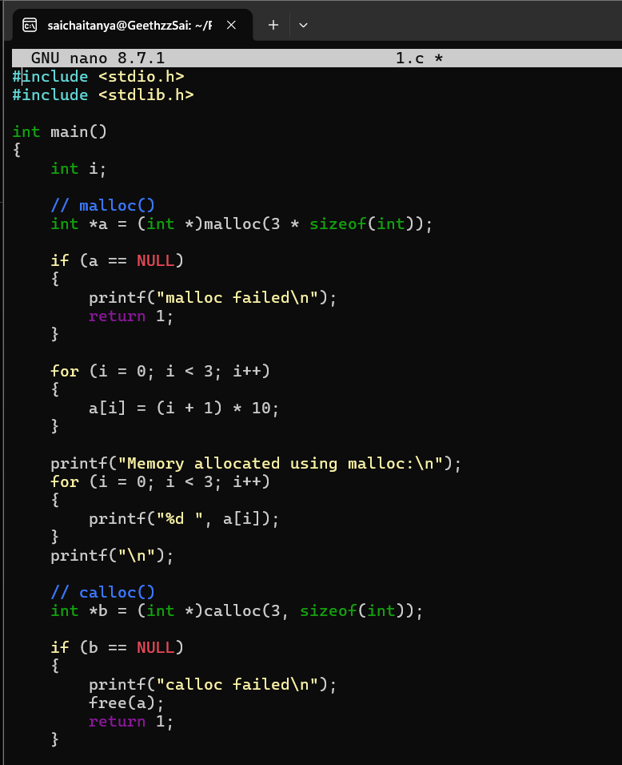
- write a code

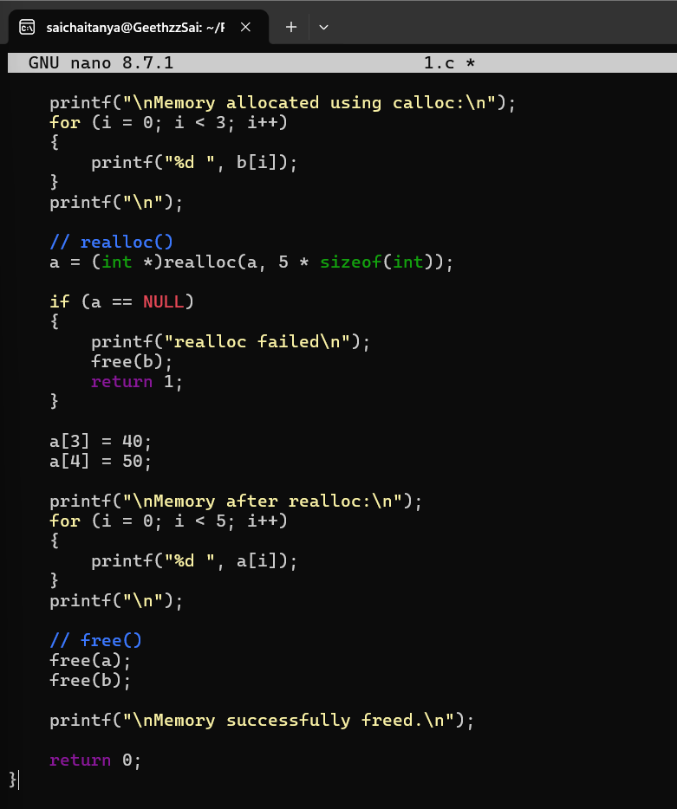
  - To save press control O
  - To come back to shell press control X
  - Then DO compilation

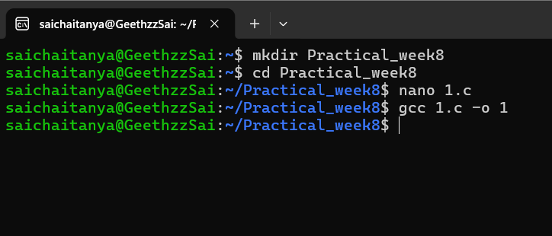

OUTPUT:
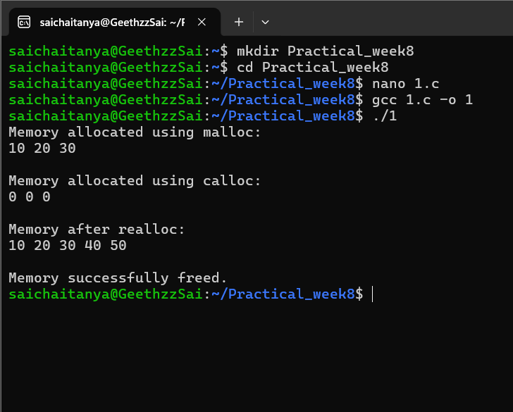

Task-2: Develop a program that demonstrates Copy-on- Write behavior after a fork(). Analyze memory usage before and after modifying data in the child process.

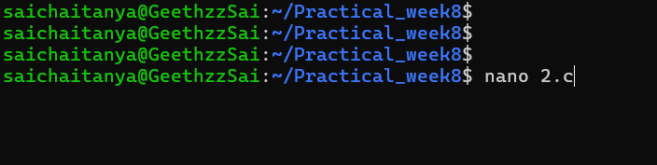

CODE:
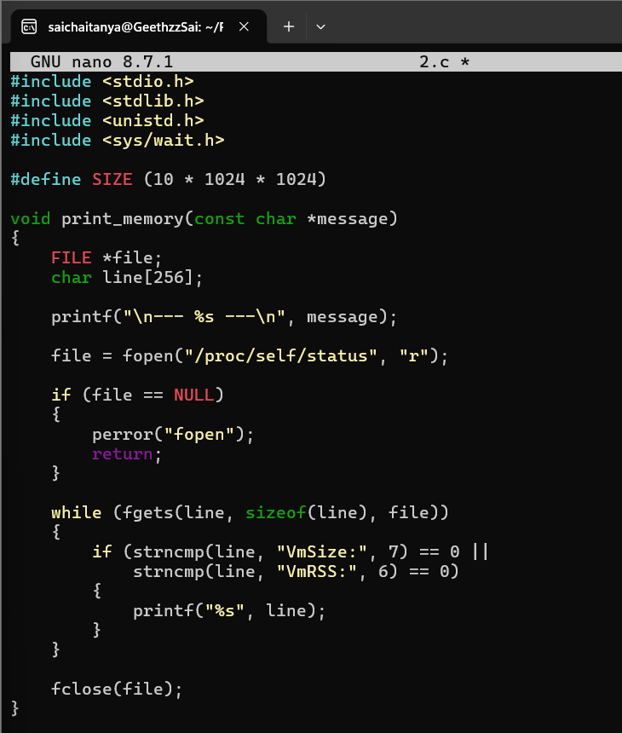

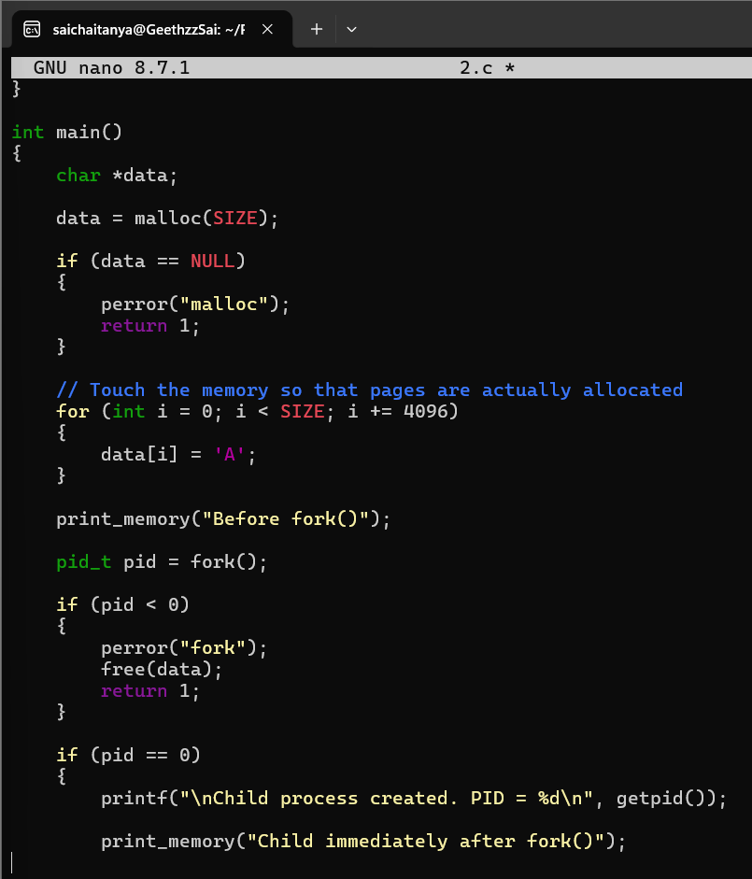

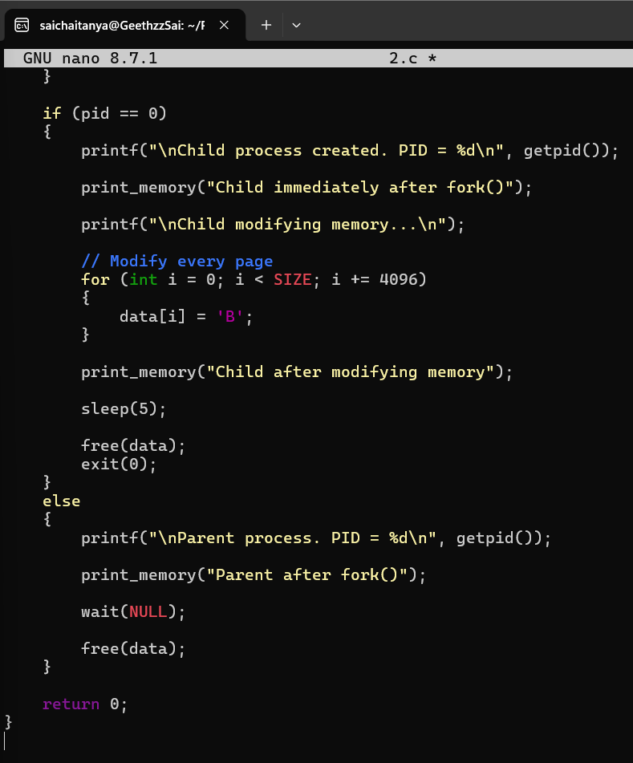

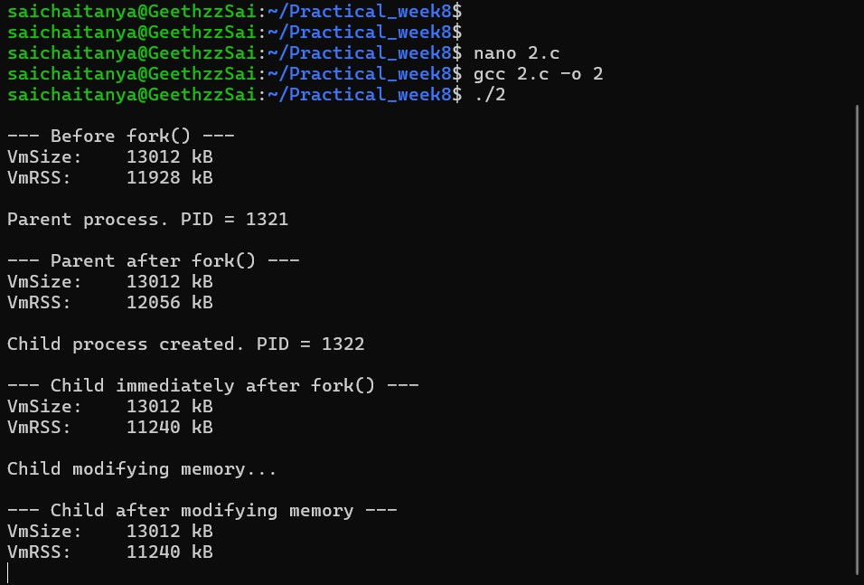
OUTPUT:

