Assignment 2: Convolution
Shivam Shekher · Advanced Machine Learning · October 2026

Executive Summary
In 6 experiments I trained convolutional networks to classify cats vs. dogs. For each training size, the experiment was repeated with a network trained from scratch and a network with a pre-trained VGG16 frozen. The pretrained network was ahead for all sizes. It achieved higher test accuracy (95.3%) than the scratch network with 5 times as much data (82.4%). I added images to the scratch network and the percentage increased from 60.3% for 1000 images to 82.4% for 5000 images, and it had not reached saturation point at that maximum number of images. The accuracy of the pretrained network stabilized around 97% after 2,000 pictures.
The pretrained VGG16 trained on 2000 images is the one I suggest. This was within one test image of the best accuracy, and required only 40% of the data required for the 5,000-image run. The lowest test loss is from the 5,000-image run (0.127), so, if the probabilities will be used to make decisions, then the 5,000-image run is better.

Key Terms
Term | What it means here
Training, validation and test sets | The training images are used to adjust the weights of the network. Validation images choose when to stop training. The test images are evaluated at the end of the experiment, one at a time.
Test accuracy | The percentage of images correctly identified from the 1000 images tested. Random guesses would result in approximately a 50% accuracy rate.
Test loss | Test set binary cross-entropy. It can be changed even if the accuracy doesn't because it rewards confident correct answers and penalises confident wrong ones.
Convolutional layer | A small grid of weights that slides over the image and reacts to a pattern, for example an edge or a texture. These are learned by the network during training.
Max-pooling | Maintains the most powerful response in each of the two halves (2 × 2) of a feature map.
Frozen base | The layers whose weights are fixed and trained on the ImageNet database, VGG16. Only the upper new classifier is trained.
Data augmentation | A certain amount of random flips, rotations and zooms during training, so that the network almost never sees the same image twice.
Early stopping | Continues to train until validation loss does not improve for 5 epochs, at which point it stops and resets to the best weights.

1. How I Ran the Experiments
The data set is Dog and Cat Classification Dataset by Bhavik Jikadara from Kaggle. It contains a Cat and a Dog subfolder in its PetImages folder. The copy I used has 12,499 JPEG images per class (24,998 images in total). I use the large sample set, as the extra credit option specifies. The code was executed using the Google Colab T4 GPU and TensorFlow 2.21.0.
I double checked all of the files prior to training. PIL's test passed all 24,998 files, but this test will not decode the pixels from the file, it just scans the header. My first attempt with Experiment 2 failed for a clipped picture. I added another check that runs the same decoder that the training pipeline calls, which is the one provided by TensorFlow. It found seven images that cannot be decoded: Cat/10404.jpg, Cat/4351.jpg, Dog/2494.jpg, Dog/2317.jpg, Dog/11912.jpg, Dog/9500.jpg and Dog/11233.jpg. All 7 were in the training pool so I only took them out of the pool. No one was in the validation and test sets. If an image in those sets is not readable, the notebook will stop with an error message.
I ran the classes with seed 42, shuffling each one. The first 500 cats and 500 dogs were used as a test set, the next 500 of each used as a validation set, and the remaining cats and dogs used as a training set. Each training subset is the first N images of the shuffled pool of images of each class. Then the 2,000-image set is included in the 1,000-image set, and the 5,000-image set is included in the 2,000-image set. The only difference between runs is the number of additional training images that the network is exposed to. The weights are never updated by validation and test images, and the test set was only applied once at the end of the training per experiment.

Split | Cats | Dogs | Total
Test | 500 | 500 | 1,000
Validation | 500 | 500 | 1,000
Training pool, after removals | 11,497 | 11,494 | 22,991

Table 1. How the 24,998 usable images were split. Seven unreadable training images were removed, so the pool is slightly smaller than the 11,499 per class you would expect from the raw counts.

The network was trained from scratch. The from-scratch network has 150 × 150 colour images as input, and a series of four convolution blocks with 32, 64, 128, and 128 filters respectively is run on the network. The 3 × 3 convolution with ReLU activation is followed by 2 × 2 max-pooling for each block. The output is flattened, dropped half of the pixels (0.5 rate) and passed through a 512-unit dense layer and finally the output is a single sigmoid unit for a probability of a dog. There are 3,453,121 trainable parameters in the model. Only during the training phase there are random flips and rotations up to 10% and zooms up to 10%.
The pretrained network. The pre-trained network is VGG16 and weights are from the ImageNet database (Simonyan and Zisserman, 2014). I froze its convolutional base, so its ~14.7 million weights are not modified. I simply put a flatten layer, dropout at 0.5, a 256-unit dense layer and a sigmoid output on top of it.I just added a flatten layer, a dropout with a rate of 0.5, a dense layer with 256-units and a sigmoid output. There are approximately 2.1 million parameters to train. VGG16 expects its input scaling, so I did not divide the pixels by 255, instead I used Keras's preprocess_input. A plain 0–1 scaling would not represent the range which the weights were trained on in ImageNet.
Training settings. The parameters are the same for all six runs: Adam optimizer with a learning rate of 1e-4, binary cross-entropy loss, batch size of 32 images and at most 30 epochs. The number of callbacks that are used to manage training is three. If the validation loss does not decrease for five epochs, then the early stopping stops the training, and the best weights are restored. Learning-rate reduction is to decrease the learning rate by half when the model errors fail to decrease for two epochs. The weights that were saved from the epoch that had the lowest validation loss were stored at a checkpoint. I have set the random seed before each run so that the same conditions are used for each.
Selecting the sample sizes. Experiment 1 is based on the 1000 images mentioned in the assignment. The professor has told us that the total is 2000, so that is what Experiment 2 will use. After the end of Experiment 2, I decided on 5,000 for Experiment 3. It's a bigger jump than the first two and I wanted to take a look and see if the scratch network had improved further. Experiments 4, 5 and 6 are the same three sizes, allowing direct comparison of each size.

Experiment | Approach | Training images (cats + dogs) | Reason for this size
1 | From scratch | 1,000 (500 + 500) | Assignment requirement
2 | From scratch | 2,000 (1,000 + 1,000) | Total given in the professor's clarification
3 | From scratch | 5,000 (2,500 + 2,500) | Larger step, chosen after Experiment 2
4 | Pretrained VGG16 | 1,000 (500 + 500) | Matches Experiment 1
5 | Pretrained VGG16 | 2,000 (1,000 + 1,000) | Matches Experiment 2
6 | Pretrained VGG16 | 5,000 (2,500 + 2,500) | Matches Experiment 3

Table 2. The six experiments. Validation and test sets are 500 cats and 500 dogs each in every run.

2. What I Found
The scratch network continues to grow, albeit slowly. When I doubled the training set, test accuracy increased by 15.8 points to 76.1%. Going from 2,000 to 5,000 images added 6.3 points. Both are greater than the uncertainty in the test set of ~1.3 points and so regard them as real. However, the second gain is not as big as the first. In the last epoch of the Experiments 2 and 3, the validation loss was still decreasing, indicating that the network did not reach its final training state. If you have more data or more epochs, it could've gone further, but I did not tested that.
The pretrained network doesn't take off until it reaches high accuracy. The frozen VGG16 achieved 95.3% on 1,000 images, which is close to the best possible result on this task. It rose to 96.9% at 2,000 images and was 96.8% at 5,000. The latter one is a single image in the 1000 image test set, so I would say it's not getting better from 2,000 images and up. Test loss kept falling, from 0.601 to 0.398 to 0.127. The network remained equally as accurate, but more confident in the images that it was correct.
Pretraining has the greatest benefit when data is limited. As more data was added to the scratch network, the difference between the two approaches decreased: 35.0 points at 1,000 images, 20.8 points at 2,000 and 14.4 points at 5,000. The scratch network lagged behind the pretrained network with 1,000 images by 12.9 points even at the lowest of 5,000 images. When there is a lack of labeled data, the ImageNet does most of the work. I can't say where the two curves would intersect because in the biggest size I tried, the scratch network hadn't caught up.
Overfitting. The scratch network that was trained on 1000 images was the most apparent overfitted. It reached a training accuracy rate of 68.6% at the last epoch and 62.2% in validation, which means it has a difference of 6.4 points. The other five runs were within 1 point of the validation accuracy at the last epoch. The “pretrained” runs exhibit a distinct signal. Each one's test loss came out higher than its best validation loss: 0.601 against 0.340 at 1,000 images, 0.398 against 0.234 at 2,000 and 0.127 against 0.085 at 5,000. Some of that gap is to be expected, since the validation loss is merely looking at the weights that have been saved and therefore is slightly superior to what it should be. The fairer test is the test set.
The optimum setup will vary according to the measure. The highest accuracy was for Experiment 5 (96.9%) and Experiment 6 (96.8%) was one image behind. The test loss for Experiment 6 was the lowest (0.127) compared to Experiment 5 (0.398). Accuracy alone is not the distinguishing characteristic so I wouldn't choose by just the accuracy.

3. Results at a Glance
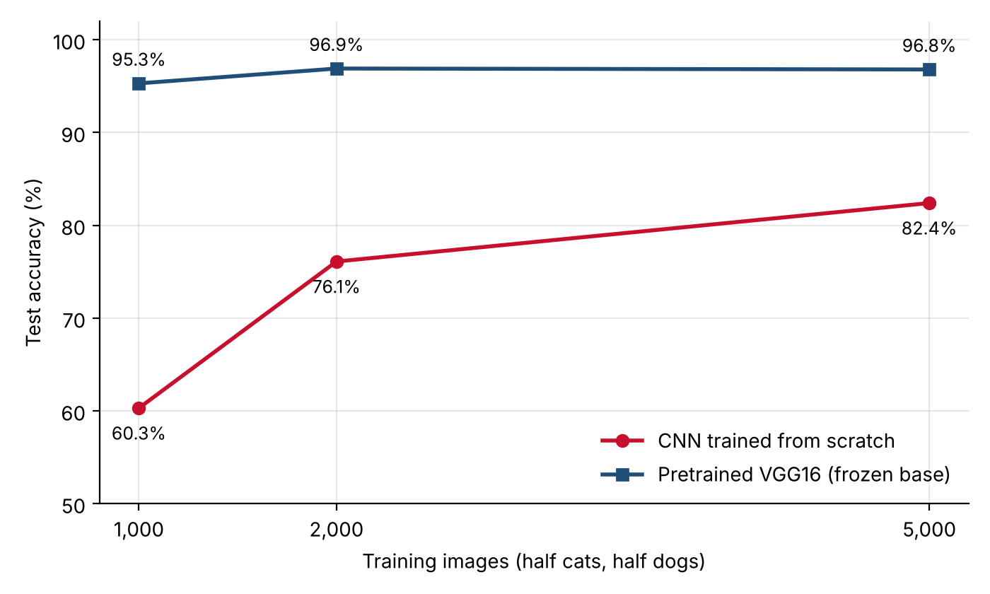
Figure 1. Test accuracy against training images for both approaches. Each point is one run, scored on the same 1,000-image test set. The gap is widest at 1,000 images and narrows as the scratch network gets more data.
Exp. | Approach | Training images | Test accuracy | Test loss | Epochs run | Minutes
1 | From scratch | 1,000 | 60.30% | 0.6382 | 13 (early stop) | 0.7
2 | From scratch | 2,000 | 76.10% | 0.5064 | 30 (full) | 2.2
3 | From scratch | 5,000 | 82.40% | 0.3849 | 30 (full) | 4.0
4 | Pretrained VGG16 | 1,000 | 95.30% | 0.6006 | 11 (early stop) | 1.1
5 | Pretrained VGG16 | 2,000 | 96.90% | 0.3984 | 17 (early stop) | 2.4
6 | Pretrained VGG16 | 5,000 | 96.80% | 0.1270 | 19 (early stop) | 5.3

Table 3. Results for all six experiments. Test accuracy and loss are measured on the same 1,000 test images. Minutes is wall-clock training time on the Colab T4 GPU. The shaded row is the recommended model.

4. Recommendation
For pretrained VGG16 that was trained over 2000 images, I recommend this one (Experiment 5). It is one test image off from the top-scoring run, required 40% fewer images than the 5,000-image run, and took 2.4 minutes to train. It also is flat at the beginning, so there is little benefit to including data beyond the beginning in this configuration.

If the probabilities will be passed on to a decision, then I would opt for the 5,000 image pretrained run (Experiment 6) over the others, because the extent to which the model is confident will be as important as its correctness. The test loss of 0.127 is less than one-third of the loss for the 2,000-image run. In any case I would continue early stopping like the notebook does, so that training terminates at the optimum epoch and not a fixed epoch.

5. Limitations and Next Steps
The test set contains 1000 images and each experiment was repeated once using one seed. The uncertainty of the test-set is approximately ±1.3 points when the test-set accuracy is 80%, and two or three points are not sufficient. The difference between Experiments 5 and 6 is only 0.1 point, which represents one image.
The data copy is more significant than I thought. In the previous run, 12,500 images were used per class, with two unreadable images. Its split was different and its Experiment 1 scored 69.8% compared to 60.3% for the run reported here. I have only looked at the current run, but the lesson to take is that the change of split can lead to a big difference in a single small sample result. I would not consider any 1,000 images to be "settled" without repeats.
The following tests were conducted on the frozen base only. Optimizing the final block of VGG16 may further improve its performance, but may also overfit more rapidly. The sizes were not predetermined, as I picked up the 5,000 image size after seeing the 2,000 image size result. Early stopping was also based on validation loss and that results in some degree of optimism in the values for validation loss.
My next steps would be to plant 3 seeds for each configuration, run fine-tuning on the last block of VGG16 and finally evaluate Experiment 5 with a confusion matrix to determine into which class the false answers fall.

6. Conclusion

The training size had different impacts on the two approaches. The scratch network was the most data intensive and was still growing at 5,000 images. The pretrained network was very good right from the beginning and reached a plateau at 2,000. I use the pretrained approach for this size of data set. It remains uncertain whether a scratch network can catch up with a lot more data.

References
1. Jikadara, B. Dog and Cat Classification Dataset. Kaggle. https://www.kaggle.com/datasets/bhavikjikadara/dog-and-cat-classification-dataset
2. Simonyan, K., & Zisserman, A. (2014). Very deep convolutional networks for large-scale image recognition. arXiv:1409.1556. https://arxiv.org/abs/1409.1556
3. Deng, J., Dong, W., Socher, R., Li, L.-J., Li, K., & Fei-Fei, L. (2009). ImageNet: A large-scale hierarchical image database. In CVPR 2009. https://doi.org/10.1109/CVPR.2009.5206848
4. Kingma, D. P., & Ba, J. (2014). Adam: A method for stochastic optimization. arXiv:1412.6980. https://arxiv.org/abs/1412.6980
5. Srivastava, N., Hinton, G., Krizhevsky, A., Sutskever, I., & Salakhutdinov, R. (2014). Dropout: A simple way to prevent neural networks from overfitting. Journal of Machine Learning Research, 15, 1929–1958.
6. TensorFlow. Keras applications: VGG16 and preprocess_input. https://www.tensorflow.org/api_docs/python/tf/keras/applications/vgg16/preprocess_input
7. Course materials, Advanced Deep Learning for Computer Vision: slides and transcripts on convolution, max-pooling, padding and strides, the Cats & Dogs example, data augmentation and pretrained convnets.
AI tools (Claude) helped draft and debug the notebook code. I ran every cell, checked the outputs against the code, and am responsible for the results and conclusions in this report.

