Name: - Shivam Tayal
Reg. No.: - 18BIT0271
JAVA LAB ASSIGNMENT 1
Day 1: -

import java.lang.*;
import java.util.*;
class demo1
{
public static void main(String args[])
{
System.out.print("Enter Radius: ");
Scanner cin = new Scanner(System.in);
double r = cin.nextDouble();
System.out.println("Area:"+((22*r*r)/7));
}
}

class demo2
{
public static void main(String args[])
{
boolean flag=false;
System.out.print("Enter Number: ");
Scanner cin = new Scanner(System.in);
int n = cin.nextInt();
if(n%3 == 0)
if(n%5==0)
flag=true;
if(flag==true)
System.out.println("Yes");
else
System.out.println("No");

}
}

class demo3
{
public static void main(String args[])
{
System.out.print("Enter Input: ");
Scanner cin = new Scanner(System.in);
int x = cin.nextInt();
if(x==604)
System.out.println("Java Programming");
else if(x==605)
System.out.println("Python Programming");
else
System.out.println("iNVALID INPUT");

}
}

class demo4
{
public static void main(String args[])
{
System.out.print("Enter Number: ");
Scanner cin = new Scanner(System.in);
int n = cin.nextInt();
System.out.print("Sum: "+(n*(n+1))/2);
}
}

class demo5
{
public static void main(String args[])
{
System.out.print("Enter Number: ");
Scanner cin = new Scanner(System.in);
int n = cin.nextInt();
int sum=0;
for(int i=0;i<n+1;i++)
{
sum+=i*i;
}
System.out.print("Sum: "+sum);
}
}

class demo6
{
public static void main(String args[])
{
System.out.print("Enter Number: ");
Scanner cin = new Scanner(System.in);
int n = cin.nextInt();
for(int i=1;i<11;i++)
System.out.println(n+"x"+i+"="+(n*i));
}
}

class demo7
{
public static void main(String args[])
{
boolean flag=true;
do
{
System.out.print("Enter 1: ");
Scanner cin = new Scanner(System.in);
int a = cin.nextInt();
System.out.print("Enter 2: ");
int b = cin.nextInt();
System.out.println("Sum:"+(a+b));
System.out.println("ur choice 1 to cont. else exit");
int c = cin.nextInt();
if(c!=1)
flag=false;
}
while(flag);
}
}

class demo8
{
public static void main(String args[])
{
System.out.print("Enter n: ");
Scanner cin = new Scanner(System.in);
int n = cin.nextInt();
System.out.println("Pattern a:");
for(int i=1;i<n+1;i++){
for(int j=1;j<i+1;j++)
System.out.print("*");
System.out.println();
}

System.out.println("Pattern b:");
for(int i=n;i>0;i--){
for(int j=1;j<i+1;j++)
System.out.print(j);
System.out.println();
}

System.out.println("Pattern c:");
for(int i=1;i<n+1;i++){
for(int j=1;j<i+1;j++)
System.out.print(j);
System.out.println();
}
for(int i=n;i>0;i--){
for(int j=1;j<i+1;j++)
System.out.print(j);
System.out.println();
}

}
}

Output: -
Q1-
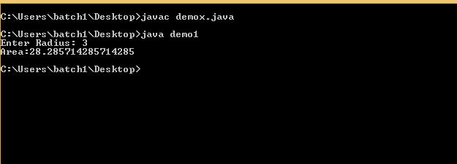

Q2-
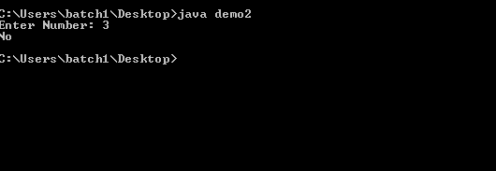

Q3-
Q4-
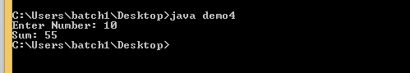
Q5-
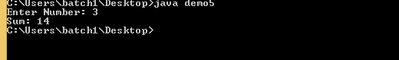
Q6-
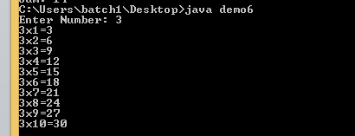
Q7-
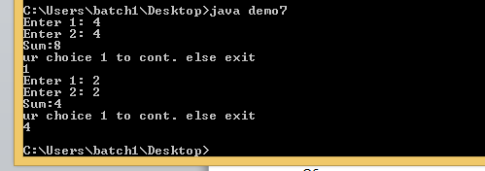

Q8-
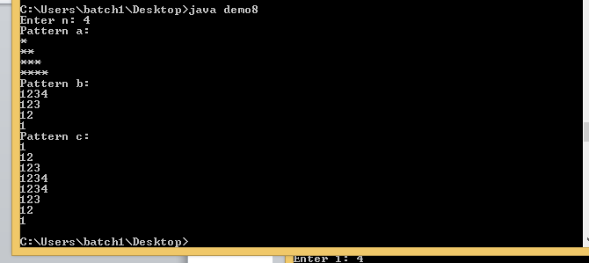

Day 2: -
import java.util.*;
import java.util.Scanner;
class ques1
{
public static void main(String[] args) {
Scanner cin = new Scanner(System.in);
System.out.println("Enter the length of array");
int n = cin.nextInt();
int arr[] = new int[n];
for(int i=0;i<n;i++)
{
System.out.println("Enter the "+i+":");
arr[i]=cin.nextInt();
}
for (int i = 0; i < n-1; i++)
for (int j = 0; j < n-i-1; j++)
if (arr[j] > arr[j+1])
{
int temp = arr[j];
arr[j] = arr[j+1];
arr[j+1] = temp;
}
for (int i = 0; i <= n/2; i++)
{
System.out.println(arr[n-i-1]);
if(i != (n-i-1))
System.out.println(arr[i]);
}
cin.close();
}
}
class ques2
{
public static void segregate(int a[] , int n)
{
int left=0 , right=n-1 ,i;
while(left<right)
{
while(a[left]%2==0 && left<right)
left++;

while(a[right]%2==1 && left<right)
right--;

if(left<right)
{
int temp=a[left];
a[left]=a[right];
a[right]=temp;
left++ ; right--;
}
}
}
public static void main(String[] args)
{
Scanner scan = new Scanner(System.in);
int n = scan.nextInt();
int a[] = new int[1000];
for(int i=0;i<n;i++)
{
int x=scan.nextInt();
a[i]=x;
}
segregate(a,n);
for(int i=0;i<n;i++)
System.out.print(a[i]+" ");
scan.close();
}
}
class ques3
{
public static int removeDuplicateElements(int arr[], int n){
if (n==0 || n==1){
return n;
}
int[] temp = new int[n];
int j = 0;
for (int i=0; i<n-1; i++){
if (arr[i] != arr[i+1]){
temp[j++] = arr[i];
}
}
temp[j++] = arr[n-1];
for (int i=0; i<j; i++){
arr[i] = temp[i];
}
return j;
}

public static void main (String[] args) {
Scanner scan = new Scanner(System.in);
int n = scan.nextInt();
int arr[] = new int[1000];
for(int i=0;i<n;i++)
arr[i]=scan.nextInt();
Arrays.sort(arr);
int length = arr.length;
length = removeDuplicateElements(arr, length);
for (int i=0; i<length; i++)
System.out.print(arr[i]+" ");
}
}
class ques4
{
public static int[] twoSum(int[] nums, int target) {
int arr[]={0,0},i,j,len=nums.length;
for(i=0;i<len;i++)
{
int value = target - nums[i];
for( j=i+1;j<len;j++)
if(value==nums[j])
{
arr[0] = i;
arr[1] = j;
return arr;
}
}
return arr;
}
public static void main (String[] args) {
Scanner scan = new Scanner(System.in);
int n = scan.nextInt();
int arr[] = new int[1000];
for(int i=0;i<n;i++)
arr[i]=scan.nextInt();
int target = scan.nextInt();
int a[] = new int[2];
a = twoSum(arr, target);
for (int i=0; i<2; i++)
System.out.print(arr[a[i]]+" ");
}
}
class ques5
{
public static void main(String[] args) {
Scanner cin = new Scanner(System.in);
System.out.println("Enter the length of matrix");
int n = cin.nextInt();
int arr[][] = new int[n][n];
for(int j=0;j<n;j++)
for(int i=0;i<n;i++)
{
System.out.println("Enter the "+j+" "+i+":");
arr[j][i]=cin.nextInt();
}
int matrix[] = new int[n];
for(int i=0;i<n;i++)
for(int j=0;j<n;j++)
{
matrix[i] += arr[i][j];
}
System.out.println("The values are: -");
for(int i=0;i<n;i++)
{
System.out.println(matrix[i]);
}
cin.close();
}
}
class ques6
{
public static void main(String[] args) {
Scanner cin = new Scanner(System.in);
System.out.println("Enter the length of matrix 1");
int n = cin.nextInt();
int arr[][] = new int[n][n];
for(int j=0;j<n;j++)
for(int i=0;i<n;i++)
{
System.out.println("Enter the "+j+" "+i+":");
arr[j][i]=cin.nextInt();
}
System.out.println("Enter the length of matrix 2");
int arr2[][] = new int[n][n];
for(int j=0;j<n;j++)
for(int i=0;i<n;i++)
{
System.out.println("Enter the "+j+" "+i+":");
arr2[j][i]=cin.nextInt();
}
for(int j=0;j<n;j++)
for(int i=0;i<n;i++)
{
arr[j][i]+=arr2[j][i];
}
System.out.println("Sum:");
for(int j=0;j<n;j++)
for(int i=0;i<n;i++)
{
System.out.println(arr[j][i]);
}
cin.close();
}
}
class ques7
{
public static void main(String[] args) {
Scanner cin = new Scanner(System.in);
System.out.println("Enter the length of matrix 1");
int n = cin.nextInt();
int arr[][] = new int[n][n];
for(int j=0;j<n;j++)
for(int i=0;i<n;i++)
{
System.out.println("Enter the "+j+" "+i+":");
arr[j][i]=cin.nextInt();
}
int trans[][] = new int[n][n];
for(int j=0;j<n;j++)
for(int i=0;i<n;i++)
{
trans[i][j]=arr[j][i];
}
cin.close();
}
}
class ques8
{
public static void main(String[] args) {
int i,j;
double t;
int arr[][]= new int[4][];
Scanner sc = new Scanner(System.in);
for(i=0;i<arr.length;i++)
{
System.out.println("Enter number of students for batch" + (i+1)+" ");
t = sc.nextDouble();
arr[i] = new int[(int)Math.ceil(t/4)];
for(j=0;j<arr[i].length;j++)
{
if(t>=4)
arr[i][j]=4;
else
arr[i][j]=(int)t;
t=t-4;
}
}
sc.close();
int cfour = 0;
System.out.println("Contents of 2D Jagged Array: ");
for (i = 0; i < arr.length; i++) {
for (j = 0; j < arr[i].length; j++) {
System.out.println(arr[i][j]+ " ");
if(arr[i][j]==4)
cfour++;
}
System.out.println();
}
System.out.println("Number of tutors with 4 students are: "+ cfour);
}
}

Output: -
Ques 1
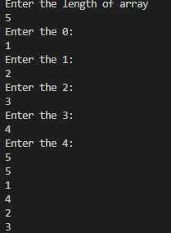
Ques 2
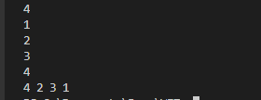
Ques 3
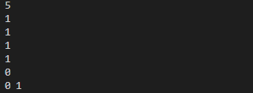
Ques 4
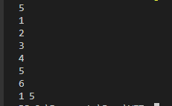
Ques 5
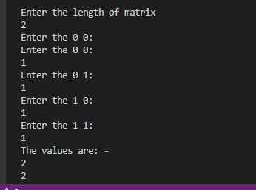
Ques 6
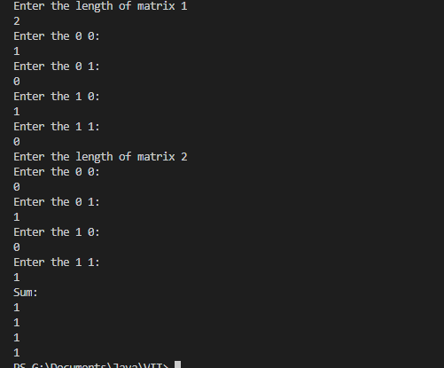
Ques 7
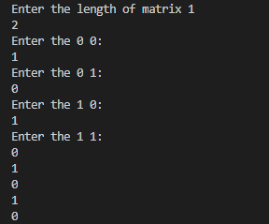

Ques 8
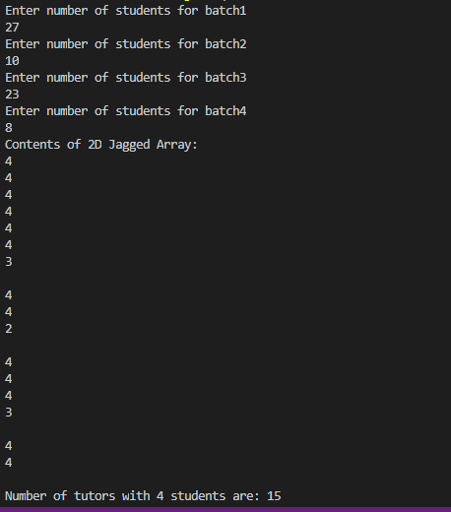

Day 3: -

Ques 1: -
public class rectangle{
double width,height;
rectangle()
{
width=1.0d;
height=1.0d;
}
rectangle(double width,double height)
{
this.width=width;
this.height=height;
}
public void getArea()
{
double area=height*width;
System.out.println("the area of rectangle is"+area);
}
public void getPerimeter()
{
double peri=2*(height+width);
System.out.println("the perimeter of rectangle is"+peri);
}
public void getArea(int height,int width)
{
int area=height*width;
System.out.println("the area of rectangle is"+area);
}
public static void main(String args[])
{
rectangle r1=new rectangle(5,50);
r1.getArea();
r1.getPerimeter();
rectangle r2=new rectangle(2.5,45.7);
r2.getArea();
r2.getPerimeter();
} }

Output:-
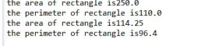

Ques 2: -
import java.util.*;
public class Student {
String RegNo,name,course;
double currentCgpa;
Student(String RegNo,String name,String course,double currentCgpa)
{
this.RegNo=RegNo;
this.name=name;
this.course=course;
this.currentCgpa=currentCgpa;
}
public void getDetails()
{
System.out.println("Reg no is:"+RegNo);
System.out.println("Course is:"+course);
System.out.println("Name is:"+name);
System.out.println("Cgpa is:"+currentCgpa);
}
public static void main(String args[])
{
Scanner s=new Scanner(System.in);
System.out.println("enter n:");
int n=s.nextInt();
s.nextLine();
String reg,name,course;
double cgpa;
Student st[]=new Student[n];
for(int i=0;i<n;i++)
{
System.out.println("enter the details of the student");
System.out.println("enter the reg no:");
reg=s.nextLine();
System.out.println("enter name:");
name=s.nextLine();
System.out.println("Enter course");
course=s.nextLine();
System.out.println("enter the cgpa");
cgpa=s.nextDouble();
st[i]=new Student(reg,name,course,cgpa);
s.nextLine();
}
System.out.println("The student with cgpa greater than 9");
System.out.println();
for(int i=0;i<st.length;i++)
{
if(st[i].currentCgpa>=9.0d) {
st[i].getDetails();
System.out.println();
}
}
}
}

Output: -
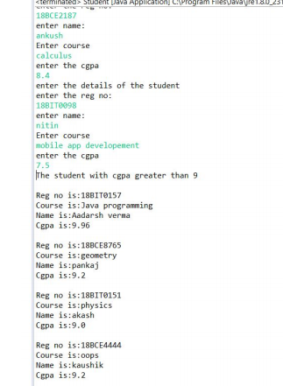

Ques 3: -
import java.text.*;
import java.util.*;

public class Main {
public static void main(String[] args) {
Date dt = new Date(1000000000000L);
DateFormat[] dtformat = new DateFormat[6];

dtformat[0] = DateFormat.getInstance();
dtformat[1] = DateFormat.getDateInstance();
dtformat[2] = DateFormat.getDateInstance(DateFormat.MEDIUM);
dtformat[3] = DateFormat.getDateInstance(DateFormat.FULL);
dtformat[4] = DateFormat.getDateInstance(DateFormat.LONG);
dtformat[5] = DateFormat.getDateInstance(DateFormat.SHORT);

for(DateFormat dateform : dtformat) System.out.println(dateform.format(dt));
}
}

Output: -
