PBL III: SOFTWARE ENGINEERING AND MODELLING
LAB ASSIGNMENTS
AY 26-27 SEM V
TY CSE SEM
ASSIGNMENT NO: 1
Process Model Selection and Project Plan - "Git Visualiser"

Aim
To develop a project plan for the given problem statement using one of the software process models (Waterfall, RAD, Incremental, or Agile), selected after a comparative analysis, and to outline for the selected model: (a) the phases or stages involved, (b) key activities and deliverables, (c) how the model addresses requirements, design, development, testing and deployment, and (d) the advantages and challenges of using the model for the chosen project.

Problem Statement
"Git Visualiser" is a web-based dashboard application that helps developers understand the evolution of a Git repository at a glance, without manually digging through raw git log output. The system visualizes four core aspects of a repository:
- Commit History - a chronological, searchable timeline of commits with author, message, and timestamp.
- Branch & Merge Structure - an interactive graph showing branches, how they diverge, and where they merge back together.
- Contributor Analytics - statistics on who contributed how much (commit counts, lines added/removed, activity over time).
- File Change Patterns - which files change most frequently, and insertion/deletion trends per commit or per file.
The application connects to a repository (a local .git folder, or a remote host such as GitHub via its API), extracts the required metadata, and presents it through an interactive dashboard suitable for developers, team leads, or open-source maintainers who want a quick, visual understanding of a project's history and activity.

PART I

1. Nature of the Project
- Size - Git Visualiser is a small-to-medium sized project, realistically buildable by a single developer or a small team of 2-3 students within a college semester. It is a focused tool with a handful of well-defined feature areas, not a large enterprise system.
- Complexity - Moderate. The core difficulty is integrative rather than algorithmic: the system must parse Git's internal object model (commits, trees, refs) - via Git commands, a library such as libgit2/isomorphic-git, or a hosting platform's REST/GraphQL API - and then transform that data into interactive visualizations. Handling larger repositories (thousands of commits) efficiently adds a secondary layer of complexity around performance and data aggregation.
- User Involvement - Low-to-moderate. As an academic/personal project, the developer is largely also the primary stakeholder defining requirements; there is no external paying client demanding continuous requirement changes. Feedback comes mainly from self-testing, peer review, and faculty evaluation at lab checkpoints, rather than from a dedicated on-site customer.
- Time Constraints - Fixed and externally imposed - the project must fit within the academic semester's lab submission schedule, with intermediate checkpoints/deadlines rather than a single distant deadline.
- Requirement Clarity - High for the core feature set. Concepts like commit history, branch graphs, and contributor stats are well understood, and comparable tools already exist as reference points (e.g. gitk, GitHub's Insights tab, the Git Graph extension for VS Code). Some uncertainty remains around UI/UX polish and the exact technology stack, which is expected to be refined as development proceeds.

2. Selected Process Model
Given the nature of the project described above, the Incremental Model has been selected as the most suitable software process model for developing Git Visualiser.

3. Justification and Comparison
The Incremental Model fits this project well because its four core features - commit history, branch/merge graph, contributor analytics, and file change tracking - decompose naturally into four largely independent, self-contained increments. Each increment can be designed, built, tested, and delivered as a working piece of the dashboard on its own, rather than requiring the entire system to be built before anything can be demonstrated.
Comparison with the Agile Model: Agile is the closest alternative, since it also delivers software iteratively and values working software early and often. However, Agile is optimized around continuous, close collaboration with an on-site customer whose requirements are expected to evolve through frequent feedback loops (sprint reviews, backlog grooming, daily stand-ups). For Git Visualiser, there is no external customer driving evolving requirements - the four features are already well understood upfront, and the "customer" is effectively the developer and course evaluators at fixed checkpoints. Running full Agile ceremonies would add process overhead without a matching benefit. The Incremental Model gives the same core advantage Agile offers - early, working, demonstrable software - while staying lighter-weight and better matched to a small team working against fixed academic deadlines with reasonably stable requirements.
Comparison with the Waterfall Model: Waterfall was also considered and rejected. Waterfall requires all requirements to be frozen upfront and produces only a single delivery at the very end of the project. This is risky for Git Visualiser: if any single phase overruns (for example, deciding on a visualization library, or a design choice for the branch graph), there would be no working software to show at intermediate lab checkpoints, and problems discovered late (e.g. a chosen visualization approach that doesn't scale to large repos) would be expensive to fix. The Incremental Model avoids this risk by surfacing such problems early, one feature at a time.
For these reasons - decomposable, well-understood requirements; a fixed academic deadline that benefits from checkpointed deliveries; and a small team without a continuously-iterating external customer - the Incremental Model offers the best balance of structure, low risk, and early demonstrable progress for this project.

PART II

1. Phases/Stages of the Incremental Model for Git Visualiser
The project is broken into four increments, each passing through the same five phases - Requirements, Design, Development, Testing, and Deployment - before its output is folded into the growing final product:
- Increment 1 - Core Repository Parsing & Commit History View: connect to a Git repository, extract commit metadata (hash, author, message, timestamp, parent commits), and render it as a browsable, searchable timeline/list view.
- Increment 2 - Branch & Merge Graph Visualization: extract branch references and commit-parent relationships, and render an interactive graph showing how branches diverge and merge (similar in spirit to gitk or GitHub's network graph).
- Increment 3 - Contributor Analytics: aggregate commit data by author to compute per-contributor statistics (commit counts, lines added/removed, activity timeline) and present them as charts and a contributor leaderboard.
- Increment 4 - File Change Tracking & Dashboard Integration: compute per-file change frequency and insertion/deletion statistics, then integrate all four views into a single, cohesive dashboard with unified navigation and polish.
The diagram below illustrates how each increment passes through its own Requirements - Design - Development - Testing - Deployment cycle, delivering a working piece of functionality that feeds into the final Git Visualiser dashboard, while insight gained from each delivered increment can refine the requirements of the next.
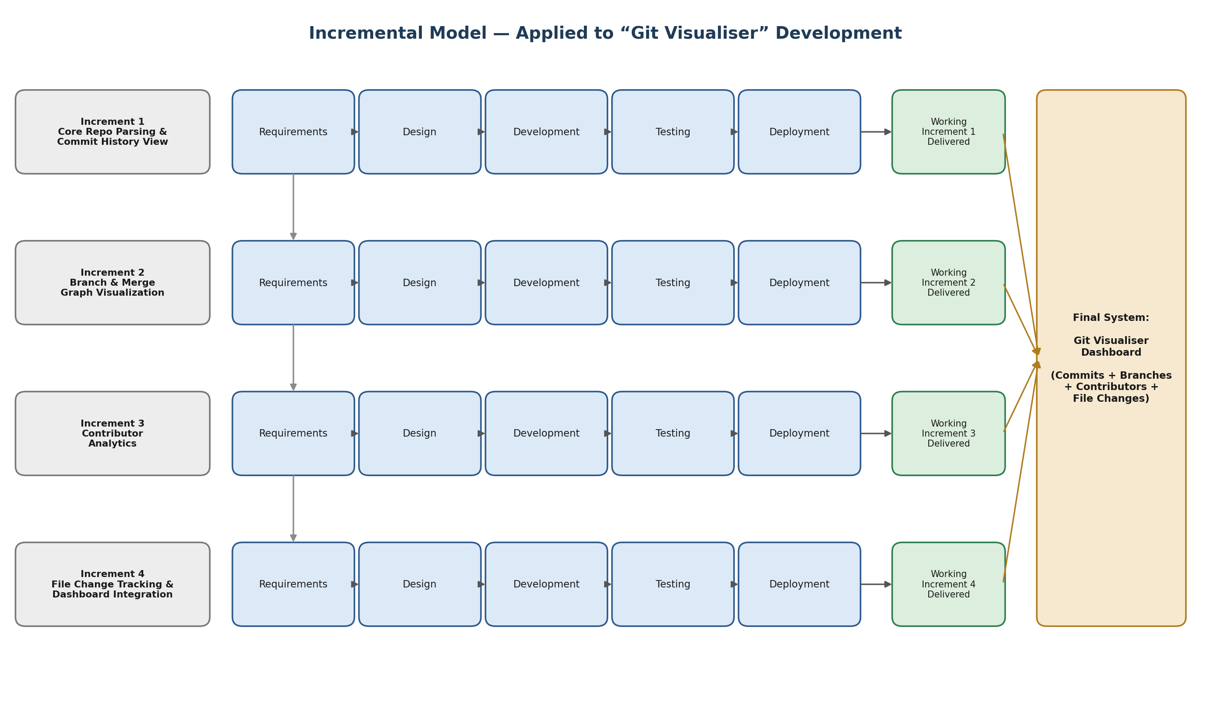
Figure 1: Incremental Model applied to the Git Visualiser project, showing the four increments each passing through Requirements, Design, Development, Testing and Deployment, and feeding into the final integrated dashboard.

2. Activities and Deliverables per Stage
Increment | Requirements | Design | Development | Testing | Deployment & Deliverable
Increment 1  Commit History | Which commit fields to show; how far back history should load | Commit data model; timeline UI wireframe | Git-log parsing module + timeline UI component | Verify commit data against raw git log output | Release commit history view - Deliverable: working commit history viewer
Increment 2  Branch/Merge Graph | How to represent branches, merges and HEAD visually | Graph layout approach; node/edge schema | Branch-graph extraction logic + graph rendering UI | Validate on repos with multiple branches and merges | Add branch graph as a new dashboard view - Deliverable: working branch/merge visualization
Increment 3  Contributor Analytics | Which contributor metrics matter (commits, LOC, recency) | Aggregation logic; chart types for stats | Contributor aggregation module + charting components | Cross-check aggregated stats against manual counts | Add contributor analytics panel - Deliverable: working contributor analytics view
Increment 4  File Changes & Integration | File-level metrics; final dashboard navigation/UX | File-change data model; unified dashboard layout | File-change tracking module + final UI integration | End-to-end testing; usability testing with peers | Final release of complete dashboard - Deliverable: fully integrated Git Visualiser

3. Advantages and Limitations of the Incremental Model for This Project
Advantages:
- Working software is available after every increment, so progress can be demonstrated at each lab checkpoint rather than only at the final deadline.
- Each increment is smaller and easier to design, code, and test in isolation, which lowers the risk of a single large, hard-to-debug system.
- Lessons learned from an earlier increment (e.g. which visualization library performs well) can directly improve later increments.
- Even if later increments (e.g. file-change tracking) slip due to time pressure, earlier increments (commit history, branch graph) still constitute a usable, demonstrable product.
Limitations:
- Because functionality is added incrementally, the overall system architecture must be planned carefully upfront; a poor initial design (e.g. a commit data model that doesn't anticipate contributor/file-level aggregation) can force costly rework in later increments.
- Each new increment must be integrated with, and regression-tested against, previously delivered increments, which adds cumulative testing overhead as the project progresses.
- It can be harder to estimate total project effort/time upfront compared to a single-shot plan, since the scope of later increments may shift based on what is learned earlier.
- There is some risk of scope creep - it can be tempting to keep "adding one more increment" rather than converging on a final, polished deliverable.

Conclusion
Developing Git Visualiser using the Incremental Model allowed the project's four natural feature areas - commit history, branch visualization, contributor analytics, and file change tracking - to be treated as four manageable, self-contained increments, each following its own requirements-design-development-testing-deployment cycle. This approach matched the project's well-understood but moderately complex requirements and the fixed academic timeline far better than a single-shot Waterfall delivery or a full Agile process built around continuous customer collaboration. By the end of the final increment, the individually delivered pieces combine into a complete, working dashboard, with the added benefit that a usable product existed at every checkpoint along the way, reducing the risk of an incomplete or non-functional submission at the final deadline.

FAQs
1. If two projects have the same budget but different requirements, would you choose the same process model? Why or why not?
No. Budget determines how much can be spent, but it says nothing about how well-understood or how likely to change the requirements are - and that is the primary factor driving process model choice. A project with clear, stable requirements can be planned confidently in advance and suits models like Waterfall or Incremental even on a modest budget. A project with vague or fast-changing requirements needs the flexibility and constant feedback loops of Agile, regardless of how large the budget is - forcing a rigid, sequential model onto volatile requirements typically leads to expensive rework later, no matter how much money is available.
2. Why is software testing integrated into every process model?
Because every process model, regardless of how it structures its phases or iterations, ultimately has to deliver software that actually works - and testing is the mechanism that verifies this. Defects are also far cheaper to fix the earlier they are found: an error caught during testing of a single increment or sprint is comparatively cheap to fix, while the same error found after deployment (or, worse, in production) can be dramatically more expensive and disruptive. So whether a model delivers once (Waterfall) or many times (Incremental, Agile, RAD), testing has to be embedded at every delivery point to catch defects before they compound or reach the user.
3. What factors should be considered while selecting a software process model?
Key factors include: clarity and stability of requirements (well-defined vs. likely to change), project size and complexity, team size and experience, how flexible or fixed the timeline is, budget and resource availability, the level of customer/user involvement available during development, the project's risk tolerance (how costly a late-discovered defect would be), and the team's familiarity with the chosen technology. Together, these factors determine whether a sequential model (Waterfall), a risk-driven model (Spiral), a rapid-prototyping model (RAD), a phased model (Incremental), or a highly adaptive model (Agile) fits best.

