**Ques: 1**

**'Number' class**

import java.util.*;

class Number {

double real;

double imaginary;

public Number(double real,double imaginary)

{

this.real =real;

this.imaginary=imaginary;

}

public void setImaginaryPart(double imaginary) {

this.imaginary = imaginary;

}

public double getImaginaryPart() {

return imaginary;

}

public void setRealPart(double real) {

this.real=real;

}

public double getRealPart() {

return real;

}

}

class Complex extends Number {

public Complex(double real,double imaginary)

{

super(real,imaginary);

}

public void checkComplex()

{

double real = getRealPart();

double imaginary = getImaginaryPart();

if(real!=0 && imaginary!=0)

{

System.out.println("The given number is complex\n"+real+" + i"+imaginary);

}

else

{

System.out.println("The given number is real");

}

}

}

class PurelyImaginary extends Complex {

public PurelyImaginary(double real,double imaginary)

{

super(real,imaginary);

}

public void checkPurelyImaginaryNumber()

{

double real = getRealPart();

double imaginary = getImaginaryPart();

if(real==0)

{

System.out.println("i"+imaginary+"\nThe number is purely imaginary");

}

else

{

System.out.println("The number is not purely imaginary");

}

}

}

public class Source {

public static void main(String[] args) {

Scanner in = new Scanner(System.in);

PurelyImaginary num = new PurelyImaginary(in.nextDouble(), in.nextDouble());

System.out.println(num.getImaginaryPart());

num.checkComplex();

num.checkPurelyImaginaryNumber();

}

}

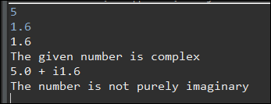

**Ques: 2**

**Banking System**

import java.util.*;

class SavingAmount {

//write your code here

int saving;

public void setInitialSaving(int saving)

{

this.saving=saving;

}

public int getCurrentSaving()

{

return saving;

}

public void incrementSaving()

{

saving+=1000;

}

public void decrementSaving()

{

saving-=100;

}

public void checkSaving()

{

if(saving>=1000)

{

System.out.println("Congratulations! You have saved a good amount");

}

else if(saving<1000 && saving>=0)

{

System.out.println("Insufficient saving!");

}

else

{

System.out.println("You are in debt");

}

}

}

public class Source {

public static void main(String[] args) {

SavingAmount obj = new SavingAmount();

Scanner in = new Scanner(System.in);

obj.setInitialSaving(in.nextInt());

obj.decrementSaving();

obj.incrementSaving();

obj.checkSaving();

System.out.println("Your current savings are Rs " + obj.getCurrentSaving());

}

}

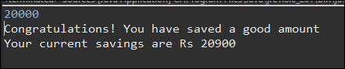

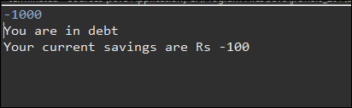

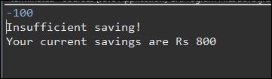

**Q3**

**Bank Loan**

import java.util.*;

abstract class Homeloan {

double amount;

int time;

public abstract double getRateOfInterest();

public abstract double simpleInterest();

//Write your code here

}

class Bank1 extends Homeloan {

double roi=7.2;

Bank1(double amount, int time){

this.amount=amount;

this.time=time;

}

public double getRateOfInterest(){

return roi;

}

//Write your code here

public double simpleInterest() {

return (roi*amount*time)/100;

}

}

class Bank2 extends Homeloan {

double roi=8.1;

Bank2(double amount, int time){

this.amount=amount;

this.time=time;

}

//Write your code here

public double getRateOfInterest(){

return roi;

}

public double simpleInterest() {

return (roi*amount*time)/100;

}

}

class Source {

public static void main(String args[]) {

Scanner in = new Scanner(System.in);

double amount = in.nextDouble();

if (amount<=0){

System.out.println("Invalid Amount");

System.exit(-1);

}

int time = in.nextInt();

Homeloan obj1 = new Bank1(amount, time);

Homeloan obj2 = new Bank2(amount, time);

if (obj1.simpleInterest() < obj2.simpleInterest()) {

System.out.println("File for a loan in Bank1");

System.out.println(amount+obj1.simpleInterest());

} else {

System.out.println("File for a loan in Bank2");

System.out.println(amount+obj2.simpleInterest());

}

}

}

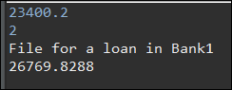

**Q4**

**Employee Details**

class Employee {

private int empId;

private String empFirstName;

private String empSecondName;

private double empSalary;

public Employee(int empId, String empFirstName,String empSecondName,double empSalary) {

this.empId=empId;

this.empFirstName = empFirstName;

this.empSecondName = empSecondName;

this.empSalary = empSalary;

}

public String toString() {

return "employee full name "+empFirstName+" "+empSecondName+"\nemployee annual package "+empSalary;

}

}

public class Source {

public static void main(String[] args) {

Employee E1 = new Employee(101512031, "Sushil", "Kumar", 45000.58);

Employee E2 = new Employee(101512032, "Tara", "Sharma",51000.99);

System.out.println(E1.toString());

System.out.println(E2.toString());

}

}

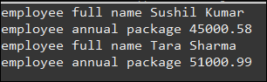

**Ques:5**

**Cards game**

import java.util.*;

class Cards {

int value;

String suit;

public void setCards(String suit, int r) {

this.value = r;

this.suit = suit;

}

//Write your code here.

int getSuitPriority(String suitString) {

int priority=0;

if(suitString.equals("Spades"))

{

priority =4;

}

else if(suitString.equals("Diamond"))

{

priority =3;

}

else if(suitString.equals("Hearts"))

{

priority =2;

}

else if(suitString.equals("Clubs"))

{

priority =1;

}

return priority;

}

}

class ClassicGame {

int points1 = 0;

int points2 = 0;

public void game(Cards c1, Cards c2) {

if(c1.getSuitPriority(c1.suit)==(c2.getSuitPriority(c2.suit)))

{

if(c1.value>c2.value)

points1++;

else

points2++;

}

else if(c1.getSuitPriority(c1.suit)>(c2.getSuitPriority(c2.suit)))

{

points1++;

}

else if(c1.getSuitPriority(c1.suit)<(c2.getSuitPriority(c2.suit)))

{

points2++;

}

System.out.println("points of player 1 :" + " " + points1);

System.out.println("points of player 2 :" + " " + points2);

}

}

public class Source {

public static void main(String[] args) {

//Two objects (cards) of class Cards

Cards c1 = new Cards();

Cards c2 = new Cards();

Scanner in = new Scanner(System.in);

//Enter the suit of card 1

String s1 = in.nextLine();

c1.setCards(s1, in.nextInt());

in.nextLine();

//Enter the suit of card 2

String s2 = in.nextLine();

c2.setCards(s2, in.nextInt());

ClassicGame c = new ClassicGame();

c.game(c1, c2);

}

}

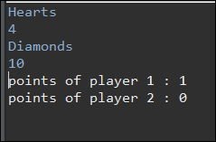

**Ques:6**

**ASCII String**

import java.io.*;

import java.util.*;

import java.lang.Math;

public class Main2 {

public static void X(String A,String B,int C)

{

switch(C)

{

case 1:

try {

int num = Integer.parseInt(A);

int num2 = Integer.parseInt(B);

int sum = num+num2;

System.out.println(sum);

}

catch(Exception e)

{

try

{

int sum1=0;

char[]c1= A.toCharArray();

for(int i=0;i<c1.length;i++)

sum1+=c1[i];

int sum2=0;

char[]c2= B.toCharArray();

for(int i=0;i<c2.length;i++)

sum2+=c2[i];

System.out.println(sum1+sum2);

}

catch(Exception e1)

{

System.out.println("This operation required one should be Integer and other should be String");

}

}

break;

case 2:

String result=A.concat(B);

System.out.println(result);

break;

case 3:

try

{

int sum1=0;

char[]c1= A.toCharArray();

for(int i=0;i<c1.length;i++)

sum1+=c1[i];

int sum2=0;

char[]c2= B.toCharArray();

for(int i=0;i<c2.length;i++)

sum2+=c2[i];

System.out.println(sum1+sum2);

}

catch(Exception e)

{

System.out.println("This operation required one should be Integer and other should be String");

}

break;

default:

System.out.println("Invalid Operation");

}

}

public static void main(String[] args){

Scanner scan = new Scanner(System.in);

String A;

A=scan.next();

String B;

B=scan.next();

int C;

C=scan.nextInt();

X(A,B,C);

return ;

}

}

