**Experiments -1 Installation of GIMP AND BLENDER.**

**GIMP:** GIMP is a cross-platform image editor available for GNU/Linux, OS X, Windows and more operating systems. It is [free software](https://www.gnu.org/philosophy/free-sw.html), you can change its [source code](https://git.gnome.org/browse/gimp) and [distribute](https://www.gnu.org/licenses/quick-guide-gplv3.en.html) your changes.  
It is used for image manipulation and image editing, free-form drawing, transcoding between different image file formats, and more specialized tasks.

**Steps to follow for installing:**

Step-1: Go to the official GIMP download page, and click it’s link to download GIMP to your computer.

Step-2: When the files are finished downloading, open up the Zip file, then open the installer to begin installing GIMP.

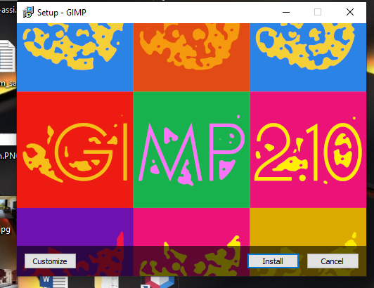

Step-3: Click on the install button for start installing

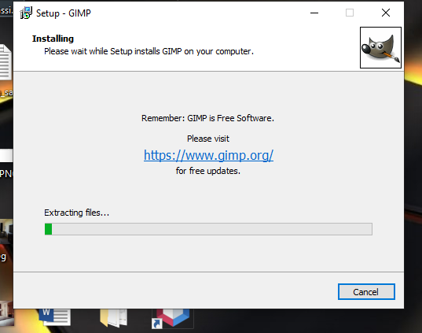

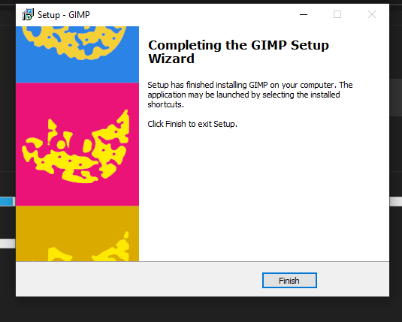

Step-4: after installation is complete following screen is showed in which required data files are load

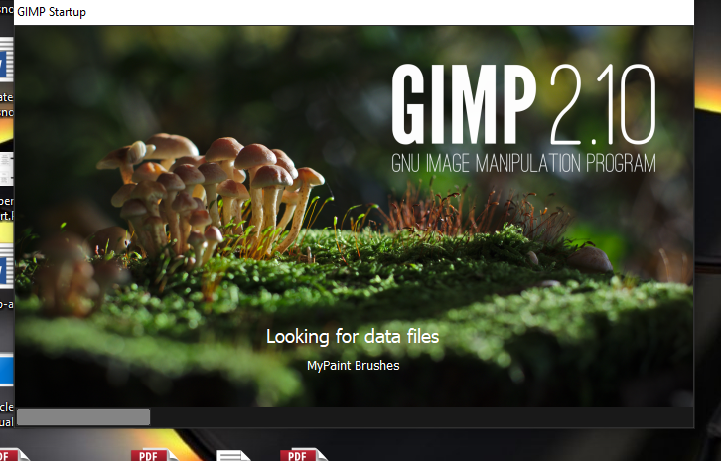

**Blender:** Blender is the free and open source 3D creation suite. It supports the entirety of the 3D pipeline—modeling, rigging, animation, simulation, rendering, compositing and motion tracking, video editing and 2D animation pipeline.

**Steps to follow for installing Blender:**

Step-1: Go-to the official site of the blender for downloading the setup.

Step-2: click on setup for installing

Step-3: After clicking on setup following screen is showed up then click next button to proceed for further steps.

.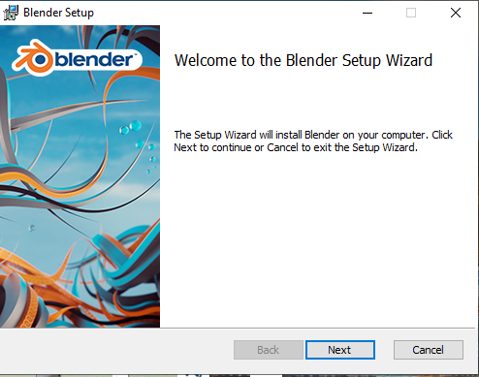

Setp-4: After clicking next button license agreement page is come and have to agree all the term and condition to proceed further.

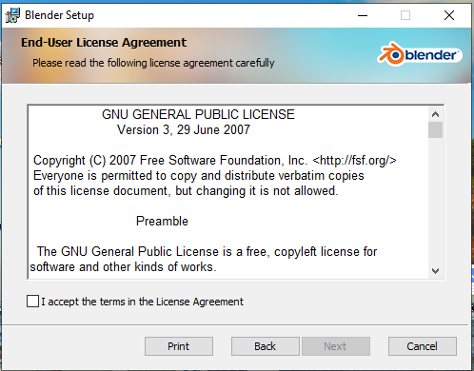

Step-5: set the location of the blender

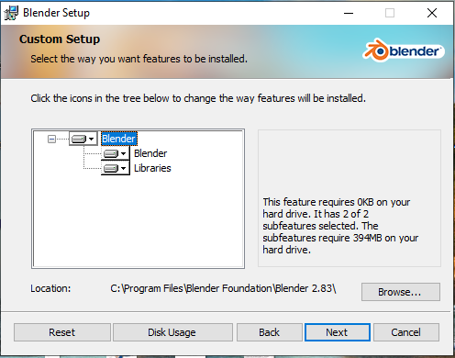

Steps-6: click install button to start the installation.

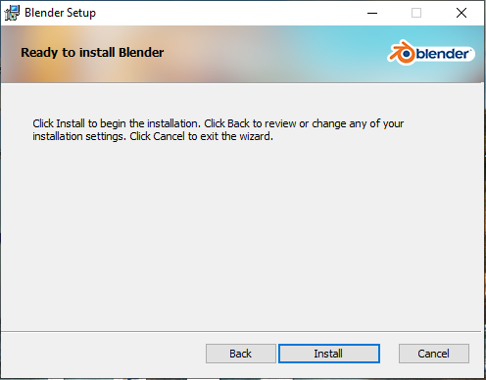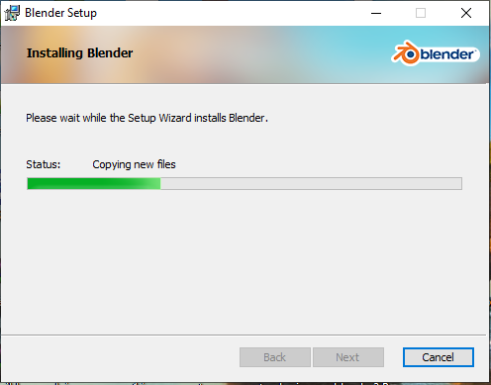

Step-7: Installation is done

