

**UNIVERSITY OF PETROLEUM AND ENERGY STUDIES**

**School of Computer** **Science**

**2020-21**

**GRAPHICS AND ANIMATION TOOLS LAB**

**Faculty: Dr. DURGANSH SHARMA**

**Assistant Professor**

**Department of Cybernetics.**

**School of Computer Science, UPES**

**Submitted By:**

**Name- Shivam Saxena**

**Roll no-R100217070**

**Batch-B2**

**Semester- 7**

**Course-B.tech. CSE-OSOS   
Sap Id- 500062332**

**EXPERIMENT NO 5**

**Aim** :- Design of 3D Text using Blender.

**Objective** :- To Design a 3D Text using features of Blender 2.8 .

**STEPS TO MAKE DESIGN A 3D TEXT:-**

1. Open Blender workspace delete the existing cube and Click on the add option and add text of your choice in my case I have added my own name
2. Then we will make some adjustments in the text like depth and extrude we will set the depth as 0.02 and extrude as the 0.05
3. After making changes in the text we will add the Bezier circle and adjust the Bezier circle around the text in such a manner that it surrounds the text
4. After the above step add the random color to the text and add camera point on the boundary of the circle which is surrounded by the text
5. After the above step now we will add the metallic effect to the text and add the shading effect to the text and also we are going to change the color of the point to the color of your choice
6. After the above step then we will render the animation

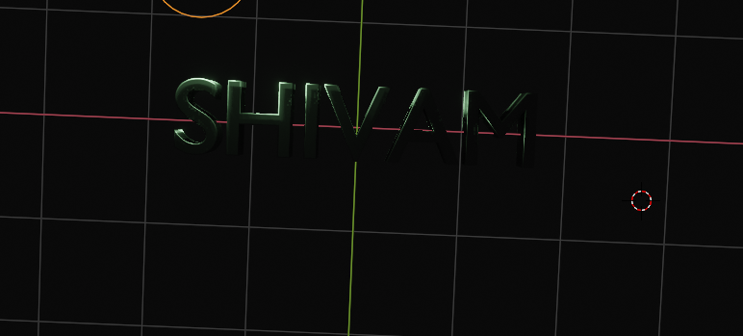

Link for Google drive:-   
  
<https://drive.google.com/drive/folders/1XTSIMrU2Y3sBJgoKlWRBDRAtS3CXgCsL?usp=sharing>