**Experiments -7 Create 3D rocket using blender**

Steps:

1. First add a mesh and choose cone.

2. Set suitable vertices in the cone properties and scale the cone.

3. Move cone upwards in z axis.

4. Select bottom face of the cone and extrude it downwards in z axis till the length of extruded part is twice the height of cone.

5. Again extrude a small portion from the bottom face and than scale it to reduce the radius of bottom face.

6. Again extrude the bottom face downwards in z axis nearly twice the height of head part.

7. Again extrude a small portion and than from this portion select four faces at equal intervals and extrude them.

8. Again extrude a small portion from bottom face and than extrude it upwards in z direction to give a hollow look at the bottom of the rocket.

9. At last color the rocket using red, white and yellow colors.

10. then apply quick smoke effect on rocket so that it look animated.

11. For applying quick smoke effect click on object button and then goto quick effect and then select quick smoke .

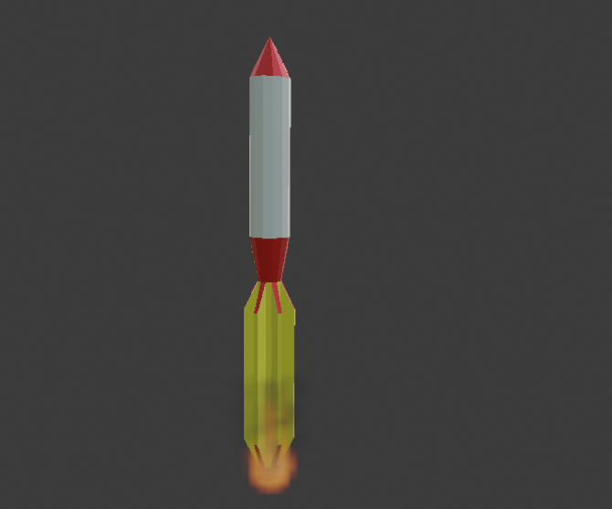

Google drive link: https://drive.google.com/drive/folders/1XTSIMrU2Y3sBJgoKlWRBDRAtS3CXgCsL?usp=sharing