**EXPERIMENT – 8**

Step-1: Create a new file in Blender.

Step-2: Scale the cube in x-axis and make three loop cut by using shortcut ctrl+r.

Step-3: select the middle portion of the cube the extrude the upper face of this portion in upward direction.

Step-4: select the whole object and scale it in x-axis so that it start lookinh like a basic structure of the car.

Step-5: Click edit mode and use vertex select to tweak the shape of our model

Step-6: Now use face select and extrude option to create windows, other stuffs.

Step-7: Select circle to create the headlights, tyres of the car.

Step-8: Create duplicate object of the headlight by pressing shift+d for the back light of the car.

Step-9: Press “I” for inspect the circle and then extrude and then extrude outward to make the basic shape of the tyres.

Step-10: Create new material with color of your preference and assign it to the car object.

Step-11: Similarly set colour for tyres, and headlights.

Step-12: use sphere for the light and apply emmison and bloom on sphere to look like a light source.

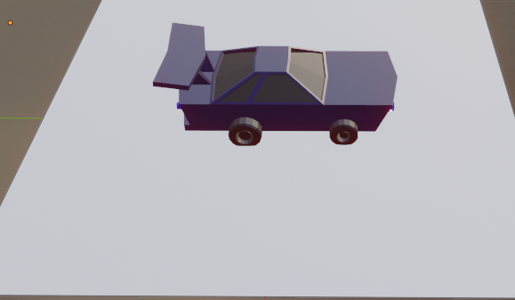

Link: https://drive.google.com/drive/folders/19RVYWhyJdCLlrxHaRXPG5M0kgE1xtz9D?usp=sharing