

**UNIVERSITY OF PETROLEUM AND ENERGY STUDIES**

**School of Computer** **Science**

**2020-21**

**GRAPHICS AND ANIMATION TOOLS LAB**

**Faculty: Dr. DURGANSH SHARMA**

**Assistant Professor**

**Department of Cybernetics.**

**School of Computer Science, UPES**

**Submitted By:**

**Name- Shivam Saxena**

**Roll no-R100217070**

**Batch-B2**

**Semester- 7**

**Course-B.tech. CSE-OSOS**

**Sap Id- 500062332**

**Steps To Design Snowy mountain with falling snow in gimp:-**

Step-1 Add an image of mountains to GIMP.

Step-2 Set foreground color to black.

Step-3 Add a new layer and set its color as foreground color.

Step-4 Go to filters -> noise -> HSV noise.

Step-5 Set dulling and value to full.

Step-6 Go to filters -> blur -> Gaussian blur.

Step-7 Set size X and Y to 1.0.

Step-8 Go to colors -> levels.

Step-9 Bring right most arrow to left. Adjust the positioning of the arrows till they give a snoweffect.

Step-10 Go to Mode -> Screen.

Step-11 Now add another layer for bigger snow flakes.

Step-12 Go to filters -> noise -> HSV noise.

Step-13 Set dulling to 1 and value to full.

Step-14 Go to filters -> blur -> Gaussian blur.

Step-15 Set size X and Y to 3.0.

Step-16 Go to colors -> levels.

Step-17 Bring right most arrow to left. Adjust the positioning of the arrows till they give a snow effect.

You will get the snow effect over your image.

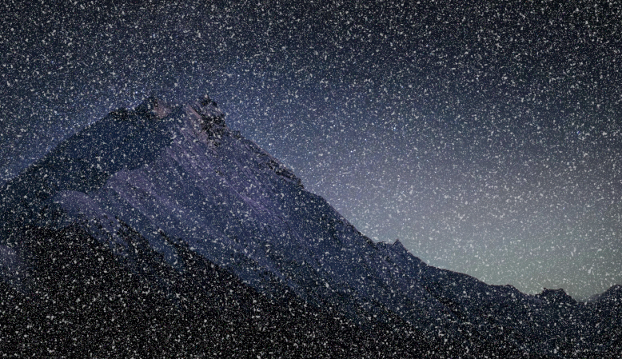

**Steps To design a skyscraper in Blender:-**

Step-1. Open Blender workspace delete the existing cube and Click on the add option and add cube.

Step-2. Then we will make some adjustments in the cube like length and breadth.

Step-3 Make a 150 loop cut because burj khalifa has 150 floors .

Step-4. After making changes in the cube we will select the upper face of cube and then extrude it. Like this we are going to increase the length of our building.

Step-5. After this add edge loops to make windows of the building.

Step-6. Now add new material on the windows and set roughness to 0 and transmission to1.

Step-7. Now go to shading part and add various properties like noise texture ,bump etc to give realistic effects on windows.

Step-8. Extrude the lower part of the building outwards to make shape accordingly.

Step-9 At the add some color in my case I add while color .

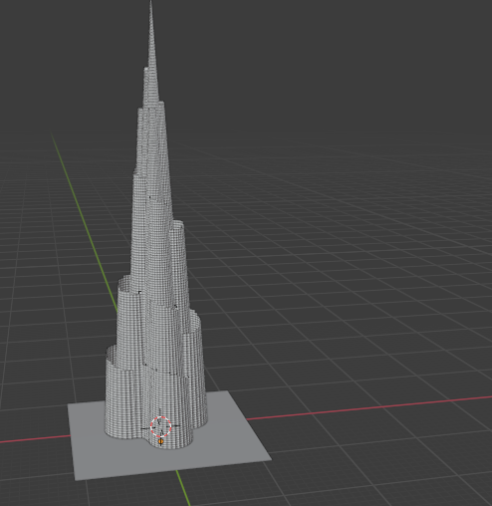

Link: <https://drive.google.com/drive/folders/16UFj2KlwWD7PgOFt6wol2aYpjaEWgFps?usp=sharing>