Assignment No. 2

Name:- Shivam Chougule PRN :- 2018BTECS00112

1. Create a separate workspace for your project using selected IDE.
2. Write a program to start a Node.js server on localhost and listens to the client requests on port number 8080.

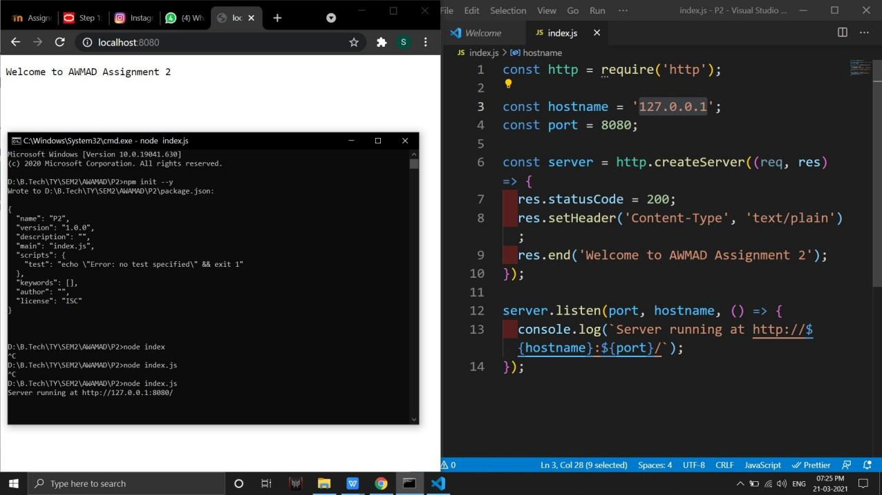

1. Perform the fundamentals programming constructs such as operations, loops, variable assignments and printing their values using Node.js REPL environment.
2. Save the REPL session to a file and reload the REPL session.

