**A**

**PROJECT REPORT ON**

**“Freelance Platform using Web Scrapping”**

**Submitted by**

|  |  |
| --- | --- |
| **Shivam Verma** | **S188003** |
| **Anushka Gulave** | **S188038** |
| **Shivam Mahale** | **S188034** |

**Guided by,**

**Mayura Kulkarni**

**A Report submitted to MIT Academy of Engineering Alandi submitted in partial fulfilment of the requirement for Fourth Semester of BACHELOR OF TECHNOLOGY in School of Computer Engineering and Technology.**



**SCHOOL OF COMPUTER ENGINEERING AND TECHNOLOGY**

**MIT Academy of Engineering**

**Dehu Phata, Alandi (D)**

**Pune - 412105, Maharashtra (India)**

**2018-19**

|  |  |
| --- | --- |
| **Alandi (D), Pune – 412105** | School of Computer Engineering & Technology  **(Accredited by NBA, ISO 9001:2008 Certified)** |

**CERTIFICATE**

This is certify that,

|  |  |
| --- | --- |
| **Shivam Verma** | **S188003** |
| **Anushka Gulave** | **S188038** |
| **Shivam Mahale** | **S188034** |

of S. Y. B. Tech. have submitted a Report on,

**Project Title**

The said work is completed by putting the requirement of hours as per prescribed curriculum during the academic year 2018 – 19. The report is submitted in the partial fulfilment of the requirements for the course **Minor Project** in the Fourth Semester of Degree of Engineering in –School of Computer Engineering and Technology, MIT Academy of Engineering.

Date: / /

Place:

Signature: Signature:

Name : Name : Prof. R. R. Badre

**Project Advisor Dean SCET**

# CONTENTS

|  |  |  |  |
| --- | --- | --- | --- |
| Acknowledgements | | | i |
| Abstract | | | ii |
| List of Figures | | | iii |
| List of Tables | | | iv |
|  | Introduction | |  |
|  | 1.1 | Motivation |  |
|  | 1.2 | Objectives and Scope |  |
|  | 1.3 | Problem Statement |  |
|  | Literature Survey | |  |
|  | System Design | |  |
|  | 3.1 | Hardware Requirements |  |
|  | 3.2 | Software Requirements |  |
|  | 3.3 | Circuit Diagram (If Applicable) |  |
|  | 3.4 | Mechanical Drawing (If Applicable) |  |
|  | 3.5 | Use Case Diagram (If Applicable) |  |
|  | 3.6 | Sequence Diagram (If Applicable) |  |
|  | 3.7 | Activity Diagram (If Applicable) |  |
|  | Implementation Details | |  |
|  | Results | |  |
|  | Conclusion and Future scope | |  |
| References | | |  |

**1. Introduction:-**

When it comes to alternative work situations, there are many terms thrown around such as freelancer, contractor, telecommuter and more. A freelancer is a self-employed person who offers services to clients. These services are often, though not necessarily, are offered to businesses, though the proliferation of sharing economy apps like TaskRabbit and Mechanical Turk. However, individuals can offer their services directly to clients, without third-party resources that often take a cut of the pay.Nearly every type of service needed by most businesses could be provided by a freelancer. Some of the most common freelance opportunities include Graphic design,Accounting,Web design/development,Coding,etc.

Freelance income varies depending on the skills offered, your experience, and the market you're targeting. In general, freelancers earn anywhere from $10 to $75 per hour. Skills that require more education or experience, such as accounting or website coding, generally pay more than skills that don't require as much. Freelancing can be a fast and affordable way to get started working as your own boss, often from the comfort of home.So,the need of freelancers have increased alot.Therefore,we have decided to build a website which will compare the projects and will give the right project the user needs.



Fig No. 1.1: **Freelancers** → A person who is self employed

https://proxy.duckduckgo.com/iu/?u=http%3A%2F%2Fupload.wikimedia.org%2Fwikipedia%2Fcommons%2F1%2F1d%2FHellofreelancer_logo.jpg&f=1

**1.1 Motivation:-**

There are many people who have talent and wish to work but they can’t go out of home.So,they want to work from their home and get paid for their work but they don’t know how to start.In the market there are dozens of freelancing websites and for the new user it is very difficult to choose the right one for his need whether he is contractor or client.And many freelancing websites recommend only popular clients to the contractor so the project is done and both the client and contractor are happy and will use that website again or on other times the websites take money from users to get highlighted at the top.So,it is very difficult for the new user to find or approach for a project.From this conditions we have decided to create a platform for the users where they can choose project as per their requirements and it will be easy for them to directly contact the contractor without paying to the website.

There will be no partiality between the old user or new user,all the users will be treated same no specific project or user will be highlighted on top.

**1.2 Objective and Scope:-**

To create a Metasearch platform that’ll facilitate various organisations to get best freelancers at cheapest price using web scrapping.The purpose of this website is to reduce the growth of direct traffic on some of the most famous websites.We are going to create a website where we are going to collect data from various freelancing websites and display it on a single interface to gain easy access to the data.To create a user friendly interface for the users so it will be easy for them to find project according to their requirements.This will help clients as well as for contractors to search for the project and to upload the project.



Fig No. 1.2: **MetaSearch Platform**

https://proxy.duckduckgo.com/iu/?u=http %3A%2F%2Fblog.hubstaff.com%2Fwp-content%2Fuploads%2F2014%2F05%2Fodesk-vs-elance-vs-freelancer.jpg&f=1

**1.3 Problem Statement:-**

The new users find difficult to choose website according to their needs as there are plenty of freelancing websites and to reduce the growth of direct traffic on the most famous websites.



Fig No. 1.3: **FREELANCER2HIRE**

https://proxy.duckduckgo.com/iu/?u=http%3A%2F%2Fwww.thelogomix.com%2Ffiles%2Fimagecache%2Fv3-logo-detail%2Ffreelance%2520folder.jpg&f=1

**2. Literature survey:-**

We have done survey on internet as well as we have asked to some of our friends which are in freelancing field about our project.

Freelancers:

* Which sites do you know for freelancing projects?

- Freelancer,99designs,upwork

* How many freelancing sites do you use?

- 1

* How did you get your first few clients and what problems you faced for getting them?
* It was a quite hard to get first few clients,as I was a new freelancer so they were quite doubtful about my work but after continuous try of 2 months a client hired me so it was very time consuming
* Why did these clients originally hire you?
* After giving ideas to various projects,a client liked my idea for his project and his budget was minimum and I was fitting in his condition so he hired me to do his project
* What do you think of a website where all projects comparison will be there?

- Yes,it is nice idea.It will be great to see all projects under one roof and it will be easy for us to search and apply for a project

Contractors:

* If you want important project done do you pay whatever the developer asks?
* Yes,I pay whatever the developer asks for my important project as I have

to get it in complete in time and done fully

* Do you wanna see all the developers under same website?
* Yes,it will very nice for us then because we will meet new developers

and their new ideas will make our projects more interesting

* Due to trusted issues to you give your projects to same developer?
* Yes definitely,we give our projects to same developer sometimes due to their punctualness of doing project in time even if they charged more.We are unable to find new developers in time and due to trusted issues



Fig No. 2.1: **Businessman + Freelancer**

<https://proxy.duckduckgo.com/iu/?u=https%3A%2F> %2Fcdn-images-1.medium.com%2Fm%2F1600%2F1*crWXuzmqSqykuBDKd9repQ.jpeg&f=1

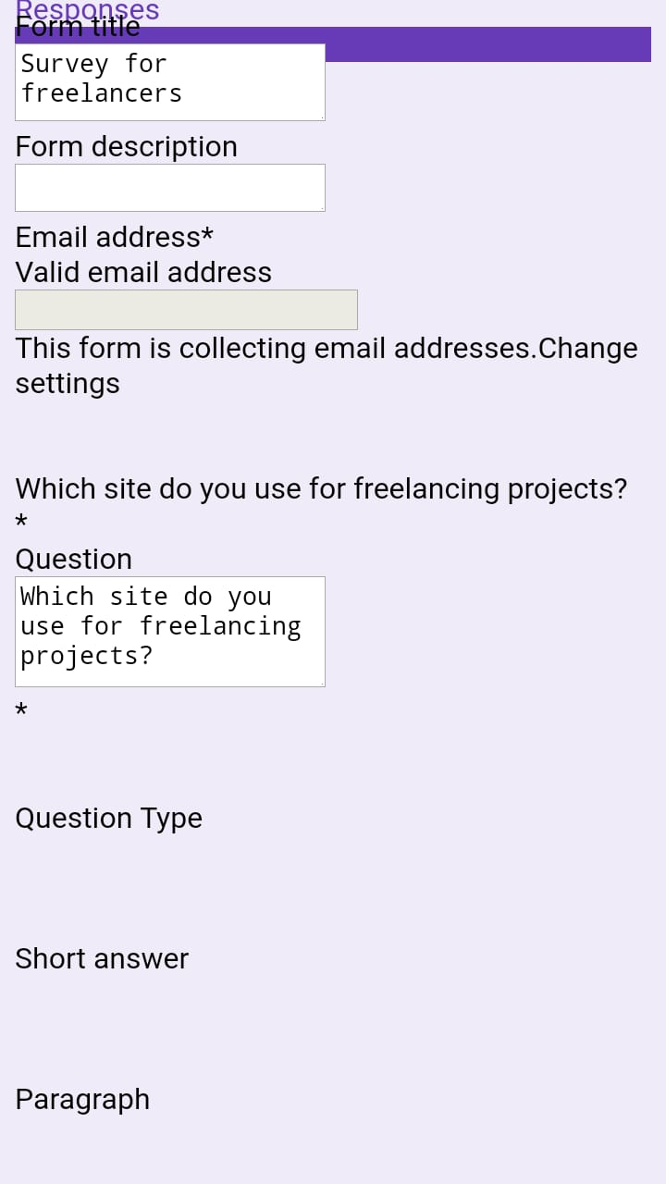

Fig No. 2.2: **Google form Survey**

**3. System Design:-**

**3.1 Hardware Requirements:-**

As we are dealing with formation of a website using server – client technologies, there’s no any need of any hardware except a system with complete installation of whatever dependencies our project needs to host locally.

**3.2 Software Requirements:-**

Most website make use of both server side and client side. Front end scripting is good for anything that requires user interaction. Back-end scripting is good for anything that requires dynamic data to be loaded.

* **Server Side:**

Server-side scripting is a technique used in web development which involves employing scripts on a web server which produce a response customized for each user's (client's) request to the website.

* + **PHP:** Hypertext Preprocessor is a server-side scripting language designed for Web development, but also used as a general-purpose programming language.
* **Client Side:**

Client-end scripts are embedded in a website’s HTML markup code, which is housed on the server in a language that’s compatible with, or compiled to communicate with, the browser.

* + Bootstrap is a free and open-source CSS framework directed at responsive, mobile-first front-end web development. It contains CSS- and (optionally) JavaScript-based design templates for typography, forms, buttons, navigation and other interface components.
* **Database:**

**MongoDB:** It is a free and open-source cross-platform document-oriented database program. Classified as a NoSQL database program, MongoDB uses JSON-like documents with schemas.

**3.5 Use Case Diagram:-**

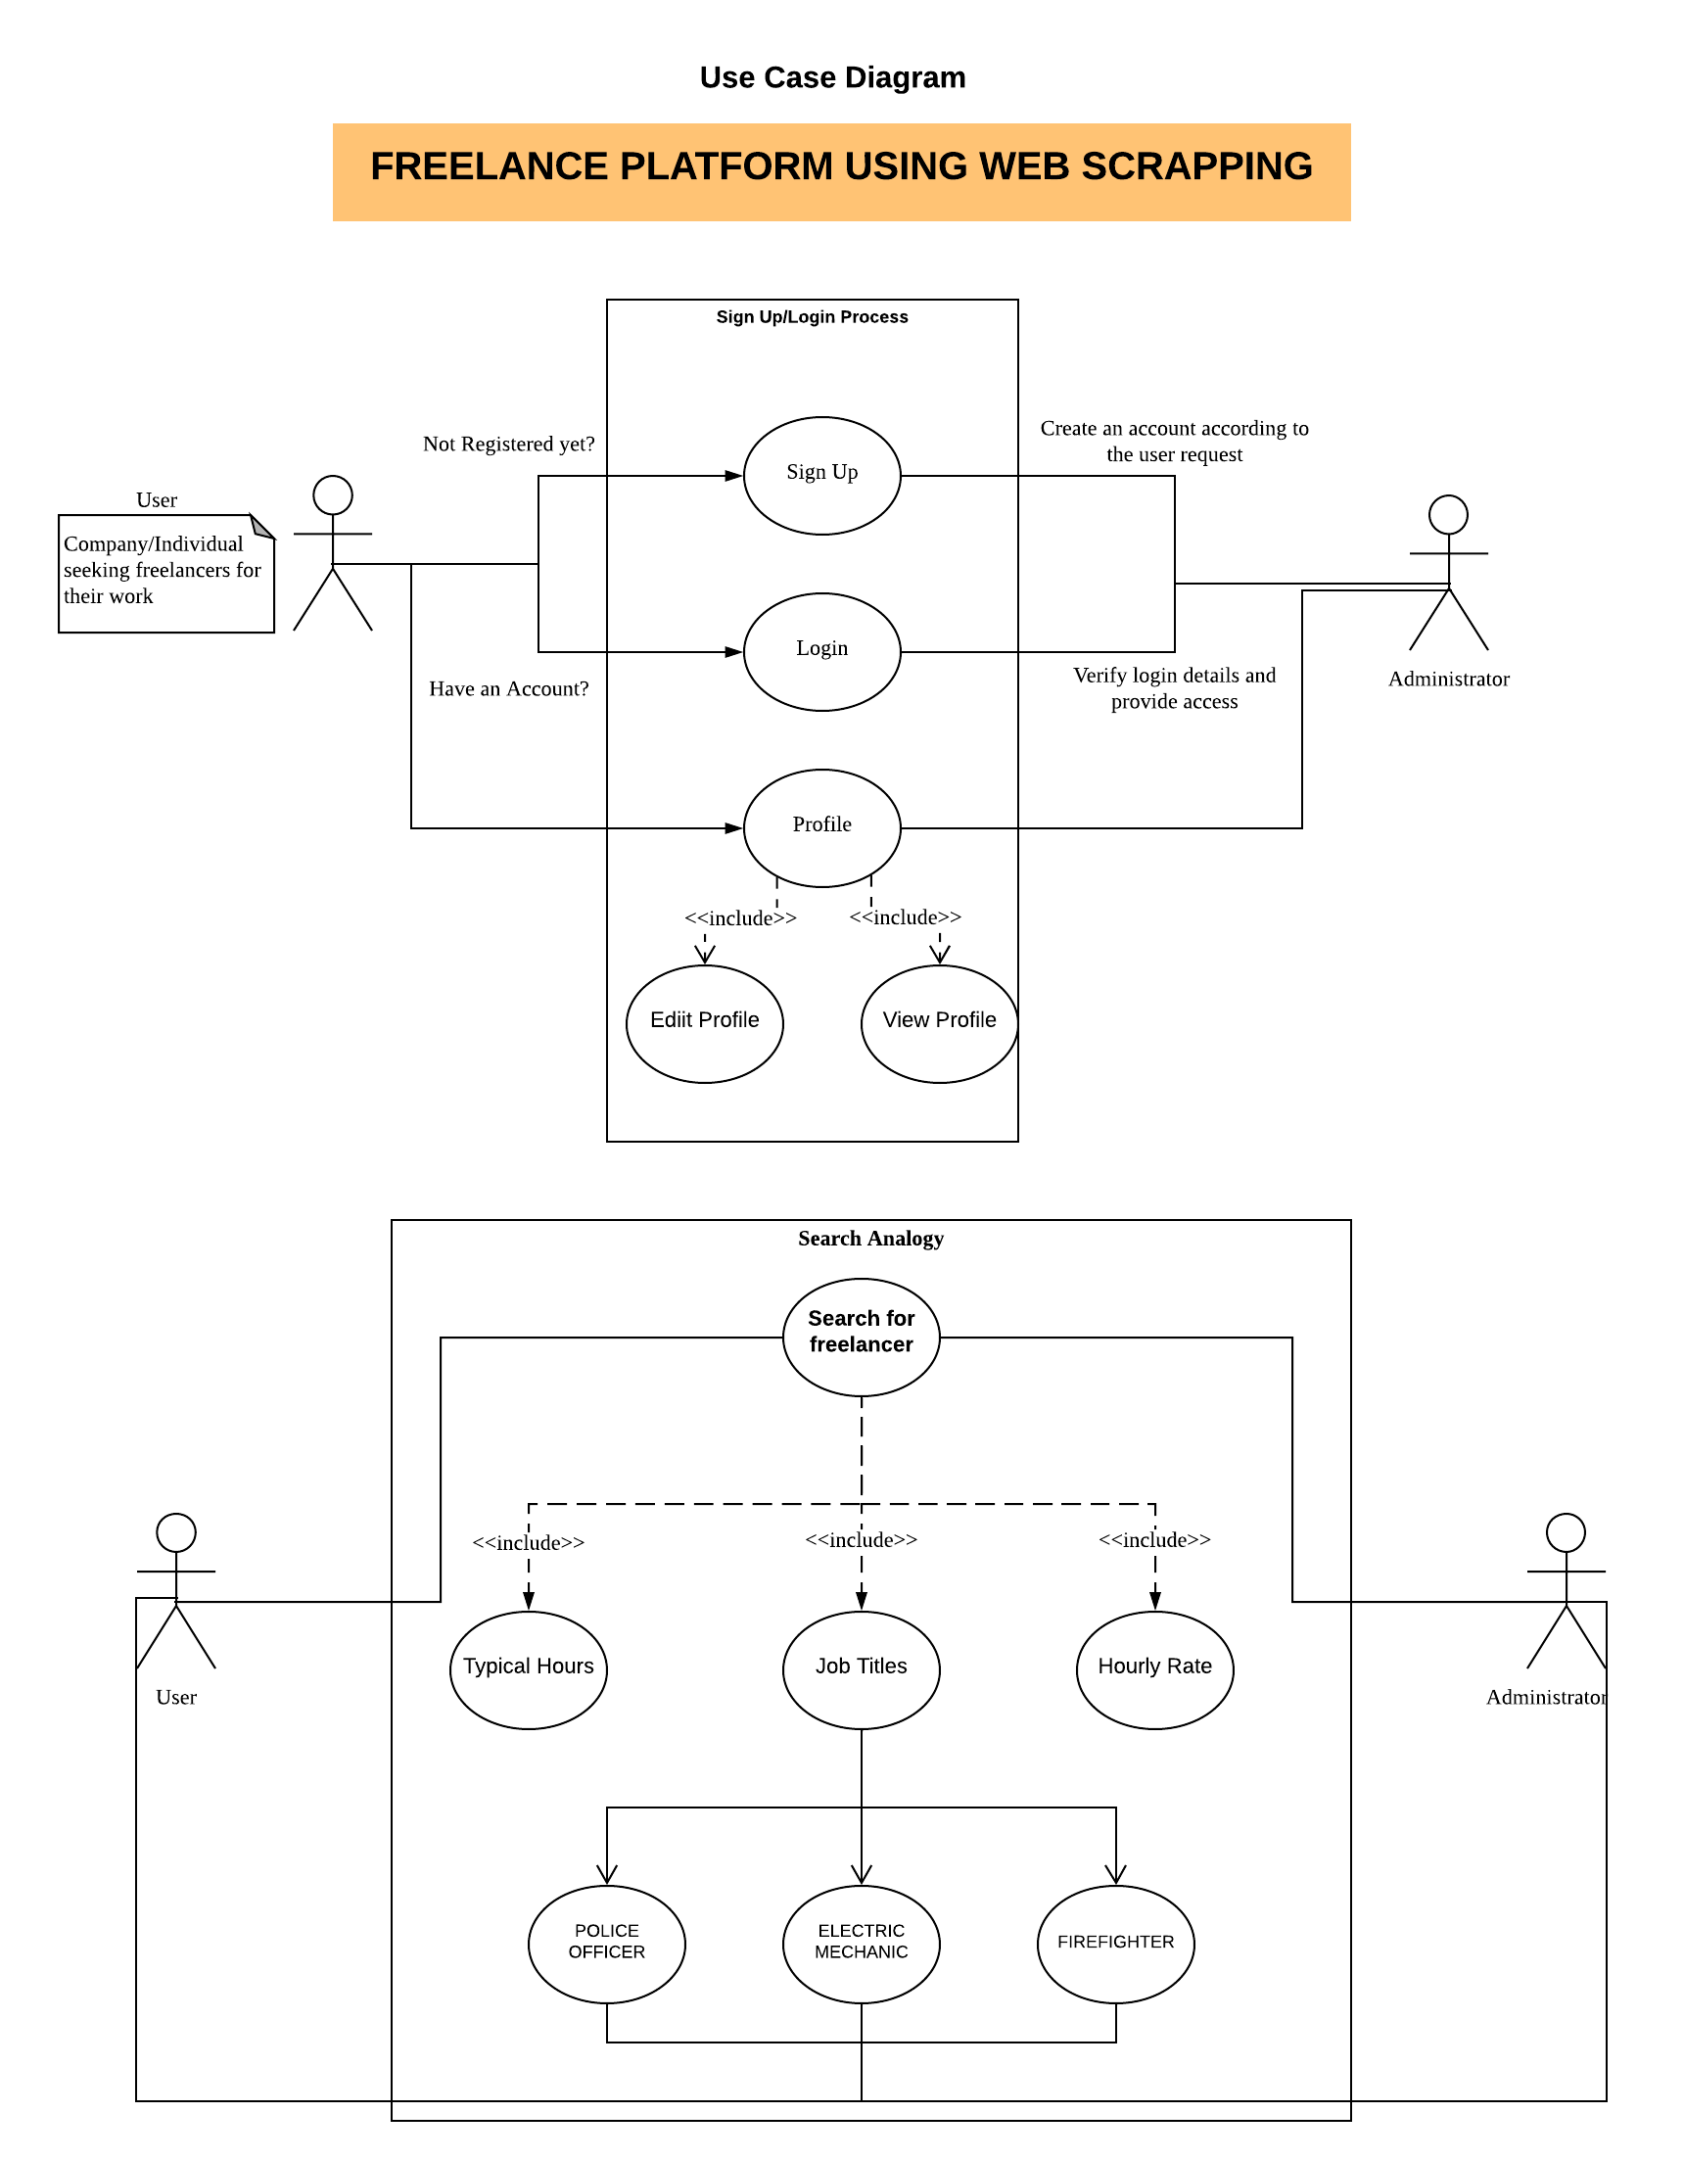

Fig No. 3.1 : **Use Case 1**

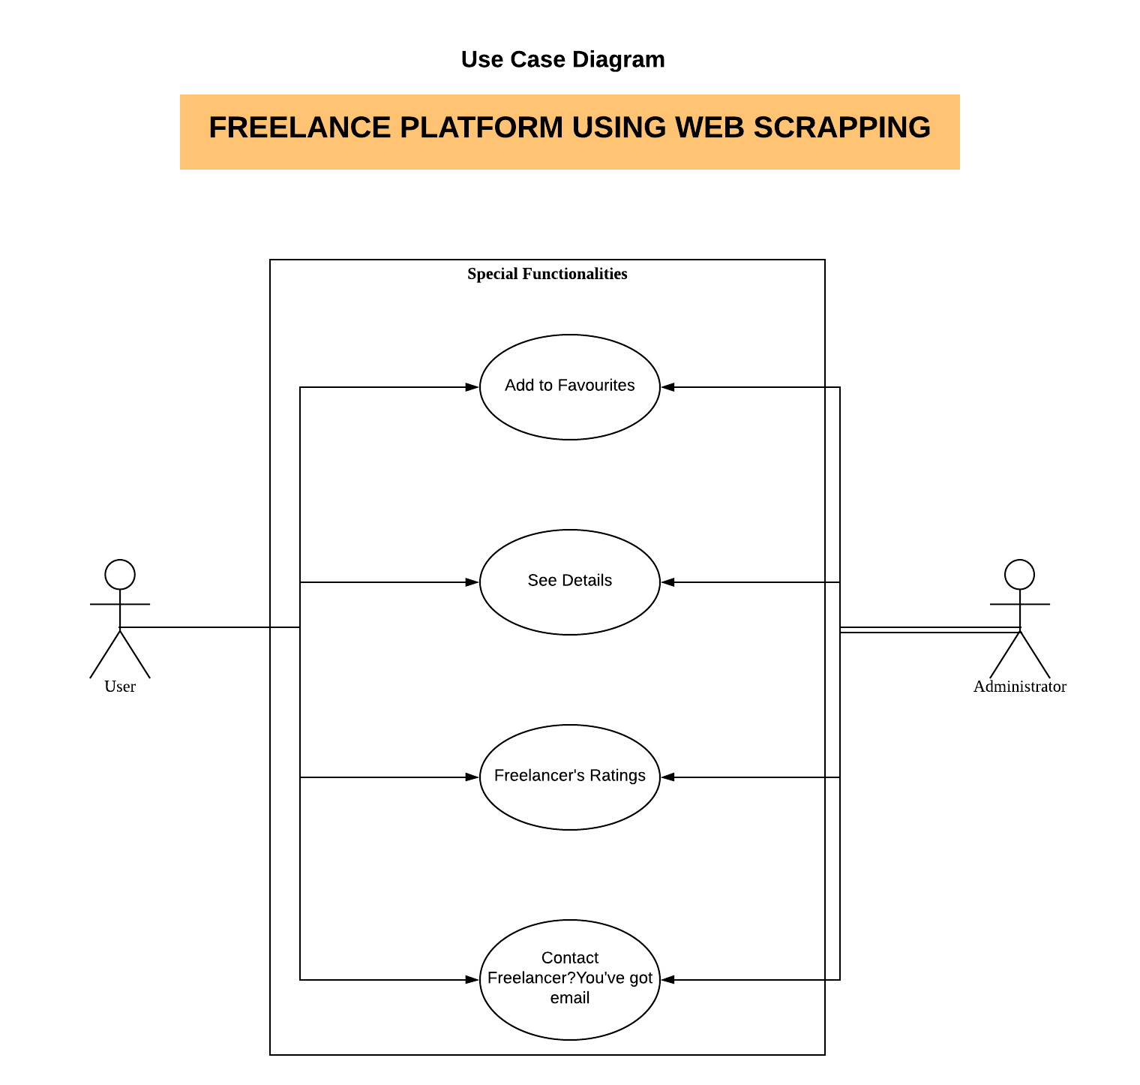Fig No. 3.2 : **Use Case 2**

**3.6 Sequence Diagram:-**

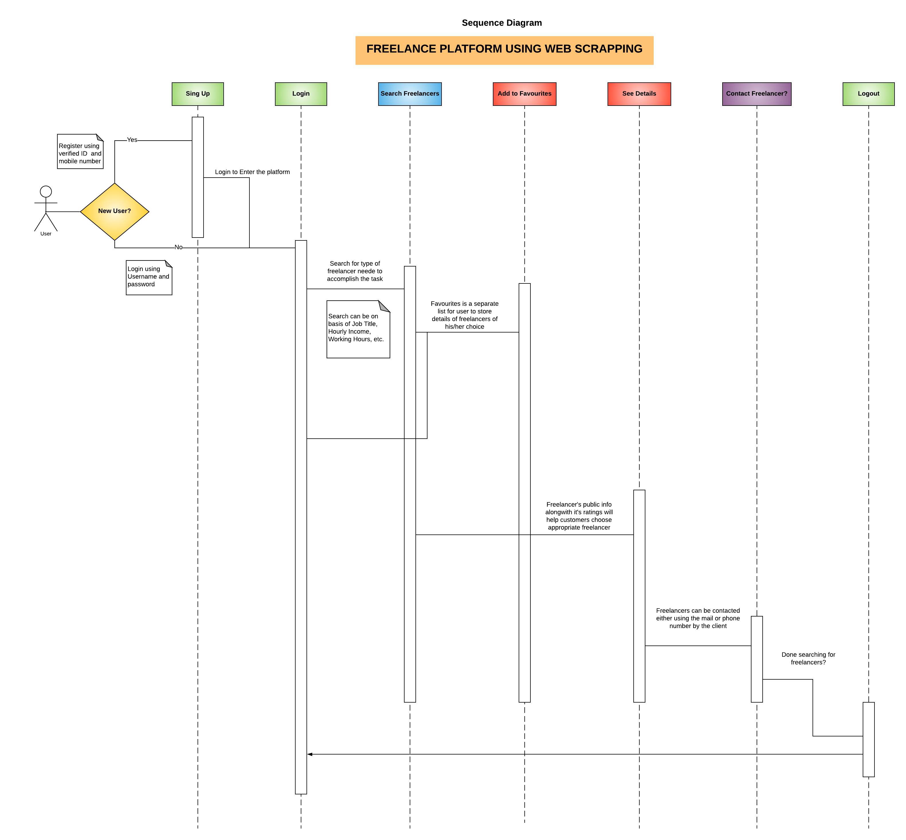

Fig No. 3.3 : **Sequence Diagram**

**3.6 Activity Diagram:-**

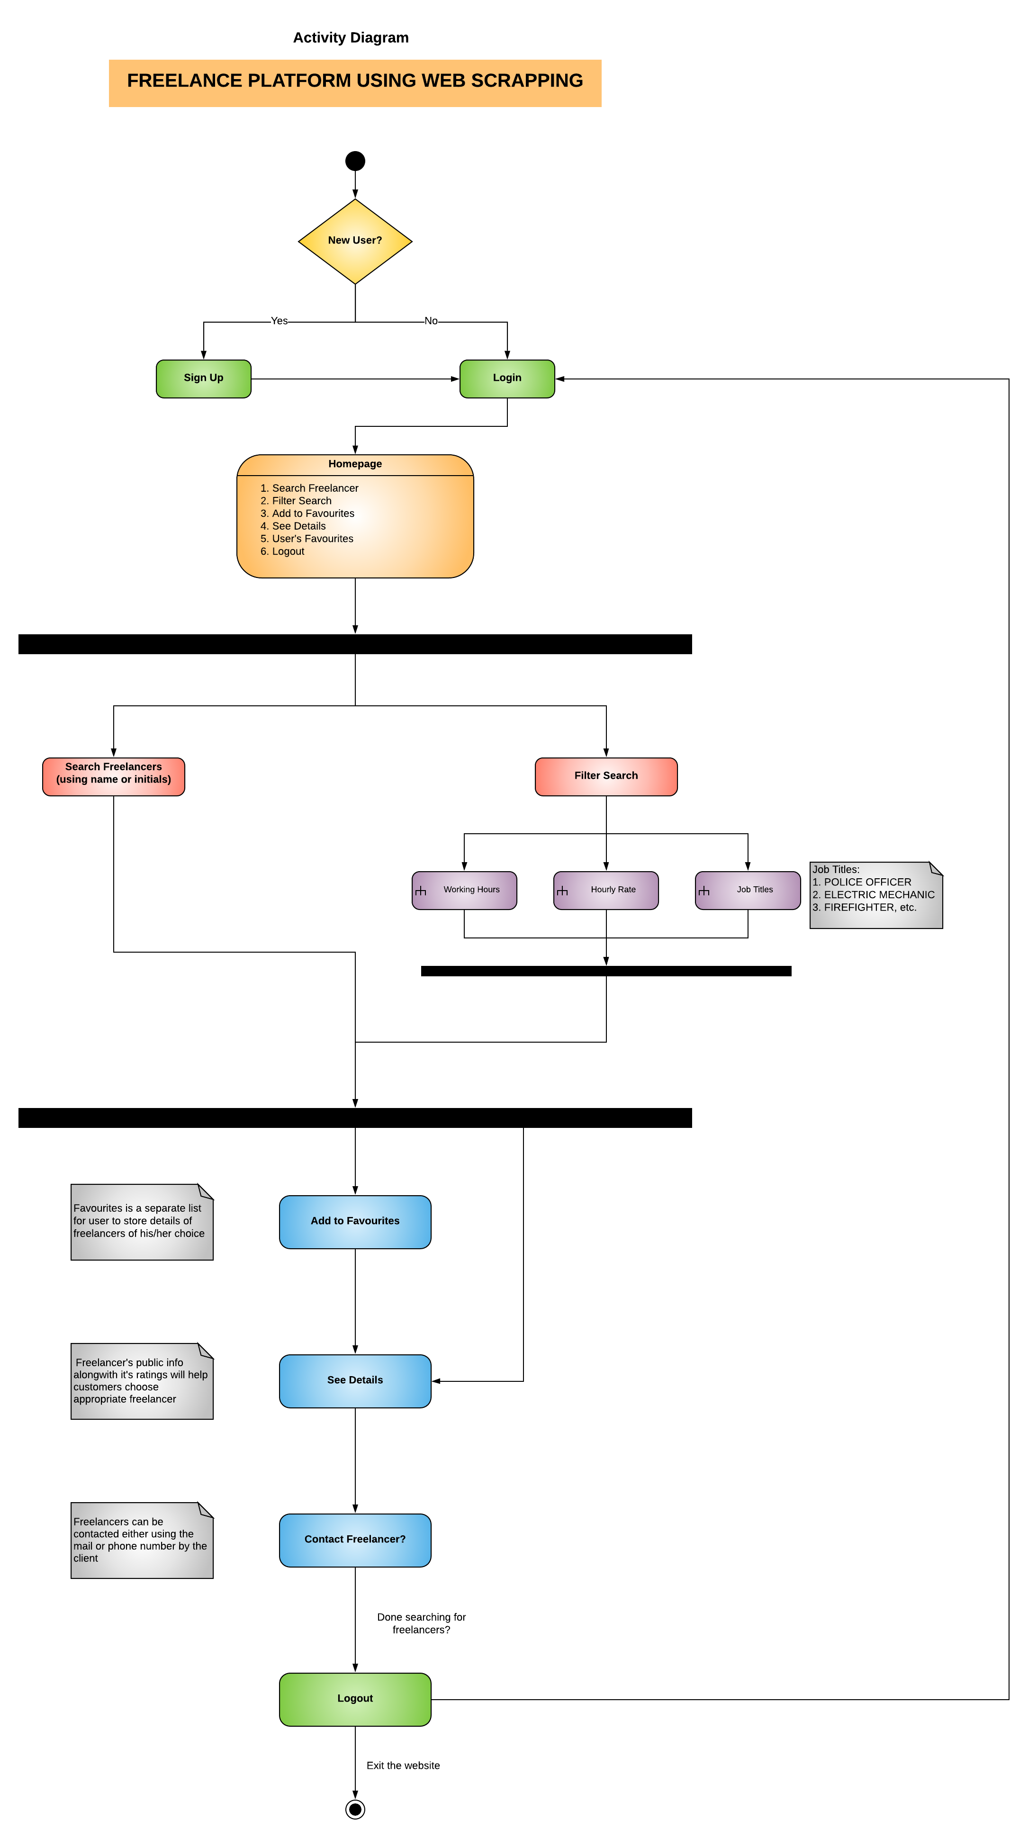

Fig No. 3.4: **Activity Diagram**

**4. Implementation Details:**

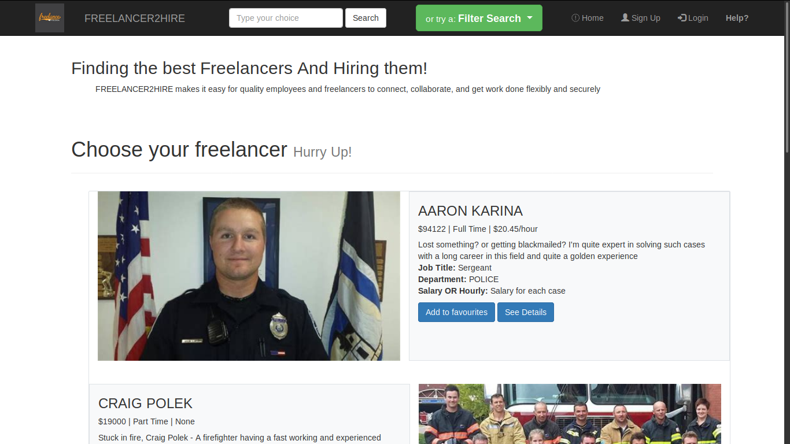

Fig No. 4.1: **FREELANCER2HIRE Homepage**

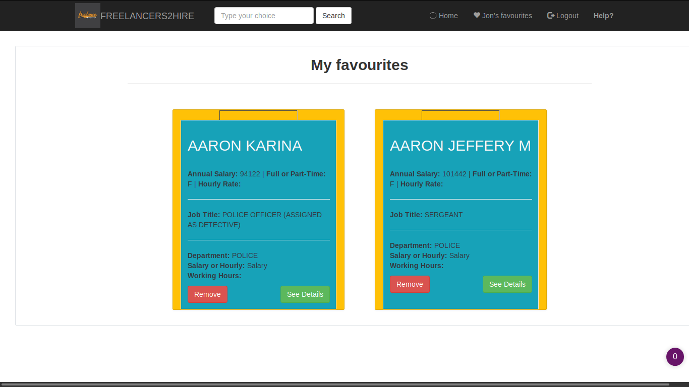Fig No. 4.2:  **User’s Favourites List**

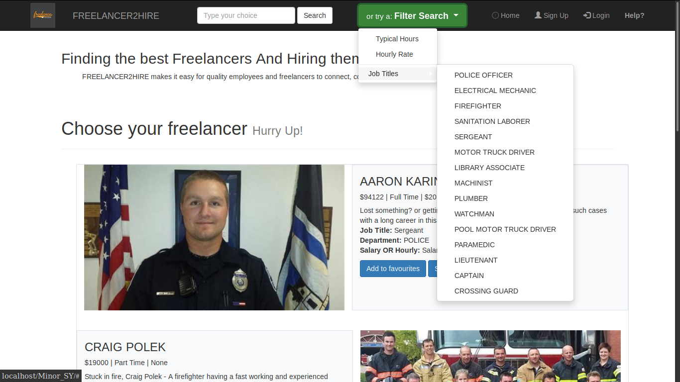

Fig No. 4.3:  **Dropdown related to various Job Titles**

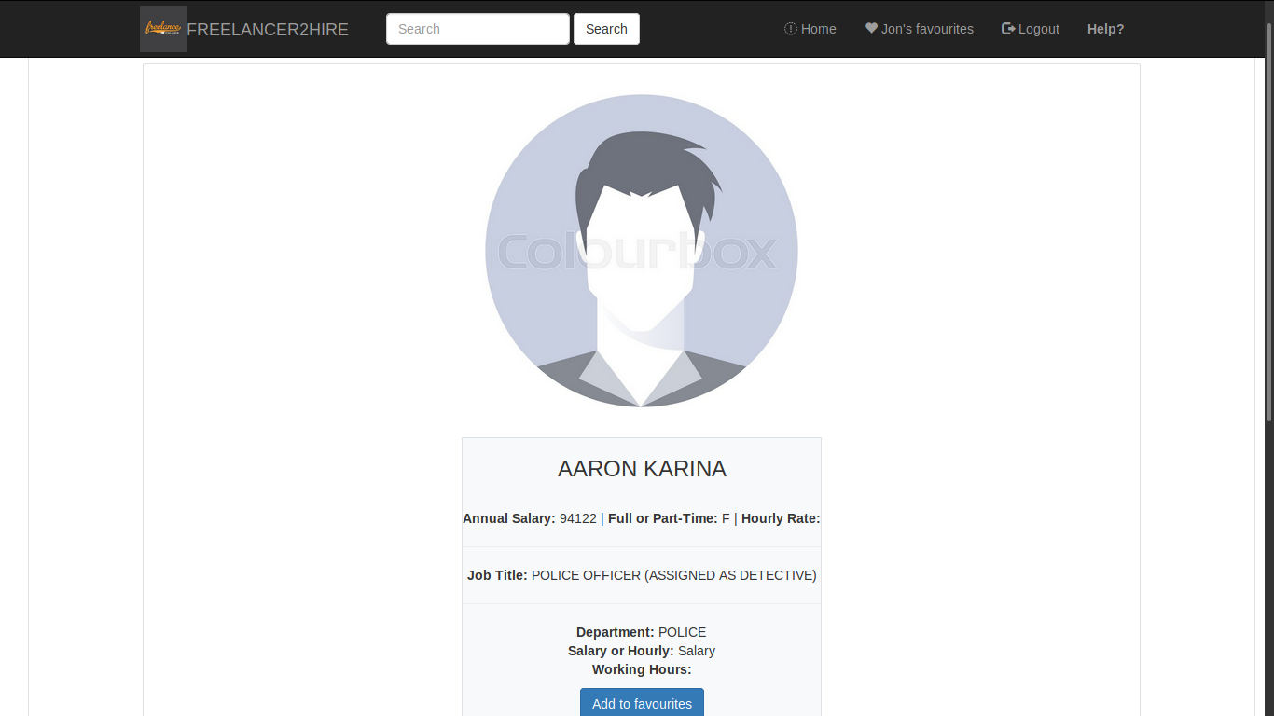

Fig No. 4.4: **Freelancer’s Details**

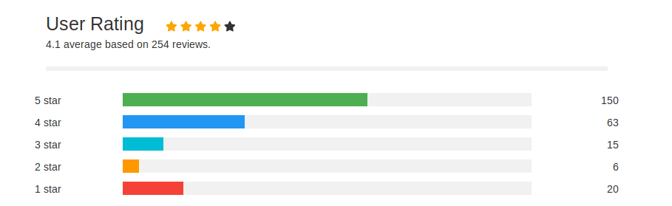Fig No. 4.5: **Freelancer’s Rating**

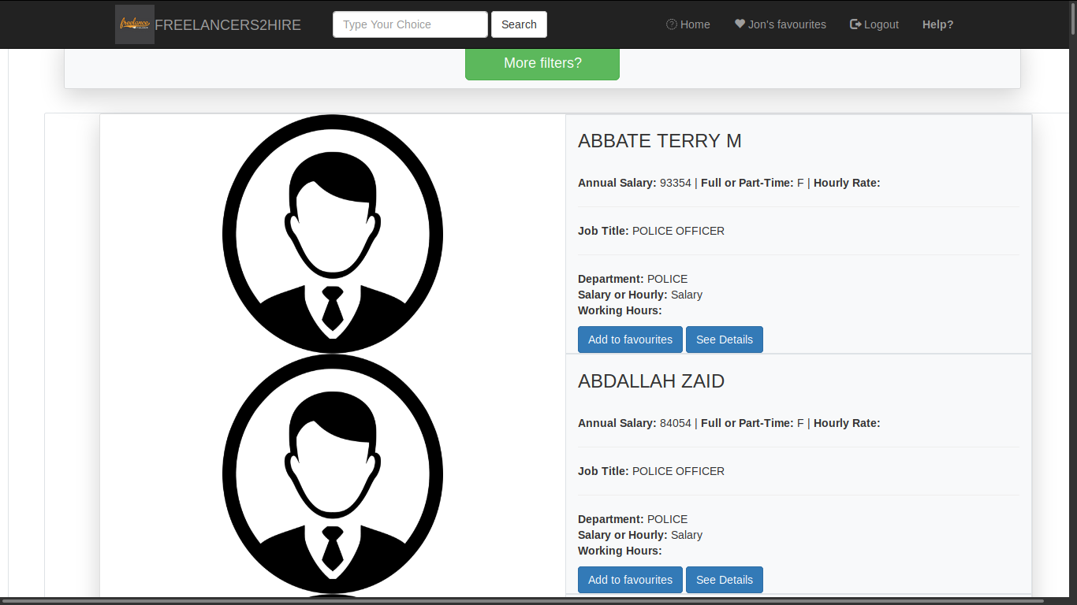

Fig No. 4.6: **Search Details**

**5. Conclusion:-**

All the freelancers info. will be under same platform so it will be easy for the users to search for the freelancers with different skills. There are various filters such as Working Hours, Job Titles, Hourly Rate, etc. that will help client to sort freelancers based on their necessity.

No partiality will be there between new users and old users all the users will be treated same means everyone will get their own choice to choose their project according their skills as filters will sort the freelancers based on the condition imposed. Such thing will help new and rightful freelancers to showcase their skills and increase their experience.

**6. Future Scope:-**

* First of all our main focus in future will be to improve the GUI of our website and make it more user-friendly. Using Javascript for enhancing the GUI of our website
* Also, we will try to increase the functionality of our project by taking data from various reputed websites such as freelancers.com, upwork.com, etc. that will bring the actual freelancers into market using our websites
* Making it a deploy-able one so that people can use our website and we can improve more on our website using their feedbacks.

**7. References:-**

* **https://www.thebalancesmb.com/what-is-freelancing-1794415**
* **https://www.quora.com/What-are-the-differences-between-HTML5-and-pre-5-HTML**
* [**Python data scraping and format output into json data**](https://stackoverflow.com/questions/50314709/python-data-scraping-and-format-output-into-json-data)
* **MongoDB - PHP**
* **https://getbootstrap.com/**