**0 Design an automatic night lighting system (with 4 connected led’s) such the system is only activated when the master control switch is pressed. a) Below 50% value of full brightness all LED’s constantly ON. b) Above 50% value of full brightness only first LED is ON.**

Circuit Diagram

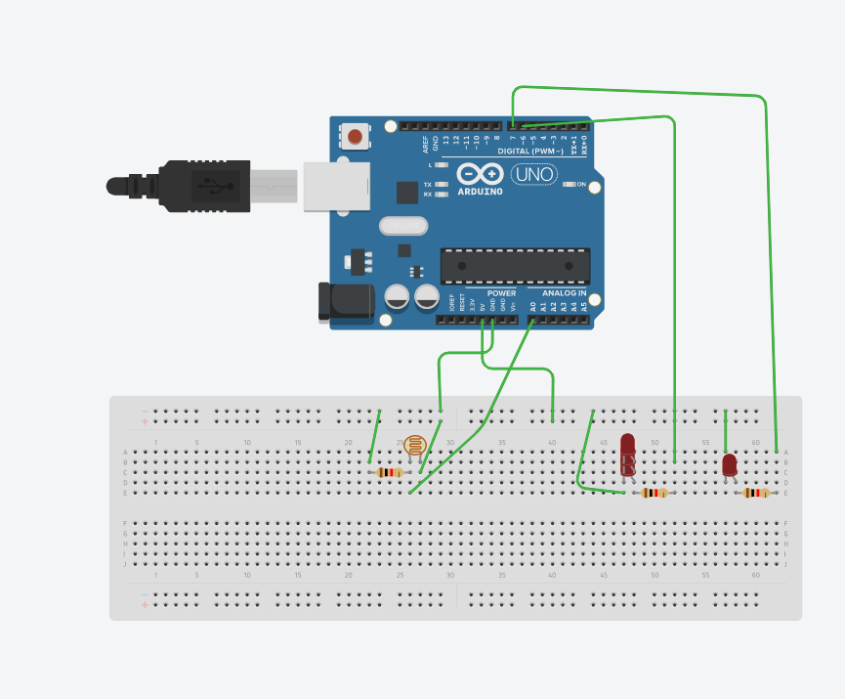

Automatic night lamp as the name suggests is for turning ON and OFF the lamp automatically without the need of human interventions. It senses the light intensity from surroundings and find whether its day or night. And it automatically turns ON when the surrounding is dark and it turns OFF when it receives light from surroundings. A sensor called LDR is used to detect the light intensity. This project finds wide outdoor applications in streets, gardens and public places where it finds difficulty to appoint a person to operate the lights.

**Advantages:**

* Highly sensitive
* Works according to the light intensity
* Fit and Forget system
* Low cost and reliable circuit
* Complete elimination of manpower
* Can handle heavy loads up to 7A
* System can be switched into manual mode whenever required
* Working
* The main part of this circuit is the light dependent resistor (LDR). It is a sensor which is a particular kind of resistor whose resistance decreases when exposed to light. Likewise it offers high resistance in dark. The resistance value changes from few 100 ohms to mega ohm range. The LDR is placed in a potential divider network. So voltage across LDR changes with intensity of light. Voltage across the LDR is given to the positive terminal of a comparator. Now a reference voltage is required to compare with the voltage across LDR. That reference voltage is made by using the pot or preset. So this preset can be used to adjust the sensitivity of the circuit. Next is the comparator made using LM358 op-amp which compares the voltage levels at its two inputs and gives output accordingly. If the voltage at positive terminal is greater, the output will be high and if the voltage at negative terminal is greater, the output will be low. That is if it is dark, resistance across LDR is high, so voltage drop across the LDR is high and voltage at positive terminal will be greater than the reference voltage. Therefore output of comparator will be high. The output of comparator is given to a [transistor wired as a switch](https://electrosome.com/transistor-as-a-switch/). Since enough voltage appears across the base emitter junction, the transistor conducts and current passes through the relay coils. So relay switches its contact and the bulb glows. Bulb is connected to the NO (Normally Open) pin of relay as it should be off when the relay coils are not energized. If the output of comparator is low, then transistor will be in OFF stage. So no current flows through the relay and bulb remains in OFF stage.

## LDR Working

* Light Dependent Resistor is also know as LDR. It changes its resistance according to the light intensity. When there is high light intensity the resistance of LDR increases resulting conductivity decreases. When there is low light intensity, it mean darkness, the resistance of LDR decreases, resulting conductivity increases. By using this phenomenon of sensing darkness, we build this project.

## Working of LDR circuit

* This circuit is operated with 9V power supply. The LDR is used to sense the darkness. When there is a darkness, the resistance is decreases and it is able to drive the base of the transistor. Here transistor Q1 acts as switch. When there is high at base of Q1, it will turn ON. The transistor Q1 will drive the transistor Q2 to turn ON the relay. When there is light on the LDR, the resistance increases, then there will be low at base of the transistor Q1, then the transistor acts as OFF switch and turns OFF the relay.

Program

const int lamp = 7;

void setup() {

Serial.begin(9600);

pinMode(lamp, OUTPUT);

pinMode(6,OUTPUT);

}

void loop() {

int c = analogRead(A0);

delay(500);

if ( c<300){

digitalWrite(lamp,HIGH);

delay(1000);

digitalWrite(6,HIGH);

delay(1000);

}

else {

digitalWrite(lamp,HIGH);

delay(1000);

digitalWrite(6,LOW);

delay(1000);

}

}