Introduction

This project is a web based online shopping system for anime merchandise. Objective of the project is to provide online merchandise shopping application for users.

Online shopping is the process where consumers directly buy goods or services from a seller in real-time, without an intermediatory services over the internet. It is a form of e-commerce.

The project entitled ”Anime Merchandise” is a web based application software developed in HTML,CSS,PHP & MYSQL using HTML & CSS as front end on Pentium machine. The main aim of “Anime Merchandise” is to improve the services customer and vendors. Further we are improving it by adding customer payments, product recipts and also updation and deletion of the same. It now stored the details of the user entered through the registeration page. The prime features of the project entitled “Anime Merchandise” are high accuracy, design flexibility and easy availability and also it uses database tables representing entities and relationship between entites. The central concept of application is to allow the customer to shop virtually using the internet & allow customer to buy items and articles of their desired choices. The servers will process the customers and the item will be shipped at customers provided address. We will continuously work on this website to make it fully functional.

Software Requirements and Specifications

**HTML:-**

It means Hypertext Markup Language. This language is used to create web page also supports other languages such as CSS,PHP,JAVASCRIPT etc. in creating interactive & responsive pages. It helps users and also web developers to create new features easily on website.

**PHP:-**

It is a serverside scripting language that is used to develop static or dynamic website or web applications. It is designed for who development to implement dynamic webpages and can be embedded to HTML for it to be displayed.

**CSS:-**

CSS is simply referred to as Cascading Style Sheet. CSS is used to define styles for webpages, including the design, layout and variations and in display for other devices & screens.

**General Structure for CSS:-**

Basic Syntax:

Selector{property: value}

HTML Tag you want to modify

The property you want to change

The value you want the property

Example:-

P{

Color: black;

Font-family: arial;

}

**CSS can be used in separate style sheet or used in webpage:**

<!Doctypehtml>

<html lang=”en-us”>

<head>

<meta charset=”UTF-8”>

<link rel=”stylesheet” type=”text/css” href=”style.css”>

</head>

**MYSQL:-**

MYSQL is a free source code database system, and it enables the cost-effective delivery of reliable and a high-performance and scalable web-based and embedded database application. It is relational database system (RDBMS). It is high performing program and scalable to meet the demand of user and data. MYSQL is written in C & C++ so it is compatible with most of the operating system available around the world.

MYSQL {PHP,CSS}Website.

DBMS

**Concept of MYSQL.**

**Visual Studio Code:-**

Visual studio code is a source code editor made by Microsoft for windows, Linux and mac OS. Feature includes support for debugging, system highlighting, intelligent code competition, snippets, code refracting and embedded gift.

**WAMP server:-**

WAMP is acronym that stands for windows, Apache, MYSQL & PHP. It’s a software stack which means installing WAMP installs Apache, MYSQL & PHP on your operating system. Even though you can install them separately, they are usually bundled up and force good reason too.

**PHP My Admin:-**

It is free and open source MYSQL management program application written in PHP & was first launched in 1998 under GNU preffered Public license. It is cross platform help for the essential working structure and helps management of more than one servers. It supports most MYSQL capabilities and has an intuitive net interface. It additionaly has support developing PDF graphics of database layout, importing information from CSV and SQL formats as well as exporting recorder to various codes such as SQL, XML, PDF & CSV.

**Need of Anime Merchandise Website:-**

The anime merchandise website is developed according to the current anime fans. This online shopping website provides facility for purchasing merchandises of their fanwork anime series we are further adding some different variety of products. Now a days there are very few websites that provides only merchandise so we are enhancing this branch of e-commerce and by using this online shopping portal users that want to purchase some products will first register an account through registration page and then login with their username and password and then select items which they want to purchase and further we will add checkout system by giving payment details. So by using this site users can easily purchase items from their homes. It is very convenient for every one to shop anytime, anywhere & on any device instead of visiting shops in person. It also broaden the range of product, services for scale, expanding business, bringing more custom & diversifying your scales.

**Project Design Diagram:-**

**Products**

**Orders**

**Customer**

**Verify**

**Make Payment**

**Payment**

**Login**

**Register**

**Has**

**Homepage:-**

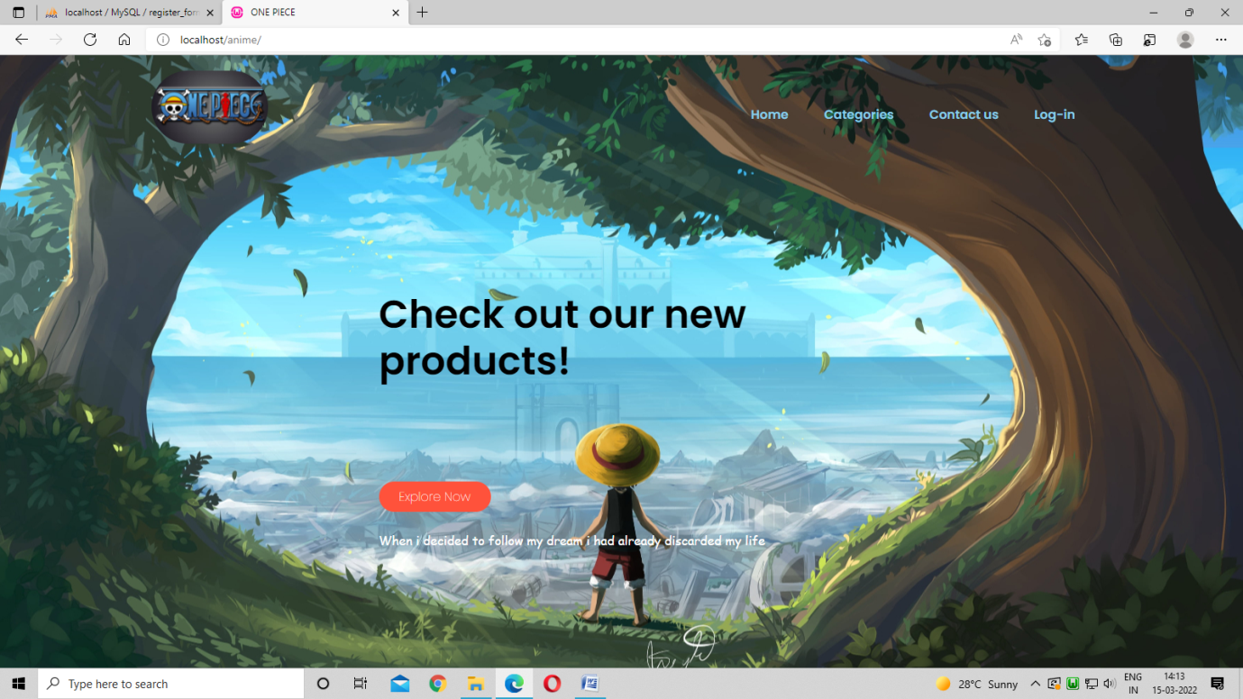

Conclusion

The central concept of the application is to allow the customer to shop virtually using the internet and allow consumers to buy the items and articles of their desire from the store.

The information pertaining the products are stored on an RDBMS at serverside(store). The server processes the customers and the items are shipped to the address submitted by them.

The application was designed for anime fans who wants to buy merchandise of their favourite anime series.

The application which is deployed at the customers databases, the details of the items are brought forward from the menu and the database of all the products are updated at the end of each transaction.