Assignment: Auto-mating in an assembly

The problem
To find every place in an ‘assembly’ where those faces selected on the ‘part’ would seat, and determine whether it is an exact fit or has clearance.

The approach
Initially used a pruning based approach (find all compatible faces for each face selected on the part, and then ‘prune’ off based on compatibility with the face with the least matches). Then, shifted to a group-based approach to avoid ambiguity, which is still similar to the first approach, but cuts down very quickly due to closeness and overlap checks.

Method (properties/semantics and the whys)

Face records are used to identify the type and properties (outward normal, axis, cone base angle, etc.). Relations between faces (on the ‘part’) are captured through relative angle between them, or the distance (if parallel), or axis distance for cylindrical to capture features that are tied to relative positions rather than absolute positions. These are used further for matching.
Convexity of mating surfaces is taken care of. For instance, a hole and the shaft must have opposing convexities. This is relevant only for round faces, since for flat ones, we are anyway looking at surface normals’ directions.
During ‘search’ is where the first approach fails (face candidates and pruning) since the number blows up for larger geometries. Hence, a group search method was employed.
It still looks for candidates. For instance, for a flat face of the ‘key’ part, it looks for other flat faces. To avoid massive calculations, a condition has been set up to avoid picking ‘sliver’ faces (tiny faces that are technically flat, but are too small to be useful, based on area). Iteratively, we now find a partner face for one of the faces, then remove all the ones from other faces’ partner sets based on angle or distance relations in this case.
From each group it solves the position that brings the selected faces onto their partners. The directions left free name the joint: a key can still slide (prismatic), a shaft can still turn (revolute). Then, on the real shapes, the faces must overlap over a real area, and the part must not pass through anything. A part that can slide is pushed in until it touches. These checks are what remove the false positives: four flats at the right spacing on two different parts are not a socket, for example.
Fit identification - Up to 0.02 mm of clearance counts as exact, up to 1 mm as clearance, and an overlap of up to 0.05 mm as a press fit. All limits are defined in config.py. The clearance limit can also be raised for a single run and can also be changed in the web UI.
With regards to all instances, a part placed three times is searched once and checked three times, because each copy has different neighbours. The example in the case of the lathe is the ‘pinion’ part that is repeated thrice (hence ensuring the same fit for key) but in different orientations, resulting in differing neighbours.

How it did
With ‘a little help’ from an agent, 9 small test assemblies (chuck + key, keyed shaft, bench vice, pulley on motor shaft etc) and 10 stress cases were built and tested: nested sub-assemblies, chamfered and split faces, a mirror-image socket, holes right on the tolerance limits, 36 randomly turned bushings, decoys. All 19 pass, in 0.1 to 2 s each. Indeed, all were fairly quick compared to the larger STEP file of the lathe.
On the real WM290V lathe (much larger and with 79 parts), parts were taken out of the assembly and searched for each in the whole machine:
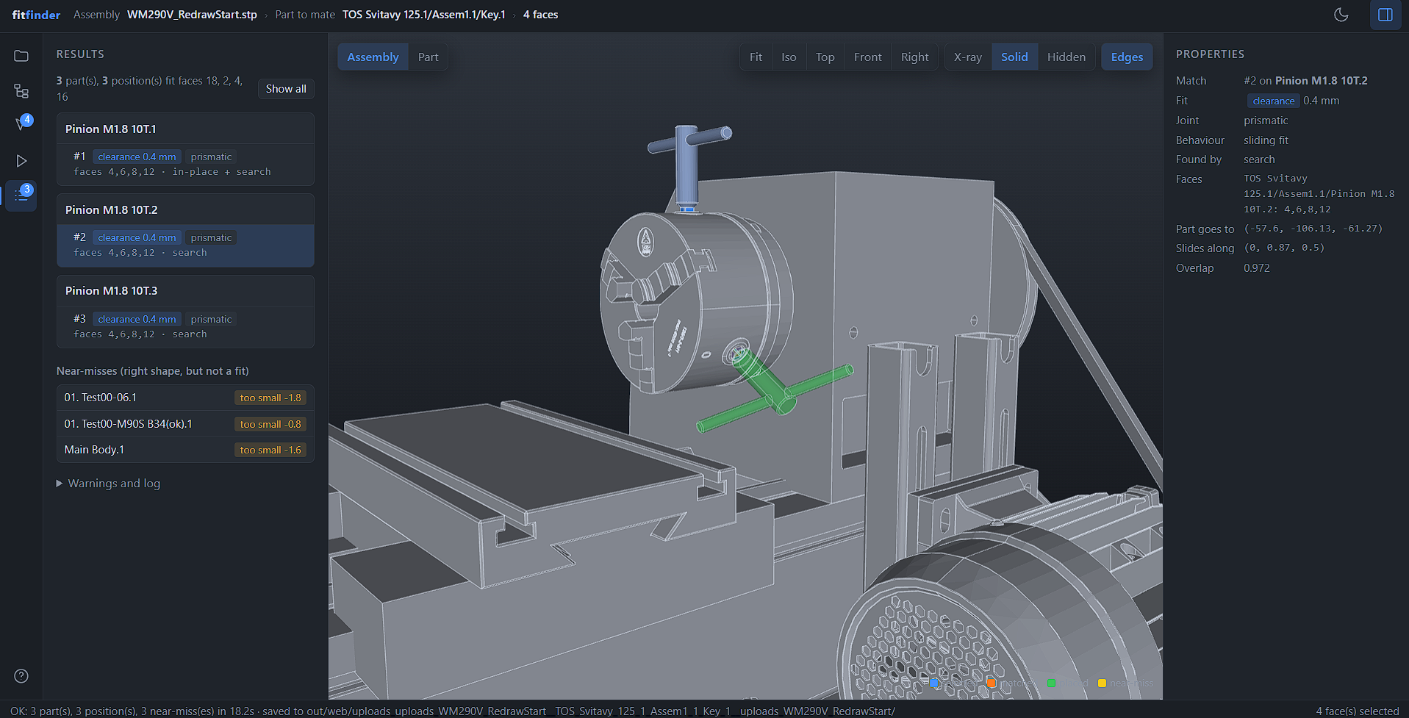
- Chuck + key: all three chuck pinions, 0.4 mm clearance, sliding (prismatic).
- Keyed shaft: the motor's 24 mm shaft with its key. Nothing fits, but no hub in the lathe with a keyway was seen.
- Pulley on the motor shaft: the taper bush's cone fits the small pulley, exact. Its bore fits only the 20 mm lead screw, because the bush still has a 20 mm pilot bore and the motor shaft is 24 mm.
- Dovetail slide: the two 45° faces of the slideway plus the flat between them find the slide on it, with 2.8 mm of clearance (set at 3mm on the UI). One 45° face touches while the other leaves room, so this needs the clearance limit raised to 3 mm.
A second taper bush, an M8 bolt and a retaining pin also come out right. The table is in the README.

What breaks
- Only planes, cylinders, cones and spheres get partners for now. A bolt is matched on its shank and head, never its thread.
- A single plane fits almost anywhere, so the program says the selection is under-constrained and doesn't search. A single cylinder fits every hole of its size, and all of them are listed. One more face fixes it. Not really a break, but still has some edge cases associated.
- Mates across two parts (possibly the most significant). All selected faces must land on one part. A bolt head on a washer with the shank in a housing isn't found as one match.
- Where the CAD itself has parts overlapping, only the in-place check reports the fit. If the part weren't already there, it would be missed.
- Loose fits need the limit raised by hand. Above 1 mm of play, a fit is only reported if you raise the clearance limit. Worse, the near-miss doesn't always say "too loose": for the dovetail it says "position residual", which doesn't tell you to raise it.

With another week
- Inspect OCP’s overlap check that caused issues (possibly a cadquery-OCP issue)
- Let the user allow a small overlap, so that modelled interferences don't block a fit.
- Report a loose fit as "too loose (+2.8 mm)" whatever the selection, so the user knows to raise the clearance limit
- Run the per-position checks in parallel; they are independent (like the three pinions).
- Refine the solved position on sampled surface points, so that freeform faces can join a match.
- Derive tolerances from STEP’s tolerances
- Run more real cases to identify issues such as a bearing in a housing, a splined gear, bench vice

