Results
KEY: Blue selected · orange matched · green part placed.
Chuck + key · test assembly
Key's 4 drive flats → 4 pinions, exact fit, slides [prismatic]
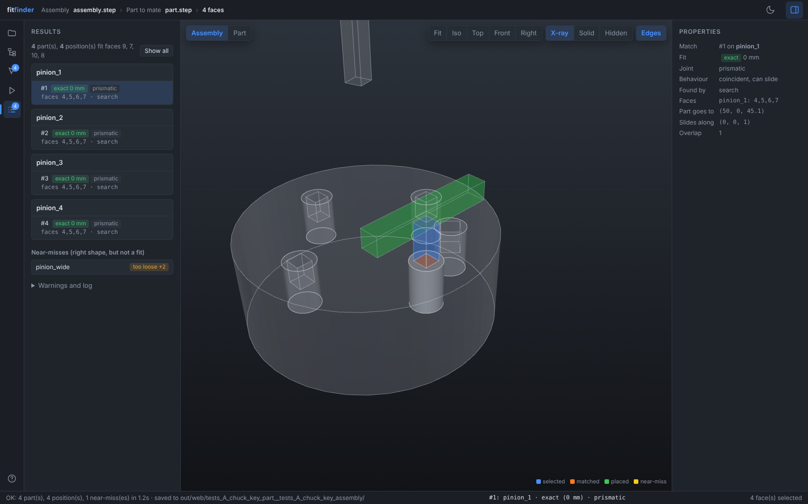
Keyed shaft · test assembly
Shaft + key → 2 hubs, exact fit, slides [prismatic]
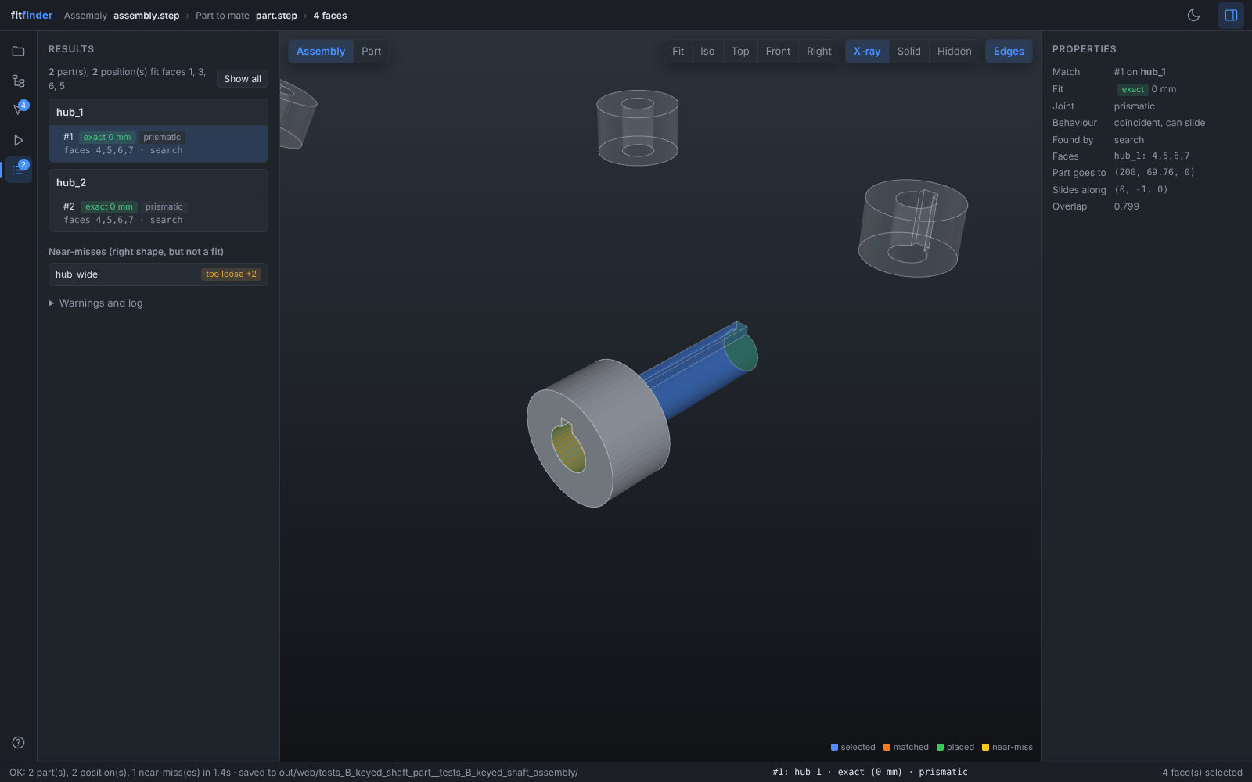
Bench vice · test assembly
Jaw's 5 guide faces → vice body, 0.2 mm clearance, slides [prismatic]
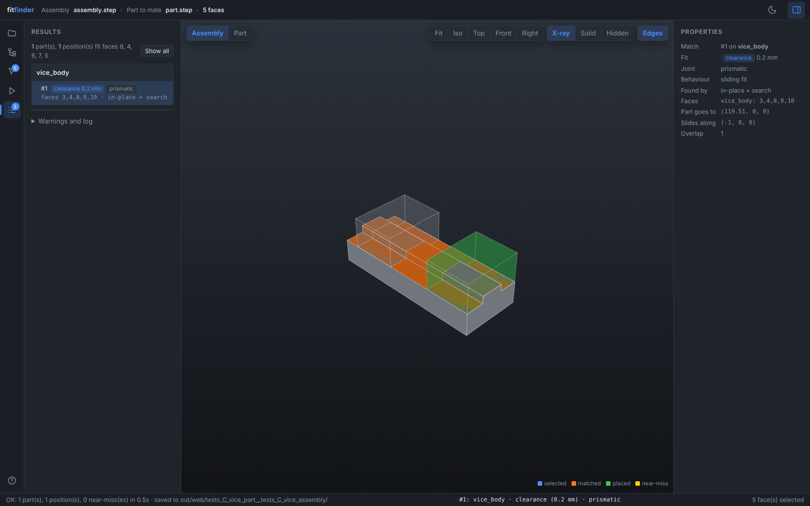
Pulley on motor shaft · test assembly
Pulley's D-bore → 2 motors, 0.05 mm clearance, slides [prismatic]
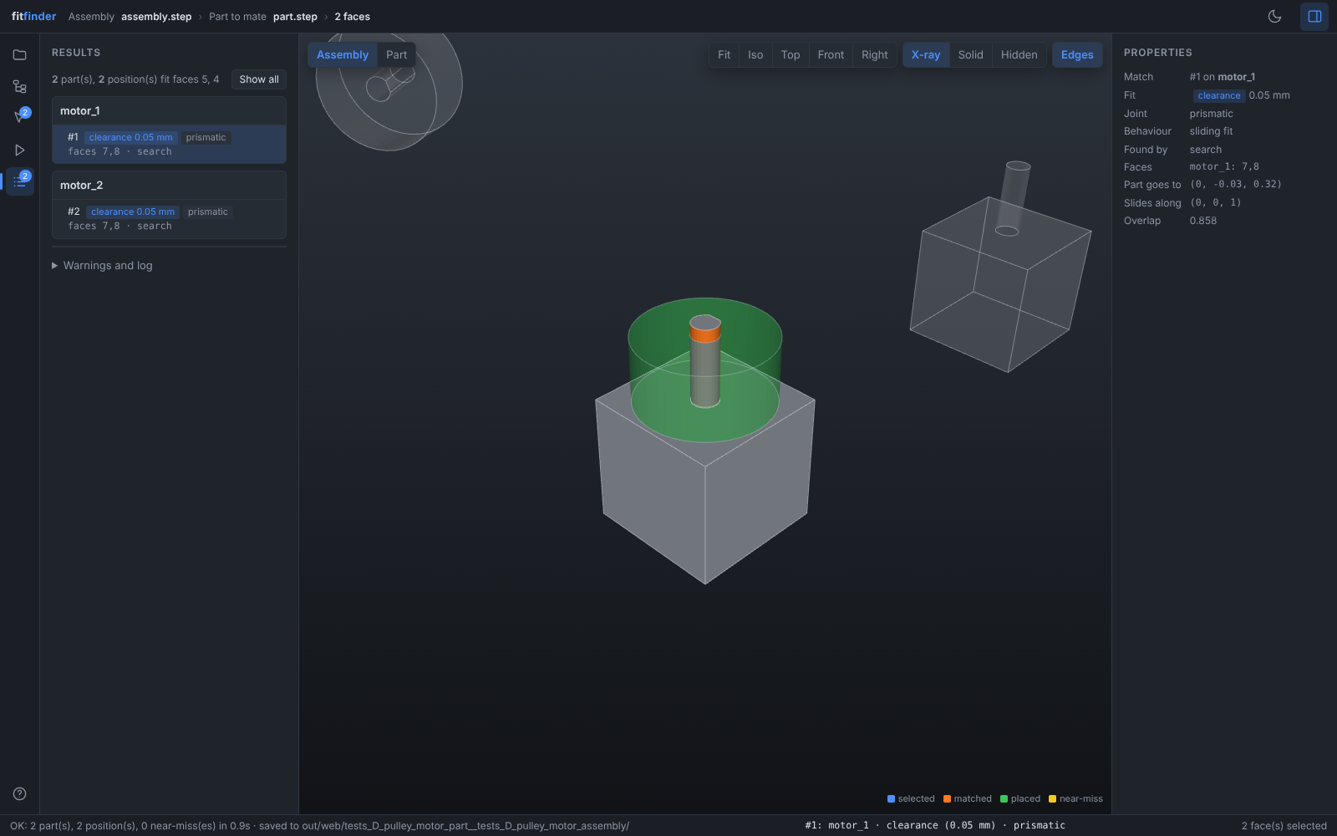
Chuck + key · WM290V lathe [also shown in writeup]
Key's 4 drive flats → 3 pinions, 0.4 mm clearance, slides [prismatic]
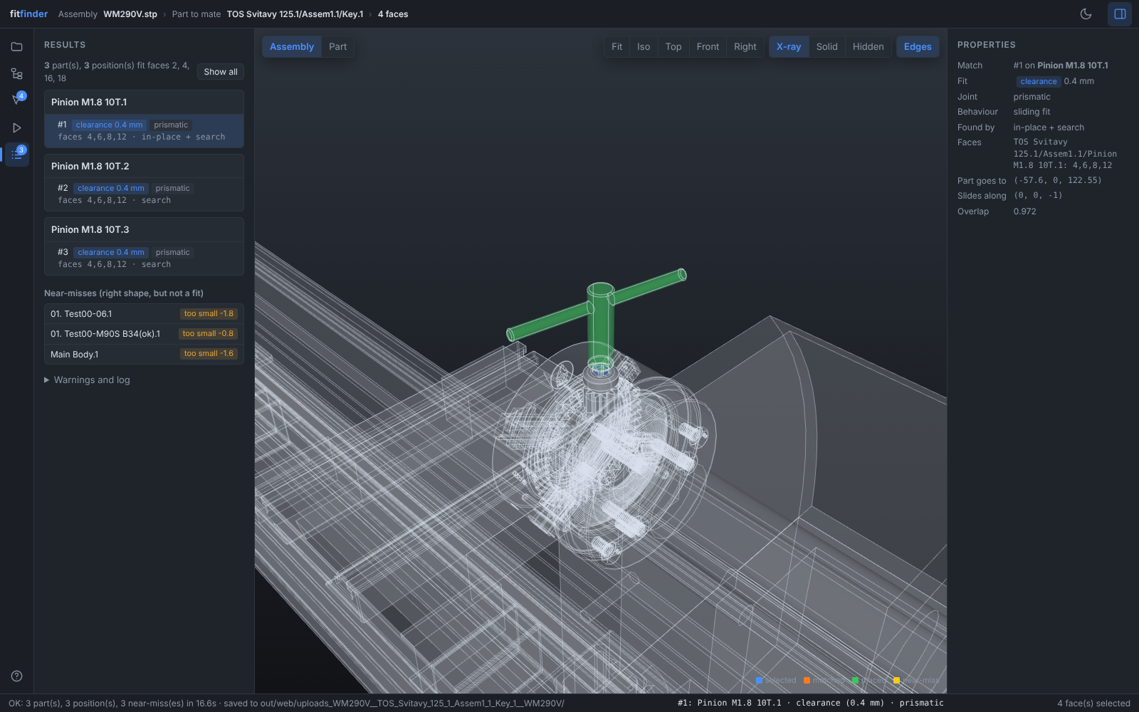
Keyed shaft · WM290V lathe
Motor shaft + key (blue) → no fit: no hub in the lathe has a keyway.
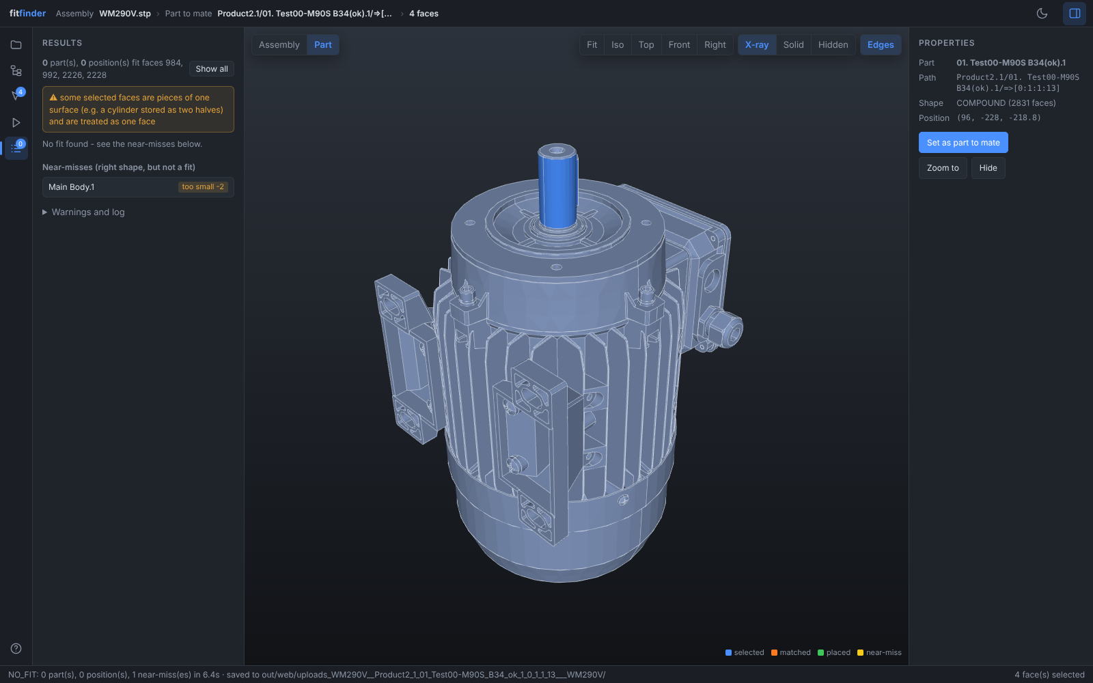
Pulley on motor shaft · WM290V lathe
Taper bush cone → small pulley, exact fit, turns [revolute]
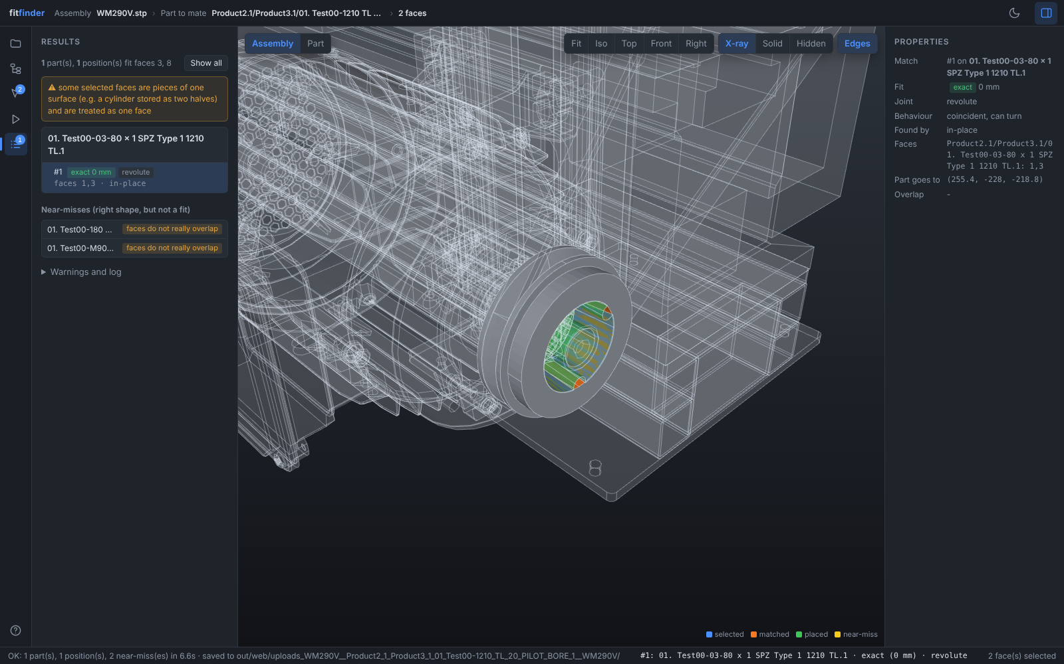
Vice → chuck jaw · WM290V lathe
Jaw's sides + slot → its slot in the chuck body, exact fit, slides [prismatic]
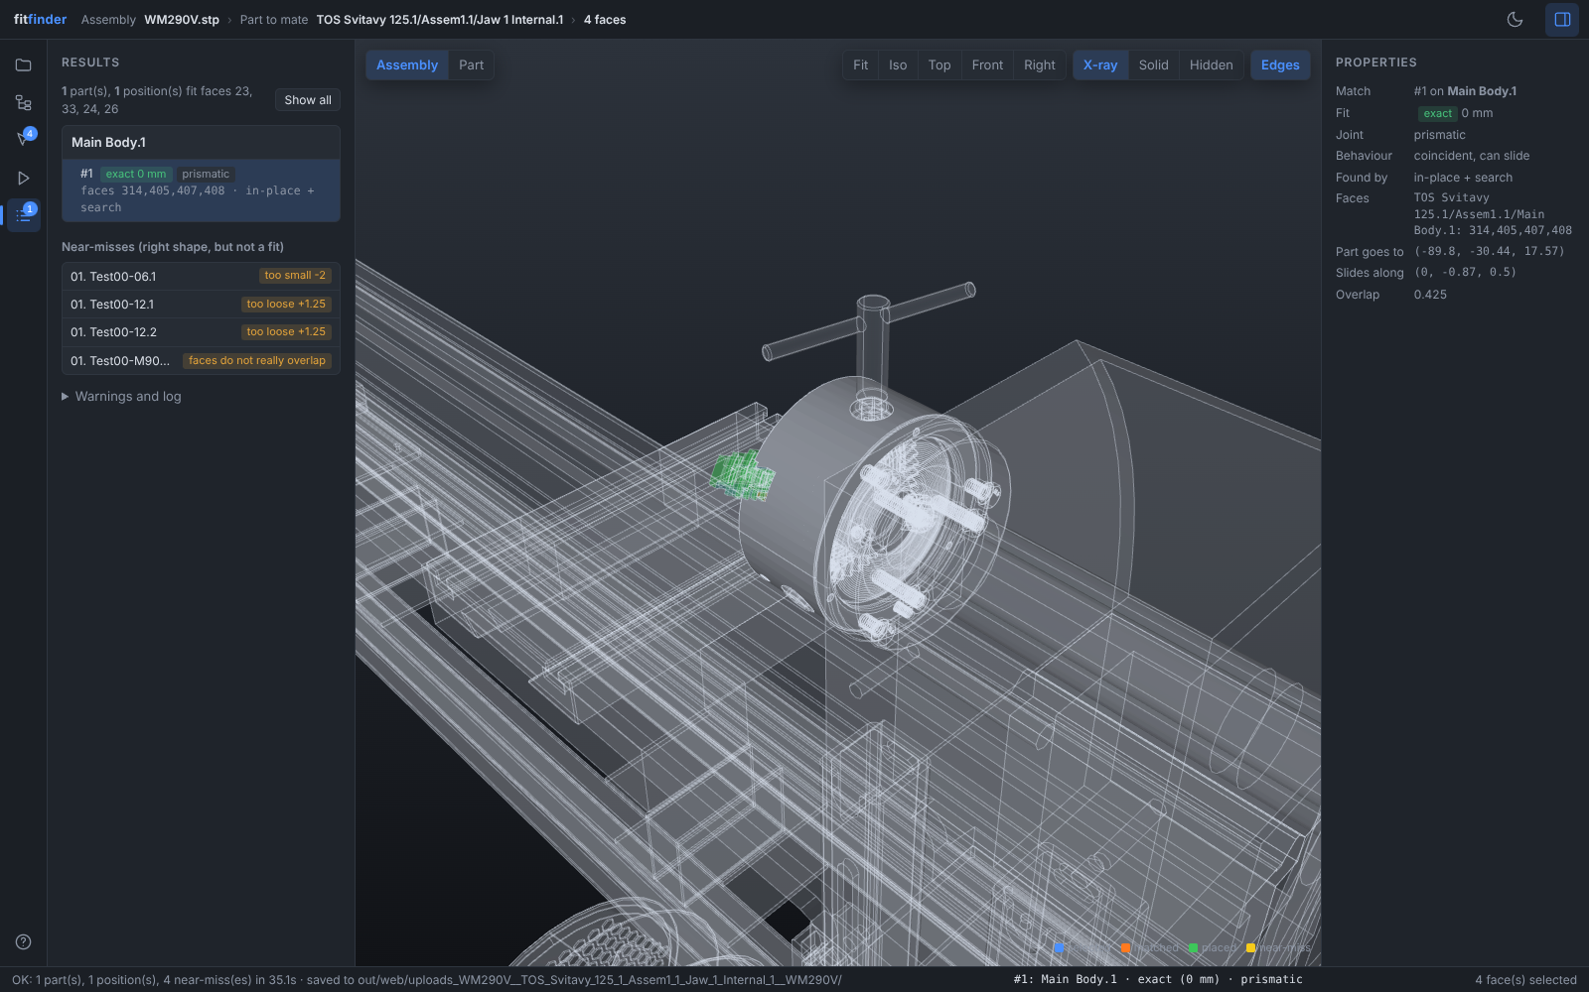
Dovetail slide · WM290V lathe
Slideway's 45° faces + flat (largest clearance 3 mm) → slide, 2.82 mm clearance [prismatic]


