Notes on cell balancing for BMS AFE.
Why balance cells in a battery?
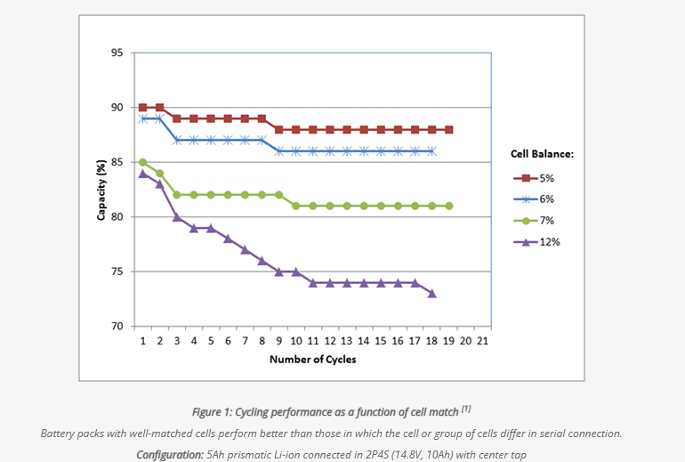

https://batteryuniversity.com/article/bu-803a-cell-matching-and-balancing
A battery expert once said: “I have not seen a cell balancing circuit that works.” For multi-cell packs, he suggested using quality Li-ion cells that have been factory-sorted on capacity and voltage. This works well for Li-ion packs up to 24V; packs above 24V should have balancing. Most balancing is passive; active balancing is complex and is only used in very large systems.

Key attributes of a Cell and how to model the key parameters:
SoC (%) 0-100%: charge of the battery as a percentage of its total capacity SoH (State of Health)
SoH(amp-hours, AH) The amount of charge/capacity of the cell. Typically 3-10AH
OCV: Open circuit voltage of a cell, primarily depends on the SoC. The OCV to SoC characteristic may change with use/cycles/life. This characteristic will also vary by Temperature.

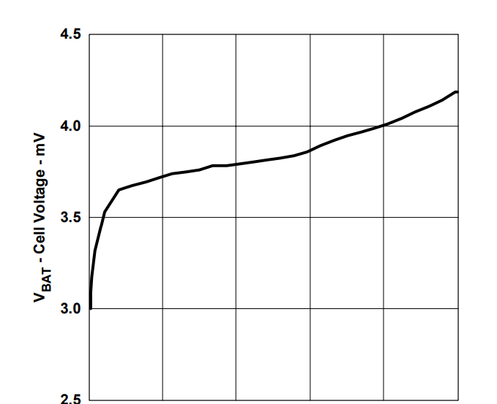
ESR: Equivalent series resistance. Generally in milli-ohms. Frequency dependent generally upto two time constants. Equivalent circuit:
The inductor is small and not too relevant, the two RC’s work over two time constants, so over a long time 100s, we ger full resistance=sum of all three resistors, in ms time just the first, second 100ms-1s, second 20s+

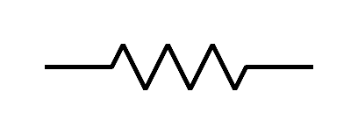
L
R₀
R_{CT}
R_{D}
C_{DL}
C_{D}
Most of the series resistance components are linearIndependent of current, but resistance from polarization depends on current, dependence is linear increase in resistance vs. log(current).
ESR is generally constant between 20-100% SoC and steeply increases below that.

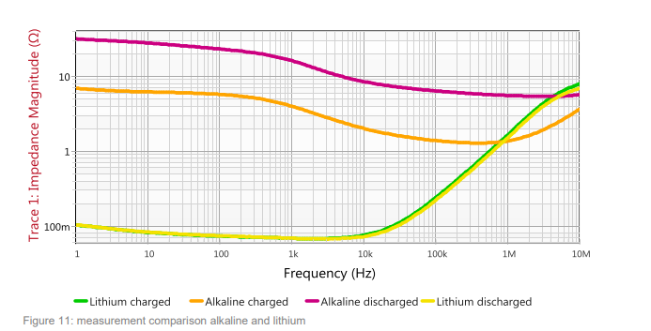
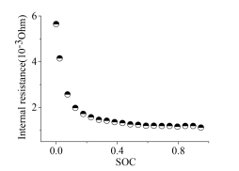

Self discharge rate: Leakage in the cell is usually few (small single digit percent per month.

Coulombic efficiency: (Qdischarge/Qcharge)x100%, Varies from cell to cell. Balance energy must be lost as heat in the battery. Assume uniform loss with SoC.

Self Heating: I²R from ESR plus Coulombic inefficiency, deltaQ*V/time or IV*(1-CoulombicEffeciency) plus self discharge.

Temperature dependence of OCV vs. SoC
https://www.electronicdesign.com/technologies/test-measurement/article/21808722/temperature-impact-on-ocv-of-lithium-ion-cells
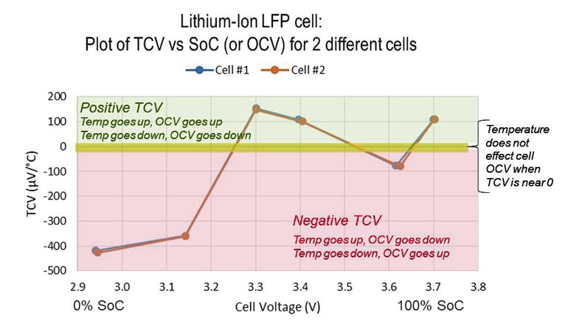
Linear with Temperature,

https://www.ti.com/download/trng/docs/seminar/Topic%202%20-%20Battery%20Cell%20Balancing%20-%20What%20to%20Balance%20and%20How.pdf
Key points:
- At high SoC, the cell with lower SoH has higher voltage and overcharging beyond a voltage can be dangerous (safety hazard, explosion), cascade reaction from one cell to entire battery. Make sure to discharge this “weak” cell to prevent overcharging.
- OCV difference is going to be small for reasonable SoC at very low SoC, small imbalances will show significant voltage differences, but it is a too late now, since much more current is needed to balance. Also passive balancing is not going to be useful, since we will not extend the range much.
- At low SoC or high depth of discharge DoD, the ESR is also higher. Weak cells generally have higher ESR.
- Cell to vell variation of ESR can be as much as 15% within one batch with SoC and SoH starting case are matched withing a few percent.
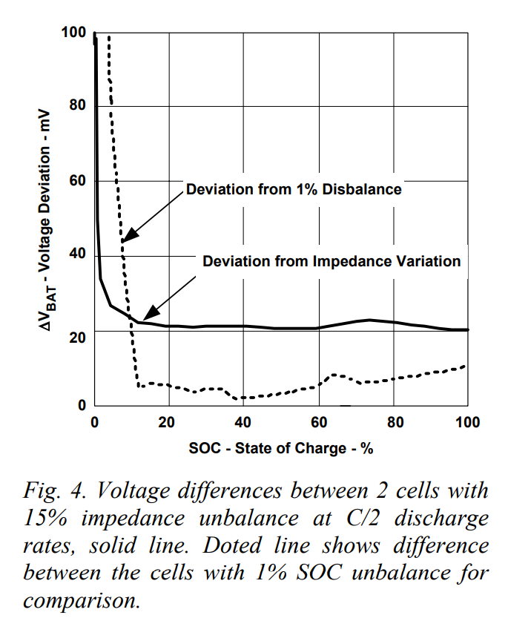
Bsttery Degradation:
https://batteryuniversity.com/article/bu-808-how-to-prolong-lithium-based-batteries#google_vignette
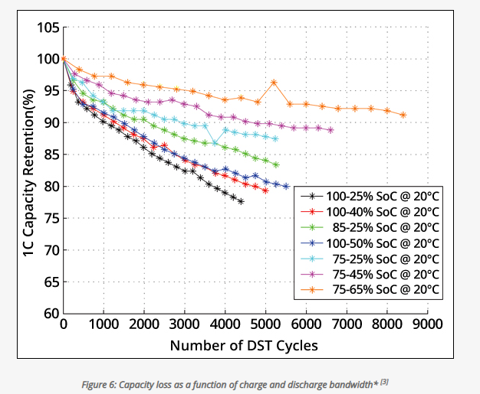

Model proposal:
Cell as a python Object:
SoC, SoH, ESR (all five parameters),
- OCV vs. SoC a look-up or a curve with option for MC variation.
- TCV (Tempco of OCV) vs. SoC
- ESR vs. OCV
- Based on SoH modify OCV vs. SoC
  - Look-up table or function that is scaled based on the SoH value. Follow the principle 30% degradation in SoC leads to 10% higher OCV at high SoC
MC variation withing a range, specify mean, sigma and take gaussian distribution uncorrelated for SoC, SoH, ESR
Mechanism to stop charge/discharge when a cell cross too much OCV or too little.
Some degradation mechanism with cycles, degradation rate accelerating on
- Depth of discharge: A percentage loss in SoH based on DoD
- Overcharging: A percentage loss in SoH based on SoC_max
- Temperature: Time at temperature leads to higher self-discharge, also model capacity degradation based on long term degradation at Temp. OCV or SoC may be a factor? Modelling this is TBD.
  - One idea is to model self-discharge and say that a certain amount of self-discharge leads to a certain degradation. Physically it means as the battery self-discharges it deposits or removes/damages some part that accumulates with time.
- Should we just add up the degradation or do an rms like adding noise sources? Need references/data to figure out.
Simulate several charge discharge cycles 500, with various cell balancing schemes. Each time step (variable) will be some percentage of discharge/charge eg. 1%. Monitor the charge corrections performed per time step and estimate “current needed” and how many cells will need to be “balanced”

References:
https://www.sciencedirect.com/science/article/abs/pii/S0378775316301148
https://ieeexplore.ieee.org/abstract/document/8247206

