REGRESSION ANALYSIS

In our discussion of regression analysis, we will first focus our discussion on simple linear regression and then expand to multiple linear regression. The reason for this ordering is not because simple linear regression is so simple, but because we can illustrate our discussion about simple linear regression in two dimensions and once the reader has a good understanding of simple linear regression, the extension to multiple regression will be facilitated. It is important for the reader to understand that simple linear regression is a special case of multiple linear regression. Regression models are frequently used for making statistical predictions -- this will be addressed at the end of this chapter.
Simple Linear Regression
Simple linear regression analysis is used when one wants to explain and/or forecast the variation in a variable as a function of another variable. To simplify, suppose you have a variable that exhibits variable behavior, i.e. it fluctuates. If there is another variable that helps explain (or drive) the variation, then regression analysis could be utilized.
An Example
Suppose you are a manager for the Pinkham family, which distributes a product whose sales volume varies from year to year, and you wish to forecast the next years’ sales volume. Using your knowledge of the company and the fact that its marketing efforts focus mainly on advertising, you theorize that sales might be a linear function of advertising and other outside factors. Hence, the model’s mathematical function is:

SALES_{t} = B₀ + B₁ ADVERT_{t} + Error
Where: SALES_{t} represents Sales Volume in year t
ADVERT_{t} represents advertising expenditures in year t
B₀ and B₁ are constants (fixed numbers)
and Error_{t} is the difference between the actual sales volume
value in year t and the fitted sales volume value in year t

Note: the Error_{t} term can account for influences on sales volume other than advertising.

Ignoring the error term one can clearly see that what is being proposed is a linear equation (straight line) where the SALES_{t} value depends on the value of ADVERT_{t}. Hence, we refer to SALES_{t} as the dependent variable and ADVERT_{t} as the explanatory variable.
To see if the proposed linear relationship seems appropriate we gather some data and plot the data to see if a linear relationship seems appropriate. The data collected is yearly, from 1907 - 1960, hence, 54 observations. That is for each year we have a value for sales volume and a value for advertising expenditures, which means we have 54 pairs of data.

Year Advert Sales

1907 608 1016
1908 451 921
. . .
. . .
. . .
. . .
1959 644 1387
1960 564 1289

To get a feel for the data, we plot (called a scatter plot) the data as is shown as Figure 1. (Hereafter, the scatter plot will be called plot.)

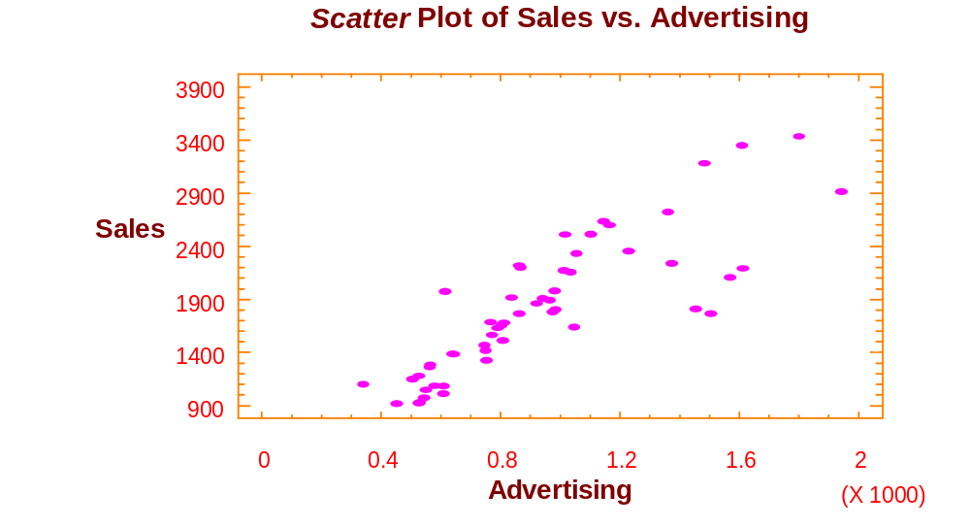
Figure 1. Scatter Plot of Sales vs. Advertising

As can be seen, there appears to be a fairly good linear relationship between sales (SALES) and advertising (ADVERT) (at least for advertising less than 1200 ~ note scaling factor for ADVERT x 1000). At this point, we are now ready to conclude the specification phase and move on to the estimation phase where we estimate the best fitting line.
Summary: For a simple linear regression model, the functional relationship is: Y_{t} = B₀ + B₁ X_{t} + E_{t} and for our example the dependent variable Y_{t} is SALES_{t} and the explanatory variable is ADVERT_{t}. We suggested our proposed model in the example based upon theory and confirmed it via a visual inspection of the scatter plot for SALES_{t} and ADVERT_{t}. Note: In interpreting the model we are saying that SALES depends upon ADVERT in the same time period and some other influences, which are accounted for by the ERROR term.
Estimation
We utilize the computer to perform the estimation phase. In particular, the computer will calculate the “best” fitting line, which means it will calculate the estimates for B₀ and B₁. The results are
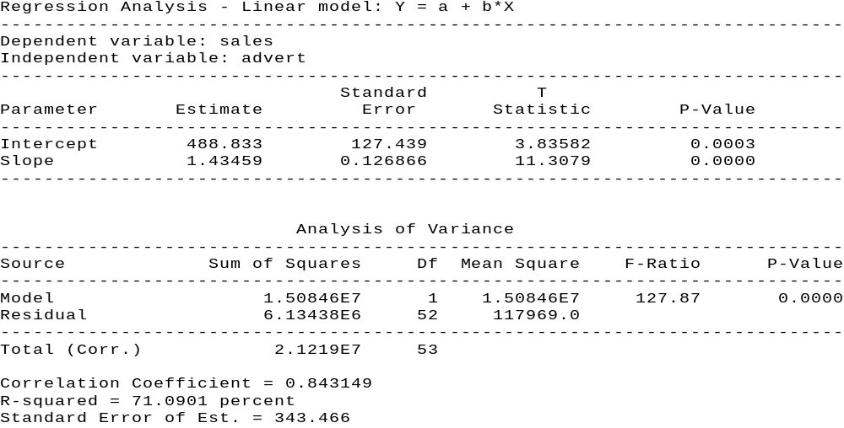

Table 1.

Since B₀ is the intercept term and B₁ represents the slope we can see that the fitted line is:

SALES_{t} = 488.8 + 1.4 ADVERT_{t}

The rest of the information presented in Table 1 can be used in the diagnostic checking phase that we discuss next.
Diagnostic Checking
Once again the purpose of the diagnostic checking phase is to evaluate the model’s adequacy. To do so, at this time we will restrict our analysis to just a few pieces of information in Table 1.
First of all, to see how well the estimated model fits the observed data, we examine the R-squared (R²) value, which is commonly referred to as the coefficient of determination. The R² value denotes the amount of variation in the dependent variable that is explained by the fitted model. Hence, for our example, 71.09 percent of the variation in SALES is explained by our fitted model. Another way of viewing the same thing is that the fitted model does not explain 28.91 percent of the variation in SALES.
A second question we are able to address is whether the explanatory variable, ADVERT_{t}, is a significant contributor to the model in explaining the dependent variable, SALES_{t}. Thus, for our example, we ask whether ADVERT_{t} is a significant contributor to our model in terms of explaining SALES_{t}. The mathematical test of this question can be denoted by the hypothesis:

H₀ : β₁ = 0
H₁ : β₁ ≠ 0

which makes sense, given the previous statements, when one remembers that the model we proposed is: SALES_{t} = B₀ + B₁ ADVERT_{t} + ERROR_{t}
Note: If B₁ = 0, (i.e. the null hypothesis is true), then changes in ADVERT_{t} will not produce a change in SALES_{t}. From Table 1, we note that the p-value (probability level) for the hypothesis test, which resides on the line labeled slope, is 0.00000 (truncation). Since the p-value is less than α =. 05, we reject the null hypothesis and conclude that ADVERT_{t} is a significant explanatory variable for the model, where SALES_{t} is the dependent variable.
An Example

To further illustrate the topic of simple linear regression and the model building process, we consider another model using the same data set. However, instead of using advertising to explain the variation in sales, we hypothesize that a good explanatory variable is to use sales lagged one year. Recall that our time series data is in yearly intervals, hence, what we are proposing is a model where the value of sales is explained by its amount one time period (year) ago. This may not make as much theoretical sense [to many] as the previous model we considered, but when one considers that it is common in business for variables to run in cycles, it can be seen to be a valid possibility.

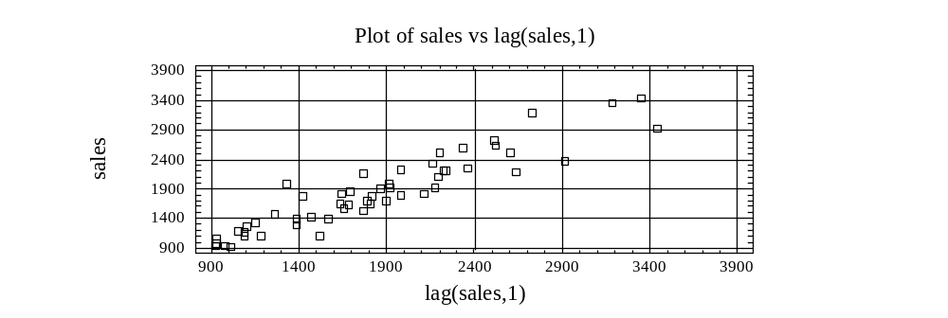

Figure 2. Plot of Sales vs. Lag(Sales,1)

Looking at Figure 2 as shown above, one can see that there appears to be a linear relationship between sales and sales one time period before. Thus the model being specified is:

SALES_{t} = B₀ + B₁ SALES_{t-1} + Error_{t}

Where: SALES_{t} represents sales volume in year t
SALES_{t-1} represents sales volume in year t-1
B₀ and B₁ are constants (fixed numbers)
and Error_{t} is the difference between the actual sales volume value in year t and the fitted sales volume value in year t

Estimation

Using the computer, (StatGraphics software), we are able to estimate the parameters B₀ and B₁ as is shown in Table 2.
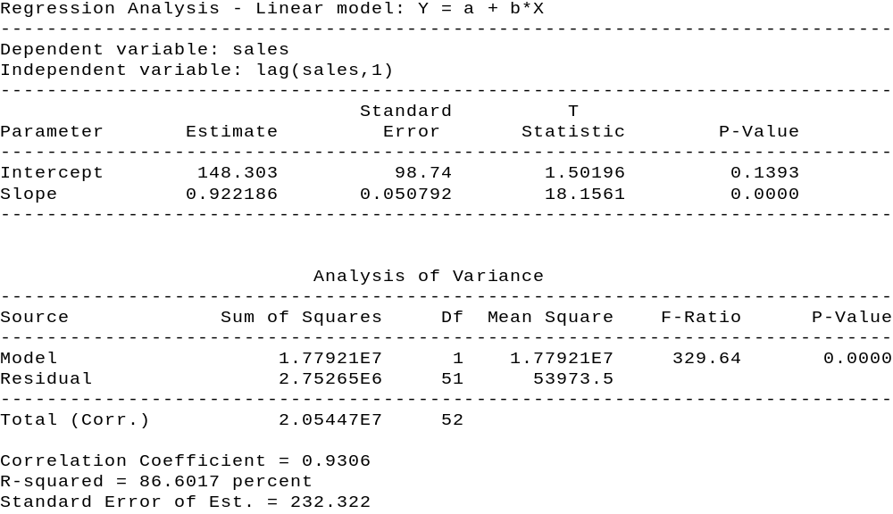

hence, the fitted model is:
SALES_{t} = 148.30 + 0.92 SALES_{t-1}

Diagnostic Checking
In evaluating the attributes of this estimated model, we can see where we are now able to fit the variation in sales better, as R², the amount of explained variation in sales, has increased from 71.09 percent to 86.60 percent. Also, as one probably expects, the test of whether SALES_{t-1} does not have a significant linear relationship with SALES_{t} is rejected. That is, the p-value for
H₀: β₁ = 0
H₁: β₁ ≠ 0
is less than alpha (.00000 < .05). There are other diagnostic checks that can be performed but we will postpone those discussions until we consider multiple linear regression. Remember: simple linear regression is a specific case of multiple linear regression.
Update
At this point, we have specified, estimated and diagnostically checked (evaluated) two simple linear regression models. Depending upon one’s objective, either model may be utilized for explanatory or forecasting purposes.
Using Model
As discussed previously, the end result of regression analysis is to be able to explain the variation of sales and/or to forecast value of SALES_{t}. We have now discussed how both of these end results can be achieved.
Explanation
As suggested by Table 1 and 2, when estimating the simple linear regression models, one is calculating estimates for the intercept and slope of the fitted line (B₀ and B₁ respectively). The interpretation associated with the slope (B₁) is that for a unit change in the explanatory variable it represents the respective change in the dependent variable along the forecasted line. Of course, this interpretation only holds in the area where the model has been fitted to the data. Thus usual interpretation for the intercept is that it represents the fitted value of the dependent variable when the independent (explanatory) variable takes on a value of zero. This is correct only when one has used data for the explanatory variable that includes zero. When one does not use values of the explanatory variable near zero, to estimate the model, then it does not make sense to even attempt to interpret the intercept of the fitted line.
Referring back to our examples, neither data set examined values for the explanatory variables (ADVERT_{t} and SALES_{t-1}) near zero, hence we do not even attempt to give an economic interpretation to the intercepts. With regards to the model:
SALES_{t} = 488.83 + 1.43 ADVERT_{t}
the interpretation of the estimated slope is that a unit change in ADVERT ($1,000) will generate, on the average, a change of 1.43 units in SALES_{t} ($1,000). For instance, when ADVERT_{t} increases (decreases) by $1,000 the average effect on SALESt will be an increase (decrease) of $1,430. One caveat, this interpretation is only valid over the range of values considered for ADVERT, which is the range from 339 to 1941 (i.e., minimum and maximum values of ADVERT).
Forecasting
Calculating the point estimate with a linear regression is a very simple process. All one needs to do is substitute the specific value of the explanatory variable, which is being forecasted, into the fitted model and the output is the point estimate.
For example, referring back to the model:
SALES_{t} = 488.8 + 1.4 ADVERT_{t}
if one wishes to forecast a point estimate for a time period when ADVERT will be 1200 then the point estimate is:
2168.8 = 488.8 + 1.4 (1200)
Deriving a point estimate is useful, but managers usually find more information in confidence intervals. For regression models, there are two sets of confidence intervals for point forecasts that are of use as shown in Figure 3 on the next page.
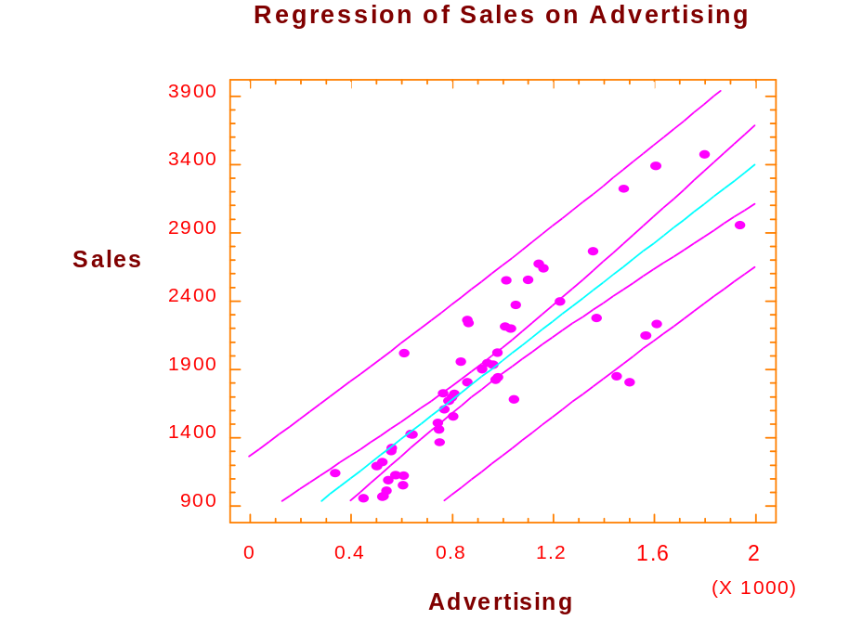
Figure 3. Regression of Sales on Advertising

Viewing Figure 3 as shown, one can see two sets of dotted lines, each set being symmetric about the fitted line. The inner set represents the limits (upper and lower) for the mean response for a given input, while the other set represents the limits of an individual response for a given input. It is the outer set that most managers are concerned with, since it represents the limits for an individual value. For right now, it suffices to have an intuitive idea of what the confidence limits represent and graphically what they look like. So for an ADVERT value of 1200 (input), one can visually see that the limits are approximately 1500 and 2900. (The values are actually 1511 and 2909.) Hence, when advertising is $1,200 for a time period (ADVERT_{t} = 1,200) then we are 95 percent confident that sales volume (SALES_{t}) will be between approximately 1,500 and 2,900.

MARKET MODEL - Stock Beta’s

An important application of simple linear regression, from business, is used to calculate the ß of a stock. The ß’s are measures of risk and used by portfolio managers when selecting stocks.
The model used (specified) to calculate a stock ß is:
R_{j,t} = α + β R_{m,t} + ε_{t}

Where: R_{j,t} is the rate of return for the j^{th} stock in time period_{t}
R_{m,t} is the market rate of return in time period_{t}
ε_{t} is the error term in time period_{t}
α and β are constants

To illustrate the above model, we will use data that resides in the data file SLR.SF3. In particular, we will calculate β‘s for Anheuser Busch Corporation, the Boeing Corporation, and American Express using the New York Stock Exchange (NYSE - Finance) as the “market” portfolio. The data in the file SLR.SF3 has already been converted from monthly values of the individual stock prices and dividends to represent the monthly rate of returns (starting with June 1995).
For all three stocks, the model being specified and estimated follows the form stated in the equation shown above, the individual stocks rate of returns will be used as the dependent variable and the NYSE rate of returns will be used as the independent variable.
1. Anheuser Busch Co. (AnBushr)

Using the equation, the model we specify is AnBushR_{t} = α + β DJIAVGRt + ε_{t}.

The estimation results are shown below in Table 3:
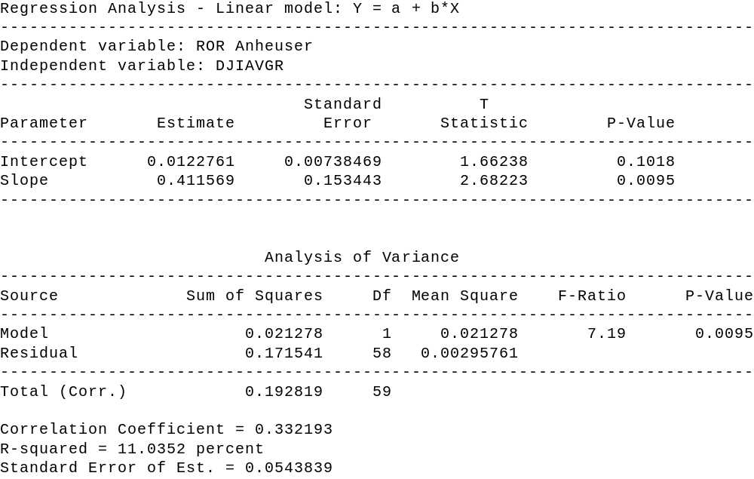
Table 3

As shown in the estimation results, the estimated β for Anheuser Busch Co. is 0.411. Note that with a p-value of 0.00254, the coefficient of determination, R-squared, is only 11.04 percent, which indicates a poor fit of the data. However, at this point we only wish to focus on the estimated β.

2. The Boeing Co.

The model we specify, using equation (1) is BoeingR_{t} = α + β DJIAVGRt + ε_{t}
The results appear below in Table 4.

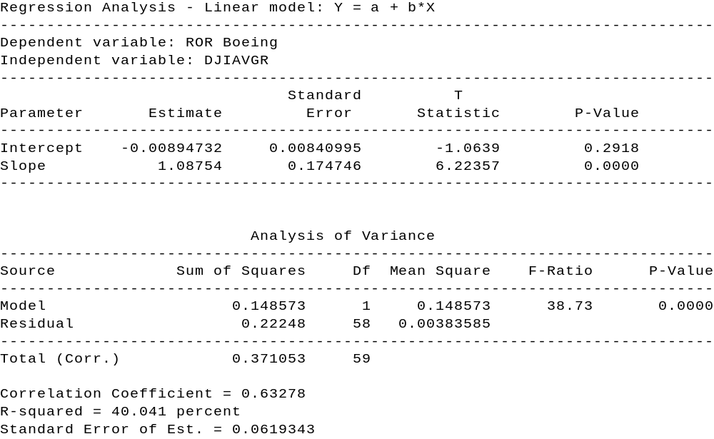

Table 4

Note that the estimated β for The Boeing Co. is 1.08 while the R² value is 40.04percent.
3. American Express
The model we specify, using the equation is as follows:
AmExpR_{t} = α + β DJIAVGRt + ε_{t}
which can be estimated using StatGraphics

The results appear in Table 5:

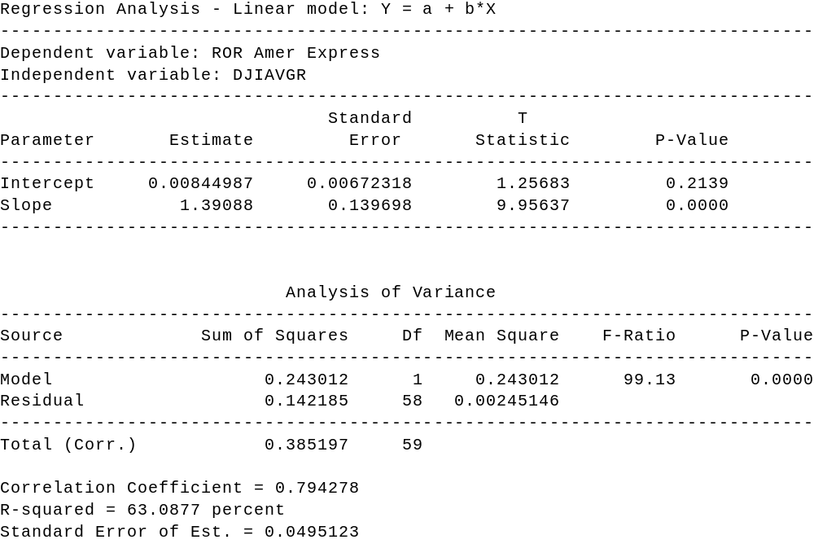

Table 5

The estimation results indicate that the β is 1.39, with an R-squared value of 63.09 percent.

Summary
Using monthly values from June 1995 to June 2000, we utilized simple linear regression to estimate the β‘s of Anheuser Busch Co. (0.411), the Boeing Co. (1.09), and American Express (1.39). Note that the closer the β‘s are to 1.0, the closer the stocks move with the market. What does that imply about Anheuser Busch Corporation, the Boeing Corporation, and American Express?
The risk contribution to a portfolio of an individual stock is measured by the stock’s beta coefficient. Analysts review the market outlooks - if the outlook suggests a market decline, stocks with large positive coefficients might be sold short. Of course, the historical measure of β must persist at approximately the same level during the forecast period. (Additional discussion about stock betas appears in the Appendix.)

Multiple Linear Regression
Referring back to the Pinkham data, suppose you decided that ADVERT_{t} contained information about SALES_{t} that lagged value of SALES_{t} (i.e. SALES_{t-1}) did not, and vice versa, and that you wished to regress SALES_{t} on both ADVERT_{t} and SALES_{t-1}; the solution would be to use a multiple regression model. Hence, we need to generalize our discussion of simple linear regression models by now allowing for more than one explanatory variable, hence the name multiple regression. [Note: more than one explanatory variable, hence we are not limited to just two explanatory variables.]
Specification: Going back to our example, if we specify a multiple linear regression model where SALES_{t} is again the dependent variable and ADVERT_{t} and SALES_{t-1} are the explanatory variables, then the model is:
SALES_{t} = B₀ + B₁ ADVERT_{t} + B₂ SALES_{t-1} + ERROR_{t}
where: B_{0,} B_{1,} and B₂ are parameters (coefficients).
Estimation: To obtain estimates for B₀, B_{1,} and B₂ via StatGraphics, the criterion of least squares still applies, the mathematics employed involves using matrix algebra. It suffices for the student to understand what the computer is doing on an intuitive level; i.e. the best fitting line is being generated. The results from the estimation phase are shown in Table 7.

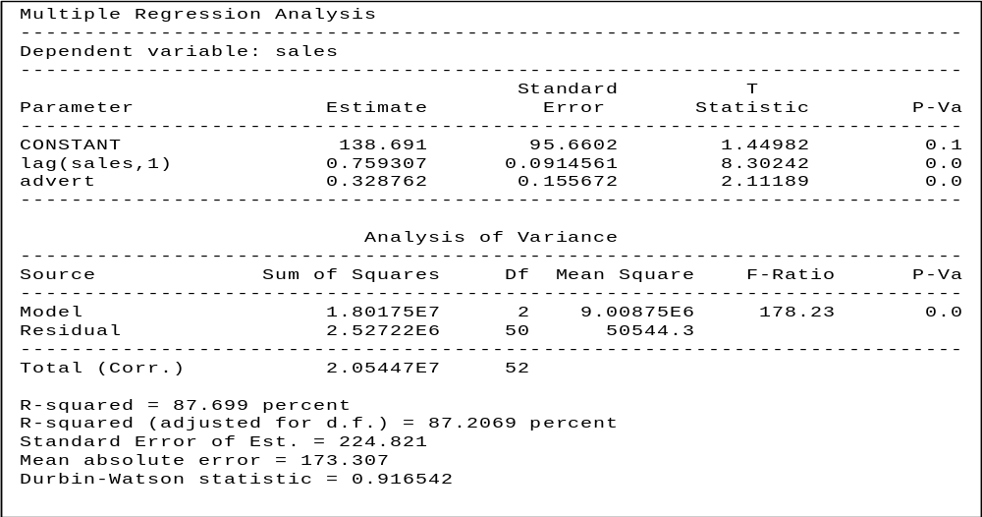

Table 7
Diagnostic Checking
We still utilize the diagnostic checks we discussed for simple linear regression. We are now going to expand that list and include additional diagnostic checks, some require more than one explanatory variable but most also pertain to simple linear regression. We waited to introduce some of the checks [that also pertain to simple linear regression] because we didn’t want to introduce too much at one time and most of the corrective measures involve knowledge of multiple regression as an alternative model.
The first diagnostic we consider involves focusing on whether any of the explanatory variables should be removed from the model. To make these decision(s) we test whether the coefficient associated with each variable is significantly different from zero, i.e. for the i^{th} explanatory variable:
H₀: β_{i} = 0
H₁: β_{i} ≠ 0
As discussed in simple linear regression this involves a t-test. Looking at Table 7, the p-value for the tests associated with determining the significance for SALES_{t-1} and ADVERT₁ are 0.0000 and 0.0397, respectively, we can ascertain that neither explanatory variable should be eliminated from the model. If one of the explanatory variables had a p-value greater than α =. 05, then we would designate that variable as a candidate for deletion from the model and go back to the specification phase.
Another attribute of the model we are interested in is the R² adjusted value that in Table 7 is 0.8721, or 87.21 percent. Since we are now considering multiple linear regression models, the R² value that we calculate represents the amount of variation in the dependent variable (SALES_{t}) that is explained by the fitted model, which includes all of the explanatory variables jointly (ADVERT_{t} and SALES_{t-1}). At this point we choose to ignore the adjusted (ADJ) factor included in the printout.
Since we have already asked the question if anything should be deleted from the model the next question that should be asked if there is anything that is missing from the model, i.e. should we add anything to the model. To answer this question we should use theory but from an empirical perspective we look at the residuals to see if they have a pattern, which as we discussed previously would imply there is information. If we find missing information for the model (i.e. a pattern in the residuals), then we go back to the specification phase, incorporate that information into the model and then cycle through the 3 phase process again, with the revised model. We will illustrate this in greater detail in our next example. However, the process involved is very similar to that which we employed earlier in the semester. We illustrate the residual analysis with a new example.
Example
The purpose behind looking at this example is to allow us to work with some cross sectional data and also to look in greater detail at analyzing the residuals. The data set contains three variables that have been recorded by a firm that presents seminars. Each record focuses on a seminar with the fields representing:
- number of people enrolled (ENROLL)
- number of mailings sent out (MAIL)
- lead time (in weeks) of 1st mailing (LEAD)
The theory being suggested is that the variation in the number of enrollments is an approximate linear function of the number of mailings and the lead-time. As recommended earlier, we look at the scatter plots of the data to see if our assumptions seem valid. Since we are working with two explanatory variables, a three dimensional plot would be required to see all three variables simultaneously, which can be done in StatGraphics with the PLOTTING FUNCTIONS, X-Y-Z LINE and SCATTER PLOT options (note the dependent variable is usually Z). See Figure 7 for this plot.

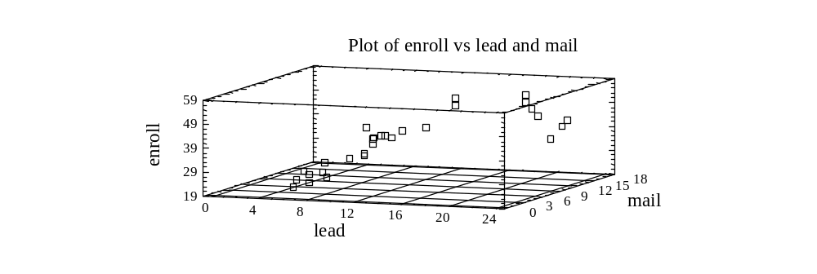
Figure 7. Plot of Enroll vs. Mail & Lead

This plot provides some insight, but for beginners, it is usually more beneficial to view multiple two-dimensional plots where the dependent variable ENROLL is plotted against the different explanatory variables, as is shown in Figures 8 and 9.

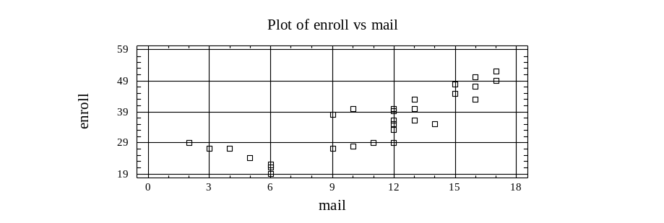

Figure 8. Plot of Enroll vs. Mail

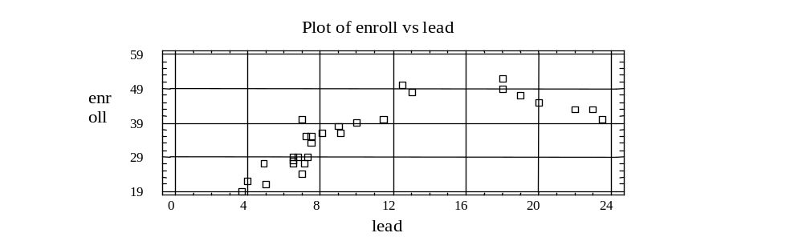

Figure 9. Plot of Enroll vs. Lead

Looking at Figure 9, which plots ENROLL against LEAD, we notice that there is a dip for the largest LEAD values which may economically suggest diminishing returns i.e. at a point the larger lead time is counterproductive. This suggest that ENROLL and LEAD may have a parabolic relationship. Since the general equation of a parabola is:
y = ax² + bx + c
we may want to consider including a squared term of LEAD in the model. However, at this point we are not going to do so, with the strategy that if it is needed, we will see that when we examine the residuals, as we would have ignored some information in the data and it will surface when we analyze the residuals. (In other words we wish to show that if a term should be included in a model, but is not identified, one should be able to identify it as missing when examining the residuals of a model estimated without it.)

Specification
Thus the model we tentatively specify is:
ENROLL_{i} = B₀ + B₁ MAIL_{i} + B₂ Lead_{i} + ERROR_{i}
Estimation
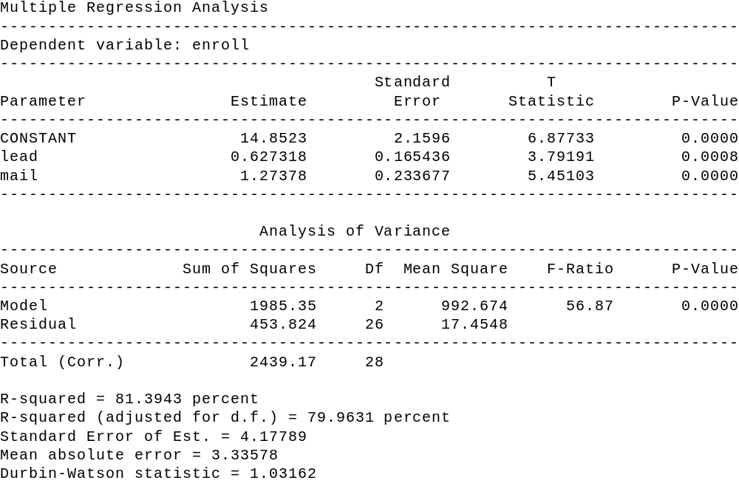

Table 8
Note that MAIL and LEAD are both significant, since their p-values are 0.0000 and 0.0008, respectively. Hence, there is no need at this time to eliminate either from the model. Also, note that R²_{adj} is 79.96 percent.
To see if there is anything that should be added to the model, we analyze the residuals to see if they contain any information. Utilizing the graphics options icon, one can obtain a plot of the standardized residuals versus lead (select residuals versus X). Plotting against the predicted values is similar to looking for departures from the fitted line. For our example since we entertained the idea of some curvature (parabola) when plotting ENROLL against LEAD, we now plot the residuals against LEAD. This plot is shown as Figure 10.

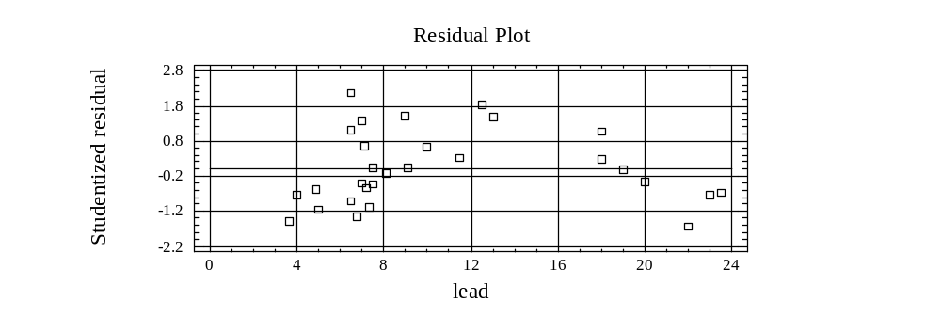

Figure 10. Residual Plot for Enroll against Lead

What we are looking for in the plot is whether there is any information in LEAD that is missing from the fitted model. If one sees the curvature that still exists, then it suggests that one needs to add another variable, actually a transformation of LEAD, to the model. Hence we go back to the specification phase, based upon the information just discovered, and specify the model as:
ENROLL_{i} = B₀ + B₁ MAIL_{i} + B₂ Lead + B₃ (LEAD)²_{i} + ERROR_{i}
The estimation of the revised model generates the output presented in Table 9.

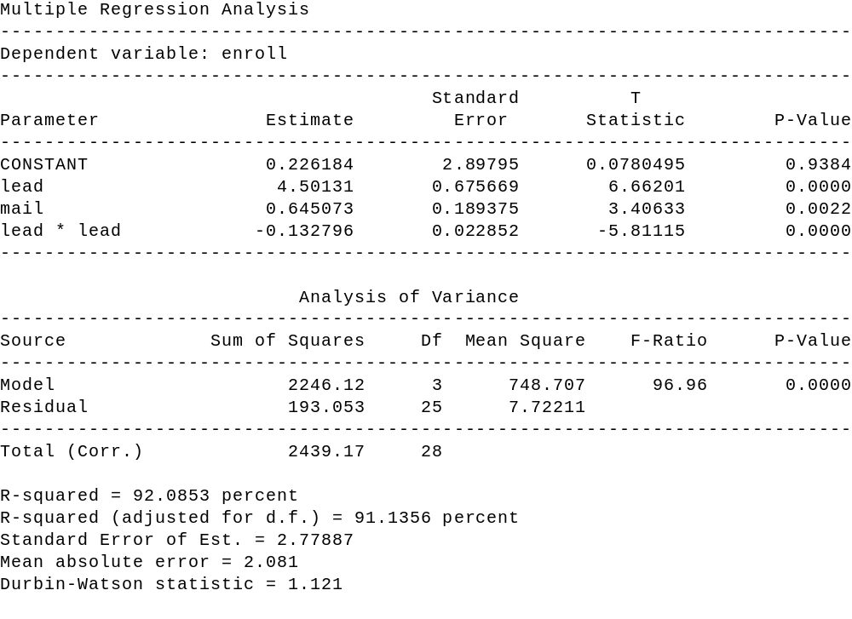

Table 9

Diagnostic Checking
At this point we go through the diagnostic checking phase again. Note that all three explanatory variables are significant and that the R²_{adj} value has increased to 91.13 percent from 79.96 percent. For our purposes at this point, we are going to stop our discussion of this example, although the reader should be aware that the diagnostic checking phase has not been completed. Residual plots should be examined again, and other diagnostic checks we still need to discuss should be considered.
Before we proceed however, it should be pointed out that the last model is still a multiple linear regression model. Many students think that by including the squared term, to incorporate the curvature, that we may have violated the linearity condition. This is not the case, as when we say “linear” it is linear with regards to the coefficients. An intuitive explanation of this is to think like the computer, all LEAD² represents is the squared values of LEAD, therefore, the calculations are the same as if LEAD² was another explanatory variable.
The next three multiple regression topics we discuss will be illustrated with the data that was part of a survey conducted of houses in Eugene, Oregon, during the 1970’s. The variables measured (recorded), for each house, are sales price (price), square feet (sqft), number of bedrooms (bed), number of bathrooms (bath), total number of rooms (total), age in years (age), whether the house has an attached garage (attach), and whether the house has a nice view (view).

Dummy Variables

Prior to this current example, all the regression variables we have considered have been either ratio or interval data, which means they are non-qualitative variables. However, we now want to incorporate qualitative variables into our analysis. To do this we create dummy variables, which are binary variables that take on values of either zero or one. Hence, the dummy variable (attach) is defined as:
attach = 1 if garage is attached to house
0 otherwise (i.e. not attached)
and
view = 1 if house has a nice view
0 otherwise

Note that each qualitative attribute (attached garage and view) cited above has two possible outcomes (yes or no) but there is only 1 dummy variable for each. That is because there must always be, at maximum, one less dummy variable than there are possible outcomes for the particular qualitative attribute. We mention this because there are going to be situations, for other examples, where one wants to incorporate a qualitative attribute that has more than two possible outcomes in the analysis. For example, if one is explaining sales and has quarterly data, they might want to include the season as an explanatory variable. Since there are four seasons (Fall, Winter, Spring, and Summer) there will be three (four minus one) dummy variables. To define these three dummy variables, we arbitrarily select one season to “withhold” and create dummy variables for each of the other seasons. For example, if summer was “withheld” then our three dummy variables could be
D₁ = 1 if Fall
0 otherwise
D₂ = 1 if Winter
0 otherwise
D₃ = 1 if Spring
0 otherwise
Now, what happens when we withhold a season is not that we ignore the season, but the others are being compared with what is being withheld.

Outliers
When an observation has an undue amount of influence on the fitted regression model (coefficients) then it is called an outlier. Ideally, each observation has an equal amount of influence on the estimation of the fitted lines. When we have an outlier, the first question one needs to ask is “Why is that observation an outlier?” The answer to that question will frequently dictate what type of action the model builder should take.
One reason an observation may be an outlier is because of a recording (inputting) error. For instance, it is easy to mistakenly input an extra zero, transpose two digits, etc. When this is the cause, then corrective action can clearly be taken. Don’t always assume the data is correct! Another source is because of some extra ordinary event that we do not expect to occur again. Or the observation is not part of the population we wish to make interpretation/forecasts about. In these cases, the observation may be “discarded.”
If the data is cross-sectional, then the observation may be eliminated, thereby decreasing the number of observations by one. If the data is times series, by “discarding the impact” of the observation one does not eliminate observations since doing so may effect lagging relationships, however one can set the dummy variable equal to one (1) for that observation, zero (0) otherwise.
At other times, the outcome, which is classified as an outlier, is recorded correctly, may very well occur again, and is indeed part of the concerned population. In this case, one would probably want to leave the observation in the model construction process. In fact, if an outlier or set of outliers represents a source of specific variation then one should incorporate that specific variation into the model via an additional variable. Keep in mind, just because an observation is an outlier does not mean that it should be discarded. These observations contain information that should not be ignored just so “the model looks better.”
Now that we have defined what an outlier is and what action to take/not take for outlier, the next step is to discuss how to determine what observations are outliers. Although a number of criteria exist for classifying outliers, we limit our discussion to two specific criteria - standardized residuals and leverage.
The theory behind using standardized residuals is that outliers are equated with observations which have large residuals. To determine what is large, we standardize the residuals and then use the rule that any standardized residual outside the bounds of -2 to 2 is considered an outlier. [Why do we use -2 and 2? Could we use -3 and 3?]
The theory behind the leverage criteria is that a large residual may not necessarily equate with an outlier. Hence, the leverage value measures the amount of influence that each observation has on the set of estimates. It’s not intuitive, but can be shown mathematically, that the sum of the leverage points is equal to the number of B coefficients in the model (P). Since there are N observations, under ideal conditions each observation should have a leverage value of P/N. Hence, using our criteria of large being outside two standard deviation, the decision rule for declaring outliers by means of leverage values is to declare an observation as a potential outlier if its leverage value exceeds 2*P/N. StatGraphics employs a cut off of 3* P/N.
To illustrate, identifying outliers, we estimate the model:
Price_{i} = B₀ + B₁ SQFT_{i} + B₂ BED + Error

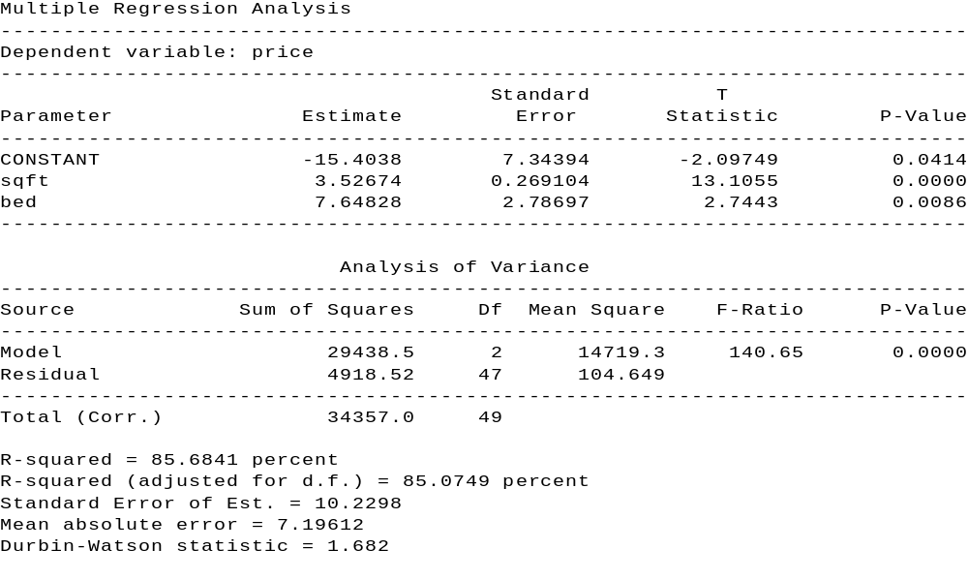

Table 10
With the results being shown in Table 10, in our data set of houses, clearly some houses are going to influence the estimate more than others. Those with undue influences will be classified as potential outliers. Again, the standardized residuals outside the bounds -2, +2 (i.e. absolute value greater than 2), and the leverage values greater than 3 3/50 (P = 3 since we estimated the coefficient for two (2) explanatory variables and the intercept and n = 50 since there were 50 observations) will be flagged. After estimating the model we select the "unusual residuals" and "influential points" options under the tabular options icon. Note that from tables 11 and 12 observations 8, 42, 44, 47, 49 and 50 are classified as outliers.
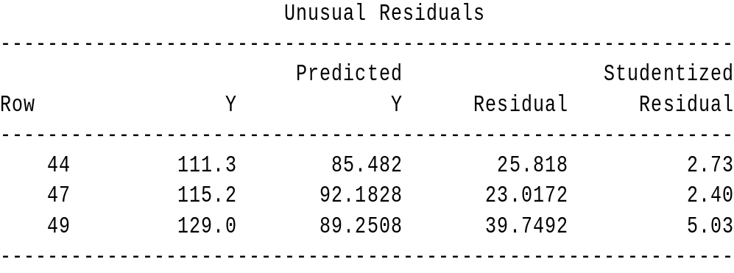

Table 11
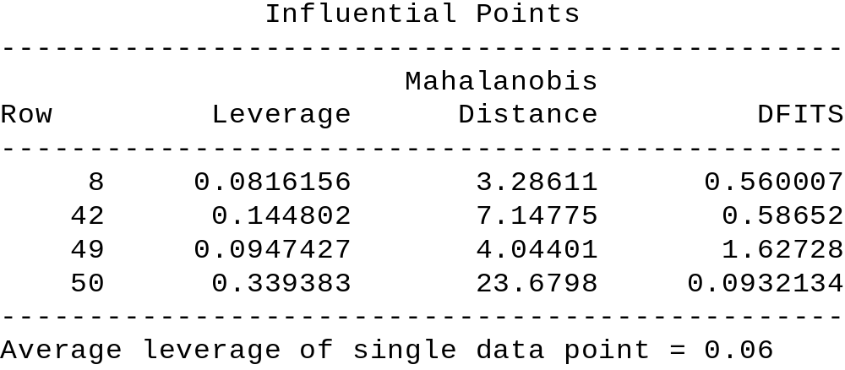

Table 12

Once the outliers are identified one then needs to decide what, if anything, needs to be modified in the data or model. This involves checking the accuracy of the data and/or determining if the outliers represent a specific source of variation. To ascertain any sources of specific variation one looks to see if there is anything common in the set, or subset, of observations flagged as outliers. In Table 11 one can see that some of the latter observations (42, 44, 47, 49, and 50) were flagged. Since the data ( n = 50) was entered by ascending price, one can see that the higher priced homes were flagged. As a result, for this example, the higher priced homes are receiving a large amount of influence. Hence, since this is cross-sectional data, one might want to split the analysis into two models - one for “lower” priced homes and the second for “higher” priced homes.
Multicollinearity
When selecting a set of explanatory variables for a model, one ideally would like each explanatory variable to provide unique information that is not provided by the other explanatory variable(s). When explanatory variables provide duplicate information about the dependent variable, then we encounter a situation called multicollinearity. For example, consider our house data again, where the following model is proposed:
Price = B₀ + B₁ SQFT + B₂ BATH + B₃ TOTAL + ERROR
Clearly there is a relationship among the three (3) explanatory variables. What problems might this create? To answer this, consider the estimation results, which are shown on the following page.

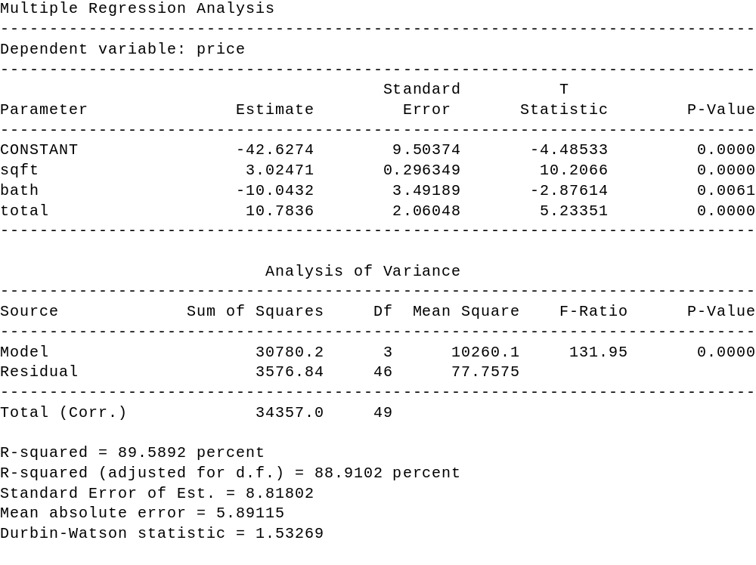

Table 13
If one were to start interpreting the coefficients individually and noticed that bath has a negative coefficient, they might come to the conclusion that one way to increase the sales price is to eliminate a bathroom. Of course, this doesn’t make sense, but it does not mean the model is not useful. After all, when the BATH is altered so are the TOTAL and SQFT. So a problem with multicollinearity is one of interpretation when other associated changes are not considered. One important fact to remember, is that just because multicollinearity exists, does not mean the model can not be used for meaningful forecasting, provided the forecasts are within the data region considered for constructing the model.

Predicting Values with Multiple Regression

Regression models are frequently used for making statistical predictions. A multiple regression model is developed, by the method of least squares, to predict the values of a dependent, response variable based on two or more independent, explanatory variables.
Research data can be classified as cross-sectional data or as time series data. Cross-sectional data has no time dimension, or it is ignored. Consider collecting data on a group of subjects. You are interested in their age, weight, height, gender, and whether they tend to be left-handed. The time dimension in collecting the data is not important and would probably be ignored; even though researchers tend to collect the data within a reasonably short time period.
Time series data is a sequence of observations collected from a process with equally spaced periods of time. For example, in collecting sales data, the data would be collected weekly with the time (the specific week of the year) and sales being recorded in pairs.
Using Cross-sectional Data for Predictions
When using regression models for making predictions with cross-sectional data, it is imperative that you use only the relevant range of the predictor variable(s). When predicting the value of the response variable for a given value of the explanatory variable, one may interpolate within the range of the explanatory variables. However, contrary to when using time series data, one may not extrapolate beyond the range of the explanatory variables. (To predict beyond the range of an explanatory variable is to assume that the relationship continues to hold true below and/or above the range -- something that is not known nor can it be determined. To make such an interpretation is meaningless and, at best, subject to gross error.)

An Example: Using a Regression Model to Predict
Consider the following research problem - a real estate firm is interested in developing a model to predict, or forecast, the selling price of a home in a local community. Data was collected on 50 homes in a local community over a three week period.
The data can consist of both qualitative and quantitative values. Quantitative variables are measurable whereas qualitative variables are descriptive. For example: your height, a quantitative value, is measurable whereas the color of your hair, a qualitative variable, is descriptive.
For our real estate example, the dependent variable (selling price) and the explanatory variables (square feet, number of bathrooms, and total number of rooms) are all quantitative variables. None of the data are qualitative variables.

Table 13. Variable With Range of Values
Variables | Range of Values
Price (selling) ($1000) | 30.6 - 165
Square feet (100 ft²) | 8 - 40
Number of Bathrooms | 1 - 3
Total number of rooms | 5 - 12

As a review, the multiple regression model can be expressed as:

Y_{i} = β₀ + β₁X₁ + β₂X₂ + β₃X₃ + ε_{i}

The slope, β_{i}, known as a net regression coefficient, represents the unit change in Y per unit change in X_{i} taking into account (or, holding constant) the effect of the remaining explanatory variables. In our real estate problem, b₁ , where X₁ is in square feet, represents the unit change selling price per unit change in square feet, taking into account the effect of number of bedrooms, and total number of rooms.
The resulting model fitting equation is shown in Table 14.

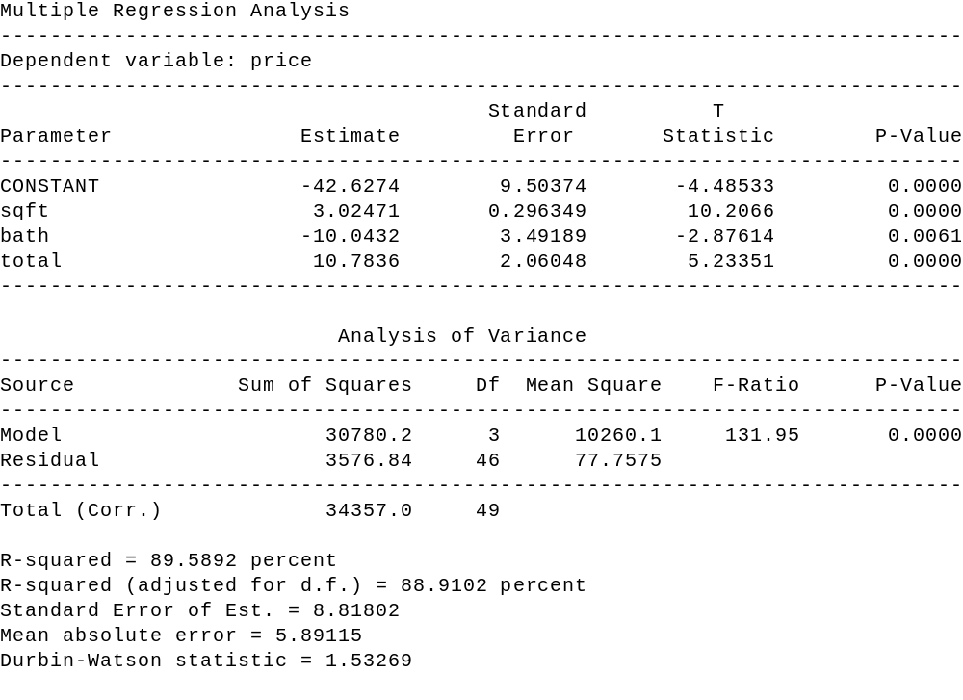

Table 14

Multiple regression analysis is conducted to determine whether the null hypothesis, written as H_{o}: β_{i} = 0 (with i = 0 - 3), can be rejected. If the null hypothesis can be rejected, then there is sufficient evidence of a relationship (or, an association) between the response variable and the explanatory variables in the sample. Table 14 also displays the resulting analysis of variance (ANOVA) for the multiple regression model using the explanatory variables listed in Table 12.
The ANOVA for the full multiple regression shows a p-value equal to 0.0000, thus H_{o} can be rejected (because the p-value is less than α of 0.05). Since the null hypothesis may be rejected, there is sufficient evidence of a relationship (or, an association) between selling price and the three explanatory variables in the sample of 50 houses.
CAUTION: As stated, when using regression models for making predictions with cross-sectional data, use only the relevant range of the explanatory variable(s). To predict outside the range of an explanatory variable is to assume that the relationship continues to hold true below and/or above the range -- something that is not known nor can be determined. To make such an interpretation is meaningless and, at best, subject to gross error.

Suppose one wishes to obtain a point estimate, along with confidence intervals for both the individual forecasts and the mean, for a home with the following attributes
- square feet, 1 bath, 6 total rooms.
To do this using Statgraphics, alls one needs to do is add an additional row of data to the data file (HOUSE.SF). In particular one would insert a 15 in the sqft column (remember that the square feet units is in 100 's), a 1 in the bath column and a 6 in the total column. We leave the other columns blank, especially the price column, since Statgraphics will treat it as a missing value and hence estimate it. To see the desired output, one runs the regression, using the additional data points, goes to the tabular options icon and selects the "report" option. Table 15 shows the forecasting results for our example.
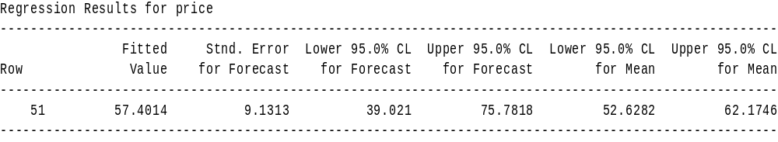

Table 15

Summary
In the introduction to this section, cross-sectional data and time series data were defined. With cross-sectional data, the time dimension in collecting the data is not important and can be ignored; even though researchers tend to collect the data within a reasonably short time period. When predicting the value of the response variable for a given value of the explanatory variable with cross-sectional data, a researcher is restricted to interpolating within the range of the explanatory variables. However, a researcher may not extrapolate beyond the range of the explanatory variables because it cannot be assumed that the relationship continues to hold true below and/or above the range since such an assumption cannot be validated. Cross-sectional forecasting is stationary, it does not change over time.
On the other hand, time series data is a sequence of observations collected from a process with equally spaced periods of time. Contrary to the restrictions placed on cross-sectional data, when using time series data a major purpose of forecasting is to extrapolate beyond the range of the explanatory variables. Time series forecasting is dynamic, it does change over time.
Practice Problem
As part of your job as personnel manager for a company that produces an industrial product, you have been assigned the task of analyzing the salaries of workers involved in the production process. To accomplish this, you have decided to develop the “best” model, utilizing the concept of parsimony, to predict their weekly salaries. Using the personnel files, you select, based on systematic sampling, a sample of 49 workers involved in the production process. The data, entered in the file company, corresponds to their weekly salaries, lengths of employment, ages, gender, and job classifications.

a. y = _________________________________________________________
b. H₀: ______________________ H₁: _______________________
p-value: ___________________ Decision: __________________
c. In the final model, state the value and interpret for R²_{adj}. R²_{adj}: ________ %
d. In the final model, state the value and interpret for b₁ . b₁ = ________
e. Predict the weekly salaries for the following employees:

Category | Employee #1 | Employee #2
Length of employment (in months) | 10 | 125
Age (in years) | 23 | 33
Gender | female | male
Job classification | technical | clerical

Employee | 95% LCL | y | 95% UCL
# 1
# 2

[Check documentation on file to ascertain gender coding for female and male. Also check for proper coding for job classification.]


Stepwise Regression
When there exists a large number of potential explanatory variables, a good exploratory technique one can utilize is known as stepwise regression. This technique involves introducing or deleting variables one at a time. There are two general procedures under the umbrella of stepwise regression -- forward selection and backwards elimination. A hybrid of both forward selection and backwards elimination exists and is generally known as stepwise.
In the sections below, we describe the three (3) procedures cited above. In order to follow the discussion, we first need to review the t- test for regression coefficients. Recall that for the model
Y_{i} = β₀ + β₁ X_{1,i} + β₂ X_{2,i} + ......... + β_{k} X_{k,i} + ε_{t}
the t-test for: H₀ : β_{k} = 0
H₁ : β_{k} ≠ 0
actually tests whether the variable X_{k} should be included in the model. If one rejects H_{0,} then the decision is to keep X_{t} in the model, whereas if one does not reject H₀ the decision is to eliminate X_{t} from the model. Since rejecting H₀ is usually done when either t ≤ -2.0 or t ≥ 2.0, one can see that having a variable in the model is equated to having a t-value with an absolute value greater than 2. Likewise, if a variable has a corresponding t-value, which is equal to or less than 2 in absolute terms, it should be eliminated from the model.
To simplify the programming for the stepwise procedures, the software packages generally rely on the fact that squaring a distribution gives one an F distribution. Hence, the discussion above about the t value and whether to keep or eliminate the corresponding variable can be expressed as:

If the F-statistic ( F = t ²) is greater than 4.0 , then the corresponding variable should be included in the model. If the F-statistic is less than 4.0, then the corresponding variable should not be included in the model.

Given this background information, we now discuss the three (3) stepwise procedures.
Forward Selection
This procedure starts with no explanatory variables in the model, only a constant. It then calculates an F-statistic for each variable and focuses its attention on that variable with the highest F-value. If the highest F-value is greater than 4.0, then the corresponding variable is inserted into the model. If the highest F-value is less than 4.0, then the process stops. Assuming the first variable is inserted in the model, an F-statistic is then calculated for each of the variables not in the model, conditioned upon the fact that the first variable selected is in the model. The procedure then focuses on the variable with the highest F-value and asks whether the F-value is greater than 4.0. If the answer is yes, the associated variable is inserted into the model and the process continues by calculating an F- statistic for each of the variables not included in the model, conditioned upon the fact that the first two variables selected are included in the model. Once again, the procedure focuses attention on that variable with the largest F-value and determines whether it is larger than 4.0. If the answer is yes the associated variable is inserted into the model and the process continues by calculating an F-statistic for each of the variables not included in the model, conditioned upon the fact that the first three variables selected are included in the model. This process continues on until finally either all of the variables have been included in the model or none of the remaining variables are significant.
Backward Elimination
This procedure starts with all of the explanatory variables in the model and successively drops one variable at a time. Given all of the explanatory variables in the model, the “full” regression is run and an F-statistic for each explanatory variable is calculated. The attention now focuses on the variable with the smallest F-value. If the F-value is less than 4.0, then that variable is eliminated from the model and a new regression model is estimated. From this “smaller regression” F-statistics are examined and again the attention now focuses on that variable with the smallest F-value. If the F- value is less than 4.0, then that variable is eliminated from the model and a new regression model is estimated. This process continues on until either all of the explanatory variables have been eliminated from the model or all of the remaining explanatory variables are significant.
Stepwise
This procedure is a hybrid of forward selection and backwards elimination. It operates the same as forward selection, except at each stage the possibility of deleting a variable, as in backward elimination is considered. Hence, a variable that enters at one stage may be eliminated at a later stage (due to multicollinearity)
Summary
Generally all three stepwise procedures will provide the same model. Under extreme collinear conditions (explanatory variables) the final results may be different. Keep in mind that stepwise procedures are good exploratory techniques, to provide the model builder with some insight. One should not be fooled into thinking that stepwise models are the best because the “computer generates the models.” Stepwise procedures fail to consider things such as outliers, residual patterns, autocorrelation, and theoretical considerations.


RELATIONSHIPS BETWEEN SERIES

When building models one frequently desires to utilize variables that have significant linear relationships. In this section we discuss correlation as it pertains to cross sectional data, autocorrelation for a single time series (demonstrated in the previous chapter), and cross correlation, which deals with correlations of two series. Hopefully, the reader will note the relationship between correlation, autocorrelation, and cross correlation.
Correlation
As we mentioned previously, when we talk of statistical correlation we are discussing a value which measures the linear relationship between two variables. The statistic

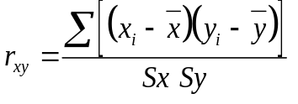

where S_{y} and S_{x} represent the sample standard deviation of Y and X respectively, measures the strength of the linear relationship between the variables Y and X. Again we are not going to dwell on the mathematics, but will be primarily concerned with the interpretation.
To interpret the correlation coefficient, it is important to note that the denominator is included so that values generated are not sensitive to the choice of metrics (i.e. inches vs. feet, ounces vs. pounds, cents vs. dollars, etc.). As a result, the range of possible values for the correlation coefficients range from -1.0 to 1.0.
Since the denominator is always a positive value, one can interpret the sign of the correlation coefficient as the indicator of relationship of how X and Y move together. For instance, if the correlation coefficient is positive, this indicates that positive (negative) changes in X tend to accompany positive (negative) changes in Y (i.e. X and Y move in the same direction). Likewise, a negative correlation value indicates that positive (negative) changes in X tend to accompany negative (positive) changes in Y (i.e. X and Y move in opposite directions).
The absolute value of the correlation coefficient indicates how strong of a linear relationship two variables have. The closer the absolute value is to 1.0 the stronger the linear relationship.
To summarize we consider the plots in Figure 1, where we show five different values for the correlation coefficient. Note that (1) the sign indicates whether the variables move in the same direction and (2) the absolute value indicates the strength of the linear relationship.
Autocorrelation
As indicated by its name, the autocorrelation function will calculate the correlation coefficient for a series and itself in previous time periods. Hence, when analyzing one series and determining how (linear) information is carried over from one time period to another, we will rely on the autocorrelation function.
The autocorrelation function is defined as:
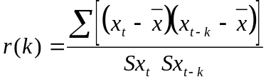

where again Sx and Sx(t-k) are the sample standard deviations of X_{t} and X_{t-k}; which if you think about it are the same value. Hence when you substitute X_{t} and X_{t-k} into the correlation equation for Y and X you can see the similarity. The one difference is with the time element component and hence the inclusion of k. What k represents is the “lag” factor. So when one calculates r(1), that is the sample autocorrelation of a time series variable and itself 1 time period ago, r(2) is the sample autocorrelation of a time series variable and itself 2 time periods ago, r(3) is the sample autocorrelation of a time series variable and itself 3 time periods ago, etc.
To illustrate the value of the autocorrelation function, consider the series TSDATA.bubbly (StatGraphics data sample), which represents the monthly champagne sales volume for a firm. The plot of this series shows a strong seasonality component as shown on the next page in Figure 2.

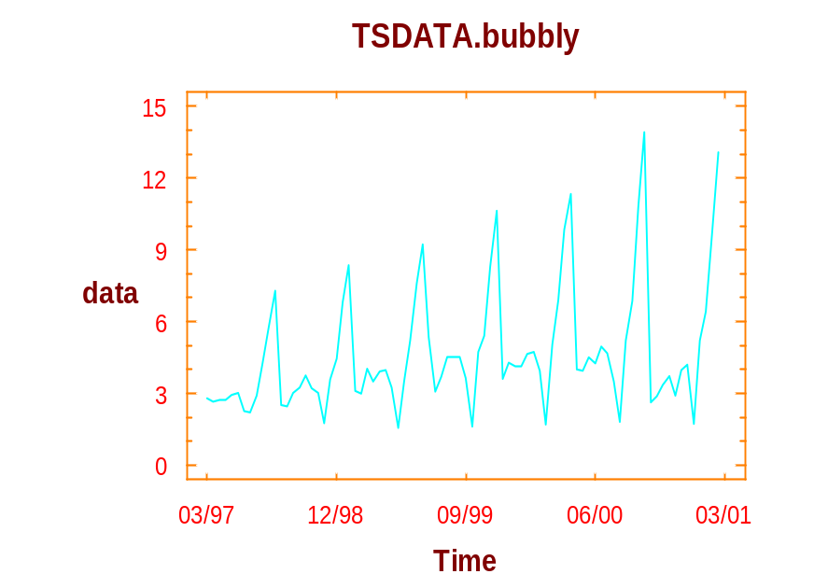

Figure 2. Time Sequence Plot for Bubbly Data

The autocorrelation function can be displayed numerically, Table 1, below:

Table 1. Estimated autocorrelations for TSDATA.bubbly
----------------------------------------------------------------
Lag Estimate Stnd.Error Lag Estimate Stnd.Error
----------------------------------------------------------------
1 .48933 .10911 2 .05787 .13269
3 -.15498 .13299 4 -.25001 .13512
5 -.03906 .14052 6 .03647 .14065
7 -.03773 .14076 8 -.24633 .14088
9 -.18132 .14592 10 -.00307 .14858
11 .37333 .14858 12 .80455 .15935
13 .40606 .20200 14 .02545 .21150
15 -.17323 .21153 16 -.24418 .21322
17 -.05609 .21652 18 .02920 .21669
19 -.03339 .21674 20 -.20632 .21680
21 -.14682 .21913 22 -.01295 .22029
23 .27869 .22030 24 .60181 .22446
----------------------------------------------------------------

The autocorrelation function can also be displayed graphically (where dotted lines -- symmetric about 0 -- represent the significance limits) as shown in Figure 3.

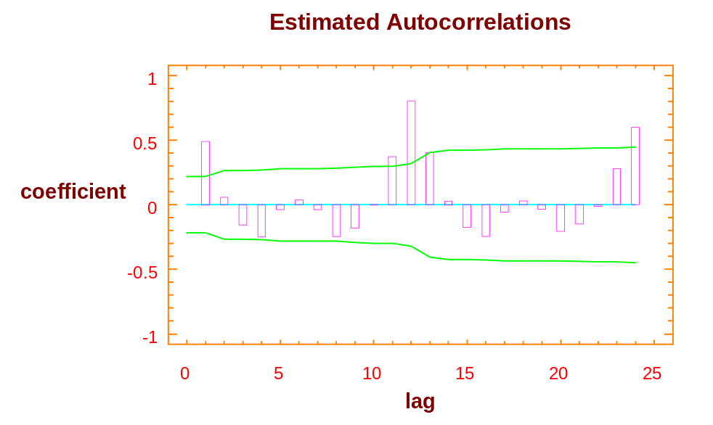

Figure 3. Estimated Autocorrelations

By analyzing the display, the autocorrelation at lags 1, 11, 12, 13, and 24 are all significant (α = 0.05). Hence, one can conclude that there is a linear relationship between sales in the current time period and itself and 1, 11, 12, 13, and 24 time periods ago. The values at 1, 11, 12, 13, and 24 are connected with a yearly cycle (every 12 months).

Stationarity
The next topic we wish to discuss in this section is the cross correlation function, which will be used to examine the relationship between two series displaced by k time periods. This will allow us to begin identifying leading indicators. However in order to discuss the cross correlation function, we first need to review what it means for a series to be stationary. This discussion is necessary because the interpretation of the cross correlation function only makes useful sense if both series involved are stationary.
Recall, a series is stationary if it has a constant mean and variance. Common departures from stationarity (i.e. non-stationary series) are shown below:

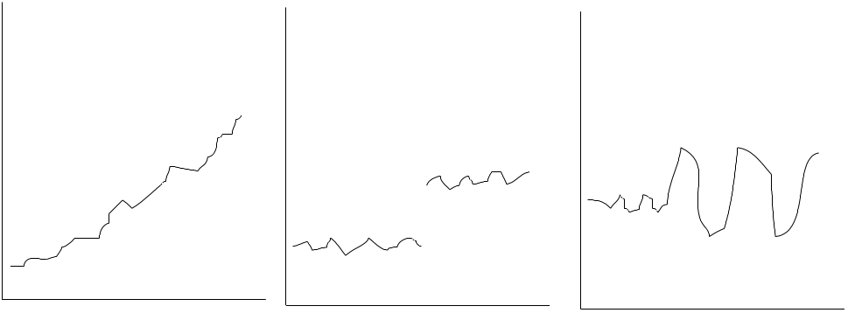

When a series is nonstationary because of a changing variance, one can treat this problem by taking logs of the data [logs in this course will be natural logs (Ln), not common logs (base 10)]. When a series is nonstationary due to a changing mean then one can take differences to treat that problem. If seasonality exists then one may in addition to taking differences of consecutive time periods, take seasonal differences.
If a nonstationary series has a nonconstant mean and a nonconstant variance then differences and logs may both be required to achieve a transformation to a stationary series. When taking both logs and differences one must take the logs first (i.e. treat the nonconstant variance and the attack the nonconstant mean). Why?
Cross Correlation
With the knowledge discussed in the autocorrelation section and the stationarity section, we are now prepared to discuss the cross correlation function, which as we said before is designed to measure the linear relationship between two series when they are displaced by k time periods. The cross correlation function is shown below. (The formula is shown on extra large type to highlight the components of the formula.)
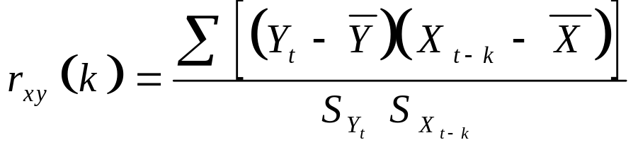

To interpret what is being measured in the cross correlation function one needs to combine what we discussed about the correlation function and the autocorrelation function. Again note, like in the autocorrelation function, that k can take on integer values, only now k can take on positive and negative values.
For instance, let Y represent SALES and X represent ADVERTISING for a firm. If k = 1, then we are measuring the correlation between SALES in time period t and ADVERTISING in time period t-1. i.e. we are looking at the correlation between SALES in a time period and ADVERTISING in the previous time period. If k = 2, we would be measuring the correlation in SALES in time period t and ADVERTISING two time periods prior. What if k = 3, k = 4, ....? Note that when k is zero we are considering the relationship of ADVERTISING in the same time periods.
When k takes on negative values then our interpretations are the same as above, except that now we are looking at cases were Y (SALES) are leading indicators for X (ADVERTISING). This is the “opposite” of what we were doing with the positive values for k. Note the cross correlation function is not symmetric about 0. i.e.
r_{xy} (k) ≠ r_{xy} (-k) for all x,y, k ≠ 0
An Example

To illustrate the cross correlation function, we consider the data TSDATA.units and TSDATA.leadind. This data is sample data from Statgraphics and resides on the network.

The joint plot of units and leadind, is shown in Figure 4 on the following page. Note how leadind “leads” units. And how both series are nonstationary. Given at least one of the series is nonstationary, the cross correlation function will be meaningless if it is applied to the original data. Since both series can be transformed to stationary series by simple differences (verify this), we will apply the cross correlation function to the differenced series for both series.

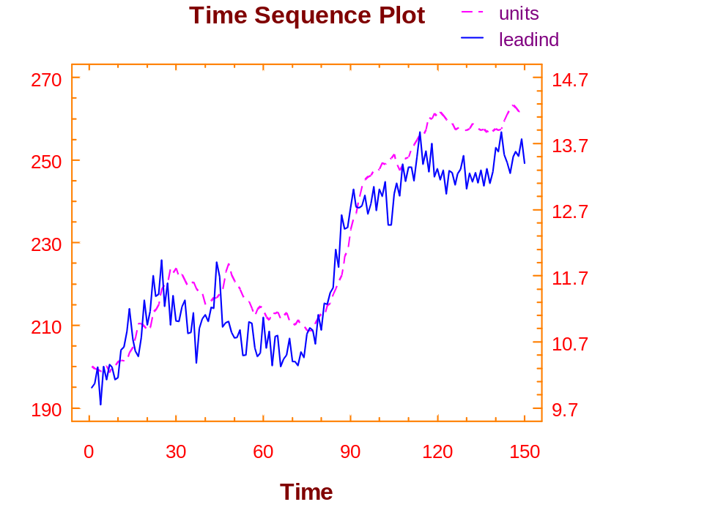

Figure 4. Time Sequence Plot of Lead and Lag Indicators

Looking at the CCF (cross correlation plot) plot displayed in Figure 5 on the next page, we can see significant cross correlation values at lags 2 and 3. Given leadind was the input (X _{t-k}) value and units is the output (Y_{t}) value, we can conclude that leadind is a leading indicator of units by 2 and 3 time periods. So a change in leadind will result in a change in units two and three time periods later. Note it takes two time periods for a change in leadind to show up in units.

(Note: for a situation where it is of interest to determine whether advertising leads sales, then advertising would be the input and sales would be the output.)

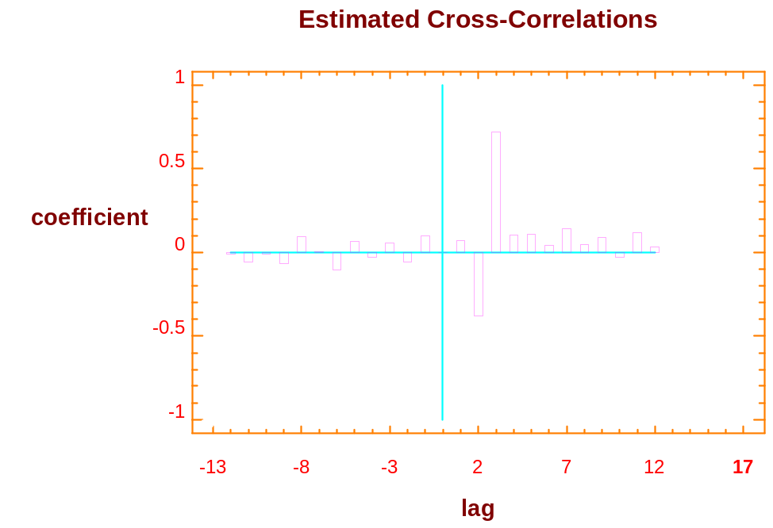

Figure 5. Estimated Cross-Correlations

Questions:
- Does units lead leadind?
- What do you think would be the relationship between sales and advertising for a firm?

In the units/leadind example, what does the CCF value for k = 0 mean?

Mini-Case
Herr Andres Lüthi owns a bank in Bern, Switzerland. One of Herr Lüthi’s requirements of his employees is they must continually solicit unnumbered accounts from foreign investors. Herr Lüthi prefers to call such accounts “CDs” because they have time limits similar to certificates of deposits used in the United States.
Being very computer literate, Herr Lüthi created a file, cd, to store his data. In this historical file, he maintains data of the sales volume of CDs, volume, for his bank. All the data is maintained on a monthly basis. Included in the data set are call (the number of cold calls Herr Lüthi’s employees made each month during the period January 1990 through July 1995), rate (the average rate for a CD), and mail (the number of mailings Herr Lüthi sent out to potential customers). Because of the excellent services provided by the bank, it is the norm for customers to roll their CDs over into new CDs when their original CDs expire.
It should be noted that several years ago Herr Lüthi took many of his employees on an extended ski vacation. Records show that the ski vacation was in 1992, February through May. The few non-skiers, who opted to take their holidays in Spain, continued soliciting CDs. They were, of course, credited with any walk-in traffic and any roll over accounts.
You were recently offered a position at Herr Lüthi’s bank. As part of your responsibilities, you are to construct a regression model that can be used to analyze the bank’s performance with regards to selling CDs. When the Board of Directors met last week, they projected the following for next month:
Number of Cold Calls | 900
Average Rate for a CD | 3.50
Number of Mailings | 4,500

Prepare your analysis for Herr Lüthi.

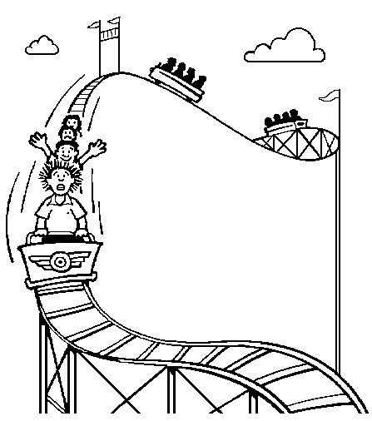

Figure 3 was obtained by selecting Plot of Fitted Line under the Graphical Options icon.
For an additional explanation on the concept of stock beta’s, refer to the Appendix.
StatGraphics also used two other techniques for identifying outliers (Mahalanobis Distribution and DIFTS), which we have elected not to discuss since from an intuitive level they are similar to the standardized residual/leverage criteria.

