IR ASSIGNMENT 1 - GOOGLE ADVANCED SEARCH

Shivam Milind Butale
MIS : 111603009

Advanced search is a built-in feature of Google (and most search websites) which allows a user to specify additional requirements for a search. When used for searching the Web, an advanced search gives additional information to Google, which helps refine the search.
There are a couple of ways to access these additional features for advanced search, using specific characters like the parentheses, which are called “operators,” and using Google's advanced search web page, which does a lot of the work for you and can be easier to use for beginners.
The text area where you enter your search term on Google or other search sites is called the “search box.” When you enter characters in that box and click or tap to search Google uses whatever you entered to search its database of websites and return web site listings relevant to your request.
Certain punctuation marks can be used to provide additional instructions to Google's search. .

GOOGLE ADVANCED SEARCH WEB PAGE

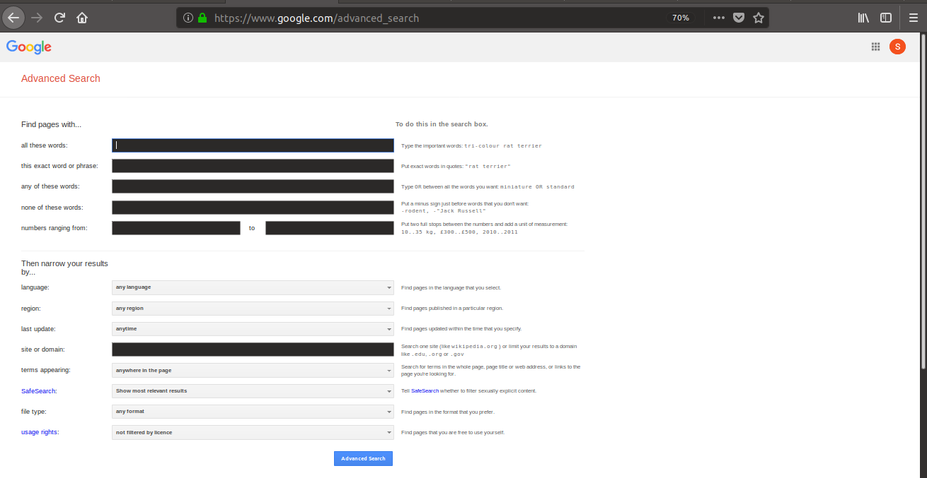
GOOGLE SEARCH OPERATORS(42)

“search term”
Force an exact-match search. Use this to refine results for ambiguous searches, or to exclude synonyms when searching for single words.
Example: “steve jobs”

OR
Search for X or Y. This will return results related to X or Y, or both. Note: The pipe (|) operator can also be used in place of “OR.”
Examples: jobs OR gates / jobs | gates

AND
Search for X and Y. This will return only results related to both X and Y. Note: It doesn’t really make much difference for regular searches, as Google defaults to “AND” anyway. But it’s very useful when paired with other operators.
Example: jobs AND gates

-
Exclude a term or phrase. In our example, any pages returned will be related to jobs but not Apple (the company).
Example: jobs -apple

*
Acts as a wildcard and will match any word or phrase.
Example: steve * apple

( )
Group multiple terms or search operators to control how the search is executed.
Example: (ipad OR iphone) apple

$
Search for prices. Also works for Euro (€), but not GBP (£)
Example: ipad $329

define:
A dictionary built into Google, basically. This will display the meaning of a word in a card-like result in the SERPs.
Example: define:entrepreneur

cache:
Returns the most recent cached version of a web page (providing the page is indexed, of course).
Example: cache:apple.com

filetype:
Restrict results to those of a certain filetype. E.g., PDF, DOCX, TXT, PPT, etc. Note: The “ext:” operator can also be used—the results are identical.
Example: apple filetype:pdf / apple ext:pdf

site:
Limit results to those from a specific website.
Example: site:apple.com

related:
Find sites related to a given domain.
Example: related:apple.com

intitle:
Find pages with a certain word (or words) in the title. In our example, any results containing the word “apple” in the title tag will be returned.
Example: intitle:apple

allintitle:
Similar to “intitle,” but only results containing all of the specified words in the title tag will be returned.
Example: allintitle:apple iphone

inurl:
Find pages with a certain word (or words) in the URL. For this example, any results containing the word “apple” in the URL will be returned.
Example: inurl:apple

allinurl:
Similar to “inurl,” but only results containing all of the specified words in the URL will be returned.
Example: allinurl:apple iphone

intext:
Find pages containing a certain word (or words) somewhere in the content. For this example, any results containing the word “apple” in the page content will be returned.
Example: intext:apple

allintext:
Similar to “intext,” but only results containing all of the specified words somewhere on the page will be returned.
Example: allintext:apple iphone

AROUND(X)
Proximity search. Find pages containing two words or phrases within X words of each other. For this example, the words “apple” and “iphone” must be present in the content and no further than four words apart.
Example: apple AROUND(4) iphone

weather:
Find the weather for a specific location. This is displayed in a weather snippet, but it also returns results from other “weather” websites.
Example: weather:san francisco

stocks:
See stock information (i.e., price, etc.) for a specific ticker.
Example: stocks:aapl

map:
Force Google to show map results for a locational search.
Example: map:silicon valley

movie:
Find information about a specific movie. Also finds movie showtimes if the movie is currently showing near you.
Example: movie:steve jobs

in
Convert one unit to another. Works with currencies, weights, temperatures, etc.
Example: $329 in GBP

source:
Find news results from a certain source in Google News.
Example: apple source:the_verge

_
Not exactly a search operator, but acts as a wildcard for Google Autocomplete.
Example: apple CEO _ jobs

#..#
Search for a range of numbers. In the example below, searches related to “WWDC videos” are returned for the years 2010–2014, but not for 2015 and beyond.
Example: wwdc video 2010..2014

inanchor:
Find pages that are being linked to with specific anchor text. For this example, any results with inbound links containing either “apple” or “iphone” in the anchor text will be returned.
Example: inanchor:apple iphone

allinanchor:
Similar to “inanchor,” but only results containing all of the specified words in the inbound anchor text will be returned.
Example: allinanchor:apple iphone

blogurl:
Find blog URLs under a specific domain. This was used in Google blog search, but I’ve found it does return some results in regular search.
Example: blogurl:microsoft.com
Google blog search discontinued in 2011

loc:placename
Find results from a given area.
Example: loc:”san francisco” apple
Not officially deprecated, but results are inconsistent.

location:
Find news from a certain location in Google News.
Example: loc:”san francisco” apple
Not officially deprecated, but results are inconsistent.

Google search operators that have been discontinued and no longer work
+
Force an exact-match search on a single word or phrase.
Example: jobs +apple
You can do the same thing by using double quotes around your search.

~
Include synonyms. Doesn’t work, because Google now includes synonyms by default. (Hint: Use double quotes to exclude synonyms.)
Example: ~apple

inpostauthor:
Find blog posts written by a specific author. This only worked in Google Blog search, not regular Google search.
Example: inpostauthor:”steve jobs”
Google blog search was discontinued in 2011.

allinpostauthor:
Similar to “inpostauthor,” but removes the need for quotes (if you want to search for a specific author, including surname.)
Example: allinpostauthor:steve jobs

inposttitle:
Find blog posts with specific words in the title. No longer works, as this operator was unique to the discontinued Google blog search.
Example: intitle:apple iphone

link:
Find pages linking to a specific domain or URL. Google killed this operator in 2017, but it does still show some results—they likely aren’t particularly accurate though. (Deprecated in 2017)
Example: link:apple.com

info:
Find information about a specific page, including the most recent cache, similar pages, etc. (Deprecated in 2017). Note: The id: operator can also be used—the results are identical.
Although the original functionality of this operator is deprecated, it is still useful for finding the canonical, indexed version of a URL. Thanks to @glenngabe for pointing this one one!
Example: info:apple.com / id:apple.com

daterange:
Find results from a certain date range. Uses the Julian date format, for some reason.
Example: daterange:11278–13278
Not officially deprecated, but doesn’t seem to work.

phonebook:
Find someone’s phone number. (Deprecated in 2010)
Example: phonebook:tim cook

#
Searches #hashtags. Introduced for Google+; now deprecated.
Example: #apple

References :
https://ahrefs.com/blog/google-advanced-search-operators/
https://www.bobology.com/public/What-is-Advanced-Search-on-Google.cfm

