

RESCIS – Real Estate Sales &

Commission Intelligence System
DETAILED TECHNICAL DOCUMENTATION
Author: Shivam Giradkar
Salesforce Developer | Apex | Visualforce | LWC | Automation



Table of Contents
1. Introduction
2. Business Goals
3. System Architecture
4. Data Model
5. Apex Trigger Logic
6. Apex Controllers
7. Visualforce UI
8. Dashboard Design
9. Testing Strategy
10. Governor Limit Handling
11. Future Enhancements
12. Conclusion

1. INTRODUCTION
RESCIS (Real Estate Sales & Commission Intelligence System) is an enterprise-grade Salesforce-based automation system that integrates Property Sales, Agent Commission Tracking, Approval Workflows, and Business Intelligence into one unified platform. It is designed to solve real-world real estate operational challenges using Apex, Visualforce, SOQL, and Lightning Reporting.

2. BUSINESS GOALS
The system automates manual processes, ensures accuracy in commission calculation, improves decision-making through dashboards, and provides a scalable architecture for real estate organizations.

3. SYSTEM ARCHITECTURE
RESCIS follows a multi-layer architecture:
- Presentation Layer (Visualforce, Lightning Dashboard)
- Business Logic Layer (Apex Trigger, Controllers)
- Data Layer (Custom Objects)
- Analytics Layer (Reports & Dashboards)
- Security Layer (Sharing, FLS)

4. DATA MODEL
The data model includes Sales Regions, Sales Offices, Properties, and Agents. Properties store commission %, amount, sale price, agent reference, and approval status.
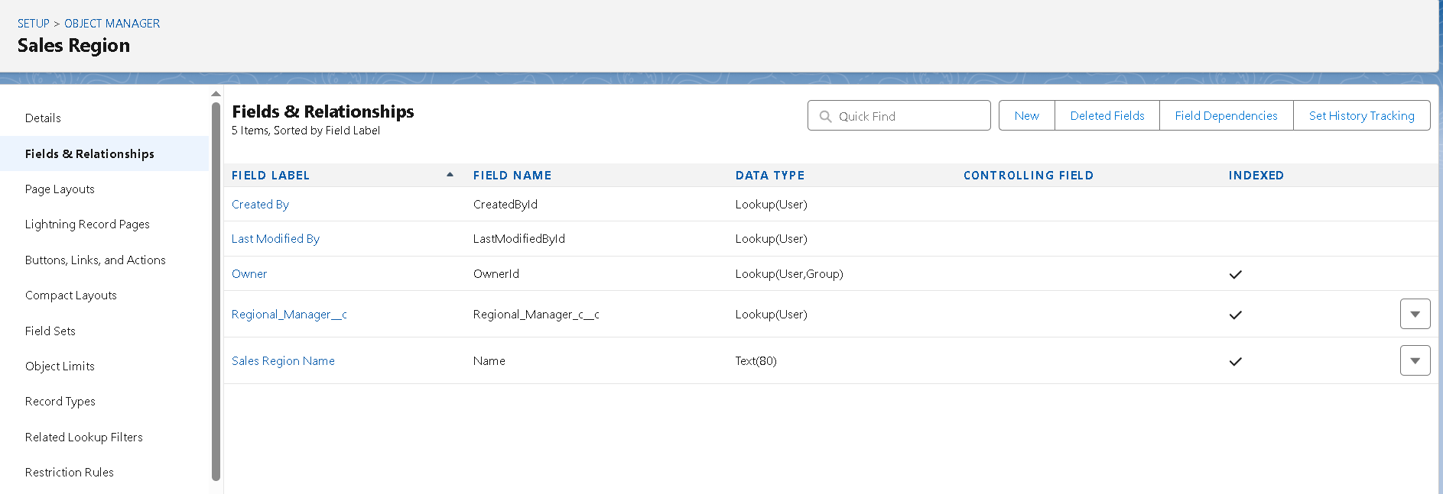

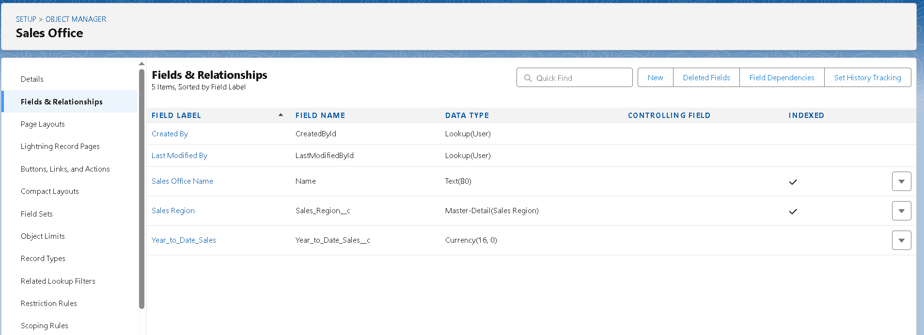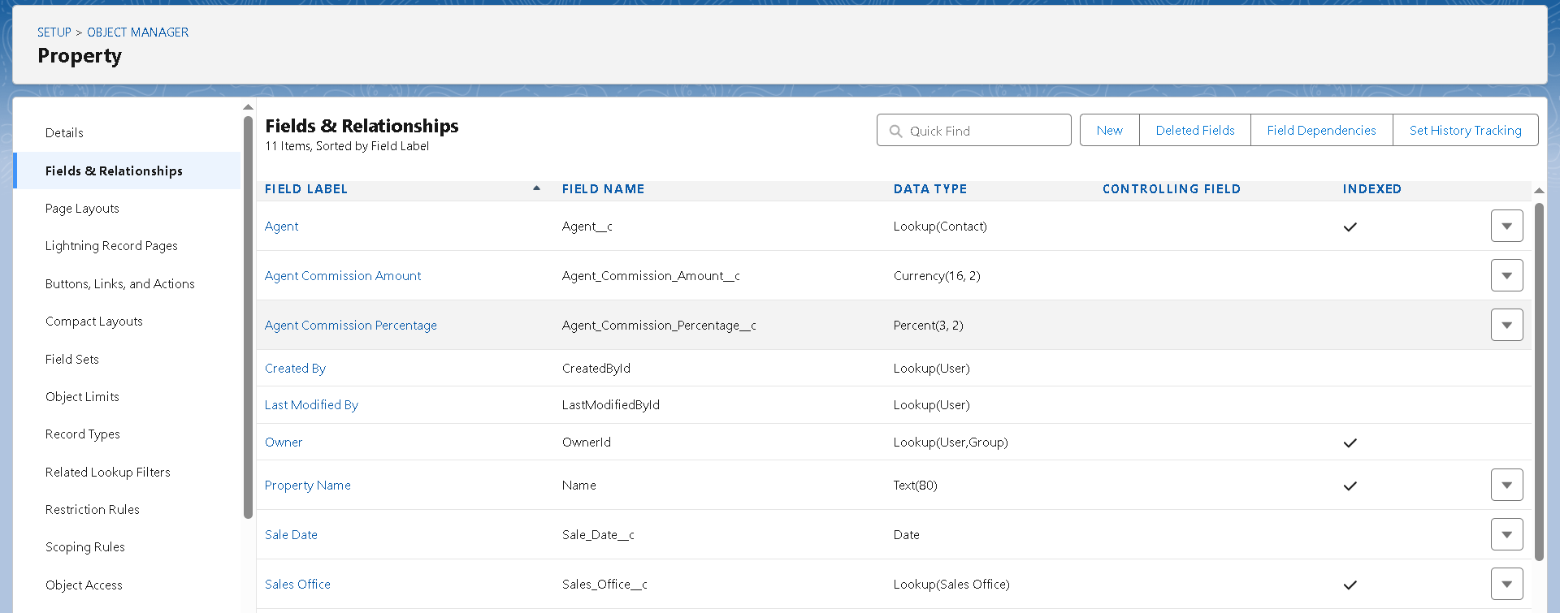

5. APEX TRIGGER LOGIC
The trigger calculates commissions, validates transitions, updates YTD totals, and prevents data corruption through row locking and bulkified logic.

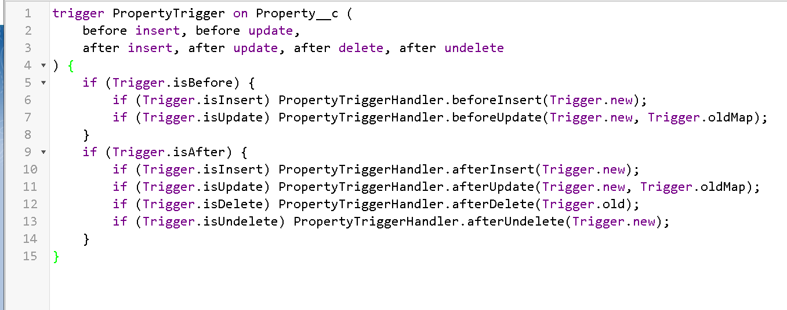
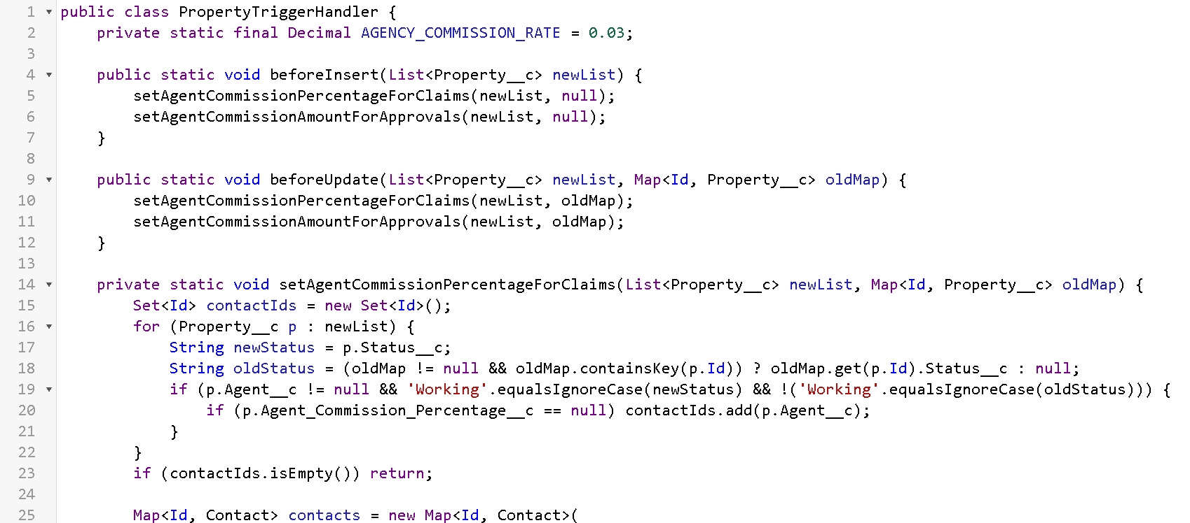

6. APEX CONTROLLERS
The ApproveCommissionsController powers the manager interface: bulk approvals, record locking, pagination, and dynamic SOQL queries.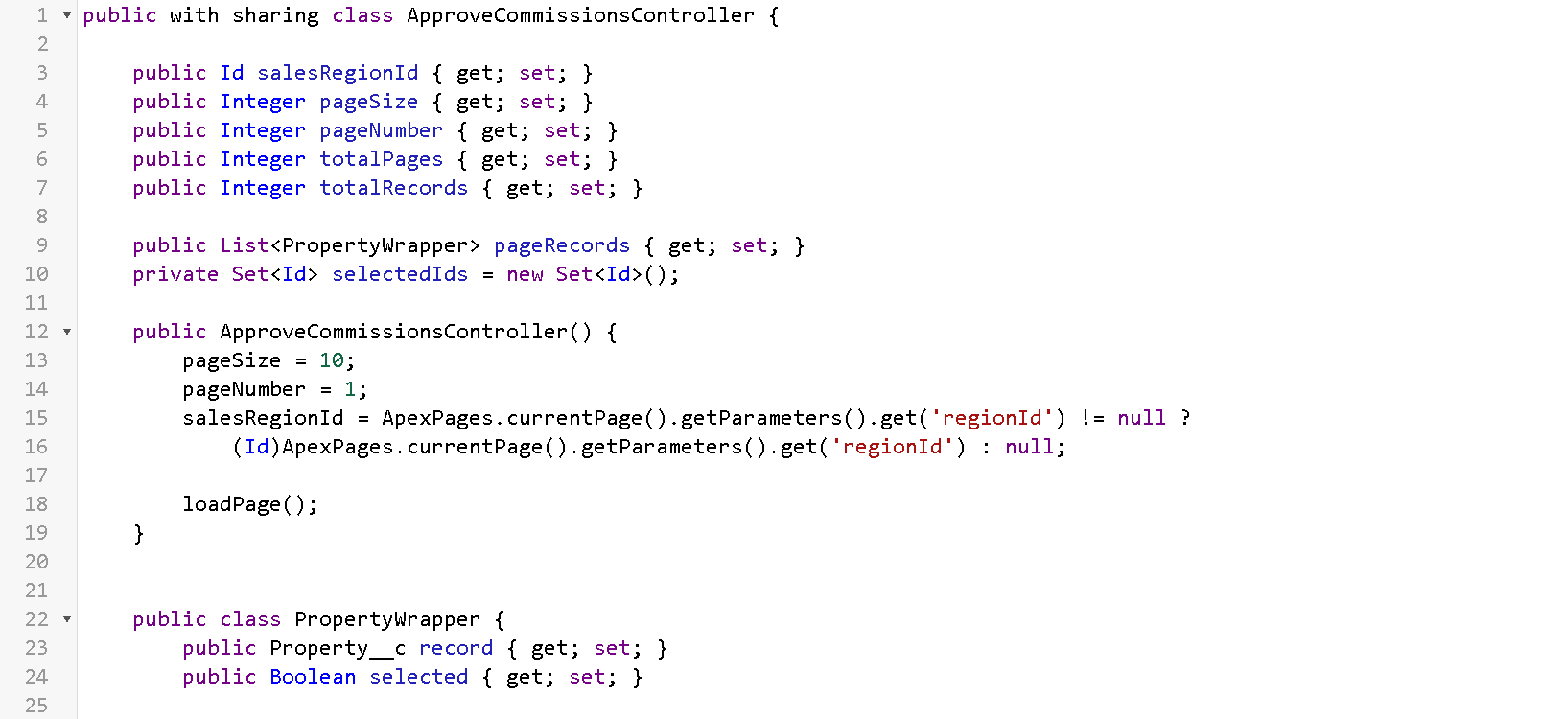

7. VISUALFORCE UI
The VF page provides a custom UI for commission approval with tables, checkboxes, pagination, and action buttons routed through the Apex controller.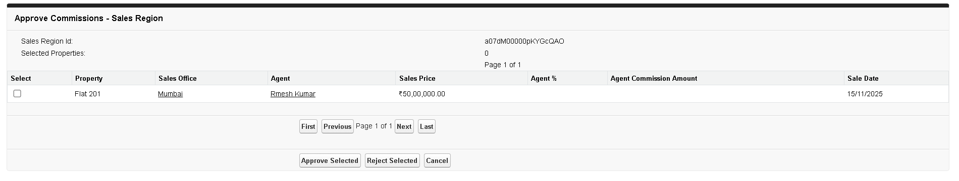

8. DASHBOARD DESIGN
The dashboard includes KPI tiles, donut charts, bar charts, and summary analytics showing revenue, commission, and agent performance.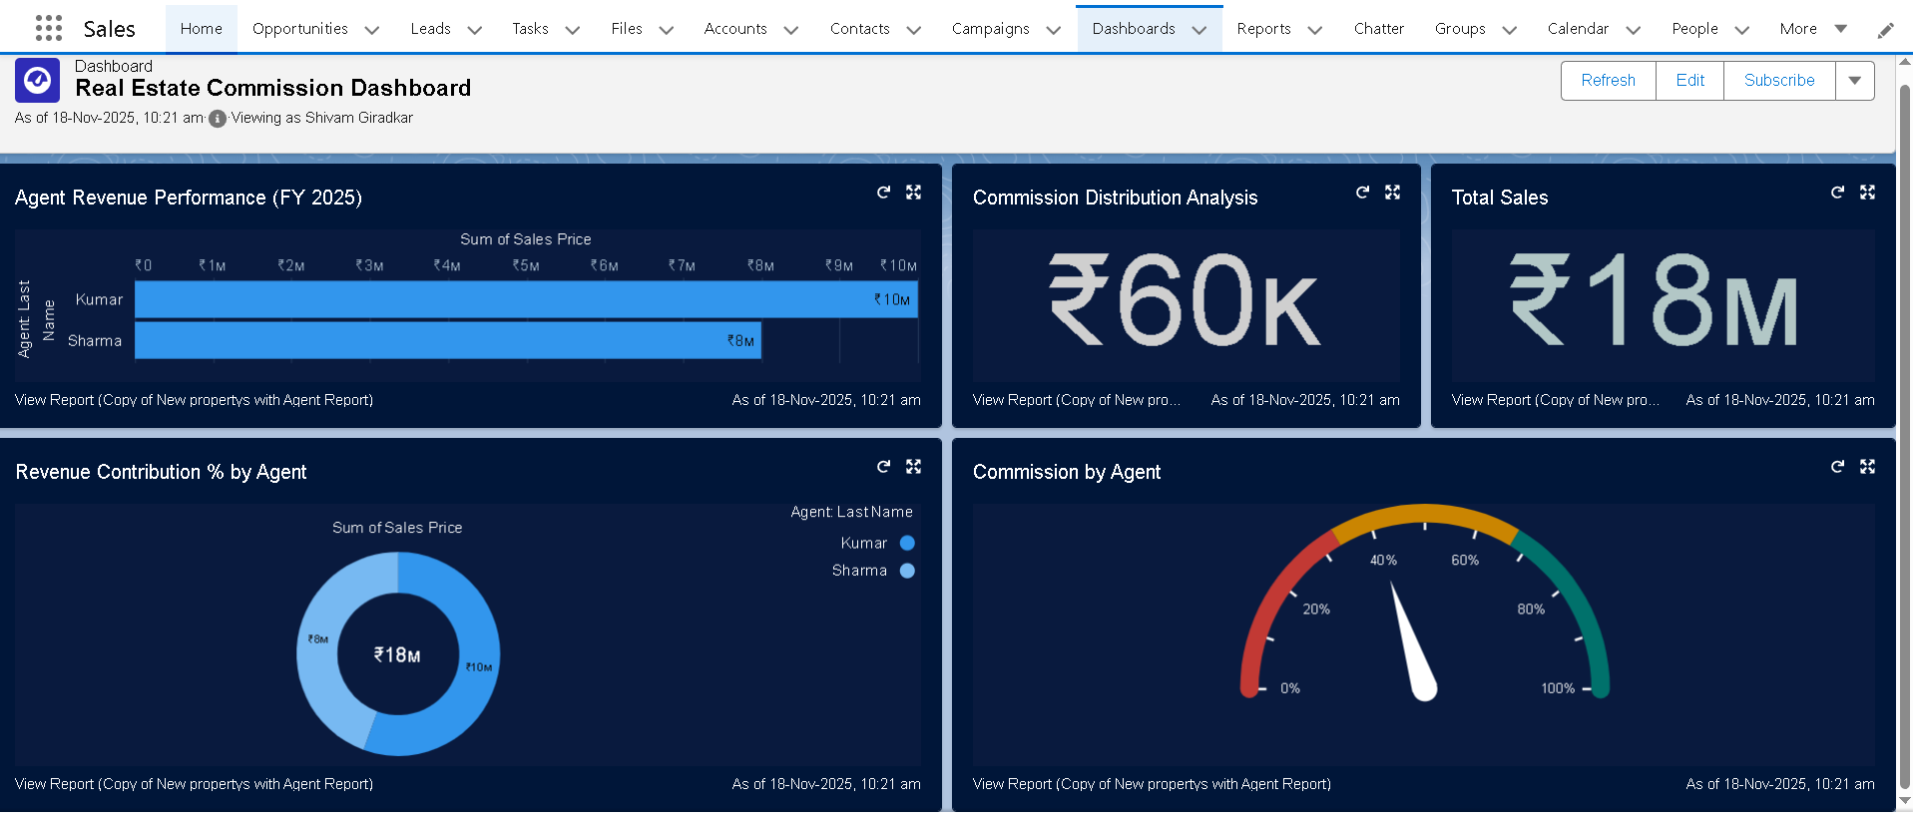

9. TESTING STRATEGY
Functional, technical, and bulk testing ensures reliability. Test cases include approval flow, commission calculation, rejection flow, pagination, and performance under load.

10. GOVERNOR LIMIT HANDLING
FOR UPDATE prevents race conditions.

11. FUTURE ENHANCEMENTS
LWC migration, AI-based forecasting, automated notifications, and extended dashboards for executives.

12. CONCLUSION
RESCIS demonstrates professional Salesforce engineering: Apex automation, MVC design, advanced reporting, and scalable enterprise architecture.

