SmartPlate — Stage 2 Implementation Report
EECS 3311, Fall 2026 · AI-Human Collaborative Implementation Repository: https://github.com/ShivamGlotra/EECS-3311-AI-Smart-Recipe-and-Meal-Planning-Agent
Fields marked [Team] are facts only the team can supply (video links, other tools used, the team's own review notes). Fill them in before exporting the final PDF.

Contents
- Project overview and implementation status
- Feature to implementation mapping
- Implemented design patterns (with the updated UML)
- Changes and rationale
- AI tools and collaboration log
- Development and verification summary
- Demonstration index

1. Project overview and implementation status
What SmartPlate is. SmartPlate is a Java 17 desktop application (Swing GUI) with a matching command-line interface. It helps a home cook plan dinners: it keeps a preference profile and a pantry, searches a recipe collection, recommends recipes and builds or edits a 5–7 day dinner plan with an AI agent, scales recipes, substitutes ingredients, and computes nutrition and a shopping list.
Users. Home cooks and students who want quick, constraint-aware meal plans (diet, allergies, dislikes, cooking time, what is already in the pantry).
AI/LLM integration. The agent (MealPlanningAgent) never lets the LLM invent anything. For each request it reads hard constraints from the request text, retrieves the recipes, shortlists up to 15 candidates with the selected strategy, sends them to the LLM through the AIModel interface, parses the answer, and validates every chosen recipe in Java (ConstraintValidator, using each recipe's ingredient list). If anything is wrong it revises once with the violation messages; otherwise it reports the failure. Four interchangeable models implement AIModel:
Model | Class | Use
Mock AI (offline, deterministic) | MockAIModel | default without keys; all automated tests
Google Gemini (REST API) | GeminiAdapter | free/cheap cloud model, key in .env
Local model through Ollama (team uses gemma4:e4b) | OllamaAdapter | free, runs on the user's machine
Anthropic Claude (official Java SDK) | AIAdapter → AIClient | optional, key in .env
The model is chosen from .env at start-up and can be switched at run time in the GUI (feature F11).
Implementation status. All ten Stage 1 features (F01–F10) and one new feature (F11, AI model selection) work in both the GUI and the CLI. All five Stage 1 design patterns are implemented, plus a Factory for model creation. mvn test runs 129 automated tests (0 failures). Gemini and the local Ollama model were run by the team; the Claude path is implemented but was only unit-tested, because no Anthropic key was available.
Limitations (honest list).
- No persistence: profile, pantry and plan are kept in memory and lost when the app closes (not required by the course; listed as future work).
- Plans always start on Monday; one dinner per day.
- Plan edits get one AI attempt (no revision), as designed in SD05.
- The offline Mock AI is simple: it re-ranks the shortlist with word matching, so its picks are less clever than a real model's (it is meant for testing and offline demos).
- Other tabs stay editable during a long AI request (the AI model and strategy boxes are locked).
- Sample data (30 recipes, nutrition values) was written for the demo and not checked against a nutrition database.
- Allergies match by ingredient name on purpose (an allergy to "milk" also blocks "coconut milk").

2. Feature to implementation mapping
All paths are under src/main/java/com/smartplate/. Every feature is reached through SmartRecipeFacade from both MealPlannerGUI (via the tab panels in presentation/gui/) and MealPlannerCLI. "Video" links are filled in from §7.

F01 — Preference Profile Management
Field | Entry
Stage 1 reference | F01 / UC01 / SD01
Status | Implemented (entries may now contain accented letters, e.g. "jalapeño")
Type | Deterministic
Classes / responsibilities | PreferencesPanel (form, error banner, field highlighting); MealPlannerCLI (profile set …); SmartRecipeFacade (entry point, keeps the active profile); UserProfile (data + validate() rules); InvalidProfileException (carries the problem list)
Key methods | SmartRecipeFacade.setupProfile, UserProfile.validate, UserProfile.checkEntries, PreferencesPanel.save
Design patterns | Facade
Video | §7, F01
How it works. The panel or CLI builds a UserProfile and calls setupProfile. validate() returns every problem (servings or time below 1, unknown diet, duplicate or malformed entries). If the list is empty the facade stores the profile; otherwise it throws InvalidProfileException, the previous profile stays active, and the GUI lists the problems in a red banner and outlines each offending field.

F02 — Pantry Inventory Management
Field | Entry
Stage 1 reference | F02 / UC02 / SD01
Status | Implemented (adding an item already in the pantry merges compatible units, e.g. 500 g + 1 kg)
Type | Deterministic
Classes / responsibilities | PantryPanel (form + table); MealPlannerCLI (pantry add|update|remove); SmartRecipeFacade; Pantry (items, rules); PantryItem, Ingredient, PantryAction; Units (unit families and conversion)
Key methods | SmartRecipeFacade.managePantry, Pantry.addItem, Pantry.updateItem, Pantry.removeItem, Units.convert
Design patterns | Facade
Video | §7, F02
How it works. managePantry(action, item) dispatches ADD / UPDATE / REMOVE to Pantry. Adding an existing item converts and adds the quantity if the units are compatible; zero or negative quantities, unknown units, incompatible units, and updating or removing a missing item are rejected with a message shown next to the right field.

F03 — Recipe Search
Field | Entry
Stage 1 reference | F03 / UC03 / SD02
Status | Implemented
Type | Deterministic
Classes / responsibilities | RecipesPanel (search box + results table); MealPlannerCLI (search, recipes, show); SmartRecipeFacade; RecipeRepository (the 30 recipes from SampleData)
Key methods | SmartRecipeFacade.searchRecipes, RecipeRepository.search, RecipeRepository.findById, RecipeRepository.findAll
Design patterns | Facade
Video | §7, F03
How it works. An empty query is rejected; otherwise every word of the query must appear in the recipe's name, tags or ingredient names. The results table opens the selected recipe.

F04 — AI Recipe Recommendation
Field | Entry
Stage 1 reference | F04 / UC04 / SD03
Status | Modified (constraints written in the request are enforced; see §4)
Type | Hybrid (AI chooses, Java validates)
Classes / responsibilities | AssistantPanel (request box, results, agent trace); MealPlannerCLI (recommend, trace); SmartRecipeFacade; MealPlanningAgent (the agent loop); RequestConstraints (rules read from the request); RecipeSelectionStrategy + PantryFirstStrategy / FastestMealStrategy (shortlist); PromptFormat (prompt/answer protocol); AIModel and its adapters (the LLM); ConstraintValidator, ValidationResult, DietRules (checks)
Key methods | SmartRecipeFacade.recommendRecipes, MealPlanningAgent.recommend, RequestConstraints.parse/applyTo, RecipeSelectionStrategy.selectRecipes, AIModel.generate, ConstraintValidator.validateRecipe
Design patterns | Facade, Strategy, Adapter
Video | §7, F04
How it works. The request ("3 quick vegetarian dinners using rice, avoid red onion") is parsed into constraints that are added to a copy of the profile. The strategy filters and ranks all recipes and keeps 15 candidates. The agent builds a prompt (TASK, REQUEST, DIET, AVOID, MAX_TIME, CANDIDATES, RESPONSE_FORMAT) and asks the model, which answers RECIPES: id, id. Unknown ids and recipes that fail validation become violations; the agent then asks once more with PREVIOUS_VIOLATIONS and EXCLUDE. Only validated recipes are returned, and the trace shows each step.

F05 — AI Weekly Meal Planning
Field | Entry
Stage 1 reference | F05 / UC05 / SD04
Status | Modified (request constraints, 5–7 day check before any AI call; see §4)
Type | Hybrid
Classes / responsibilities | as F04, plus MealPlan (composite: the plan), PlannedMeal (leaf: one dinner), Days (day names), CommandHistory (cleared for a new plan)
Key methods | SmartRecipeFacade.createMealPlan, MealPlanningAgent.createPlan, RequestConstraints.planDays, MealPlan.addMeal, ConstraintValidator.validatePlan
Design patterns | Facade, Strategy, Adapter, Composite
Video | §7, F05
How it works. The number of days (default 7) must be 5–7, else an error is shown without calling the AI. The model answers one Day: id line per day; each id becomes a PlannedMeal in a MealPlan. validatePlan checks every day exists and every recipe respects allergies, dislikes, diet and time. One revision is allowed; the facade stores the valid plan and clears the undo history.

F06 — Meal Plan Editing and Undo
Field | Entry
Stage 1 reference | F06 / UC06 / SD05
Status | Modified (the AI may choose the day when the request names none; day detection fixed; see §4)
Type | Hybrid
Classes / responsibilities | AssistantPanel (Edit plan / Undo, "CHANGED" marker, before/after card); MealPlannerCLI (edit, undo); SmartRecipeFacade; MealPlanningAgent.editPlan; Days.findIn; ConstraintValidator; Command, ReplaceMealCommand (stores day, old and new meal), CommandHistory (invoker, undo stack), MealPlan
Key methods | SmartRecipeFacade.editMealPlan, SmartRecipeFacade.undoLastChange, MealPlanningAgent.editPlan, ReplaceMealCommand.execute/undo, CommandHistory.execute/undo/canUndo, MealPlan.replaceMeal
Design patterns | Facade, Adapter, Command
Video | §7, F06
How it works. The agent finds the day named in the request (Days.findIn; "sun-dried" is not Sunday), or lets the model pick it. The model answers DAY: and RECIPE:; the replacement must exist, differ from the current meal and pass validateRecipe. The agent returns a ReplaceMealCommand, which the facade runs through CommandHistory; Undo pops it and restores the old meal.

F07 — Serving-Size Adjustment
Field | Entry
Stage 1 reference | F07 / UC07 / SD06
Status | Implemented
Type | Deterministic
Classes / responsibilities | RecipesPanel (Servings + Scale, working copy badge); MealPlannerCLI (scale); SmartRecipeFacade; ServingScaler; Recipe (immutable; scaling returns a copy)
Key methods | SmartRecipeFacade.adjustServings, ServingScaler.scale
Design patterns | Facade
Video | §7, F07
How it works. Every quantity is multiplied by servings / recipe.servings; fewer than 1 serving or an invalid quantity is rejected. The scaled copy is shown as a working copy until Reset.

F08 — Ingredient Substitution
Field | Entry
Stage 1 reference | F08 / UC08 / SD06
Status | Implemented (a disliked dairy food no longer rules out its plant-based substitute; see §4)
Type | Deterministic
Classes / responsibilities | RecipesPanel (ingredient box + Substitute); MealPlannerCLI (substitute); SmartRecipeFacade; SubstitutionService (33 known substitutions); Substitution; DietRules (conflict check)
Key methods | SmartRecipeFacade.substituteIngredient, SubstitutionService.findSubstitute, SubstitutionService.applySubstitution, DietRules.conflicts
Design patterns | Facade
Video | §7, F08
How it works. The facade checks the recipe contains the ingredient; the service returns the first known substitute that does not conflict with the profile, then replaces the ingredient and converts the quantity with the conversion factor (e.g. butter → olive oil ×0.8, in ml).

F09 — Nutrition Information
Field | Entry
Stage 1 reference | F09 / UC09 / SD06
Status | Implemented
Type | Deterministic
Classes / responsibilities | RecipesPanel (recipe nutrition), AssistantPanel (Plan nutrition view); MealPlannerCLI (nutrition <id>, nutrition plan); SmartRecipeFacade; NutritionService; NutritionInfo; PlanComponent, MealPlan, PlannedMeal
Key methods | SmartRecipeFacade.calculateRecipeNutrition/calculatePlanNutrition, NutritionService.calculateRecipe/calculatePlan, PlanComponent.getNutrition
Design patterns | Facade, Composite
Video | §7, F09
How it works. A recipe's nutrition is its per-serving values times servings. For the plan, MealPlan.getNutrition() sums PlannedMeal.getNutrition() of its children, so the service treats one meal and the whole plan the same way.

F10 — Shopping List Generation
Field | Entry
Stage 1 reference | F10 / UC10 / SD06
Status | Implemented (counted items are rounded up to whole pieces; see §4)
Type | Deterministic
Classes / responsibilities | AssistantPanel (Shopping list view, copy/export); MealPlannerCLI (shopping); SmartRecipeFacade; ShoppingListService; ShoppingList, ShoppingItem; Pantry; PlanComponent
Key methods | SmartRecipeFacade.generateShoppingList, ShoppingListService.generate, PlanComponent.getIngredients, ShoppingList.consolidate, ShoppingList.roundUpQuantities
Design patterns | Facade, Composite
Video | §7, F10
How it works. The plan's ingredients (collected through the Composite) are merged per ingredient in compatible units, the pantry is subtracted, counted items are rounded up to whole pieces, and notes explain skipped or incomparable lines. The GUI also lists what the pantry already covers.

F11 — AI Model Selection (new)
Field | Entry
Stage 1 reference | New (extends Stage 1 §1.5 "the provider can change without touching MealPlanningAgent") / new UC11 / new SD07
Status | New
Type | Deterministic (chooses which LLM the hybrid features use)
Classes / responsibilities | MealPlannerGUI (AI model box; disabled during a request); SmartRecipeFacade (setAIProvider, getAIProviders); AIModelFactory (builds the right model, reports missing keys); EnvFile (reads .env); GeminiAdapter, OllamaAdapter, AIAdapter/AIClient, MockAIModel; MealPlanningAgent.setAIModel; SmartPlateApp (start-up choice, --mock)
Key methods | SmartRecipeFacade.setAIProvider, AIModelFactory.fromEnvironment/create/forProvider/missingSetting, EnvFile.load, MealPlanningAgent.setAIModel, AssistantPanel.onBusyChange
Design patterns | Adapter (two new adapters), Factory, Facade
Video | §7, F11
How it works. At start-up SmartPlateApp asks AIModelFactory for the model named by SMARTPLATE_AI_PROVIDER (default auto: Claude if its key is set, else Gemini, else Mock). In the window, choosing a provider calls setAIProvider, which re-reads .env; if the key is missing, the previous model stays and the box shows the reason. Otherwise the factory builds the adapter and the agent uses it from the next request on; a running request keeps the model it started with. The CLI uses the start-up choice (or --mock).

3. Implemented design patterns
The updated UML is in docs/umlet-diagrams/stage2/ (UMLet .uxf files plus PNG). The Stage 1 diagrams are unchanged in docs/umlet-diagrams/ for comparison.
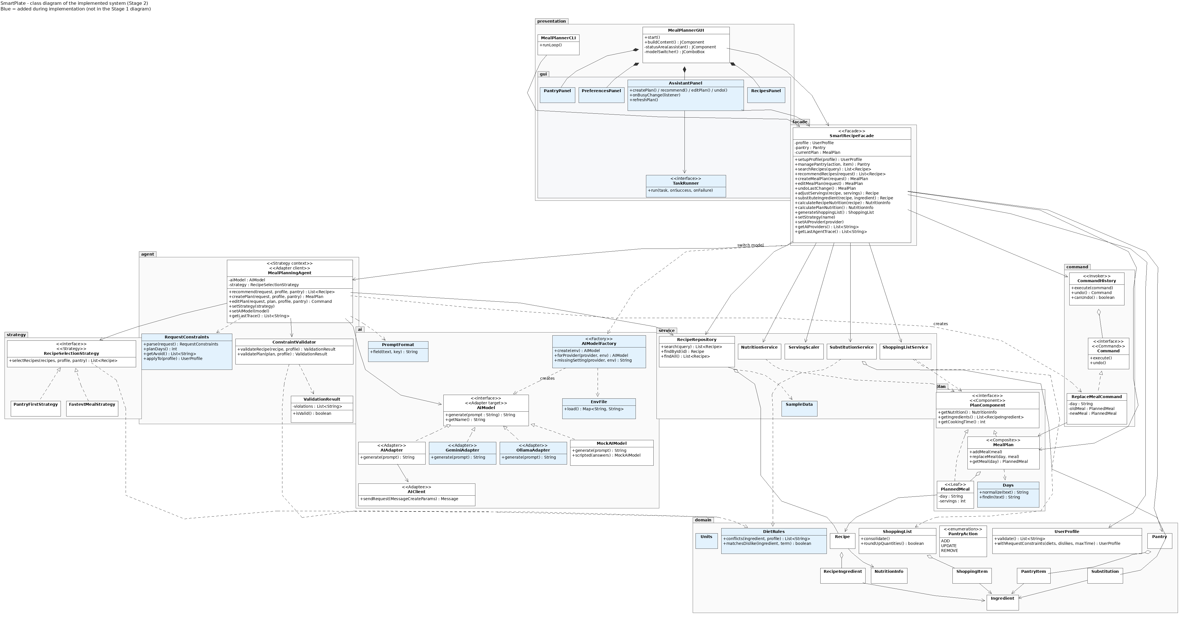
Class diagram of the implemented system (overview). Blue classes were added during implementation; stereotypes show each pattern role. Full size: docs/umlet-diagrams/stage2/class/SmartPlate_Stage2_ClassDiagram.png (UMLet source: SmartPlate_Stage2_ClassDiagram.uxf in the same folder).

3.1 Facade
- Problem. Two user interfaces need the same ten features, and neither should know the agent, services, command history or AI classes.
- Participants. Facade: SmartRecipeFacade. Subsystem: MealPlanningAgent, RecipeRepository, NutritionService, ServingScaler, SubstitutionService, ShoppingListService, CommandHistory, AIModelFactory. Clients: MealPlannerGUI (and its panels), MealPlannerCLI.
- Code. facade/SmartRecipeFacade.java: one method per feature (setupProfile … generateShoppingList), plus setStrategy and setAIProvider.
- How / why. Each method validates its input, calls one subsystem, and returns a result or throws a SmartPlateException with a user-facing message, so the GUI and CLI behave identically and the presentation layer imports nothing below the facade.
- Stage 1 match. As designed; the facade also owns the session state and offers read methods (§4).

3.2 Adapter
- Problem. The agent must work with any LLM provider (and offline) without depending on a provider's API.
- Participants. Target: AIModel (generate(prompt), getName()). Adapters: AIAdapter (Claude), GeminiAdapter, OllamaAdapter. Adaptee: AIClient (Anthropic SDK types MessageCreateParams / Message); the Gemini and Ollama REST APIs are adapted directly through the JDK HttpClient. Alternative implementation: MockAIModel. Client: MealPlanningAgent.
- Code. ai/AIAdapter.java (buildRequest, extractText), ai/GeminiAdapter.java (buildRequestBody, extractText), ai/OllamaAdapter.java (buildRequestBody, extractText, stripThinking), ai/AIClient.java (sendRequest).
- How / why. Each adapter turns the plain prompt into the provider's request and the provider's reply back into text, and maps provider errors to AIServiceException. Two providers were added in Stage 2 without changing the agent, which is exactly what the pattern promised.
- Stage 1 match. Extended (two more adapters; AIClient.sendRequest uses SDK types, §4).

3.3 Strategy
- Problem. Candidate recipes can be shortlisted in different ways, chosen at run time.
- Participants. Strategy: RecipeSelectionStrategy (with the shared filter fitsProfile). Concrete strategies: PantryFirstStrategy, FastestMealStrategy. Context: MealPlanningAgent (setStrategy, shortlist).
- Code. strategy/*.java; switched with SmartRecipeFacade.setStrategy from the GUI's Strategy box or the CLI's strategy command.
- How / why. The agent calls selectRecipes without knowing which rule is active; a new rule is a new class.
- Stage 1 match. As designed.

3.4 Command
- Problem. Plan edits must be undoable without the facade knowing how each edit is reversed.
- Participants. Command: Command (execute, undo). Concrete command: ReplaceMealCommand (day, old meal, new meal). Invoker: CommandHistory (stack). Receiver: MealPlan. Client: MealPlanningAgent.editPlan creates the command; SmartRecipeFacade executes and undoes it.
- Code. command/*.java, MealPlan.replaceMeal.
- How / why. The command stores what it needs to undo itself; a new plan clears the history.
- Stage 1 match. As designed (ArrayDeque instead of Stack, §4).

3.5 Composite
- Problem. Nutrition and shopping lists must be computed for one meal and for a whole plan.
- Participants. Component: PlanComponent (getNutrition, getIngredients, getCookingTime). Composite: MealPlan (5–7 meals). Leaf: PlannedMeal (one recipe at its servings). Clients: NutritionService, ShoppingListService.
- Code. plan/*.java.
- How / why. MealPlan sums its children, so the services treat a plan and a meal the same way.
- Stage 1 match. As designed.

3.6 Factory (added in Stage 2)
- Problem. Several AIModel implementations need configuration (keys, model names, URLs) read from the environment and .env, at start-up and when the user switches model.
- Participants. Factory: AIModelFactory (create, forProvider, missingSetting, providerOf). Products: the AIModel implementations. Configuration: EnvFile. Clients: SmartPlateApp, SmartRecipeFacade.setAIProvider.
- How / why / impact. All construction rules live in one class, so neither the entry point nor the facade knows the concrete adapters; adding a provider means one new adapter and one case (see §4, pattern changes).

3.7 Updated use-case and sequence diagrams
- Use cases: new UC11 Select AI Model (use-case/SmartPlate_Stage2_UseCase.uxf).
- Sequence diagrams updated because the Stage 1 versions became inaccurate: SD03 (request constraints, 15-candidate shortlist, "no candidates" branch), SD04 (request constraints and the 5–7 day check), SD05 (day from the request or chosen by the AI). New SD07 for F11. SD01, SD02 and SD06 still match.
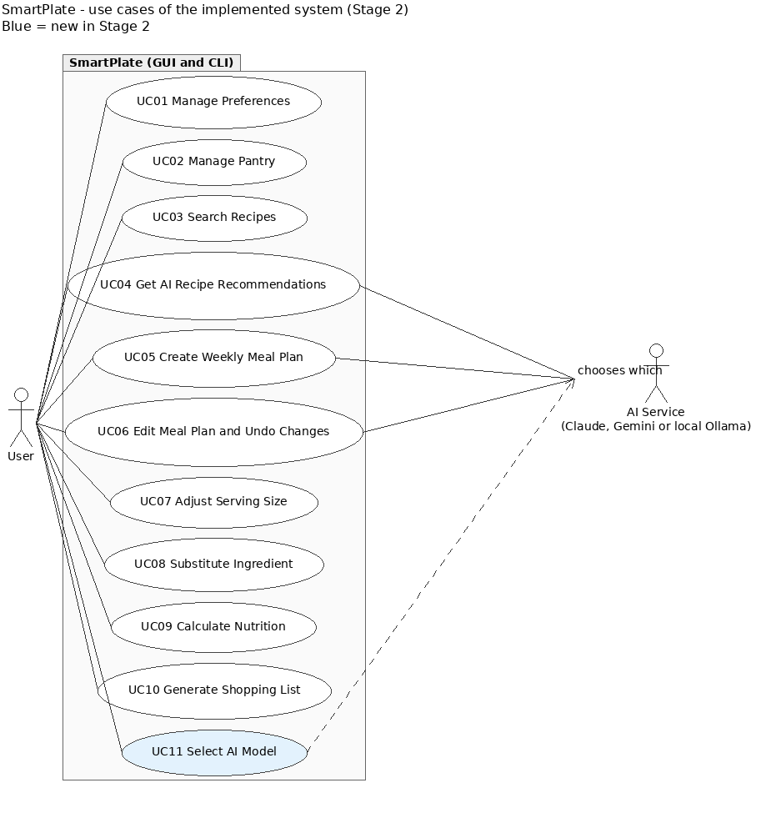
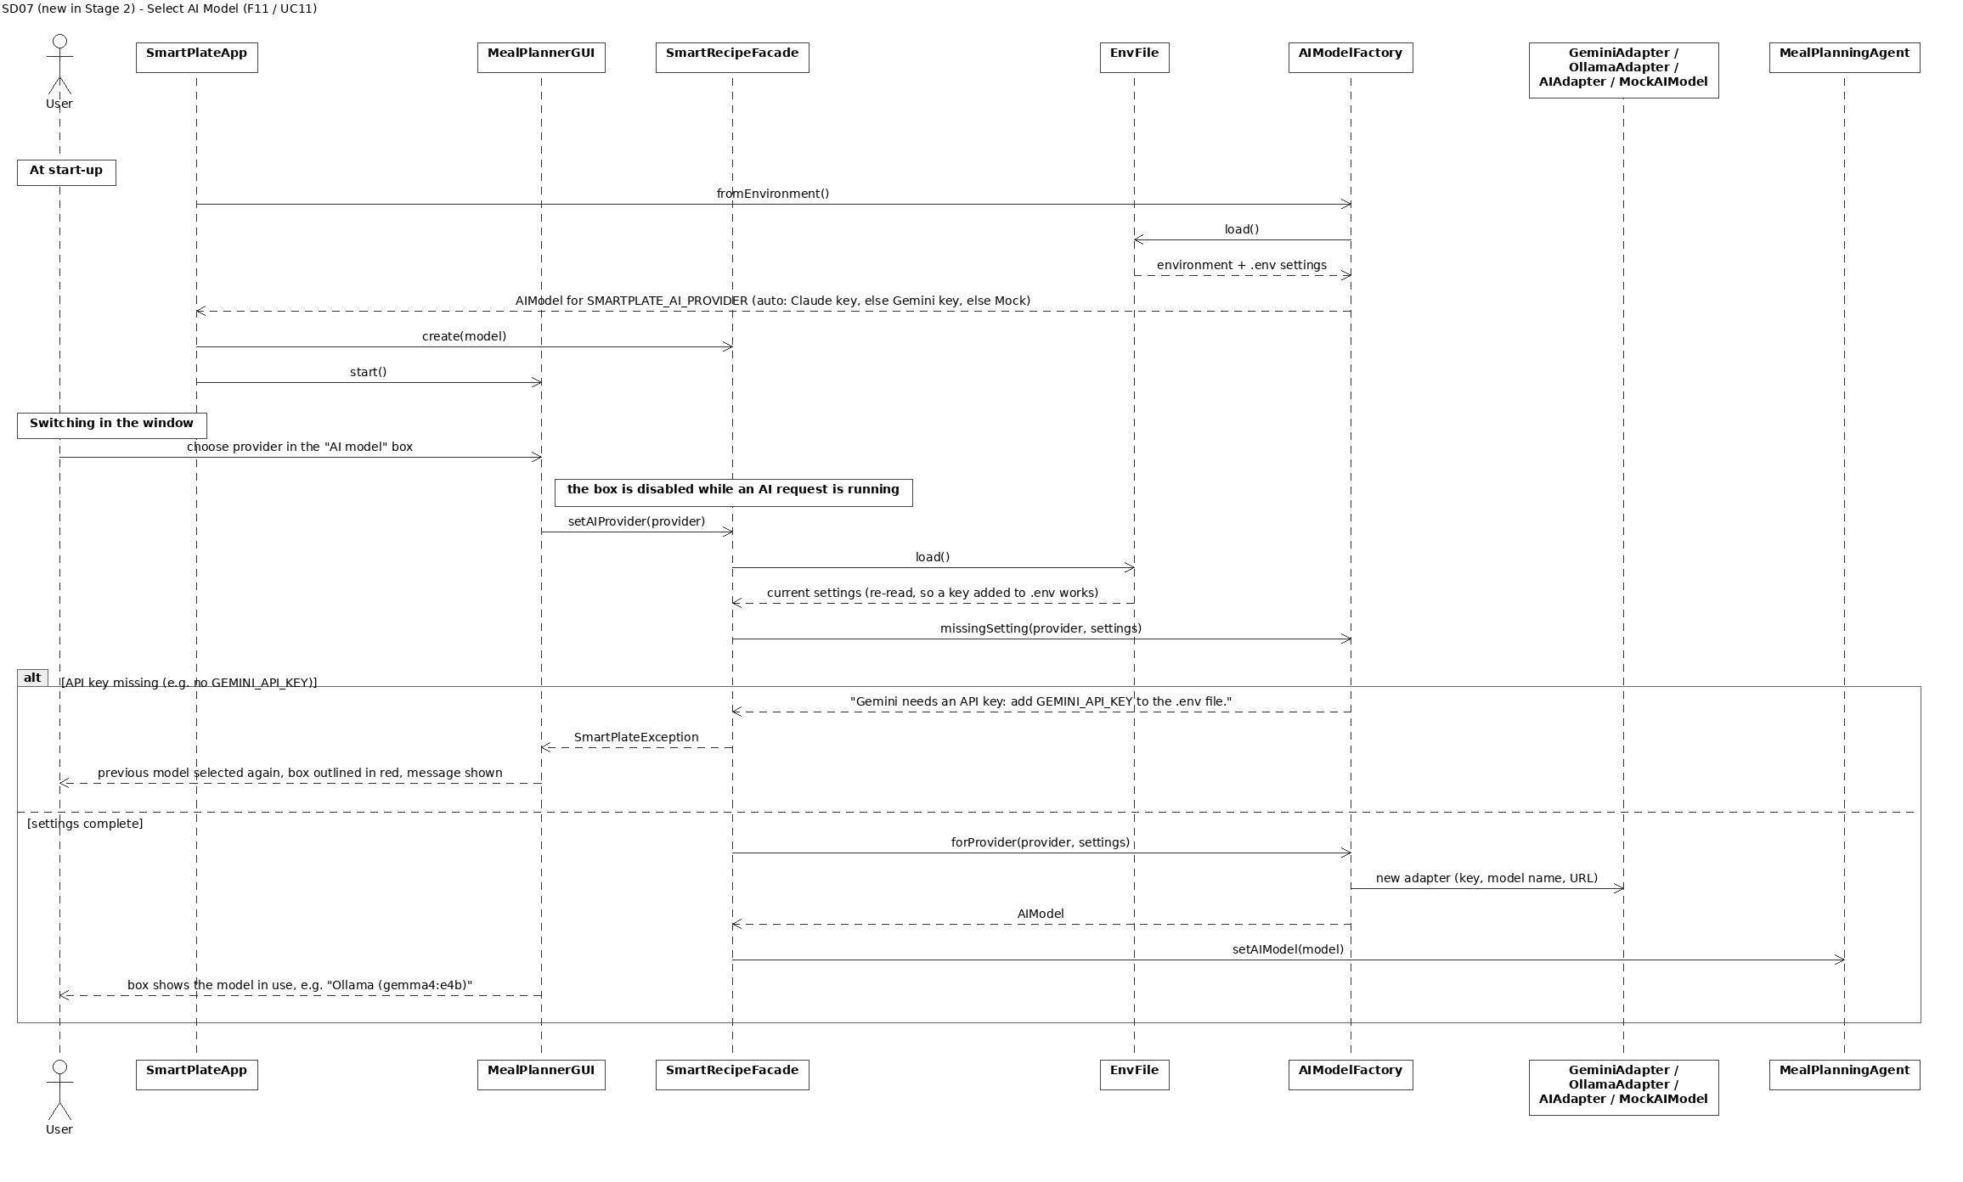
The updated SD03, SD04 and SD05 are in docs/umlet-diagrams/stage2/sequence/ (PNG next to each .uxf).

4. Changes and rationale

4.1 Consolidated record
# | Original design | Implemented change | Reason | Impact
1 | Request text goes to the AI; the validator checks the profile (F04–F06) | RequestConstraints reads diet, "avoid …", time limit, number of days/items and servings from the request; UserProfile.withRequestConstraints adds them to a copy of the profile | An LLM can ignore constraints that are only in the prompt; this keeps "AI chooses, Java checks" true for the request too | New class in agent/; SD03–SD05 updated; the stored profile is never changed
2 | AIClient.sendRequest(prompt : String) : String | sendRequest(MessageCreateParams) : Message (Anthropic SDK types) | With strings on both sides there would be nothing to adapt; now AIClient is a real adaptee | Adapter matches the textbook roles; agent unaffected
3 | One external LLM behind AIAdapter → AIClient | GeminiAdapter, OllamaAdapter added; AIModelFactory picks one | Free/cheap models for the team (the course allows any cheap or free model); the design planned for provider changes | Agent unchanged; new Factory pattern; tests with fake servers
4 | Model fixed at start | F11: switch in the GUI; MealPlanningAgent.setAIModel, SmartRecipeFacade.setAIProvider; one model per request; boxes locked while a request runs | Compare models in a demo; avoid a request answered by two models | New UC11 / SD07; GUI still only uses the facade
5 | "Key from an environment variable" | EnvFile also reads a git-ignored .env; .env.example with placeholders | Easier local setup without committing keys (Stage 2 key-protection rule) | New class; README explains copy → fill → run
6 | Free-form prompt and answer | PromptFormat KEY: value protocol shared by agent, mock and real models | Reliable parsing; the mock exercises the same parsing code | New class in ai/
7 | Validation "using each recipe's ingredient list" | DietRules (ingredient-level matching: plurals, food groups, accents, dairy dislikes) and Units (unit conversion) | Validator, strategies, substitution and pantry need one shared set of rules | Two helper classes in domain/
8 | Ten GUI screens (Appendix B) | Four tabs (AI Assistant, Recipes, Pantry, Preferences) built from presentation/gui/*; "Clean Slate" design chosen by the team | Fewer screen switches, every Appendix B screen still present | MealPlannerGUI delegates to four panels and small UI helpers
9 | Conceptual CLI commands (recipe search, plan create …) | Short commands (search, recommend, plan, edit, undo, scale, …) plus strategy and trace | Shorter to type; trace shows the agent's steps | CLI help documents all commands
10 | Facade shows currentPlan and the 12 feature methods | Facade also owns profile, pantry, last substitution; read methods for the UIs | UIs must display state without bypassing the facade | Layering preserved
11 | editPlan with the day in the request | If no day is named, the AI chooses it (validated); Days.findIn keeps hyphenated words whole | Natural requests ("swap the shrimp dish …"); fixes "sun-dried" = Sunday | SD05 updated
12 | CommandHistory.undoStack : Stack<Command> | ArrayDeque<Command> | Java's recommended stack | None
13 | Errors shown as "error" returns | SmartPlateException, InvalidProfileException, AIServiceException | One user-facing message for both UIs, shown next to the field | New exception classes
14 | Shopping list quantities as computed | Counted items rounded up to whole pieces, with a note | People buy whole items | ShoppingList.roundUpQuantities
15 | Disliking an ingredient blocks every name containing it | A disliked dairy food ignores non-dairy ingredients named after it; allergies unchanged | "Milk" dislike blocked oat milk, its own substitute | DietRules.matchesDislike
16 | Not specified | Days, SampleData (30 recipes, pantry, 33 substitutions), SmartPlateApp, MAX_CANDIDATES = 15 | Needed to run; short prompts | —

4.2 New and substantially modified features (Section 3 of the instructions)
F11 AI Model Selection — new. (1) Original: none (new). (2) Implemented: the AI model box lists Mock, Claude, Gemini and Ollama; choosing one switches the agent's model, or explains which key is missing; start-up choice from .env/SMARTPLATE_AI_PROVIDER; --mock forces the mock. (3) Why: the course allows cheap or free models and the team wanted to compare a free local model with a cloud model; the Stage 1 design already promised provider independence. (4) User need: users without a paid key can still use a real LLM (local Ollama), and everyone can run offline. (5) Affected: new UC11 and SD07; classes AIModelFactory, EnvFile, GeminiAdapter, OllamaAdapter, MealPlannerGUI, SmartRecipeFacade, MealPlanningAgent, AssistantPanel, SmartPlateApp; methods setAIProvider, setAIModel, forProvider, missingSetting, onBusyChange; patterns Adapter, Factory, Facade.
F04/F05/F06 — modified. (1) Original: F04, F05, F06. (2) Implemented: constraints in the request are enforced as hard rules; plans need 5–7 days before any AI call; edits may let the AI choose the day; each request uses one model. (3) Why: see rows 1, 4 and 11 above. (4) The original need (validated AI choices) is met more strictly. (5) Affected: UC04–UC06, SD03–SD05, MealPlanningAgent, RequestConstraints, Days, ConstraintValidator; patterns unchanged.
F01, F08, F10 — small behaviour changes, not new features: accented entries (F01), dairy dislikes vs plant-based substitutes (F08), whole-piece rounding (F10). Use cases and patterns unchanged.

4.3 New and modified design patterns
Factory — added. (6) Original pattern: none. (7) Implemented: a static factory, AIModelFactory. (8) Roles: factory AIModelFactory; products AIAdapter, GeminiAdapter, OllamaAdapter, MockAIModel (all AIModel); configuration source EnvFile; clients SmartPlateApp, SmartRecipeFacade. (9) Problem: model construction needs provider-specific settings at two places (start-up and run-time switch). (10) Appropriate because it keeps construction out of the entry point and the facade; architecture impact: one new class in ai/, presentation still unaware of adapters.
Adapter — extended. (6) Original: AIAdapter → AIClient plus MockAIModel. (7) Implemented: the same pattern with two more adapters. (8) Roles as in §3.2. (9) Problem: support free providers. (10) The agent and facade did not change, which confirms the Stage 1 choice.
The five Stage 1 patterns are all implemented; none was replaced.

5. AI tools and collaboration log

5.1 AI tools and models used for development
Tool / platform | LLM model | Features, classes or tasks | Tokens and cost
Claude Code (Anthropic's coding agent, used in claude.ai/code cloud sessions) | [Team] — record the model exactly as shown in the Claude Code session details | Generated the implementation of F01–F10 and the five patterns, the GUI redesign, the Gemini/Ollama adapters and the model switcher, most tests, the docs and this report's draft; diagnosed defects A1–A6 and wrote the proposed fixes the team applied; produced the Stage 2 UMLet diagrams | One session, 5–29 Oct 2026 (session usage record, as of 29 Oct): 93,041 input tokens, 751,231 output tokens, 139,867,422 cache-read tokens, 4,516,068 cache-write tokens; reported cost ≈ US$79.01. [Team] update with the final numbers and state whether this was billed or covered by a subscription.
[Team] other tools (e.g. a chat assistant used for the Stage 1 report or for AIModelFactory) | [Team] | [Team] | [Team]
LLMs inside the product (run time, not development tools): Mock AI (offline), Google Gemini (GEMINI_MODEL, default gemini-flash-latest), a local Ollama model (team: gemma4:e4b), and optionally Anthropic Claude (SMARTPLATE_AI_MODEL). [Team] add any API cost you incurred while running them.

5.2 Representative AI–human interactions
Drafted from the Claude Code session history; [Team] confirm each entry and add your own review notes and other interactions.
# | Task | Input / instruction | AI contribution | Human contribution | Outcome
CL-01 (5 Oct) | Implement the Stage 1 design in Java | "Make the complete project in Java implementing every feature as said in the report …" | Generated all classes from the class diagram, sample data, GUI and CLI over the facade, 88 tests, code documentation; followed SD05 where the text was silent (one AI attempt for edits) | Wrote the design that was implemented; chose the branch holding the final design. [Team] review notes | Incorporated (commit 0f85939)
CL-02 (5 Oct) | Front-end options and a backend guide | Asked how a React/Flutter front end could use the Java logic, then for a Spring Boot guide; "do not make it or run … Do not make anything" | Explained the REST approach; wrote a conversion guide; stopped verifying it by building when told | Kept the AI to explanation only, protecting the project scope | Not incorporated (personal reference)
CL-03 (15 Oct) | GUI design proposals | "Give me a bunch of designs … and a Figma AI prompt" | Mockups of several directions with real sample data; Figma prompt | Asked whether the AI had read the code first; corrected the platform ("it is a desktop app, only light mode"); showed the current GUI; chose Direction B | Direction B became the specification
CL-04 (15 Oct) | Implement Direction B in Swing | Build it on a new branch | Four tab panels, FlatLaf theme, 14 GUI tests; tests and screenshots exposed four GUI bugs, which it fixed | Chose the design; required a separate branch; supplied the submitted Stage 1 report | Incorporated (e4c412d)
CL-05 (15 Oct) | Make the code understandable to the team | "Give me a complete guide … (I know React, not much Java)" | DEVELOPER_GUIDE.md with React analogies, function reference, walkthroughs | Asked for a format the team can learn from and maintain | Incorporated, kept up to date
CL-06 (15 Oct) | Question a technical choice | "Why JDK 21? … Why not JDK 25?" | Explained the Java 17 target and why 21 was recommended | Challenged an unexplained decision | No change
CL-07 (15 Oct) | Choose the AI model by configuration | Team design: OllamaAdapter implements AIModel; team wrote AIModelFactory and the new SmartPlateApp.chooseModel | Added the team's files unchanged; wrote OllamaAdapter to the factory's API; tested with a fake server; merged the team's Stage 1 merge into its branch | Designed the extension with the Stage 1 Adapter; wrote the factory; ran the app with gemma4:e4b | Incorporated (7451c60)
CL-08 (15 Oct) | Keep API keys out of git | "Can I have some safe way of adding the key that I don't have to push?" | Started implementing .env support before approval | Stopped it: "Don't keep adding things unless I ask. Tell me first."; reviewed and approved the change | Incorporated (6eacd8f)
CL-09 (15 Oct) | Gemini and a model switcher | "Add an adapter for Gemini … proper commits … an option on top right to switch models" | GeminiAdapter (chose the gemini-flash-latest alias after conflicting sources), switcher, four commits; fixed a truncated label found in a screenshot | Ran the app with both models locally; decided model names belong in .env | Incorporated (5430d5a, 4bf232f)
CL-10 (23–28 Oct) | Check against the Stage 2 instructions | Pasted the Stage 2 PDF; "scan the repo … give me a roadmap" | Gap analysis (report format, UML, videos, commits); scanned history for leaked keys (none) | Set the scope; told the professor about the early start; chose the branching strategy (develop + fix/*) | Roadmap (phases A–F)
CL-11 (28 Oct) | Fix defects A1–A3 | "I can fix it. Just tell me where and how" | Reproduced each defect, explained the cause, wrote the code, tests and CLI/GUI test steps | Implemented, tested and committed the fixes on separate branches; kept the model defaults as they were | Incorporated (6bfd56c, f70e701, 86b5b1e)
CL-12 (29 Oct) | Fix defects A4–A6 | "Give me all remaining fixes together … I will do it branch by branch" | Prepared and pre-tested four fixes on a scratch copy, plus patch files and test prompts | Applied each fix on its own branch, ran the checks, merged through PRs #6–#9 | Incorporated (db82527, 9deb476, 82148d6, 94a8a8a)
CL-13 (29 Oct) | Stage 2 UML | Phase B | First drew the diagrams in PlantUML | Corrected the format: "We have to submit UMLet files" | Diagrams redone as UMLet .uxf (same style as Stage 1)
CL-14 (29 Oct) | Prepare the feature videos | Phase E1: a recording script | Wrote docs/DEMO_SCRIPT.md after running every error case in the CLI; found that a second undo printed "Undone." before the error, and prepared a fix with a test | [Team] applied the fix (A7) on a fix branch and recorded the videos | [Team]
CL-15+ | [Team]

6. Development and verification summary

6.1 Branching strategy and commit summary
The team uses main ← develop ← short-lived fix/* / feat/* branches, merged through pull requests with merge commits (no squash), so every commit stays visible. To count meaningful code commits on all branches: git log --all --no-merges -- src pom.xml.
Implementation started before the Stage 2 period (the professor was informed); the team counts total meaningful code commits across the stage.
Period (Toronto) | Meaningful code commits | Links
Before 20 Oct (early start) | 6 | 0f85939 implementation of F01–F10 · e4c412d GUI redesign · 7451c60 model factory + Ollama · 6eacd8f .env · 5430d5a Gemini · 4bf232f model switcher
1: 20–26 Oct | 0 | (planning against the Stage 2 instructions)
2: 27 Oct – 2 Nov | 7 so far | 6bfd56c whole-piece rounding · f70e701 "sun-dried" day fix · 86b5b1e multi-word avoid · db82527 dairy dislikes · 9deb476 one model per request · 82148d6 accented entries · 94a8a8a boundary tests
3: 3–9 Nov | [Team] | [Team] add the commits made in this period
Total | 13 so far | 15 required in total
Pull requests: #3–#9 (one per fix branch). Documentation-only commits (report, diagrams, README) are not counted.

6.2 Checks performed
- Automated tests: mvn test → 129 tests, 0 failures (JUnit 5, all offline; 16 GUI tests run headless). The agent loop is tested with scripted bad AI answers; every AI adapter is tested against a fake server speaking its API.
- Running the application: the packaged jar was run through the CLI and the GUI after each change (GUI on a virtual display, with screenshots); the team ran it on their machines with Gemini and with the local Ollama model gemma4:e4b.
- Each defect fix: reproduced first (CLI/GUI), then a test that fails without the fix and passes with it, then the CLI/GUI check repeated.
- Secrets: the full git history was scanned for API-key patterns; none found. .env is git-ignored.

6.3 Important defects found and corrected
Defect | How it was found | Fix
Pantry "Added …" message disappeared at once | new GUI test | message set after the row selection
Pantry error shown next to the wrong field | new GUI test | error-to-field mapping order
Preferences column clipped; table headers misaligned | GUI screenshots | layout fixes
Model name cut off in the AI model box ("Ollama (ge…") | GUI screenshot | box re-measured after each switch
A1 "13.5 pcs garlic" in the shopping list | review of CLI output | round counted items up (6bfd56c)
A2 "sun-dried" read as Sunday (edit failed or changed Sunday) | review of the day parser | Days.findIn (f70e701)
A3 "avoid red onion" avoided "red" (and red lentils) | review of the request parser | phrase-based avoidedItems (86b5b1e)
A4 disliking milk blocked oat milk as milk's substitute | substitution test | DietRules.matchesDislike (db82527; the commit message says "allergy", but the change applies to dislikes; allergies stay strict)
A5 a request could use two models if switched mid-way | code review | one model per request, boxes locked (9deb476)
A6 "jalapeño" rejected as malformed | manual test | accented letters accepted (82148d6)
A7 CLI printed "Undone." and then "Nothing to undo." | checking every error case for the demo script | undo first, print after; new CLI test ([Team] commit id)

6.4 Remaining limitations
See §1. Stage 3 will add the full deterministic test report and the KUMA agent-behaviour testing.

7. Demonstration index
Each implemented feature has a labelled video segment. Recordings use a real model (Gemini or the local Ollama model) for the AI features and show both the GUI and the CLI. The recording script is in docs/DEMO_SCRIPT.md. [Team] paste the links and timestamps.
Feature | Shown in | Link / timestamp
F01 Preference Profile Management | GUI + CLI (invalid profile error) | [Team]
F02 Pantry Inventory Management | GUI (merge units, error) + CLI | [Team]
F03 Recipe Search | GUI + CLI (empty query error) | [Team]
F04 AI Recipe Recommendation | GUI with trace + CLI | [Team]
F05 AI Weekly Meal Planning | GUI (avoid, time limit; 8-day error) + CLI | [Team]
F06 Meal Plan Editing and Undo | GUI (CHANGED marker, Undo) + CLI | [Team]
F07 Serving-Size Adjustment | GUI + CLI | [Team]
F08 Ingredient Substitution | GUI (dislike milk → oat milk) + CLI | [Team]
F09 Nutrition Information | GUI (recipe and plan) + CLI | [Team]
F10 Shopping List Generation | GUI (pantry subtracted, whole pieces) + CLI | [Team]
F11 AI Model Selection (new) | GUI (switch model, missing-key message, boxes locked during a request) | [Team]

