1. select count(*) Total_loan_applicant from Bank_loan_data;

select count(id) as MTD_

1. Total_loan_Application from Bank_loan_data

where month(issue_date) = 12 and YEAR(issue_date)=2021;



1. Select count(id) as PMTD_Total_loan_Application from Bank_loan_data

where month(issue_date) = 11 and YEAR(issue_date)=2021;



1. select sum(loan_amount) as Total_Funded_Amount from Bank_loan_data;



1. select sum(loan_amount) as PMTD_Total_Funded_Amount from Bank_loan_data

where month(issue_date) = 11 and YEAR(issue_date) = 2021;



1. select sum(loan_amount) as MTD_Total_Funded_Amount from Bank_loan_data

where month(issue_date) = 12 and YEAR(issue_date) = 2021;



1. select sum(total_payment) as Total_received_amount from Bank_loan_data;



1. select sum(total_payment) as MTD_Total_received_amount from Bank_loan_data

where month(issue_date) = 12 and Year(issue_date) = 2021;



1. select sum(total_payment) as PMTD_Total_received_amount from Bank_loan_data

where month(issue_date) = 11 and Year(issue_date) = 2021;



1. select round(avg(int_rate),4) * 100 Avg_interest_rate from Bank_loan_data;



1. select round(avg(int_rate),4) * 100 MTD_Avg_interest_rate from Bank_loan_data

where month(issue_date)=12 and Year(issue_date)=2021;



1. select round(avg(int_rate),4) * 100 PMTD_Avg_interest_rate from Bank_loan_data

where month(issue_date)=11 and Year(issue_date)=2021;



1. select round(avg(dti),4) * 100 Avg_DTI from Bank_loan_data;



1. select round(avg(dti),4) * 100 MTD_Avg_DTI from Bank_loan_data;

where month(issue_date) = 12 and Year(issue_date) = 2021;



1. select round(avg(dti),4) * 100 PMTD_Avg_DTI from Bank_loan_data;

where month(issue_date) = 12 and Year(issue_date) = 2021;



1. select(((select round(avg(dti),4) * 100 MTD_Avg_DTI from Bank_loan_data

where month(issue_date) = 12 and Year(issue_date) = 2021) - (select round(avg(dti),4) * 100 PMTD_Avg_DTI from Bank_loan_data

where month(issue_date) = 11 and Year(issue_date) = 2021)) * 100)

/

(select round(avg(dti),4) * 100 PMTD_Avg_DTI from Bank_loan_data

where month(issue_date) = 11 and Year(issue_date) = 2021)

as MTM_Avg_dTI;



1. Select

(count(case when loan_status = 'Fully Paid' OR loan_status = 'Current' then id END) *100)

/

count(id) as Good_loan_percentage

from Bank_loan_data;



1. Select count(ID) as Good_loan_application from Bank_loan_data

where loan_status = 'Fully Paid' OR loan_status = 'Current';



1. Select sum(loan_amount) as Good_loan_funded_amount from Bank_loan_data

where loan_status = 'Fully Paid' OR loan_status = 'Current';



1. Select sum(total_payment) as Good_loan_received_amount from Bank_loan_data

where loan_status = 'Fully Paid' OR loan_status = 'Current';



1. Select

(count(case when loan_status = 'Charged Off' then id END) *100)

/

count(id) as Bad_loan_percentage

from Bank_loan_data;



1. Select count(ID) as Bad_loan_application from Bank_loan_data

where loan_status = 'Charged Off';



1. Select sum(loan_amount) as Bad_loan_funded_amount from Bank_loan_data

where loan_status = 'Charged Off';



1. Select sum(total_payment) as Bad_loan_received_amount from Bank_loan_data

where loan_status = 'Charged Off';



1. select

loan_status,

count(id) as Loan_count,

Sum(total_payment) as Total_amount_received,

Sum(loan_amount) as Total_funded_amount,

Avg(Int_rate * 100) as interesr_rate,

Avg(dti * 100) as DTI

From

Bank_loan_data

Group by

loan_status;

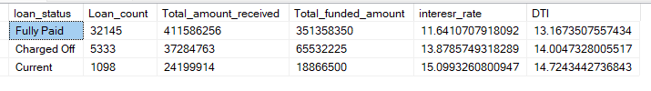

1. select

loan_status,

Sum(total_payment) as MTD_Total_amount_received,

Sum(loan_amount) as MTD_Total_funded_amount,

Avg(Int_rate * 100) as MTD_interest_rate,

Avg(dti * 100) as MTD_DTI

From

Bank_loan_data

where month(issue_date)=12 and year(issue_date)=2021

Group by

loan_status;

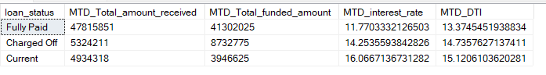

1. select

loan_status,

Sum(total_payment) as PMTD_Total_amount_received,

Sum(loan_amount) as PMTD_Total_funded_amount,

Avg(Int_rate * 100) as PMTD_interest_rate,

Avg(dti * 100) as PMTD_DTI

From

Bank_loan_data

where month(issue_date)=11 and year(issue_date)=2021

Group by

loan_status;

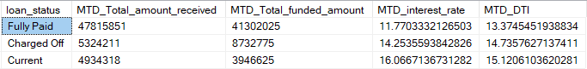

1. select

home_ownership,

count(id) as Loan_count,

Sum(total_payment) as Total_amount_received,

Sum(loan_amount) as Total_funded_amount,

Avg(Int_rate * 100) as interesr_rate,

Avg(dti * 100) as DTI

From

Bank_loan_data

Group by

home_ownership

having

home_ownership = 'MORTGAGE';



1. select

month(issue_date) as Month_number,

DATENAME(Month, issue_date) as Month_name,

count(id) as Loan_count,

Sum(total_payment) as Total_amount_received,

Sum(loan_amount) as Total_funded_amount

From

Bank_loan_data

Group by

Month(issue_date),

DATENAME(Month, issue_date)

Order by

Month(issue_date);

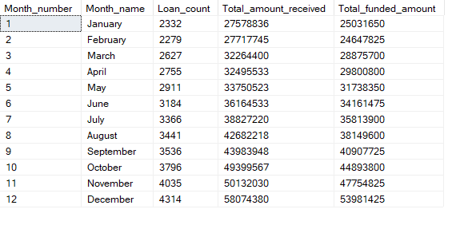

1. select

address_state,

count(id) as Loan_count,

Sum(total_payment) as Total_amount_received,

Sum(loan_amount) as Total_funded_amount

From

Bank_loan_data

Group by

address_state

Order by

Total_funded_amount desc;

1. select

term,

count(id) as Loan_count,

Sum(total_payment) as Total_amount_received,

Sum(loan_amount) as Total_funded_amount

From

Bank_loan_data

Group by

term

Order by

Loan_count desc;

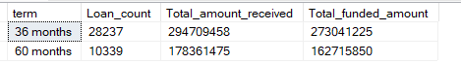

1. select

emp_length,

count(id) as Loan_count,

Sum(total_payment) as Total_amount_received,

Sum(loan_amount) as Total_funded_amount

From

Bank_loan_data

Group by

emp_length

Order by

emp_length;

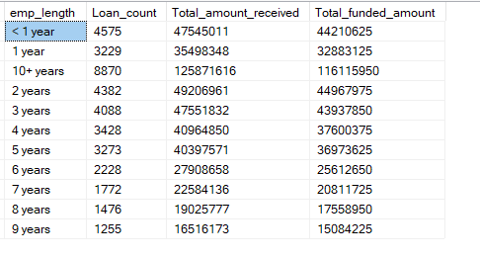

1. select

purpose,

count(id) as Loan_count,

Sum(total_payment) as Total_amount_received,

Sum(loan_amount) as Total_funded_amount

From

Bank_loan_data

where loan_status = 'Fully Paid' OR loan_status= 'Current'

Group by

purpose

Order by

Loan_count;

