MAGICBRICKS

Ad Package pricing-

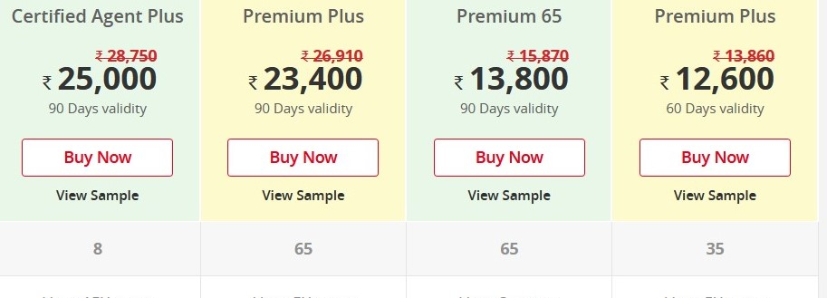

Tenant verification-

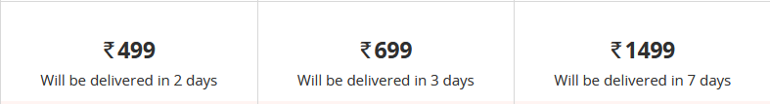

99ACRES

Single Ad package pricing-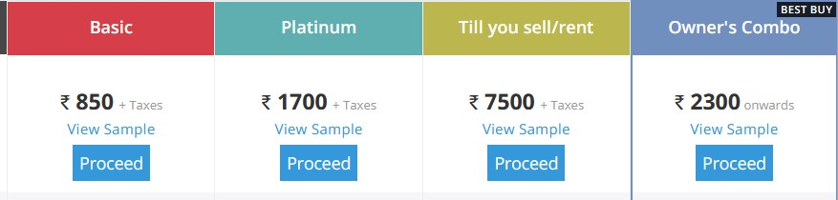

MAKAAN.com

Charges on closed transactions

Problems-

1. Awkward tenant/owner relationship, which hasn’t been addressed by anyone yet.

2.No place to manage/store tenant paperwork/documents.

3. A large time/resources consumed in tenant verification.

4. Badly treated or expectations not met even after paying for premium in rental search apps.

5. Difficulty in managing many apartments.

6. Complaints/requests being ignored by owners.

In Depth analysis:

1. Tenants dislike or feel humiliated, angry and embarrassed when the owner asks for rent. Or if the owner is rude and confronts them face to face regarding things like noise, in-out timings. In short, they hate being told “you can’t do this” at their face.
2. Tenants prefer work to work kind of relationship with the owners .
3. Tenants feel that the issues raised by them are often ignored or not addressed. They don’t have a platform to raise their concerns/issues or give anonymous feedbacks to owners.
4. Many a times they rent accommodations with bad owners as no genuine history or reviews are available.
5. Most often in PG’s there are recurrent problems like Reminding owners every month like oh the tv recharge is due etc. So calling the owner again and again is also an issue.
6. Owners feel that managing different apartments and keeping note of rents gets a bit hectic.
7. They also feel that paperwork is hard to manage and not easily accessible.
8. Many owners feel that personally confronting tenants about things like rent increase or rent delay and other problems like noise can lead to bad relationships with long term tenants. They want to keep good and distant relationship with tenants without interfering in each other’s lives.
9. Owners do not have tools to address all the tenants at once. For eg no electricity/water today.
10. For owners living away from the rented apartments they are constantly worried about sound/noise issues which might disturb the neighbors.
11. Tenant verification and background check is a law and hence mandatory. So it gets hard for pg owners in particular who have high tenant frequency rate to take out time for these verifications.
12. Physical confrontation often led to bad blood between tenants and the owners.
13. People who want to sell/rent accommodations often have to pay for the listings on a platform.
14. Agents and builders are charged a hefty amount for this.
15. People who opt for these paid services are unsatisfied and angry due to lack of customer support/ghosting.
16. Buggy apps.
17. Users start getting calls from a lot of brokers etc.
18. Even users can contact a limited number of owners. So basically everything is charged for.
19. Some owners restrict tenants from using services like terrace. Tenants felt that restricting them on their face is quite rude and the owner should opt for a softer or a less rude approach and the owner on the other hand is compelled to be clear and explicit so that his conditions are taken care of.

Solution-

A Tenant management and communication tool with unlimited free listings.

1. Stores all tenant paperwork and documents online(of every tenant till date).
2. Tenants can file complaints or address issues to the owner(can be anonymous) so that the owner is reminded of unresolved complaints.
3. Owners can address all of it’s tenants at once.
4. Can manage different apartments.
5. Owner can send rent increased or rent due etc notifications to tenants.
6. A tenant will be automatically reminded of the due rent
7. Tenant verification can also be initiated by paying a small amount
8. Other small charges which are shameful to be asked for can be added to the application itself.
9. Tenants can view the rules and regulations or the rent agreements any time.
10. Unlimited listings (with some catch like limited photos for unsubscribed accounts or maybe not. Can be used as an attraction too,), rehashing the ads so that every ad gets equal visibility no matter old or new. No brokers, no shared contacts of users.
11. An integrated sound level meter which would notify owners and tenants in case of increased noise levels.

Market-

1. **$20 billion** residential rental market. (India)
2. There are **27.4 million** **rented households in India.**

**Business Model**

1. Charged for tenant verification(even if we earn INR 100/year from each household, the revenue will account to 274 crores )
2. Can be charged for a higher quality/visibility listing. Can charge 500/month(purely tentative) for better visibility of their ads.(around 10 Lac Real Estate Brokers many of whom currently pay more than 23,000/3 months for around 8 listings at high visibility)(amounts to max amount INR 600 crores)

Maximum revenue with min pricing=INR 874 crores)

1. Many other things are yet to be thought of.

INNAGO

Founded-2017

Funding-$3.7 million

What is it?

Easy to use property management software for small-to-mid-sized landlords.

Active in – USA

Details- Landlords can collect rent via ACH or credit cards. Users can set rents, configure late fees, waive fees if needed and manage recurring charges

like parking fees and utility bills. Email reminders are sent to tenants before rent is due, when rent is due and if a payment is late. Innago also includes invoice generation, late fee assessment, account deposits and invoice tracking. Multiple bank accounts are supported.

Esignature tools let tenants sign leases remotely from mobile or desktop devices. Landlords and tenants can access documents remotely as well, built-in lease templates allow users to configure rental amounts, lease dates and pet addendums. Users can also add, remove, and sublease tenants. Communication tools let users contact individuals or entire properties.

APARTMENT.COM/COSY

Cosy is tenant management. Listings are on apartment.com

Owner ke paper lagte hai ya nahi? Verification me