Sometimes we need to compile reviews for a variety of locations, and one area we may turn to is Google Map reviews.

Here is how I gather Google Maps reviews using Selenium Python and store them in.csv files.

Please feel free to give it a try as well!

Go to the Google Map and select the location where you would like reviews before we begin.

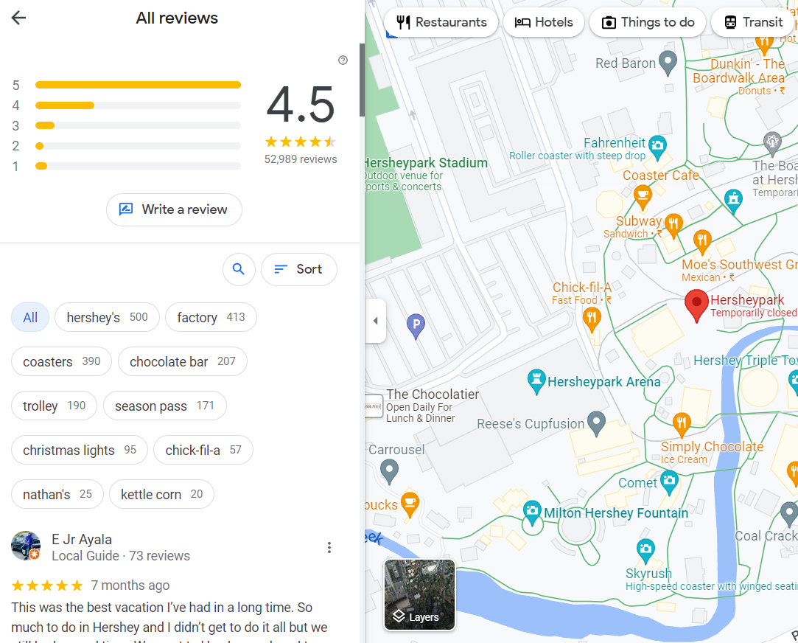

Scroll to the review part:

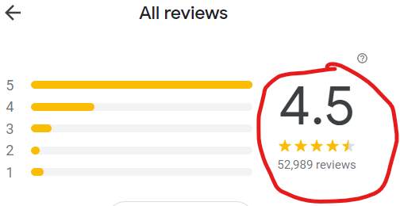

After that copy the link

Keep that URL open, then return to our Python script. Import the necessary libraries as listed in the requirement.txt document

Then connect your chrome driver.

Put the link that you copied into the variable name "url".

On my end, I'd like to see the most recent evaluation because I'll schedule it every day so that the operation team of our business can take the necessary action as soon as possible. Therefore, whether you require the same or different items depends on your needs.

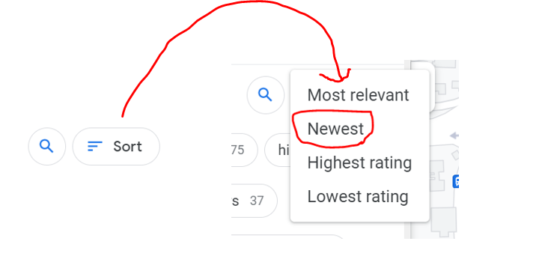

I will browse to the bottom of the page after it has been sorted by newest in order to gather all the necessary data. You'll see that I put 5 scrolls in the code because I only require the most recent 50 reviews on a daily basis. If you don't, you'll only receive 10 reviews by default. There will be an additional 10 reviews for each scroll.

After scrolling, we need to open all the "More" under reviews. Else we will not be able to get the full reviews.

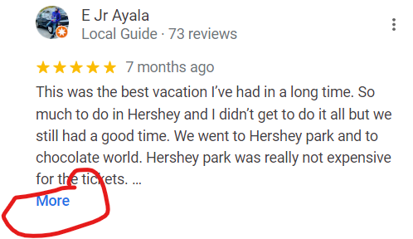

As a result, I navigate to the portion of the script section where all the reviews are stored. Using "inspection," you may obtain the xpath.

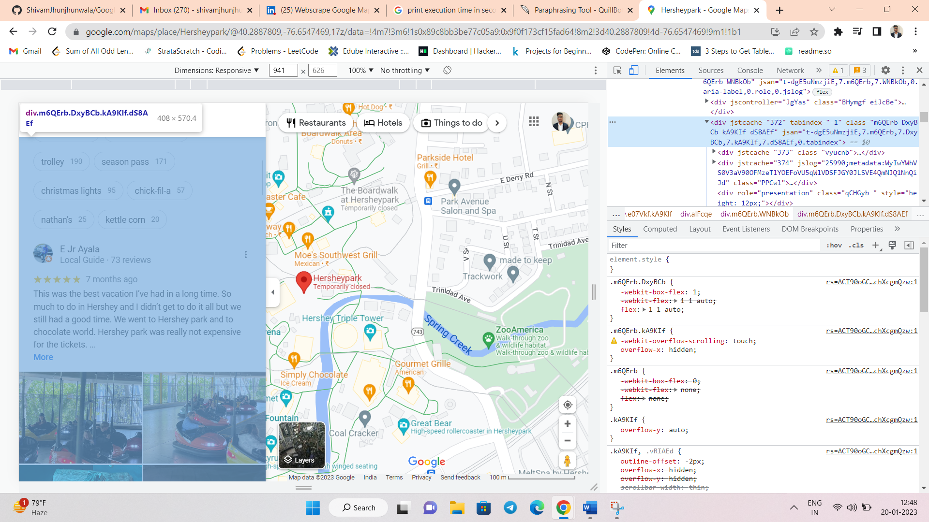

I created empty list as well for me to append data and convert into Data Frame.

I then proceed to click "More" on each review that contains it. After that, I add all of the information to the newly created empty list based on the class I discovered for name, ratings, review, and the day they commented.

Then we can now convert our findings into .csv file.