***ABSTRACT* - In present Day scenario there are lots of threats for the Army personals, so our project is to prepare an unmanned robot to ensure the safety. Basically, it is designed for the surveillance in the remote location. It can detect the bomb as well as send an alert of the bomb location using the GPS module to the specified person. At the time of surveillance in the remote areas, if there is a suspicious activity by an intruder then it immediately captures the face and sends it to the specified person and it can live stream the video so that we can track the further activities of the intruder. Along with this, it can be used in the forest for the surveillance as well as to detect the forest fires so that there will be no harm to the nature.**

**Military Surveillance Robot**

**INTRODUCTION**

Surveillance is major thing when we are going to secure anything as it is tedious job peoples are getting boarded because of that it will might risky to observing all these things we are going to make a robot which is continuously monitor thing. This robot continuously watches and sending a live streaming of it to an authorized person. Because of that monitoring the work will be somewhat easy and it will be making accurate because of technology.

The project is aimed at evaluating the performance of an operating system on an embedded system. Before delving into its implementation, an introduction is needed to the parts involved in the project. The whole report is centred around the field of embedded systems and the use of Linux to run applications on them. Hence an introduction to Embedded Systems and using Linux as an OS in them is provided.

The implementation of this project to resolve the problem of replacing human to surveillance robot, because of this we reduce harm of human resource. Robot are usually miniature in size so they are enough capable to enter in tunnels, mines and small holes in building and also have capability to survive in harsh and difficult climatic conditions for life long time without causing any harm. Military robots were designed from last few decades.

Nowadays, most of the system uses a mobile robot with a camera for surveillance. The camera mounted on the robot can move to different locations. These types of robots are more flexible than the fixed cameras. In it is given that mostly used surveillance robots are wheel robot. The wheel-based robots are more suitable for flat platform. With the development in wireless communication and internet, the videos captured by wheel robot can be seen remotely on computer or laptop.

The complexity of computer software depends on how difficult the robot’s tasks are. In this project we use internet to establish communication between the user and a bomb detection robot. This is a reliable connection and a continuous tracking and video feedback is available to control the bomb detection robot. Due to the use of internet, there is no limitation on range or distance between the user and the bomb detection robot. Internet robotics has opened up a completely new range of real-world applications namely tele-surgery, tele-manufacturing, tele-training, tele-surgery, traffic control, health care, space exploration, disaster rescue etc. and the list is supposed to increase further in the coming years.

**LITERATURE REVIEW**

In the paper [1] “Surveillance and monitoring system using Raspberry Pi and Simple CV” by Paul, M., Haque published in 2015 features Simple CV In Raspberry pi for surveillance and stream in MPJG streamer online video by using Simple CV in Raspberry pi, Webcam and local host server. It has the characteristics as same network local host Server for streaming.

In the paper [2] “Pibot: The raspberry pi controlled multi-environment robot for surveillance & live streaming” by Ikhankar published in 2015 featuresLocal host server with master and client approach by using Raspberry pi webcam and stream broadcast server. It has the characteristics as Same network local host Server for streaming

In the paper [3] “Live video streaming system using raspberry pi with cloud server” by Filteau published in 2016 features Embedded Real Time Video monitoring system out cloud host by using Cloud host to interface between Service master and Client. It has the characteristics Broadcasting to all area network.

In the paper [4] “Wireless sensor-based control of mobile robots’ motion” by Mester published in 2009 features Bluetooth Signal controlling smaller range host by using Bluetooth module, local host server and end mobile application to embed on controls. It has the characteristics as A smaller range Remote control.

In the paper [5] “Wi-Fi Control Bot with Real-Time Video Streaming” by Khiangte published in 2016

features Wi-fi based cloud computing with embedded Adafruit IO libraries by using Wi-fi network with cloud implementation to create wide area server. It has the characteristics as Universal range remote.

In the paper [6] “Human detection in surveillance videos and its applications” by Paul published in November 2013 features image processing as a technique to detect human motions. by using KTH human motion dataset, Weizmann human action dataset, INRIA XMAS multi-view dataset. It has the characteristics as Video sequences, object detection, object classification and human detection.

In the paper [7] “A Review on Human Activity Recognition Using Vision-Based Method” by Zhang, Shugang & Wei published in Jul 2017 features Intra class variation and intra class similarity, Recognition under real-world setting, Recurrent and deep neural network by using NTU-MSR Kinect Hand Gesture Dataset, Action/Activity Data sets, KTH Activity Data sets. It has the characteristics as Dynamic time-wrapping, Deep learning architecture, human tracking.

In the paper [8] “Human detection from videos and images” by Doulamis, Anastasios & Voulodimos published in 2012 features Template matching, local Binary pattern and its variation, Olson’s and Jain’s Method. by using Template matching with edge orientation training the detector. It has the characteristics as Shape modelling and extraction Generalised distance transform.

In the paper [9] “Fire Detection Algorithm using image processing” by Poobalan, Kumarguru & Liew published in 2015 features RGB Colour model, Sobel edge detection, segmentation technique by using Wide range of CCTV, wireless camera even to UAVS. It has the characteristics as Colour Properties, detect the growth of fire, separate fire from non-fire background.

In the paper [10] “Forest Fire Detection Using a Rule-Based Image Processing Algorithm” by Mahmoud, Mubarak & Ren, Honge published in Oct 2018 features Movement Containing Region Detection, temporal variation by using Fire image sequence, fire alarm. It has the characteristics as Uses of fire colour pixels, binary image using rule

In the paper [11] “A framework of human detection and action recognition” by Sharif, Muhammad & Khan published in December 2017 features Uniform segmentation and combination of Euclidean distance by using Database for uniform segmentation human actionimage. It has the characteristics as joint entropy-based features selection, frame acquisition, action recognition.

In the paper [12] “Fire Detection” by Petra, Mohamad & Abu Bakar published in April 2017 features Automated Fire Extinguishing System with GSM Alarm, Image Segmentation by using Infrared images, RGB shading space. It has the characteristics as Flame Detection using Image Processing Techniques, Flame detection.

In the paper [13] “Fire Detection by using Digital Image Processing Technique” by Poobalan, Kumarguru & Liew, Siau-Chuin published in 2016 featuresSobel edge detection and motion detection by using Video input, motion detection. It has the characteristics as Fame image detected in a white background.

**HARDWARE AND SOFTWARE USED**

**HARDWARE**

**Raspberry pi**

The Raspberry Pi 3 Model B is a third-generation Raspberry pi. This is a low cost and small size single powerful board computer can be used for in many applications. Raspberry pi 3 has most powerful processor and it is 10 times faster than previous generation. This 3rd generation pi has additional wireless LAN and Bluetooth connectivity which is making it the ideal solution for IOT application. The Raspberry pi 3 contains many ports like camera connector, Ethernet port, GPIO pins which is mainly used for interfacing sensors and switches, USB port for external I/O devices, HDMI ports for monitor and audio jack port. These all are attached with a single board. It does not have any its own operation system.

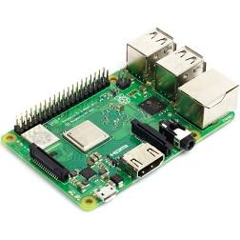

Figure 1: R Pi

|  |  |
| --- | --- |
| Raspberry pi | Model 3B |
| Processor | BCM2837 64 bit |
| Wi-fi module | BCM43143 |
| Bluetooth module | Version 4.1 |
| Total pins | 40(26 GPIO, 6 GND, 6 Vcc, 2 I2C ) |
| Operating voltage | 5v |
| Operating current | 2A |
| USB | 4 Port |
| Operating frequency | 1.2GHz |
| RAM | 1GB |

**DC Motor & Motor Driver**

Dc motor is use to drive the robot for that we use 2 dc motor. The speed of motor is depending on diameter of wheel and Rpm of motor. As we know that RPM is inversely proportional to torque. If the speed of motor is gradually increase torque of motor will be decrease. The L293 and L293D are quadruple high current half - H drivers. The L293 is designed to provide bidirectional drive currents of up to 1A at voltages from 4.5V to 36V.The L293D is designed to provide bidirectional drive currents of up to 600mA at voltages from 4.5V to 36V. Both are designed to drive inductive loads such as relays, solenoids, dc and bipolar stepping motors.

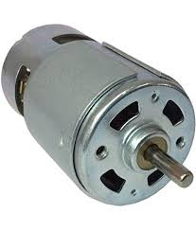

Figure 2: DC motor

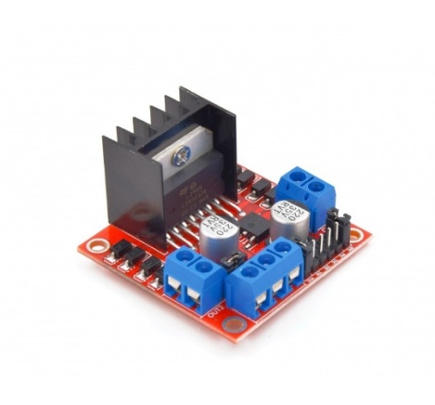

Figure 3: motor driver

**Web Camera**

A webcam is a compact digital camera you can mount on your computer to broadcast video images in real time. The digital camera captures light through a small lens at the front using a tiny grid of microscopic light-detectors built into an image-sensing microchip. the image sensor and its circuitry convert the picture in front of the camera into digital format or we can say in zeros and ones. a webcam has no memory chip or flash memory card so he not stores pictures because it's designed to capture and transmit them immediately to a computer. That's why webcams have USB cables coming out of the back. The USB cable supplies power to the webcam from the computer and takes the digital information captured by the webcam's image sensor back to the compute from where it travels on to the Internet. We can also work wirelessly and don't need to be connected to a computer, typically we use Wi-Fi to transmit the pictures to the Internet router, which can then make them available to other machines on our home network or, using the Internet, to anyone, anywhere in the world.

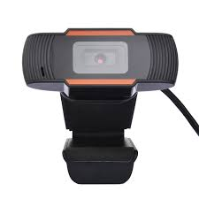

Figure 4: webcam

**Metal Detector Sensor**

A metal detector contains a circular coil of wire known as the transmitter coil. When electricity flows through the coil, a magnetic field is created all around it. As we sweep the detector over a plane surface the magnetic field also moves. If we move the detector over a metal object, the moving magnetic field affects the atoms inside the metal so it changes the way the electrons move. A battery in the top of the metal detector activates the transmitter circuit that passes electricity down through a cable in the handle to the transmitter coil.

When electricity flows through the transmitter coil, it creates a magnetic field all around it. If we sweep the detector above a metal object, the magnetic field penetrates right through it. The magnetic field makes an electric current flow inside the metal object. This flowing electric current creates another magnetic field all around the object. The magnetic field cuts through the receiver coil moving about up above it. The magnetic field makes electricity flow around the receiver coil and up into the receiver circuit, and start sending the signal as programmed.

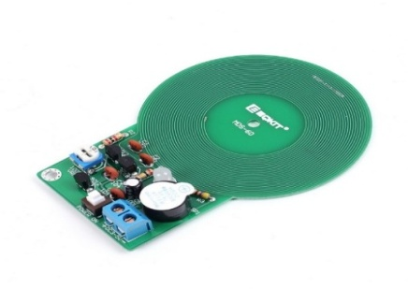

Figure 5: metal detector

**SOFTWARE**

**Open cv**

Open CV is computer vision library to perform the Face detection and recognition. Robot with the help of camera get face recognition and according to that manually we can proceed. Open CV includes inbuilt functionality to provide “Haar” cascade-based object detection. It can perform “Full Body Detection”, “Upper Body Detection” and “Lower Body Detection”. Open CV also has HOG pedestrian detection (Histograms of oriented gradients for human detection) which has an inbuilt pre-trained model for Human Detection. There are more than thousand types of algorithms that can be used to identify objects, classify human actions in videos, track camera movements, track moving objects, extract 3D models of objects, produce 3D point etc. Open CV has a modular structure, that means the package includes several shared or static libraries. Open CV handles all the memory automatically. So, if a function has one or more input arrays and some output arrays, the output arrays are automatically allocated or reallocated. The current Open CV implementation is fully re-enterable. That is, the same function or the same methods of different class instances can be called from different threads. Open CV also capable of error detection and handling. OpenCV uses exceptions to signal critical errors. When the input data has a correct format and belongs to the specified value range, but the algorithm cannot succeed for some reason, it returns a special error code.

**Firebase**

Firebase is a Backend-as-a-Service (BaaS) that started as a startup and grew up into a next-generation app-development platform on Google Cloud Platform. Firebase's first product was the Firebase Real-time Database, an API that synchronizes application data across iOS, Android, and Web devices, and stores it on Firebase's cloud. When we connect our system to Firebase, we connect it to a web-socket instead of a normal HTTP. Web Sockets are much, much faster than HTTP. we don’t have to make individual WebSocket calls, because one socket connection is plenty. All of your data syncs automagically through that single WebSocket as fast as your client’s network can carry it. Firebase sends the data as soon as it’s updated. Firebase Storage has its own system of security rules to protect your data. The major advantage of this firebase is that it authentication integrates directly into Firebase Database, so we can use it to control access to our data.

**METHODOLOGIES AND IMPLEMENTATION**

The robot that aims to implement the SLAM (simultaneous localization and mapping algos) to make it map the complete environment and then move autonomously after a certain periodic interval to check everything. The purpose of this project is to control the robot from internet with live video streaming as a means of visual feedback. This project advantage is that with port forwarding it is possible for a person in a different country to see the robot and control it according to his needs, whereas many other projects require user to be at the station as there is no means of giving a visual feedback.

Our project aims to develop a system that integrates and implements several features and can thoughtfully aims to replace the border forces and can provide surveillance at remote and arid areas. This project also aims to develop an automated bot operated by mobile application or military remote control with live streaming the current view with an additional feature of human, fire and bomb detection. The feature integrated on system includes Live Streaming, Human, Fire and Bomb Detection, Bot Control, API message alert and Server configuration.

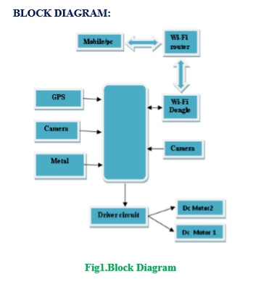

**Live Streaming**

In this project we try to implement Live video streaming using Raspberry Pi in IOT devices, with a single board computer which computes the Motion Detection Algorithm written in python as programming environment. The system uses the algorithm to significantly decrease the storage space and to save the cost. The algorithm is implemented on the Raspberry Pi, which provide the live streaming with motion detection. The live steaming can be viewed from any web browser or even from mobile in the real time.

In this architecture we use the camera module, Raspberry Pi device and connection among the devices to access video streaming. The camera module has been connected to the Raspberry pi board and be used for high definition video and still photographs. The Raspberry setup with a python script and which automatically delivery the video stream to cloud server.

To live streaming in the remote places and they need to install a motion software, and a camera for capturing image, if in the place internet access is by ADSL line and configuration for the router with IP address connected to Raspberry Pi. When some movement occur, it analyses the incoming image and store important items, and here we can view the JPEG images and video will be played smoothly even we can watch on mobile with good reliable performance. While remotely can view in the 640×360 MJPEG image, the Raspberry Pi reports 67% CPU without overlocking.

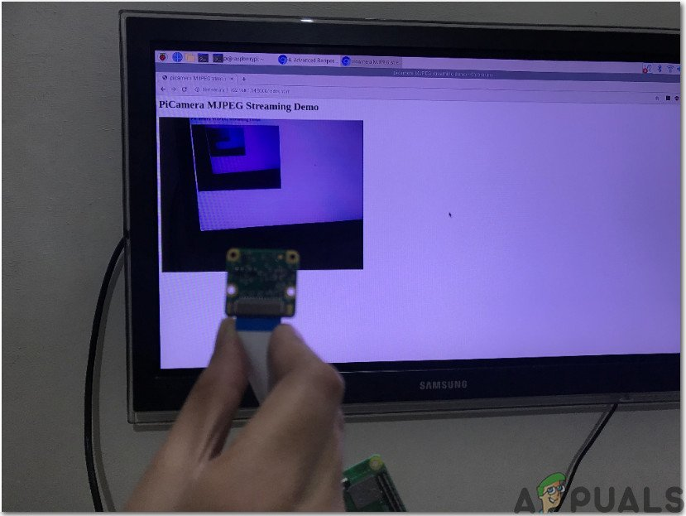

Live Streaming with Raspberrypi and Camera

**Human Detection**

Human Detection is a branch of Object Detection. Object Detection is the task of identifying the presence of predefined types of objects in an image. This task involves both identification of the presence of the objects and identification of the rectangular boundary surrounding each object (i.e. Object Localisation). An object detection system which can detect the class “Human” can work as a Human Detection System.

For this project we formulated with human detection using Haar cascade-based approach. Haar feature based approach for object detection is proposed by Paul Viola and Michael Jones in their paper “[Rapid Object Detection using a Boosted Cascade of Simple Features](https://www.cs.cmu.edu/~efros/courses/LBMV07/Papers/viola-cvpr-01.pdf)” published in 2001. This approach is widely used for Face Detection.

OpenCV includes inbuilt functionality to provide Haar cascade-based object detection. Pre-trained models provided by OpenCV for “Full Body Detection”, “Upper Body Detection” and “Lower Body Detection” are available.

There are several methods available to obtain Human presence detection but in order to formulate an optimum solution Haar method overcomes others. They require comparatively less computing power compared to modern deep learning-based approaches. (No need of GPUs to work in real-time.) These approaches are readily available in computer vision libraries such as OpenCV, making them attractive first choices.

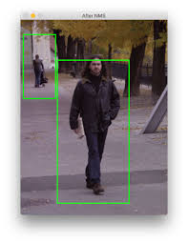

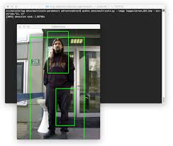

Human Detection

**Fire Detection**

Forest fires represent a real threat to human lives, ecological systems, and infrastructure.Many commercial fire detection sensor systems exist, but all of them are difficult to apply at large open spaces like forests because of their response delay, necessary maintenance needed, high cost, and other problems. In this project we aimed to incorporate this feature so as to compensate a human tour to forest to regulate the dense wildlife and its dangers.

For this implementation firstly, background subtraction is applied to movement containing region detection. Secondly, converting the segmented moving regions from RGB to YCbCr colour space and applying five fire detection rules for separating candidate fire pixels were undertaken. Finally, temporal variation is then employed to differentiate between fire and fire-colour objects.

The used method is tested using data set consisting of 6 videos collected from Internet. The final results show that this method achieves up to 96.63% of true detection rates. These results indicate to have effective integration and can be used in automatic forest fire-alarm systems.

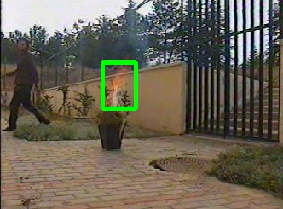

Fire Detection

**Bot Control**

This is the internet of things (IOT) based project, where we are particularly uses the Raspberry Pi, USB web camera and two DC motor with Robot chassis to build this Robotic car setup. It has a web camera mounted over it, through which we will get live video feed and the interesting part here is that we can control and move this robot from a web browser or an android application over the internet. The webcam will capture live data with regards to its surroundings and then send it to a desired device through internet. The user will be observing this data on the monitor at the user end. According to the desired movement, the user will control the robotic vehicle through the developed mode available at the user end.

Bot consists of a web camera, voltage regulator circuitry with L298N motor driver and raspberry pi. The real time video and control are displayed in the webpage which can be viewed from anywhere in the world using internet or within the Wi-Fi range and one can control it using those control provided. Setting up the raspberry pi and installation of Operating system from raspberrypi.org. Here we are using Raspbian OS. Now design the control page that provides a way to control our robot this page is designed HTML and python and write the controlling of the robot code based on the L293N IC logic we have used. Connect to a network through on-board Wi-Fi. Once it is connected through putty software configure, we got the IP address we can use it for controlling purpose.

Python programming is used here. Software design is divided into 4 codes namely: Webcam Server is the code run in the Raspberry Pi to capture the images and stream them over the internet. Here the images will be compressed into .jpg format to reduce their size prior to their transmission over the internet. They are sent using byte array over the UDP soccer. Webcam Client is run by the user to receive these images in the form of byte array. They are then displayed on the monitor at a rate closer to 5 images per second so that they appear like a continuous video. Motor Server is run by the user. Monitoring the video, the user manoeuvres the robotic vehicle or the robotic arm accordingly. This is done by accepting input either from the keyboard or the webpage. It is done by checking the key press events. Motor Client as per the input from the user, either the robotic vehicle or the robotic arm moves. This is done by making High or Low the desired GPIO pins of the Raspberry Pi. 4 GPIO pins are connected to the 4 servo motors and 4 to the motor driver IC l293d.

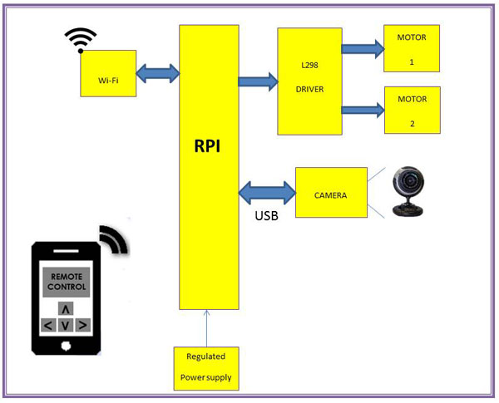

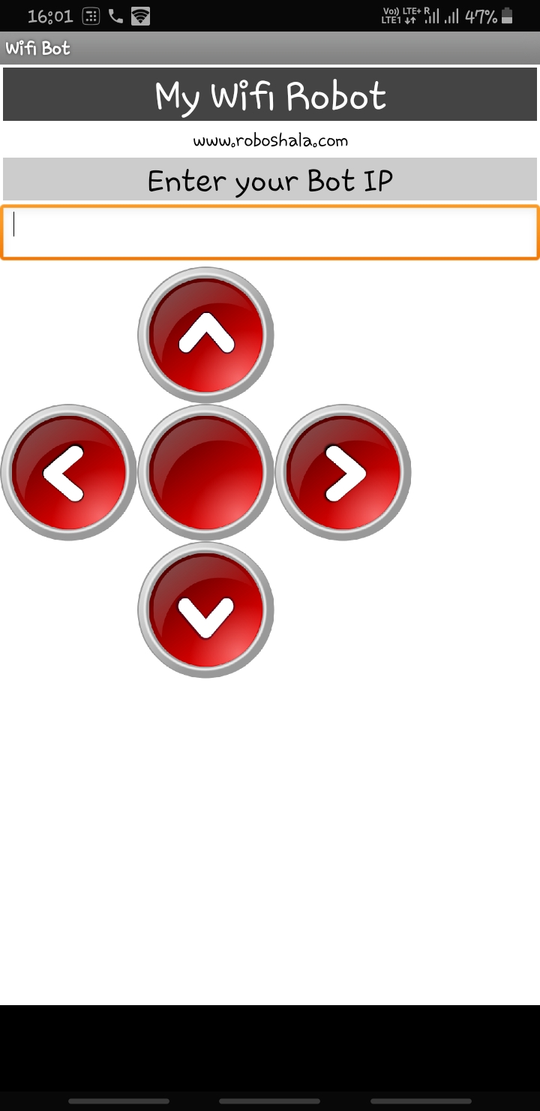

Bot Control Block Diagram

**API alert message:**

In alarming situations in order to keep the surveillance active and reliant out project aims to send an alerting notification or message to the personal posted to avoid the situations of danger. For incorporation of this feature, a cloud server with inbuilt API configuration has be instantiated, Firebase.

Firebase is a cloud service provider, provided by Google, which provides [Mobile backend as a service (MBaaS)](https://www.tothenew.com/blog/infographics-building-mobile-apps-with-mbaas/), also known as “backend as a service” (BaaS). Using Firebase, you can quickly sync up your data and make it available it on your app, which is being used by multiple users.

Firebase Cloud Messaging (FCM) provides a cross-platform messaging solution that allows reliable delivery of messages at no cost. Using this we can send notification messages (2KB limit) or data messages (4KB limit), distribute messages to a single device, groups of devices, or to devices subscribed to some topics, send acknowledgments, chats, and other messages from devices back to the server over FCM’s reliable and battery-efficient connection channel.

Using Notification messages, developers can send users a visible display message with some predefined keys and optional custom key-value pairs (data payloads).

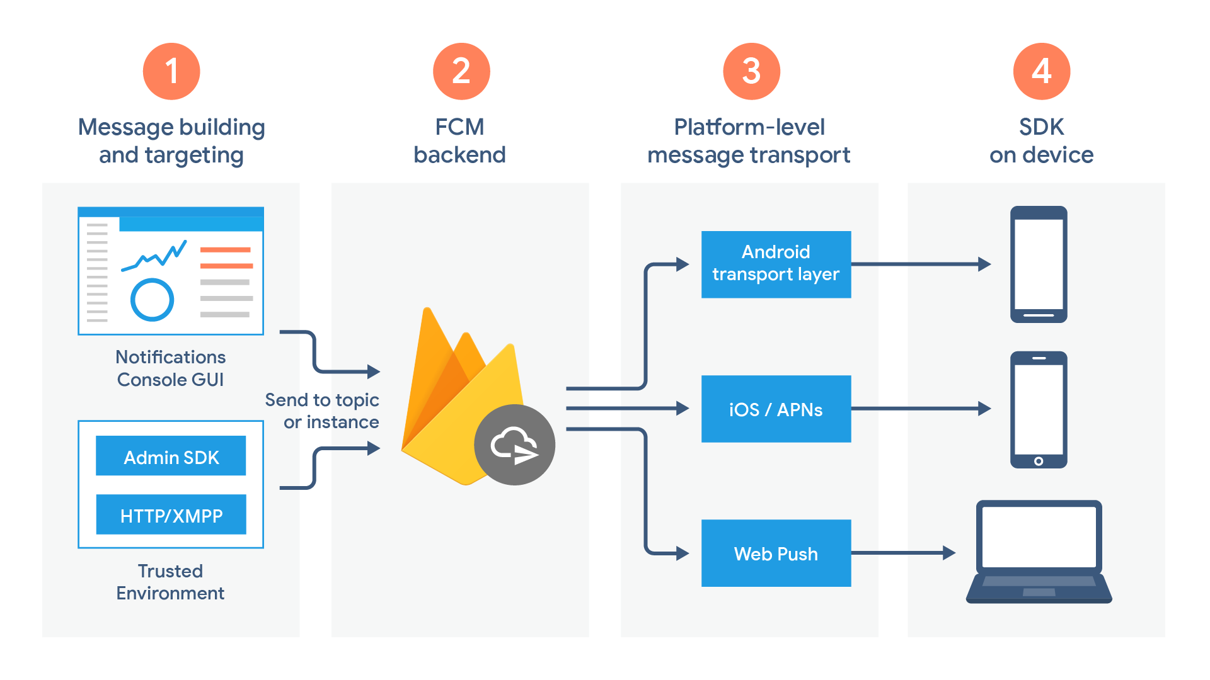

Firebase Console Cloud Messaging Block Diagram

**Server Configuration**

The integrated system needs several auxiliary space and technical support in order to function. For smooth working the system needs to incorporate and maintain server for three main functionalities.

**a). Live streaming.**

In this feature Raspberrypi is used to create a local server operated in same network and as the Raspberrypi connected to. The local server generates the live video feed and broadcast in all the network nearby. So, any device with same network and Raspberrypi’s IP address can view feed in any browser.



Local Area Server Created by RaspberryPi

**b). Bot control**

To control bot wirelessly an interface between Android app or web browser and bot is to be created to store current status of bot’s motion and direct bot for further control. A cloud interface (Firebase) is used to moderate between bot and human control and work efficiently. Here the command from user and is send and stored and constantly updated as per given instructions. The Raspberrypi continuously calls for command from cloud and recall for updates.

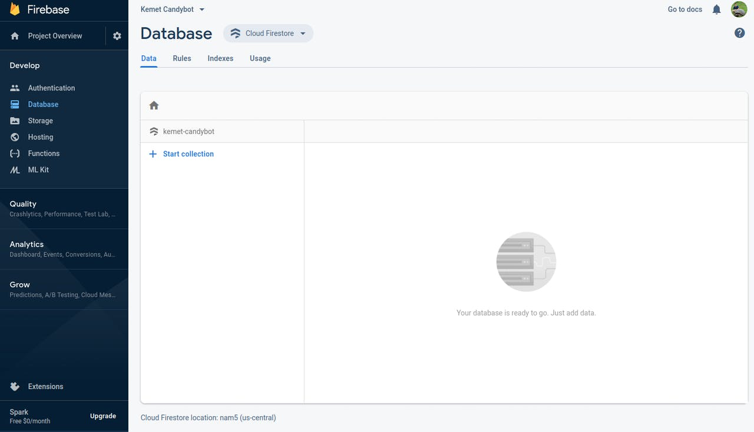

Cloud Firestore to carryout bot motion.

**c) Alert message notification**

Whenever either human, fire or bomb is detected or a malfunctioning in bot is observed it sends alerts to cloud to the person maintain server can be alarmed about it. But if he misses the alarm it is also configured to send an API message alert using an inbuilt functionality of firebase which helps to alert the personal posted.

**FUTURE SCOPE**

Some of the aspects that provides room for future advancements with evolving technologies.

**Image Processing**

Open CV is computer vision library to perform the Face detection and recognition. Robot with the help Of camera get face recognition and according to That manually we give the command to the robot Unfortunately the current binary version of OpenCV Available to install in the Raspbian operating system through apt-get (version [2](http://www.ijecs.in/index.php/ijecs/article/view/4066#IDaf8ef69f-5f7a-49d8-a88d-8699e763dd48).3.x) is too old to contain the face recognition algorithms used by this project. However, you can download, compile, and install a later version of OpenCV to access the face recognition algorithms

**Ammunition Incorporation**

As we place robot instead of human solider it is necessary that the robot will be defence himself and protect our nation from the enemy. To make robot self-defence we give the robot laser gun. The laser gun with the help of open cv and raspberry pi camera will detect the enemy and shoot according to mode of operation i.e. automatic and manual mode. It will be a good application of surveillance robot to protect the nation from enemy.

**Tracker**

To build a DIY motion tracking airsoft (or nerf gun) turret with a raspberry pi 3. The airsoft turret is autonomous so it moves and the gun when it detects motion. There is also an interactive mode so that you can control it manually from your keyboard. We used an airsoft gun for this project, but you can easily change modify this build to use a Nerf instead. This project is small, lightweight and entirely battery operated. Motion Detection uses OpenCV and computer vision to track moving targets in front of the camera.

**Swarm bots**

Swarm robots must often operate in an unstructured environment cluttered with obstacles and with many possible action paths to accomplish a variety of tasks. Such machines have many potential useful applications in medicine, defence, industry and even the home so that the design of such machines is a challenge with great potential rewards.

**Multipoint Hand Posture Based Interaction:**

This goal implies the restriction of real-time response and the use of unconstrained environments. In this we hope for a new algorithm to track and recognize hand gestures for interacting with a robot. This algorithm is based on three main steps: hand segmentation, hand tracking and gesture recognition from hand features. For the hand segmentation step, we use the colour cue due to the characteristic colour values of human skin, its invariant properties and its computational simplicity. To prevent errors from hand segmentation we add the hand tracking as a second step.

**RESULTS**

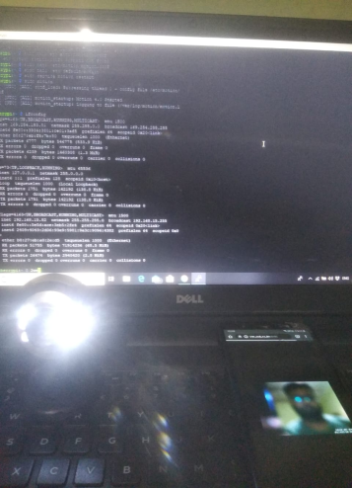

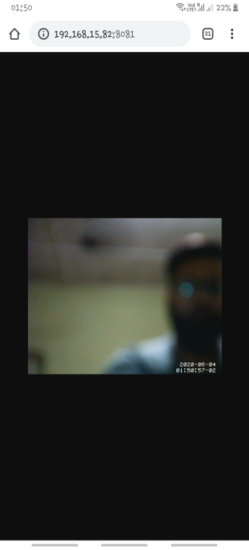

**Live Streaming**

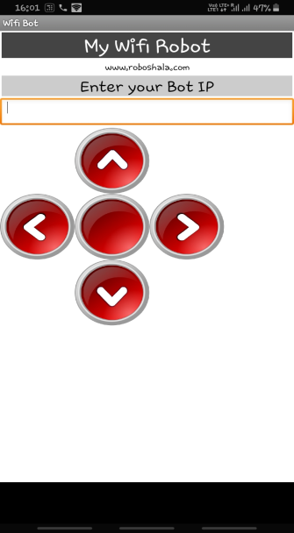

Bot Control





Human Detection

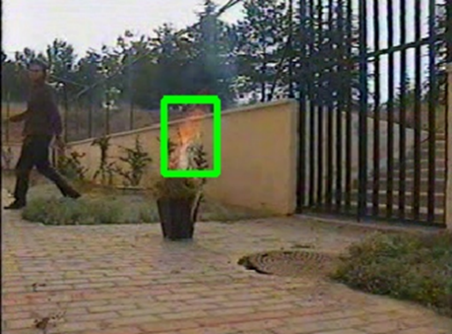

Fire Detection

**CONCLUSION**

In this project we have implemented a smart surveillance robot for military application with the help of this robot. We plan to substitute army personal from the border forces by bot that can help of this bot. The surveillance robot gives us live streaming video according to that we give the command. This bot is also incorporated with features of Human Detection and Fire Detection with help of image processing on OpenCV and python. Both the feature uses different algorithms for functioning. An additional feature of Bomb Detection (via Metal detection) with the help of landmine sensor functioned with Raspberrypi. Our system also sends the alert to cloud if there is possible detection of any of the three: Human Intervention, Forest fires or the landmine to army personal nearby hoping with immediate action. This project seems to have some limitation with memory and server strength. With implementation of better cloud server for live streaming. This model provides an efficient and considerable solution to the problem statement we estimated.

**REFERENCES**

1. Paul, M., Haque, S.M.E. & Chakraborty, S. Human detection in surveillance videos and its applications - a review. *EURASIP J. Adv. Signal Process.* **2013,**176 (2013).
2. Ikhankar, Rupali & Kuthe, Varun & Ulabhaje, Sarang & Balpande, Shruti & Dhadwe, Mahendra. (2015). Pibot: The raspberry pi controlled multi-environment robot for surveillance & live streaming. 1402-1405. 10.1109/IIC.2015.7150968.
3. Filteau, Jordan & Lee, Sukjin & Jung, Changyong (Andrew). (2018). Real-Time Streaming Application for IoT Using Raspberry Pi and Handheld Devices. 1-5. 10.1109/GCIoT.2018.8620141.
4. Mester, Gyula. (2009). Wireless Sensor-Based Control of Mobile Robots Motion. SISY 2009 - 7th International Symposium on Intelligent Systems and Informatics. 81 - 84. 10.1109/SISY.2009.52911190.
5. Khiangte, Chawngsangpuii & Ralte, Lalchhanhima & Regmi, Ramchandra & Srivastava, Mayank & Das, Rohit. (2016). Wi-Fi Control Bot with Real-Time Video Streaming. 570-575. 10.1109/RAIT.2016.7507961.
6. Paul, Manoranjan & Haque, Shah & Chakraborty, Subrata. (2013). Human detection in surveillance videos and its applications - A review. EURASIP Journal on Advances in Signal Processing. 2013. 25. 10.1186/1687-6180-2013-176.
7. Zhang, Shugang & Wei, Zhiqiang & Nie, Jie & Huang, Lei & Wang, Shuang & Li, Zhen. (2017). A Review on Human Activity Recognition Using Vision-Based Method. Journal of Healthcare Engineering. 2017. 1-31. 10.1155/2017/3090343.
8. Doulamis, Anastasios & Voulodimos, Athanasios & Varvarigou, Theodora. (2018). Human face region detection driving activity recognition in video. 10.4018/978-1-5225-5204-8.ch092.
9. Poobalan, Kumarguru & Liew, Siau-Chuin. (2015). FIRE DETECTION ALGORITHM USING IMAGE PROCESSING TECHNIQUES.
10. Mahmoud, Mubarak & Ren, Honge. (2018). Forest Fire Detection Using a Rule-Based Image Processing Algorithm and Temporal Variation. Mathematical Problems in Engineering. 2018. 1-8. 10.1155/2018/7612487.
11. Sharif, Muhammad & Khan, Muhammad & Akram, Tallha & Javed, Muhammad & Saba, Tanzila & Rehman, Amjad. (2017). A framework of human detection and action recognition based on uniform segmentation and combination of Euclidean distance and joint entropy-based features selection. EURASIP Journal on Image and Video Processing. 2017. 10.1186/s13640-017-0236-8.
12. Petra, Mohamad & Abu Bakar, Muhammad & De Silva, Liyanage & Mohamed Umar, Malik. (2017). State of the art of smoke and fire detection using image processing. International Journal of Signal and Imaging Systems Engineering. 10. 22. 10.1504/IJSISE.2017.10005428.
13. Poobalan, Kumarguru & Liew, Siau-Chuin. (2015). FIRE DETECTION ALGORITHM USING IMAGE PROCESSING TECHNIQUES.